CURRENT STATE AND ISSUES OF THE HEAVY LIQUID METAL COOLANT TECHNOLOGY DEVELOPMENT (PB, PB-BI)
R.SH. ASKHADULLIN¹, A.YU. LEGKIKH¹, V.V. ULIYANOV¹, I.A. VORONIN¹

¹ IPPE JSC, Obninsk, Russia

Email contact of corresponding author: raskhadullin@ippe.ru

Abstract

The heavy liquid metal coolant (HLMC) technology is a set of measures that make it possible to do the following: to prepare the coolant for filling the primary circuit of the reactor facility (RF); to maintain the conditions in the coolant so as to ensure corrosion resistance of structural steels; to perform purification of the coolant from solid-phase slag based both on lead oxides and oxides of structural steels’ components; to clean up the cover gas from aerosols of the coolant and corrosion products; to perform diagnostics of the circuit state. By now a considerable scope of R&D work has been carried out on the HLMC implementation in the BREST-OD-300 reactor and special purpose RFs. The report presents the achievements of the IPPE JSC specialists in the HLMC technology over the recent years.

INTRODUCTION
Heavy liquid metals (lead and lead-bismuth eutectic) are coolants that meet the requirements for heat removal and nuclear properties of intermediate and fast neutron power reactors, as well as breeder reactors. This very fact explains the existence of civil fast neutron reactor designs with heavy liquid metal coolants in Russia, and development of foreign designs of reactors with the coolants mentioned.
In Russia significant attention is paid to the issues of HLMC technology provided for the reactors and test facilities. All newly constructed reactors and research circulation circuits and rigs are outfit with the equipment for HLMС quality control, monitoring and maintenance, and the culture of handling liquid metal coolants at the enterprises of State Corporation Rosatom is enhancing and improving.
A complex of measures for the HLMC technology solves the following tasks:
1) to ensure pure coolant and clean surfaces of the circulation circuit to maintain the design thermal-hydraulic characteristics during a long service life of the installations;
2) to ensure the conditions for corrosion resistance of structural steels during a long service life of the installations;
3) to ensure current safety requirements at various stages of reactor operation (coolant preparation, reactor start-up, routine operation, repairs and refueling, depressurization, modes with deviations from normal operating conditions).
Hereinafter the current status of the complex of measures on HLMC technology has been considered in more detail.

PREPARATION OF THE COOLANT TO FILL THE PRIMARY CIRCUIT
The HLMC preparation to fill the primary circulation circuit of the reactor is one of the most important stages in providing its reliable, failure-free and safe operation in the future.
Before its melting, the metal, which will later be used as a coolant, is carefully checked for compliance with the impurity composition requirements. Chemical analysis of metal samples is carried out for the content of 12 impurities [1]: silver, copper, zinc, bismuth, arsenic, tin, antimony, cadmium, iron, magnesium, calcium, sodium. The control is carried out with the use of modern methods and tools for chemical analysis.
The content of impurities in the coolant is important because their presence affects the radiation environment, contributes to nuclear-physical parameters, and impacts slag formation and corrosion processes.
Before being loaded into the primary circuit, the metal is melted. For a lead-bismuth alloy with a melting point of about 125 °C, melting is performed at 250 °C, for lead having a melting point of about 327 °C, melting is performed at 400 °C.
After melting, the metal is loaded to the primary circuit. Two ways to load the metal into the installation are the most convenient:
– by a special pump that provides pumping of liquid metal from the loading system to the primary circuit;
– by supplying overpressure to the loading system for liquid metal displacement to the primary circuit.
In the pipeline through which the liquid metal is loaded, a filtration purification system must be installed, which rules out any ingress of solid impurities into the primary circuit.
When the coolant is loaded, an important aspect is the primary circuit tightness and the presence of an inert gas atmosphere during the filling process. Inert gases of high purity are used as a gaseous medium: argon, nitrogen, helium.
In Russia, at the State Corporation Rosatom enterprises involved in the development of HLMC reactors, the procedures for preparation and filling the circuits have been worked out at test facilities and developed for advanced HLMC reactors.

MAINTENANCE OF THE PROPER CONDITIONS IN THE COOLANT TO ENSURE CORROSION RESISTANCE OF STRUCTURAL STEELS
An HLMC specific feature consists in the need to form protective oxide films on the surfaces of structural steels, which can ensure their corrosion resistance during a long-term operation. One of the key conditions for the formation of oxide films on steels and their reduction during the operation is the HLMC oxidation potential maintenance within the specified limits. The HLMC oxidizing potential is characterized by the thermodynamic activity (TDA) of oxygen dissolved in the coolant. During the reactor operation, continuous monitoring of oxygen TDA should be ensured. To maintain the oxygen TDA at a specified level during the HLMC circuit operation, it will be necessary to regularly feed the coolant with dissolved oxygen.
In Russia, at the State Corporation Rosatom enterprises, oxygen activity sensors (OAS) are used to monitor oxygen TDA. Based on the experience of IPPE JSC, which is one of the Rosatom enterprises, and within the framework of the activities dedicated to development of various control devices for nuclear power facilities, solid-electrolyte based OASs were developed to control oxygen TDA in lead and lead-bismuth coolants. Various designs and modifications of sensors have been developed and certified as a measuring instrument to ensure the convenience of their use in both research facilities and reactors [2-5]. The photos of some sensor designs are shown in Figure 1.
The CSE is the main OAS element. It is based on a solid electrolyte made of zirconium dioxide and stabilized with yttrium oxide. As a result of the studies carried out by the IPPE JSC specialists, it was found that the developed CSEs based on solid electrolytes from oxide ceramics are capable of operating for a long time under conditions of elevated temperatures and thermal shocks in HLMC, have stable conductive and mechanical properties, heat resistance and low gas permeability [6]. Various CSE versions and methods of their connection with the steel body of the sensor’s sensitive element have been developed. Some of the CSE designs, including the external view of the CSE in a steel body, are shown in Figure 2.
One of the important issues in the development of oxygen activity sensors is the control of their metrological characteristics to ensure oxygen TDA measurements with a specified accuracy.
At the IPPE JSC, calibration facilities have been developed and certified, which allow for metrological certification and calibration of oxygen activity sensors.
One of the calibration facilities has been certified as a standard oxygen TDA unit by the Federal Agency for Technical Regulation and Metrology of Russia [7]. The manufacturer of that calibration facility is IPPE JSC. In the calibration facility, oxygen TDA levels are set by means of steam-gas mixtures. The error in reproducing oxygen TDA in liquid lead within the temperature range from 380 °C to 600 °C is 2%. The calibration facility is intended for certification, primary and periodic calibration of measuring channels whose output parameter is oxygen TDA.

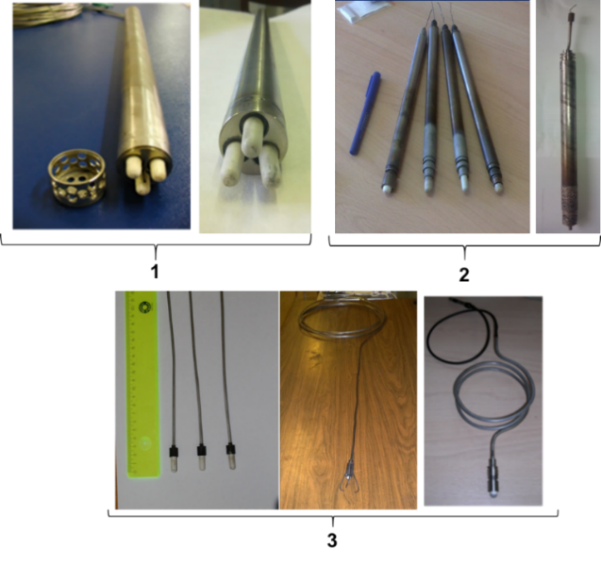
Figure 1. Oxygen activity sensors developed at IPPE JSC (1 – OAS with three reference electrodes and built-in thermoelectric converter; 2 – OAS with one reference electrode; 3 – OAS with one reference electrode of a cable type)

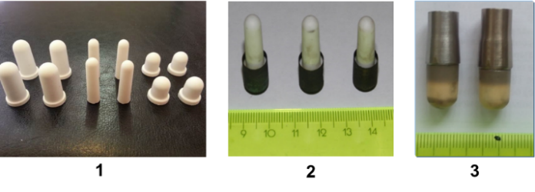
Figure 2. Ceramic sensitive element designs (1 – ceramic capsules of different sizes; 2 – ceramic capsules in a steel body, connection is made with the use of glass ceramics; 3 – ceramic capsules in a steel body, connection is made by soldering)

The Federal Agency for Technical Regulation and Metrology of Russia has certified the second calibration facility as a type of measuring instrument. In the facility, the specified EMF levels in the liquid heavy metal are reproduced by chemical reagents. The calibration facility is used to control the metrological characteristics of oxygen activity sensors whose output parameter is EMF.
Proceeding from R&D activities carried out at IPPE JSC, the most promising method for introducing dissolved oxygen into HLMC with the aim to maintain oxygen TDA at a given level in the course of operation is the solid-phase method based on the process of dissolving solid-phase lead oxide placed in the coolant flow. Technical implementation of the solid-phase method for oxygen TDA control is carried out with the use of mass transfer apparatus [8]. In mass transfer apparatus, solid-phase lead oxide is used in the form of granules from 8 mm to 12 mm in size.
By now, oxygen solubility in liquid lead and lead-bismuth has been investigated, and the kinetics of dissolution of lead oxide granules in these melts has also been studied. Conditions availability of the above-mentioned data made it possible to create efficient mass transfer apparatus [9-11] and develop the methods to calculate their technical parameters [12-14].
As of 2020, the team of the laboratory for liquid metal technologies in IPPE JSC developed 60 mass transfer apparatus (MTA), which have various designs and are based on different principles of arrangement of lead oxide granules dissolution.
A significant experience has been gained during a long-term operation of the developed MTA at the test facilities with lead-bismuth and lead coolants, which testifies to their reliability, capability of accurate control of the dissolved oxygen injection rate, without any negative effect on the circuit as a whole.
The designs of mass transfer apparatus can be classified into a few basic types (by the method of initiating a coolant flow rate through the filling of lead oxide granules in the MTA):
- the designs with induction of the coolant flow rate by means of its heating by an internal or external heater;
- the designs where the coolant flow rate is controlled with a built-in pump;
- the designs where gas is used as a coolant flow rate activator;
- the designs where the flow rate is controlled by the pressure difference at the point of MTA location.
Figure 3 shows the photos of different MTA designs developed, fabricated and tested at IPPE JSC.
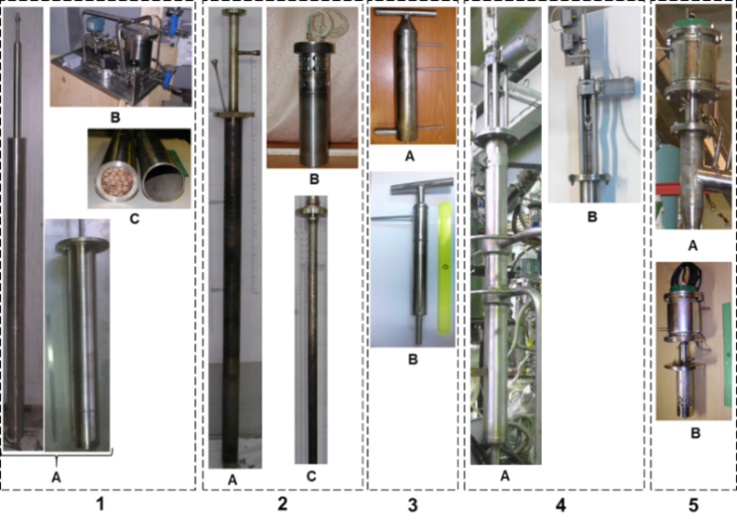
1 – MTA with an internal heater (A – submerged part design option, B – gas loop, C – reaction tank lattice filled with lead oxide granules);
2 – MTA with an internal heater (А – MTA with one heater; B – MTA with a few heaters; С – electric bar heater);
3 – MTA with a valve (А – MTA as part of the test facility; B – valve actuator);
4 – MTA with a built-in pump (А – MTA as part of the test facility; В – axial-flow pump).

Figure 3. Mass transfer apparatus

The presence of a sensor for continuous monitoring of oxygen TDA (OAS) and a device for dosed injection of dissolved oxygen into HLMC (MTA) makes it possible to automate the process of maintaining conditions in the coolant to ensure the corrosion resistance of structural steels, namely, the process of maintaining oxygen TDA at a given level.
At the IPPE JSC the prototype automated systems for maintaining a given oxygen regime in HLMC have been developed. These systems provide the necessary feeding of the coolant with dissolved oxygen by adjusting the rate of oxygen injection from the MTA by means of a software and hardware complex with the OAS signal feedback, which makes it possible to ensure high control accuracy actually without any operator involvement.
The measuring unit is developed on the basis of standard components and is designed to be connected to a personal computer with the appropriate software installed.
The scientific studies performed and the experience gained in the operation of prototype automated systems for maintaining a specified oxygen regime in HLMC as part of test facilities allow us to conclude that it is possible to develop an effective system for continuous maintenance of the oxygen regime for almost any facility with HLMC.

HYDROGEN purification OF THE COOLANT
As it is known, insufficient knowledge of the lead-bismuth coolant and, at the initial stage of its operation, the prevailing idea that by cleaning the coolant from excess oxygen from its free surfaces, it would be possible to ensure the purity of the circulation circuit, caused an accident of the left-side reactor system at the the nuclear submarine, Project 645, in 1968, and a pre-emergency situation at the ground prototype at the 27/VT test facility [15, 16].
It turned out that the key problem consisted in frequent and long-lasting repairs of steam generators, accompanied by depressurization of the primary circuit and constant formation of slags based on lead oxides caused by the interaction of the coolant with ambient oxygen. As the result, the lack of an effective method for purification the primary circuit led to an excessive accumulation of slags, their sudden throw into the core because of an increase in the intensity of steam generator leakage, which caused a sharp deterioration in heat removal and subsequent melting of fuel elements.
By the time the reactor systems for nuclear submarines under Projects 705 and 705K were put into operation, considerable experience had already been gained in lead-bismuth coolant handling. And generalization of the experience of their operation from 1975 to 1996 demonstrated that none of the nine reactors had any failures caused by excessive slag accumulation [17]. Nevertheless, once every 1-2 years the above-mentioned reactor systems were subject to diagnostic purification from slags, regardless of the need for it. The operating conditions and design features of those reactor systems significantly differed from the current requirements and concepts consisting in the monoblock-type configuration and a long-term operation with achievement of the maximum capacity factor. Therefore, the approaches and requirements for hydrogen purification of lead-containing coolants have changed by now.
The most general definition of slag [18] should be considered an unpumpable cohesive dispersed system with a lead oxide binder, filled with an unoxidized coolant and metal oxides with an affinity for oxygen higher than that of lead, sufficiently strong and indestructible, for example, by heating to 500 °C. The composition of various slags generated during the operation of real circulation circuits with lead-bismuth coolant is shown in Table 1 [19]. Calculation of the oxygen content with reference to lead oxide shows that PbO covers from 33 to 54 wt.%. The rest is mainly constituted by the components of the coolant.

TABLE 1. COMPOSITION OF SLAGS GENERATED IN THE COURSE OF OPERATION OF TEST FACILITIES
Slag sample number | Contents of elements in the slag, wt.%
 | O | Pb | Bi | Fe | Cr | Ni
1  2  3  4 | 2.4  3.9  3.5  2.6 | 51.6  51.9  55.9  75.3 | 46.4  42.1  39.5  18.6 | 4⋅10⁻⁴  2.6⋅10⁻²  4.2⋅10⁻¹  6⋅10⁻¹ | 3⋅10⁻⁴  2.4⋅10⁻²  1.5⋅10⁻¹  1⋅10⁻² | 3⋅10⁻⁴  1.2⋅10⁻³  9.5⋅10⁻²  5⋅10⁻²

The formation of lead oxide in lead-containing coolants is possible only in case of ingress of oxygen-containing compounds, primarily air oxygen, into them when the circuit is depressurized. The analysis should not exclude the possibility of lead oxide formation in the course of coolant interaction with water and water vapor that enters because of micro-leaks in steam generators. At the same time, it is inappropriate to consider the possibility of lead oxide formation by reduction of iron oxide that is the basis of protective coatings for structural steels. This is due to the greater affinity for oxygen in iron compared to lead, so it is iron that will reduce lead oxide, and not vice versa [20–23].
Control over the scope of slag accumulation is necessary for making a decision on hydrogen purification of the coolant and circuit surfaces as the hydrogen purification procedure is carried out when the reactor is shut down. Primary purification is mandatory immediately after the circuit is filled with coolant, and during a long-term operation of the circuit, the slag accumulation is determined by the change in the nitrogen content in the gas. An increase in the nitrogen content indicates that air containing oxygen has entered the circuit, i.e. the conditions favorable for solid slag formation from lead oxide have occurred.
In principle, different methods can be used to clean heavy liquid-metal coolants from slags based on lead oxides:
- filtration cleaning of the coolant from slags;
- low-temperature cleaning with hydrazine hydrate (N₂H₄⋅H₂O), which was widely used at the early stages of lead-bismuth coolant development;
- according to the authors, the most technologically advanced method for purification of the heavy liquid metal coolants from lead-oxide based slags is treatment of the circuit surfaces and the coolant itself with “hydrogen - water vapor - inert gas” gas mixtures.
In the general case, in the process of coolant purification with gas mixtures, three main types of inter-phase interaction can be distinguished: at the “lead oxide – hydrogen”, “coolant - hydrogen” and “lead oxide - coolant” interfaces. As a rule, the determinant is the first interaction, where due to chemical reaction (9) of the interaction of hydrogen and lead oxide, the slags are destroyed and water vapor and lead are generated. And lead goes back to the composition of the coolant.
$〈PbO〉+\left(H_{2}\right)→\left(H_{2}O\right)+\left\{Pb\right\}$ (9)
where $〈PbO〉$ is solid-phase lead oxide (slags); $\left(H_{2}\right)$ is gaseous hydrogen; $\left(H_{2}O\right)$ is water vapor; $\left\{Pb\right\}$ is liquid product of the reaction, i.e. lead.
Chemical interaction of hydrogen and lead oxide begins at the temperatures above 200 °C, and within the temperature range of 300-350 °C the process significantly accelerates. This is explained by elimination of the diffusion barrier due to transition of the reaction product (lead) from the solid to liquid state. The kinetics of such reactions is described by the Erofeev equation [24]:
$α=1-e^{-kτ^{n}}$, (10)
where α – fraction of the reacted substance (degree of lead oxide reduction); τ – reaction time; k – reaction rate constant; n – order of the reaction.
It is kinetically more advantageous to reduce lead oxides in the coolant when the “lead oxide-hydrogen” interaction is realized, because the presence of a coolant between oxide and hydrogen significantly slows down the purification process in the circulation circuit. Therefore, purification must be carried out by introducing the gas mixture into the coolant flow.
When the “hydrogen-water vapor-inert gas” mixture is only supplied to the gas volume, the slag destruction will go due to the slow process of slags dissolution, with successively realized interactions of “lead oxide-coolant”, “coolant-hydrogen”.
In the case of a large local accumulation of lead oxides, the process can proceed as follows: when interacting with a hydrogen-containing gas mixture, lead-oxides-based slags become friable and fall off from their deposition sites, being carried away by the coolant flow. Due to the effect of flotation, dispersed particles of loosened and disintegrated lead oxides can “settle” at the “gas phase-coolant” interface and then be transported with a bubble as part of a two-component flow or directly by the coolant flow. Subsequently, separation of all the impurities suspended in the coolant takes place on the melt mirror and lead is finally and completely reduced from floated-up oxides.
To inject the gas mixture into the coolant flow, various devices can be used depending on the design features of the circulation circuit: ejectors and injectors, nozzle extensions or mechanical gas dispersers with moving structural elements. For each circuit, the choice of the device for injecting the gas mixture is individual, and it is determined mainly by the average rates of the downcoming flow of the coolant in the circuit.
So, if the circuit has a loop-type design, high rates of downcoming currents (> 0.6 m/s), and the flow rate is created by centrifugal circulation pumps, then the use of ejectors on the pump bypass is justified (see Figure 4). This way of gas injection was successfully used for purification commercial circuits of propulsion reactors [18].
Having circulated along the circuit, gas bubbles are separated at the “coolant-gas” interface. The incompletely reacted hydrogen-containing gas mixture enters the gas volume of the circuit, from where it is again introduced into the coolant flow by the ejector. Water vapor is condensed in the cold sections of the gas loop, and the process is controlled by the rate of decrease in the hydrogen concentration in the gas system [27].
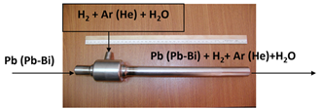
Figure 4. An ejector for injecting gas into the lead-containing coolant flow

Large-sized reactor systems have an integral or improved loop-type design (monoblock) without pipelines and with significant coolant-gas interfaces [28]. It is impossible to use classical ejectors to inject gas into the coolant, but mechanical devices with moving parts are justified. In fact, these devices combine a small pump and a narrow part (similar to ejectors) with a reduced coolant pressure (see Figure 5).
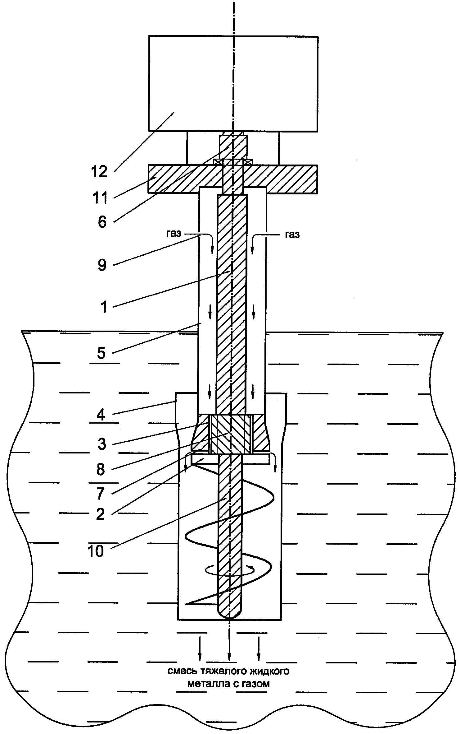
Figure 5. A device to inject gas into liquid metal with moving parts (RF Patent No. 2639721)

As you can see, such a device consists of an electric motor (12), a magnetic coupling (6), a shaft (1), a housing (5) with holes (9), a lower rotating disc (2) and an upper fixed (stationary) disc (7), a shroud (4) , a coolant flow rate booster (10), a support shaft assembly (8) with the channels (3).
The electric motor (12) is installed outside the circuit, fixed to the flange (11) and connected to the shaft (1) by means of a magnetic coupling (6). Part of the housing (5) located above the coolant level has holes (9). The working part of the device consists of a lower rotating disc (2) mounted on the shaft (1) and a stationary disc (7) located on the housing (5). Inside the shroud (4) with a gap there are upper fixed (7) and lower rotating (2) discs. The coolant flow rate booster (10) is located inside the shroud (4) with a gap and is mounted on the lower part of the shaft (1).
In the cases where it is impossible to use ejectors and mechanical dispersers, it can be justified to clean the coolant with the gas mixture introduced by means of nozzle extensions.
Nozzle extensions installed in the required areas of the circuit and connected with a pipeline with a gas pressure source (a compressor, a gas cylinder) are the simplest way to introduce gas into the coolant flow. However, the diameter of the created gas bubbles depends on the diameter of the holes in the nozzle extension; therefore, it is impossible to create a finely dispersed phase for the circuits with low rates of the coolant downcoming flow. On the other hand, the simplicity of the design allows the nozzle extensions to be placed anywhere in the circuit, including at great depths, of course, in compliance with the required safety measures. A photograph of a nozzle extension made in the form of a pipe with a set of holes is shown in Figure 6.
Figure 6. A nozzle extension to introduce gas into the coolant flow

The main potentially dangerous drawback of nozzle extensions is the possibility of “throwing” the coolant into the pipelines and equipment of the gas system with its subsequent solidification and the need for complex operations to remove the solidified metal from them. Prevention of the coolant “overflow” into the gas pipelines can be achieved by installing ball check valves or other devices. It is also possible to use other, rarely applied in practice, methods of gas injection into the coolant flow, given below.
When the coolant jets and drops fall on its free surface, depending on the height of the fall, the “entrainment” of the gas component by the drops and jets of the flow is possible.
For the formation of suspensions, emulsions or foam with sufficiently small-sized (microns or less) particles in various industries (oil refining, chemical, metallurgical, etc.), powerful ultrasound sources are widely used. An example of gas injection into a liquid by ultrasound. The efficiency of such devices is quite high, but their implementation requires a special geometry of the mixing chambers eliminating any damage to structural elements under the influence of ultrasound. This fact limits the applicability of such devices in liquid lead.
Thus, in the opinion of Russian scientists today, the best way to eliminate slag accumulation is hydrogen purification of the circuit with gas mixtures of “hydrogen – water vapor – inert gas”. Moreover, the greatest purification efficiency is achieved when the gas mixtures are introduced directly into the coolant flow with special devices, i.e. gas dispersers. The design of gas injection devices depends on the design features of the circuits: their layout, the way the circulation is arranged, the coolant flow rates. Almost all the test circuits with heavy liquid metal coolants in the Russian Federation are equipped with mechanical dispersers with moving parts (an example of a device in operation at the IPPE test facility is shown in Figure 7), ejectors or nozzle extensions.

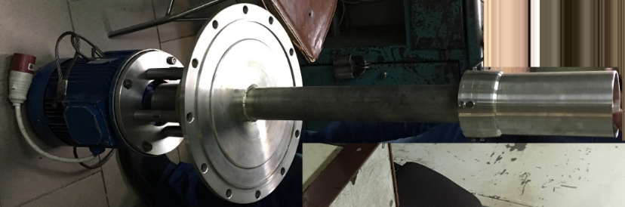
Figure 7. Gas disperser in operation at the IPPE test facility

The main task being solved at present is introduction of gas injection devices at reactor facilities, the construction licenses of which are justified for the Russian regulator of safety issues in the use of nuclear energy. As applied to the designs of reactors with lead and lead-bismuth coolants, a mechanical disperser of gas mixtures has already proven its endurance characteristics and the ability to deliver a reducing gas medium to all points of the circuit, including the core.

COOLANT FILTRATION
A long-term experience in operation of the circuits with HLMC indicates the inevitability of formation of suspended solid impurities in them, which can have a negative effect on the reactor operational characteristics [29]. Therefore, despite the success achieved in recent years in reducing the level of mass transfer processes in the circuits due to the introduction of advanced technologies for HLMC handling, it seems impossible to completely rule out the possibility of negative consequences associated with the presence of suspensions without special measures taken to remove them.
During the entire period of reactor operation, there is a constant flow of solid suspended impurities into the primary circuit, distributed in a certain way over its various elements. The source of their supply is, first of all, the diffusion of structural material elements through the protective passivation film, corrosion of structural materials (for example, crevice corrosion), abrasion of rubbing elements, chipping of protective films, erosion, steam generator leakage, overflow of impurities into the primary circuit during the repair work.
To reduce the intensity of corrosion and mass transfer processes in a pressurized circuit, the oxygen TDA in the circulating coolant is maintained at a preset level. The considered high-temperature process of oxidation of iron, chromium and other elements of structural materials in a lead coolant as a heterogeneous system, during their diffusion intake, follows the classical pattern according to the mass-action law and is the total result of parallel complex reactions.
As shown by the analysis of samples, the iron concentration in the coolant is as a rule relatively low and does not exceed the values of (1-5)∙10-4 wt.%. However, this fact does not rule out the slag formation in certain parts of the circuit. This situation is determined by the “self-cleaning” property of the coolant: the suspended solids formed in it because of the low solubility of iron and other elements in the coolant are separated at the “coolant - wall” and “coolant - gas” interfaces and, concentrating in the corresponding areas, form slags. The intensity of these processes depends on the intensity of the source of their formation, the ratio of the rates of ingress of impurities directly into the coolant and their flow, which determine the steady-state concentration of suspensions. It is noticed that when a dynamically “high” concentration of suspended solids is reached in the coolant (at a level of С ≥10⁻³ wt.%), slag formation is especially intense in certain sections of the circuit.
Figure 8 shows suspended particles’ size distribution in HLMC with indication of the area of slag-forming particles and the areas of the filter and sump operability [29].
It is clearly seen that large particles of d > 10 μm can be retained by both the filter and the sump and precipitate on the “coolant - gas” interface. Particles of micron and submicron size (colloidal) pose a potential hazard to the “coolant - structural material” interface because during their concentration there is a risk of potential formation of the so-called coherent disperse structures characterized by their increased viscosity. Particles of this size can only be retained by the filter.
At the IPPE JSC more than 10 filter designs have been developed, applicable both for test facilities and for the HLMC reactor circuits.
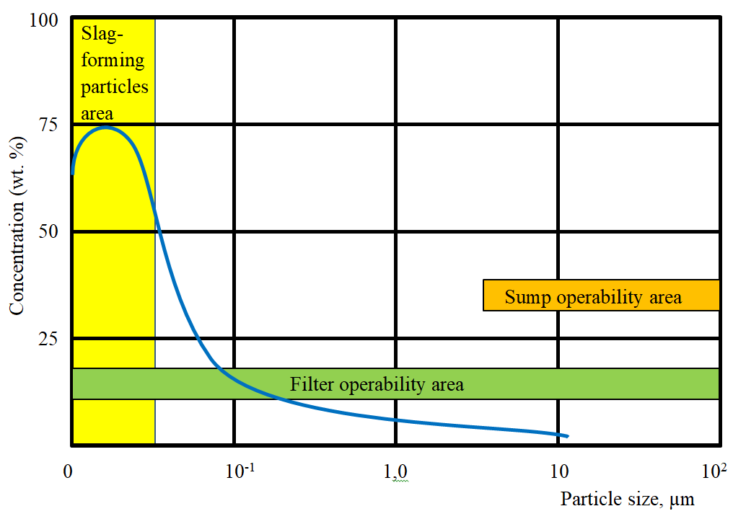
Figure 8. Suspended particles’-size-distribution (wt.%.) in heavy liquid metal coolant;
the areas of the filter and sump operability the area of slag-forming particles
References
- ASKHADULLIN R.SH., STOROZHENKO A.N., MELNIKOV V.P., LEGKIKH A.YU., ULYANOV V.V. “Provision of Heavy Liquid Metal Coolant Technology in Reactors of a New Generation”, the Fifth Conference “Heavy Liquid Metal Coolants in Nuclear Technologies (HLMC-2018)”, (Russia, Obninsk, 2008), Transactions (2008).AUTHOR, A., Internal Report Title in Title Case, internal report, Organization, Location, Year.
- Patent 2 298 176. The Russian Federation, MPK G01N 27/406. Oxygen Concentration Solid-Electrolyte Sensor and the Method for its Manufacturing. Published 27.04.2007 / Gulevsky V.A., Martynov P.N., Chernov M.E.
- Patent 2 584 378. The Russian Federation, MPK G01N 27/411. The Method for Measuring Oxygen Thermodynamic Activity in Liquid Metals. Published 20.05.2016 / Martynov P.N, Askhadullin R.Sh., Storozhenko A.N., Shelemetiyev V.M., Sadovnichy R.P., Skomorokhov A.N.
- Oxygen Thermodynamic Activity (TDA) Sensors. The Measuring Instrument Type Approval Certificate. State Register Number 77046-19. 2019.
- Oxygen Activity Sensors in Lead-Containing Liquid Metals, DAK-03. The Measuring Instrument Type Approval Certificate. State Register Number 63266-16. 2016.
- ASKHADULLIN R.SH., STOROZHENKO A.N., SHELEMETIYEV V.M., SKOMOROKHOV A.N., SADOVNICHY R.P., LEGKIKH A.YU. The Current Status of the IPPE JSC Development of Oxygen Activity Sensors for Reactor Facilities with a Heavy Liquid Metal Coolant //VANT. Series: Nuclear Reactor Constants: - 2017, special issue, P. 12-19.
- “Standard Unit of Thermodynamic Activity of Oxygen”. Standard Approval Certificate No. 392.0392-2019 as of 06/26/2019, No.3. ADI.0392.2019 in the Register of the Federal Information Fund (2019).
- MARTYNOV P.N., ASKHADULLIN R.SH., LEGKIKH A.YU., SIMAKOV A.A. Analysis of Means of Oxygen Potential “Solid-Phase” Control in HLMC // VANT. Series: Nuclear Reactor Constants: - 2015. No. 3. - P. 79 - 84.
- Patent 2547104. The Russian Federation, MPK B01J8/00, B01F1/00. Mass Transfer Apparatus / Martynov P.N., Askhadullin R.Sh., Simakov A.A., Legkikh A.Yu., 2015.
- Patent 2510291. The Russian Federation, MPK B01J8/00, B01F1/00. Mass Transfer Apparatus with Discrete Gas Supply / Martynov P.N., Askhadullin R.Sh., Simakov A.A., Legkikh A.Yu., Chaban A.Yu., 2014.
- Patent 2281140. The Russian Federation, MPK B01D 3/00. Mass Transfer Apparatus with Continuous Gas Supply / Martynov P.N., Askhadullin R.Sh, Simakov A.A., Legkikh A.Yu., Chaban A.Yu., 2013.
- LEGKIKH A.YU., MARTYNOV P.N., ASKHADULLIN R.SH. Calculation of Mass Transfer Apparatus to Ensure a Preset Oxygen Regime in a Heavy Liquid Metal Coolant // Izvestiya Vuzov. Nuclear Energy. – 2013. – No.1. – Pp. 80-91.
- ASKHADULLIN R.SH., MARTYNOV P.N., RACHKOV V.I., LEGKIKH A.YU. Computational and Experimental Studies to Justify the Mass Transfer Apparatus Used to Ensure a Preset Oxygen Regime in HLMC (Pb, Pb-Bi) // Izvestiya Vuzov. Nuclear Energy – 2014. – No.1. – Pp. 160-171.
- ASKHADULLIN R.SH., LEGKIKH A.YU. Estimation of Changes in the Performance of the Mass Transfer Apparatus due to the Oxygen Supply Consumption. // VANT. Series: Nuclear Reactor Constants: – 2019. - No. 1. – Pp. 152 – 160.
- MARTYNOV P.N., GULEVICH A.V., ORLOV YU.I., GULEVSKY V.A. Water and Hydrogen in Heavy Liquid Metal Coolant Technology // Progress in Nuclear Energy. 2005. Volume 47, Issues 1-4. Pp. 604-615.
- ORLOV YU.I., EFANOV A.D., MARTYNOV P.N., ULYANOV V.V. Hydrodynamic Problems of Heavy Liquid Metal Coolants Technology in Loop-Type and Monoblock-Type Reactor Installations // Nuclear Engineering and Design. 2007. Volume 237, Issues 15-17. Pp. 1829-1837.
- EFANOV A.D., IVANOV K.D., MARTYNOV P.N., ORLOV YU.I. Lead-Bismuth Coolant Technology at Nuclear Power Plants of the First and Second Generations.// Izvestiya Vuzov. Nuclear Energy. 2007. No.1. Pp. 138-144.
- Gromov B.F., Orlov Yu.I., Martynov P.N, Gulevsky V.A. Problems of Heavy Liquid Metal Coolants (Lead, Lead-Bismuth) // Transactions of Papers. “Heavy Liquid Metal Coolants in Nuclear Technologies” Conference. Obninsk. 1999. V. 1. – Pp. 92-106.
- ZRODNIKOV A.V., EFANOV A.D., ORLOV YU.I. The Technology of Heavy Liquid Metal Coolants, Lead-Bismuth and Lead. // Nuclear Energy. 2004. V.97. No.2. P. 98-103.
- TURKDOGAN E.T. Physical Chemistry of High Temperature Technology. Translation from English. Moscow: Metallurgy, 1985. P. 344.
- ARNOLDOV M.N., SOLOVIOV V.A., KOMAROV G.S., SHORINA L.M. Solubility of Elements in Liquid Lead. Moscow: Nuclear Engineering Publishing House, 2015. P. 192.
- Handbook on Lead-Bismuth Eutectic Alloy and Lead Properties, Materials Compatibility, Thermal-hydraulics and Technologies // OECD/NEA Nuclear Science Committee, 2007. ISBN 978-92-64-99002-9. – P. 693.
- GROMOV B.F., SHMATKO B.A. Physical and Chemical Properties of Liquid Lead Bismuth // Izvestiya Vuzov Nuclear Energy. 1996. No. 4. Pp. 35-41.
- DIACHENKO A.N., SHAGALOV V.V. Chemical Kinetics of Heterogeneous Processes: Textbook. Tomsk Polytechnic University. - Tomsk: Tomsk Polytechnic University Publishing House, 2014 – P. 102.
- MALENKOV I.G. On the Motion of Large Gas Bubbles Floating up in the Liquid. Applied Mechanics and Technical Physics, 1968, No. 6, Pp. 130-131.
- BERDNIKOV V.I., LEVIN A.M. On the Gas Bubble Floating-up Rate in Metal and Slag Melts. Izvestiya Vuzov, Ferrous Metallurgy, 1977, No. 12, Pp. 24-27.
- ULYANOV V.V., GULEVSKY V.A., MARTYNOV P.N. Investigation of Hydrogen Purification Processes and Devices as Applied to Circulation Circuits with Heavy Liquid Metal Coolants // Izvestiya Vuzov. Nuclear Energy, No.2, 2013, Pp. 33-38.
- DRAGUNOV YU.G., LEMEKHOV V.V., MOISEEV A.V., SMIRNOV V.S. Fast Neutron Reactor with Lead Coolant (BREST). // Engineering and Automation Problems. 2015. No. 3. Pp. 97-103.
- MARTYNOV P.N, ASKHADULLIN R.SH., PAPOVYANTS A.K., VORONIN, I.A., YAGODKIN I.V., MELNIKOV V.P. “HLMC Filtration Cleaning from Impurities” “Heavy Liquid Metal Coolants in Nuclear Technologies Conference (HLMC-2013): Transactions of Papers. – Obninsk: SSC RF IPPE. 2014. Pp. 364-373.

