Development of submerged
electromagnetic pump for liquid lead

D.M. Obukhov, P.Yu. Chaika, M.M. Golovanov, I.R. Kirillov, S.A. Krizhanovsky, K.A. Komov, A.N. Labusov, G.V. Preslitsky, P.A. Tukeev, V.S. Federyaeva

Joint stock company “D.V. Efremov Institute of Electrophysical Apparatus”, St. Petersburg, Russian Federation

obukhov@sintez.niiefa.spb.su

Abstract

Development results of submerged electromagnetic pump (EMP) for fast breeder reactor (FBR) BREST-OD-300 with liquid lead are presented. EMP is planned to use for liquid lead level regulation in the reactor during putting it into exploitation under partial or full EMP submergent in lead. Main EMP parameters: pressure head 1.0 MPa, nominal flow rate 2.0 m³/hr, lead temperature 390-420 °С. Required service life time under nominal conditions is 1000 hours. EMP optimum design was chosen – annular linear induction pump (ALIP), calculations supporting its main characteristics were done, list of necessary tests for supporting design and main parameters was estimated.
- INTRODUCTION
Electromagnetic pump (EMP) is developed for liquid lead level regulation in FBR BREST-OD-300 [1] during putting it into exploitation. The EMP is installed in the reactor vessel at the commissioning stage after lead filling. The pump's task is to pump out an excess volume of lead to accurately set the coolant level in the reactor vessel. After adjusting the lead level, it is planned to dismantle the pump, which will not be used during further operation of the reactor. In this regard, long-term operation of the pump is not planned.
The EMP is submerged fully or partially into liquid lead with temperature 390-420 °С.
- WORKING PARAMETERS AND SPECIFICATIONS
The EMP working position is vertical. To provide for leak tightness it is placed in hermetic containment that separates the pump from environment - lead and argon-nitrogen mixture (nitrogen not more than 10%) above lead surface with temperature 390-420 °С.
The EMP winding has no forced cooling and is cooled by heat exchange with surrounding liquid lead.
Working regimes of the EMP are the following: preliminary warm up to 420 °С; placement in liquid lead; preparations for switching on (outer pipe welding, feeding and instrumentation cables connection); liquid lead level regulation with lead temperature 390-420 °C under nominal flow rate 2 m³/hr and pressure head 1.0 MPa.
The EMP specified life time – not less than 1 year, time to failure – not less than 1000 hrs.
- DESIGN DESCRIPTION
Typical design of the annular linear induction pump [2] was chosen as an optimum variant with identification ALIP 10/2 (Annular Linear Induction Pump, nominal developed pressure 10 bar at flow rate 2 m³/hr). Its operating principle is based on interaction of travelling magnetic field created by inductor winding with currents generated in liquid lead in an annular duct. Electromagnetic force is generated as a result of this interaction that provides for liquid metal motion in upward direction.
EMP design scheme is shown in Fig. 1. The EMP consists of transporting element, case, EMP flange, outlet pipe, inductor and duct. The duct consists of two shells (inner and outer) that provides for annular gap where lead is flowing. Inner magnetic structure made of electrotechnical steel is placed inside the inner shell. The inductor consists of magnetic structure and winding coils, connected in three phase system. The magnetic structure has batches from electrotechnical steel with slots for coils.
The inductor, duct and outlet pipe are placed in hermetic case. The case preserves these elements from contact with lead and takes stretching forces from pump weight during its lifting and compression floating forces during pump immersion in lead. The transporting element for pump movement is attached to the pump flange.
The EMP flange is bolted to the reactor vessel cover plate after EMP immersion in liquid lead and centering in vertical position with EMP inlet structure. EMP is filled with argon-nitrogen mixture, outlet pipe is welded to the lead loop, electrical connections are switched to the electric supply system and the EMP is ready to work.
The pump uses materials manufactured in the Russian Federation. The materials of the channel and casing parts in contact with lead are made of corrosion-resistant austenitic steel grade 08X18N10T. The magnetic core is made of electrical steel grades 3407 and 2212. Coils are wound from heat-resistant wire with copper nickel-plated conductive core grade POT-400AC, which can be used as part of compounded windings at temperatures up to 600 °C. Case insulation made of mica-plastic material and impregnation with an organic-silicate composition OS-82-05AS is applied for coils additional protection.

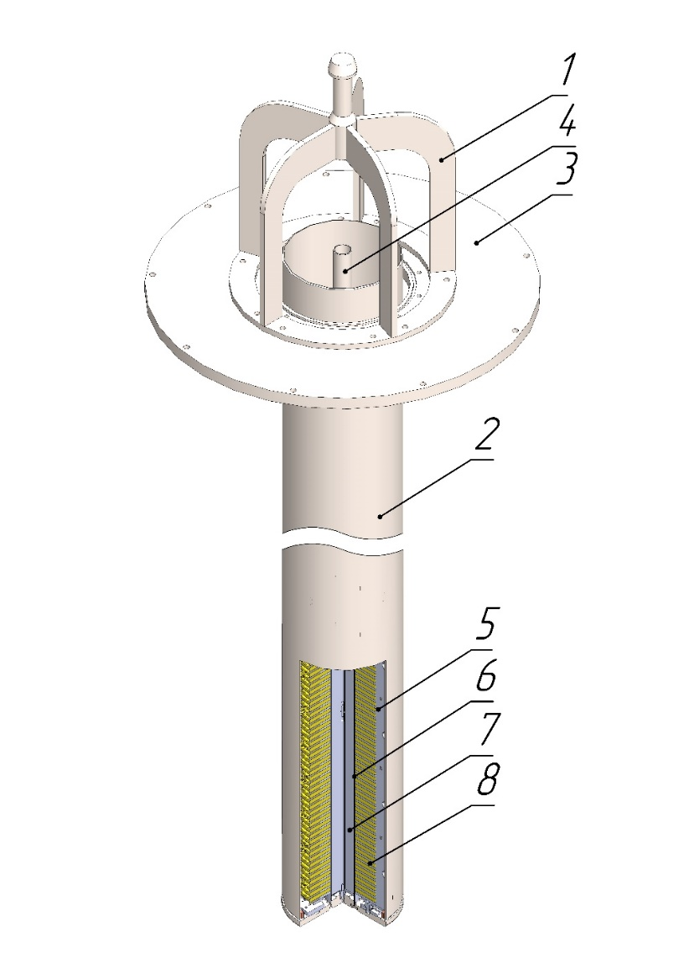
Fig. 1. EMP design scheme: 1 - transporting element (lifting device), 2 - case, 3-EMP flange, 4 - outlet pipe, 5 - inductor, 6 - duct, 7 - inner magnetic structure, 8 – coil.

- RESULTS OF ANALYSIS
The following analysis was made to support the design: electromagnetic, thermal, strength analysis and reliability evaluation.
4.1. Electromagnetic analysis results
Engineering approach is used for electromagnetic analysis based on the analytical relations for “ideal” EMP with corrective coefficients taking account of “real” peculiarities, like:
- different materials in the air gap between the magnetic structures;
- electromagnetic field attenuation over the gap;
- magnetic system finite length;
- moving media velocity profile.
Corrective coefficients are obtained from solutions of the corresponding MHD specific tasks. More details may be found in [2]. This engineering approach is supported with many years of design and exploitation of EMPs developed in Efremov Institute.
As a result of this analysis EMP optimum design, inductor and duct main dimensions and power supply parameters were chosen (Table 1). Nonstandard frequency was chosen to improve EMP characteristics and this will require a frequency convertor.
Efficiency of the pump is defined as the ratio of useful power (product of developed pressure to flow rate) to the supplied power. Lead has relatively low electrical conductivity and large density. For this reason, the pump efficiency is low - 1.1% and cannot be significantly increased further. But for the current pump application (for reactor lead level regulation during reactor vessel filling) efficiency is not as important as the pump reliability and simplicity.

Table 1. Electromagnetic analysis results

Parameter | Symbol | Value
Pressure head, kg/cm² | р | 10.2
Flow rate, m³/hr | Q | 2
Frequency, Hz | f | 80
Power consumed, kW | Р₁ | 51.1
Efficiency, % | η | 1.1
  - Thermal analysis results
Thermal analysis was made with ANSYS code. Liquid metal flow in the duct was modeled with program feature “Thermal Fluid и Mass Flow Rate” allowing taking care of temperature gradient along the flow and internal heat generated in liquid metal by induced currents.
As a result, the winding maximum temperature was obtained that determines the pump life time and its reliability. Electric power needed to heat up the outlet pipe to prevent lead solidification was determined as well. Analysis was done for EMP different height of submerging in lead.
The following results were obtained. Maximum winding temperature at 2 meters pump submerging and nominal parameters is 471 ºС. A reliability analysis gives time to failure – 4200 hrs. and this is more than required.
Winding maximum temperature at 2.5 meters pump submerging and switching off the power (pre-starting procedure) is 420 ºС that gives 23300 hrs. time to failure.
Power for heating up the outlet pipe is 332 W that provides for led temperature 372 ºС.
  - Structural analysis results
Stress analysis and strength estimation were made according to rules [3]:
- strength estimation of the duct shell at hydraulic tests, vacuum tests and normal operation;
- buckling analysis of the pump case during pump immersion into lead;
- strength estimation of screwed joints at working conditions and during transportation;
- strength estimation of the pump lifting device.
The test pressure during hydraulic tests of the pump duct according to rules [3] is determined by the formula
$p_{\text{ht}}=\text{1.25 p}\frac{σ_{\text{0,2}}^{\text{20}}}{σ_{\text{0,2}}^{\text{500}}}= \text{1.25}⋅1.26⋅\frac{\text{216}}{\text{147}} = 2,31 \text{MPa}$, | (1)
where: p = 1.26 MPa – maximum pressure in the pump duct during operation;
$σ_{\text{0,2}}^{\text{20}} ,σ_{\text{0,2}}^{\text{420}}$- nominal permissible stresses during hydraulic tests at 20 °С and at working temperature 420 °С.
Membrane stresses in the duct shell from the action of internal pressure during hydraulic tests are determined by the formula
$$σ=\frac{p_{\text{ht}}⋅D}{\text{2s}},$$ | (2)

where D=0.107 m - the average diameter of the duct shell, s=0.001 m - duct wall thickness.
The calculated membrane stress value according to formula (2) is equal to 124 MPa and does not exceed the permissible value 194 MPa for the duct steel 08X18N10T.
In the process of the pump testing, the pump duct is vacuumized. The membrane stresses under the action of external atmospheric pressure are equal to 5 MPa, which is less than the permissible 194 MPa.
The stability of the duct shell under the action of external pressure at duct vacuum test was evaluated. The critical stress for the duct shell during this operation is determined by
$$σ_{\text{cr}}=\text{1}\text{.}\text{1}⋅E^{}⋅{\left(\frac{s}{D}\right)}^{2}=1.1⋅2.05⋅10^{5}⋅{\left(\frac{0.001}{0.107}\right)}^{2}=20 MPa,$$ | (3)
where E = 2.05∙10⁵ MPa modulus of elasticity of the duct material at 20 °C.
Critical pressure is
$$p_{\text{cr}}=\text{2}{\text{σ}}_{cr}⋅\frac{s}{D}=2⋅20⋅\frac{0.001}{0.107}=0.37 MPa.$$ | (4)
Permissible external pressure is determined by
$$\left[р\right]=\text{0}\text{.}\text{5}⋅ξ⋅p_{\text{cr}}=0.5⋅0.7⋅0.37=0.13 MPa,$$ | (5)
where $ξ$=0.7 - correction factor.
The calculation showed that the permissible external pressure for the outer duct shell is equal to [p] = 0.13 MPa, which is greater than the external pressure 0.1 MPa during vacuum test. Therefore, the duct outer shell is stable at the vacuum test.
The 1-st buckling mode of the outer hermitic case at normal operation under lead outer pressure is shown in Fig. 2. Equivalent stress distribution in the pump lifting device is shown in Fig. 3.

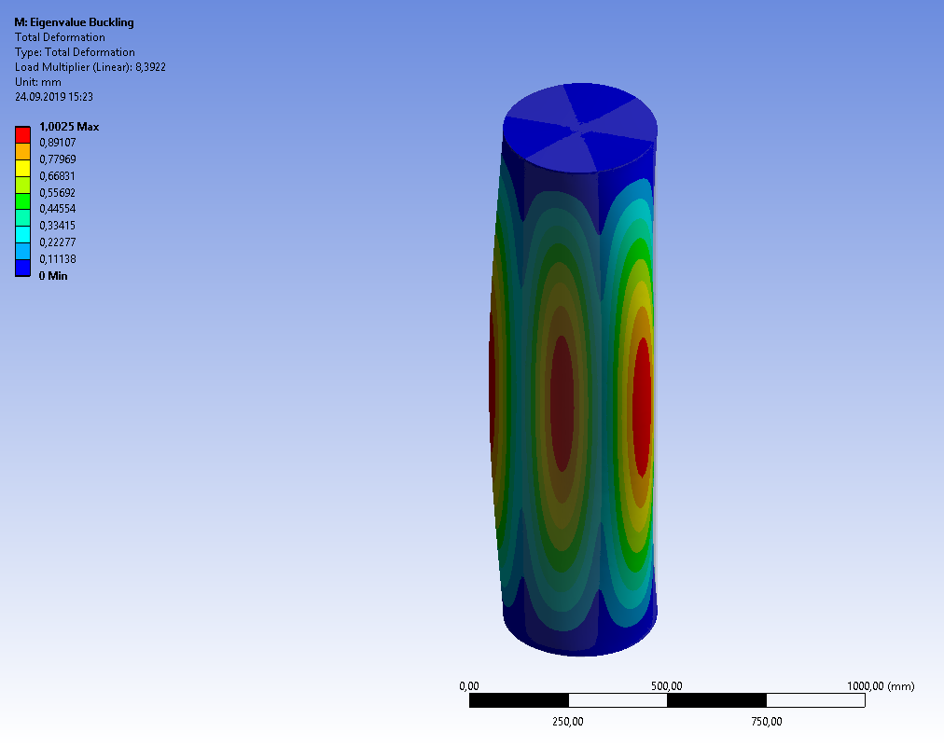
Fig. 2. The 1-st buckling mode at working operation under lead outer pressure.

Fig. 3. Equivalent stress distribution (MPa) in the pump lifting device
Analysis has shown that stresses in considered elements do not exceed allowable limits at operating conditions and at hydraulic tests. The pump design satisfies structural design criteria.
- PLANNED WORK AND TESTS PRIOR TO PUMP MANUFACTURING
The following works are planned to confirm the pump design and its parameters:
- long run tests (up to 1000 hours) of winding mock-ups to prove its reliability;
- the pump shortened length mock-up manufacturing and testing in lead facility to prove nominal parameters (pressure head 1.0 MPa, flow rate 2 m³/hr at lead temperature 390-420 °С.
After successful completion of these works the EMP ALIP 10/2 manufacturing and shipment to reactor BREST-OD-300 is planned.
- CONCLUSION
The immersed EMP ALIP 10/2 for liquid lead level regulation in the FBR BREST-OD-300 was developed. Supporting analyses of the design confirm its characteristics and working ability. The necessary tests are defined for validation of technical decisions and pump characteristics. It is planned to manufacture and test a pump mock-up to confirm design decisions and calculations and conduct long run tests of winding mock-ups to confirm EMP life time. In case of positive tests results a decision will be made on the manufacture and supply of the pump to the BREST-OD-300 reactor.

References

[1] Yu.G. Dragunov, V.V. Lemekhov, A.V. Moiseyev, V.S. Smirnov, O.A. Yarmolenko, V.P. Vasyukhno, Yu.S. Cherepnin, D.A. Afremov, Yu.V. Lemekhov. BREST-OD-300 Reactor Facility: Development Stages And Justification. FR17: International Conference on Fast Reactors and Related Fuel Cycles: Next Generation Nuclear Systems for Sustainable Development; Yekaterinburg (Russian Federation); 26-29 Jun 2017.
[2] G.A. Baranov, V.A. Glukhih, I.R. Kirillov. Calculation and design of induction MHD machines with a liquid metal working fluid, Atomizdat, Moscow, 1978 (in Russian)

[3] Rules of strength calculation for equipment and pipelines of nuclear power plants PNAE G-7-002-86, Energoatomizdat, Moscow, 1989 (in Russian).

