Development of Plasma Nitriding as
alternate hardfacing technique for
Large components of FBR and Assessment
of static In-Sodium Stability of Plasma
Nitrided Layer

:
Akash Singh, R. Thirumurugesan, R. Mythili, P. Parameswaran, S. Raju,
S. Ravishankar, R.Punniyamoorthy, S.Krishnakumar, S.Chandramouli, B.K.Nashine, Shaju K. Albert

Indira Gandhi Centre for Atomic Research, Kalpakkam, India

Email contact of corresponding author: akash@igcar.gov.in

Abstract

Plasma nitriding is considered as a plausible alternate hard-facing technology for enhancing the wear and fatigue resistance of large size and intricate fast reactor components. Plasma nitriding is an environmentally clean process that can be adopted in principle, to produce high surface hardness in a controlled manner, with little distortion of finished components. In this regard, an attempt has been made to adopt plasma nitriding for the casing ring of the secondary sodium pump of PFBR. Model rings of SS316L were fabricated. These rings were stress relieved, followed by chrome plating to a thickness of ~100 µm and plasma nitriding at 500ºC for about 48 h. No gross dimensional distortion of the component was found after plasma nitriding. Possible variation in microstructure and hardness profiles of the ring was characterized to assess the effectiveness of plasma nitriding in achieving a nitrided layer of reasonable case depth. X-ray diffraction analysis was also carried out understand the formation of chromium nitride phases. Also to assess the stability of plasma nitrided layer in liquid sodium, sections of the nitrided ring were subjected to long term exposure in static sodium at 550 ºC up to 5000h While a minor reduction in hardness was observed after prolonged high temperature exposure in sodium, no significant change in microstructure or nitride layer case depth was observed, suggesting the long term integrity of the plasma nitrided stainless steel in static sodium. The details of the study are presented in the paper.

- INTRODUCTION
Plasma nitriding is considered as a viable alternate technology for controlled hardfacing of various precision components that experience wear and fatigue. During plasma nitriding, ion bombardment in combination with plasma induced dissociation promotes chemisorption and surface layer intermixing at relatively lower temperatures than in conventional gas nitriding. Pulsed direct current glow discharge is one of the surface hardening techniques, which uses plasma for the nitriding of steels. Plasma nitriding process enables nitrogen to diffuse in to the surface of components and thereby produce high surface hardness. Since the process allows for lower work piece temperature, distortion of the components can be minimized. Further, the process avoids handling of hazardous and toxic chemicals and it has the distinct advantage of cleaning the finished product with argon plasma, therefore it is considered as a relatively clean technology [1-8]. The process involves: (i) stress relieving, (ii) hard chrome plating to required thickness and (iii) plasma nitriding of the work piece. Though electroplated chromium itself exhibits high hardness, corrosion resistance and low coefficient of friction, there are limitations in the applications of electroplated Cr coatings [9]. The micro-cracks developed during electroplating reduce wear and corrosion resistance. Besides, the hardness decreases significantly with increasing temperature above 623K [10]. In order to overcome these disadvantages, the surface of the electroplated chromium is modified by means of plasma nitriding. Chromium nitride coatings exhibit excellent thermal stability, wear and corrosion resistance and has been found as an alternative to titanium nitride coatings in tribological applications [11-12].
In sodium cooled Fast Breeder Reactors (FBR), primary sodium is pumped into the reactor by primary sodium pumps and flows by gravity to the intermediate heat exchangers and then back to the pump suction. Secondary sodium is pumped into the intermediate heat exchangers by secondary sodium pumps. After removing heat from primary sodium, the secondary sodium enters the steam generators. The SS316L casing ring of secondary sodium pump seals the pumping system during its operation. Hence hardfacing of the casing ring to enhance galling /wear resistance of contacting surfaces is essential and in this study an effort has been made to hard face the casing ring of secondary sodium pump of Fast Breeder Reactor (FBR) through plasma nitriding and also assess the stability of plasma nitrided layer during long static exposure to liquid sodium at 550°C.

MATERIAL AND METHODS
SS 316L casing ring has an outer diameter of 558.5 mm and inner diameter of 529 mm with a thickness of 14mm with a step on one side have twelve equi-spaced circumferential holes. A scaled down model of this casing ring was also fabricated with an outer diameter of 420 mm, maintaining the other aspect ratios to serve as a mock up piece for post nitriding characterization studies. The rings were annealed at 1050°C for 1h in vacuum, followed by cooling in flowing nitrogen at 3 bar pressure in order to prevent surface oxidation and ensure fast cooling. The rings were then electrolytically chrome plated at 58°C. The rings were then plasma nitrided at 500°C for 48h in a gas mixture of H₂ and N₂ with a ratio of 1:3. Fig.1 shows the photograph of the nitrided casing ring. Quality control inspection was also carried out prior to and after nitriding to check for dimensional distortion during the nitriding process.

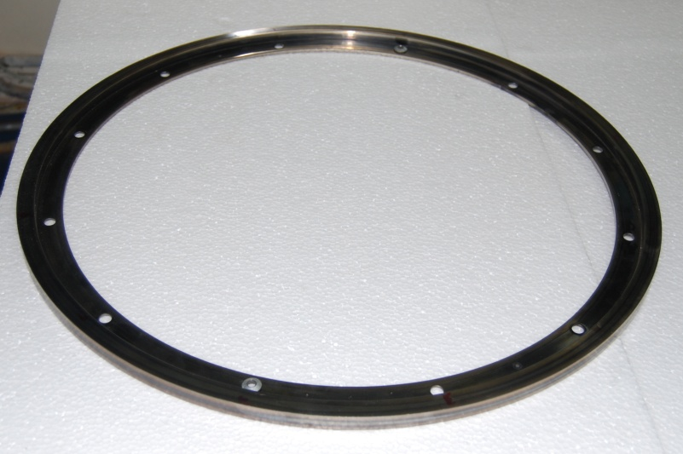

Fig. 1. Photograph of the plasma nitrided casing ring.
In-sodium stability of plasma nitrided ring specimens was evaluated through static sodium exposure studies in the test pot of an in-house Test Facility. The specimens were tightly attached to a rod using wire mesh and introduced into the vessel through a nozzle in the cover flange. The specimens were positioned in such a way that they are completely immersed in liquid sodium, when the vessel is filled up to the operating level. The sodium hold up in the vessel is around 0.87 m³. Argon cover gas pressure in the vessel was maintained around 0.3 bar. After the introduction of specimens, a pressure hold test of the vessel was conducted and found to be leak tight. Subsequently after preheating, reactor grade sodium was filled in the vessel by differential pressure method up to operating level followed by increasing the temperature of sodium to 550°C. The specimens were exposed in sodium for 1000, 2000, 3000 and 5000 h. After sodium exposure these specimens were taken out and cleaned and visually inspected for any surface damage.
To check the effectiveness of the plasma nitriding, the above plasma nitrided specimens were subjected to XRD analysis using Cu Kα₁ X-rays to identify the phases before and after sodium exposure. To evaluate the case depth of nitriding, hardness and microstructural analysis was carried out on cross-section samples after standard metallographic specimen preparation.

RESULTS AND DISCUSSION
This section presents the results on characterisation of the nitrided layer of the casing ring through dimensional, hardness and microstructural analysis and its stability during long term exposure to high temperature sodium.

  - Analysis of Dimensional stability after plasma nitriding
As plasma nitriding is the final step in component fabrication, it is essential to ensure the dimensional stability after the process. The inner diameter, outer diameter and thickness of the ring were measured prior to nitriding and after nitriding for any possible distortion during the process. The results of quality inspection reports are given in Table 1. It is seen that there is only a slight deviation in the observed dimensions, which suggests that there is no significant distortion due to plasma nitriding. However, there is a slight increase in the height of the ring after the nitriding process and it is due to chrome plating layer prior to nitriding. The average surface roughness for the component before and after nitriding was also measured and it was found to be 254 and 325 nm respectively.

Table 1: Dimensional inspection prior TO and after nitriding process

Description | Required Dimension  As per drawing(in mm) | Observed dimension (in mm)
 |  | Prior to nitriding | After nitriding
OD | Ø558.5 + 0.020/- 0.066 | Ø558.46/558.36 | 558.40/558.48
ID | Ø529 + 0.07/-0.80 | Ø528.86/529.09 | 528.90/529.13
Height | 14 | 13.80/13.94 | 13.92 / 14.05
 | 3.75 | 3.75/3.79 | 3.78 /3.87

3.2 Structural analysis for phase identification
XRD patterns of well annealed 316L steel and Cr plated steel in Fig. 2 shows the peaks corresponding to FCC austenite and BCC Cr respectively. Fig. 3 shows the XRD patterns of plasma nitrided ring specimen before and after sodium exposure. The presence of hexagonal Cr₂N, CrN phases along with Cr is observed after nitriding. The presence of chromium in the nitrided steel suggests the retention of some amount of chromium, which is not converted into corresponding nitrided phases. A very small amount of Cr₂O₃ is detected, which could be due to the surface oxidation. From the XRD patterns, it is clear that mainly Cr₂N phase is dominating than the CrN phase, which could be attributed to the preferential formation of Cr₂N phase at slightly lower temperatures than CrN, which forms at high temperatures [13]. Also no other new phases are observed to form due to Na exposure. These observations show that nitrided layer remains intact even after 5000 h of sodium exposure.

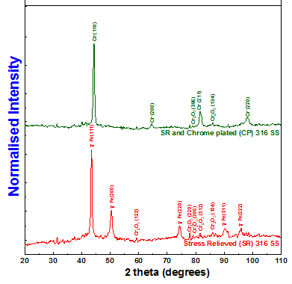

FIG. 2 XRD patterns of Stress relieved; Stress relieved (SR) and chrome plated (CP);
Stress relieved, Cr plated and plasma nitrided ring
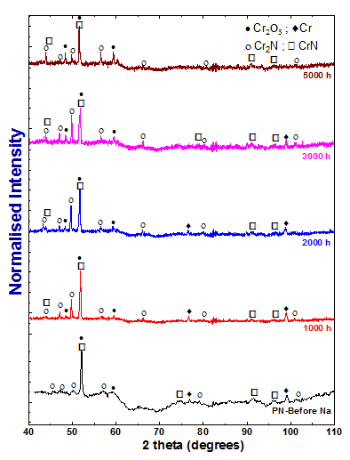
FIG. 3 XRD patterns of plasma nitrided ring specimens before and after sodium exposure

3.3 Microstructural analysis
Fig. 4 (a-d) shows the microstructure of the plasma nitrided ring specimens before and after sodium exposure at 550°C up to 5000h. It is seen that the adherence of the plasma nitrided layer to the matrix is good and its thickness is estimated to be about ~100 µm. A few micro-cracks, which are inherent to chrome plating are observed in the nitrided layer and the density of cracks per unit area is evaluated to be <3%, which is not expected to have any significant detrimental effect. It can be seen that the thickness of the nitrided layer after sodium exposure is also about 100 µm, indicating that sodium exposure did not induce any significant microstructural change.
(a)
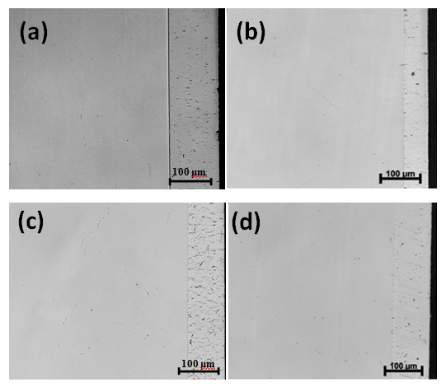
FIG.4 Optical micrographs of the plasma nitrided ring (a) before sodium exposure and after sodium exposure at 550C for (b) 1000h (c) 3000h and (d) 5000h.
3.4 Hardness evaluation

In order to assess the case depth of nitriding, variation of hardness from the surface was studied on the Cr plated and plasma nitrided sections of the casing ring. The maximum hardness obtained by chrome plating was around 1110 VHN, with a case depth of about 100 µm. The hardness profiles were measured across the cross section of the sample before and after plasma nitriding and it was estimated to be ~ 800VHN (Fig. 5), which is expected to offer a high wear resistance [11]. This value is about four times higher than that of the austenitic steel matrix, which is around 220VHN. The case depth from hardness measurements is estimated to be around 100 µm, which is in agreement with that estimated from the optical micrograph.

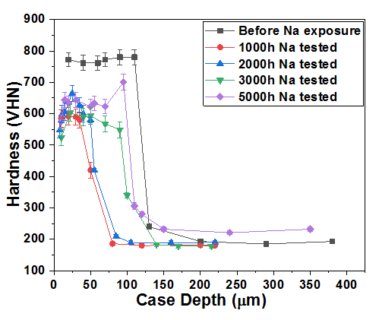

FIG. 5 Hardness depth profile of nitrided ring before and after sodium exposure
(a)
(b)

The hardness profile of sodium exposed specimens was also measured and shown in fig.5. It can be seen that the maximum hardness obtained is around 560-700 VHN. This reduction in maximum hardness by 12-15% after long term sodium exposure could be due to the softening of unnitrided regions of chromium plating at higher temperature (550ºC). However the case depth of the nitrided layer of the ring did not show any significant change due to long term sodium exposure at 550ºC, as is also revealed from Fig. 4. These observations confirm the retention of hard chrome nitrided layer even after 5000 hours of static sodium exposure. It is also planned to perform wear test (ball on disc) on these samples to understand the wear behaviour.

CONCLUSIONS

- Plasma nitriding of 316L casing ring of secondary sodium pump of FBR was carried out as per recommended procedures.
- It is seen that there is no significant distortion of the component after plasma nitriding.
- Well stress relieved component could be chrome plated successfully to about 100 µm.
- Maximum hardness obtained was ~ 1100 VHN for chrome plated layer and 800 VHN for the plasma nitrided surface, which was identified to be due to the formation of Chromium Nitride phases.
- In-sodium performance of the plasma nitrided SS316L casing ring was studied through long term exposure at 550°C up to 5000h. It was found that the nitrided case depth was almost similar to that before sodium exposure with a slight decrease in hardness in the range of 560 -700 VHN due to high temperature sodium exposure.
- The above studies show that the overall integrity of the plasma nitrided layer under long term exposure to high temperature static sodium is satisfactory.

ACKNOWLEDGEMENTS
The authors thank Dr. A.K Bhaduri, Director, IGCAR, for his constant encouragement and motivation in the course of the present work.
References
- Rembges W. and Oppel W., Process control of plasma nitriding and plasma nitrocarburizing in industry, Surface & Coatings Technology 59 (1993) 129-134
- Borgioli F., Fossati A., Galvanetto E., Bacci T., Glow-discharge nitriding of AISI 316L austenitic stainless steel: influence of treatment temperature, Surface & Coatings Technology 200 (2005) 2474 – 2480
- David P., Practical Nitriding and Ferritic Nitrocarburizing. ASM International Ohio 2003
- Czerwiec T., Renevier N., Michel H., Low-temperature plasma-assisted. Surface & Coating Technology 131 (2000) 267-277
- SMITH, Donald L., Thin-Film deposition – Principles and Practice. McGraw-Hill, Inc.1995
- Rie K.T., Recent advances on plasma diffusion processes, Surface and Coating Technology 112 (1999) 56-62
- Varman AVJP, Balasubramanian M., Wear analysis of DC pulsed plasma nitriding of aisi 4340 low alloy steel for crank shaft application, TMS 142nd Annual Meeting (2013) 209–215
- Varman AVJP, UWE H., Balasubramanian M., Effect of pulse repetition time on pulsed plasma nitriding of AISI 4340 steel, Journal of Materials Science and Surface Engineering 4(3) (2016)386–391
- JewburY P., Materials Forum 9(3) (1986) 179-181
- Kuppusami P. and Raghunathan V.S. , Metals Materials and Processes 3(3) (1991) 147-174
- Torres H., Varga M., Adam K. and RodrIguez Ripoll M., The Role of Load on Wear Mechanisms in High Temperature Sliding Contacts, Wear 364-365 (2016)73- 83
- Kuppusami P., Dasgupta A. and Raghunathan V. S. , J. of the Iron and Steel Institute of Japan International 42(2002) 1457
- Brokman A. and Tuler F.R., J. Appl. Phys. 52 (1) (1981) 468

