The δ-ferrite transformation behavior and mechanical properties of 316 weld metal during high temperature service
S.t. Wei
Shenyang National Laboratory for Materials Science, Institute of Metal Research, Chinese Academy of Sciences, Shenyang, China
S.P. LU
Shenyang National Laboratory for Materials Science, Institute of Metal Research, Chinese Academy of Sciences, Shenyang, China
Email: shplu@imr.ac.cn
Y.Y. LI
Key Laboratory of Nuclear Materials and Safety Assessment, Institute of Metal Research, Chinese Academy of Sciences, Shenyang, China
Abstract
316 austenitic stainless steel is widely used in the manufacture of nuclear reactor components owing to its excellent comprehensive properties, such as main vessel, support assembly, etc. During the fusion welding of austenitic stainless steel, the tendency of hot cracking tends to occur when the structural restraint is too large. For preventing the cracking, it is usually desirable to form a certain amount of δ-ferrite in the weld. However, the δ-ferrite is harmful to the mechanical and corrosion properties of the weld during high temperature service process, so the δ-ferrite content in weld metal must be strictly controlled. The microstructure evolution and mechanical properties of the 316 stainless steel weld metals with different C contents were studied at the aging temperature of 550 and 600 ℃ for different times. The results indicated that during the aging process, the rapid precipitation of M₂₃C₆ carbide occurred in δ-ferrite firstly owing to the high diffusion rate of C. Once the carbon is depleted by precipitation of M₂₃C₆, the slow formation of σ phase occurred through eutectoid transformation of the remained δ-ferrite depending on the diffusion of Cr and Mo. Furthermore, after a long enough aging time, a transformation from M₂₃C₆ to σ occurred. The C content and aging temperature have a significant influence on the δ-ferrite transformation behavior. The increasing aging temperature accelerated the transformation process, and the increasing C content promotes the formation of M₂₃C₆ carbides and inhibits the formation of σ phase. The variations of mechanical properties with aging conditions depended mainly on the microstructures at different aging conditions. The σ phase improved the strength and deteriorated the toughness obviously. Therefore, for the low C weld metal aged at 550 and 600 ℃ and high C weld metal aged at 600 ℃, as the aging time increased, the volume fraction of σ increased, which led to the increase of strength and decrease of impact energy. For the high C weld metal aged at 550 ℃, only M₂₃C₆ formed within the aging time of 3000 h. The depletion of the solid solution C as a result the M₂₃C₆ precipitation deteriorated the strength and impact energy. This research provides theoretical and practical guidance for the control of the chemical composition in the 316 weld metal for high temperature service.

INTRODUCTION
Nuclear power is a clean and efficient way of generating electricity, but the safety of nuclear power must be highly valued. The safety, economy and life of nuclear power plants depend to a large extent on the properties of nuclear power plant structural materials, including the performance of welded joints, and nuclear power reactors. The nuclear power plant is welded by different parts. Due to the large structure size, compact and complex design, the welding process is complicated and the welding workload is large [1-3]. During the operation of the reactor, the structural materials in the reactor are exposed to high temperature, high corrosion, and high radiation environment for a long time, and the working conditions are extremely harsh. In addition, these key components cannot be replaced during the service period (design life of 40 years). Based on the consideration of the above factors, the engineering design puts forward higher requirements on the performance of the welding materials used for the key components in the reactor to ensure the safety and reliability of the reactor operation [4]. Therefore, the research on the long-term stability of the welded joint structure and performance is also the key content to ensure the safe service of the reactor.
Austenitic stainless steel is widely used in the manufacture of the main structure of the reactor vessel due to its excellent comprehensive properties. During the melting and welding of austenitic stainless steel, the tendency of thermal cracking is prone to occur when the structural constraint is too large. In order to prevent cracks in the welding process, it is usually desirable to form a certain amount of δ-ferrite in the weld. The austenite weld contains a certain amount of δ-ferrite, which makes the refines the austenite columnar grains and increases the grain boundaries. The low melting point eutectic will be divided and discontinuously disperse on grain boundaries, which will reduce the tendency of hot cracking. However, too much δ-ferrite is detrimental to the long-term performance of the weld metal, δ-ferrite will transform into different decomposition products under different aging temperature and time conditions, such as M₂₃C_{6,} σ, etc. These phases have significant impacts on the properties of the weld. Therefore, the δ-ferrite content in the weld metal must be strictly controlled [5-7].
At present, there are a small amount of literatures on the research of the microstructure and properties of 316 austenitic stainless steel weld metals for nuclear power. In view of this situation, this paper takes the 316 austenitic stainless steel weld metal for nuclear power as the research object and systematically studies the effect of aging conditions and C content on the microstructure and mechanical properties of the weld metal of 316 austenitic stainless steel welding wires. The transformation behavior of δ-ferrite and precipitation mechanisms of M₂₃C₆ and σ phase in the weld metals with different C contents aged at 550 and 600 ℃ for different aging times were investigated. The variations of tensile and impact properties of the weld metals were analyzed. Furthermore, the relationship between microstructure evolution and mechanical properties of the weld metals were discussed. This research can not only provide theoretical reference and practical guidance for the performance control of austenitic stainless steel welding wires for nuclear power, but also have a great significance for understanding the microstructure and mechanical property transformation mechanisms of austenitic stainless steel weld metal during high-temperature service.

EXPERIMENTAL PROCEDURE
Two kinds of ER316 stainless steel welding wires with different C contents were used in the experiment to weld a 16 mm thick 316H stainless steel plate by automatic tungsten inert gas ( TIG) welding with the welding current of 180 A, arc voltage of 14 V, and welding speed of 0.1 m/min. The schematic diagram of the joint is shown in Fig. 1. The chemical compositions of the base metal, welding wires and corresponding weld metals are listed in Table 1. The Thermo-Calc software was used to confirm the relationship between phase types and contents in the different weld metals at different temperature. After welding, the qualified welded plates were aged at 550 and 600 ℃ for different times up to 3000 h. Ferrite Determ SP10a ferrite tester was used to measure δ-ferrite volume fractions in the as-welded weld metal and as-aged weld metals for different aging times.
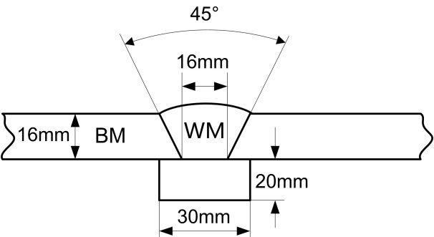
FIG. 1 Schematic diagram of the joint.
The electrochemical extraction of the precipitates in the as-welded weld metal and as-aged weld metals for different aging times at 550 and 600 ℃ were conducted in the solution of 10% hydrochloric acid and 90% methanol at volume fractions at room temperature with the constant extraction current was selected to be 0.2 A. The phase types and volume fractions of the residual phases were analyzed by X-ray diffraction analysis equipment using a Cu Kɑ source for scanning between 10°-90°.
For metallographic observation, samples were cut perpendicular to the welding direction. Subsequently, standard metallographic procedure was applied. Samples were mounted using phenolic resin, ground, polished up to 0.25 μm diamond paste and then etched with 40% aqua regia solution to reveal the microstructure. Optical microscope was used to observe the microstructure of the weld metals.
Tensile tests of the different weld metals were performed at room temperature using a computerized tensile testing system on an Instron-type testing machine with a constant crosshead velocity of 2 mm min⁻¹. The impact specimens were examined on a Charpy impact testing machine at room temperature. In total three tests were performed to evaluate the mechanical properties of the weld metal for each aging condition.
TABLE 1. chemical compositions of the base metal, welding wires and weld metals (wt %).
Materials | C | Si | Mn | Cr | Ni | Mo | Fe
Base metal | 0.052 | 0.42 | 1.52 | 18.3 | 12.4 | 2.71 | Bal.
Low C welding wire | 0.015 | 0.41 | 1.59 | 19.0 | 12.7 | 2.53 | Bal.
Low C weld metal | 0.016 | 0.41 | 1.54 | 19.1 | 12.5 | 2.48 | Bal.
High C welding wire | 0.064 | 0.47 | 1.59 | 18.8 | 12.7 | 2.45 | Bal.
High C weld metal | 0.062 | 0.43 | 1.55 | 18.9 | 12.4 | 2.49 | Bal.

RESULTS AND DISSCUSION
The Thermo-Calc software was used to estimate the phase types and contents in the weld metal with different C contents under different temperatures in equilibrium conditions, as shown in Fig. 2. Fig. 2 indicates that under different temperatures, the increasing C content increases the σ phase content, and decreases the M₂₃C₆ and δ-ferrite contents. At the aging temperature of 550 and 600 ℃ in this experiment, both M₂₃C₆ and σ phase exist under the equilibrium condition, which indicates that after aging at the temperature of 550 and 600 ℃ for a long enough aging time, δ-ferrite will be totally replaced by the M₂₃C₆ and σ phase. Furthermore, the weld metals aged at 600 ℃ have high σ phase contents than the weld metals aged at 500 ℃. The Thermo-Calc calculation results of the phase types and contents in the weld metal under the equilibrium condition could be used to determine the transformation products during aging process primarily.
The optical micrographs of the as-welded and as-aged weld metals with different C contents are presented in Fig. 3. It indicated that both of the as-welded weld metals with different C contents contained austenite and a certain amount of δ-ferrite, and with the high C weld metal contained the lower δ-ferrite content. It is consistent with the Thermo-Calc calculation results. The δ-ferrite contents in the as-welded low C and high C weld metals obtained by the ferrite tester were 7.2% and 2.8%, respectively. The microstructure of the weld metals aged at 550 and 600 ℃ for 3000 h showed that the δ-ferrite transformed into other phases during different aging process.
FIG. 2 Calculation results of the phase types and contents in the weld metal with different C contents under different temperatures in equilibrium conditions.
FIG. 3 Optical micrographs of the as-welded and as-aged weld metals with different C contents: (a) as-welded low C weld metal; (b) low C weld metal aged at 550 ℃ for 3000 h; (c) low C weld metal aged at 600 ℃ for 3000 h; (d) as-welded high C weld metal; (e) high C weld metal aged at 550 ℃ for 3000 h; (f) high C weld metal aged at 600 ℃ for 3000 h.
The δ-ferrite transformation fractions in the as-welded and as-aged weld metals with different C contents measured by the ferrite tester are shown in Fig. 4. It indicated that as the aging time increased the δ-ferrite transformation fraction in weld metals increased significantly at initial stage, further increasing the aging time, the δ-ferrite transformation fraction increased slowly. The increasing aging temperature increased the δ-ferrite transformation fraction. Under the aging temperature of 600 ℃, The δ-ferrite in the low C and high C weld metals transforms into other phases completely within 3000 h. No δ-ferrite was detected in the weld metals aged at 600 ℃ for 3000 h.
FIG. 4 Effects of aging procedure and C content on δ-ferrite transformation fraction.
The X-ray diffraction analysis results of the residues of the as-welded and as-aged weld metals under different aging temperatures and times after electrochemical extraction are shown in Fig. 5. After aging at 550 and 600 ℃ for 50 hours, only M₂₃C₆ was found in the as-aged weld metals with different C content [8-12]. For the high C weld metal aged at 550 ℃, with the increasing of aging time to 1000 h, still only M₂₃C₆ was observed, while for the low C weld metal aged at 550 and 600 ℃ and high C weld metal aged at 600 ℃, both M₂₃C₆ and σ phase were found. Further increasing the aging time to 2000 and 3000 h, for the low C weld metals aged at 550 and 600 ℃ and high C weld metal aged at 600 ℃, the volume fraction of M₂₃C₆ decreased, while the volume fraction of σ phase increased, while the high C weld metal aged at 550 ℃ still only contained M₂₃C₆ phase, no σ phase was found. For the high C weld metal aged at 600 ℃, as shown in Fig. 4, the δ-ferrite decomposed completely within 1000 h. However, Fig. 5(b) showed that when the aging time increased to 2000 and 3000 h, the volume fraction of M₂₃C₆ decreased, while the volume fraction of σ phase increased, which indicated that as the aging time increased, some M₂₃C₆ phase converted into σ phase [13-16]. Furthermore, Fig. 5 also indicated that the increasing C content promoted the formation of M₂₃C₆ and inhibited the formation of σ phase. It is consistent with the Thermo-Calc calculation results as shown in Fig. 2.
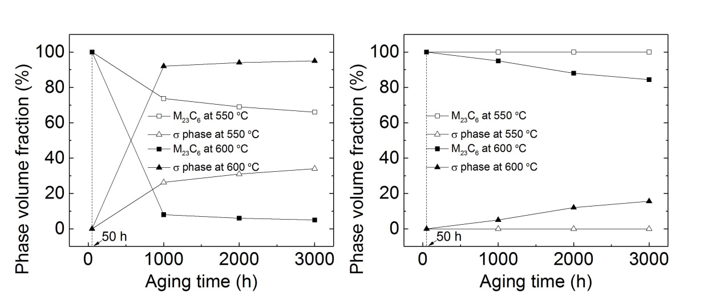
(b)
(a)
FIG. 5 Effects of aging procedure and C content on δ-ferrite transformation product and volume fraction: (a) Low C weld metal; (b) High C weld metal.
The above mentioned results indicated that at the initial stage of aging treatment, δ-ferrite decomposed to form M₂₃C₆ phase firstly owing to the high diffusion rate of C. When the carbon was depleted by precipitation of M₂₃C₆, the slow formation of σ phase occurred through eutectoid transformation of the remained δ-ferrite depending on the diffusion of Cr and Mo. Furthermore, as the aging time increased, the transformation from M₂₃C₆ to σ phase occurred [8-16]. The increasing aging temperature accelerated the transformation process.
The effect of aging temperature and time on the tensile strength and impact energy of the low C and high C weld metals are shown in Fig. 6. The variations of the mechanical properties with the aging procedure depended on microstructure differences of different aging conditions. For the low C weld metal at the aging temperature of 550 and 600 ℃, as the aging time increased, the tensile strengths first increased rapidly, then increased slightly, while the impact energy decreased first decreased sharply, then decreased slowly. For the high C weld metal, with the increase of the aging time at the aging temperature of 550 ℃, the tensile strength decreased slowly, while with the increase of the aging time at the aging temperature of 600 ℃, the tensile strength increased slightly. Furthermore, with the increase of the aging time at the aging temperatures of 550 and 600 ℃, the impact energy of high C weld metal decreased. The variation trends of tensile strength are consistent with the changing tendency of the σ phase. The σ phase improved the strength and deteriorated the toughness obviously. For the high C weld metal aged at 550 ℃, only M₂₃C₆ formed within the aging time of 3000 h. The depletion of the solid solution C as a result the M₂₃C₆ precipitation deteriorated the strength and impact energy [14-17].
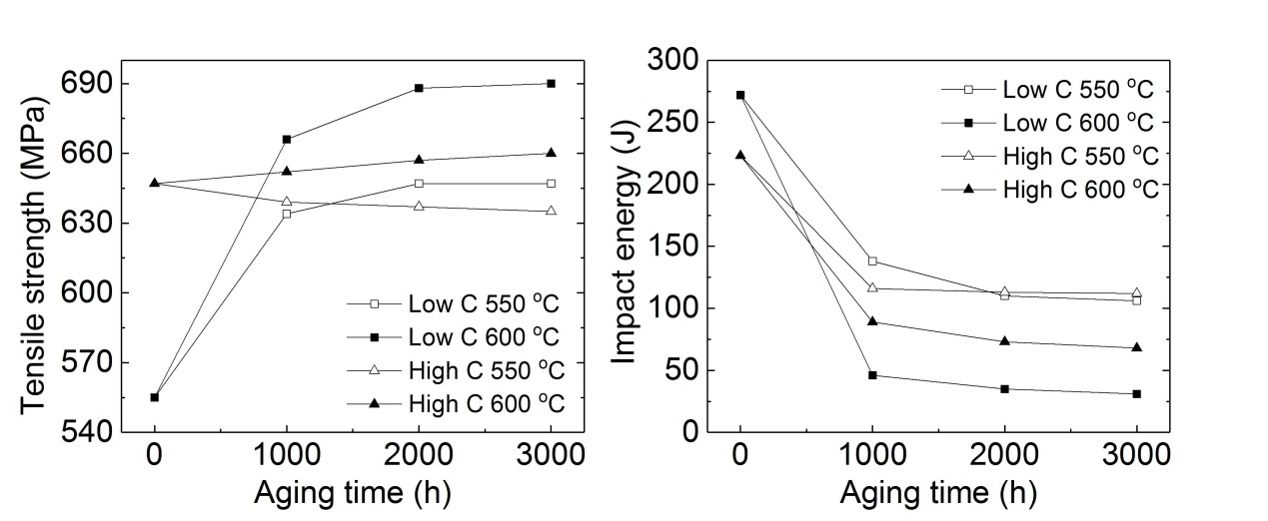
(b)
(a)
FIG. 6 Effects of aging procedure and C content on mechanical properties: (a) Low C weld metal; (b) High C weld metal.

CONCLUSIONS
In this research, the 316 weld metals with different C contents were aged at 550 and 600 ℃ for different aging times, and microstructural evolution as well as mechanical properties of the weld metals under different aging procedures were evaluated and analyzed. The following conclusions can be drawn:
(1) The Thermo-Calc software calculation showed that under the equilibrium condition the increasing C content increases the σ phase content, and decreases the M₂₃C₆ and δ-ferrite contents. It is consistent with the experimental results.
(2) During the aging process, the δ-ferrite transformation occurred. As the aging time increased, the δ-ferrite transformation fraction in weld metals increased significantly at initial stage, further increasing the aging time, the δ-ferrite transformation fraction increased slowly. The increasing aging temperature increased the δ-ferrite transformation fraction.
(3) X-ray diffraction analysis results of the electrochemical extraction residues indicated that after aging at 550 and 600 ℃ for 50 hours, only M₂₃C₆ was found in the as-aged weld metal. For the high C weld metal aged at 550 ℃, with the increasing of aging time, still only M₂₃C₆ was observed. However, for the low C weld metal aged at 550 and 600 ℃ and high C weld metal aged at 600 ℃, as the aging time increased, both M₂₃C₆ and σ phase were found, and the volume fraction of M₂₃C₆ decreased, while the volume fraction of σ phase increased.
(4) At the initial stage of aging treatment, M₂₃C₆ phase occurred firstly owing to the high diffusion rate of C. When the carbon was depleted by precipitation of M₂₃C₆, the slow formation of σ phase occurred through eutectoid transformation of the remained δ-ferrite. And as the aging time increased, the transformation from M₂₃C₆ to σ phase occurred. Furthermore the increasing aging temperature accelerated the transformation process.
(5) The variations of the mechanical properties with the aging procedure depended on microstructure differences of different aging conditions. The σ phase improved the strength and deteriorated the toughness obviously. Therefore, for the low C weld metal aged at 550 and 600 ℃ and high C weld metal aged at 600 ℃, with the increase of the aging time, the volume fraction of σ increased, which resulted in the increase of strength and decrease of impact energy. For the high C weld metal aged at 550 ℃, only M₂₃C₆ formed within the aging time of 3000 h. The depletion of the solid solution C as a result the M₂₃C₆ precipitation deteriorated the strength and impact energy.

ACKNOWLEDGEMENTS
The authors are grateful for the financial support from the Opening Foundation of Key Laboratory of Nuclear Materials and Safety Assessment, Institute of Metal Research, Chinese Academy of Sciences under Grant No. 2019NMSAKF04 and China Institute of Atomic Energy under Grant No. 2016-DGB-I-KYSC-0024.
References
- YAN Q., WANG A., WANG G., YU W., CHEN Q., Nuclear power development in china and uranium demand forecast: Based on analysis of global current situation, Prog. Nucl. Energ. 53 6 (2011) 742-747.
- ABE H., WATANABE Y., Low-temperature aging characteristics of type 316L stainless steel welds: Dependence on solidification mode, Metall. Mater. Trans. A 39 6 (2008) 1392-1398.
- THOMAS R.G., YAPP D., The effect of heat treatment on type 316 stainless steel weld metal, Weld. J. 57 12 (1978) 361s-366s.
- CHANDRA K., KAIN V., BHUTANI V., RAJA V.S., TEWARI R., DEY G.K., CHAKRAVARTTY J.K., Low temperature thermal aging of austenitic stainless steel welds: Kinetics and effects on mechanical properties, Mat. Sci. Eng. A 534 12 (2012) 163-175.
- MILLS W.J., Fracture toughness of type 304 and 316 stainless steels and their welds, Int. Mater. Rev. 42 2 (1997) 45-82.
- VITEK J.M., DAVID S.A., ALEXANDER D.J., KEISER J.R., NANSTAD R.K., Low temperature aging behavior of type 308 stainless steel weld metal, Acta Metall. Mater. 39 4 (1991) 503-516.
- DAVID S.A., VITEK J.M., ALEXANDER D.J., Embrittlement of Austenitic Stainless Steel Welds, J. Nondestruct. Eval. 15 3-4 (1996) 129-136.
- GILL T.P.S., SHANKAR V., PUJAR M.G., RODRIGUEZ P., Effect of composition on the transformation of δ-ferrite to σ in type 316 stainless steel weld metals, Scripta Metal. Mater. 32 10 (1995) 1595-1600.
- RHOUMA A.B., AMADOU T., SIDHOM H., BRAHAM C., Correlation between microstructure and intergranular corrosion behavior of low delta-ferrite content AISI 316L aged in the range 550-700℃, J. Alloys Compd. 708 (2017) 871-886.
- FARRAR R.A., THOMAS R.G., The microstructure and phase transformations in Duplex 316L submerged arc weld metals, J. Mater. Sci. 18 (1983) 3461-3474.
- SMITH J.J., FARRAR R.A., Effect of composition on the transformation behaviour of duplex 316 weld metal, J. Mater. Sci. 26 (1991) 5025-5036.
- GILL T.P.S., SHANKAR V., VIJAYALAKSHMI M., PORDRIGUEZ P., Influence of carbon on the transformation kinetics of delta-ferrite in type 316 stainless steel weld metals, Scripta Metal. Mater. 27 3 (1992) 313-318.
- WEISS B., STICKLER R., Phase instabilities during high temperature exposure of 316 austenitic stainless steel, Metall. Mater. Trans. B 3 (1972) 851-866.
- ZHAO L.L.,WEI S.T., WU D., GAO D.B., LU S.P., δ-ferrite transformation mechanism and its effect on mechanical properties of 316H weld metal, J. Mater. Sci. Technol., 57 (2020) 33-42.
- GILL T.P.S., VIJAYALKSHMI M., RODRIGUEZ P., PADMANABHAN K.A., On microstructure-property correlation of thermally aged type 316l stainless steel weld metal, Metall. Trans. A 20 (1989) 1115-1124.
- WEI S.T., ZHAO L.L., WU D., GAO D.B., LU S.P., Influence of Aging Treatment on the Microstructure Evolution and Mechanical Properties of 316H Weld Metals with Different C Contents, ISIJ Int. 61 3 (2021) 911-918.
- SHAIKH H., KHATAK H.S., SESHADRI S.K., GNANAMOORTHY J.B., RODRIGUEZ P., Effect of ferrite transformation on the tensile and stress corrosion properties of type 316 L stainless steel weld metal thermally aged at 873 K, Metall. Mater. Trans. A. 26 7 (1995) 1859-1868.

