A NOVEL METHOD OF MANUFACTURING A HEAVY INTEGRATED SUPPORT RING IN FAST REACTOR

M.Y SUN^{1,2}, B. XU^{1,2}, B.J XIE^{1,2}, J.Y ZHANG^{1,2}, L.Z. ZHAO^{1,2}, D.Z LI², Y.Y LI²

¹Key Laboratory of Nuclear Materials and Safety Assessment, Institute of Metal Research, Chinese Academy of Sciences, Shenyang, China
²Shenyang National Laboratory for Materials Science, Institute of Metal Research, Chinese Academy of Sciences, Shenyang, China

Email contact of corresponding author: mysun@imr.ac.cn

Abstract

Support ring is a key heavy structural component of the sodium-cooled Fast Reactor (SFR), which supports the whole reactor vessel and the reactor internals, are subjected to high pressure and high temperature and other wind loads, seismic loads, dead loads etc. Therefore, the security and stability of the support ring is essential to nuclear reactor. As the support ring has a super large diameter up to 15.6 meters, it will theoretically consume more than 200 tons of stainless steel ingot. Unfortunately, it is basically impossible to make such heavy stainless steel ingot without segregation and shrinkage defects by using traditional manufacturing method. As an alternative, although the welding type of support ring could be manufactured successfully, the security and stability of the support ring will be significantly impaired due to several longitudinal welds. To tackle this grand challenge, we put forward a novel strategy to manufacture an integral weldless support ring (φ=15.6 m) by metal Additive Forging. In sharp contrast to the conventional wisdom that a heavy forging must be created by a larger roughcast, the core idea of this technique is to manufacture large high-quality component by building much smaller and cheaper metal slabs. The specific technological process is as follow. Before forging, the 316 stainless steel casting billets with cleaned surfaces are stacked in order and then vacuum-packaged by electron beam welder. Subsequently, the whole package is hot-compression bonded until the bonding interfaces were healed perfectly to form the initial billet. In order to obtain much larger billet, the initial billets are molded into the required billet shape and vacuum-packaged again by electron beam welder for secondary hot-compression bonding. After that, two initial billets are hot-compression bonded into a large billet required for ring rolling. Next, punching and broaching are performed on the cylindrical forging. Then, rolling process is carried out to acquire the required shape, size and microstructure. Finally, an integral support ring (φ=15.6 m) was manufactured successfully.

INTRODUCTION
It is believed that uranium reserves were limited, so systems that could maximize the energetic potential of the available uranium were afforded a high priority. As one of the six nuclear systems of generation IV [1], Sodium-cooled Fast Reactor (SFR) can utilize uranium more effectively and burn-up long-lived actinides. Thus many countries are paying more attention to the development of SFR. A critical issue for accelerating nuclear power plant construction is the availability of heavy engineering plants to make the reactor components, especially for these large reactors.
Support ring [2] is the key heavy structural component of the sodium-cooled Fast Reactor (SFR), which support more than 5000 tons of weight from the whole reactor vessel and the reactor internals. Besides, it is subjected to high pressure and temperature and other wind loads, seismic loads, dead loads etc, so its security and stability are essential. This support ring possesses a large diameter of up to 15.6 meters, which will consume more than 150 tons of stainless steel ingot. However, it is particularly difficult to make large stainless steel ingot without segregation and shrinkage defects [3, 4]. The welding type of support ring may be manufactured successfully, but the security and stability of the support ring will be greatly reduced due to several longitudinal welds. To avoid this problem, a novel method called metal Additive Forging (MAF) [5] was put forward to manufacture an integral prototype support ring (φ=15.6 m) without any welded seams.
In the present paper, the manufacturing process of a heavy integral prototype support ring (φ=15.6 m) by using MAF was characterized. Afterwards, the microstructure and mechanical tests of the support ring proved that the support ring manufactured by this technique possesses excellent mechanical properties, which satisfied the demands of heavy forgings used in nuclear power plant.

MATERIALS AND METHODS
316L stainless steel as the typical nuclear power structure material was selected to manufacture the support ring by means of MAF. Jumping out of the concept that a heavy forging must be manufactured by a larger roughcast, we put forward a novel technology of manufacturing large high-quality component by building much smaller and cheaper metal slabs. Fig. 1 shows the detailed manufacturing processes of the integral prototype support ring through MAF technique. Before forging, the contaminations and oxide coatings on the surface of the 316 stainless steel casting billets were removed, the slabs were stacked in order and then the stacked slabs were vacuum packaged by vacuum electron beam welder as presented in Fig. 1a. Subsequently, the whole package is pressure forged and multiple forged under high temperature until the interfaces were welded together perfectly as shown in Figs.1b, c and d. Next, the punching and broaching were performed on the cylindrical forging, as indicated in Fig.1e. Fig. 1f displays the rolling process of ring forging, which can achieve corresponding shape, size and microstructure. Finally, an integral prototype support ring (φ=15.6 m) was manufactured successfully as shown in Fig. 1g. This MAF technique, which can reduce the manufacturing cost by more than 20%, is promising to be applied to fabricate large size metal components with excellent densification and homogeneity. Up to now, the ring piece with a diameter of 15.6 m has been manufactured by this technology successfully, which exhibits excellent mechanical properties in thousands of tests including fatigue item, confirming the advancement and reliability of this technology.
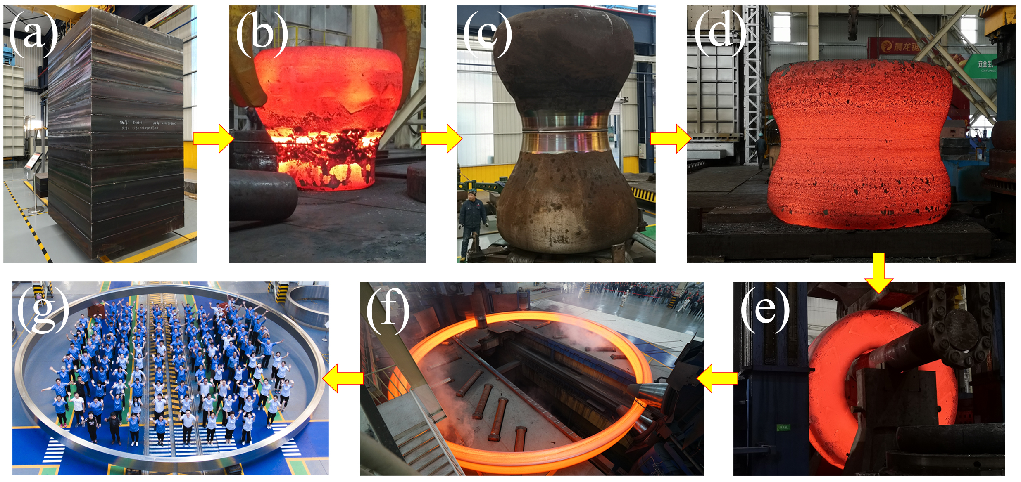
Fig. 1. Manufacturing process of the weldless stainless steel forging ring by the metal Additive Forging (MAF) method.
In order to characterize the internal defects of the support ring, masterscan-340 ultrasonic No Destructive Testing (NDT) instrument was used to detect the finished piece, and the NB/T47013.3-2015 standard was used as the detection standard. Metallographic microstructure characteristics were observed by metallurgical microscope. To evaluate the quality of the ring piece, the tensile, impact and fatigue specimens were sampled from 0°, 120° and 240° positions of the ring piece with different orientations including tangent direction (TD), axial direction (AD) and radial direction (RD) (Fig. 2). Tensile test was performed by Z150 tensile experiment equipment and the experiment temperatures were 27 ℃, 350 ℃, 400 ℃, 450 ℃, 550 ℃ and 650 ℃, respectively. The strain-controlled fatigue tests were performed by Instron fatigue experiment equipment at room temperature.
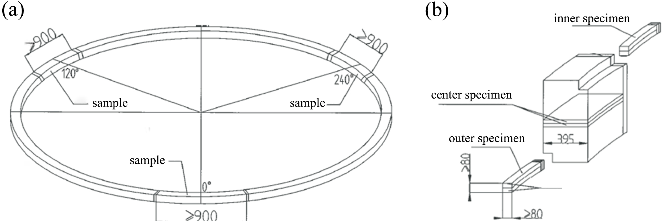
Fig. 2. The sampling scheme of tensile, impact and fatigue specimens from the ring piece.

RESULTS AND DISCUSSION

NDT & microstructure analysis
The result of ultrasonic NDT test reveals that the quality of finished product reaches the strictest quality acceptance level of NB/T47013.3-2015, it is suggested that the bonding interfaces healed completely and there are no macro defects in the internal finished product. Fig. 3 displays the cross-sectional microstructures of the support ring. It can be concluded that the support ring has relatively uniform grain size and inclusion size. The differences of the grain size and inclusion size in different regions are small, which meets the requirements of nuclear power standards.
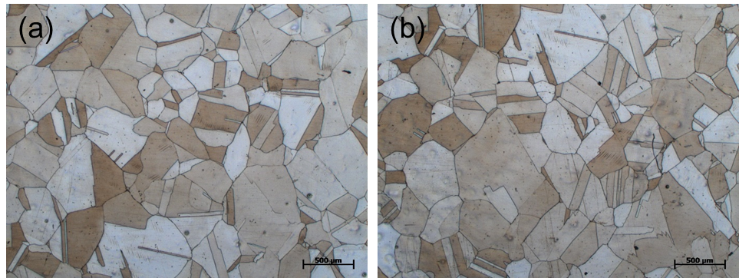
Fig. 3. The microstructures of the different positions of the ring piece.

Mechanical properties

Tensile properties
Fig. 4 provides the results of tensile tests in different positions and directions at room temperature, it is obviously noted that the tensile properties of all specimens in different positions and directions are nearly in the same level, which meet the requirements of technical conditions. When sampling in the same direction at the same position of the support ring, the maximum axial deviation of the room temperature yield strength is 43 MPa, the circumferential deviation is 41 MPa, and the radial deviation is 27 MPa. When sampling in the same direction at different positions of the support ring, the circumferential deviation of the yield strength is 50 MPa, the radial deviation is 48 MPa, and the axial deviation is 63 MPa. when in different positions and different sampling directions (all data), the maximum and minimum yield strength deviation is 75 MPa.
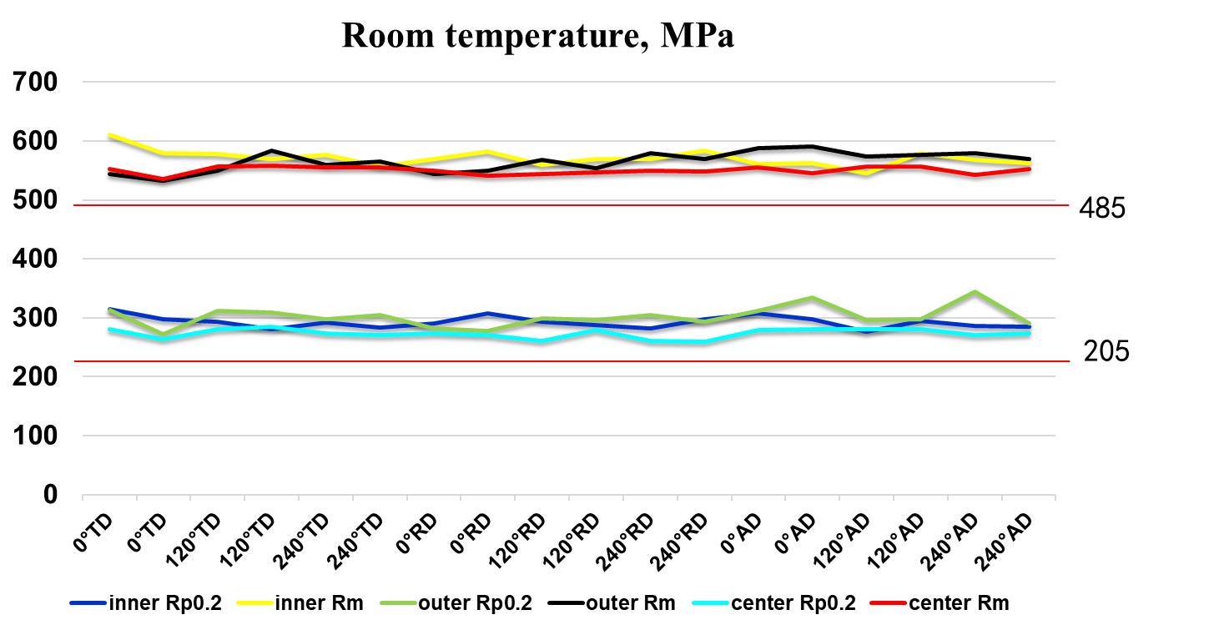
Fig. 4. Tensile strength of the different positions of the ring piece (φ=15.6 m) at room temperature

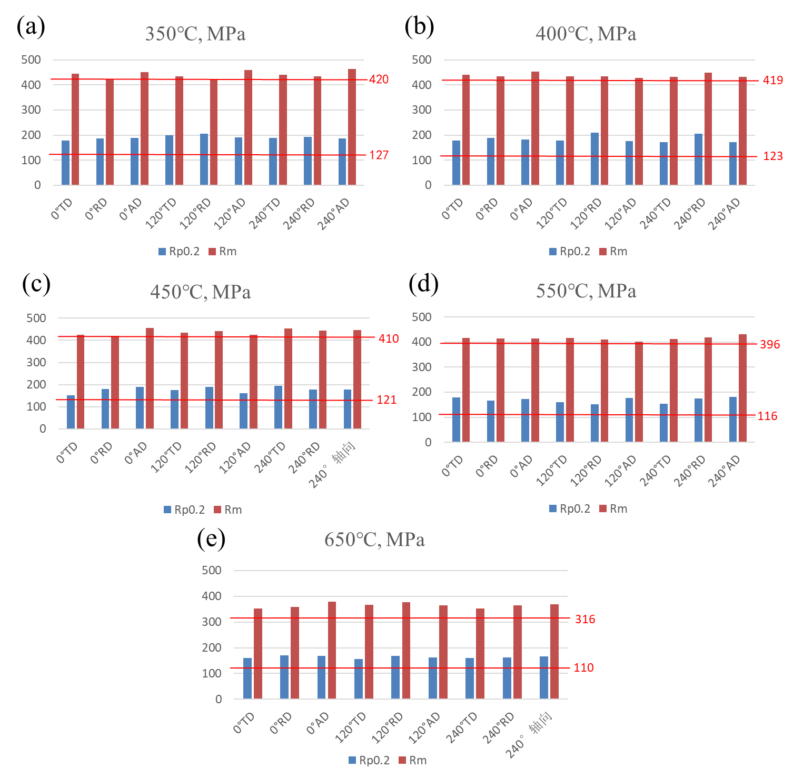
Fig. 5. High temperature tensile strength of the outer ring piece (φ=15.6 m) at (a) 350 °C, (b) 400 °C, (c) 450 °C, (d) 550 °C and (e) 650 °C.

Moreover, the high temperature tensile tests for different positions and directions of the ring piece were carried out at 350 °C, 400 °C, 450 °C, 550 °C and 650 °C. Figs. 5-7 show the high temperature tensile strength of the outer, inner and center ring pieces at different positions, directions and temperatures, respectively. It can be seen that all the tensile samples have uniform and reasonable high temperature tensile properties at 350 °C, 400 °C, 450 °C, 550 °C and 650 °C, all of which meet the technical requirements.
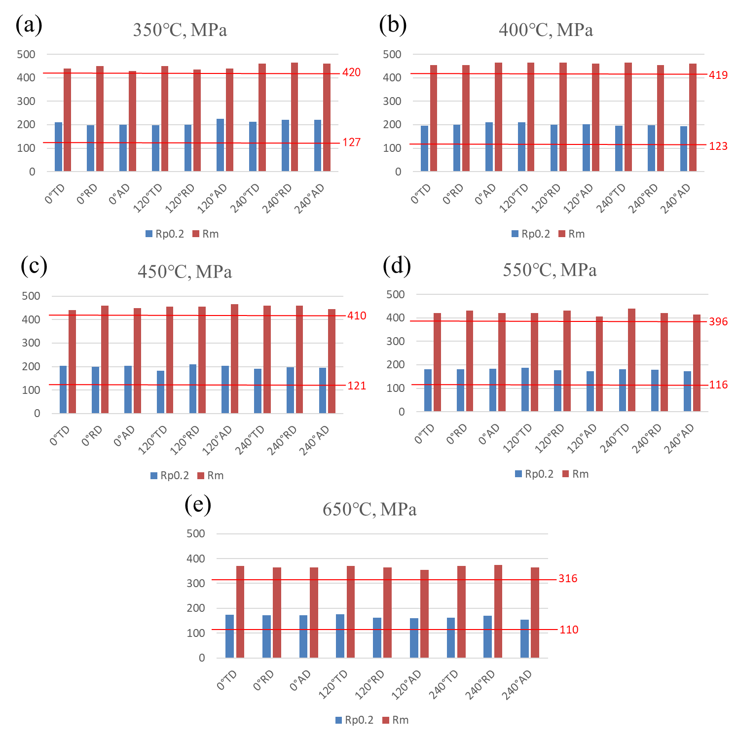
Fig. 6. High temperature tensile strength of the inner ring piece (φ=15.6 m) at (a) 350 °C, (b) 400 °C, (c) 450 °C, (d) 550 °C and (e) 650 °C.

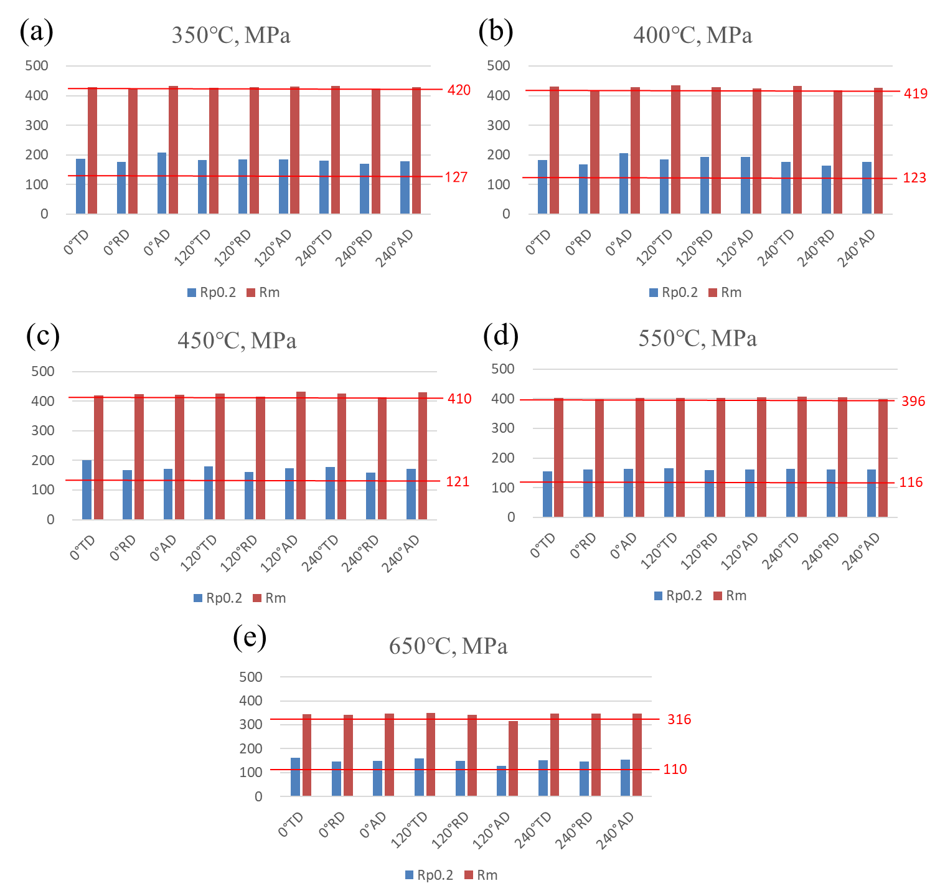
Fig. 7. High temperature tensile strength of the center ring piece (φ=15.6 m) at (a) 350 °C, (b) 400 °C, (c) 450 °C, (d) 550 °C and (e) 650 °C.

Impact properties
Meanwhile, after the heat treatment, the Kv impact tests for different positions and directions of the ring piece were also carried out at room temperature. For the test result in Fig. 8, it can be seen that the impact absorption energy of the ring piece developed by AMF technology are > 225 J, which meets the technical requirements for trial production. The deviation of the impact absorption energy in different positions and directions is 77 J. Besides, when sampling at the same position and different directions of the ring piece, the deviation of the average impact absorption energy for the inner position is 44 J, the deviation of the average impact absorption energy for the outer position is 46 J, and the deviation of the average impact absorption energy for the central position is 19 J. From the above results, the impact absorption energy in different directions of the outer ring is relatively high, and the impact absorption energy in different directions of the inner and center ring is relatively close to each other. As for the center position, the deviation is only 19 J.
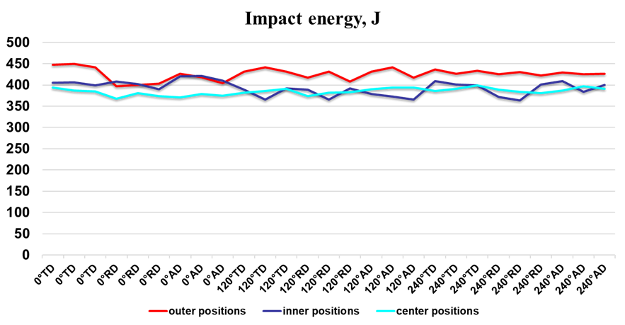
Fig. 8. The impact test results of the ring piece (φ=15.6 m) at room temperature.

Fatigue properties
Fig. 9 shows the fatigue test results of the ring piece at different positions and directions. Comparing the fatigue test results with the ASME standard curve (Fig. 9a), it can be seen that the fatigue test results of 159 pieces are relatively stable and mainly concentrated near the standard curve. The results with a strain amplitude of ±0.5% are mostly higher than the ASME standard fatigue curve index requirements except for individual values. Meanwhile, most of the fatigue test results with an amplitude of ±0.3% are slightly lower than the ASME standard curve. It is basically equivalent to the ASME standard fatigue curve standard as a whole and meets the ASME standard fatigue curve.
Through analysing the fatigue properties of different positions and directions of the ring piece with a strain amplitude of ±0.3%, it can be seen that the fatigue cycles of the ring piece are mostly concentrated between 15,000 and 30,000 cycles, and there is no obvious difference in the fatigue performance in the same position with different directions, and the radial fatigue is relatively low on the whole. Comparing the fatigue data of different positions of the ring piece, it can be seen that the fatigue data of the inner and outer positions are more divergent, and the fatigue test results at the central position are more concentrated. According to the overall comparison of the fatigue test results in different directions of 0°, 120°, and 240°, it can be seen that the fatigue cycles in the 0° and 120° directions are relatively lower than that in the 240° direction.
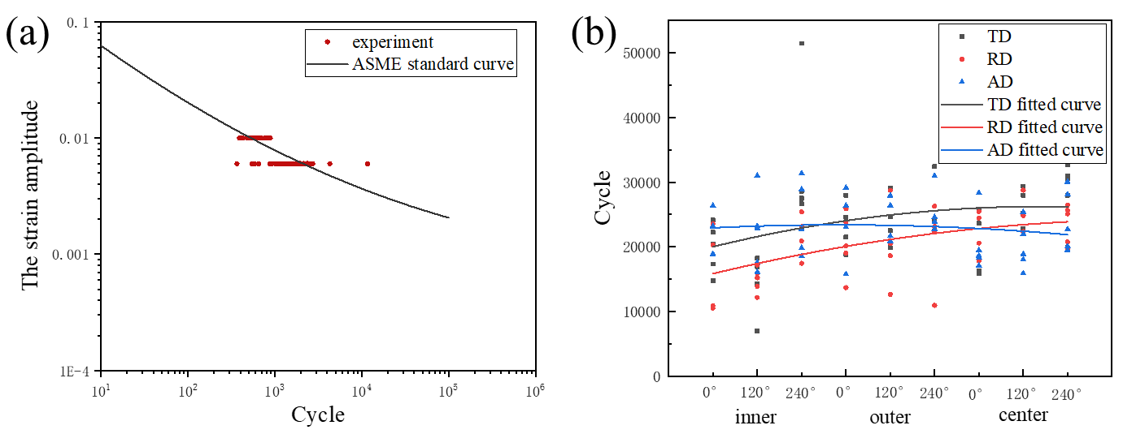
Fig. 9. The fatigue test results of the ring piece (φ=15.6 m) at room temperature: (a) the fatigue cycles as a function of the strain amplitude, (b) the comparison of the fatigue cycles at different positions and directions with a strain amplitude of ±0.3%.

CONCLUSIONS
The heavy integral prototype support ring (φ=15.6 m) is manufactured successfully by means of metal Additive Forging technology. The test results indicate that the microstructure and mechanical properties of the support ring in different directions and regions are uniform and stable, which meets the design requirements and confirms the advancement and reliability of this novel technology. The successful manufacture of the support ring is of great significance to the construction of the fourth generation nuclear power unit as it greatly improves the safety and reliability of nuclear power operation and significantly accelerates the construction progress, which provides a universal strategy for heavy component manufacturing
ACKNOWLEDGEMENTS
This study was supported by the National Key Research and Development Program [Grant No. 2018YFA0702900], the National Natural Science Foundation of China [Grant No. 51774265], the National Science and Technology Major Project of China [Grant No. 2019ZX06004010], Program of CAS Interdisciplinary Innovation Team, and Youth Innovation Promotion Association, CAS. We acknowledge the support given by Haitao Xu, Yaping Li, Chunguang Yan, Mingzheng Wang and Donghui Zhang from China Institute of Atomic Energy. We thank Ying Zhuang and Wei Yin from Taiyuan Iron and Steel Corporation for providing stainless steel casting billets. Xiufeng Ren, Wei Yin and Yugang Niu from Shandong Iraeta Heavy Industry Co., Ltd are also gratefully acknowledged for providing superior production conditions.
References
- T. Abram, S. Ion, Generation-IV nuclear power: A review of the state of the science, Energy Policy 36(12) (2008) 4323-4330.
- J.-M. Berniolles, S. Gallo, Fast nuclear reactor, Google Patents, 1976.
- M.C. Flemings, Our understanding of macrosegregation: past and present, ISIJ Int. 40(9) (2000) 833-841.
- D. Li, X.-Q. Chen, P. Fu, X. Ma, H. Liu, Y. Chen, Y. Cao, Y. Luan, Y. Li, Inclusion flotation-driven channel segregation in solidifying steels, Nature Communications 5 (2014) 5572.
- S. Mingyue, B. Xu, D. Li, Y. Li, Constructing-and-forging method for preparing homogenized forged pieces, Google Patents, 2019.

