InflUence of Low Dose Irradiation on Permanent Core StrUctUral Materials of PFBR

Ran Vijay Kumar^{1, 2}, Ashish Kolhatkar¹, M. Shreevalli², V. V. Jayaraj¹, C. Padmaprabu¹, V. Karthik^{1,2}, C.N. Venkiteswaran¹, P. Parameswaran^{1,2}, Divakar R^{1,2} and Shaju K. Albert^{1,2}

¹Indira Gandhi Centre for Atomic Research, Kalpakkam, TN 603102, India.
²Homi Bhabha National Institute, Kalpakkam, TN 603102, India

Email contact of corresponding author: rvijay@igcar.gov.in

Abstract

Permanent components of sodium cooled fast reactors experience a temperature of 350°C-550°C and accumulate life-time neutron doses of 1-2 dpa. Austenitic stainless steel (SS) 316L(N) is the material of choice for Prototype Fast Breeder Reactor (PFBR) internals such as main vessel, grid plate, core support structure, core catcher, control plug, inner vessel, intermediate heat exchanger etc., while the safety vessel is made of SS304L(N). An irradiation experiment was undertaken in Fast Breeder Test Reactor (FBTR) with an aim to compare the irradiation performance of SS316L(N) and SS304L(N) at neutron doses of 2-5 dpa and to explore the feasibility of replacing SS316L(N) with SS304L(N) for T < 400°C for future FBRs. In this paper, the mechanical test results and microstructural changes of the irradiated steels are compared and presented. The studies reveal that the uniform elongation for both the steels is well above 10% ductility limit for neutron doses of up to 2 dpa. However, considering higher life designs of future FBRs (~60 years), SS316L(N) is the preferred choice of structural material due to its better retention of tensile and impact properties.

INTRODUCTION
Replaceable core components of sodium cooled fast reactors (SFR) such as cladding and ducts are subject to extreme conditions of intense fast-spectrum neutron irradiation leading to displacement damage of ~100–150 dpa (displacements per atom) and high-temperatures (400–700°C) in sodium coolant. On the other hand, large non-replaceable components, such as core support structure, reactor vessels, piping, etc., are usually subject to neutron damage of ~1-3 dpa and operating temperatures of 350°C–550°C. These permanent structures need to function satisfactorily throughout the reactor life time. The main concern for permanent structures [1] located below the core such as the grid plate, operating at ~400°C is the loss of ductility and toughness due to displacement damage, while for above core structures subjected to high temperatures (~550°C), irradiation induced reduction in time dependent properties such as creep and creep-fatigue resistance are the life limiting factors.
Austenitic stainless steel (SS) of grades 316L(N) and SS304 L(N) are the materials selected for Prototype Fast Breeder Reactor (PFBR) permanent components. They experience a temperature of 350°C-550°C and accumulate neutron doses of < 1 dpa in their design life time of ~40 years. An irradiation experiment was undertaken in Fast Breeder Test Reactor (FBTR) with the objective of comparing the performance of SS316L(N) and SS304L(N) to explore the possibility of replacing SS316L(N) with SS304L(N) for T ≤ 400 °C for future SFR’s.

MATERIALS AND TEST PROCEDURE
The irradiation experiment consisted of subjecting pre-fabricated tensile, disc and Charpy V notch specimens of SS316L(N) and SS304L(N) to neutron irradiation in FBTR to displacement damage in the range 2-5 dpa at an irradiation temperature of ~400°C. The chemical compositions of the base materials prior to irradiation as determined by optical emission spectrometry are given in Table1 where Ferrite number measured using a Fisher FMP-30 Ferrite scope (precision: ±0.05 FN) has also been included.

Irradiation experiment
The dimensions of the sub-size tensile, sub-size Charpy V Notch (CVN) and disc specimens machined from SS316 L(N) and SS304 L(N) base metal plates are shown in Fig. 1.The tensile, impact and disc specimens were machined by wire Electric Discharge Machining (EDM) and loaded in six compartments of two SS316 irradiation capsules. Each irradiation capsule was loaded and locked in a special hexagonal steel sub-assembly (referred as experimental sub-assembly) and was irradiated in FBTR for 72 Effective Full Power Days (EFPDs). Displacement damage experienced by the specimens ranged from 1.76 to 5.73 dpa (NRT). The damage accumulation rate in this irradiation experiment was ~8×10⁻⁷ dpa/s. With the inlet temperature of the sodium being 380-395ºC during irradiation in FBTR, the irradiation temperature of the specimens in different compartments is estimated to be in the range 400-415ºC.

Table.1: Chemical compositions (in wt %) of the materials used in this study prior to irradiation

Alloy | C | N | Ni | Cr | Mo | Mn | Si | Cu | Co | W | V | Sn | Ti | Al | FN*
SS316L(N) Base | 0.03 ±0.01 | 0.07  ±0.01 | 12.1 ±0.5 | 17.1  ± 0.5 | 2.24 ±0.02 | 1.96 ±0.05 | 0.28 ±0.02 | 0.52 ±0.02 | 0.19 ±0.02 | <0.05 | - | <0.01 | <0.08 | <0.03 | 0.2
SS304L(N) Base | 0.04 ±0.01 | 0.10 ±0.01 | 9.5 ±0.5 | 17.7 ±0.5 | 0.24 ±0.02 | 1.8 ±0.05 | 0.46 ±0.02 | 0.25 ±0.02 | 0.12 ±0.02 | 0.06 ±0.01 | 0.12 ±0.02 | <0.01 | <0.08 | <0.03 | 0.5
*FN: Ferrite Number

FIG.1 Schematic of the specimens (a) sub-size tensile specimen (b) Disc specimen of 0.5 mm thickness and (c) sub-size Charpy V-notch specimen (All dimensions in mm)

Post-irradiation Examinations
The experimental sub-assemblies were dismantled in hot cells for retrieval of irradiated specimens. Uniaxial tensile tests were carried out using a 20kN capacity screw driven UTM as per the ASTM E-8 and ASTM E-21 standards. In this campaign, tensile tests were performed at 340°C to keep the recovery effects due to imposed temperature minimal and to obtain a conservative estimate of the ductility. The stress-strain curve of each irradiated condition was determined from load-crosshead displacement data and analysed to estimate the 0.2% offset Yield Strength (YS), Ultimate Tensile Strength (UTS) and residual ductility. The ductility values were defined by the parameters [2] Strain to Necking (STN) and Strain to Failure (STF). Impact tests on irradiated CVN specimens were carried out using a 450J capacity pendulum type instrumented impact testing machine as per ASTM E-23 procedures. Impact tests were conducted at a velocity of 5.23 m/s at ambient temperature. The absorbed energy was measured by the optical encoder based on fall and rise angles of the pendulum hammer while the dynamic yield load (P_{gy}), and peak load (P_{m}) were determined by analysis of the load (P)-deflection data. Two tensile and impact tests were conducted for each of dpa condition.
Microstructural characterisation of irradiated conditions was carried out using Transmission Electron Microscope (TEM) operated at 120kV. Discs of 3.0 mm diameter and 0.5 mm thick punched from 8.0 mm diameter samples were mechanically ground to a thickness of 50 microns, followed by electrolytic thinning using a twin jet polisher to obtain electron transparent regions. The presence of magnetic phases were inferred through ferrite measurements using a Fisher FMP-30 Ferrite scope (precision: ±0.05 FN) on disc specimen prior to deformation. X-ray Diffraction (XRD) patterns of the unirradiated and irradiated samples were collected from 3mm diameter disc specimens using synchrotron radiation of wavelength 0.828Å at Raja Ramanna Centre for Advanced Technology (RRCAT), India. Diffracted signals were collected in the 2θ range of 20°-50° with a step size of 0.0029° using MYTHEN detector and analyzed. For subtracting the instrumental broadening, NIST standard silicon sample was used.

3.0 RESULTS

3.1Tensile Test Results
Stress-strain curves (Fig. 2a) clearly show an increase in strength (both YS and UTS) and a decrease in the ductility with increase in dpa. The rate of increase in YS with dpa is higher than that of UTS. With increase in irradiation damage, the narrowing of the gap between YS and UTS manifests as a loss of work hardening and uniform elongation. One interesting observation was that of a sigmoidal or two-stage hardening in 5.08 dpa specimen of SS304L(N) not observed in any other irradiation condition of SS316L(N) and SS304L(N). Similar peculiarities in the plastic flow of irradiated stainless steels have been reported [3] as due to the formation and accumulation of deformation induced martensite in irradiated steels leading to an increase in strain hardening rate and ductility. The microstructural investigations on the deformed 5.08 dpa SS304L(N) samples are reported in the later section.
The trends of strength and uniform elongation of irradiated SS316L(N) and SS304L(N) are compared in Fig.2b. It can be seen that the SS 304L(N) exhibits a higher rate of hardening with dpa and correspondingly a lower ductility compared to SS316L(N) at all dpa. At 3.54 dpa, the uniform elongation of SS316L(N) drops by ~25%, while in SS304L(N), the uniform elongation reduces significantly by 74% to 0.05.

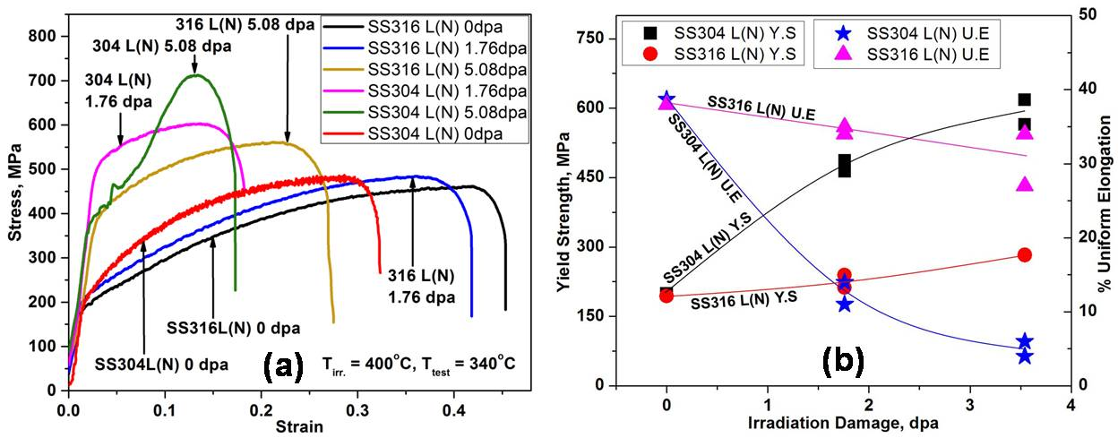
FIG. 2: (a) Engineering stress-strain curves and (b) trends in YS and uniform elongation of SS316L(N) and SS304L(N) as a function of dpa

3.2 Impact tests
The impact energy (C_{v}) of SS316L(N) showed no significant change as displacement damage increased to 5.6 dpa, while C_{v} of SS 304 L(N) decreased marginally by ~10% at 3.8 dpa and by ~25% at 5.2 dpa. None of the irradiated CVN specimens completely separated into two halves indicating ductile behaviour of both 316L(N) and 304L(N) steels at room temperature. The load (P) - displacement (d) data were analysed as per ASTM 2298 to estimate general yield load, P_{gy}. This was determined as the load at the intersection of the initial straight-line portion of the load (P) - displacement (d) curve representing elastic deformation and a quadratic curve fitted to P-d pairs slightly after yielding to maximum load (P_{max}). Following are the salient observations. (i) A higher increase in dynamic yield load (P_{gy}) for SS304L(N) as compared to SS 316L(N) with increase in dpa and (ii) P_{max}/P_{gy} (a measure of ductility, closeness to 1.0 implies brittle) decreases considerably beyond 2.5 dpa for SS304L(N) compared to SS316L(N) as seen in Fig.3. The higher dynamic yield load and the larger decrease in the impact energy as well as P_{max}/P_{gy} exhibited by SS304L(N) with dpa, as compared SS316L(N), are similar to trends of strength and ductility obtained in uniaxial tensile tests.

FIG. 3: The load-displacement curves and trend of P_{max}/P_{gy} for SS316 L(N) and SS304 L(N) as function of dpa

Microscopy
TEM examination of SS304L(N) base metal samples of 1.76 dpa and 3.54 dpa showed dislocation pile ups at various locations, while formation of dislocation loops and stacking fault tetrahedra were observed for 3.54 dpa sample (Fig. 4). SS316L(N) base metal exhibited lower number density of irradiation induced loops even at 5.08 dpa, as compared to 3.54 dpa of SS304 L(N). The higher density of dislocation loops in SS304L(N) as compared to SS316L(N) leads to larger increase in strength and reduced work hardening capability causing higher decrease in strain to necking.

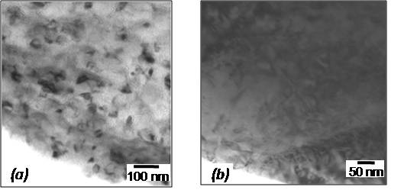
FIG. 4: TEM images (a) dislocation loops in 3.54 dpa SS304 L(N)and (b) dislocation pile ups in 5 dpa SS316 L(N)

SEM examination of metallographically prepared specimen from deformed gage section of 5.08 dpa SS304L(N) showed formation of chain of secondary phases (Fig. 5). XEDS mapping carried out on this area indicated enrichment of chromium and a corresponding depletion of nickel in the secondary phase relative to the initial composition. Quantitative elemental spot analysis using WDS indicated that nickel content is lower by ~1.2 wt% while chromium content is higher by ~1 wt% in the secondary phase as compared to parent material. Using the chemical composition obtained in two different regions, the stacking fault energy (SFE) was estimated using the equation [4]: SFE (mJ.m⁻²) = -53 + 6.2(%Ni) + 0.7(%Cr) + 3.2(%Mn) + 9.3(%Mo) as 18.3mJ/m² for secondary phase and 25.4mJ/m² for parent phase. The reduced SFE due to micro chemical segregation could possibly lead to activation of martensitic transformations as reported by Wharry et al. [5] The fractographic analysis of the tensile tested SS304 L(N) steel irradiated to 5.08 dpa indicated ductile features along with series of cavities (Fig.6) at locations corresponding to the secondary phase.

FIG. 5: a) Morphology and (b) SEM XEDS mapping of irradiated (5.08 dpa), tensile testedSS304 L(N) showing secondary phase with higher chromium content and lower nickel content.

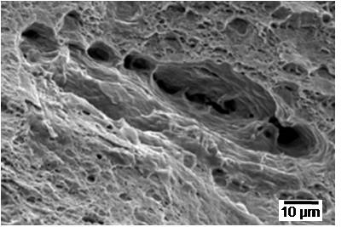
Fig. 6: Fractograph of tensile tested SS304L(N) of 5.08 dpa showing series of cavities

Ferrite content measurements
The variation in the ferrite number of irradiated disc specimens (undeformed) of 316L(N) and 304L(N) at various dpa is shown in Fig. 7. The irradiated SS304L(N) were seen to exhibit higher ferrite number compared to the unirradiated condition as well as that of irradiated SS316L(N). The increased ferrite content suggests possible γ to α transformation under neutron irradiation. This has been reported by Gusev et al. [6] for irradiated austenitic stainless steels.

FIG. 7: Ferrite number measurements on irradiated specimen surfaces of SS316L(N) and SS304L(N) as a function of dpa

3.5XRD results
Fig. 8 shows the X-ray diffraction profiles recorded for the undeformed neutron-irradiated SS316L(N), SS304L(N) and deformed (SS304L(N) 5dpa TT) steels. In addition to peaks {111}, {200}, {220}, {311} and {222} corresponding to reflection from γ austenite phase (FCC), the peaks {110} and {211} corresponding to reflections from α phase (BCT) were observed in irradiated conditions, confirming γ to α transformation. This transformation is known to be caused by either strain induced martensite transformation or as radiation induced segregation and precipitation [6, 7].
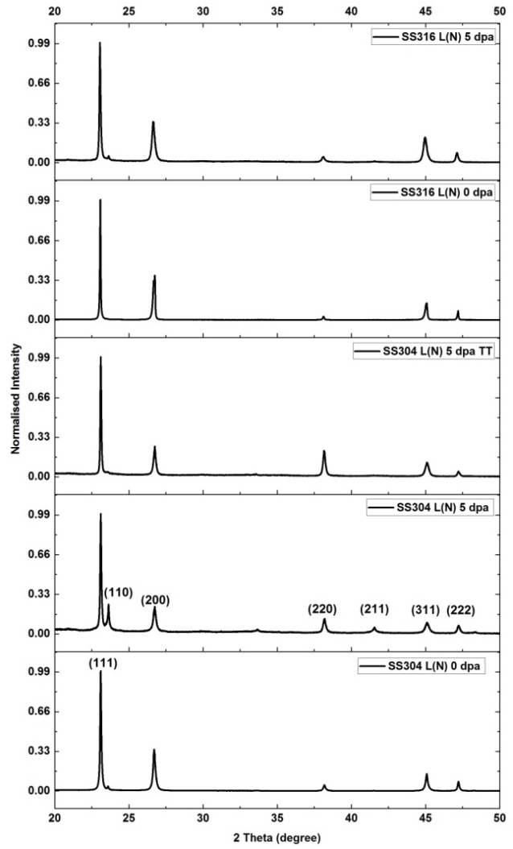
FIG. 8: XRD patterns for SS316L(N) and SS304L(N)at various dpa

FIG. 9: The peak profile belonging to the (311) reflection for 5.08 dpa sample of 304L(N) and 316L(N)along with the pre-irradiation peak profiles.
Peak broadening, shift in the peak position and asymmetry in peak profiles were observed in the XRD profiles of irradiated conditions. Peak broadening of the individual peaks were determined by fitting with split pseudo-Voigt function [8]. The peak profile belonging to the (311) reflection for 5.08 dpa sample of 304L(N) and 316L(N) is compared in Fig. 9. The higher peak broadening in irradiated 304L(N) points to the higher defect density compared to 316L(N) and is consistent with higher hardening observed for 304L(N) in mechanical tests.

4.0 Discussion
The macroscopic changes in mechanical properties are primarily caused by the microstructural and micro chemical changes induced by irradiation. The strength increase after neutron irradiation is known to be due to the impediment to the movement of dislocations by defects and defect clusters including network dislocations, dislocation loops, cavities (bubbles and voids) and precipitates, depending on the irradiation temperature. For irradiation temperature around 400°C and low neutron doses of 4-5 dpa, the microstructure of SS316L(N) and SS304L(N) is dominated by dislocation loops and network dislocations. Loss of work hardening and ductility is attributed to the nature of interactions between the dislocations and the irradiated microstructure. The dislocation interactions with the irradiation induced obstacles [9] such as Frank loops leads to reduction in the effectiveness of the barriers or the elimination of barriers. The stability of the Frank loops and annihilation mechanisms [10] are governed by the stacking fault energy which is related to the chemical composition of the steel. The differences in irradiation induced defect concentrations and the hardening behaviour of SS316L(N) and SS304L(N) could be attributed to the differences in the solute contents, especially molybdenum and its effect on binding and migration energies of the defects.
The effects of low dose neutron irradiation have been incorporated in the design standards of FBR structural materials by various fast reactor working groups [11]. In the early 90’s, the Design and Construction Rule Committee (DCRC), formed within EFR (European Fast Reactor) Associates concluded that no change in material data of 316L(N) needs to be considered if the irradiation damage is < 1 dpa in negligible creep conditions (< 450°C) [12]. A design limit of 10% fracture elongation was set to limit the accumulated fast neutron fluence of Monju reactor. Similarly, in both the Fast Flux Test Reactor and Chalk River Breeder Reactor design, 10% total elongation was chosen as the threshold end-of-life ductility for in vessel components [13]. This design criterion assured ductile mode of deformation and permitted conventional structural analysis methods.
In the RCC-MRx code, a neutron fluence of 2 dpa has been set to separate the negligible and non-negligible irradiation domain in the temperature range of 425-550°C for SS316L(N) steels.The present study reveals that the uniform elongation SS316L(N) base metal is well above 10% ductility limit for neutron doses up to 5 dpa, while uniform elongation of SS304L(N) base metal drops below the 10% ductility limit at neutron doses beyond 2 dpa. Based on this and considering the negligible changes in impact energy of SS304L(N) up to 2 dpa, SS304L(N) could possibly be considered instead of SS316 L(N) for components operating in negligible creep regime (< 450°C) for life time neutron doses of less than 2 dpa. However, considering higher life designs of future FBRs (~60 years) and for lifetime neutron doses greater than 2 dpa, SS316L(N) is the preferred choice of structural material even for components operating in negligible creep regime owing to better retention of mechanical properties as compared to SS304L(N).

Conclusions
A comparative study of the irradiation performance of SS316L(N) and SS304L(N) irradiated side-by-side in FBTR to low neutron doses (2-5 dpa) have been carried out. Irradiated SS316L(N) and SS304L(N) exhibited an increase in YS and UTS and a concurrent decrease in uniform and total elongations with increase in neutron dose up to 5 dpa. Results of tensile and impact test showed that SS304L(N) base exhibited higher hardening and ductility loss compared to SS316L(N) base metal at all dpa. Signatures of radiation induced ferrite formation was observed through magnetic measurements in SS304L(N) at 2-5 dpa. A two-stage hardening behavior was exhibited by SS304L(N) at 5.08 dpa pointing to deformation induced transformations. The higher hardening in SS 304L(N) is attributed to higher density of radiation induced defects in SS304L(N) compared to SS316L(N) corroborated by microscopy and X ray diffraction results. The performance of irradiated SS316L(N) with respect to the tensile and impact properties is found to be superior to that of irradiated SS 304L(N).
ACKNOWLEDGEMENTS
The authors gratefully acknowledge Director, IGCAR and Director, Metallurgy & Materials Group, IGCAR for their keen interest, encouragement and support. Authors are thankful to Dr. Tapas Ganguli, Head, Synchrotron Utilization Section, Dr. Haridas G., Radiological Safety Officer and their team at RRCAT Indore for facilitating Synchrotron based XRD studies. The contributions of a number of colleagues of PIE division and Health Physicist, RML during the course of examinations are gratefully acknowledged.
References
- A. A. Tavassoli, “Materials and Operating Conditions of Fast Breeder Reactor Internal Structures”, Influence of low dose irradiation on the design criteria of fixed internals in fast reactors (Proc. Int. Conf., Gif-sur-Yvette 1993), IAEA, Vienna (1995), IAEA TECDOC-817 (1995) 9-16.
- M.G. Hortsen and De Vries, “Irradiation Hardening and loss of ductility of type 316 L(N) Stainless steel plate material due to neutron irradiation, Effect of Radiation on Materials, ASTM STP 1270 (1996) 919-932.
- M.N. Gusev, O.P. Maksimkin, F.A. Garner, Peculiarities of plastic flow involving deformation waves observed during low-temperature tensile tests of highly irradiated 12Cr18Ni10Ti and 08Cr16Ni11Mo3 steels, J. Nuclear Materials 403 (2010)121-125.
- Hamilton Ferreira Gomes de Abreu et al., Deformation Induced Martensite in an AISI 301LN Stainless Steel: Characterization and Influence on Pitting Corrosion Resistance, Mat. Research, 10(2007) 359-366
- J.P. Wharry and K.S. Mao, The role of irradiation on deformation induced martensitic phase transformations in FCC alloys, J Materials Research 35 (2020) 1660-1671.
- M.N. Gusev, J.T. Busby, L. Tan and F.A. Garner, Magnetic phase formation in irradiated austenitic alloys, J. Nuclear Materials 448 (2014) 294–300.
- X. Li and A. Almazouzi, Deformation and microstructure of neutron irradiated stainless steel with different stacking fault energy, J. Nuclear Materials, 385 (2009) 329-333.
- G. Caglioti, A. Paoletti, F.P. Ricci, Choice of collimators for a crystal spectrometer for neutron diffraction, Nucl. Instrum. 3 (1958) 223-228.
- G.E. Lucas, The evolution of mechanical property changes in irradiated austenitic stainless steels, J. Nuclear Materials, 206 (1993) 287-305.
- C. Pokor, X. Averty, Y. Brechet, P. Dubuisson, J.P. Massoud, Effect of irradiation defects on the work hardening behaviour, Scripta Materialia 50 (2004) 597–600.
- K. Aoto, and Y. Wada, Concept of design criteria of low dose irradiation for FBR structural materials, Influence of low dose irradiation on the design criteria of fixed internals in fast reactors, IAEA TECDOC-817 (1995) 79-87.
- C. Escaravage, R. Ward and W. Dietz, “EFR-DCRC proposal to introduce in design work the low dose irradiation effects”, Influence of low dose irradiation on the design criteria of fixed internals in fast reactors (Proc. Int. Conf., Gif-sur-Yvette 1993), IAEA, Vienna (1995), IAEA TECDOC-817 (1995) 63-66.
- Pavek Tsvetkov, Alan Walter and Donald Todd, “Reactor Plant systems”, Fast Spectrum Reactors, Springer, US (2012).

