Gear test assembly: first liquid metal component testing in the mechanisms Engineering Test Loop

E.F. Kent
Argonne National Laboratory
Lemont, IL USA
Email: kente@anl.gov

H.A. Belch
Argonne National Laboratory
Lemont, IL USA

H.T. Chien
Argonne National Laboratory
Lemont, IL USA

S. Bakhtiari
Argonne National Laboratory
Lemont, IL USA

T.W. Elmer
Argonne National Laboratory
Lemont, IL USA

M. Li
Argonne National Laboratory
Lemont, IL USA

C. Grandy
Argonne National Laboratory
Lemont, IL USA

Abstract

The Gear Test Assembly (GTA) is an experimental apparatus designed to test mechanical components, specifically gears and bearings, used in advanced fuel handling systems of liquid-sodium cooled fast-spectrum nuclear reactors. The existing data is insufficient for proper lifetime calculations of gearing components which operate under load in a high-temperature liquid-sodium environment. Testing of the GTA in the Mechanisms Engineering Test Loop (METL) at Argonne National Laboratory began in February 2019, and is on-going. A total of 11,184 simulated fuel assembly maneuvers (372.8 hours of continuous use) have been completed to date using the original set of Inconel 718 gears. Testing has twice been paused to replace failed mechanical bearings. The performance of 52100 steel tapered roller bearings, with and without heat treatment, has been investigated. Extensive pre- and post-op nondestructive evaluation has been performed to record the health of the gears over the course of operation. Eddy current testing methods are used for detection of surface and subsurface flaws on the gear teeth. Ultrasonic testing methods are used for local and volumetric examinations. Pin-over dimensions are recorded before and after every testing campaign to monitor the gross wear of the gear teeth. Finally, extensive temperature/vibration/torque/sodium-oxygen content data have been collected by the GTA and METL over the course of operation. Testing will continue until the gears fail.

INTRODUCTION
The Gear Test Assembly (GTA) is an experimental apparatus designed to test mechanical components used in advanced fuel handling systems of liquid-sodium cooled fast-spectrum nuclear reactors. The need for advanced fuel handling system testing was identified during a component and infrastructure technology gap analysis for advanced reactors that was performed for the DOE-NE Advanced Reactor Concept program in 2009. Reviews of existing documentation indicated a lack of testing for specific mechanical components used in the construction of advanced fuel handling systems. Most historical dynamic testing performed to-date used a pin rubbing on a plate to test various materials for friction, wear, and self-welding. The existing data are insufficient for proper lifetime calculations of gearing which operate under load in a high-temperature liquid-sodium environment. The loads applied to the components in the GTA are based upon maximum design loading conditions calculated for a fuel handling system that utilizes normal spur gears operating under conservative conditions.
The testing environment for the GTA is the Mechanisms Engineering Test Loop (METL) at Argonne National Laboratory (ANL). METL is an intermediate-scale liquid metal experimental facility that provides purified reactor-grade sodium to various experimental test vessels. In these test vessels, components that are required to operate in an advanced fast reactor can be tested in a prototypical sodium environment. Experiments conducted in METL significantly assist in the development and maturation of systems and components for advanced reactors. The METL facility consists of multiple test segments including: a purification and diagnostic loop (cold trap based on that used at EBR-II), two 457 mm (18”) diameter test vessels with 150 L capacities capable of operating in static or dynamic flow at 538°C, two 711 mm (28”) diameter test vessels with 644 L capacities capable of operating in static or dynamic flow at 650°C, and a 3,180 L dump tank with 21 instrumentation ports.

Gear test assembly overview
The GTA (Figure 1) is designed for maximum testing flexibility and can accommodate various sizes of normal spur and parallel helical gears, as well as mechanical roller bearings. The system can be modified to test worm gears and straight or spiral bevel gears as well as other bearing geometries with minimal replacement of parts inside the liquid sodium testing environment. All testing to-date has examined normal spur gears as these are intended for use in the ANL advanced fuel handling system. Resulting data are taken using torque sensors, vibration probes, tachometers, thermocouples, etc. and compared with data recorded by the METL system such as sodium temperatures, purity, and flow rates. There is considerable reserve capacity in the system for additional measurements devices. Extensive pre- and post-test non-destructive evaluation (NDE) analysis of the gears is employed to determine the onset and evolution of mechanical failure.

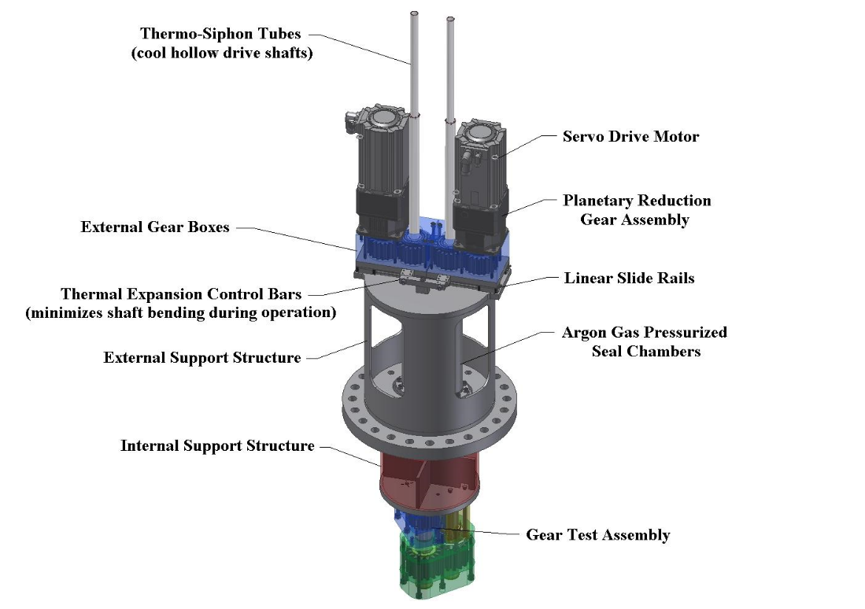
18” ANSI Flange
Figure 1: GTA System Overview [1].
The GTA is currently configured to accommodate spur gear sizes of 150 mm diameter and smaller in the test gearboxes (Figure 2). The maximum torque applied to the input shaft is approximately 678 newton-meters (Nm) (6,000 inch-pounds) and is applied by a pair of servo motors through a 15:1 reducing gearhead. This type of peak force may be required to release a stuck core assembly during refuelling operations. The weight of a commercial size core assembly can be approximately 453.6 kg (1,000 pounds). Continuous loads are applied during GTA operations simulating the entire removal process of a core assembly.

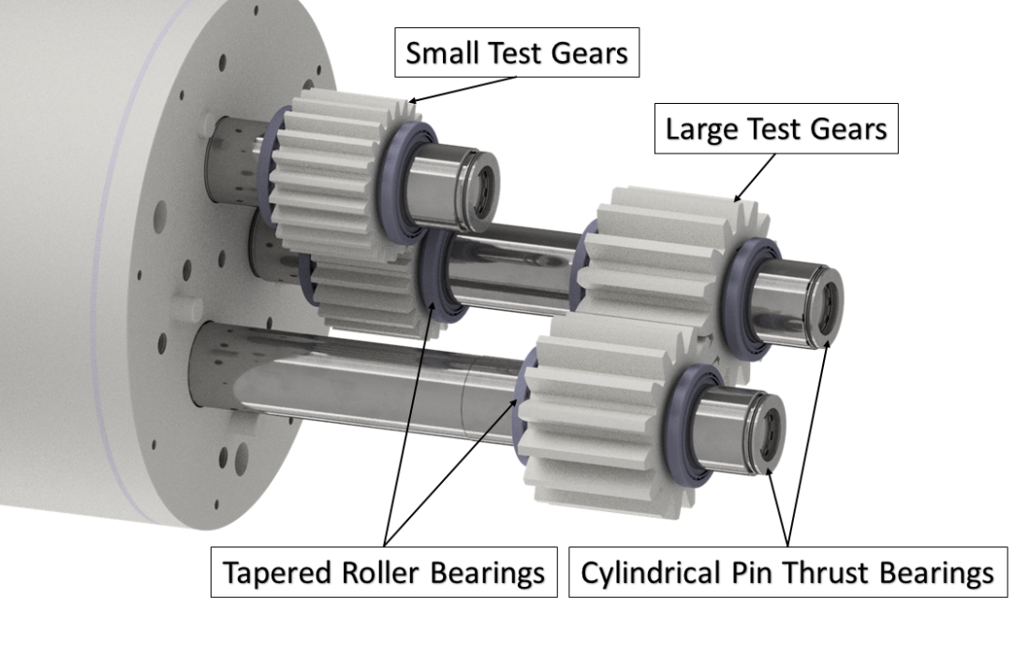
Figure 2: 3D Model representation of the test gears and bearings. View is rotated 90° CCW from true.

Gear and Bearing Design
The required lifetimes of the gears have been sized based upon 20,000 hours of continuous use in a high-temperature air environment. The 20,000-hour lifetime of the gears was sized to exceed the required number of fuel handling operations that would occur in the 60-year plant life of the Advanced Fast Reactor (AFR). The calculations for the gears were performed in accordance with the requirements of ANSI/ AGMA 2001-D04:2005 and have determined acceptable lifetime rating safety factors for fatigue bending and pitting of the gear teeth based on the Inconel 718 material and the selected heat treatment process [2]. Other materials and heat treatments may be selected based on subsequent findings. The equations used to determine the AGMA evaluated bending and contact stresses are based upon several aspects of their loading and environmental conditions. The American Gear Manufacturers Association has developed these methodologies for designing gearing components by calculating the lifetime of gearing components using lifetime reduction factors for various loading and environmental considerations. Equations for safety factors of contact and bending fatigue are utilized to evaluate the lifetimes of the designed gearing components and provide a method for assuring the gears perform for their intended lifetime within the applicable ranges of validity of the design lifetime reduction factors. Factors for lifetime reduction for operation in an elevated temperature flowing liquid sodium environment have not been developed.
The bearings used in the assembly are commercially available tapered roller bearings made of ASTM A-295 52100 bearing steel. 52100 steel is a high-carbon, low-friction chrome steel with a standard hardness around 60 HRC [3]. The effect of heat treatment on the performance of 52100 steel has been investigated.

experimental operation
In early October 2018, all necessary pre-sodium commissioning work was completed in Building 206 and the GTA was moved to Building 308. The GTA was assembled in the experimental test assembly workstation on the METL Mezzanine to ready the system for insertion into METL (Figure 3). All supporting electrical hardware and support instrumentation was moved and installed in 308 to properly operate the GTA. This hardware included:

- 2x 480 VAC Transformers
- 480 VAC Disconnect Panel for Motor Power
- 240 VAC Disconnect Panel for Heater Power
- 2x Parker Compax3 Motor Controllers with Braking Resistors
- Argon Gas Supply Manifold
- Instrumentation and Control Panel

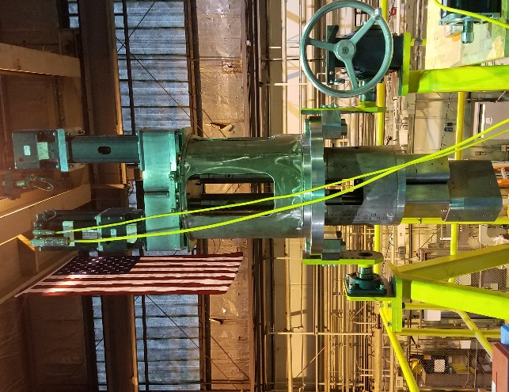
Figure 3: The GTA Fully Assembled at METL [4].
The GTA was installed and sealed in Test Vessel 1 in early January 2019. Leak testing was performed to confirm the performance of the main flange seal, the dynamic shaft seals, and the instrument port seal. This was accomplished by applying a positive helium pressure in Test Vessel 1 via the sample port on the METL Valve Manifold. A helium leak detector with sniffer wand was used to probe the various seals and confirmed all three were operating satisfactorily. The GTA was fully instrumented following the installation and leak testing of the test article.
Final in-vessel commissioning was performed to confirm the operation of the various supporting instrumentation. The GTA was insulated using alumina/silica insulating blankets and prepared for heat-up. Test Vessel 1 and the GTA began the gradual heat-up and bake-out process on January 10, 2019 when the system was set to raise to a temperature of 250°C at 1.5°C/hour. After reaching the operating temperature of 250°C, Test Vessel 1 and the GTA sat for roughly 2 weeks with regular argon purges to bake-out any moisture that could cause problems during sodium fill. On February 1, 2019, Test Vessel 1 was filled to the overflow line with sodium from METL’s dump tank. The sodium inventory was then purified using the cold trap set to an internal temperature of 175°C to reduce oxygen content of the sodium to <10ppm, as this limits the corrosion of the materials in contact with the high-temperature liquid sodium as well as promotes wetting [5]. Testing began on February 5th 2019.
The loading procedure (Table 1) starts at the maximum load expected for 2 seconds to simulate core assembly being released from the grid plate structure and surrounding core assemblies. While continuing to turn, the resisting load is rapidly reduced to simulate handling the dead weight of a typical commercial-size fuel assembly in step 2 for 58 seconds. At the final step in removing the core assembly, the loading proceeds to step 3 where the motion pauses for 30 seconds to simulate time during other motions of the fuel handling system. Next, the control system reverses the motor directions and motor operation modes from driving to resisting (and vice versa).

TABLE 1. TORQUE PROFILE

Load  Step | Torque at Gear  [Nm] | Time  [s] | Motor A Operation Mode | Motor B Operation Mode | Equivalent Process in Core Assembly Handling Procedure
1 | 678 | 2.0 | Driving | Resisting | Lifting core assembly with resistance due to adjacent core assembly load pads and nose piece to grid plate removal
2 | 113 | 58.0 | Driving | Resisting | Lifting core assembly weight
3 | 0 | 30.0 | Dwell | Dwell | Core assembly vertical position unchanged during horizontal traverse (motor direction and operation reverses)
4 | 113 | 58.0 | Resisting | Driving | Lowering core assembly weight
5 | 678 | 2.0 | Resisting | Driving | Lowering core assembly with resistance due to adjacent core assembly load pads and nose piece to grid plate insertion
6 | 0 | 30.0 | Dwell | Dwell | Core assembly vertical position unchanged during horizontal traverse (motor direction and operation reverses)

With the direction reversed, the simulated core assembly weight is lowered in step 5 for 58 seconds. The load is rapidly increased in step 5 to simulate contact of the core assembly nose piece into the inlet plenum for 2 seconds. The motion is paused again for 30 seconds to simulate other motions of the fuel handling system in step 6. The test duty cycle then begins again at step 1 and continues until testing is complete, interim inspections and measurements are required, or component failure occurs.

results

First Experimental Campaign
The first campaign ended after the system experienced a mechanical failure that prevented the shafts from rotating. The test vessel was drained, the GTA was removed and cleaned of residual sodium, and the system was disassembled. The failure was identified as a broken bearing in the test gearbox (Figure 4 & Figure 5). Microhardness testing was performed on the bearing races and cage to examine the condition of the bearing material after failure (Figure 6). The results showed that both races likely received the prescribed heat treatment as the surface material showed increased hardness compared to the inner material. But the cage material was found to be significantly softer than the races, indicating that it was likely a different material with no heat treatment. The combination of the microhardness testing and visual inspection suggest the failure to have occurred at the bearing cage. The first experimental campaign completed 9,800 cycles of the torque profile described in Table 1, or the equivalent of 9,800 fuel assembly maneuvers.

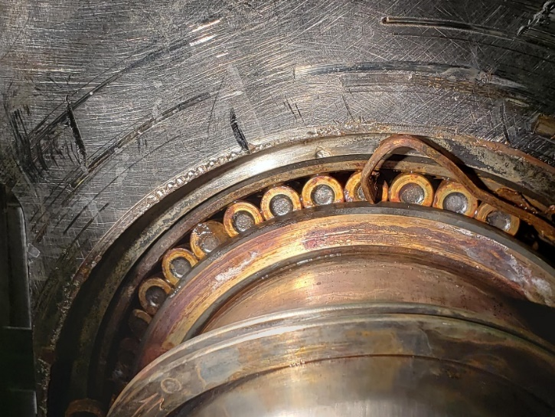
Figure 4: Failed Bearing Showing Damaged Cage [6].
Figure 5: Failed Bearing Cage (left), Failed Bearing Inner Race (mid), New Bearing (right) [7].
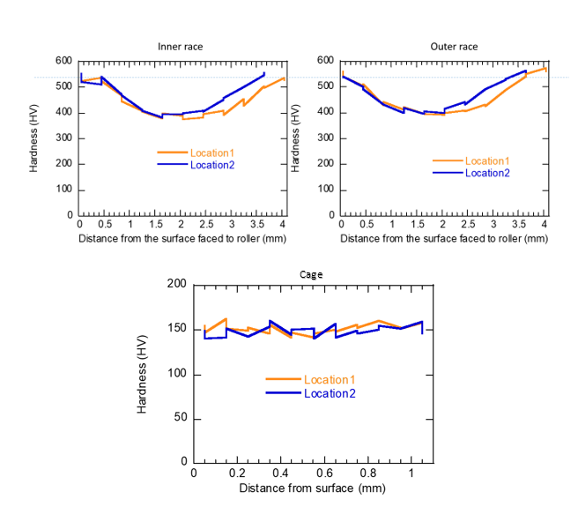
Figure 6: Micro-hardness testing of cross-sections of the inner race (left), outer race (right), and cage (bottom) [7].

Second Experimental Campaign
The second experimental campaign began after the GTA was fully cleaned, disassembled, repaired, and reassembled. The testing procedure was identical to the first campaign, except that the new bearings had not received any heat treatment. The bearing geometry was maintained, but the heat treatment was not requested to examine the influence this process has on the lifetime of the bearings. The testing procedure described in Table 1 was followed until the vibration sensor installed on the test gearbox measured a significant increase in vibration. The noise from the gearbox was also readily observable by the operator, so the testing was stopped. During disassembly the failed component was again found to be a bearing, though this time the damage was far more significant. A bearing in the test gearbox had failed and the races, cage, and rollers were completely fragmented (Figure 7). The second campaign completed 1,384 cycles of the torque profile described in Table 1, or the equivalent of 1,384 fuel assembly maneuvers. The bearings with no heat treatment lasted roughly 14% the lifetime of the heat treated bearings.

Figure 7: Remains of Fragmented Bearing [6].

Gear Non-destructive Evaluation
After each campaign the gears were examined using three NDE techniques. The simplest method used is over-pin dimension measurements. Two identical dowel pins are placed in the roots of opposing gear teeth and the distance is measured from the outer diameter of both dowels. Recording the change in this dimension gives a coarse measurement of the overall wear the gear teeth experience over the course of the campaign. After the first campaign, a maximum material loss of 0.09 mm (0.0036”) was observed which corresponds to roughly 5% of the 20,000-hour lifetime. After the shorter second campaign, all measurements fell below the uncertainty of the calipers used to make the measurement. Future measurements will be made with a high accuracy micrometer.
The second NDE technique used to monitor the gear health is eddy current testing (ECT). A custom ECT system has been developed at ANL for NDE of advanced reactor components. This system uses probes that generate high frequency signals that can induce currents in electrically conductive materials, and these induced currents can be measured. The system can tell the difference between homogenous, undamaged material and damaged material that has surface and sub-surface deformations. This method is ideal for identifying sub-surface cracking that may not be visible to the naked eye. Measurements of all gear teeth surfaces were made prior to operation, as well as after each campaign. This provides a detailed record of the evolution of mechanical wear the gears experience over the course of testing. All ECT efforts have shown that the gears are experiencing relatively uniform mechanical wear (single colour on images in Figure 8) with some identifiable discrete deformations (circled in red on Figure 8). This wear has so far been minimal with no obvious cracking detected, and the gears have not been retired after ECT.

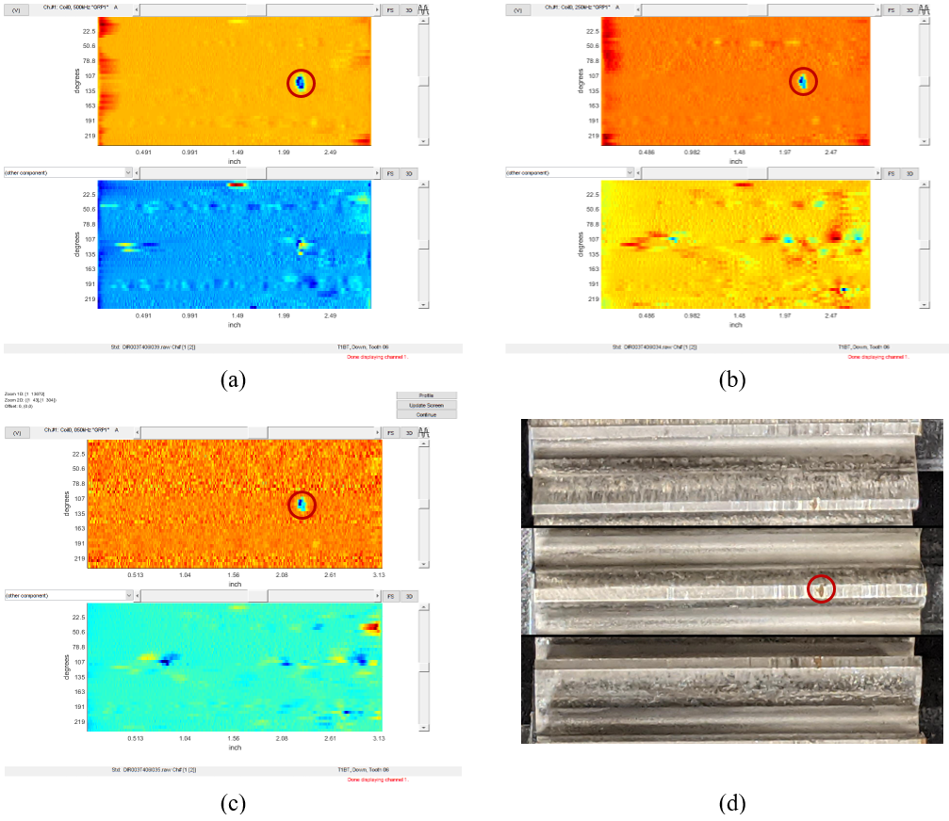
Figure 8: Representative data collected with an EC array probe. Shown above are the vertical (top) and horizontal (bottom) components of the processed EC data in image format at (a) 500 kHz, (b) 250 kHz and (c) 50 kHz. The x-axis shows the location along the gear width, and the y-axis shows the rotation angle about the center axis of the gear. The corresponding photo of the gear tooth is displayed in (d) [8].
Ultrasonic testing (UT) is an NDE technique used for in-situ examination of complex parts for detection and volumetric sizing of defects. Two UT methods are employed for the examination of the GTA gears. The first is real-time intensity imaging (Figure 9) which can give additional visual information when used in conjunction with standard photography. The second method is the pulse-echo technique where an ultrasonic transducer generates a signal on one side of the gear that travels through the body of the gear, reflects off the back surface of the gear, and returns to the transducer. Any internal defect will disturb the transmission of the signal through the gear material, indicating an internal defect. The pulse-echo technique was selected to detect internal defects, as the ECT method is capable of monitoring surface and subsurface defects. An UT imaging system was assembled for nondestructive inspection of four manipulator spur gears before and after in-manipulator tests in sodium. UT identified several discrete flaws on the surface of the gear teeth, but no internal defects have been identified. The original set of gears have not been retired after UT.
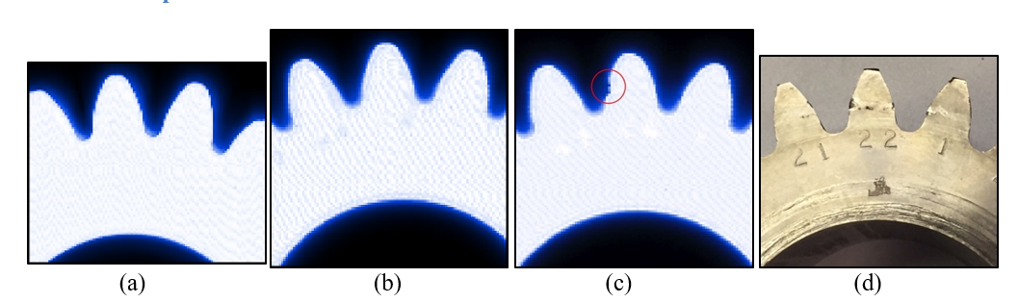
Figure 9: (a) UT image before sodium testing. (b) UT image after first campaign. (c) UT image after second campaign. (d) Photo of gear after second campaign [8].

conclusion
The Gear Test Assembly has completed two experimental campaigns in the Mechanisms Engineering Test Loop at Argonne National Laboratory. The Inconel 718 spur gears have operated in 250°C reactor grade liquid sodium for the equivalent of 11,184 fuel assembly maneuvers (372.8 hours of continuous operation) with minimal observable degradation. Tapered roller bearings in 52100 bearing steel with heat treatment operated for 9,800 fuel assembly maneuvers before failure. Identical tapered roller bearings with no heat treatment operated for 1,384 fuel assembly maneuvers before failure. Testing will continue until the gears are unable to operate. In that time, further investigation of bearing geometries and materials will take place as these are currently the limiting component. Beyond this, new gear geometries and materials will be investigated.
ACKNOWLEDGEMENTS
Argonne National Laboratory’s work was supported by the U. S. Department of Energy Advanced Reactor Technology (ART) Program under Prime Contract No. DE-AC02-06CH11357 between the U.S. Department of Energy and UChicago Argonne, LLC. We gratefully acknowledge the support provide by Alice Caponiti of DOE-NE, Deputy Assistant Secretary, Office of Reactor Fleet and Advanced Reactor Deployment; Thomas Sowinski, Advanced Reactor Technologies, R&D Program Manager; Brian Robinson of DOE-NE, Advanced Reactor Technologies, Fast Reactor Manager, and Robert Hill of Argonne National Laboratory, ART R&D Fast Reactor National Technical Director.
The authors would like to extend their gratitude to METL team members Daniel Andujar, Dzmitry Harbaruk, and Anthony Reavis for operating METL as well as supporting the experimental work.

References

[1] BELCH, H. et al, Gear Test Assembly – Status Report for FY2016, ANL-ART-66, Argonne National Laboratory, United States, 2016.

[2] AMERICAN GEAR MANUFACTURERS ASSOCIATION. ANSI/AGMA 2001-D04, Fundamental Rating Factors and Calculation Methods for Involute Spur and Helical Gear Teeth, American Gear Manufacturers Association, Alexandria, VA, USA (2004).

[3] BURRIER, H., Bearing Steels, Properties and Selection: Irons, Steels, and High-Performance Alloys, ASM Handbook, Vol 1, ASM International (1990).

[4] KENT, E. et al., Gear Test Assembly – Status Report for FY2019, ANL-ART-178, Argonne National Laboratory, United States, 2019.

[5] EICHELBERGER, R. L., THE SOLUBILITY OF OXYGEN IN LIQUID SODIUM: A RECOMMENDED EXPRESSION, AI-AEC-12685, Atomics International, United States, 1968.

[6] KENT, E. et al., Gear Test Assembly - Report on Experimental Testing (FY2020), ANL-ART-212, Argonne National Laboratory, United States, 2020.

[7] KENT, E. et al., Status of GTA Gear Inspection after Testing in Sodium, ANL-ART-188, Argonne National Laboratory, United States, 2020.

[8] KENT, E. et al., Gear Test Assembly – Report Experimental Testing and Gear Analysis – FY2021 Midyear Report, ANL-ART-224, Argonne National Laboratory, United States, 2021.

