CREEP AND TENSILE PROPERTIES OF INDIAN
FAST REACTOR ADVANCED CLAD TUBES
(IFAC-1) FOR FUTURE FBRs
S.LATHA, G.V. PRASAD REDDY, M. VASUDEVAN, R. DIVAKAR, SHAJU K. ALBERT, A.K. BHADURI
Indira Gandhi Centre for Atomic Research, Kalpakkam 603102, India
*Corresponding author E-mail: prasadreddy@igcar.gov.in
Abstract
Towards the materials development for future cores of sodium cooled Fast Breeder Reactors of India, an improved clad material named as Indian Fast Reactor Advanced Clad (IFAC-1) was developed in the form of clad tubes (20% cold worked) of length more than 3 meters. The composition optimization of IFAC-1 SS was arrived at based on the extensive evaluation of tensile and creep properties on 15 different stainless steel heats with varying contents of Ti, Si and P, apart from void swelling studies employing ion irradiation. The article briefly introduces the development of IFAC-1 SS clad tube and the tensile and creep strength properties, in comparison with the similar materials developed internationally. The tensile strength and ductility properties of IFAC-1 SS clad tube are found to be higher or comparable to those of imported Valinox D9 SS (France), in the temperature range 300-923 K. The total elongation of IFAC-1 SS varied from 8.4-21% at temperatures 573-923 K. The creep rupture strength of IFAC-1SS, evaluated at 923-1023 K, is compared with the internationally developed D9 SS clad tubes and it must be emphasized that the indigenously developed IFAC-1 SS clad tubes show promising creep rupture strength over a wide range of stress levels (100 – 225 MPa). The IFAC-1 SS clad tube is a promising material and has potential to enhance the residence time of the fuel in FBR and it is expected to provide safe operation up to a fuel burn up of ~ 150 GWd/t.
Keywords: Indian SFR, Alloy Development, IFAC-1 SS, Creep and Tensile properties

1. INTRODUCTION
The Ti-modified Fe-Cr-Ni austenitic stainless steel, in cold worked condition, has been the potential material for fuel clad tubes of sodium cooled fast reactors (SFRs) operating with Oxide fuel. At present, ‘20% cold worked Ti modified 14Cr-15Ni stainless steel (named as D9 SS)’ is being used as the material for clad and wrapper components of Indian Prototype Fast Breeder Reactor (PFBR) which is under construction at Kalpakkam [1]. However, D9 stainless steel (SS) limits the achievable target burn-up of fuel to about 100 GWd/t, with a residence time close to 1.5 years in the reactor. Currently, worldwide, alloying elements are being preferentially optimized in Ti-modified Fe-Cr-Ni SS alloy system to achieve higher fuel burn-up, by improving high temperature tensile and creep properties and resistance to irradiation induced void swelling. A similar material development program was undertaken at IGCAR to develop an improved version of D9 SS, called as D9I SS, by optimizing the contents of titanium, phosphorous and silicon [2-3]. The elements titanium (and hence titanium/carbon ratio), silicon and phosphorous are known to influence mechanical properties, void swelling resistance and weldability, and thus the alloy developmental work is aimed at evaluation of these properties systematically. Based on the extensive testing carried out on the developmental heats, the composition of D9I SS has been optimized that lead to the development of new alloy named as Indian Fast Reactor Advanced Clad (IFAC-1) for future SFRs of India. In the current study, development of IFAC-1 SS is briefly described and its high temperature tensile and creep properties are presented and compared with D9 SS clad tubes.

2. EXPERIMENTAL DETAILS
IFAC-1 SS clad tubes of more than 3000 mm long with 6.6 mm outer diameter and 0.45 mm wall thickness were produced indigenously at M/s. Nuclear Fuel Complex, Hyderabad. The chemical composition of the IFAC-1 and D9 SS clad tubes is given in Table 1. The gauge length of the clad tube specimens for tensile and creep tests is 25 mm and 50 mm respectively. Tensile tests on IFAC-1 SS were conducted at strain rates of 3×10⁻⁴ s⁻¹ and 3×10⁻⁵ s⁻¹ in the temperature range of 300-923 K, and creep tests were conducted at 923, 973 and 1023 K. The creep strength of IFAC-1 SS is compared with indigenously produced D9 tubes (M/s. Nuclear Fuel Complex), imported D9 tubes (M/s. Valinox, France) and with the biaxial data on D9 tubes from Hanford Engineering Development Laboratory (HEDL, USA), while the tensile properties are compared with NFC-D9 and Valinox-D9 clad tubes.

TABLE 1. CHEMICAL COMPOSITION (IN Wt.%) OF IFAC-1 SS AND D9 SS CLAD TUBES
IFAC-1 | C | Mn | Mo | Cr | Ni | Ti | N | S | Si | P | Co | B (in ppm)
 | 0.041 | 1.87 | 2.14 | 14.0 | 15.2 | 0.26 | 0.007 | 0.005 | 0.75 | 0.04 | 0.03 | 37
D9 | 0.045 | 1.67 | 2.26 | 14.0 | 15.1 | 0.24 | 0.005 | 0.001 | 0.59 | 0.007 | 0.005 | 15

3. RESULTS AND DISCUSSION
3.1. Development of IFAC-1 SS
Fifteen laboratory heats of D9 SS variant were produced with varying contents of phosphorous (0.025 and 0.04 wt.%), silicon (0.75 and 0.95 wt.%) and titanium (0.18, 0.20, 0.24 and 0.30 wt.%), keeping the other major elements (Fe-14.5Cr-15Ni-0.04C-2.5Mo) unchanged in all the heats. Boron content in all the heats was also increased from ~10 ppm to ~50 ppm. Creep properties of the various heats were evaluated at 973 K. The synergistic effect of phosphorous plus silicon content on the creep life is examined for heats with Ti/C ratio close to 5.7+0.45, and is shown in Fig.1 at stress levels of 200, 175 and 150 MPa. As evident from figure, the heat with 0.025 wt.% phosphorous and 0.75 wt.% silicon exhibited maximum creep strength, among the different combinations of phosphorous and silicon contents. The Fig.1 also shows the variation of creep rupture life at various Ti/C ratio for the heats with fixed phosphorous (0.025%) and silicon (0.75%) contents, at a stress level of 150 MPa. It may be noted that the heat containing Ti/C ratio of 5.9 showed the highest rupture life. Similar effect has been observed at the other stress levels in the range of 250-175 MPa and the peak in rupture life appeared at Ti/C ratio of 5.9. Based on the above studies, it must be emphasized that heat with 0.75% silicon, 0.025% phosphorous and Ti/C ratio of ~6.0 possessed highest creep strength. At all the combinations of phosphorous and silicon, the creep exposed material possessed precipitates such as phosphides, carbides (TiC, M₆C) and Fe₂Mo Laves phase [4]. The highest creep rupture life of the D9 SS variant is observed with 0.025% phosphorous plus 0.75% silicon and is found to be associated with the large fraction of beneficial fine TiC and phosphides, with a relatively smaller fraction of M₆C and Laves phase. It must also be highlighted that even after prolonged creep exposure (>15000 hours) at 973 K and 150 MPa, the cold work microstructure has been retained in the form of deformation shear bands in the creep tested samples. In the case of tensile properties, the heat with contents of ‘‘0.04% P + 0.75% Si” or ‘‘0.025% P + 0.95% Si’’ only improved the overall tensile properties [3]. However, the ion-irradiation induced void swelling studies, with 5.0 MeV Ni²⁺ ions on samples (pre-injected with Helium), indicated the beneficial effect of higher phosphorous content on significant reduction in swelling apart from shift in peak swelling temperature towards lower temperatures [3]. The aforementioned results on swelling and creep properties led to the optimization of composition of improved D9 SS. The optimized alloy system is Fe-14Cr-15Ni-0.04C-2.5Mo-0.25Ti-0.04P-0.75Si with ~ 50 ppm Boron and is named as Indian Fast Reactor Advanced Clad (IFAC-1). Based on the composition optimized
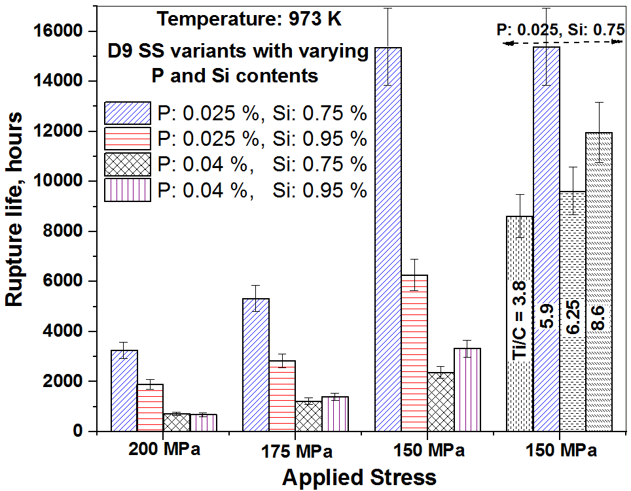

Fig.1: Illustrates the combined effect of phosphorous and silicon contents on creep rupture life of four variants of D9 SS at stress levels of 200-150 MPa, and also the effect of Ti/C ratio on variants of D9 SS heat with 0.025% phosphorous and 0.75% silicon.

for IFAC-1 SS and the processing windows generated from workability studies, SFR clad tubes of 6.6 mm outer diameter and 5.7 mm inner diameter with a wall thickness of 0.45 mm were produced with tube lengths above 3000 mm. The pulsed-TIG welding technology was optimized to demonstrate integration of IFAC-1 SS clad tube to 316LN SS end plug and crack free welds have been achieved successfully [3]. The IFAC-1 SS is being considered as the clad material for future cores (with oxide fuel) of SFRs of India and is expected to provide fuel burn ups up to 150 GWd/t. Indeed, several clad materials of type Fe-15Cr-15Ni-Ti SS alloyed with silicon and/or phosphorous i.e., SS clads with elemental constituents same as that of IFAC-1 SS, have been reported to show neutron irradiation resistance up to ~150 dpa [5].

3.2. Tensile properties of IFAC-1 SS clad tubes
The tensile properties of IFAC-1 SS were evaluated in the temperature range of 300-973 K at strain rates of 3×10⁻⁴ s⁻¹ and 3×10⁻⁵ s⁻¹. The Figs.2a-b portray variation of ultimate tensile strength and percentage uniform elongation with temperature. As apparent from Fig.2, IFAC-1 SS exhibited only nominal differences in strength and uniform elongation between the two strain rates. Serrations in the plastic portion of stress-strain curves were observed at the intermediate temperatures 723-823 K, indicating the occurrence of dynamic strain aging (DSA, i.e., dislocation solute atom interactions). The sluggish decrease in ultimate tensile strength at intermediate temperature regime (573-823 K) also marks the occurrence of DSA, though serrations were not evidenced at temperatures below 723 K. The rapid drop at temperatures beyond 873 K indicates the predominance of thermally activated dislocation motion by climb/cross-slip (i.e. thermal recovery) over the strain hardening arising from dislocation-dislocation interactions.

The results of IFAC-1 SS are compared with the indigenously produced Alloy D9 SS (M/s. NFC) and imported D9 SS tubes (M/s. Valinox, France) and are shown in Figs.3a-c. It can be seen from the Fig.3 that the strength properties and total elongation of IFAC-1 SS clad tube are comparable to those of NFC and Valinox D9 clad tubes. The total elongation of IFAC-1 SS varied from 8.4-21% at temperatures 573-923 K. It may however be noted that IFAC-1 SS properties in Fig.3 are from tests at a relatively lower strain of 3×10⁻⁴ s⁻¹ compared to the D9 SS tubes that were tested at a strain rate of 1.3×10⁻³ s⁻¹. The aforementioned results demonstrate that

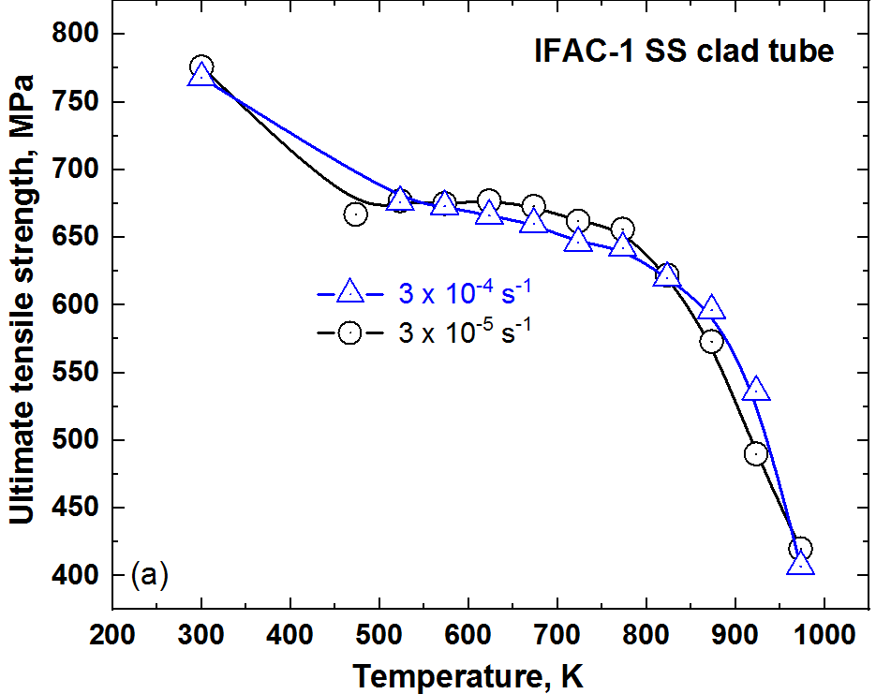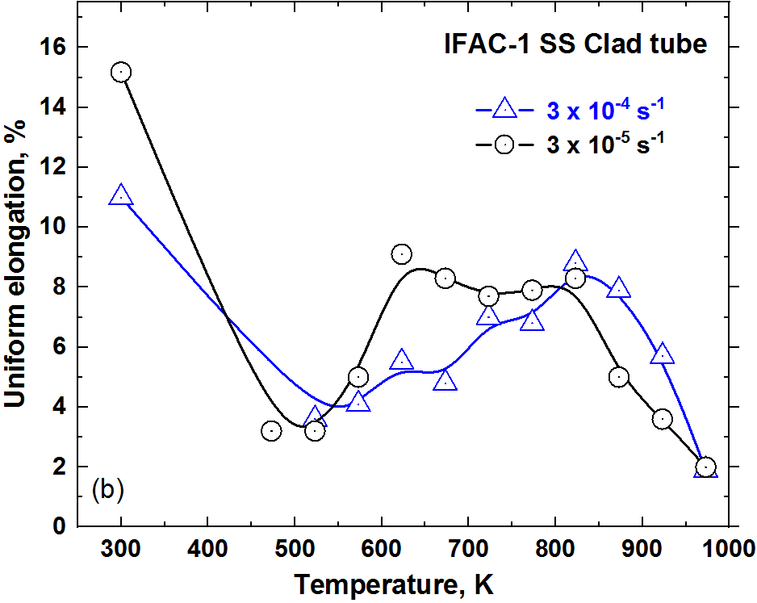
Fig.2: Effect of strain rate on (a) ultimate tensile strength and (b) uniform elongation of IFAC-1 SS clad tubes.

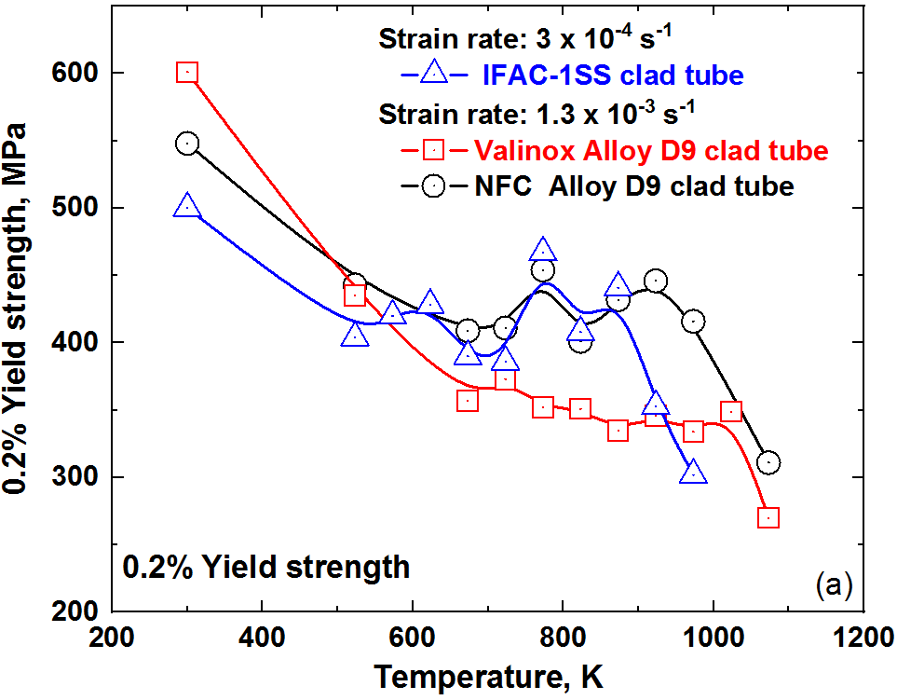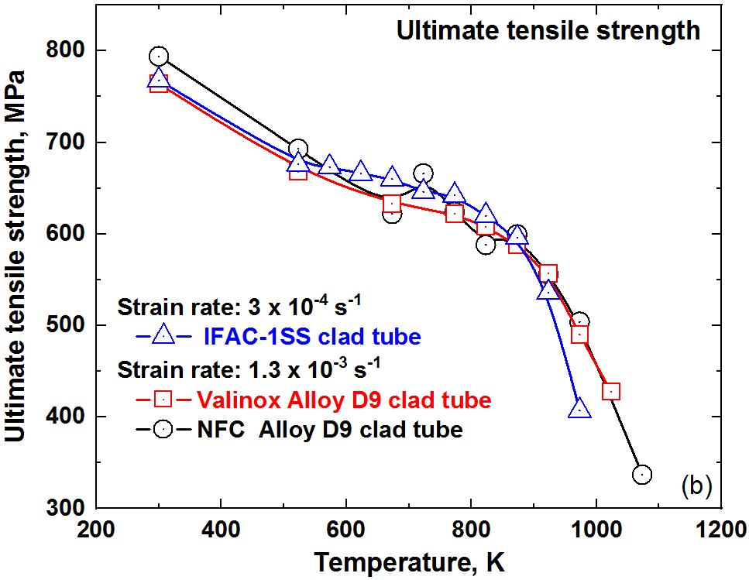
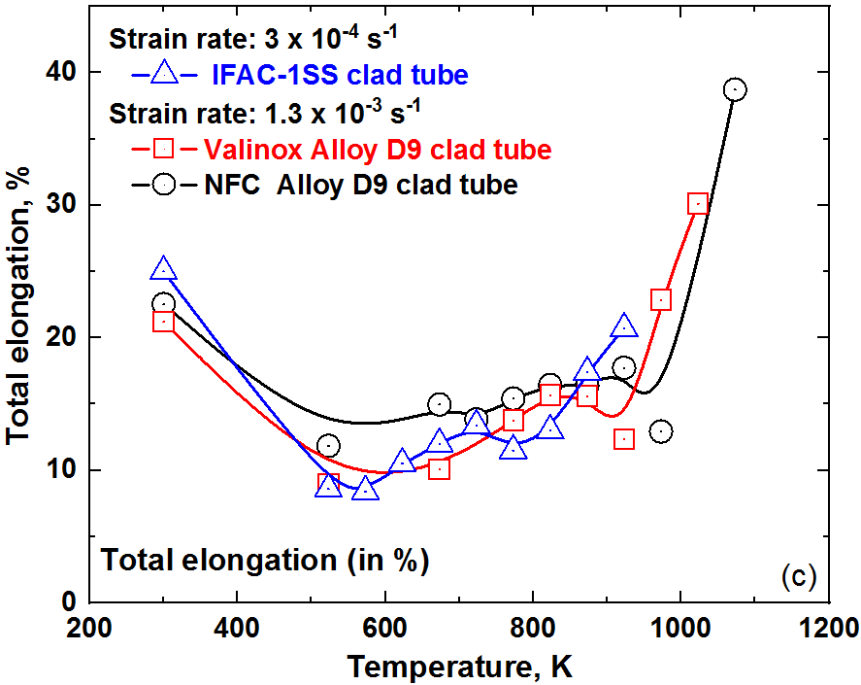

Fig.3: Comparison of tensile strength and ductility properties of IFAC-1 SS clad tubes with those of D9 SS tubes from M/s. NFC, India and M/s. Valinox, France, (a-b) strength properties and (c) total elongation.
IFAC-1 SS clad tube, in spite of having higher silicon and phosphorus contents, retains the tensile strength and ductility properties equivalent to or slightly above those of D9 SS tubes.

3.3 Creep properties of IFAC-1 SS clad tubes
Creep properties have been evaluated at temperatures 923, 973 and 1023 K and at selected stress levels between 100-225 MPa. The creep curves of IFAC-1 SS indicated short primary creep, secondary creep and extended tertiary creep regimes, as shown in Fig.4a at temperatures 923 and 973 K. The duration of steady state creep regime is considerable at temperature 923 K and at stress levels less than 150 MPa and 125 MPa at 973 K and 1023 K respectively (not shown in Fig.4a). The stress versus rupture life plots are presented in Fig.4b. Rupture life increased by nearly a factor of ten with decrease in temperature. Non-monotonous variation of rupture elongation with rupture life is observed at all the temperatures and it varies from 3.5 to 18% depending upon the test conditions. Rupture elongation of 3.5-8.0% is observed at rupture lives of 5000-11000 hours for IFAC-1 SS samples tested at temperatures 923 and 973 K.

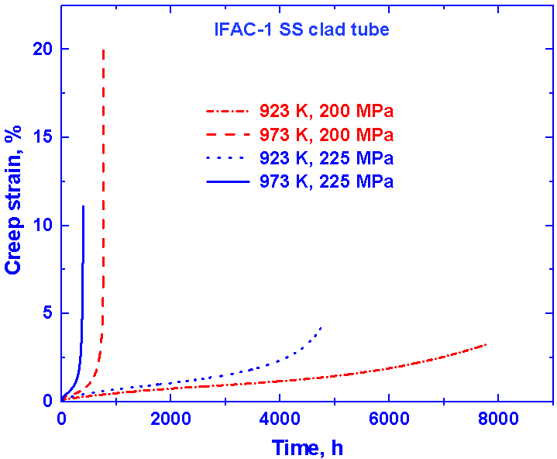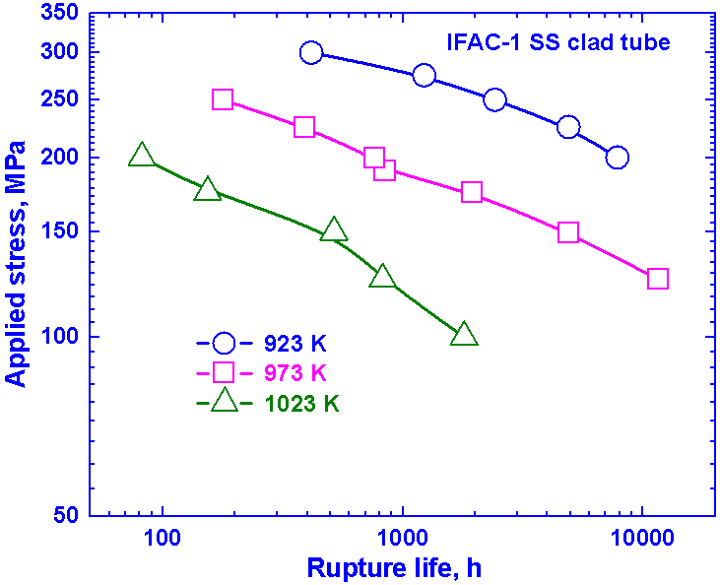

Fig.4: (a) Typical creep curves of IFAC-1 SS clad tube at 923 K and 973 K, and (b) Variation of creep rupture life with applied stress at 923-1023 K.
The variation of minimum creep rate with applied stress, in Fig.5, obeyed Norton’s power law of the form $\dot{ϵ }=A σ^{n}$, where $\dot{ϵ}$ is the minimum creep rate, σ is the applied stress, n is the stress exponent, and A is an empirical constant. The values of the constant ‘A’ are 8 × 10⁻²⁴, 2.9 × 10⁻²³ and 4.4 × 10⁻¹⁵ at temperatures 923, 973 and 1023 K respectively. The power law creep exponent ‘n’ decreased from 6 to 3 with increase in temperature to 1023 K, thereby indicating the contribution from thermally activated dislocation motion to the apparent creep rate. In line with this, the observed stress exponent values also signify creep deformation by dislocation creep mechanism (dislocation glide plus climb). Similar values of stress exponent have been observed for the Ti- modified D9 SS variants [6]. Activation energy for creep was estimated by conducting creep tests at 923, 948 and 973 K at a stress level of 200 MPa, and was calculated from the plot of minimum creep rate versus inverse of temperature. The estimated activation energy is ~143 kJ/mol which is close to the activation energy for dislocation core or pipe diffusion of gamma iron (160 kJ/mol) [7]. It may be noted that the activation energy for core diffusion is 0.6 times the value of activation energy for lattice diffusion which is 270 kJ/mol for gamma iron [7]. Hence, the estimated activation energy value of ~143 kJ/mol infers that the core diffusion of solute atoms contribute to the creep deformation.

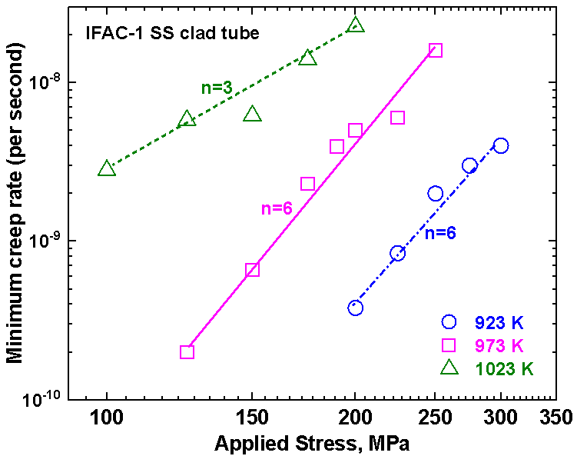

Fig.5: Variation of minimum creep rate with applied stress at temperatures 923, 973 and 1023 K.

The comparison of creep rupture strength of IFAC-1 SS clad tubes with data on Valinox-D9 SS clad tubes is shown in Fig.6a. The IFAC-1 SS tubes possess slightly improved creep strength over Alloy D9 SS at higher stress levels as apparent from Fig.6a, whereas the creep strength at lower stresses is comparable for both the tubes. It must be mentioned here that phosphorous content plays an important role in controlling the creep strength [4,8-9]. For phosphorous contents above 0.03 wt.%, the earlier in-house creep studies on aforementioned fifteen SS heats have shown an increase in fraction of M₆C carbides with corresponding decrease in favourable MC carbides and hence rupture life [4]. This is attributed to the fact that increasing phosphorus levels enhance the tendency to formation of Ti-rich phosphides that in turn decrease the fraction of MC type TiC precipitates which are beneficial for stabilizing cold work structure and in improving creep strength and void swelling resistance. The resulting excess carbon in solid solution therefore induces precipitation of blocky M₂₃C₆ / M₆C carbides [9] that are detrimental for thermal creep strength. In a study

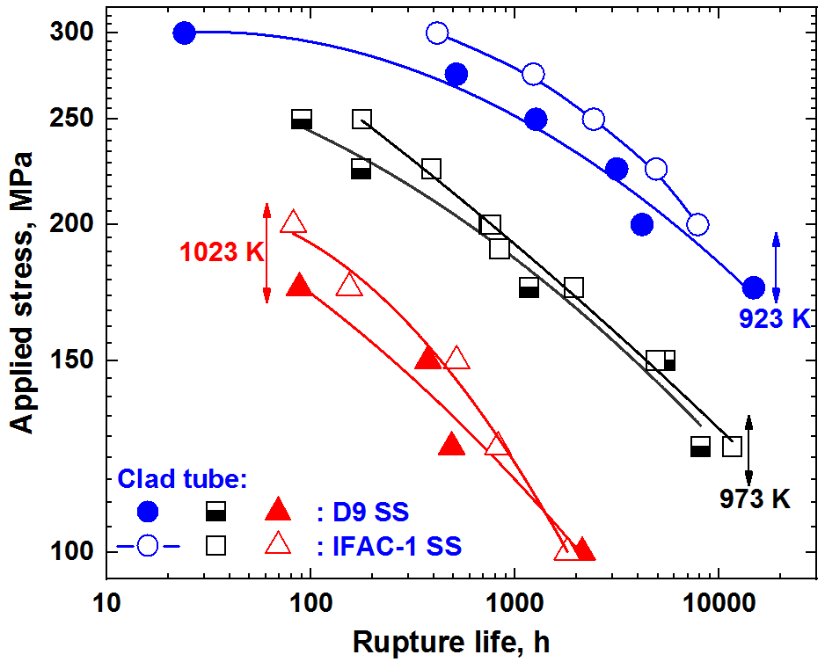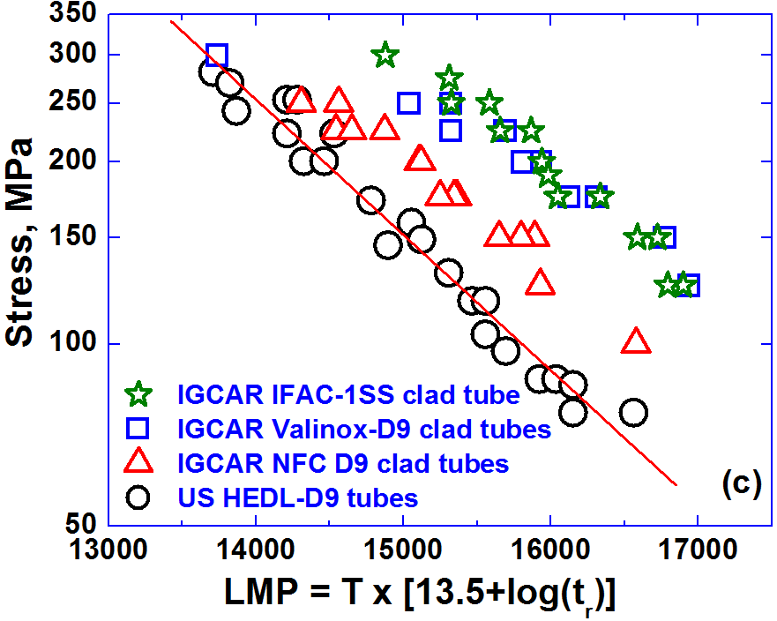

Fig.6: (a) Creep rupture strength of IFAC-1 SS versus D9 SS (M/s. Valinox, France), and (b) Stress versus LMP plots illustrating the comparison of creep rupture strength of IFAC-1 SS clad tubes [11] with those of D9 SS (France and India) and HEDL-D9 SS (USA).

conducted on the Fe-16.2Ni-13.9Cr alloy containing phosphorus contents from 0.024 to 0.07 wt.%, Todd et al. have shown that the alloy with 0.024% phosphorous exhibited higher rupture life compared to the alloy containing 0.04 and 0.07% phosphorous [8]. It must be also mentioned that higher silicon contents also promote detrimental Laves phase (Fe2Mo). However, the addition of higher contents of phosphorus and silicon in IFAC-1 SS promotes improved void swelling as aforementioned in section 3.1. Further, it may be noted that IFAC-1 SS with 0.04% phosphorus and 0.75% silicon retains creep strength comparable with that of imported D9 SS tubes (M/s. Valinox, France) as evident from Fig.6a at all the temperatures. It must also be emphasized that the contents of phosphorus and silicon in IFAC-1 SS are in line with the internationally developed Ti-modified 15Cr-15Ni SS variants and their improved versions wherein the silicon content varies in the range of 0.4–1.0 wt.% with a limit on phosphorus content at 0.04 wt.% for most of the stainless steel clad materials [5].

The parametric analysis of creep rupture life at various test temperatures for indigenous NFC-D9 tubes, imported Valinox-D9 tubes and IFAC-1 SS tubes has been carried out using Larson Miller Parameter (LMP) represented by $LMP=T ×[C+\log{t_{r}}]$, where T is the temperature in Kelvin and rupture life (t_{r}) in hours. The value of LMP constant ‘C’ is chosen as 13.5 which is being widely used for Alloy D9 SS [10]. The creep rupture strength of IFAC-1 SS clad tube is compared with the internationally developed D9 SS clad tubes (USA and France), in the form of stress versus Larson-Miller parameter plots (in Fig.6b). The creep data on HEDL-D9 SS tubes is from internal pressurized creep tests at temperatures 848-1023 K [10], while the data on indigenous and imported D9 SS tubes in the present study are from the uniaxial creep tests at 923 K and 973 K [11]. It may be noted that biaxial creep strength data on HEDL-D9 tubes is included in Fig.6b for reference and that all the uniaxial strength data from D9 SS and IFAC-1 SS tubes indicate the presence of sufficient margin to be exercised for correlating such uniaxial and biaxial creep results. As also apparent from the Fig.6b, it must be emphasized that the indigenously developed IFAC-1 SS clad tubes show promising creep rupture strength over the indigenous D9 SS tubes (M/s. NFC, Hyderabad) and possesses creep strength in par with imported D9 SS tubes (M/s. Valinox, France), over a wide range of stress levels. It may however be noted that, in French SFR programme, the material currently considered for clad tubes is AIM1 stainless steel.

4. SUMMARY
The tensile and creep properties of Indian Fast Reactor Advanced Clad (IFAC-1) are presented after a brief review on development of IFAC-1 SS clad tubes. The aforementioned properties are compared with the data on indigenously developed D9 SS (M/s. Nuclear Fuel Complex, India), imported D9 SS (from M/s. Valinox, France) and with HEDL-D9 SS (USA). The important observations from the study are summarized below:

- The IFAC-1 SS composition is developed based on tensile, creep and selected ion-irradiation studies on fifteen variants of D9 SS heats with varying titanium, phosphorous and silicon contents. Clad tubes of more than 3000 mm long with 6.6 mm outer diameter and 0.45 mm wall thickness were produced based on workability studies.

- The tensile properties of IFAC-1 SS clad tubes evaluated in the temperature range of 300-973 K and at strain rates of 3×10⁻⁴ s⁻¹ and 3×10⁻⁵ s⁻¹ showed nominal dependence on strain rate. The IFAC-1 SS clad tube possesses tensile strength and ductility properties comparable to or slightly above those of D9 SS tubes (NFC-D9 and Valinox-D9).

- In the creep tests conducted at 923, 973 and 1023 K and at selected stress levels between 100-225 MPa, creep rupture life of IFAC-1 SS increased by nearly a factor of ten with decrease in temperature from 1023 K to 923 K. The rupture elongation varied from 3.5 to 18%.

- The Norton’s power law stress exponent decreased from 6 to 3 with increase in temperature to 1023 K, signifying creep deformation by dislocation creep mechanism with contribution from thermally activated dislocation motion to the creep rate.

- The higher silicon (0.75 wt.%) and phosphorous contents (0.04 wt.%) of IFAC-1 SS have not degraded the creep strength below that of D9 SS. The applied stress versus Larson-Miller Parameter plots demonstrate promising creep strength of IFAC-1 SS clad tubes over the indigenous D9 SS tubes (M/s. NFC, Hyderabad) and indicate creep strength in par with the imported D9 SS tubes (M/s. Valinox, France), over a wide range of stress levels.

ACKNOWLEDGMENTS
The authors wish to thank Ms. S. Pannerselvi for the coordination in conducting tensile tests.

REFERENCES
[1] JAYAKUMAR, T., MATHEW, M.D., LAHA, K., SANDHYA, R., Materials development for fast reactor applications, Nucl. Engg. Design 265 (2013) 1175-1180.
[2] LATHA, S., MATHEW, M.D., PARAMESWARAN, P., NANDAGOPAL, M., MANNAN, S.L., Effect of titanium on the creep deformation behaviour of 14Cr-15Ni-Ti Stainless steel, J. Nucl. Mater. 409 (2011) 214-220.
[3] MATHEW, M.D.., GOPAL, K., MURUGAN, S., PANIGRAHI, B., BHADURI, A.K., JAYAKUMAR, T., Development of IFAC-1 SS: An Advanced Austenitic Stainless Steel for Cladding and Wrapper Tube Applications in Sodium-Cooled Fast Reactors, Adv. Mater. Res. 794 (2013) 749–756
[4] LATHA, S., NANDAGOPAL, M., PARAMESWARAN, P., PRASAD REDDY, G.V., Effect of P and Si on the creep induced precipitation of 14Cr-15Ni stainless steel fast reactor clad, Mater. Sci. Engg A. 759 (2019) 736-744.
[5] PRASAD REDDY G.V., KARTHIK V., LATHA S., VENKITESWARAN C.N., DIVAKAR RAMACHANDRAN, SHAJU K. ALBERT, Core Materials for Sodium-cooled Fast Reactors: Past to Present and Future Prospects, Mater. Perform. Charact. 2021 (In press), DOI: 10.1520/MPC20200208.
[6] LATHA, S., MATHEW, M.D., PARAMESWARAN, P., LAHA, K., PANNERSELVI, S., MANNAN, S.L., Improvement in creep damage tolerance of 14Cr-15Ni-Ti Modified stainless steel by addition of minor elements, Procedia Engg. 55 (2013) 58-63.
[7] FROST, H.J., ASHBY, M.F., “Pure iron and ferrous alloys”, DEFORMATION MECHANISM MAPS - THE PLASTICITY AND CREEP OF METALS AND CERAMICS, Pergamon Press, Oxford (1982).
[8] TODD, J.A., JYH-CHING REN, Effect of cold work on the precipitation kinetics of advanced austenitic steel, Mater. Sci. Engg. A 117 (1989) 235-245.
[9] MIN-HO JANG, JUN-YUN KANG, JAE HOON JANG, TAE-HO LEE, CHANGHEE LEE, The Role of Phosphorus in precipitation behavior and its effect on the creep properties of alumina-forming austenitic heat resistant steels, Mater. Sci. Engg. A 684 (2017) 14-21.
[10] PUGH, R.J., HAMILTON, H.L., IN-REACTOR CREEP RUPTURE BEHAVIOR OF THE D9 ALLOYS, HEDL-SA-3458, Hanford Engineering Development Laboratory, Richland, WA, USA, 1986.
[11] LATHA, S., PRASAD REDDY, G.V., SHAJU K. ALBERT, TENSILE AND CREEP PROPERTIES OF IFAC-1 STAINLESS STEEL CLAD TUBES, IGC-372, Indira Gandhi Centre for Atomic Research, Kalpakkam, India, 2021.

