FABRICATION AND PERFORMANCE ASSESSMENT

OF 14CR ODS FECRAL CLADDING TUBE

JING LI¹, SAJIAN WU¹, YING YANG², LIANGYIN XIONG¹, SHI LIU¹

¹CAS Key Laboratory of Nuclear Materials and Safety Assessment, Shi-changxu Innovation Center for Advanced Materials, Institute of Metal Research, Chinese Academy of Sciences, Shenyang, China
²China Nuclear Power Operation Company, China General Nuclear Power Corporation, Shenzhen, China

*Corresponding author E-mail: jingli@imr.ac.cn

Abstract

A fabrication of 14Cr ODS FeCrAl cladding tube by the cold rolling process was presented herein. The changes of grains and nanoparticles in the alloy along the fabrication were characterized by optical microscope, EBSD, TEM and SEM. The resulting mechanical properties of the manufactured cladding tubes were investigated by tensile tests both in longitudinal and hoop directions. The results show that 20 ~ 40% cross-section reduction for each pass and the gradual increase of the intermediate heat-treatment temperature are demonstrated to be effective and safe for the cladding tube manufacturing. After rolling and final annealing, the oxide nanoparticles are homogenously distributed in the grains and at the grain boundaries. The cladding tube exhibits an elongated grain structures and a strong γ-fiber texture of <111>∥ND. However, the texture of cladding tube has insignificant effect on the mechanical properties in longitudinal and circumferential directions.

INTRODUCTION
Oxide dispersion strengthened (ODS) FeCrAl alloys have been considered as a promising candidate structural material for Generation IV nuclear reactors due to their good mechanical strength, structural stability and chemical durability at elevated temperatures [1]. These distinguished properties are inseparable from the dispersed nanoparticles mainly composed of Y-Al-O oxides in the alloy matrix. The fabrication of ODS FeCrAl cladding tube usually involves mechanical alloying (MA) of matrix powder with yttria particles, hot consolidation at high temperature and high pressure, and tube fabrication by thermal-mechanical processing. Extensive studies, such as alloying composition, MA parameters and consolidation techniques on microstructure of consolidated alloys and constituent of oxide precipitates, have been made [2-4]. In contrast, there are few reports about the influence of tube fabrication and processing technology on the microstructure and mechanical properties of ODS FeCrAl [5].
Recently, the fabrication of 14Cr ODS FeCrAl cladding tubes with an outside diameter of 9.5 mm, a wall thickness of 0.3 mm and a length of more than 4 m, has been achieved by our team. In this study, the latest results of tube fabrication and characterization on the ODS FeCrAl cladding are provided. It will aid in discussing and understanding the microstructural evolution in the course of tube fabrication, thus elucidating the influence of manufacturing process on macro performance.

Experimental procedure
The ferritic ODS alloy with chemical composition (wt. %) of 14Cr-4.5Al-0.4Ti-2W-0.4Y-0.16O-Bal.Fe was selected to fabricate cladding tube, which is named SM-14 according to our previous investigation [6]. The first two of the three steps for manufacturing ODS FeCrAl tubes are MA and consolidation using hot isostatic pressing (HIP). The detailed procedure of MA and the characterization of nanoscale Y-Al complex oxides in the as-HIPed alloy were described elsewhere [6]. Using pilger cold rolling process to manufacture into thin-wall cladding tube is the last step. The as-HIPed ingot, after heating at 1150 °C, was forged to a rod of about 25 mm in diameter. Then, the mother tube with an outer diameter of 24 mm and a wall thickness of 5 mm was obtained through surface turning and drilling. After an initial heat treatment of mother tube at 800 °C for 1 hr, the repeated cold rolling and intermediate annealing were applied to fabricate the thin-walled cladding tube. The cross-section reduction of each pass was ranged from 20% to 40%, until the final tube geometry with an outer diameter of 9.5 mm and a wall thickness of 0.3 mm was reached. Both tube diameter and wall thickness were within the dimensional tolerance limit of 0.05 mm. Finally, these manufactured tubes were annealed at 800 °C for 1 hr in vacuum.
To evaluate the microstructure stability of the ODS alloy, the annealed cladding tube was isothermally aged at 400 °C for 1500 hrs in a box type heat-treatment furnace. Longitudinal tensile tests of the cladding tubes before and after aging treatment were carried out at room temperature, 700 °C and 1000 °C on a Zwick Z150 tensile testing machine with an initial strain rate of 2×10⁻⁴ s⁻¹ and a change of 2×10⁻³ s⁻¹ after yielding. Ring tensile tests were performed at room temperature and 700 °C using a Shimadzu AG-100KN universal testing machine with a strain rate of 2×10⁻⁴ s⁻¹. During the ring tensile test, the gage sections of the tube specimen were oriented at the top and bottom of the half-cylinder die inserts. As the strength increases with the increase of friction, boron nitride with low friction was added between the ring specimen and the half-cylinder insert. All tensile tests of each material were repeated at least twice and carried out in air.
The chemical composition of the ODS alloy was specified by PANalytical Axios PW4400 X-ray fluorescence spectrometry. The microhardness of ODS alloy was measured on a Micromet 5103 Vickers hardness tester using Vickers diamond pyramid indentation with a load of 500 g, and at least six measurements were made in each specimen to obtain an average value of hardness. The grain morphology on the longitudinal section of annealed cladding tube was observed by optical microscope on Olympus GX51. The analysis of microstructure and crystallographic texture was carried out by EBSD using Zeiss Merlin Compact and a NordlysNano detector with Channel 5 software, with step size of 0.15 μm at an acceleration voltage of 20 kV. The distribution of nanoparticles in the specimens was characterized using a Tecnai G2 20 TEM at an acceleration voltage of 200 kV.

Results and discussion

Hardness
Fig. 1 shows the hardness changes measured during cold rolling and intermediate annealing in the tube fabrication. At the same annealing temperature, the hardness increases with the increase of rolling pass. In order to ensure the safety of tube fabrication, the intermediate annealing temperature for material softening is raised, after several rolling passes. Additionally, it should be ensured that the hardness value does not exceed 330 Hv_{0.5}. If it exceeds the value, a fissuration would occur in the tubes.
Compared with the fabrication of ODS FeCr claddings [7-10], these hardness values are slightly reduced. This is due to the different strengthening effects of Y-Al-O and Y-Ti-O phase nanoparticles in the matrix. Meanwhile, the intermediate annealing temperatures are reduced, which results in the failure of grain recrystallization during the manufacturing process.

FIG. 1. Change in hardness during manufacturing of the SM-14 cladding tube. The blue circle represents the as-rolled hardness value and the black box represents the annealed value.

Microstructure and texture
Optical micrographs of SM14 alloy during the continuous processing are shown in Fig. 2. The as-HIPed ingots possess a homogenous structure, indicating the isotropy by HIP process. After forging, as shown in Fig. 2(b), slightly elongated grains concomitant with some large island-like grains (white contrast) along the forging direction are found throughout the microstructure of SM-14 matrix. The ferritic structure remains in the whole tube manufacturing process. With the increase of deformation, the grain aspect ratio (GAR), i.e. the ratio between sizes in longitudinal and transverse directions [11], increases remarkably. The cold working refines the grains of the ODS FeCrAl alloy, and lengthens the grains along the rolling direction. After annealing, the cladding tube exhibits a large number of fibrous grain structures as shown in Fig. 2(c).

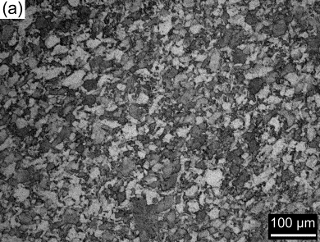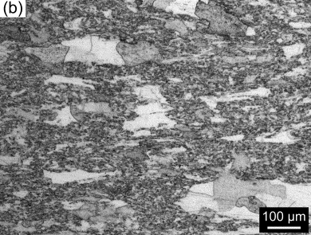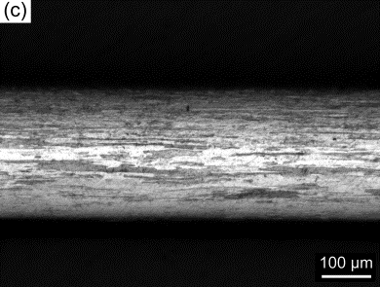
FIG. 2. Optical microstructure of SM-14 alloy at different steps: (a) as-HIPed, (b) as-forged and (c) annealed.

EBSD was also used to characterize the inverse pole figure (IPF), orientation distribution function (ODF) and grain boundary (GB) map of the final annealed cladding tube, and the results are shown in Fig. 3. High angle grain boundaries (HABs) with misorientation angle ≥10° are represented by black lines in the IPF and GB map, and low angle grain boundaries (LABs) with misorientation angle of 2~10° are represented by grey lines in the IPF map and red lines in the GB map respectively. The LABs are mainly composed of dislocations. The result indicates that the cold rolling produce a large number of dislocations. All the elongated grains are parallel to the rolling direction. The typical microstructure in SM-14 cladding is composed of bamboo-like grains with a minimum width of less than 500 nm and a length of several hundreds of microns. In the corresponding ODF result of Fig. 3(b), it can be seen that the texture of SM-14 tube consists of {223}<110> on the α-fiber (<110>∥RD) and {111}<112> on the γ-fiber (<111>∥ND). These kinds of textures are often detected in the cold-rolled and annealed ferritic alloys.

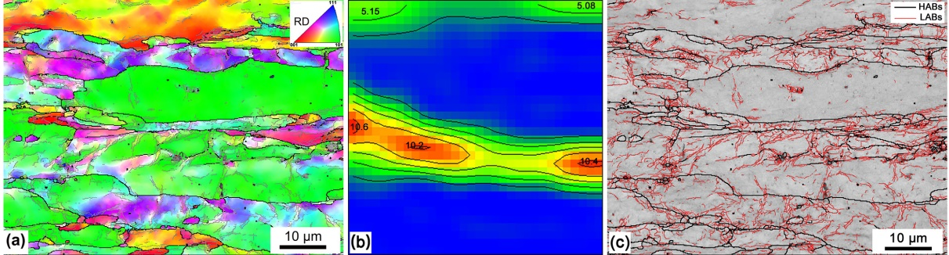
FIG. 3. EBSD characterization in the annealed SM-14 cladding: (a) IPF, (b) ODF and (c)GB map.

Precipitates and dislocations
Fig. 4 shows the morphology and distribution of nanoparticles in the annealed SM-14 cladding from the longitudinal section. To illustrate the influence of cold working on grains and secondary phase nanoparticles, the microstructure of as-HIPed ingot characterized by TEM was also presented. Similar with the result of Fig. 2(c) and Fig. 3(a), the cladding tube has a very large GAR. In the as-HIPed specimens, a substantial amount of oxide precipitates are homogeneously distributed in the whole area. Our previous study [6] has confirmed that these precipitates are composed of YAlO₃ particle with an orthorhombic structure (YAP).
After tube rolling and final annealing, the uniform distribution of oxide nanoparticles in the grains and at the grain boundaries is observed, as shown in Fig. 4(b). Small quantities of coarser particles are also detected, leading to an increase in the average diameter of oxides nanoparticles in the matrix. It is found that these coarse particles are predominantly comprised of YAlO₃ phase with an orthorhombic structure. No crystal structure change of the secondary phase nanoparticles occurred during the cold working. The phenomenon of particles coarsening has been observed in some studies on manufacturing ODS FeCr cladding tubes [9,12]. Sallez et al. [13] proposed a mechanism of grain boundary migration by observing the morphology and distribution of Y-Ti-O precipitates in the process of interrupted extrusion, in which the coherent nanoparticles were dissolved by migrating grain boundaries and ripened at the grain boundaries, and then a medium-sized precipitate was left in the grains after further grain boundary migration. Besides, Oka et al. [14] inferred that the transformation from ferrite phase to austenite phase occurred in the rolling process, and the coherent relationship between nanoparticles and previous ferrite matrix was lost. Then, these particles which are incoherent to austenitic matrix become coarse, due to Ostwald ripening. In the present investigation, no phase transformation of ODS FeCrAl alloy occurred during the rolling. And it has been confirmed that there was a good coherency between YAlO₃ nanoparticles with the matrix [6]. The authors speculate that the interaction between dispersed particles and moving grain boundaries is one of reasons for coarsening. In addition, it has been established that the diffusion rate of atoms along the dislocations is several orders of magnitude faster than that of bulk diffusion [15,16]. A great number of dislocations have been produced in the matrix during the cold rolling. Therefore, the diffusion of atoms from small to large particles through dislocations and even the final disappearance of small particles is another reason for coarsening of nanoscale oxide particles.

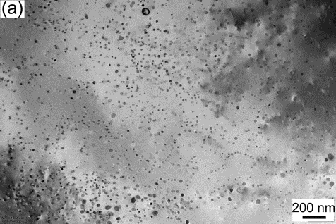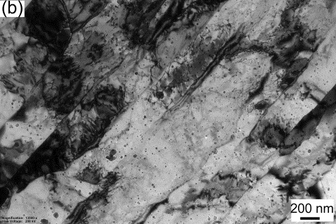
FIG. 4. TEM bright filed image of (a) as-HIPed and (b) annealed SM-14.

Fig. 5 shows the configuration between dislocations and oxide nanoparticles in the annealed SM-14 cladding tube at high magnification. After the final heat treatment at 800 °C, a large number of dislocations around nanoparticles are observed. The dislocations appear to be pinned at the departure side of particles, which suggests an attractive interaction between dislocation and nanoparticles. It is impressive that the configurations between dislocations and nanoparticles are almost the same. The angles between dislocation lines are measured to be in the range of 108° to 118°, and the dislocations are arranged to an orderly array containing nearly parallel dislocation lines and approximately equal angles, revealing the double-slip on intersecting planes [17]. Furthermore, it can be found that the nanoparticles pinning the dislocation are mainly comprised of those particles with a diameter of less than 10 nm, indicating that the attractive force exerted by the small size nanoparticles is strong and stable.

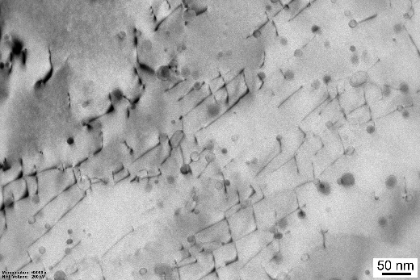
FIG. 5. Dislocation distribution in the annealed SM-14 cladding.

Fig. 6 shows the distribution of grains and oxide nanoparticles in SM-14 cladding sample after aging treatment for a long time. As can be seen, the distribution and morphology of grains and nanoparticles in the cladding tube have not changed significantly after long-term heat treatment at 400 °C. Hence, it can be predicted that no obvious impact on the performance of the tube has occurred under the aging treatment.

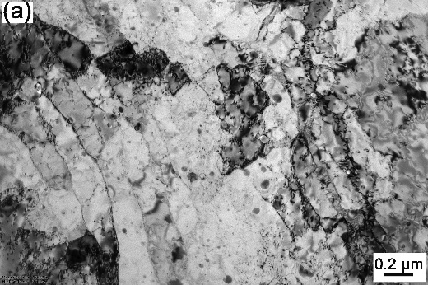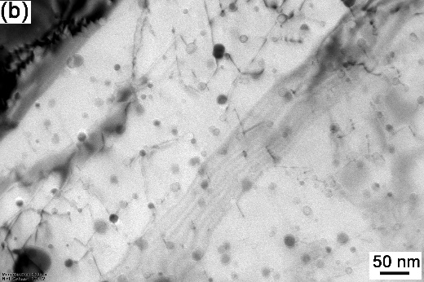
FIG. 6. TEM images of SM-14 cladding after aging at 400 °C: (a) at low magnification and (b) at high magnification.

Mechanical properties
The data of yield strength (YS) and ultimate tensile strength (UTS) of the annealed and aged cladding tube in the longitudinal direction, parallel to the cold rolling direction, are shown in Fig. 7. For comparison, the data for commercial MA956 cold-rolled sheet are also plotted [18]. YS and UTS decrease with the increase of temperature, while the total elongation exhibits an obvious parabolic change. In comparison with MA956, the content of chromium in SM-14 is significantly reduced. However, the higher strengths of SM-14 specimen are observed in the whole testing temperatures, indicating a stronger pinning of oxide nanoparticles on the movement of grain boundaries and dislocations.
Additionally, no obvious difference in mechanical strengths between cladding tubes before and after aging was identified. Consistent with the above prediction, the aging treatment at 400 °C for 1500 hrs has no notable influence on the microstructure and mechanical properties of the ODS alloy. It is also found that the total elongation of SM-14 cladding is higher than that of MA956. This is predominantly due to the fact that MA956 has not undergone heat treatment. The elongation of the annealed and the aged SM-14 exceeds 10% at all test temperatures, suggesting an attaining of strength-ductility matching.

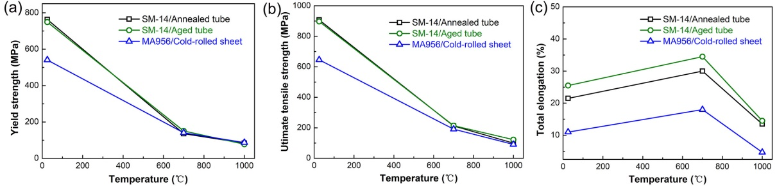
FIG. 7. (a) Yield strength, (b) ultimate tensile strength and (c) total elongation as a function of test temperature for the annealed and aged cladding tube, together with the corresponding data of MA-956 cold-rolled sheet [18].

The hoop tensile tests were also carried out at room temperature and 700 °C, and the stress-strain curves of the SM-14 cladding using the ring specimens are shown in Fig. 8. The stress-strain curve at each temperature was obtained by the average value of two tensile results. The photograph of tensile fracture specimen is displayed in the upper right corner. An average YS of 861.9 MPa as well as UTS of 989.4 MPa at room temperature, and 137.9 MPa as well as 166.2 MPa at 700 °C, respectively, is obtained in SM-14 cladding tube. At each testing temperature, the yield strength results in the circumferential direction are 10-13% higher than those in the longitudinal direction.
Based on the transformation equation proposed by Okada et al. [19], the von Mises equivalent stresses of the uniaxial longitudinal and circumferential direction are calculated. It is found that at room temperature the equivalent stress is 763 MPa from longitudinal conversion and 747 MPa from hoop conversion respectively, while at 700 °C the stresses are 126 MPa and 118 MPa respectively. The calculated von Mises equivalent stress value is close at each testing temperature. Therefore, it can be concluded that under multi-directional stress, if the stress component acting on SM-14 annealed cladding tube is greater than 763 MPa and 126 MPa, then yield will occur at room temperature and 700 °C. More work is necessary to characterize the longitudinal and hoop creep rupture strengths in the near future.

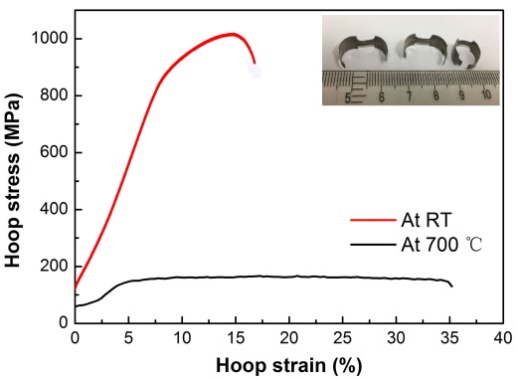
FIG. 8. Hoop stress-strain curves tested at room temperature and 700 °C for the SM-14 cladding.

Fig. 9 shows fracture micrographs of SM-14 cladding at different positions and different magnifications after hoop tensile test at room temperature. It can be seen the region where the crack starts (the edge of the sample) is covered by dimples. Also, some cleavage facets surrounded by dimples are observed on the fracture surface of tensile specimen. The propagation direction of cleavage facet is parallel to the rolling direction of cladding tube. The existence of a large proportion of dimples is conjugated with a good plasticity of this specimen, which is higher than 10%.

FIG. 9. Fracture surfaces of SM-14 cladding after tensile test at room temperature: (a) near the specimen edge at low magnification and (b) near the middle of cladding at high magnification.

In some studies of ODS-FeCr steels, the coarse particles with size of several hundred nanometers near the grain boundaries have been evidenced by postmortem SEM. It has been confirmed that the coarse particles consist of Ti-enriched precipitates and play a major role in the formation and growth of cavities. In the present investigation, neither Ti-enriched nor Y-enriched coarse particles near the grain boundaries are observed on the fracture surface of the cladding tube. This may be one of the reasons for the high hoop tensile strength.

Conclusion
In the work, the 14Cr ODS FeCrAl cladding tubes with an outer diameter of 9.5 mm and a wall thickness of 0.3 mm were produced by cold rolling processing. The microstructure and resulting mechanical properties were investigated by optical microscope, TEM, EBSD, SEM and longitudinal as well as hoop tensile tests. The conclusions are summarized as follows:
(1) During the whole processing route, raising the intermediate heat treatment temperature is beneficial to the safe rolling of cladding tubes.
(2) After cold rolling and final heat treatment, SM-14 cladding tube exhibits a strong γ-fiber texture of <111>∥ND.
(3) After cold rolling and final heat treatment, the oxide nanoparticles are uniformly dispersed in the matrix. Although a small amount of particles with the size of several tens of nanometres were observed, the coarser particles with the size of several hundred nanometres could not be found in the grains and at the grain boundaries of SM-14 cladding tube.
(4) SM-14 cladding tube would yield when the stress component exceeds 763 MPa at room temperature and 126 MPa at 700 °C respectively under the action of multi-directional stress.
(5) The aging treatment at 400 °C for 1500 hrs has no evident impact on the microstructure and mechanical properties of ODS FeCrAl cladding tube.
(6) According to the present observations, the texture of the cladding tube manufactured by cold rolling has little influence on the hoop tensile properties.
ACKNOWLEDGEMENTS
The authors acknowledge the support of this work by the National Science and Technology Major Project of the Ministry of Science and Technology of China (No.2015ZX06004001), Special Foundation for Group Innovation Strategy (No. 4500096267 and No.3100069733), Shenyang Double Hundred Project initiated by the Shenyang Science and Technology Bureau (No.Y17-0-022), and National Defense Science and Technology Industry Nuclear Material Technology Innovation Center Project (No：ICNM-2020-ZH-17).
References
- UKAI, S., OHTSUKA, S., KAITO, T., DE CARLAN, Y., RIBIS, J., MALAPLATE, J., “Oxide dispersion-strengthened/ferrite-martensite steels as core materials for Generation IV nuclear reactors”, Structural Materials for Generation IV Nuclear Reactors, Woodhead Publishing, USA (2016).
- UNOCIC, K.A., PINT, B.A., HOELZER, D.T., Advanced TEM characterization of oxide nanoparticles in ODS Fe-12Cr-5Al alloys, J. Mater. Sci. 51 (2016) 9190-9206.
- IWATA, N.Y., KIMURA, A., FUJIWARA, M., KAWASHIMA, N., Effect of milling on morphological and microstructural properties of powder particles for high-Cr oxide dispersion strengthened ferritic steels, J. Nucl. Mater. 367-370 (2007) 191-195.
- CHEN, C.L., DONG, Y.M., Effect of mechanical alloying and consolidation process on microstructure and hardness of nanostructured Fe-Cr-Al ODS alloys, Mater. Sci. Eng. A 528 (2011) 8374-8380.
- UKAI, S., OONO, N., SAKAMOTO, K., TORIMARU, T., KAITO, T., KIMURA, A., HAYASHI, S., “Development of FeCrAl-ODS steel claddings for accident tolerant fuel of light water reactors”, Proceedings of ICAPP 2017, Curran Associates, Inc., Japan (2018).
- WU, S., LI, J., LI, W., LIU, S., Characterization of oxide dispersoids and mechanical properties of 14Cr-ODS FeCrAl alloys, J. Alloys Compd., 814 (2020) 152282.
- UKAI, S., MIZUTA, S., YOSHITAKE, T., OKUDA, T., FUJIWARA, M., HAGI, S., KOBAYASHI, T., Tube manufacturing and characterization of oxide dispersion strengthened ferritic steels, 283-287 (2000) 702-706.
- TOUALBI, L., OLIER, P., ROUESNE, E., BOSSU, D., DE CARLAN, Y., On the influence of cold rolling parameters for 14CrW-ODS ferritic steel claddings, Key Eng. Mater. 554-557 (2013) 118-126.
- UKAI, S., KAITO, T., OHTSUKA, S., NARITA, T., FUJIWARA, M., KOBAYASHI, T., Production and properties of nano-scale oxide dispersion strengthened (ODS) 9Cr martensitic steel claddings, ISIJ Int. 43 (2003) 2038-2045.
- NARITA, T., UKAI, S., LENG, B., OHTSUKA, S., KAITO, S., Characterization of recrystallization of 12Cr and 15Cr ODS ferritic steels, J. Nucl. Sci. Technol. 50 (2013) 314-320.
- PIMENTEL, G., CAPDEVILA, C., BARTOLOMÉ, M.J., CHAO, J., SERRANO, M., GARCÍA-JUNCEDA, A., CAMPOS, M., TORRALBA, J.M., ALDAZÁBAL, J., Advanced FeCrAl ODS steels for high-temperature structural applications in energy generation systems, Rev. Metall. 48 (2012) 303-316.
- TOUALBI, L., CAYRON, C., OLIER, P., MALAPLATE, J., PRAUD, M., MATHON, M.H., BOSSU, D., ROUESNE, E., MONTANI, A., LOGÉR, R., DE CARLAN, Y., Assessment of a new fabrication route for Fe-9Cr-1W ODS cladding tubes, J. Nucl. Mater. 428 (2012) 47-53.
- SALLEZ, N., HATZOGLOU, C., DELABROUILLE, F., SORNIN, D., CHAFFRON, L., YRIEIX, M.B., RADIGUET, B., PAREIGE, P., DONNADIEU, P., BRÉCHET, Y., Precipitates and boundaries interaction in ferritic ODS steels, J. Nucl. Mater. 472 (2016) 118-126.
- OKA, H., TANNO, T., OHTSUKA, S., YANO, Y., UWABA, T., KAITO, T., OHNUMA, M., Effect of thermo-mechanical treatments on nano-structure of 9Cr-ODS steel, Nucl. Mater. Energy 9 (2016) 346-352.
- LOVE, G.R., Dislocation pipe diffusion, Acta Metall. 12 (1964) 731-737.
- LEGROS, M., DEHM, G., ARZT, E., BALK, T.J., Observation of giant diffusivity along dislocation cores, Science 319 (2008) 1646-1649.
- CHAUHAN, A., STRAßBERGER, L., FŰHRER, U., LITVINOV, D., AKTAA, J., Creep-fatigue interaction in a bimodal 12Cr-ODS steel, Int. J. Fatigue 102 (2017) 92-111
- INCOLOY ALLOY MA956 DATASHEET, SPECIAL METAL CORPORATION, 2004.
- OKADA, H., UKAI, S., INOUE, M., Effects of grain morphology and texture on high temperature deformation in oxide dispersion strengthened ferritic steels, J. Nucl. Sci. Technol. 33 (1996) 936-943.

