DEVELOPMENT AND DEMONSTRATION OF DIFFUSION-TYPE HYDROGEN METERS FOR SODIUM-COOLED FAST REACTORS

Hual-Te Chien, Thomas W. Elmer, and Christopher W. Grandy
Argonne National Laboratory
Lemont, IL USA
Email: htchien@anl.gov

Abstract

Among all the steam generator leak detection techniques, diffusion-type hydrogen meters (DTHMs) are highly sensitive and effective in detecting small leaks to prevent further tube failure due to wastage propagation. Argonne has developed two types of DTHM, cover-gas hydrogen meter (CGHM) and in-sodium hydrogen meter (ISHM), to be integrated into the steam generator leak detection system of an SFR. Design specifications and operating conditions of the two DTHMs were identified. CGHM and compact ISHM were designed for fast response, reduced cost, simplicity, sensitivity, and seismic ruggedness. A test apparatus for performance evaluation of CGHM prototypes was designed and constructed. Three CGHM prototypes were fabricated and two were tested with different hydrogen-argon mixtures in dynamic and equilibrium modes. Both modes demonstrated that hydrogen detection sensitivity of ISHM was down to 2 ppm or less in argon cover gas as required by the specification. Under the dynamic mode, the CGHM prototype has a response time around 1 sec. The equilibrium shows better consistency but with longer response time. Compact ISHM is operating without a sodium pump and is mechanically supported by the sodium line to which it is closely coupled. An in-sodium test apparatus was constructed and integrated with the Argonne under-sodium viewing sodium (USV) test facility. Three compact ISHM prototypes have been fabricated and in-sodium test of an ISHM prototype is in progress. Performance of the compact ISHM prototypes will then be reported. Compact ISHM is expected to promptly detect hydrogen concentration in sodium down to a range less than 100 ppb. Both DTHMs, if calibrated, can provide real-time, direct measurements of hydrogen concentration or pressure.

INTRODUCTION
Prompt detection of water-to-sodium leaks in a steam generator (SG) of a sodium-cooled fast reactor (SFR) is one of the most important safety and economic issues to be addressed in designing and operating an SFR. A water-to-sodium leak causes a violent exothermic sodium-water reaction (SWR) resulting in local temperature rise (>1,200°C) and produces hydrogen gas and highly corrosive chemicals. The SWR often induces self-enlargement (self-wastage) of the leak and rapid propagation of wastage to adjacent tubes, leading to secondary or multiple tube failures. If it is unmitigated, the hydrogen gas formation could cause a pressure increase in the intermediate heat exchanger (IHX) or the intermediate heat transport system (IHTS) and potentially may cause IHX tubing rupture or IHTS piping failure. A rapid SG tubing failure may cause a SG blowdown and ultimately result in shutdown of the reactor. In addition, if their effects are unmitigated, the highly corrosive chemicals formed could lead to and accelerate corrosion problems of SG and IHX/IHTS structures. From the viewpoint of reactor safety, the primary consideration in relation to SG leak is to maintain the integrity of the primary coolant boundary. SFRs typically incorporate a Sodium Water Reaction Pressure Relief System (SWRPRS) to prevent damage to the IHX or IHTS from pressurization and vent SWR products that might otherwise ultimately result in a lengthy shutdown of the reactor. The secondary safety consideration and an economic aspect are to effectively and rapidly detect any leaks to isolate the affected SG while maintain power on the grid. To limit the effects of SWR that include the potential for propagation of failures to other SG tubes, early leak detection and rapid SG blowdown capabilities are effective ways to mitigate the consequences of SWR.
The leak-rate range of interest spans several orders of magnitude and so a variety of sensing systems have been developed since no single instrument works well over the entire range [1,2]. There is likewise also a wide range in sensor response time. An effective SG leak detection system (SGLDS) is often incorporated and may require various types of monitors, sensors, and subsystems placed at various locations in the SG system with proper match of measurement sensitivity, range, and response time for different water/steam leak classes [3,4]. One of the applicable leak detection techniques is to detect hydrogen concentration in sodium or hydrogen pressure in cover gas by using diffusion-type hydrogen meters (DTHMs). DTHMs are highly sensitive sensors and are effective in detecting small leaks to prevent further tube failure due to wastage propagation. Argonne has developed two types of DTHM, a cover-gas hydrogen meter (CGHM) and a compact in-sodium hydrogen meter (ISHM), to be integrated into the SGLDS of an SFR [5-7]. Design specifications and operating conditions of these two DTHMs were identified [8]. CGHM and compact ISHM were designed for fast response, reduced cost, simplicity, sensitivity, and seismic ruggedness. Test apparatuses for performance evaluation of both CGHM and compact ISHM prototypes were designed and constructed. Two CGHM prototypes were tested and demonstrated a hydrogen detection sensitivity down to 2 ppm or less with a response time around 1 sec in argon cover gas, as required by the specification. The compact ISHM is operated without a sodium pump and is mechanically supported by the sodium line to which it is closely coupled. Three compact ISHM prototypes with two different nickel membrane designs were fabricated and their performance evaluation is in progress.

DIFFUSION-TYPE HYDROGEN METERS (DTHM)
Several different types of hydrogen monitoring techniques have been explored to detect water/steam leaks [1,2]. Important design parameters of a hydrogen meter are its detection sensitivity, response time, and reliability. The DTHM is the selected design of both cover-gas and in-sodium applications to detect small water/steam leaks. Typically, a CGHM is installed in the expansion tank and an ISHM at the sodium outlet of a SG. Both meters will be used for in-situ real-time hydrogen monitoring for early leak detection and repair management, but will not be integrated into the reactor safety system, which consists of pressure gauges and rupture discs for SG protection.

Design of DTHM
A DTHM generally consists of six major modules, a nickel membrane assembly; i.e., a vacuum manifold and hydrogen measuring system, an in-situ calibration unit, a leak analyzer, a control and display module, and a standpipe unit. The vacuum line of the membrane assembly leads through an isolation valve to a vacuum manifold and hydrogen measuring system. To deploy for reactor use, the standpipe will be either welded to the expansion tank or the sodium outlet of a SG.

Designs of nickel membrane probe
Hydrogen can diffuse through materials such as iron, nickel, and palladium at high temperature. Nickel–201 (ASTM B-161) is selected due to its compatibility with sodium, good hydrogen diffusion rate, and high strength, and is preferred for high temperature (> 320°C) applications. According to operating conditions, including pressure, temperature, flowrate, and coolant media, the design specifications of different types of DTHM are modified, resulting in different designs for the nickel membrane probe for CGHM and ISHM.
A nickel membrane probe generally consists of a capped tubular nickel membrane that is connected to an isolation valve, then to a vacuum manifold operated with an ion pump. The hydrogen flux diffusing through the membrane is measured by the ion pump current or by an ionization gauge. The sensitivity of these hydrogen meters is proportional to the ratio of surface area and thickness of the membrane. The response time is directly proportional to the square of its thickness and the sensor location from the leak. According to the operation conditions, three nickel membrane probe designs for DHTMs were developed; see Figure 1. CGHM uses a plain membrane with 10-mil wall thickness and an OD of 0.25”. ISHM uses either a 10-mil ribbed membrane or a 14-mil meshed membrane with 0.5” OD.
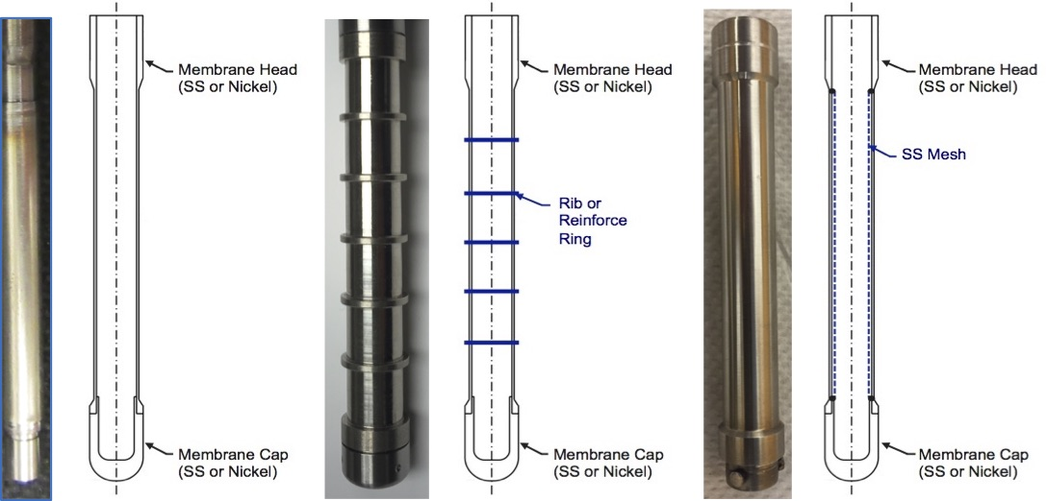
(a) (b) (c)

Fig. 1. Nickel membrane probe designs: (a) plain, (b) ribbed, and (c) meshed.

Design of CGHM
The nickel membrane assembly of a CGHM consists of a nickel membrane probe, a heater, a hydrogen injection coil tube, a heater support, a baffle, a flange unit, a thermocouple, and a hydrogen injection tube. Figure 2 shows a photo of a nickel membrane assembly of CGHM prototype. During operation, the heater is coiled around the nickel membrane, which is heated up to 560°C, which showed better diffusion performance [9].
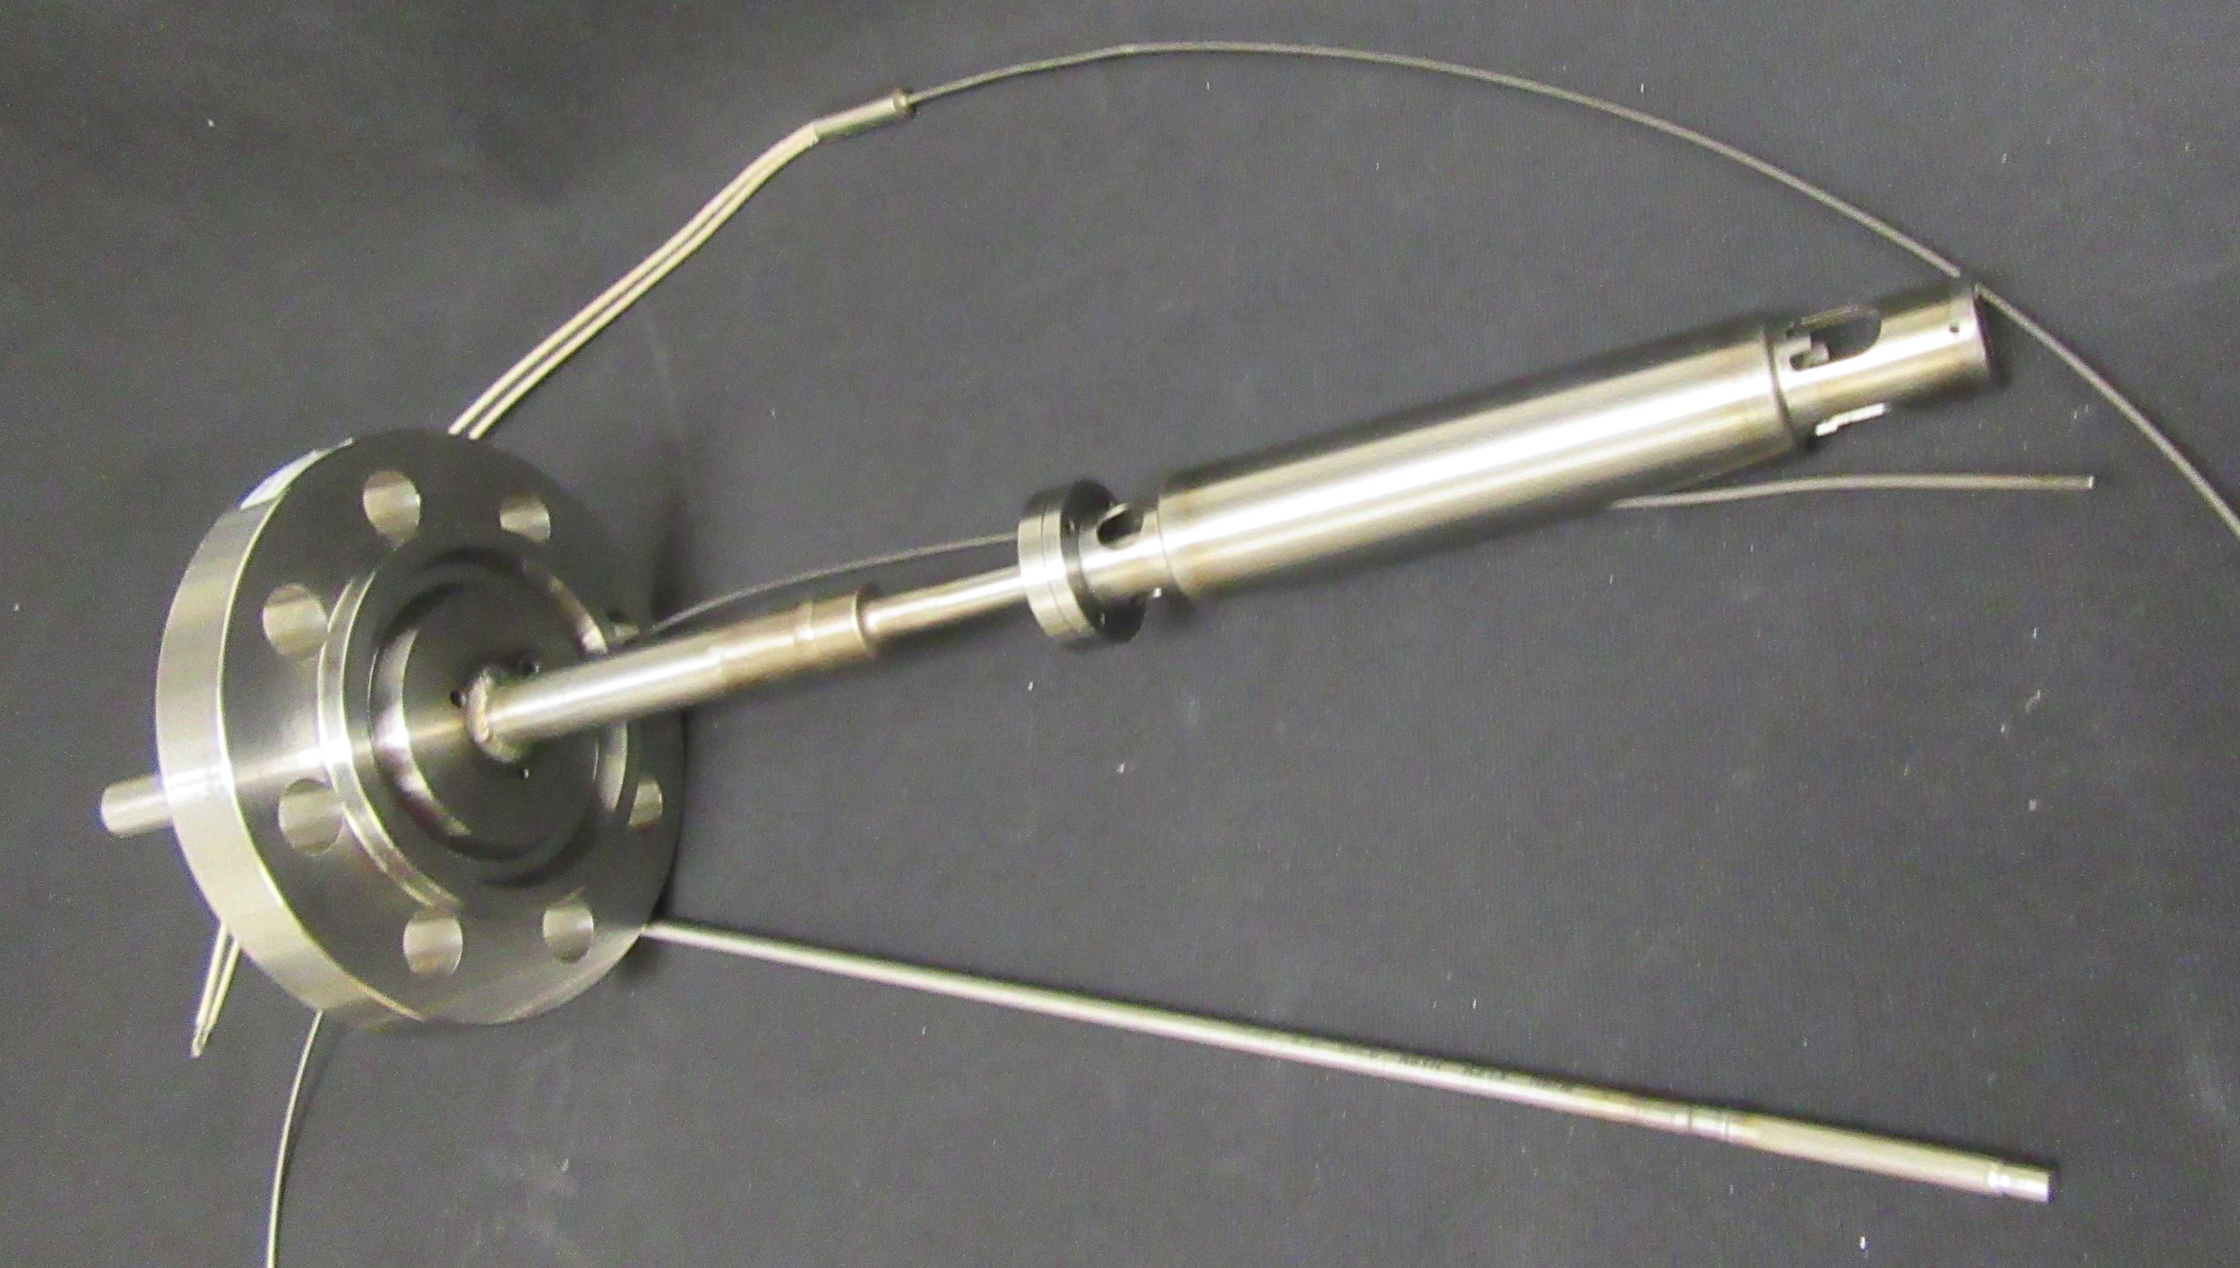

FIG. 2. Photo of nickel membrane assembly of CGHM prototype.

2.3.1. In-situ calibration of CGHM
A CGHM uses of a hydrogen injection coil tube, a 1/16” thin-wall nickel-201 tubing, placed directly below the membrane mainly for in-situ calibration of the meter. One end of the tube is connected to a hydrogen injection system, which primarily consists of a hydrogen source (or hydrogen/argon mixture), a pressure regulator, pressure gauges, a mass flow control manifold, and mass flow controllers. The mass flow control manifold mixes argon and hydrogen-argon mixture to a predetermined ratio with different flow rates for calibration. During calibration, the nickel tube is pressurized with hydrogen-argon mixture and heated up to 560°C by the membrane heater. Depending on the hydrogen concentration in the nickel tube, a known hydrogen amount would diffuse out of the nickel tube and then diffuse into the nickel membrane.

Design of ISHM
An ISHM aims at detecting small leaks in time to prevent wastage propagation to adjacent tubes and will be placed in the sodium inlet and outlet pipelines of each SG. The proposed compact ISHM is designed for fast response time, reduced cost, simplicity, sensitivity, and seismic ruggedness. The nickel membrane assembly of a compact ISHM consists of a nickel membrane probe, a meter body, a heater, a thermocouple, and a flange unit. It has no sodium pump, valves, and flowmeter and is mechanically supported by the sodium line to which it is closely coupled. Two compact ISHMs with ribbed nickel membrane probe have been fabricated and the fabrication of a compact ISHM with a meshed nickel membrane probe is in progress. Figure 3 shows a photo of a compact ISHM prototype.
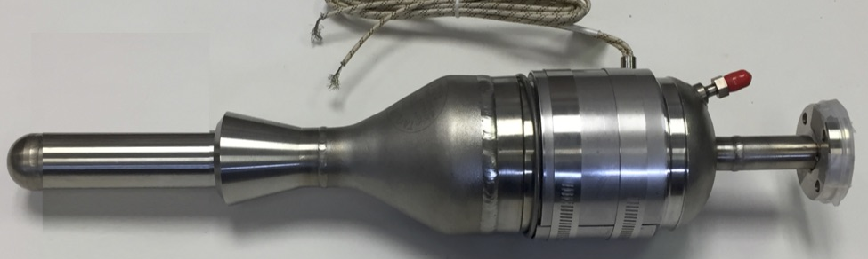

FIG. 3. Photo of nickel membrane assembly of compact ISHM prototype.

2.4.1. In-situ calibration of ISHM
For in-situ calibration of an ISHM, a sodium hydroxide (NaOH) injection assembly is fabricated and integrated into the ISHM sodium test apparatus. The NaOH injection assembly consists of a NaOH injector, sodium expansion tank, and vacuum/gas manifold. Figure 4 shows a photo of a NaOH injector. A designated amount of NaOH will be loaded and sealed in the injector inside a glove box. It will be transferred and mounted onto the injection assembly, and then injected into molten sodium at a predetermined temperature. The reaction between NaOH and sodium will produce a known amount of hydrogen that is entrained in molten sodium and flows into the meter.
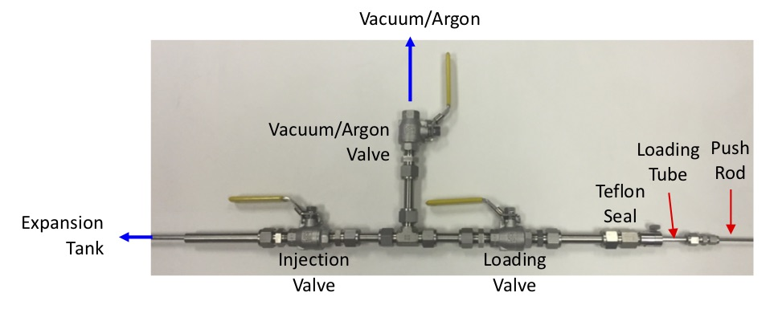

FIG. 4. NaOH injector for in-situ calibration of ISHM.

Vacuum manifold and hydrogen measuring system
Both CGHM and ISHM use a similar vacuum manifold and hydrogen measuring system, which consists of a vacuum manifold assembly, a nude ionization gauge (AgilentTM UHV-24), an ion pump (AgilentTM VacIon), an ion gauge controller (AgilentTM XGS-600), an ion-pump isolation valve, a roughing pump, and a roughing pump isolation valve. Figure 5 shows a photo of a vacuum manifold and hydrogen measuring system connected to a compact ISHM assembly.
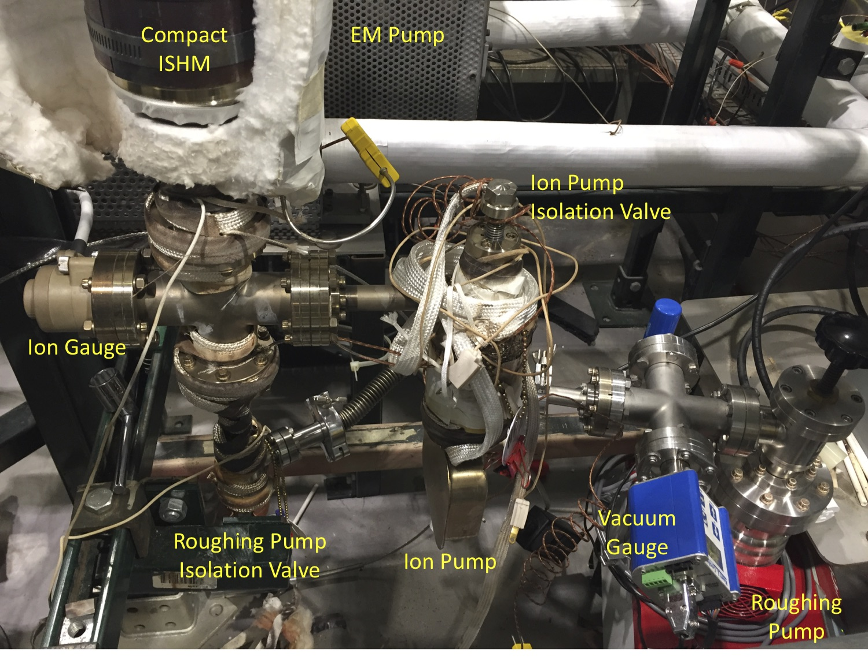

FIG. 5. In-situ calibration of compact ISHM prototype.

Control and display module
A control and display (C&D) module, running on a LabView® platform, was developed to automate the performance evaluation of both CGHM and ISHM. The C&D module is used to operate the pilot test facility and to display pressures of ion gauge/pump and some critical operational information. Pressure change and pressure changing rate are measured and are converted to hydrogen concentration and concentration changing rate, which then can be correlated to water-leak rate and water-leak changing rate, respectively. Figure 6 shows an example of photo of the Graphical User Interface (GUI) panel of the C&D module for CGHM and ISHM tests.
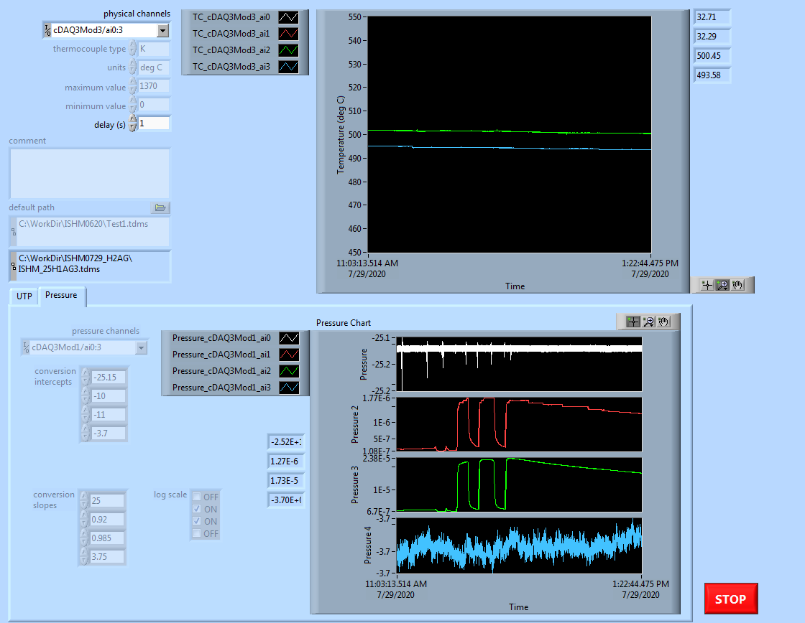

FIG. 6. GUI panel of control and display module.

Performance Evaluation of CGHM prototypes
A laboratory test apparatus was constructed for CGHM performance evaluation. Two CGHM prototypes were tested to determine their sensitivity, response time, detection limits, and reproducibility [7].

3.1. Test apparatus of CGHM
The apparatus consists of a CGHM probe assembly, a test vessel, a vacuum and hydrogen measuring system, hydrogen injection system, and C&D module. Figure 7 shows a photo of the fully assembled CGHM test apparatus. A CGHM probe assembly is mounted inside the test vessel and connected with the vacuum and hydrogen measuring system. For performance evaluation, hydrogen/argon mixtures with designated hydrogen concentrations were fed into the test vessel, which was flushed after each test. The evaluation of in-situ calibration of the meter was also conducted.
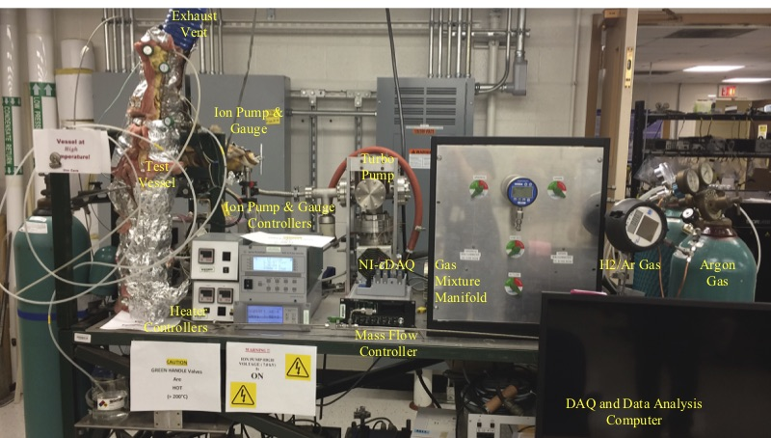

FIG. 7. Photo of CGHM test apparatus.

3.2. Test results of CGHM prototypes
Two CGHM prototypes were fabricated and tested. Two hydrogen measurement modes, dynamic and equilibrium, are conducted to determine hydrogen concentration. In general, the ion pump current reflects the hydrogen flux diffusing through the nickel membrane and thus it provides a dynamic hydrogen measurement mode capability. The ionization gauge also gives a measure of hydrogen pressure. If the ion pump is isolated, the ionization gauge gives an equilibrium mode measurement of hydrogen pressure, which represents the hydrogen partial pressure in cover gas or the hydrogen concentration in sodium. Detection sensitivity is therefore determined by the gauge sensitivity in detecting the pressure variation on the vacuum side of the membrane probe. The pressure variation depends on the amount of hydrogen gas flowing in the vacuum system per unit time, the pumping speed, and the outgassing from the gauges.

3.2.1. Dynamic mode
The temperature of the nickel membrane is at 560°C and the test vessel is at 450°C. Figure 8 shows the pressure changes of prototype #1 to different concentrations of hydrogen flowing into the test vessel in vacuum at flow rates of 500 and 1,000 sccm. The results indicate that the prototype is able to detect hydrogen as soon as a small hydrogen differential pressure between the internal and external of the nickel membrane is produced. The pressure change is used to determine the hydrogen concentration, i.e. how large is the steam/water leak of a SG; the rate of pressure change is an indication of the steam/water leak changing rate. Figure 9 shows the response of prototype #1 to different concentrations of hydrogen flow into the test vessel covered with argon at flow rate of 500 and 1,000 sccm.
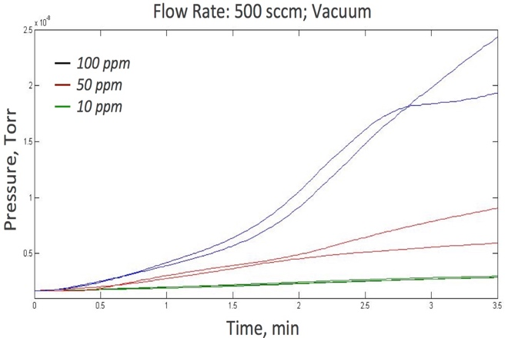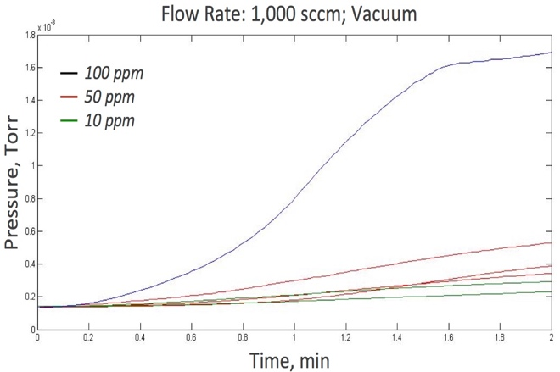

FIG. 8. Pressure changes to H₂ concentrations in vacuum at flow rates of 500 and 1,000 sccm.

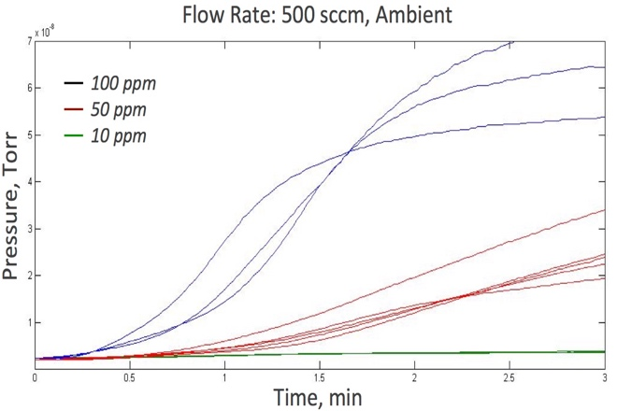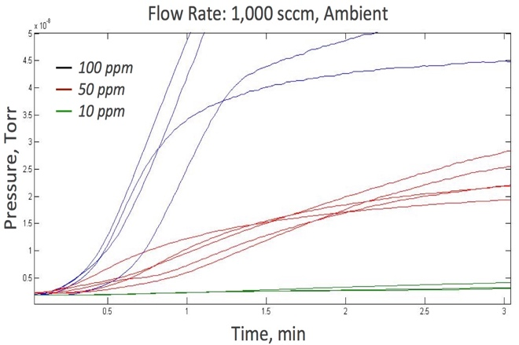

FIG. 9. Pressure changes to H₂ concentrations in argon at flow rates of 500 and 1,000 sccm.

Figure 10 shows the response time and slope, i.e. pressure change rate, of prototype #1 to different H₂/Ar mixture flowing into the test vessel covered with vacuum and argon at different flow rates. Increasing flowrate or hydrogen concentration both induce a higher overall pressure change as well as a higher pressure changing rate. The response time is faster for gas mixtures flowing into vacuum than into argon cover gas. The slope is larger for higher flow rates, as well as for flowing into argon cover gas.
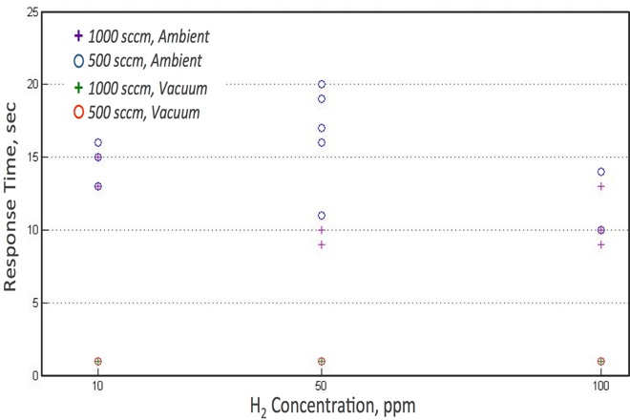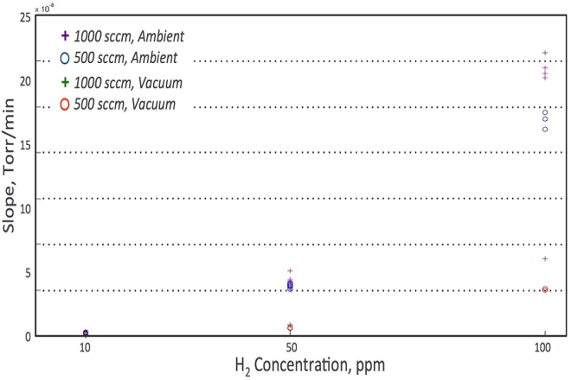

Figure 10. Response time and slope to H₂ concentrations at flow rates of 500 and 1,000 sccm.

Hydrogen concentrations were systematically stepped up and down to investigate the pressure changes associated with different hydrogen concentrations. Figure 11 shows the results of tests of hydrogen concentrations stepping up and down from 2 ppm to 100 ppm for prototype #1. Both show fast response time and larger slope for higher hydrogen concentration.
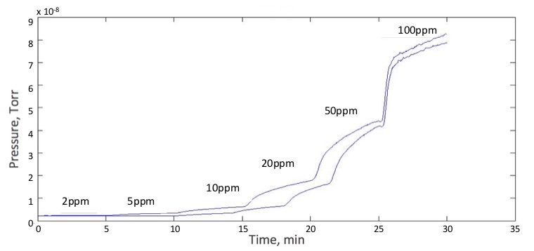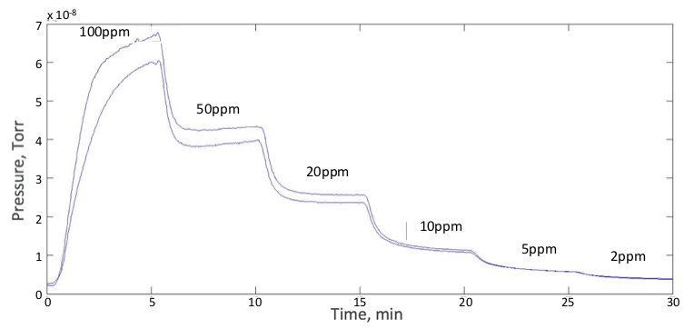

FIG. 11. Pressure changes of prototype to H₂ concentrations stepping up and down.

3.2.2. Dynamic mode
An alternative equilibrium operating mode is conducted by isolating the ion pump. The ionization gauge gives a measurement of hydrogen pressure, which represents the hydrogen partial pressure in the cover gas or the hydrogen concentration in sodium. Figure 12 shows the pressure changes of the prototype #2 for different hydrogen concentrations in this equilibrium mode. This mode offers better sensitivity and consistency, but takes a much longer time to reach equilibrium, i.e. a longer time to determine the hydrogen concentration.
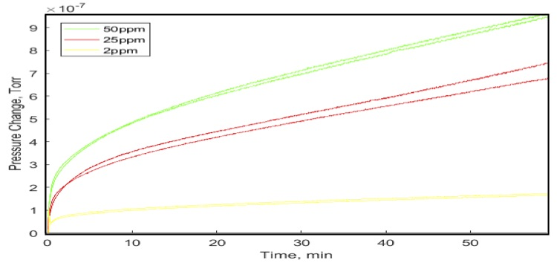
FIG. 12. Pressure Changes for Different Hydrogen Concentrations Under Equilibrium Mode.
The test results clearly show that the dynamic mode reaches an equilibrium state much faster than the equilibrium mode but with much smaller magnitude. The difference in magnitude depends on the effective pumping speed. In addition, the slope of the equilibrium curve gives a direct measure of the amount of hydrogen diffusing into the vacuum chamber, which in turn gives a direct measurement of hydrogen pressure in the sodium flowing across the nickel membrane. Both prototypes have demonstrated a detection sensitivity of hydrogen concentration down to 2 ppm. If mixing gas is flowing into a vacuum vessel, the response time is ~1 sec for any hydrogen concentration. If mixing gas is flowing into a vessel with argon cover gas, the response time is ~1 sec or longer, depending on flow rate, hydrogen concentration, and the vessel volume.

Performance Evaluation of compact ISHM Prototypes
An in-sodium test apparatus for performance evaluation of ISHM prototypes was constructed and integrated with the Argonne under-sodium viewing (USV) sodium test facility. Three prototypes have been fabricated. An ISHM prototype was tested with hydrogen/argon mixtures to verify proper function before installation into the test apparatus for in-sodium testing.

4.1. Test apparatus for compact ISHM
The test apparatus consists of a compact ISHM assembly, a sodium loop, a NaOH injection assembly, a vacuum manifold and hydrogen-measuring module, a heating control and temperature-monitoring module, and a C&D module. Figure 13 shows the ISHM test apparatus before the installation of heaters and insulation.
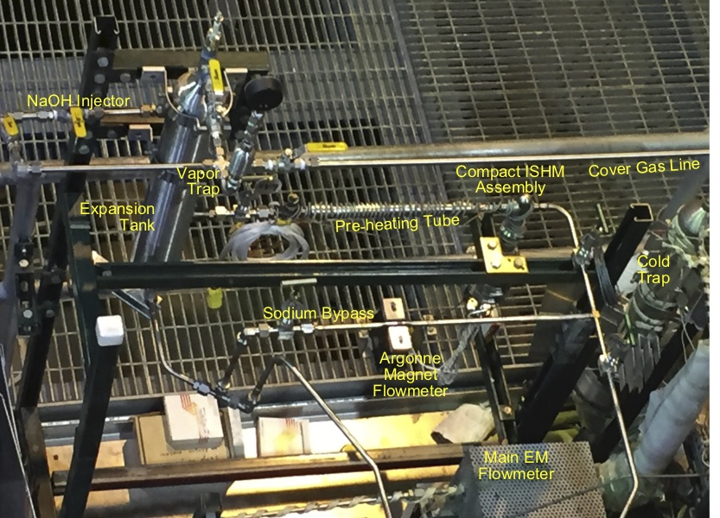

FIG. 13. Photo of ISHM test apparatus.

4.2. Test apparatus for compact ISHM prototypes
The ISHM prototype with ribbed membrane probe was tested with hydrogen/argon gas mixture (100 ppm) to verify proper function before installation into the test apparatus for in-sodium testing. The gas mixture flowed into a hot chamber (501°C, vacuum) and then into the prototype (500°C, vacuum) [7]. Figure 14 shows the pressure changes of the ion gauge and ion pump. The in-sodium test of a prototype with meshed membrane probe will be conducted once fabrication is completed.
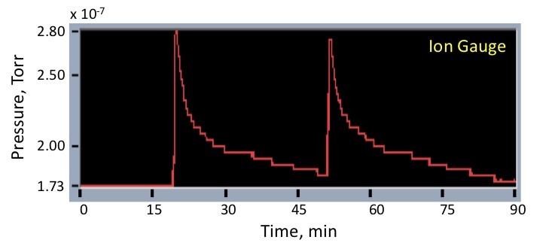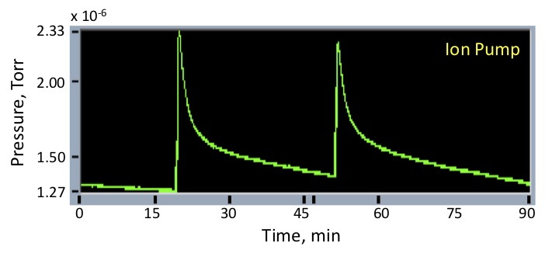

FIG. 14. Pressure changes of ion gauge and ion pump at a hydrogen concentration of 100 ppm.

conclusions
Argonne has developed both CGHM and ISHM for monitoring the hydrogen concentration in cover gas of the expansion tank and in sodium at the outlet of a SG, respectively. Test apparatuses for performance evaluation of both meters were also designed and constructed. Two CGHM prototypes were tested under dynamic and equilibrium modes and both modes have demonstrated hydrogen detection sensitivity down to 2 ppm or less in argon cover gas, as required by the performance specification. The dynamic mode showed a response time of around 1 sec and reached an equilibrium state much faster than the equilibrium mode, which showed better consistency. In addition, the slope of the equilibrium curve gives a direct measure of the amount of hydrogen diffusing into the vacuum chamber per unit time, which in turn gives a direct measurement of hydrogen pressure in the cover gas. Two compact ISHM prototypes were fabricated, and the in-sodium test is in progress. Results will be reported in the conference if no further delays are experienced due to the Pandemic.
References
- Chien, H. T., Bakhtiari, S., Sheen, S. H., Argonne National Laboratory, unpublished report (2014).
- Chien, H. T., Bakhtiari, S., Sheen, S. H., Argonne National Laboratory, unpublished report (2015).
- Latge, C., “Interaction of Na and Materials,” IAEA Education &Training Seminar on Fast Reactor Sci. and Tech., CNEA Bariloche, Argentina (2012).
- Status of Liquid Metal Cooled Fast Reactor Technology, IAEA-TECDOC-1083, IAEA, Vienna (1999).
- Wrightson, M. M., et al., “EBR-II Water-to-Sodium Leak Detection System”, Int’l Conf. on Liquid Metal Technology in Energy Production, Champion, Pennsylvania, USA (1976).
- Chien, H. T., et al., Argonne National Laboratory, unpublished report (2017).
- Chien, H. T., et al., Argonne National Laboratory, unpublished report (2019).
- McKee, J. M., Osterhout, M. M., Batten, R. L., “Use of a Steam Leak Simulator in EBR-II,” Liquid Metal Engineering and Technology, 25, ICE Publishing (1984).
- Maroni, V. A., et al., “Liquid Metals Chemistry and Tritium Control Technology Annual Report,” Technical Report ANL-75-50, Argonne National Laboratory (1975).

