# Investigation of sodium purification

V.V. Alekseev, A.P. Sorokin, Yu.A. Kuzina, R.O. Zykova, I.A. Sutyagin

A.I. Leypunsky Institute for Physics and Power Engineering

Obninsk, Russia

Email: alexeev@ippe.ru

**Abstract**

The scientific justification was developed for the creation of cold traps of an original design for BN-350, BOR-60 and BN-600. To improve the safety of a new fast neutron reactor, it has been decided to place the purification system in the reactor vessel. On the basis of calculations, using the developed codes for modelling thermal-hydraulic and mass transfer processes in cold trap, optimal technical solutions are investigated. For integrated in-vessel sodium purification system getter traps are an alternative to cold traps. To purify sodium from oxygen, both insoluble and soluble getters were used. Tests of sodium purification with zirconium getter were carried out at temperature of 550 °С. As soluble getter granular magnesium was used, the sodium temperature was maintained at 300 °C.

* 1. INTRODUCTION

Cold traps are the main sodium purification devices in fast reactor circuits. Work in this area began with the creation of the first sodium-cooled fast reactors. The features of the processes of hydrodynamics of heat and mass transfer in cold traps are investigated. An original design of a domestic cold trap was developed and substantiated, the characteristics of which were superior to those of the foreign samples [1, 2]. The trap design in principle consists of three zones connected in sequence: a non-isothermal settling chamber, a final cooling zone and an isothermal filter (Fig. 1). The design solutions for cold traps for the BR-10, BN-350, and BN-600 reactors are shown in Fig. 2 and Fig. 3.

The aim of the studies of cold traps was to obtain information on the processes of hydrodynamics and heat and mass transfer, the distribution of impurities in the traps, as well as to study their characteristics. The traps were cooled with sodium potassium alloy (prototypes of BN-350 traps) and air (prototypes of BN-600 traps). Sodium was contaminated by feeding oxygen, hydrogen or water into the loop.

During the operation of cold traps in the primary circuit of the BN-600 reactor, leaks of radioactive sodium occurred; therefore, in order to increase the safety of the new reactor, it was decided to place the cold traps into the reactor vessel [3, 4]. For the entire period of operation of the BN-600 reactor, there was a single case of sodium leakage due to depressurization of the auxiliary system of the primary circuit, which required a shutdown of the power unit in 1993. As a result of this sodium leak, radioactive sodium-24 contamination of certain rooms in the reactor compartment occurred. There was no contamination of the station territory and beyond. During the entire period of operation of the BN600 reactor, there were 4 incidents with sodium leaks in the secondary circuit. The largest leak occurred in 1995 in the lower part of the steam generator shell and was estimated to be several tens of kilograms of sodium.

The development of a cold trap built into the reactor vessel is based on previous research results in the field of sodium coolant technology. The task is to improve cold traps from the point of view of safety, economy, and environmental friendliness. The first versions of such traps have been developed [5–8]. At the first stage, argon was chosen as a coolant for cooling cold traps. Sodium and sodium-potassium eutectic alloy are also offered as alternative heat transfer fluids.

To analyse processes in cold traps recently developed methods and codes are used for numerical simulation of complex processes of three-dimensional mass transfer and deposition of impurities [9–12].

For sodium purification from oxygen inside the reactor vessel a getter purification method can be used, in which, due to chemical interaction, impurities, for example oxygen, are absorbed from sodium. The experiments were carried out to purify sodium from oxygen with a zirconium getter [1, 14].

## Experience in the development of cold traps

To substantiate the design of the cold trap of the BN-600 reactor, a model of a cold trap with a volume of 180 liters, cooled with air, was investigated. In fig. 4 shows the design of the model of a cold trap and the results of measurements of the distribution of sodium oxide in the trap by γ-method.

It was also shown that the retention coefficient of sodium oxide and hydride (the products of interaction of sodium with water) is close to unity when the sodium remains in the trap for 15–20 min. The retention coefficient (efficiency) is the ratio of the amount of impurity retained in the trap to the maximum possible amount of impurity retained at a given temperature.

The minimum concentration of oxygen and hydrogen in sodium after cleaning it with traps of different types was equal to their solubility at the temperature at the outlet of the trap. Although corrosion products and carbon were found in cold traps, it was shown that the removal of sodium from them by cold traps is not effective.

The results of testing the prototype of the three-zone trap showed that the capacity of the traps when only sodium oxide is accumulated is 25–27 vol.%, That is, only a quarter of the total volume of the trap is filled with impurities. With the accumulation of both sodium oxide and the products of interaction of sodium with water (Na2O, NaH, NaOH), their capacity is approximately 2 times lower.

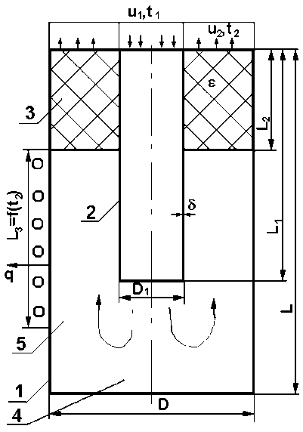

FIG. 1. Diagram of a cold trap: 1 - trap body; 2 - downpipe; 3 - filter; 4 - sump; 5 - cooling zone.



FIG. 2. Scheme of the cold trap of the BR-10 reactor: 1 - sodium inlet pipe; 2 - sodium outlet pipe; 3 - heater cavity; 4 - thermocouple pocket; 5 - water cooling coil; 6 - toluene cavity; 7 - filter; 8 - sodium cooling channel; 9 - inner body of the cold trap; 10 - outer body of the cold trap; 11 – sump.

Cold traps of the second circuits work without replacement, but on each of them, due to an increase in hydraulic resistance or the difficulty of providing the necessary operating parameters (flow rate, temperature regime), regeneration is carried out.

On the basis of thermodynamic analysis, methods of regeneration of cold traps have been proposed and substantiated, which make it possible to restore their characteristics by transferring the impurities accumulated in the trap into the caustic phase. Its melting temperature does not exceed 400 °С, and is hydraulically removed from the cold trap. The experience shows that the trap can be regenerated at least three times [13].

## 3. The sodium purification system integrated into the reactor vEssel

The system of sodium purification built into the reactor tank must meet the following requirements:

- to ensure the required cleanliness of the coolant under the conditions of long-term operation of the NPP at nominal parameters (in this case, the sources of impurities are taken into account both under the operating conditions of the installation at nominal parameters and in case of emergency contamination of the coolant);

- have the required capacity for impurities that enter the primary coolant, taking into account all modes of its operation (including emergency pollution). It is allowed to replace the elements of the purification system during the lifetime of the installation, while it is desirable that the number of replacements is minimal;

- to have a performance that guarantees purification of the coolant during maintenance operations, fuel overloads, emergency contamination.

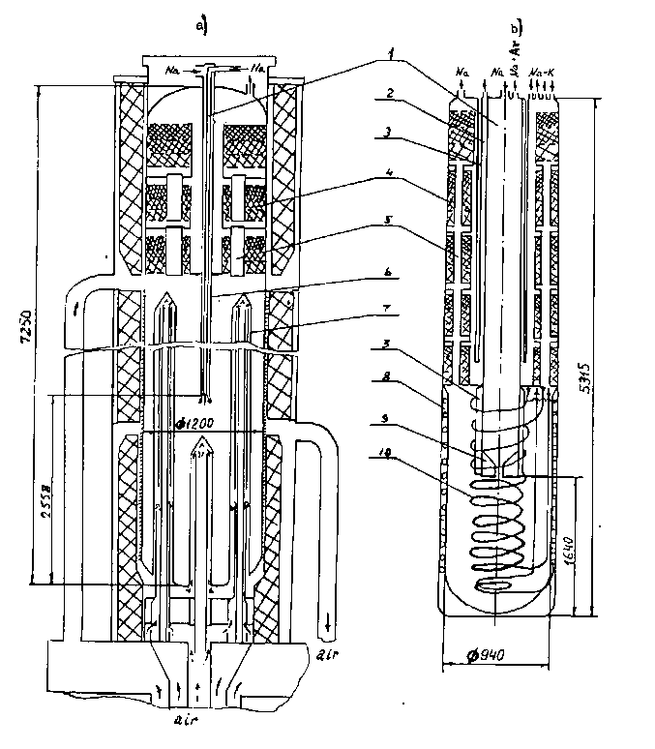

FIG. 3. Schemes of cold traps of reactors BN-600 (a) and BN-350 (b): 1 - central pipe; 2 - external channel of the recuperator; 3 - air gap; 4 - filter; 5 - flow channels; 6 - axial tube; 7 - air cooling tubes; 8 - cooling jacket; 9 - cone; 10 – coil.

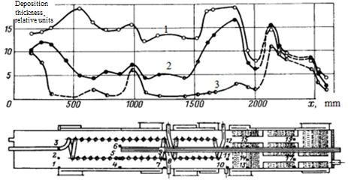

FIG. 4. Distribution of sodium oxides along the length of the cold trap model of the BN-600 reactor: 1 - 111 kg of sodium oxide; 2 - 63 kg of sodium oxide; 3 - 14 kg sodium oxide.

The sodium purification system built into the reactor tank has certain disadvantages compared to the location outside the reactor vessel:

- low productivity of the built-in purification system due to the limited sodium flowrate through the cold trap, and therefore - a significant increase in the sodium purification time to the required level of its purity;

- the need for multiple replacement of cold traps due to the insufficient capacity of the built-in purification system owing to restrictions on the size and number of cold traps;

- the presence of a complex cooling system and the need to constantly maintain the trap in the cooling mode (cold trap should be maintained at a temperature of 120–150 °С, since a long stay at the temperature of the surrounding sodium ( ≥ 410 °С) will lead to increased corrosion elements inside the cold trap);

- the possibility of the release of impurities into the reactor tank from the superheated cold trap, the formation of gaseous hydrogen and its exit into the reactor tank.

Currently, two designs of a cold trap built into the reactor vessel are being considered: cooling with argon and sodium [6–8].

For the cold trap with argon cooling at a pressure of 1.5 MPa the volume of the working cavity was 1.75 m3 [6], the calculated capacity for impurities was 350 kg.

If it is planned to place three built-in cold traps in the reactor tank, then, as estimates show, over 60 years of NPP operation, the traps will need to be replaced many times. Over the entire service life of a fast reactor about 8000 kg of impurities enter cold traps. The volume of the working cavity of the cold trap is 1.75 m3. The calculated capacity of the cold trap for impurities is assumed to be 20%, which is 350 kg. The number of cold traps in this case is 8000/350 = 23. Taking into account that three cold traps are installed on the reactor tank, 20 more traps will be required to replace during the entire life of the reactor [7].

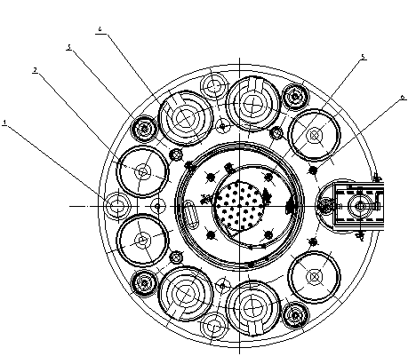

FIG. 5. Layout of built-in cold traps in the reactor tank [10]:

1 – cold trap; 2 - circulation pump; 3 - autonomous heat exchanger; 4 - intermediate heat exchanger; 5, 6 - measuring channels.

The operation of the sodium purification system in a mode that reduces the accumulation of hydrogen in the primary circuit can contribute to a decrease in the number of replacements of the primary circuit traps. The number of saved replacements of cold traps in case of excluding the accumulation of hydrogen in the primary loop of reactor is 13. Then only 7 replacements are required [7].

With the simultaneous operation of three traps for the purification of sodium from increased contamination, it will take at least 1600 hours (67 days).

In order to reduce the number of replacements of the cold traps of the primary circuit built into the reactor tank during the operation of the reactor and to reduce the time of sodium purification after increased contamination, it is necessary to increase both the useful volume of the trap and its capacity for impurities. To solve this problem, calculations were performed to optimize the parameters and operating conditions of cold traps.

The version of the sodium-cooled cold trap has the same overall dimensions as the argon-cooled trap, but the volume of its working cavity can be larger. Additionally, a coil is installed inside it. Cooling sodium circulates through two cooling paths: outside the casing of the working cavity in the jacket - up to 30% of the flow rate and through the coil located inside the working cavity - up to 70% of the flow rate (in the initial period of the trap operation). The use of sodium cooling instead of argon under pressure makes it possible to exclude an element with increased potential energy, as well as to increase the diameter of the working cavity, which improves the trap characteristics.

The advantages of sodium cooling of the cold trap are:

- the use of sodium circuits for cooling various devices is carried out with high reliability and for a long period of time (tens of years) and can be implemented for cooling cold traps built into the reactor tank;

- the ingress of cooling sodium into the sodium of the primary circuit does not cause negative effects in the primary circuit;

- calculations have shown that sodium cooling of cold traps built into the reactor tank can be implemented for a standard trap;

- sodium cooling allows to obtain more economical use of the volume inside the trap;

- the NPP has personnel and experience in handling sodium coolant.

The sodium cooling circuit must meet all requirements for alkali metal installations. Its main elements are (Fig. 6): expansion and drain tanks, circulation pump, heat exchangers, heaters and thermal insulation, fittings and pipelines, purification devices (cold or diffusion trap[1], etc.), sodium quality control devices (plugging meter or electrochemical oxygen and hydrogen sensors, etc.), instrumentation and automation, gas-vacuum system. It is obvious that such a circuit is a complex and cumbersome structure.

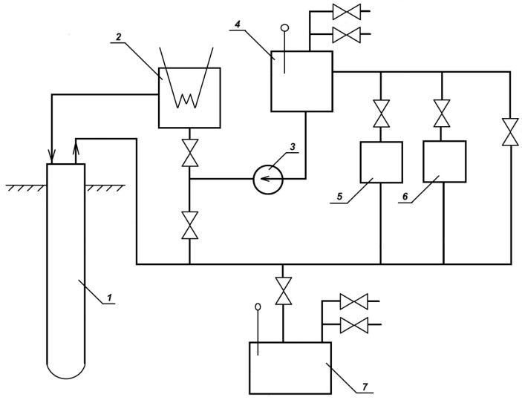

FIG. 6. Diagram of the sodium cooling circuit of a cold trap: 1 - cold trap; 2 - refrigerator; 3 - circulation pump; 4 - pump tank; 5 - sodium purifier; 6 - block of sodium quality control devices; 7 - drain tank.

It is necessary to optimize the cooling system of the cold trap in order to make it simpler and cheaper. As a result, it will be a low-inertia closed circulation system of sodium coolant, hermetically sealed and efficient for a given service life.

Cooling the cold trap with a liquid metal coolant will eliminate the danger associated with the use of argon at a pressure of 1.5 MPa and will improve the characteristics of the cold trap. Estimates have shown that the heat transfer coefficient for sodium is several times higher than for argon. Comparison of the purification systems of the BN-350, BN-600 and the in-vessel cold trap cooled with sodium and argon is given in Table 1.

Table 1 shows that the productivity and capacity of the argon-cooled purification system built into the reactor tank is almost 3 times inferior to BN-600, and almost 2.5 times when cooled with sodium. This means that, under equal conditions, the time for primary coolant purification by three in-vessel traps cooled with argon will be almost three times longer than for BN-600 [6].

Table 1. Comparison of purification systems BN-350, BN-600 and in-vessel system

|  |  |  |  |  |  |
| --- | --- | --- | --- | --- | --- |
|  | Cold trap parameters | | | | |
| Purification systems | Volume, VNa m3 | Flow rate, GNa, m3/h | Outlet temperature, °C | Capacity for Na2O, kg | VNa/GNa, h |
| BN-350 | 3×3 | 7×3 | 120 | 600×3 | 24 |
| BN-600 | 8×2 | 8×2 | 120 | 1600×2 | 62 |
| Perspective in-vessel (Ar cooling) | 1,75×3 | 2,8×3 | 150 | 350×3 | 230 |
| Perspective in-vessel (Na cooling) | 1,86×3 | 4×3 | 150 | 441×3 | 160 |

## 4. Optimization studies of mass transfer in cold traps

Optimization studies of the design of cold traps were aimed at achieving their maximum economic and technological performance (purification rate, cleaning effectiveness, trap capacity for impurities).

The solution to the optimization problem included the creation of a numerical algorithm and the structure of the computational code for modeling thermohydraulic and mass transfer processes in cold traps, obtaining and analyzing data on the fields of velocity, temperature, concentrations of dissolved impurities and solid particles in cold traps, as well as the distribution of impurity flux on the walls along the length traps. We considered the Na2O impurity.

A computational model of thermal hydraulics and mass transfer of impurities in a cold trap is proposed, which is based on the approximation of an incompressible multicomponent medium and makes it possible to model the global spatial distributions of the fields of the coolant flow velocity, temperatures, and the distribution of the impurity concentration.

The codes TURBOFLOW [5, 7], MASKA-LM [8–11] were used to simulate thermohydraulic and mass transfer processes in a cold trap.

The first version of a new three-dimensional code for multidimensional mathematical modeling of processes inside a trap has been created [12]. A modified OpenFOAM code was used to solve the thermohydraulic and mass transfer problem. The code was tested according to the obtained experimental data [12].

The best examples of domestic cold traps have an oxygen capacity of 25–27% by volume, while it is known that the capacity of the traps can be even higher. There is a possibility of increasing the capacity of cold traps by one and a half or two times. An uneven filling of the zones of cold traps with oxide takes place. To increase the capacity of a three-zone cold trap, it is necessary that the distribution of deposits in the trap is uniform. This is the main criterion for mathematical modeling of the accumulation of impurities inside the trap.

In the calculations using the MASKA-LM code, the effect of changes in the geometry of the computational area due to deposits on solid surfaces was taken into account, which made it possible to estimate the capacity of the cold trap by impurities and the time until its resource exhaustion.

It is shown that after 236 days of the purification process (before complete blockage of the flow section of the working cavity), the flow section in the trap narrows in the region of the sixth coil from the bottom. On the 240th day of purification, in this place, there is a complete blockage of the flow section of the working cavity of the trap with oxides and the cessation of sodium circulation. In the upper three sections of the filter, as calculations showed, there is practically no oxide deposits. It was assumed that the solid deposits consist of 40% oxide and 60% sodium by volume of deposits.

Calculations of mass transfer for in-vessel sodium-cooled trap using the TURBOFLOW code showed that a coil located close to the trap wall does not change the nature of the flow, but increases the cooling intensity and the circulation flow rate. A coil located close to the center of the cold trap slows down the circulation flow. The greatest cooling and a decrease in the impurity concentration at the exit of cold trap is achieved when the coil is located closer to the wall - in this case, the coil surface is maximal.

Impurity deposits the 2.3 cm thick on the wall of the cold trap and coil do not significantly impair the cooling of contaminated sodium. It is advisable to choose the diameter of the coil 20–30 cm less than the inner diameter of the cavity of the cold trap.

The influence of the length of the inlet pipe on the characteristics of the cold trap is shown in Fig. 7 and 8. The area in which the crystallized impurity is present increases with increasing pipe immersion. The uniformity of the deposition of impurities on the inner surfaces of the trap increases. The initial conditions of the simulation of the cold trap are: trap inner diameter – 620 mm; length of trap cavity without filter – 4500 mm; sodium flow rate in trap – 0.7 kg/s; sodium jet velocity in downpipe – 0.9 m/s; inlet oxygen concentration in sodium – 10 ppm; sodium inlet temperature – 210 C.

With an increase in the length of the downpipe the stagnant area at the bottom of the cold trap decreases and the circulation of the coolant intensifies. The stagnant area disappears when the downpipe is 900 mm from the bottom of the cold trap.

In a cold trap, in which the probability of local cross-section overlap is minimized, the capacity can reach 30–40% vol. These figures, apparently, should be considered the maximum - their implementation in a specific design requires special R&D. The purpose of this R&D is to provide the most uniform distribution of deposits along the length of the trap. This will lead to an increase in the capacity of the trap for the accumulation of impurities.

|  |  |  |  |  |
| --- | --- | --- | --- | --- |
|  |  |  |  |  |

*FIG. 7. Pattern of sodium flow in a cold trap at different downpipe lengths.*

|  |  |  |  |  |
| --- | --- | --- | --- | --- |
|  |  |  |  |  |

*FIG. 8. Concentration of the crystallizing impurity in the cold trap at different downpipe lengths.*

## 5. Study of sodium getter purification

The work on the substantiation of the getter system for the sodium purification of primary circuit from oxygen have included an experimental confirming the choice of a chemisorbent and filter material for purifying sodium with the parameters of the coolant close to natural ones.

Studies of the process of high-temperature (t ≥ 550°С) getter purification of sodium from dissolved oxygen by a zirconium alloy showed the applicability of this method [14]. The results of our research on an experimental sodium test loop confirmed the efficiency of high-temperature getter purification. The volume of sodium in the loop was about 400 liters. In the course of the experiments sodium in a bypass with zirconium getter was heated to temperature of 550 °C and the purification was carried out at a sodium flow rate through the module of 0.5 m3/h. During the time about 20 h of testing the getter purification at a temperature of 550 °C, a steady tendency towards a constant decrease in the oxygen concentration was observed, from an initial value of about 57 ppm to 7 ppm.

The main task of studying a soluble getter was to determine the efficiency of chemisorption, taking into account the prospects of using it for low-temperature purification of sodium.

The chemisorption purification module is shown in Figure 9. At the inlet section of the module, there is a soluble getter: magnesium with a granule diameter of 0.2-0.8 mm and a mass of ~ 25 g. The retention of granules in the module is ensured by appropriate gratings with meshes. The module also includes a filtering section. A stainless steel fiber filter was used, wire diameter 40 µm. On the side of the module, directly behind the sorption section, an additional supply of the initial sodium is provided (via the bypass).

The sodium supply in bypass line designed to ensure the oxidation of magnesium in sodium after it passes through the getter. The sodium flows is measured by electromagnetic flow meters installed on both lines. The forming MgO particles are retained partially on the filter.

The tests of the purification module were carried out on a sodium loop at temperature of 300 °С, the initial oxygen concentration in sodium was brought to 30 ppm by feeding sodium peroxide into the pump tank.

When the purification process is started, the getter unit of the chemisorption module is switched on to supply dissolved magnesium to sodium. Then the sodium flow was supplied too through the bypass of the purification module.

From the beginning of the pumping of the module, a decrease in the flow rate through the bypass was observed. To maintain the flow rate, the pump head was increased to the maximum possible value. Despite this, approximately 3 h after the start of pumping, a constant flow rate of about 40 l/h was established both through the bypass and through the soluble getter. After 8 h from the start of pumping the getter, the flow through the getter was increased to 50 l/h, but the flow through the bypass decreased to 30 l/h. After 16 hours, an increase in the flow rate through the bypass to 60 l/h was observed, but then, within two hours, both flows were established at the level of 30 l/h. Taking into account the fact that the circuit contained 250 kg of sodium, the curve for the purification of sodium from oxygen was obtained, shown in Figure 10.

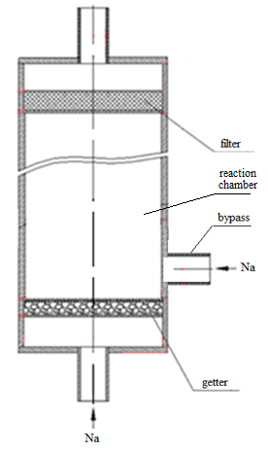

*FIG. 9. Module of chemisorption purification.*

As follows from Figure 10, during 20 hours of operation of the chemisorption module, the oxygen concentration in sodium was reduced by 12 ppm, which corresponds to the consumption of 4.5 g of magnesium. To obtain data on the removal of magnesium into sodium loop, a chemical analysis of sodium for magnesium content was performed after the experiment.

Based on the results of the analyses performed, it was found that the magnesium content in metallic sodium is ~ 40 ppm. In terms of all sodium in the circuit, this corresponds to the mass of dissolved magnesium ~ 10 g (the initial loading of magnesium in the chemisorption module is 25 g).

Taking into account the data of analyses of the studied samples and sediments, the mass of magnesium remaining in the inlet chamber is not more than 1.0 g.

In the reaction chamber ~ 4.0 g of magnesium was found. On the filter material ~ 1.0 g of magnesium was found.

Thus, the total mass of magnesium remaining in the module after the tests is ~ 6 g Mg (excluding precipitation on the module walls and gratings). According to the results of all analyses and chemical reaction 20.5 g of magnesium were found, 4.5 g of magnesium were not found. The data obtained indicate that the greater part of magnesium entered sodium of the circuit, and the filter efficiency turned out to be low.

*FIG. 10. Change in oxygen concentration in sodium during sodium purification by a chemisorption module.*



Purification time, h

Oxygen concentration in sodium, ppm

## 6. Conclusion

As a result of the research, a scientific basis was developed for creating cold traps of an original design for BN-350, BOR-60 and BN-600. Tests with cold traps have shown that they effectively remove oxygen and hydrogen from sodium. Their long-term operation has confirmed the project characteristics.

As a result of the calculated analysis, the values of the operating parameters of the reactor purification system were obtained, while maintaining them, the accumulation of hydrogen in the cold traps of the primary circuit is excluded. The possibility of reducing the number of traps in the primary circuit is shown.

For the version of integrated cold trap with argon cooling the volume of the working cavity is 1.75 m3, the calculated capacity for impurities was 350 kg. When operating the reactor purification system, which includes three cold traps, according to the usual scheme, 20 cold traps replacements are required during the entire operating life of the reactor; if hydrogen entrance into the cold traps of the primary circuit is excluded, only 7 replacements are required. The estimates were for the BN-1200 reactor. Life duration of the reactor is 60 years.

On the basis of calculations using the developed computational codes of thermal-hydraulic and mass transfer processes in a cold trap, solutions are proposed to improve the design of integrated cold trap in order to increase its productivity and capacity for impurities.

Studies of sodium purification with a soluble getter and high-temperature getter purification have been carried out. A special zirconium alloy is used as a high-temperature getter. The decrease in the concentration of dissolved oxygen in sodium during purification with a zirconium getter over 20 h was about 50 ppm.

Experiments on the purification of sodium from oxygen have shown the possibility of purification using a soluble getter. For 20 hours of operation of the chemisorption module the oxygen concentration in sodium was reduced by 12 ppm (3 g of oxygen). With the initial mass of magnesium 25 g, 4.5 g reacted with oxygen, 10 g dissolved in sodium and 6 g remained in the module.

References

1. Kozlov F.A., Volchkov L.G., Kuznetsov E.K. et al. Liquid metal coolants for nuclear power plants. Purification from impurities and their control / Ed. Dr. tech. sci. Kozlov F.A. - M .: Energoatomizdat, 1983.
2. Kozlov F.A., Alekseev V.V., Zagorulko Yu.I. et al. Results of the development of sodium technology as a coolant for fast reactors (BN) // Teploenergetika. - 2007. - No. 12.
3. Rachkov V.I., Poplavsky V.M., Tsibulya A.M. et al. Concept of an improved sodium-cooled fast reactor // Atomic Energy. - 2010. - T. 108. - Issue. 4. - S. 201-206.
4. Vasiliev B.A., Vasyaev A.V., Zverev D.L. et al. An innovative project of the BN 1200 power unit as the basis for the evolutionary development of the BN direction. Abstracts of the IV International Scientific and Technical Conference "Innovative Projects and Technologies of Nuclear Energy (MNTK NIKIET-2016)", JSC NIKIET, (September 27-30, 2016, Moscow). – M .: Publishing house of JSC NIKIET ", 2016. - S. 38-40.
5. Kozlov F.A., Alekseev V.V., Kovalev Yu.P. et al. Investigations to substantiate the sodium purification system for promising fast reactors // Atomic Energy. - 2012. - T. 112. - Issue. 1. - S. 18-24.
6. Alekseev V.V., Kovalev Yu.P., Kalyakin S.G. et al. Sodium coolant purification system for NPP with BN-1200 reactor // Teploenergetika. - 2013. - No. 5. - P. 9-20.
7. Kalyakin S.G., Kozlov F.A., Sorokin A.P. et al. Research to substantiate the sodium purification system built into the reactor vessel. Izvestiya vuzov. Nuclear power. - 2014. - No. 2. - S. 81-89.
8. Sorokin A.P., Trufanov A.A. Purification of fast reactors sodium // Problems of Atomic Science and Technology. Series: Nuclear-Reactor Constants, 2017. Issue 3. El. resource. https://vant.ippe.ru/year2017/3/thermal-physics-hydrodynamics/1381-12.html.
9. Varseev E.V., Konovalov M.A., Alekseev V.V. Results of numerical simulation of heat and mass transfer in a cold trap model // Problems of Atomic Science and Technology. Series: nuclear reactor constants. - 2014. - No. 2. - S. 105-112.
10. Alekseev V.V., Kozlov F.A., Sorokin A.P. et al. Calculations of the mass transfer of impurities in cold traps with sodium cooling // Atomic Energy. - 2015. - T. 118. - Issue. 5. - S. 257-261.
11. Alekseev V.V., Kozlov F.A., Sorokin A.P. et al. Calculations of the mass transfer of impurities in cold traps with sodium cooling / Coll. reports of the scientific and technical conference "Thermal physics of fast reactors (Thermophysics-2014)" / Ed. ed. A.P. Sorokin, A.A. Trufanov. - Obninsk: State Research Center of the Russian Federation - IPPE, 2015. - P. 380–385.
12. Kozlov F.A., Sorokin A.P., Trufanov A.A. et al. Tests on a sodium loop of the cold trap model // Atomic Energy. - 2017. - T. 122. - No. 1. - S. 29-33.
13. Kozlov F.A., Volchkov L.G. A new method for the regeneration of traps for purification alkaline liquid-metal coolants // Atomic Energy. - 1975. - T. 39. - Issue. 4. - P. 310.
14. Kozlov F.A., Kuznetsov E.K. Purification of sodium from oxygen using hot traps. // Liquid metals. Collection of articles edited by Ph.D. P.L. Kirillova, D.Sc. V.I.Subbotina, P.A.Ushakova, M., Atomizdat, 1967, P. 340-355.

1. A diffusion trap is a device in which an impurity accumulates due to diffusion from the sodium to be purified.