numerical investigation of cellular

convection in the cover gas space of

fast breeder test reactor

K. CHATURVEDI, A.K. CHAUHAN, K. NATESAN, K.V. SURESH KUMAR
Indira Gandhi Centre for Atomic Research, Department of Atomic Energy
Kalpakkam, Tamil Nadu, India
Email: kchaturvedi@igcar.gov.in

Abstract

Tilting of reactor vessel and other components due to circumferential temperature gradient is a critical safety and operational issue in loop type Fast Reactors. Natural convection of reactor cover gas developed in the narrow component penetrations is the main cause for such a phenomenon. Numerical analyses have been carried out using a CFD based computational tool to systematically investigate the possibility for development of circumferential temperature gradient in the reactor vessel of Fast Breeder Test Reactor (FBTR). The computational model which accounts for all the three modes of heat transfer has been validated against experimental results from a mock-up experimental study as well as measured data from the plant. Parametric studies have been carried out to bring out the influences of (i) physical barriers provided in the reactor, (ii) specific operational conditions of top shield cooling and biological shield cooling, and (iii) cover gas medium on the nature of circumferential temperature gradient developed in the reactor vessel.

INTRODUCTION
Fast reactor systems operate at low pressures due to which the components of these systems are very thin (~ 10 – 15 mm). In pool type reactors, the primary circuit components are located within the reactor vessel itself supported over the top cover (top shield) of the vessel forming narrow annular penetration gaps filled with the cover gas of the reactor vessel. In loop type reactors, these components are located outside the reactor vessel and with similar support arrangements. Tilting of reactor vessel during operation is observed under some conditions leading to operational and safety issues. This tilt is due to turbulent natural convection of cover gas in narrow penetrations which establishes as cellular in nature resulting in development of azimuthal temperature gradient in the structure.
Fast Breeder Test Reactor (FBTR) (Fig. 1) is a loop-type sodium cooled fast reactor system, rated at 40 MWt and 13 MWe power. Liquid sodium in the primary system extracts heat from the core and transfers to steam water system through an intermediate sodium loop, called secondary sodium circuit. Steam produced runs a turbo-generator and produces electric power. Reactor vessel of FBTR (Fig. 2) is supported at the top on structural concrete and can expand vertically downwards in response to temperature variations in the system. The reactor vessel is located below the ground level and is filled with liquid sodium from bottom till – 4450 mm elevation. There is an argon cover gas environment above this elevation, that extends well within the penetration gaps formed by the rotating plugs. The rotating plugs act as biological shield for the reactor vessel towards to the top. Reactor vessel is enveloped within a safety vessel to ensure the safety with respect to sodium leakage. The safety vessel is enclosed by borated-concrete containment on the sides and at the bottom. The reactor vessel is a 15 mm thick slender component. Because of the axial temperature gradient prevailing in the cover gas space, there would be strong turbulent natural convection developed in this region. Moreover, in the penetration gaps formed between the reactor vessel and rotating plug, natural convection of argon takes place. Because of the narrow gap of this penetration, the type of convection developed in the annular space is expected to be cellular in nature. When the width of the enclosure (e) reduces or the height of the enclosure (H) increases (i.e., as the aspect ratio, e/H reduces) the hot wall and cold wall boundary layers approach each other. At one value of aspect ratio, both the boundary layers would interact. This interaction is the condition for onset break down of symmetry in the flow structure leading to asymmetric or cellular convection [1].
Because of the complex nature of cellular convection, experimental studies have to be carried out on full scale models [2 – 4] to assess its effect on the plant components. The approach generally adopted in design is a combination of experimental and theoretical analyses. Experimental studies are used for the validation of theoretical models and design prediction are made using the validated theoretical models [5 – 7]. In order to study how cellular convection affects the FBTR operation, three dimensional computational fluid dynamics investigations have been carried out. The numerical model developed is capable of predicting the thermal hydraulic behaviour of cover gas in the penetration space of FBTR reactor vessel under different conditions.

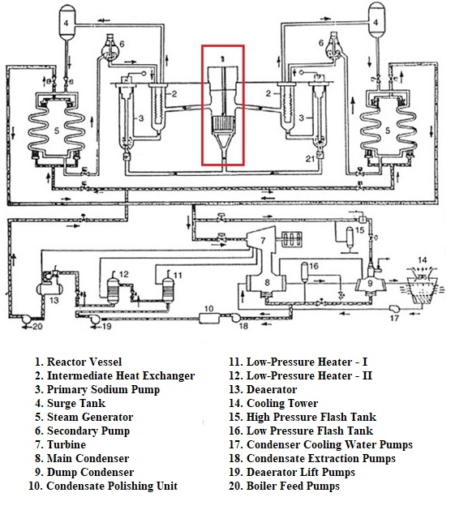
FIG. 1. Heat transport circuit of FBTR
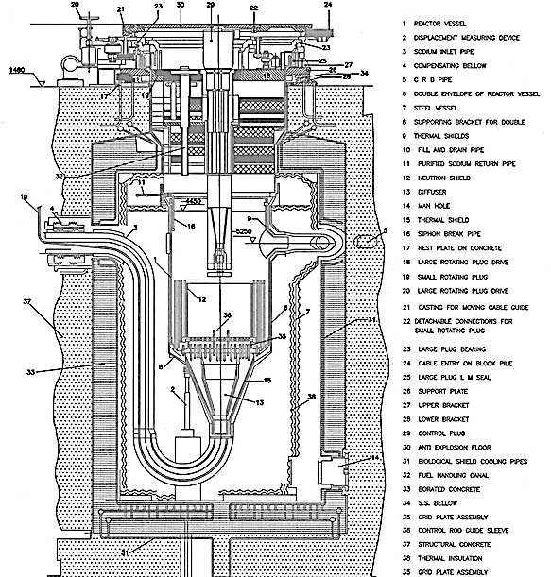
FIG. 2. Reactor Assembly of FBTR

Numerical methodology

Development of numerical model
Mathematical modelling of cellular convection requires simultaneous solution of the equations of conservation of mass, momentum and energy [8]. In cartesian coordinates, these equations are as follows:

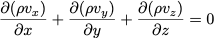 | … (1)
 | … (2)
 | … (3)
 | … (4)
 | … (5)
Here ρ is fluid density; v_{x}, v_{y} and v_{z} are velocities in x, y and z direction; p is absolute pressure; τ_{xx}, τ_{yx}, τ_{zx}, τ_{xy}, τ_{yy}, τ_{zy}, τ_{xz}, τ_{yz} and τ_{zz} are shear stress tensors; g_{x}, g_{y} and g_{z} are body forces in x, y and z directions; C_{p} is fluid specific heat capacity; T is absolute temperature; q_{x}, q_{y} and q_{z} are heat fluxes in x, y and z directions. Shear stress tensors are approximated using different turbulence models. Radiative mode of heat transfer between two surfaces, is calculated by:
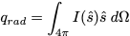 | … (6)
Here Ω is the solid angle in steradian, and I ($\hat{s}$) is the net radiative intensity or summation of the radiative energy in the direction $\hat{s}$. Radiative intensity can be approximated using different radiation models. Physical properties of the fluid, i.e., viscosity and thermal conductivity are solved as polynomial functions of temperature, while thermal conductivity of the solid is solved as a linear function with temperature. The conservation equations are discretized to second order and solved using SIMPLE algorithm [9]. Mesh generation for the computational domain ensures a fine resolution on the wall of fluid domain, so that the wall y⁺= 1. The wall y⁺ value near the wall is to be ensured in the range of 1 in order to accurately resolve the near wall effects.

Validation
Experimental data from COBA facility is used to validate the numerical methodology [10]. COBA facility (Fig. 3) is a mock-up facility for the cover gas space of FBTR which is set up at Indira Gandhi Centre for Atomic Research, Kalpakkam. The bottom surface of the cover gas space in the COBA facility is maintained at 530°C, while the top is maintained at 495°C to mimic the axial temperature gradient that develops in FBTR. A 3-D computational model of the facility was created, and grid was generated with an exceptionally fine mesh near the wall such that y⁺ ≤ 1. Surface emissivity of 0.6 and ambient temperature of 40°C is considered in the validation exercise. Temperature profile along the enclosing vessel at plug bottom elevation (Fig. 4) is compared against the experimental data. Formation of single convective loop is predicted by the model similar to that observed in the experiment. An average temperature of 230°C against experimental value of 262°C and maximum temperature asymmetry of 45°C against 44°C at plug bottom is evaluated. The formation of single cellular convection loop is predicted correctly by the model as observed in the experiment. The simulation results show a maximum of ± 20% deviation from experimental data, which can be attributed to assumptions that were made for physical properties, mathematical modelling and numerical inaccuracy. The validation exercise, however, provides confidence to adopt the numerical approach for further studies in view of the its prediction capability with respect to number of convective loops and the magnitude of circumferential temperature gradient.

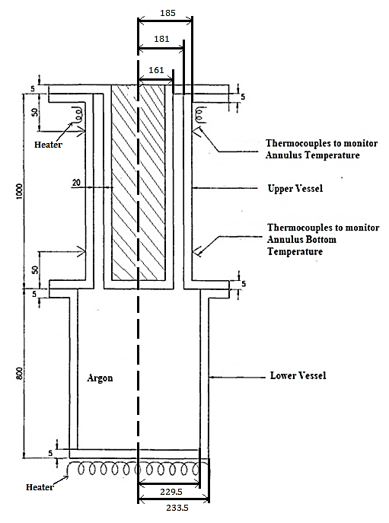 | 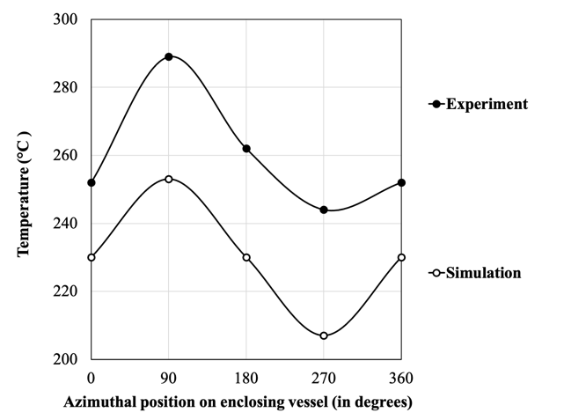
FIG. 3. Schematic of COBA facility | FIG. 4. Circumferential temperature distribution in the enclosing vessel at plug bottom

Selection of turbulence model
Turbulence characteristics of the flow domain is generally solved using Reynolds Averaged Navier Stokes (RANS) approach. Some of the popular RANS based turbulence models are – Standard k-ε, RNG k-ε, Realizable k-ε, Low-Re k-ε, Standard k-ω, and SST k-ω. In order to study the sensitivity of turbulence model and their suitability for simulation of cellular convection, studies have been carried out with respect to COBA experiment using different turbulence models. A comparison of temperature profiles along the enclosing vessel at plug bottom (Fig. 5) predicted by various turbulence models shows that the predictions are very close. However, the prediction by Realizable k-ε turbulence model with respect to the circumferential temperature gradient is closest with the experimental data and hence adopted for further studies.

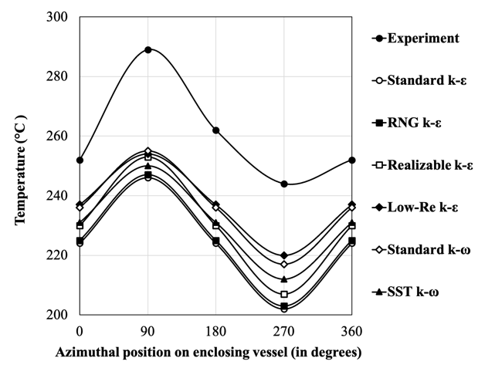
FIG. 5. Comparison of circumferential temperature distribution in the enclosing vessel at plug bottom for different turbulence models

Selection of radiation model
The fluid medium in the reactor vessel is considered as non – participating. Also, due to thin annular spaces in the system, radiation modelling methods like Rosse land and P-1 cannot be used [11]. The radiation heat transfer can be modeled by Discrete Transfer Radiation Model (DTRM), Surface to Surface (S2S) and Discrete Order (DO) model. In order to study the sensitivity of radiation model, analysis is carried out using various models and compared against COBA experimental data. A comparison of temperature profiles along the enclosing vessel at plug bottom (Fig. 6) predicted by these models shows that the simulation results are remarkably similar. However, DTRM and S2S are very time-consuming methods for systems with fine grid size. Hence, the DO model is considered for further studies.

Effect of surface emissivity
With time, solid surfaces get affected by deposition and corrosion, which influences the surface emissivity. Emissivity of stainless steel with polished surface is 0.2. However due to oxide layer on the surface that forms with time, emissivity rises to 0.6. In order to study the effect of surface emissivity on the predictions, analysis is carried out with different emissivity considered for the solid walls in the domain. A comparison of predicted temperature profiles along the enclosing vessel at plug bottom (Fig. 7) shows that with an increase in surface emissivity, the average temperature and the temperature asymmetry also increase. Considering the ageing factor of the solid walls, the optimum value of emissivity is chosen as 0.6. The results also show that the uncertainty in the emissivity parameter is one of the main contributor for the theoretical prediction of average temperature of vessel to deviate from the experimental data.

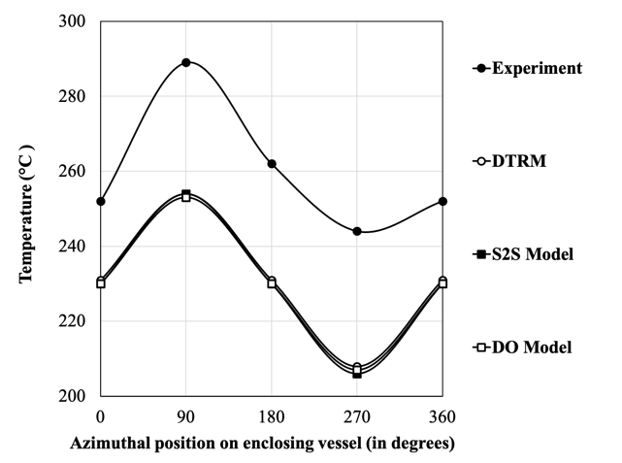 | 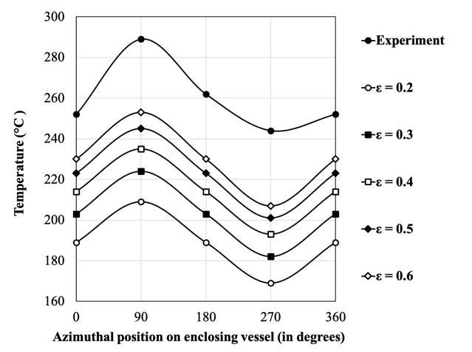
FIG. 6. Comparison of circumferential temperature distribution in the enclosing vessel at plug bottom for different radiation models | FIG. 7. Comparison of circumferential temperature distribution in the enclosing vessel at plug bottom for different surface emissivity

ANALYSIS OF cellular convection in FBtr
In FBTR reactor vessel (Fig. 8), liquid sodium surface acts as the heat source to the cover gas space whose temperature depends on the operating state of the reactor. Heat sinks for the system include the water cooling circuit on the radial biological shield (called as the Biological Shield Cooling or BSC circuit), the nitrogen cooling circuit of rotating plugs (called as the Rotating Plugs Cooling or RPC circuit) and the ambient atmosphere of the Reactor Containment Building (RCB) at the top. An isothermal condition was imposed on the sodium free surface at 200°C that corresponds to cold shutdown state of the reactor. It is also assumed that the BSC circuit is in operation with cooling water at 25°C, the RPC circuit is in poised state with stagnant nitrogen, and the ambient temperature of RCB atmosphere is assumed to be 40°C. The boundary conditions for the model are shown in Fig. 9. Mesh generation was done keeping wall y⁺ = 1 (Fig. 10). Temperature profile predicted along the reactor vessel at plug bottom (at – 3600 mm) is shown in Fig. 11. The average and maximum temperature value predicted from numerical simulations are 91°C and 42°C, while the measured values of the same at FBTR are 93°C and 50°C, respectively. Thus, the simulation results show good match with the plant data. Cellular convection velocity pattern of argon developed in the annulus between reactor vessel and rotating plug is shown in Fig. 12. Formation of single convective cell can be clearly seen in the figure. The corresponding temperature contour on the reactor vessel is shown in Fig. 13. Circumferential temperature distributions on the reactor vessel at various elevations with respect to ground level (el. + 0.0 mm) are shown in Fig. 14. It can be observed that the temperature asymmetry is maximum at the plug bottom.
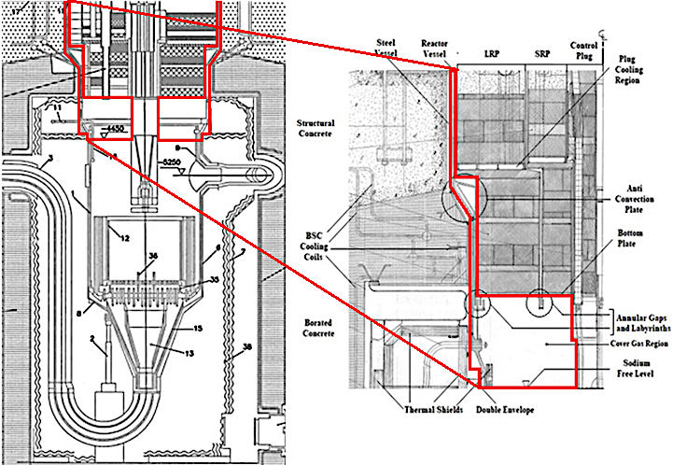
FIG. 8. The cover gas region of FBTR reactor vessel
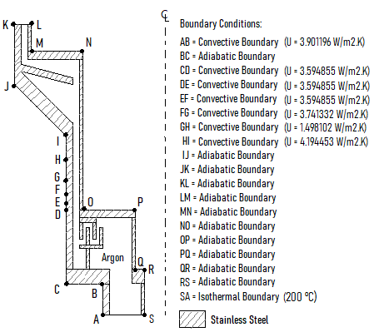
FIG. 9. Schematic of the computational domain with boundary conditions
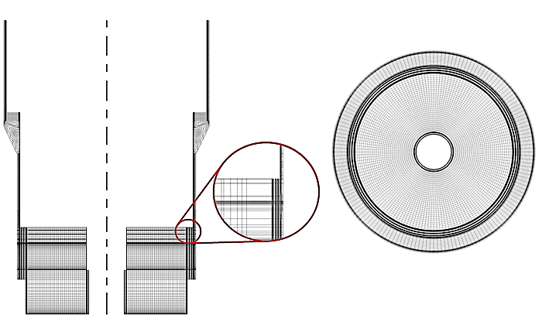
(a) |  | (b)
FIG. 10. Mesh generated for FBTR model – (a) Side View, and (b) Top View
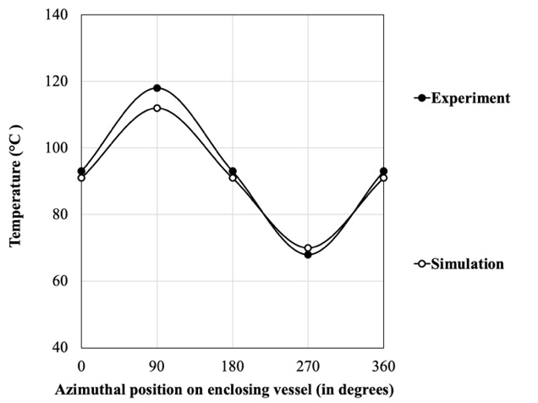 | 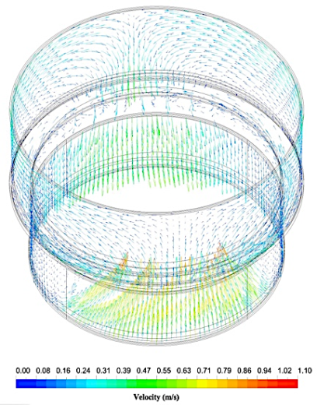
FIG. 11. Circumferential temperature distribution in the reactor vessel at plug bottom | FIG. 12. Convection currents in annular penetration gaps of rotating plugs
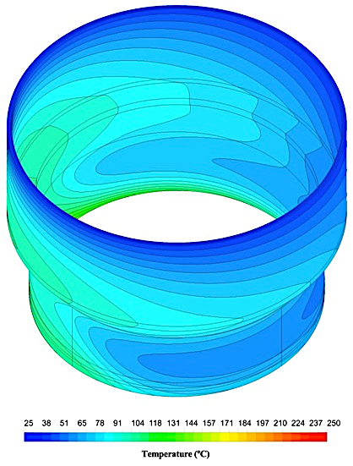 | 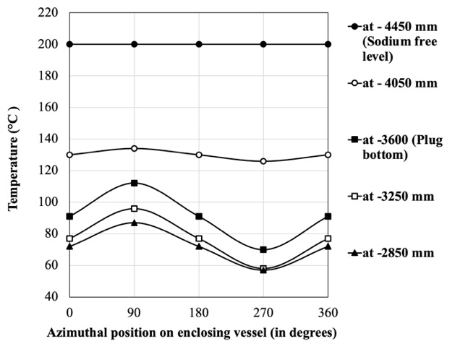
FIG. 13. Temperature profile in the reactor vessel near rotating plugs | FIG. 14. Circumferential temperature distribution in the reactor vessel at different elevations

Parametric Studies on controlling cellular convection in FBTR

Provision of physical barriers in the penetration
FBTR reactor vessel is provided with two physical barriers in the annular penetration between reactor vessel and rotating plugs, viz., a labyrinth arrangement near penetration opening at plug bottom and an anti-convection plate inside the annular penetration above the plug bottom. To study the effectiveness of these barriers, a parametric study has been carried by considering the following cases:

- Without any physical barrier
- With labyrinth and no anti – convection plate
- With anti – convection plate and no labyrinth
- With both labyrinth and anti – convection plate

Predicted circumferential temperature distributions in the reactor vessel at the plug bottom for all the four cases are shown in Fig. 15. It is evident that the average temperature and maximum circumferential temperature gradient in the reactor vessel are113°C and 46°C respectively when on barriers are present in the annulus. The above parameters reduce to ~95°C and ~42°C, respectively when labyrinth alone is added as physical barrier. However, the average temperature increases to ~120°C and the circumferential temperature gradient reduces to 30°C when anti-convection plate alone is present. It is observed that average temperature and maximum temperature asymmetry reduces to 89°C and ~ 42°C, respectively when both physical barriers are present. Thus, it can be inferred that labyrinth provided at the bottom of the annulus is effective in reducing the average temperature of the vessel at the plug bottom due to the resistance offered by it to the natural convective flow. However, when anti convection barrier alone is present, the circumferential temperature gradient reduces due to the effective reduction in the height of the annulus. It should be noted that the anti-convection barrier is located well above the plug bottom. When both the devices are present, the net effect is dominated by that due to labyrinth as the anti-convection barrier is located well above the labyrinth.

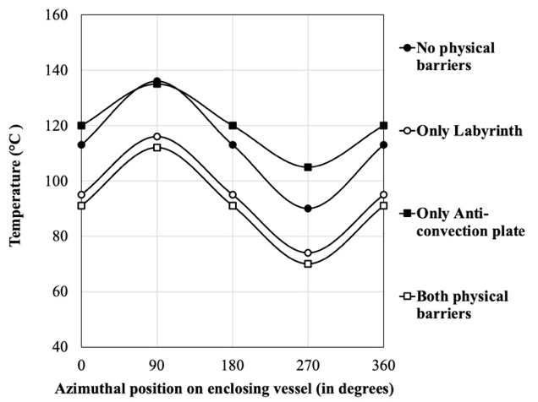
FIG. 15. Comparison of circumferential temperature distribution in the reactor vessel at plug bottom for different configurations of physical barriers in the annulus between reactor vessel and plug

Cooling of radial biological shielding by BSC circuit
The BSC circuit of FBTR cools the borated concrete surrounding the reactor vessel using a network of 180 tubes along the circumference and located 70 mm inside the concrete from the inner wall. The cooling water maintains the concrete temperature below 80 °C by manipulating water inlet temperature (using heat exchanger that uses service water or chilled water as per requirement). As the reactor vessel develops an azimuthal temperature distribution, the radially placed borated concrete also develops a similar temperature profile. It is then needed to reduce temperature asymmetry in concrete and also to keep the average temperature within the limit. The minimum possible value of water inlet temperature is 18 °C. Hence, temperature control of concrete is achieved by throttling the flow in regions of lower temperature.
The effect of selective throttling of BSC system is studied by dividing the CFD model into four equal sectors in the circumferential direction. Four cases have been analyzed. In the first, BSC circuit is considered to be supplied with nominal flow rate. Temperature distribution of reactor vessel at the plug bottom was obtained. Based on the predicted profile, the BSC flow rate through the sector in which lowest temperature for the reactor vessel is predicted is reduced to 75 %, 50 % and 25 % of nominal flow rate. Flow through other sectors is maintained at nominal condition. In order to study these cases, the heat transfer coefficient of the convective boundary condition representing the BSC cooling is specified with values corresponding to the required flow rate. A comparison of temperature profiles along the reactor vessel predicted at the plug bottom for the four cases (Fig. 16) shows that the average temperature marginally increases (from 91°C to 92°C), while the maximum temperature asymmetry reduces (from 42°C to 36°C) as the flow is throttled from 100% to 25% of the nominal value. Thus, by selective adjustment of the cooling of BSC system the circumferential temperature gradient on the reactor vessel could be managed to some extent.
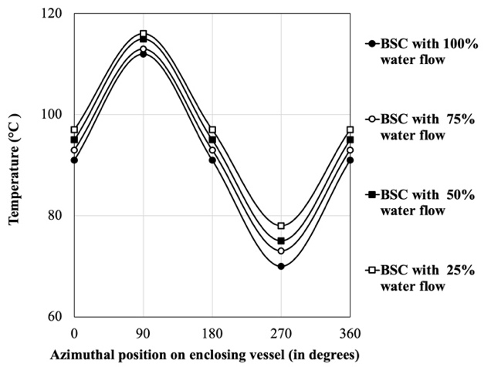
FIG. 16. Comparison of circumferential temperature distribution in the along reactor vessel at plug bottom for different cases of BSC flow-throttling

Using helium as cover gas medium
Helium is an inert gas and alternate option to argon, which can be considered for cover gas. A simulation is carried out by considering helium as cover gas. Helium has thermal diffusivity about 10 times larger than that of argon. Hence, the system Rayleigh number shall be about one-tenth, and convective turbulence weaker with helium than that with argon as the cover gas medium. A comparison of temperature profiles along the reactor vessel at plug bottom elevation for the two cases of cover gas medium (Fig. 17) shows that the average temperature increases (from 91°C to 103°C), while the maximum temperature asymmetry reduces (from 42°C to 16°C), as the cover gas medium of the system is changed from argon to helium. Temperature distribution along reactor vessel is shown in Fig. 18, where thermal homogenization in the system due to helium is clearly visible.

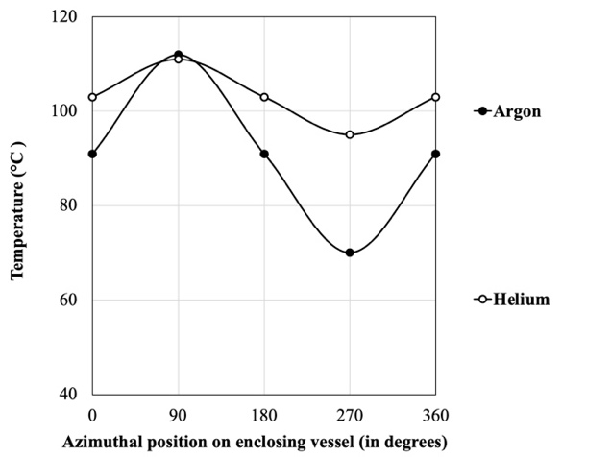 | 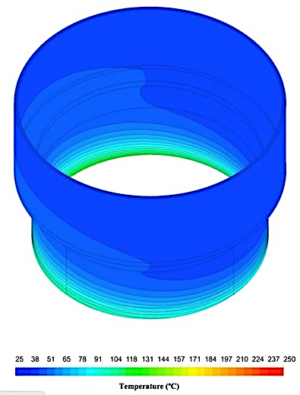
FIG. 17. Circumferential temperature distribution in the reactor vessel at plug bottom when helium is used as cover gas medium | FIG. 18. Temperature profile in the reactor vessel near rotating plugs when helium is used as cover gas medium

Conclusions
The development of cellular convection in the annular penetration gap between reactor vessel and rotating plug of FBTR, which causes tilting of the vessel, has been analysed using a three dimensional CFD model. The numerical model has been validated against experimental data from the COBA mock-up facility. Moreover, validation has also been carried out with respect to plant data during FBTR operation corresponding to cold shutdown state of the reactor. It is found that the cover gas of FBTR develops cellular convection in the penetration annulus with single loop formed, due to which the reactor vessel develops a circumferential temperature gradient. The asymmetry in circumferential temperature is found be maximum (42°C) at the bottom of the annulus. Parametric studies have been carried out to investigate the effectiveness of various methods for reducing the cellular convection in FBTR. It is seen that presence of physical barriers inside the annular penetration gaps are effective in bringing down the temperature asymmetry and the ideal location for them is the bottom of the annulus. By selective throttling of biological shield cooling in the sector where lowest temperature is observed in the reactor vessel, the effect of cellular convection could be significantly lowered. Another study has been carried out by considering helium as the cover gas medium instead of argon. It is seen that with helium as the cover gas medium, the circumferential temperature gradient in the reactor vessel could be reduced from 42°C to 16°C.
References
- GOLDSTEIN, S., JOLY, J., VIDARD, M., “Thermal analysis of the penetrations of a LMFBR”, presented at 5thInternational Conference on Structural Mechanics in Reactor Technology, Berlin, 1979.
- BALDASSARI, J.P., DURIN, M., SEVERI, Y., PRADEL, P., Open azimuthal thermosyphon in annular space – comparisons of experimental and numerical results, Abb. Liquid metal engineering and tech. (1984) 463 – 467.
- ROUX, S., ELIE, D., Comparison between measurement and computational analysis on open azimuthal thermosyphons in annular space of the Lilliput model, Abb. Liquid metal engineering and tech.(1988) 411 – 412.
- LENOIR, G., DALLONGEVILLES, M., GOLDSTEIN, S., VIDARD,M., “Thermal hydraulics of the annular spaces in roof slab penetrations at liquid sodium cooled fast breeder reactor”, presented at 6thInternational Conference on Structural Mechanics in Reactor Technology, Paris, 1981.
- YAMAKAWA, M., SAKAI, T., KAWASHIMA, H, SAKURAI, A., HATTORI S., Analysis of natural convection in narrow annular gaps of LMFBR, Abb. Journal of Nuclear Science and Technology, Vol. 23. Part. 5. (1986) 451 – 460.
- TODA, S., KUROKAWA, M., HORI, Y., SATOH, H., “Natural convection in a vertical narrow annular gap”, presented at 9thInternational Heat Transfer Conference, Jerusalem, 1990.
- FRANCOIS, G., AZARIAN, G., “SUPER PHENIX reactor block thermal hydraulic behaviour comparison between calculations and experimental results”, presented 10th International Conference on Structural Mechanics in Reactor Technology, Lyon, (1989).
- BIRD, R.B., STEWART, W.E., LIGHTFOOT E.N., TRANSPORT PHENOMENA, Second Edition, John Wiley and Sons, Inc., New York, U.S.A. (2006).
- PATANKAR, S.V., NUMERICAL HEAT TRANSFER AND FLUID FLOW, First Edition, CRC Press, Boca Raton, U.S.A. (1980).
- HEMANATH, M.G., MEIKANDAMURTHY, C., NATURAL CONVECTION IN THE ANNULUS MODEL (WITHOUT SODIUM AEROSOL), Internal Report, Indira Gandhi Centre for Atomic Research, Kalpakkam, 2005.
- MODEST, M.F., RADIATIVE HEAT TRANSFER, Second Edition, Academic Press, San Diego, U.S.A. (2003)

