CREATE: A CONCEPTUAL FRAMEWORK FOR THE EFFECTIVE DEPLOYMENT OF GEN IV REACTORS

B.J. WILCOX
College of Nuclear Science and Technology
Harbin Engineering University
Heilongjiang, China.
Nigeria Atomic Energy Commission
Abuja, F.C.T, NIGERIA
Email: infojwilcox@gmail.com

A. AYODEJI
State Key Laboratory of Industrial Control Technology, College of Control Science and Engineering
Zhejiang University
Hangzhou, China.
Nigeria Atomic Energy Commission
Abuja, F.C.T, NIGERIA
Email: ayod_abe@yahoo.com

Abstract

The generation IV reactors are the recent innovative reactor designs being developed to address the safety, sustainability, economics and proliferation issues with conventional reactors. To ensure public acceptance, novel thinking on methods to effectively promote the reactors is critical. This is to consistently demonstrate the Gen IV reactor improvements and to counter the prevailing nuclear narrative. To this end, this paper presents a conceptual framework termed CREATE (C – Collaborate, R – Renaissance, E – Engage, A – Advertise, T – Tools, and E – Educate), for effective introduction and deployment of Gen IV reactors. The paper describes the CREATE approach, and how its implementation could enhance Gen IV reactor acceptance. The paper also discusses possible implementation bottlenecks and the way forward to achieve efficient implementation of the approach.

INTRODUCTION
Nuclear energy has been successfully demonstrated to be a safe, reliable and environmentally-friendly energy source for more than 70 years. Nuclear energy presently accounts for about 10% of the world's electricity from about 440 power reactors, and also the world's second-largest source of low-carbon power [2]. Moreover, the baseload power provided by the reactors has raised the living standards around the world [1]. However, the “nuclear weapon effect”, and the relatively recent Fukushima accident has renewed public concern about the safety of conventional reactors.
The safety and environmental concerns have spurred innovative research into the study of advanced reactor and alternative reactor fuel. The generation IV (Gen IV) reactors are the recent innovative reactor designs presented to address the issues with conventional reactors. Beyond the improvements in the recently commissioned Gen III⁺ reactor design [2], the Gen IV reactor designs offer a significant improvement on the established technologies and places important considerations for plant simplicity, passive safety, the economics of operation, proliferation resistance, and physical protection. The Gen IV nuclear energy systems also provide a clean source of long-term energy with minimized nuclear waste, a clear lifetime cost advantage over other energy sources, and a low likelihood of reactor core damage. Moreover, the reactor fuel is unattractive for weapon development, thereby reducing the likelihood of acts of nuclear terrorism [3]. However, it is predictable that the public distrust of nuclear energy would dampen the expected enthusiasm and acceptance of the new designs. Moreover, the inadequate, conventional public engagement strategy by the nuclear industry further mystifies the novel approach and innovative solutions provided by the new generation reactors.
To effectively engage the public and stakeholders on the improvements presented by the new generation reactors, and to counter the prevalent nuclear narrative, there’s a need for a new, robust and effective engagement approach. That is, the generation IV reactors need to be productized, with robust, multi-layer product unveiling tools to support their introduction and improve public acceptance.
To this end, this work presents an approach termed CREATE (Collaborate, Renaissance, Engage, Advertise, Tools, and Educate), to facilitate a consistent demonstration of the Gen IV reactor design improvements and to reshape the existing nuclear narrative. The CREATE approach is a robust conceptual framework that presents a multi-layer actionable step for the effective introduction of the Gen IV reactors. The following sections contain a brief description of each step of the approach and the actionable plans to aid their implementation.

Method

2.1 The CREATE approach

2.1.1 Collaborate
The international collaboration on the peaceful use of atomic energy under the auspices of IAEA remains the most potent strength of the nuclear industry to date. Although there are many other collaboration and joint efforts between and among member states on shared objectives across the nuclear industry, there is a need for special collaborative promotional efforts, especially for Gen IV reactors. Several reasons favour collaborative effort, among which is the transboundary effect of a nuclear incident and the subtle isolating reaction in the industry. For instance, within the nuclear industry, the Chernobyl accident is largely viewed as a “Russian accident”, the three-mile island, the “USA accident”, and recently, the Fukushima is largely viewed as the “Japanese accident”. Incidentally, the global perspective and the effect of these accidents are trans-national, ranging from halting nuclear plant construction, cancellation of nuclear contracts and outright shift in energy policy in favour of other less efficient sources.
The design, development and promotion of Gen IV reactors must be viewed as a common good that warrants joint effort and international collaboration across states and vendors to promote not only the safety improvements in Gen IV reactors but also to establish the link between the technology and the society. As shown in Figure 1, there are some existing international collaboration on the Gen IV reactor development, such as the Gen IV forum, the International Nuclear Regulators Association (INRA), the Cooperation in Reactor Design Evaluation and Licensing (CORDEL), and Multinational Design Evaluation Programme (MDEP), among others. However, these fora mainly comprise Tier 1 (traditional nuclear states and nuclear technology exporters) and Tier 2 (states with sound nuclear experience) countries. A robust collaborative effort required for effective and successful Gen IV deployment would require a stronger link that goes beyond the traditional allies to the rest of the member state, through the IAEA. This will enable a truly international effort towards the promotion of technology-specific regulation, standardization, and harmonized safety and regulatory requirements towards a widely acceptable Gen IV design.
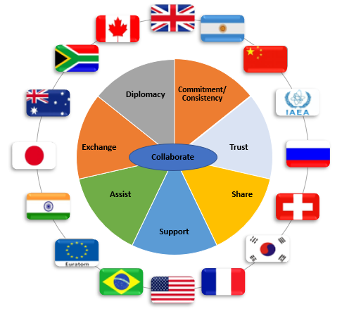
FIG. 1. Effective collaboration for Gen IV reactor promotion

2.1.2. Renaissance
The nuclear renaissance between 2001-2011 significantly improves the public perception of nuclear energy. This period witnessed a relative increase in the debate about nuclear energy, construction of new reactors and formulation of new policies that support nuclear new build. The resurgence of interest in nuclear energy is partly because of the active engagement and promotion of nuclear benefits, and the presentation of nuclear energy as a solution to the global problem of climate change. However, amid other issues, the resurgence in nuclear disinformation and the industry lethargy introduced by the Fukushima accident affected the nuclear trajectory.
According to the US Energy Information Administration, 9.1 GW of electric generating capacity is scheduled to retire in 2021 with five nuclear plants on the shutdown list accounting for 56% of total electricity capacity retirement as a result of increasing competition from renewable energy [4]. In the EU, the International Energy Agency estimates that following the current trend, nuclear capacity in 2040 will amount to 455 GW – well below the Sustainable Development Scenarios level of 601 GW [5]. With the nuclear phase-out in Germany and Switzerland, high nuclear energy policy uncertainty persists as governments spar with climate objectives, political pledges, public opinion, and cost of electricity supply [6].
For an industry in need of revival, investments in nuclear as of 2018 was at a five-year low and in 2020 investment estimates still point to a record slump [7]. Compared with other critical industries with major mishaps such as aerospace, the fallout of the Fukushima accident has a more devastating effect on the nuclear renaissance, and we hypothesize that this is caused by the general perception of nuclear power as a disposable service. Hence, towards the revival of the nuclear industry, the technical, safety and economic improvements in the Gen IV reactors need to be presented in a manner that would spur another nuclear renaissance, this time not as an alternative renewable source, but as a unique product with incomparable benefits. Towards a sustainable nuclear renaissance, Fig 2 below summarizes various aspects in dare need of new, compelling narration. Elaborating on each of the aspects is beyond the scope of the current work but it is hoped to encourage new thinking on renewed nuclear renaissance strategy.
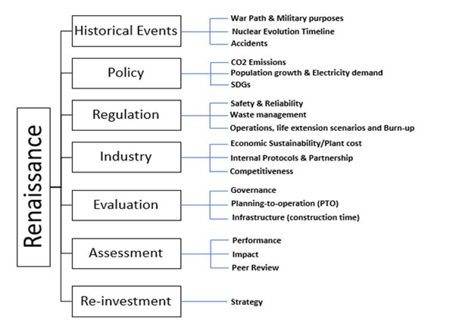
FIG. 2. The renaissance strategy implementation chart

2.1.3. Engage
To the lay people, the word “nuclear power” is still synonymous with the yore of hapless disasters. Despite the impressive attention to safety and giant strides made in nuclear energy development over the years, public perception is skewed against nuclear power, and the “not in my backyard” disposition is still a trend. Nuclear development feats are back burners in the discourse of the present danger of climate change, challenges of greenhouse gas emissions and sustainable scenarios of increasing electricity demand. Moreover, nuclear energy remains a divisive topic in the public and the believe that the risk outweighs its benefits is prevalent [8]. For new builds, public acceptance is a prerequisite for siting. Therefore, ensuring an improved public acceptance can help to support a consensus.
Hence, given the popularity of anti-nuclear groups and their effectiveness in steering public opinion, the pro-Gen IV engagement has to be robust. To improve acceptance and FastTrack favorable policy on nuclear energy, there is a need for a genuine, dispassionate and accurate narration of the “nuclear story” to policymakers as well as the general public. These stories are better told by people who understand the policies that impact the technical work, and the skill to articulate the narrative in a suitable, subtle and succinct manner devoid of technical jargons, suitable for non-academic policymakers and the general public. These skills are seldom seen in a cluster, hence, as shown in Figure 3, an involved partnership between people with technical expertise and seasoned communicators is necessary for effective engagement.
Moreover, the industry needs substantial investment and collaborative effort in crisis management activities to address disinformation in the nuclear arena, and a public relation campaign to build support for nuclear energy. To support a renewed nuclear renaissance, public engagement would not only be about the enhancements in Gen IV reactors but also to counter the prevailing nuclear narratives. To be effective, seasoned public communicators should be engaged to effectively disseminate the extended benefits of Gen IV reactors beyond electricity, using modern tools.
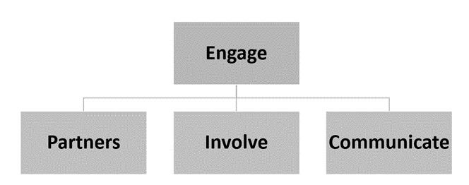
FIG. 3. The engage chart

2.1.4. Advertise
In the ever-changing landscape of today’s world, Gen IV reactors should be seen as a product that needs to be promoted. The need to productize the Gen IV reactors cannot be overstated, and, like every product, the success or otherwise of the product largely depends on consumer awareness. Hence, productizing the Gen IV reactors requires significant investments in advertisements. A survey by the institute of mechanical engineers on the public perception of nuclear power highlighted the demography of nuclear acceptance [9]. The survey also gives an insight into whom the industry has to reach. Significant effort is required in creating an engaging advertisement to generate interest in the Gen IV reactors. Moreover, the Gen IV reactors need to be presented as a solution to everyday problems, and not as a resort to compensate for the inadequacies of other energy sources.
To effectively advertise the Gen IV reactors, a novel approach to selling the nuclear idea is required, as refocusing decades of negative disposition to nuclear power requires new thinking. A robust platform that hosts quality information on the Gen IV progress, phenomenon, and potential public engagement activities, as well as the capability to bust nuclear myths and respond to malicious nuclear rumor, is critical. Moreover, with the advent of social media, the opportunity for refocused attention and social reorientation on nuclear benefits through unconventional means is huge. An instance is the nuclear energy social media influencer (“Isodope”) who uses a bait-and-switch approach to discuss the benefits of nuclear energy [10]. By developing engaging content that breaks down the technicalities of nuclear power into everyday language, such a platform can be utilized to promote the uniqueness of Gen IV reactors. This unconventional approach could also serve the renewed nuclear renaissance.
Another interesting unconventional advertisement is the competition organized by the Gen IV international forum to encourage young scholars and junior researchers to pitch their research on the Gen IV reactor [11]. A selection is made, and the best pitch is publicized on social media for voting. The idea is unique, as it has the potential to redirect attention to the novelty of Gen IV reactors. The competition could also improve young researchers’ scientific communication and persuasion skills, a critical skill required to support a renewed nuclear renaissance. Figure 4 is a flowchart of different aspect that could be considered for effective Gen IV advertisement.
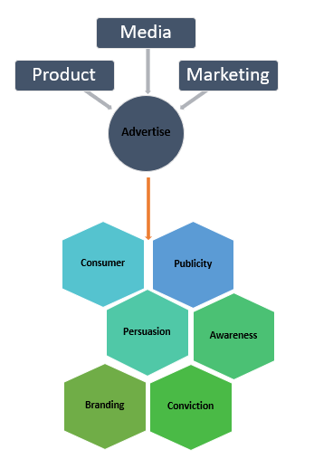
FIG. 4. Effective Gen IV advertisement strategy chart

2.1.5. Tools
The traditional decision-making approach takes a long time. Moreover, making the nuclear decision is mostly influenced by the prevailing politics. To aid nuclear policy and support decision-makers to arrive at a nuclear solution, the industry needs to invest in tools that facilitate nuclear decision support. Necessary tools range from advanced simulation codes and software with the capability to mimic relevant Gen IV phenomenon for pre, during, and post-accident scenario, to intuitive, less technical tools suitable for easy demonstration. The utilization of these tools is to support novel Gen IV research, independent safety assessment, verification and validation, as well as education and training at every stratum of the society.
Industrial application of Artificial Intelligence and augmented reality technology is becoming mainstream. The nuclear industry needs to actively develop AI and VR-based decision support and demonstration tools to demystify and simplify the technological and safety improvements in Gen IV reactors. Moreover, modernized tools useful for safety, safeguard and non-proliferation programs and systems need to be developed. The tools could be standardized as part of promotional packages for vendors. Additional inter-disciplinary tools such as super decision tools that adapt Analytic Hierarchical Process (AHP) and the Analytic Network Process (ANP) for integrated decision using judgment and data to effectively rank options and predict the outcome is necessary. Such predictive analytic tools could also aid regulators and decision-makers in selection reactor types. As outlined below in figure 5, is a view of applicable tool selection criteria for adaptation.
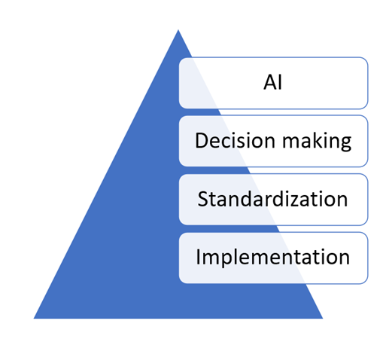
FIG. 5. Adaptative support tools criteria

2.1.6. Educate
Many mysteries surround nuclear technology and affect public reception of nuclear energy. To encourage an open and receptive public disposition, the technology needs to be demystified. First, nuclear knowledge should be decentralized and made a curriculum in secondary school. Outreach programs and community-level sensitization initiatives should be started ahead of the reactor promotion, as opposed to the conventional approach where it is done when decisions have been made and contracts have been signed.
The industry needs to sponsor and actively promote open-source tools and mobile apps or computer games that demystify nuclear technology, for better outreach. In addition to various IAEA training programs, Euratom Gen IV research and training programs, and the GIF initiative, more state-sponsored and international collaborative efforts are required to increase competence, reduce the knowledge gap and improve knowledge sharing. Similar to the ROSATOM education and training programs, and the Japanese Nuclear Education and Research Initiative (GoNERI) [12], national and local educational programs are needed to promote the social aspect of nuclear energy and to engage the public on the link between society and Gen IV reactor technology.
The Internationalization of nuclear education and training have been proposed to increase the appeal of the nuclear field with a need to educate a broad audience of people [13-14]. To deal with gaps in comparative evaluation of education programmes, knowledge management challenges, mentors and mentees, networking and future-proof courses have to be implemented [15-16]. To grapple with loss and fluctuations in expert’s ability and the decline of interests from young scientist.

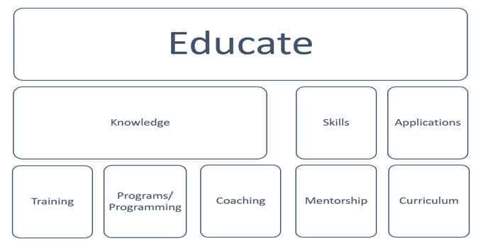
FIG. 6. Effective Gen IV education flowchart

Implementation bottlenecks and potential solution
One of the predictable bottlenecks to the effective productization of Gen IV reactors is the diversity of technology, vendors and stakeholders. To address this bottleneck, and to present an actionable step towards the next generation reactor productization, collaborative solutions need to utilize existing structures in IAEA. Education and engagement bottlenecks could be addressed with a better synergy between industry, research institutions and universities. For the promotion and sponsorship cost for educational tools and mobile apps or computer games that demystify nuclear energy, an open competition that is technology agnostic would significantly reduce the cost of acquiring the most innovative and engaging tools and apps. Dialogue contributing to public discussions and sensitizing people, popular social movements have to be employed and the ambiguity associated with nuclear which discourages participation have to be eliminated. Also, it is of the view that finding new market for new reactor designs can help a decline in the nuclear industry, for without a doubt that nuclear energy has the ability to safeguard the economy, secure rising energy demands and save our planet.

Conclusion
The design and development of Gen IV reactors would provide a robust response to most of the nuclear questions. However, the industry needs to address the existing nuclear lethargy and actively shape the nuclear narrative. This is to ensure that the prevailing nuclear narrative does not becloud the innovative solutions provided by the Gen IV reactor design, as well as ensure public acceptance of the reactor. In this work, we hypothesize that the most efficient way to do it is through a multi-layer approach to productize the Gen IV reactor and spur renewed nuclear renaissance. While techno-scientific data are the forte of experts, the general public are equipped to assess and steer public policy choices which become matters of national and international politics.
To this end, we present the CREATE framework that itemizes activities useful in reshaping the existing narrative, and critical in the effective promotion and deployment of Gen IV reactor. Exploring the framework presented in this work would significantly aid public acceptance, and enhance Gen IV reactor development and deployment.
References
[1] Walker, J. S., Wellock, T. R., A Short History of Nuclear Regulation 1946–2009, US Nuclear Regulatory Commission, United States, 2010.
[2] Olatubosun, S. A., Ayodeji, A., Amidu, M. A., "Safety assessment of AP1000: Common transients, analysis codes and research gaps," Nuclear Engineering and Design, vol. 375 (2021).
[3] Kelly, J. E., "Generation IV International Forum: A Decade of Progress through International Cooperation," Progress in Nuclear Energy, vol.77, pp. 240-246, 2020.
[4] https://www.eia.gov/todayinenergy/detail.php?id=46436.
[5] https://www.iea.org/reports/nuclear-power.
[6] https://www.nucnet.org/news/germany-s-nuclear-phaseout-could-have-significant-impact-11-5-2020
[7] https://www.iea.org/data-and-statistics/charts/global-power-sector-investment-2019-and-2020-compared-with-annual-averagae-investment-needs-by-scenario
[8] Stein, D., Reed, M. E., (2017). U.S. Nuclear Power: Regulatory Barriers and Energy Potential. STRATA. (2021).
[9] https://www.imeche.org/docs/default-source/1-oscar/reports-policy-statements-and-documents/nuclear-power-report-_2019_01_06_web.pdf?sfvrsn=62da8612_2
[10] https://grist.org/energy/this-radiant-model-wants-you-to-stop-worrying-and-love-nuclear-energy/
[11] https://www.gen-4.org/gif/jcms/c_173421/pitch-your-research-competition
[12] Ahn, J., Carson, C., Jensen, M., Juraku, K., Nagasaki, S., Tanaka, S., Reflections on the Fukushima Daiichi Nuclear Accident: Toward Social-Scientific Literacy and Engineering Resilience, SpringerOpen, Berkeley, US (2015).
[13] Van Goethem, G., “Euratom research and training program in Generation-IV systems: Breakthrough technologies to improve sustainability, safety and reliability, socioeconomics, and proliferation resistance” Handbook of Generation IV Nuclear Reactors, Elsevier, 2016.
[14] Varseev, E., “Internationalization of nuclear education and training with the use of nuclear infrastructure and simulation tools”, International Conference for Nuclear Reactor Physics (Proc. 012012, vol. 1689, No. 1ICNRP Volga 2020) In Journal of Physics, IOP Publishing. Moscow (2021).
[15] https://www.iaea.org/services/education-and-training
[16] Nuclear Energy Agency Steering Committee for Nuclear Energy., Proposal for a Global Forum on Nuclear Education, Science, Technology and Policy, Nuclear Energy Agency, Paris, 2020.

