COMPUTATIONAL FLUID DYNAMICS STUDY FOR ESTIMATION OF DILUTION FOR FAILED FUEL LOCATION

Ram Kumar Maity¹, M. Rajendrakumar¹, K. Natesan¹, S. Raghupathy¹

¹Indira Gandhi Centre for Atomic Research, Kalpakkam, India

Email contact of corresponding author: rammaity@igcar.gov.in

Abstract

In a pool type sodium cooled fast reactor, whenever failure of a fuel subassembly is detected by a global delayed neutron detection system, localization of the failed subassembly is done using a Failed Fuel Location Module (FFLM). This is achieved by sampling sodium at exit of each subassembly and looking for presence of delayed neutrons. For a 500 MWe prototype design, as part of this system sampling tubes for each fuel subassembly are installed. In the paper, dilution in concentration of a delayed neutron precursor suffered during sampling of (contaminated) sodium for FFLM system is estimated. In view of the complex hydraulics with multiple interacting jets at varied temperatures and flow rates emanating from numerous subassembly outlets a detailed three dimensional computational fluid dynamic (CFD) study is necessary. The presence of diverse scales (large domain with large number of small structures) makes this study challenging. Towards this, a detailed three dimensional CFD model of a 90º sector of hot pool of reactor has been developed. Such detailed modeling approach allows estimation of dilution for flow from individual subassemblies. The present paper summarizes the dilution estimates from numerous runs for each monitored subassembly. It is seen from the results that species dilution is insignificant for all fuel subassemblies with the maximum dilution predicted being 0.02 %, thus demonstrating reliable and accurate sample collection for failed fuel localization.

INTRODUCTION
In the event of failure of a fuel subassembly (FSA) in the form of clad breach, detection is by global delayed neutron detection systems. These systems detect fission products in primary coolant and cover gas systems. Localization of failed subassembly is done using the Failed Fuel Location Module (FFLM). Localisation is important to enable removal of the failed subassembly and minimise contamination of coolant in primary heat transport system. There are 3 FFLMs housed in Control Plug (CP). A total of 198 subassemblies can be surveyed using FFLM and each module caters to 66 subassembly positions. This includes a mix of fuel and blanket subassemblies. Details of FFLM system, showing module and sampling ends are shown in Fig.1. The localization of a failed fuel subassembly is achieved by sampling sodium at exit of each subassembly and looking for presence of delayed neutrons. Thus, as part of this system, there are sampling tubes for each fuel subassembly placed as annular tubes concentric to thermo-wells of core temperature monitoring system. Details of sampling sleeve, where sodium sample enters FFLM system are shown in Fig.1. The top end of these sleeves terminates above CCP where a sampling tube takes the sampled sodium to FFLM. The sampling end at the bottom of sampling sleeve is expected to be at an axial separation of 110 mm from core top during operation of the system towards failed fuel localization. During operation of this system, sodium after exiting subassembly top would enter and flow through sampling tubes. Sodium sample further takes a 90° turn and flows further through tubes routed above core cover plate (CCP). These tubes exit into base plate of a selector valve that selectively permits sodium from a selected fuel subassembly to pass through further. Selector valves are placed within FFLM. These are drained by a DC conduction pump that transports sodium to a storage space.
The present study is necessitated due to the hydraulics observed within hot pool of PFBR specifically in the region below core cover plate (CCP) as can be seen in earlier studies for normal operation [1]. The outlets of all subassemblies are circles of diameter equal to 110 mm with flow in the vertical direction. However, the presence of a porous skirt in line with lateral shell of control plug, imposes a pronounced flowering effect on the flow exiting subassembly outlets. Due to this prevailing flow field, outlet jets from subassembly top attain a significant radial component at the cost of their axial components. In order to account for flow flowering, thermo-wells and FFLM sampling sleeves have been offset radially by 20 mm from their respective subassembly axes [1]. This is with the exception of a few sampling sleeves which had to be positioned in line with subassembly axes due to close proximity and interference with CSR/DSR shrouds and neutron detectors. However, the conditions under which the FFLM system would work are different from that for normal operation. With respect to normal operation, this system will work at 10 % power and 20% flow. Under these flow conditions, the flowering effect is expected to be less pronounced.

Lattice Plate
Porous skirt
Core cover plate
Failed fuel location module
Sampling sleeves with thermowells
Subassembly outlet
Lattice Plate
Core cover plate
Sampling sleeve

Thermowell
Fig. 1. Vertical section of control plug (left) with detailed view of a single sampling sleeve (right)

As indicated earlier, the aim of the present study is to estimate flow dilution in FFLM sample during admission into sampling sleeve under failed fuel localization conditions. This is an important quantity that has a major impact on the overall effectiveness of the FFLM system.

- Computational Model

The model developed for the present studies is a three dimensional 90° sector model of hot pool of PFBR. The sector model consists of a full intermediate heat exchanger (IHX) and half primary sodium pump (PSP) standpipe. Figure 2 shows the overall features of the modelling approach followed for this work. Details of inlet boundary are also shown in Fig. 2. As can be seen here, sodium inlet for the model is from core top with exit through IHX outlet window. All important features of the region below core cover plate have been modelled. These include shroud tubes for safety rods (CSR/DSR shrouds) and central plug (CCP). Two porous plates in the form of lattice plate and porous skirt have been modelled. These are modelled as porous jump boundaries with flow being allowed along normal directions alone. The pressure loss coefficients of these structures are functions of porosity, diameter of the holes and thickness of the plate / shell. These values are evaluated from the correlations available in ref. [2].

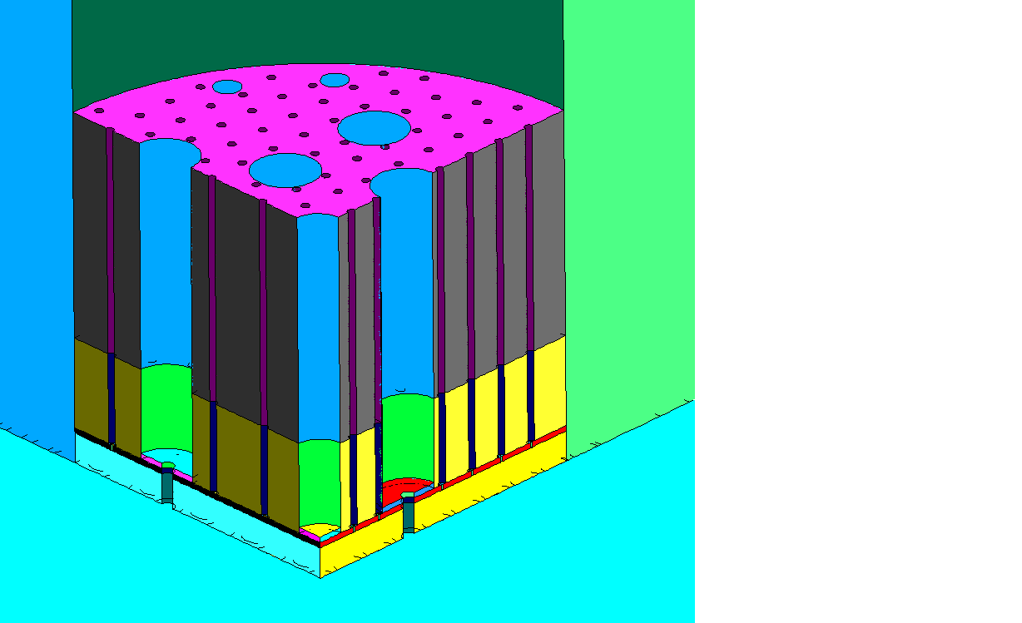
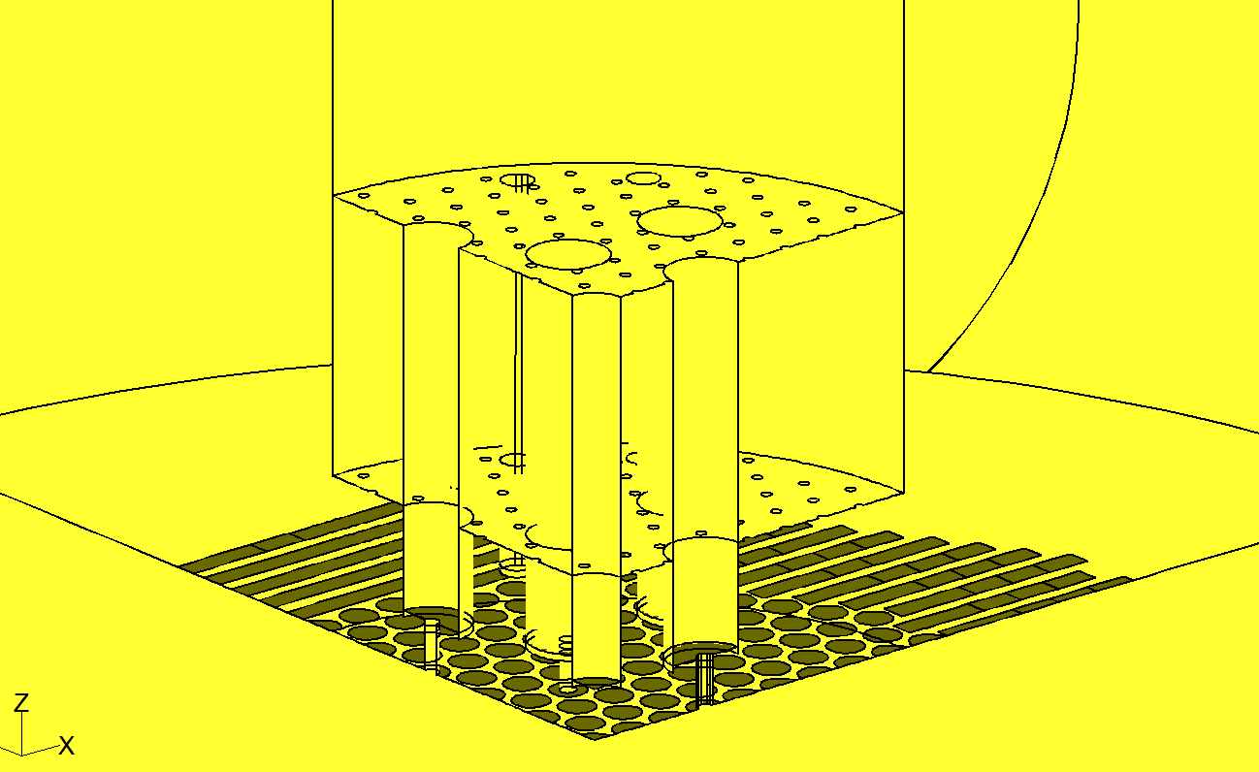
FIG. 2. Details of the CFD model of hot pool developed for the present study
CCP shroud
CSR/DSR shrouds
Neutron detectors
Symmetry
Inner Vessel
Outer surface of control plug

IHX standpipe
PSP standpipe
Control Plug lateral outlet strips
Symmetry
Free surface

Sampling sleeves
Core top
Core cover plate
Lattice plate
Core top
Porous skirt
Porous plates below core cover plate
Model inlet at core top

All sampling sleeves present within the 90° sector chosen for the present studies are modelled (Fig. 3). As discussed earlier these have been positioned at a radially 20 mm outward positions (with exceptions) with respect to subassembly centres. More details on this approach towards positioning of core monitoring system can be found in ref. [1]. About 15 % of total core flow enters control rod shrouds and flows into control plug [3]. These are modelled in the form of mass sinks at the base of shroud tubes. The outer surface of control plug has been modelled as sodium flow enters into hot pool through this surface. This sodium that enters control plug after flowing through shroud tubes, exits control plug and re-enters hot pool through seven rows of holes on the control plug shell. In the present study these rows of holes have been clumped together and modelled as circumferential strips as shown in Fig. 2. There is one strip for each row of holes with equal areas and strip wise flow rates have been imposed obtained from in-house experimental studies [3].
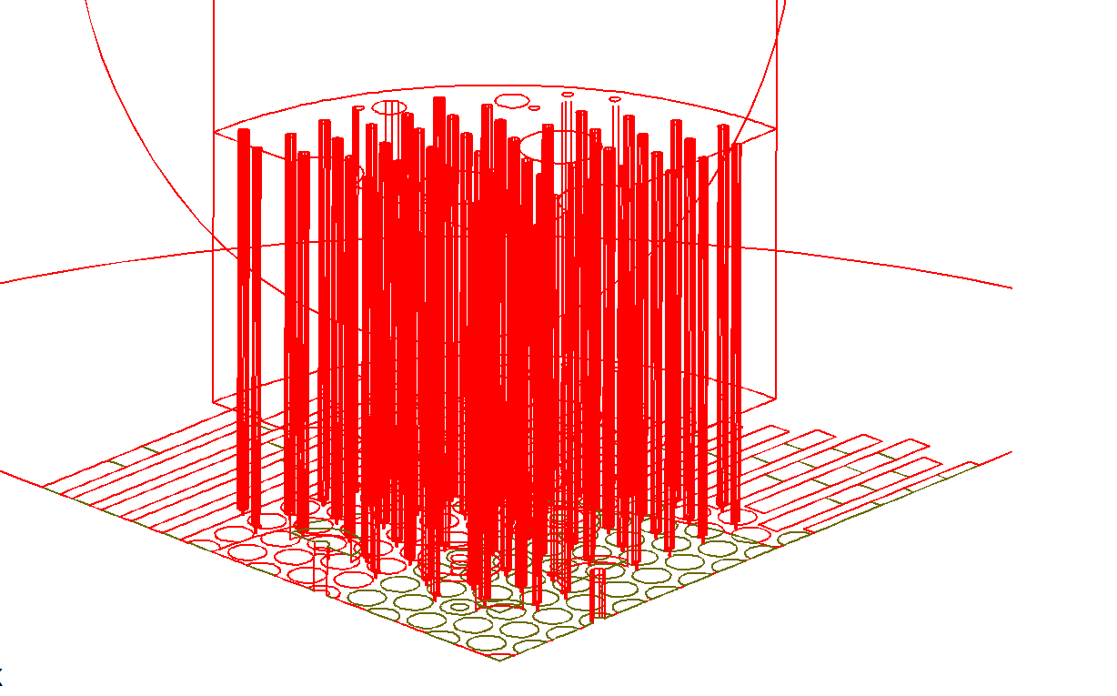
FIG. 3. Details of sampling sleeves with two typical sleeves in inset
Thermowell tip
Sample entry
Sampling sleeve

Flow inlet to computational domain is the subassembly outlet located at core top. This is modelled for the present studies in the form of discrete subassembly outlets for fuel and blanket subassemblies. As can be seen in Fig. 2, outlets of all fuel and blanket subassemblies within domain of interest have been modelled as circular openings of 110 mm diameter. Upwards of 80 % of core flow passes through fuel subassemblies with another 10 % flow through blanket subassemblies. Thus less than 10 % flow enters hot pool through outer subassemblies and these are not expected to have any significant influence on flow or temperature field within the region below core cover plate. Thus in order to optimise computational effort, and aided by the fact that flow through these subassemblies are lower by an order compared to that through blanket subassemblies, outer subassemblies (other than fuel and blanket subassemblies) have been grouped together into strips as shown in Fig. 2. Strips of similar subassembly type come under one boundary condition. Flow through these subassemblies enters hot pool in a region away from the ‘below core cover plate’ region. Thus the flow within the important ‘below core cover plate’ region stays unaffected. Flow rates for core subassemblies are taken from design values. It must be remembered that flow and temperature at subassembly outlets presented here correspond to 10% power, 20 % flow conditions w.r.t. full power conditions and correspond to end of cycle 3 (EOC-3) core configuration.
In order to simulate presence of delayed neutron precursors in sodium, a separate scalar in the form of species concentration is invoked. This species is transported exclusively through advection with diffusion coefficients being made zero. As this species would not have any effect on flow or temperature field, a steady state field for these quantities is first derived (for 10% power, 20% flow). The equations of conservation for mass, momentum and energy are given below [4]. These equations need to be discretised and solved first to derive a steady state flow and temperature field.

$∇.(ρ\vec{v})=S_{m}$ (1)
$∇.\left(ρ\vec{v}\vec{v}\right)=-∇p+μ∇.\left(∇\vec{v}+∇{\vec{v}}^{T}\right)+ρ\vec{g}+S_{P}$ (2)

$∇.\left(ρC_{P}T\vec{v}\right)=∇.\left(k∇T\right)+S_{i}$ (3)

Here, $\vec{v}$ represents the velocity vector, T stands for temperature, p stands for pressure $\vec{g}$ represents the gravity vector, $ρ$ stands for fluid density, $C_{p}$ stands for specific heat, k stands for thermal conductivity (will be accentuated by turbulence),$μ$ stands for coefficient of dynamic viscosity including contribution of turbulence, $S_{m},S_{P},S_{i}$ stand for source terms for mass, momentum and energy respectively.
Using this steady state field the species transport equation is solved with the species representing delayed neutron precursors. The species transport equation for this study can be written as:

$\frac{∂}{∂x_{i}}\left(ρu_{i}ϕ_{k}\right)=0$ (4)
Where, $ϕ_{k}$stands for scalar representing species concentration (mass fraction in this study).

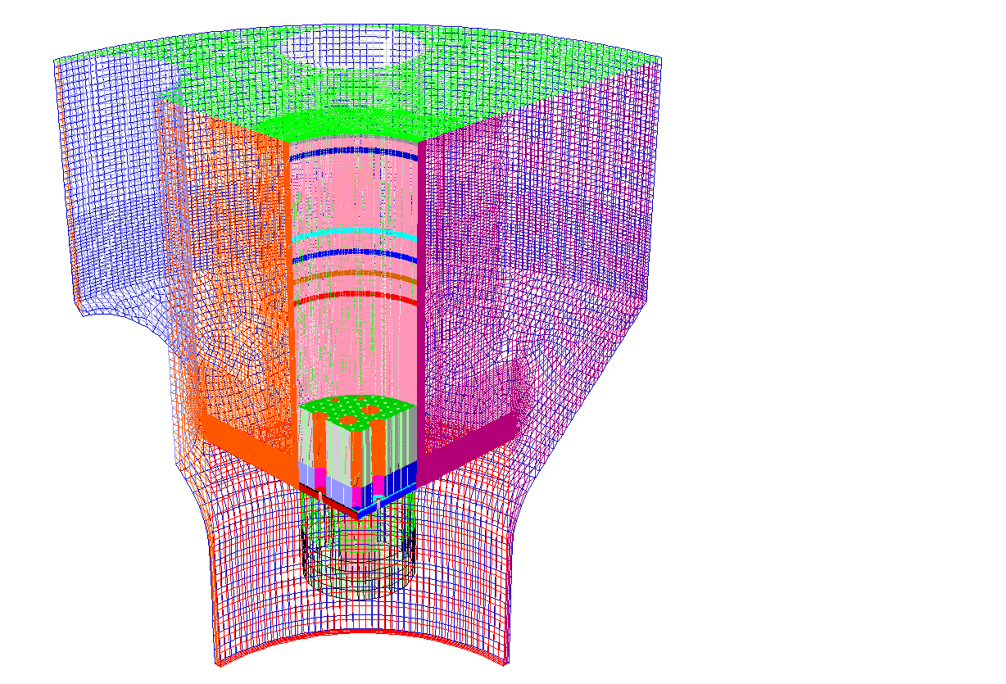
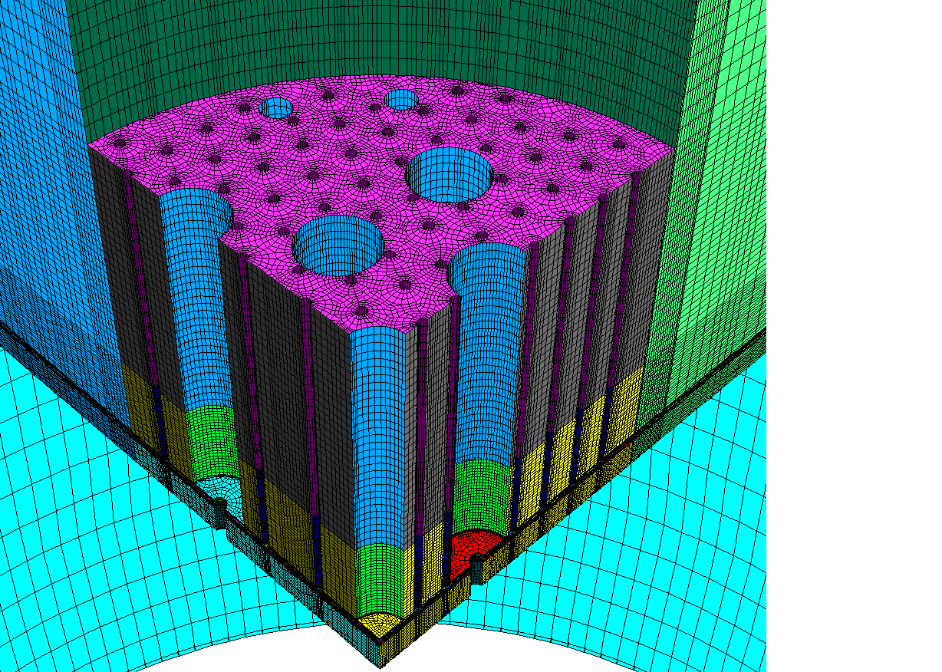
FIG. 4. Details of mesh used for Analysis with overall view of whole hot pool on left and detailed view of the region below core cover plate on right

As equation 4 shows, the species in this case representing delayed neutron precursors are transported by advection alone. The results of the present study therefore would be applicable to such species that do not dissolve in the coolant and their presence has negligible effect on flow field otherwise. Discrete studies for each monitored subassembly are carried out. In each study, species mass fraction of 0.1 is imposed at the subassembly outlet (model inlet) with flow and temperature field obtained from steady state solution considered to be unaffected. The resulting species mass fraction at respective (and any other significant) sampling sleeve entry is estimated and reported.
Mesh employed for the study is presented in Fig. 4. Complete domain has been discretized using hexahedral elements. The total number of elements used is 1.31 million that is found to be sufficient for a mesh independent result [1]. FLUENT 19.2 is used for analysis. To simulate buoyancy, Boussinesq approximation is invoked. Effects of turbulence is modeled using the κ-ε high Reynolds (realizable) model. Equations of conservation for κ and ε are given below.

$\frac{∂}{∂x_{i}}\left(ρκu_{i}\right)=\frac{∂}{∂x_{j}}\left[\left(μ+\frac{μ_{t}}{σ_{k}}\right)\frac{∂κ}{∂x_{j}}\right]+G_{κ}+G_{b}-ρϵ$ (5)

$\frac{∂}{∂x_{i}}\left(ρϵu_{i}\right)=\frac{∂}{∂x_{j}}\left[\left(μ+\frac{μ_{t}}{σ_{ϵ}}\right)\frac{∂ϵ}{∂x_{j}}\right]+ρC_{1}S_{ϵ}-\frac{ρC_{2}ϵ^{2}}{κ+\sqrt{νϵ}}\frac{C_{1ϵ}ϵ}{κ}C_{3ϵ}G_{b}$ (6)

$C_{1}=\max\left[0.43,\frac{η}{η+5}\right], η=S\frac{κ}{ϵ} , S=\sqrt{2S_{ij}S_{ij}}$ (7)

Here, $G_{κ}$ represents the generation of turbulent kinetic energy due to mean velocity gradients, $G_{b}$ is generation of turbulence kinetic energy due to buoyancy, $C_{1ϵ}, C_{2}$ are constants, $σ_{κ}, σ_{ϵ}$ are turbulent Prandtl numbers for $κ, ϵ$ respectively, $S$ represents the modulus of mean strain rate tensor.
The eddy viscosity is computed as: $μ_{t}=ρC_{μ}\left(\frac{κ^{2}}{ϵ}\right), C_{μ}$is not constant here unlike the standard $κ-ϵ$ turbulence model. Further details are available in ref. [5]. SIMPLE algorithm is used to allow pressure velocity coupling. First order UPWIND schemes are used to discretize conservation equations of momentum, turbulence quantities and species concentration. A pressure staggering option (PRESTO) available in FLUENT is used to discretize the continuity equation.

3. RESULTS AND DISCUSSION
3.1. Velocity and temperature profile in hot pool
Velocity vectors and temperature contours at a section for whole hot pool along with detailed plot for below core cover plate region are shown in Fig. 5. Due to the particular configuration of reactor pool a flowering effect on flow streams exiting subassembly can be seen clearly. This leads to a pronounced bending of subassembly outlet jets for outer subassemblies. However, a maximum velocity for conditions under which failed fuel localization operation would be carried out, anywhere within hot pool is about 0.89 m/s. This is much lower than that during normal operating conditions [1]. Due to the prevailing low velocities in reactor pool, buoyancy forces show more pronounced effect on velocity field. This is true especially for flow passing through porous skirt, which comes from hotter central subassemblies. Interaction of this relatively hotter stream of fluid with porous skirt leads to loss of momentum. However, due to the relative high temperatures this stream starts rising upwards immediately after passing through porous skirt. However, due to overall lower temperatures prevalent and the limited period of reactor operation under this condition, this is not expected to be a concern. The above mentioned behaviour can be clearly seen in temperature contours in Fig. 5. Even though hot pool shows some stratification, the temperature gradients in the axial direction are relatively small.
3.2. Transport of fission products from failed subassembly
In Fig. 6, dispersion of fission product concentration from failed subassembly due to advection in hot pool can be seen. Contours for two specific subassemblies one each from fourth and fifth rows of reactor core are presented. Similar studies are done for all subassemblies from the 90° sector of hot pool/reactor core under consideration that are monitored using the core monitoring system/failed fuel location module. This amounts to about 57 subassemblies resulting in the same number of parametric analyses as part of this study. The dispersion of species shown in Fig. 6, is as a result of advection terms alone as diffusion has been turned off. It can be clearly seen here that fission product mass fraction reduces (dilution) downstream of subassembly outlet after its exit from the subassembly. Dilution for the present study is defined as the difference in fission product mass fraction between subassembly outlet and FFLM sampling end. There are important differences in the behaviour w.r.t. dilution for subassembly outlets from different rows. It is to be noted that, there is no FFLM sampling sleeve for the central subassembly as localization of failure of central subassembly is envisaged through exclusion after testing for all other subassembly. However, the contours show that the jet from central subassembly is straight and almost all of the fission products exiting the central subassembly enters central canal plug shroud. This would mean that any delayed neutron precursor from central subassembly is expected to enter control plug and re-enter hot pool through lateral holes of the control plug shell.
For subassemblies in first row, outlet jets are quite straight and sampling sleeve inlets are well within a zone of high mass fraction of fission products. FFLM sampling as a result does not suffer any dilution at all (mass fraction at sampling sleeve inlet is more than 0.099). From here as we move outwards, subassembly outlet jets are expected to suffer more bending in a radially outward direction.
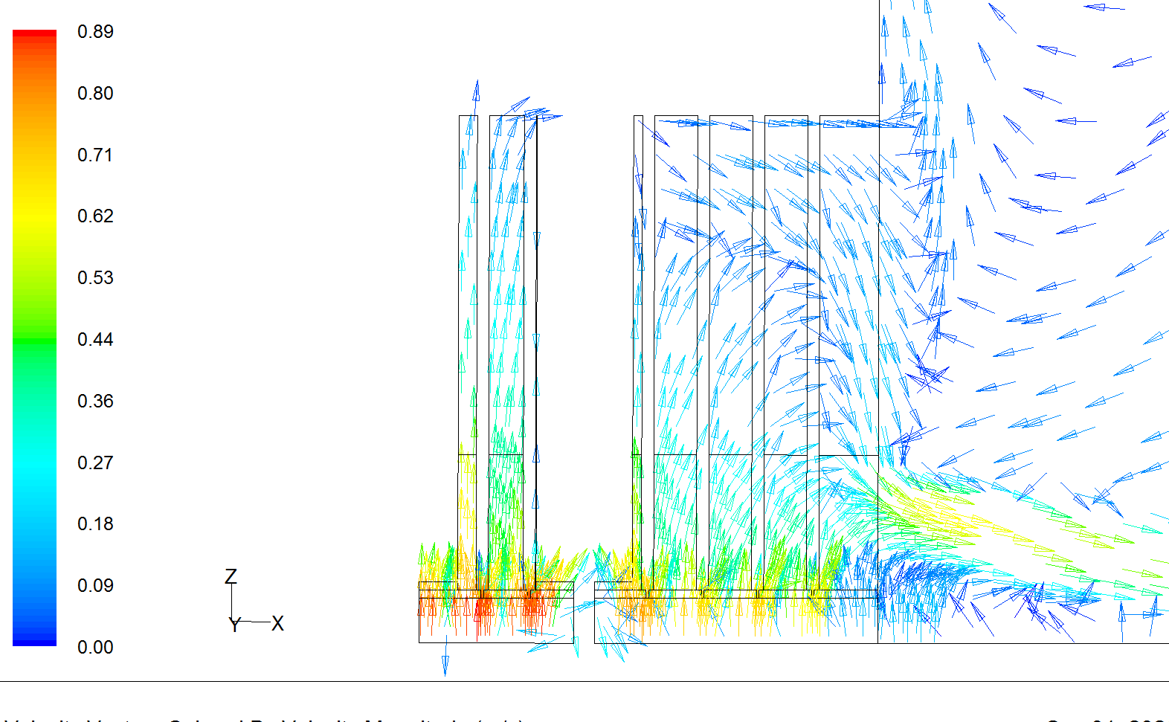
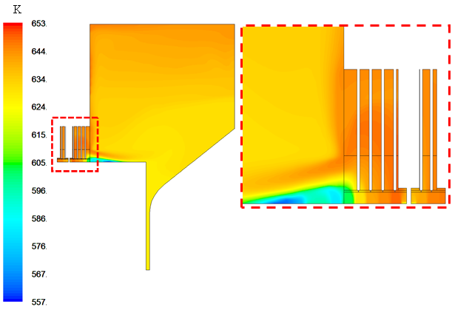
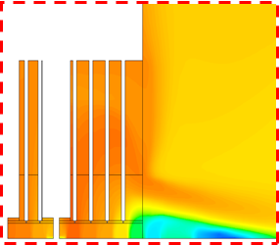
m/s
FIG. 5. Steady state velocity vectors and temperature contours

In subassemblies from 2nd row onwards up to 9th row and increasing bending of subassembly outlet jet is clearly seen from the results of parametric studies (Fig. 6). Fuel subassemblies are placed within 8th row of core. Moreover, 8th row contains both fuel and blanket subassemblies with the flow through the blanket subassemblies being lower by a factor of more than 3 compared to that through fuel subassembly. However, higher flow rate through a fuel subassembly and resulting subassembly outlet velocity is expected to lead to lower dilution.
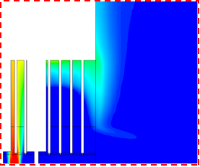
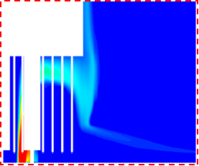
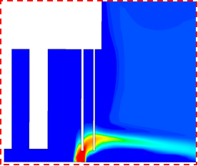
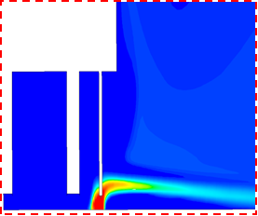
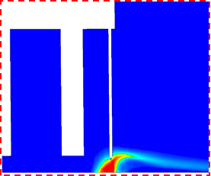
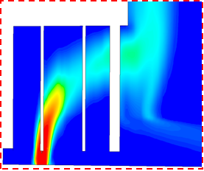
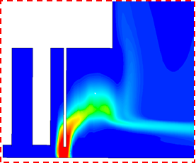
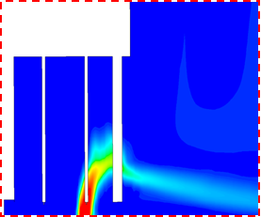
FIG. 6. Mass fraction of fission products for injection from SA from each row (typical)

First Row
Second Row
Fourth Row
Seventh Row
Eighth Row
Ninth Row
Fifth Row
Third Row
Sixth Row

As confirmed from results of studies on fuel subassemblies of 8th row, even though the bending outlet jet for such a subassembly is quite pronounced, the FFLM sampling end stays within a region of low dilution. However, the outlet jet for subassembly 950 shown in the same figure, not only shows significant jet bending, but also shows significant dilution at FFLM sampling end. It is to be noted that subassemblies in ninth row are blanket subassemblies with low outlet velocity. Higher dilution is expected in this case. Similar behaviour is seen for blanket subassemblies in 8th row as well.
Dilution in the mass fraction of fission products at FFLM sampling end for each subassembly studied is presented in Fig. 7. Dilution (in percentage) is defined as:$({{MF}_{SA}-{MF}_{FFLM}}/{{MF}_{SA}})×100$. Here, MF represents mass fraction obtained from analysis, with subscripts SA, FFLM standing for ‘at subassembly outlet’ and ‘at FFLM sampling end’ respectively. Dilution values along with a subassembly index based on its position and its subtype (‘F’ indicates fuel subassembly and ‘B’ indicates blanket subassembly) are plotted in Fig. 7. It can be seen that no fuel subassembly suffers any significant dilution with maximum dilution limited to 0.2 %. However, blanket subassembly in 8th and 9th rows exhibit substantial dilution owing to lower flow rate and subassembly outlet velocity (maximum being 83.6 % for subassembly 840).
FIG. 7. Dilution at FFLM sampling end (in percent mass fraction)
% mass fraction

4. CONCLUSION
During failure of a fuel/blanket subassembly of a fast reactor failure localization is done using a failed fuel location module (FFLM) that samples sodium at outlet of each subassembly. In order to gauge the quality of coolant sample that enters by FFLM, a 90° three dimensional CFD model of hot pool has been developed in order to capture the complex pool hydraulics. Discrete inlet boundaries along with FFLM sleeves and thermo-wells for each fuel and blanket subassembly have been modelled. Control rod shrouds are modelled accurately. Using dedicated parametric studies for each monitored subassembly within a 90° sector of reactor core an accurate estimate of dilution in the concentration of fission products at the inlet to failed fuel sampling sleeves is obtained .Fission product dilution is found to be insignificant for all fuel subassemblies. This ensures reliable and accurate sample collection for failed fuel localization. However, for blanket subassemblies, larger dilution is observed for a majority of monitored blanket subassembly. However, since blanket subassemblies are low power, low flow subassemblies and therefor have a much lower probability of failure relative to a fuel subassembly this is not deemed to be a concern.
5. ACKNOWLEDGEMENT
The authors wish to acknowledge software support from Safety Research Institute, AERB, Kalpakkam.
References
- RAM KUMAR MAITY, VELUSAMY, K., SELVARAJ, P., CHELLAPANDI, P., Computational fluid dynamic investigations of partial blockage detection by core-temperature monitoring system of a sodium cooled fast reactor, NED Vol.241 Issue 12 (2011) 4994-5008.
- WARDSMITH, A J., Pressure Losses in Ducted Flows, Butterworths, London (1971)
- BANERJEE, I., SUNDARARAJAN, T., SANGRAS, R.,VELUSAMY, K., PADMAKUMAR, G., RAJAN, K.K., Development of gas entrainment mitigation devices for PFBR hot pool, NED Vol.258 (2013) 258-265.
- KUNDU, P K., COHEN, I M., DOWLING, D R., Fluid Mechanics – Fifth Ed., Academic Press, Oxford, 2012
- ANSYS, INC., Ansys FLUENT-V 19.2, Theory Guide.

