**Study on the Method of Correction**

**of Fast Reactor Power Distribution**

**by MCNP CODE**

Jia Xiaochun1，Shao Jing1，Hu Yun1，Zhang Jian1

1 China Institute of Atomic Energy, Beijing, China

Email contact of corresponding author: nini2616@163.com

**Abstract：**

The tally cards F6 and F7 in MCNP code allow users to calculate reactor power. After a time of operation of a reactor, the fission products increased, which caused the delayed heat in the reactor. Thus, the power directly calculated by F6 and F7 would not correspond with the actual value, and for the fast reactor, the energy distribution of fuel and other structural materials will also deviate from the actual value. In this paper, to obtain more accuracy of core power distribution by the MCNP power tally cards, the first core of China Experimental Fast Reactor (CEFR) is taken as an example, the distribution of the neutron energy, prompt γ energy, delayed γ energy and delayed β energy are calculated. The delayed γ energy and delayed β energy which cannot be calculated directly have been corrected. The delayed β is regarded as deposited in the fuel area, while delayed γ would transport in the whole reactor range. A source model of fission rate distribution is described; the heat release distribution is evaluated with the effect of delayed γ energy.

## INTRODUCTION

Most of the heat released in the reactor comes from the energy released at the moment of fission in the nuclear fuel, including the kinetic energy of fission fragments, fission prompt neutrons, and fission prompt photons. In addition, in absorber materials and structural materials, reactions between neutrons or photons and the materials can also deposit the heat. During the operation of the reactor, as the fission products and the capture products in the fuel continued to accumulate, delayed γ and delayed β were produced, which also contributed to the power. According to general experience, the delayed heat releasing in fast reactors accounts for about 5% of the total power. If the correction of delayed heat were not considered, although it has little effect on the power distribution of fuel subassemblies, the impact could be great on the non-fuel subassemblies, such as control rod subassemblies, reflective layer subassemblies, and so on.

The fission energy considered by the MCNP code F7 card conforms to that at the moment of a fission reaction happened, also the calculation result conforms to the real physical process at the moment of the reactor startup, but will gradually deviate from the actual value as the operation goes on. Therefore, in order to obtain a more accurate core power distribution and the actual power of non-fuel subassemblies, the delayed heat releasing must be corrected.

## Calculation method of the delayed heat by MCNP code

The MCNP code has two types of energy tally cards, F6 and F7 [1]. F6 allows users to count the energy of all materials, both for neutron and photon deposition energy; F7 only counts the nuclear fuel fission energy, which is, the kinetic energy of fission fragments released at the moment of fission and the kinetic energy of prompt neutron kinetic energy. The function of F6 and F7 tally card for various forms of energy in the reactor are shown in Table 1.

Table 1. The tally function in MCNP code

|  |  |  |  |
| --- | --- | --- | --- |
|  | Tally Card | | Energy Forms |
| Fission energy deposition | F6:N | F7 | the kinetic energy of fission fragments (EFR) |
| F6:N | F7 | the kinetic energy of the prompt fission neutrons (ENP) |
|  |  | the kinetic energy of the delayed fission neutrons (END) |
| F6:P | F7 | the energy of the prompt γ rays (EGP) |
|  |  | the energy of the delayed γ rays (EGD) |
|  |  | the energy of the delayed β rays (EB) |
| Else energy deposition | F6:P |  | (n, γ) reaction energy |

The total heat released as the 7 sorts of form listed in Table 1, among which the kinetic energy of delayed neutrons is very small that could be ignored. The kinetic energy of fission fragments and the kinetic energy of fission prompt neutrons can be obtained by F6:N tally; all the deposition of prompt photon energy, including kinetic energy of fission prompt γ and the (n, γ) reaction energy can be obtained by F6:P tally; F7 tally are all the fission prompt energy, including fission fragment kinetic energy, fission prompt neutron kinetic energy and fission prompt photon energy. The delayed γ and delayed β energy of fission products are not calculated in MCNP. The fission energy distribution of fissionable nuclides is given in the ENDF database MT=458 (see Table 2, for example of U-235) [2]. Since the energy calculated by F6:N is the sum of the kinetic energy of fission fragments and the kinetic energy of prompt fission neutrons, the correction coefficients for delayed γ heat release and delayed β heat release can be calculated by formula (1) and formula (2).

Table 2. Energy DISTRIBUTIONS per fission of U-235（MeV）

|  |  |
| --- | --- |
| Energy Forms | Energy* (MeV) |
| the kinetic energy of fission fragments (EFR) | 169.130 |
| the kinetic energy of the prompt fission neutrons (ENP) | 4.838 |
| the kinetic energy of the delayed fission neutrons (END) | 0.007 |
| the energy of the prompt γ rays (EGP) | 6.600 |
| the energy of the delayed γ rays (EGD) | 6.330 |
| the energy of the delayed β rays (EB) | 6.500 |
| the energy of the neutrinos (ENU) | 8.750 |
| total energy less the energy of the neutrinos (ER) | 193.405 |
| total energy (ET ) | 202.155 |

*：Data in this table comes from the database library ENDF/B-VII.1.*Einc*=0。

$C_{\left(EGD\right)}=\sum_{i}{p_{i}\frac{{(EGD)}_{i}}{{(EFR+ENP)}_{i}}}$（1）

$C_{\left(EB\right)}=\sum_{i}{p_{i}\frac{{(EB)}_{i}}{{(EFR+ENP)}_{i}}}$（2）

Where the *C(EGD)* and *C(EGD)*means the correction c[oefficient](javascript:void(0);) for the energy EGD and EB, *pi* is the fission rate share of the *i*-th fission nuclide in the core , *(EGD)i*, *(EFR)i* and *(ENP)i* in the formula can be found in the database file.

Therefore, according to Table 1 and formulas (1) and (2), the method for MCNP to calculate the core power is shown in Table 3.

Table 3. The method of reactor power tally in MCNP

|  |  |
| --- | --- |
| Energy Forms | MCNP tally method |
| (EFR)+(ENP) | F6:n (whole reactor) |
| EGP | F7-(F6:n) (whole reactor) |
| the energy of other reactions such as (n,γ) | (F6:n,p)-F7 |
| EGD | F6:n (fissile zone)×C(EGD) |
| EB | F6:n (fissile zone)×C(EB) |
| total energy | (F6:n,p)+ delayed β+ delayed γ |

The energy of delayed β is deposited locally in the fuel, while the energy of delayed γ needs to be considered about its transportation in the whole reactor. Chapter 3 will take the 65MWth CEFR first reactor core as an example to calculate the above five powers shown in Table 3, and consider the influence of the distribution of delayed β and delayed γ heat release on the core power distribution.

## The power distribution of CEFR first core

The CEFR first core is taken as an example, to calculation the delayed heat release correction and the corrected core power distribution. The geometry and material data of the MCNP model come from the design report on the physical characteristics of the first core of CEFR. The core consists of 79 fuel subassemblies, a central neutron source subassembly, 8 control rod subassemblies, and 634 steel shielding and boron shielding subassemblies. The core thermal power is 65MW.

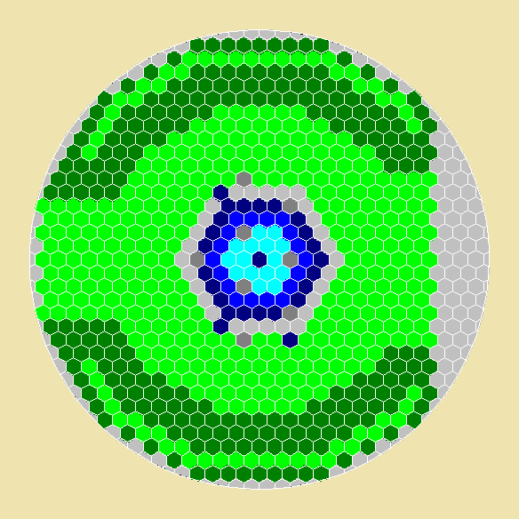

Fig.1 The first core of CEFR

To do the burn-up calculation of the first reactor core, a fuel cycle (80 days) is divided into 8 burn-up steps. At the end of each burn-up step, the summary gamma radiation source intensity is calculated by the ORIGEN code (version 2-A). The variation of the delayed γ source intensity over the burn-up time is shown in Figure 2.

Fig.2 The curve of delayed γ source intensity over time

The delayed γ comes from the short-half-life fission products, long-half-life fission products, radiation capture and other reaction products, among which the short-half-life fission products contributes the most. The figure shows that the source intensity of delayed γ reached saturation within a short period of time, and then slowly increased as the accumulation of long-half-life fission products. The state on the 50th day is selected as the research object core to calculate the power distribution.

### 3.1 The five parts of power of the core

In the current state of the core, there are four fission nuclides U-235, U-236, U-238 and Pu-239 in the fissile zone. The fission rate of the *i*-th nuclide and its share in total fission rate can be calculated by MCNP code.(A KCODE criticality calculation is taken, with source histories of 30,000, source cycles of 550, the first 50 was skipped.) The energy distribution of each fission for each nuclide can be find in ENDF database, MT=458, as shown in Table 4. The correction coefficient of the heat release rate of delayed γ and delayed β of the reactor core can be calculated according to formula (1) and formula (2). The thermal power of 65MW can be divided into five parts as shown in Table 5.

Table 4. The correction coefficient of the delayed heat release on the 50th day

|  |  |  |  |  |
| --- | --- | --- | --- | --- |
|  | U-235 | U-236 | U-238 | Pu-239 |
| *pi* | 95.332% | 0.018% | 3.615% | 1.034% |
| EFR | 169.130 | 167.500 | 169.800 | 175.550 |
| ENP | 4.838 | 4.700 | 4.558 | 6.128 |
| EGP | 6.600 | 7.300 | 6.680 | 6.741 |
| EGD | 6.330 | 7.420 | 8.250 | 5.170 |
| EB | 6.500 | 7.560 | 8.480 | 5.310 |
| *C(EGD)* | 0.03670 | | | |
| *C(EB)* | 0.03769 | | | |

Table 5. The energy distribution on the 50th day in CEFR

|  |  |  |
| --- | --- | --- |
| Energy Forms | MCNP tally method | Power(MW) |
| (EFR)+(ENP) | F6:n (whole reactor) | 55.448 |
| EGP | F7-(F6:n) (whole reactor) | 2.625 |
| the energy of other reactions such as (n,γ) | (F6:n,p)-F7 | 2.842 |
| EGD | F6:n (fissile zone)×*C(EGD)* | 2.015 |
| EB | F6:n (fissile zone)×*C(EB)* | 2.069 |
| total energy | (F6:n,p)+ delayed β+ delayed γ | 65 |

### 3.2 The distribution of the core power

In the previous section, the total power of delayed β and delayed γ of the entire core was calculated. To obtain a more accurate core power distribution, it is necessary to know the distribution of these two powers in the entire core. The total power of a subassembly should be equal to (F6: n, p) + delayed β + delayed γ, where the delayed β is deposited locally in the fuel subassembly, and the delayed γ needs to be considered its transportation effect. Take the middle row of subassemblies in the core as examples to calculate the power distribution. The positions and numbers of the middle row of subassemblies are shown in Figure 3, and the corresponding subassembly types are shown in Table 5.

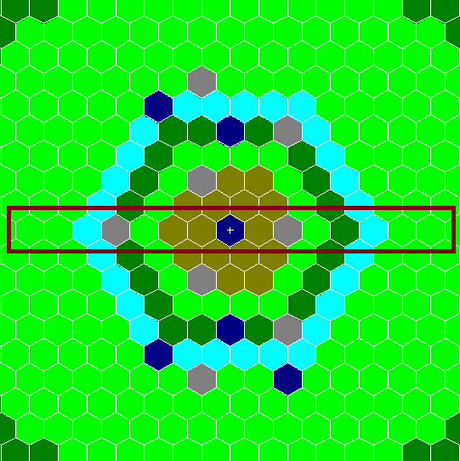



Fig.3 The positions and numbers of subassemblies in middle row of the core

An approximation is taken in this paper that the correction coefficient C(EB) of the delayed β stays the same among the whole core, and its spatial distribution keeps consistent with that of the kinetic energy of fission fragments and neutron kinetic energy in the fissile zone.

In order to study the effect of delayed γ transportation on the power distribution of the whole core, a γ source is described that the cell where the source is located is defined as the area of fissile material; the spatial sampling probability of the source is given according to the distribution of the fission rate in the nuclide fuel; The intensity and energy spectrum are calculated by the ORIGEN code. Thus the γ energy deposition of the whole core and each subassembly can be obtained. In the calculation, it is approximated that the delayed γ will not leak out of the core.

The power distribution corrected by the delayed release heat term is shown in Table 6, and the calculation deviation of the data in the table is <0.5%.

Table 6 Power distribution of the core corrected by the delayed heat (MW)

|  |  |  |  |  |  |
| --- | --- | --- | --- | --- | --- |
|  |  | Prompt power | Delayed β power | Delayed γ power | Total power |
|  | Whole core | 60.9157 | 2.0693 | 2.0150 | 65.0000 |
| 1 | Steel shielding | 0.0075 |  | 0.0002 | 0.0077 |
| 2 | Steel shielding | 0.0118 |  | 0.0017 | 0.0135 |
| 3 | Fuel in row 6 | 0.6133 | 0.0268 | 0.0138 | 0.6539 |
| 4 | Control rod SA | 0.0192 |  | 0.0042 | 0.0234 |
| 5 | Fuel in row 4 | 0.7906 | 0.0343 | 0.0243 | 0.8492 |
| 6 | Fuel in row 3 | 0.8650 | 0.0375 | 0.0241 | 0.9266 |
| 7 | Fuel in row 2 | 0.8959 | 0.0389 | 0.0234 | 0.9582 |
| 8 | Neutron source | 0.0343 |  | 0.0109 | 0.0452 |
| 9 | Fuel in row 2 | 0.8804 | 0.0382 | 0.0227 | 0.9413 |
| 10 | Control rod SH | 0.0438 |  | 0.0050 | 0.0488 |
| 11 | Fuel in row 4 | 0.7733 | 0.0335 | 0.0251 | 0.8319 |
| 12 | Fuel in row 5 | 0.6980 | 0.0303 | 0.0298 | 0.7581 |
| 13 | Fuel in row 6 | 0.6133 | 0.0268 | 0.0138 | 0.6539 |
| 14 | Steel shielding | 0.0102 |  | 0.0005 | 0.0107 |
| 15 | Steel shielding | 0.0073 |  | 0.0001 | 0.0074 |

It is shown in the table that delayed the β heat is produced by fission and is directly deposited locally, so that its distribution is only related to the fission rate distribution. The delayed γ is produced in the fuel, and most of the energy is deposited in the fuel subassemblies, a few in those farther from the central core (No. 1 and No. 15 steel shielding subassemblies). Therefore, it is necessary to calculate the distribution of the delayed heat release.

## Conclusions

According to the calculation method of the tally card in MCNP code, F7 only counts the fission prompt energy of the fission material, F6:n,p can count the neutron and photon deposition energy of all materials, but not for the delayed γ and delayed β heat release. It corresponds the actual situation at the beginning of the reactor operation, but as the fission products accumulated, the energy directly counted by F6:n,p will gradually deviate from the true value. In order to get closer to the actual core power distribution, this paper takes the first core of CEFR as an example, and divides 65MWth into five parts, which are fission fragments, fission prompt neutron energy, fission prompt γ energy, and others. Prompt γ energy (mainly (n, γ) reactive deposition energy), delayed β energy, delayed γ energy, the first three items can be obtained by statistics of F6 and F7, and the latter two items can be corrected according to the data from the nuclear database. .

The spatial distribution of the delayed heat is considered given its total value in the whole core. The calculation results showed that most of the energy of delayed γ is deposited in and near the fuel subassemblies.

The calculation method in this paper can help researchers get closer to the actual power distribution, and is used to verify the deterministic code in development for the calculation of the delayed heat release.

ACKNOWLEDGEMENTS

The data and information presented in the paper are from the design report on the physical characteristics of the first core of CEFR.

References

[1] TEAM X-M C. MCNP-A General Monte Carlo N-Particle Transport Code [M]. Los Alarmos National Laboratory,2003

[2] V. Mclane, C. L. Dunford, and P.F. Rose, ed, “ENDF-102:Data formats and Procedures for the Evaluated Nuclear Data File ENDF-6,” Brookhaven National Laboratory report, BNL-NCS-44945, revised (1995)

[3] Croff, A.G., July 1980. ORIGEN2-A Revised and Updated Version of the Oak Ridge Isotope Generation and Depletion Code. ORNL-5621.