CRITICALITY SENSITIVITY ANALYSIS IN RELATION TO

EMPTIES OF A FAST REGENERATOR NUCLEAR REACTOR

JOÃO CLAUDIO BATISTA FIEL
Military Institute of Engineering
Rio de Janeiro,RJ, Brazil
Email: fiel@ime.eb.br

Abstract
This research work, using spherical coordinates, presents a modeling of the FBR core considering an equation of the diffusion approximation to one and two energy groups for the conditions without void and, also, with the insertion of 5.87% of empty in the soda. With reference to the analytical approach developed, programs were developed in the FORTRAN language that allow the calculation of flow distribution, absorption, leakage, keff and the reactivity coefficient. The detailed results allow to show the behavior of the FBR and the sensitivity of the keff and the reactivity coefficient to the presence of void, the trend source of the results obtained through the ESCALA software. Therefore, exposed modeling will be a powerful tool in the early stages of the design of the core of a nuclear reactor.

INTRODUCTION
The current energy production, resulting from the concepts related to the fission of fissile nuclides, nuclear energy, is of the order of 397,650 MWe produced by the 449 nuclear plants in operation and another 54,364 MWe to be supplied by another 54 under construction on the planet, data that demonstrate the growth in installed capacity and the installation of electrical energy from nuclear fission. Thus, nowadays, the projection of an increase in the share of nuclear energy in energy production and supply is notorious, with the need for annual availability of approximately 62.825 thousand tons of mineral resources of its fundamental item, natural uranium, for the which is estimated at approximately 7.988 million tons of world reserves [3]. Thus, there is a horizon of around 127 years of operation of these nuclear installations to be supplied by enriched uranium. Therefore, the search for an alternative that extends this horizon is an extremely relevant aspect in the field of energy production. The regenerative reactor technology that uses natural and enriched uranium and plutonium is essential for the production of the fuel that supplies it. In the operation of this reactor, while fissile material is consumed, simultaneously more fissile material is produced from the transmutation of the uranium-238 that is at its core. This fissile material produced, when the fuel elements of the reactor core are exchanged, can be removed from that core, reprocessed, and used as fuel in other nuclear reactors. This process allows existing and estimated natural uranium reserves to be multiplied by about thirty times, thus being able to expand the horizon of electric energy production through nuclear fission for approximately thirty-eight centuries, which would allow the establishment of a new milestone in the equation of energy production on the planet. In this context, in which an important opportunity is offered, the study of the development of a fast spectrum reactor project in Brazil is an aspect to be emphasized and explored to establish parameters that allow its effective implementation. According to the following proportions: - region BP uO2 - 25% - UO2 - 75%; - region C - P uO2 - 33% - UO2 - 67%; - region D - P uO2 - 42% - UO2 - 58%. Figure 3 shows five concentric spheres whose radii were calculated so that these spheres have a volume equivalent to the respective region in the shape of a hexagonal prism of the reactor core, as shown in Figure 2. Figure 3 - Sectional View of the Equivalent Concentric Spheres to the Regions of the Reactor Nucleus. This FBR study was developed in an analytical way using the diffusion approximation method to one and two energy groups. This work, applying spherical coordinates, presents the modeling of the FBR core considering the approximation of diffusion equation to one and two energy groups for conditions without void and also with the insertion of 5.87% of void in the coolant. Taking as reference the analytical approach developed, programs were elaborated in FORTRAN language that allowed the calculation of the flow distribution, the absorption, the leakage, the kef f, and the reactivity coefficient. The detailed results allowed showing the behavior of FBR and the sensitivity of the kef f and the reactivity coefficient to the presence of void, which presented the same trend of the results obtained through the SCALE software. Therefore, the exposed modeling proved to be a powerful tool in the initial phases of the nuclear reactor core design.
The current energy production, resulting from the concepts related to the fission of fissile nuclides, nuclear energy, is of the order of 397,650 MWe produced by the 449 nuclear plants in operation and another 54,364 MWe to be supplied by another 54 under construction on the planet [2 ], data that demonstrate the growth in installed capacity and the installation of electrical energy from nuclear fission. Thus, nowadays, the projection of an increase in the share of nuclear energy in energy production and supply is notorious, with the need for annual availability of approximately 62.825 thousand tons of mineral resources of its fundamental item, natural uranium, for the which is estimated at approximately 7.988 million tons of world reserves [3]. This work, applying spherical coordinates, presents the modeling of the FBR core considering the approximation of diffusion equation to one and two energy groups for conditions without void and also with the insertion of 5.87% of void in the coolant. Taking as reference the analytical approach developed, programs were elaborated in FORTRAN language that allowed the calculation of the flow distribution, the absorption, the leakage, the kef f, and the reactivity coefficient. The detailed results allowed showing the behavior of FBR and the sensitivity of the kef f and the reactivity coefficient to the presence of void, which presented the same trend of the results obtained through the SCALE software. Therefore, the exposed modeling proved to be a powerful tool in the initial phases of the nuclear reactor core design.

Development
The FBR (fixed Bed Reactor) has a cylindrical shape, height and diameter of 180 cm, a heterogeneous core composed of five regions and is cooled with liquid sodium. It is supplied with natural uranium, 238U, in the central (A) and external (E) regions, and in the other regions (B, C and D) with a mixture of PuO2 plutonium oxides and UO2 uranium.
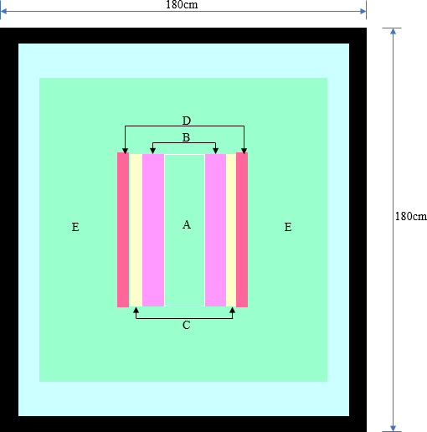
Figure 1 - Lateral view of the FBR Reactor Core.

Its main feature is to use plutonium as a fuel, thus its independent functioning of enriched uranium. Figure 1, side view of the FBR nucleus, shows the arrangement and communication existing between its regions of the FBR, with regions A, B, C and D being 90 cm high [4] [5] [1].
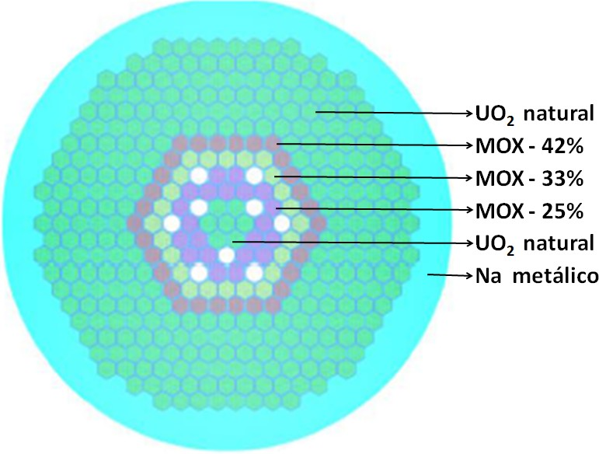
Figure 2 - Top view of the FBR reactor core.

The composition of the mixture of oxides (MOX) PuO2 and UO2 is defined according to the following proportions:
- Region B - PuO2 - 25% - UO2 - 75%;
- Region C - PuO2 - 33% - UO2 - 67%;
- Region D - PuO2 - 42% - UO2 - 58%.

Figure 3 shows five concentric spheres whose radii were calculated so that these spheres have a volume equivalent to the respective region in the form of a hexagonal prism of the reactor core, as shown in Figure 2.
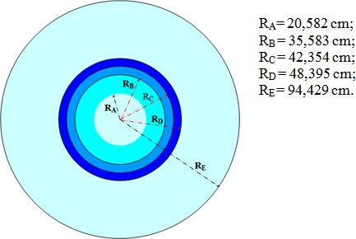
Figure 3 - Sectional View of Concentric Spheres Equivalent to the Regions of the Reactor Core.

The present FBR study was developed in an analytical way using the diffusion approximation method to one and two energy groups.
; i = A, B, C, D e E
Whrere each reagion i has:
Di - Diffusion coefficient; ∇2 - Laplacian operator; Φi - distribution of the radial neutron flux;
Σai - macroscopic absorption shock section; νi - average number of neutrons released in each fission;
Σfi - macroscopic fission shock section; and kef f - effective multiplication factor.
Making the arrangement of Eq. 2.1, we then have:
It can be placed in the following form:
Where it has:
Analysing the group constants obtained by the SCALE code for the FBR we have for regions A and E, K2 i <0 and for regions B, C and D, K2, i> 0. To obtain the solution of the differential equation representing the neutron flux in five regions of the reactor core are applied spherical coordinates, which have a single dependent variable, its radius,
Thus, after the application of the aspheric coordinates in Eq. 2.3, the solution of Eq. 2.4 for regions A, B, C, D and E of the reactor core is as follows:
Region A:
Region B:
Region C:
Region D:
Region E:
where C1, C2, C3, C4, C5, C6, C7, C8, C9 and C10 are constants to be determined. To calculate these constants and also the kef f, eleven conditions are required contour, which will be presented in the next item.
2.4.2 Boundary Conditions
First condition (i): considering the neutron flux ΦA finite at r = 0, then we have that C2 = 0; soon:
Making the neutron flux and current density equal in the borders of the regions, nine other boundary conditions are defined, as follows:
and
3. RESULTING

3.1 . Diffusion Approach - A Group of Energy

For an energy group, simulations were performed using the fbr1 program for a temperature of 423k and, as a result of these simulations, results were obtained for partial and total absorptions, leakage, keff plots as well as keff, the reactivity coefficient, neutron flows and currents, which are detailed in Appendix C and summarized in Tables 3, 4, 5 and 6.

Temperature (423K)
The following tables show the group constants, with Table 1 showing the constants for the condition without void in regions A, B, C, D and E and Table 2 showing the constants for the void condition of the equivalent volume of water. 5.87% of the sodium (Na) refrigerant from the reactor core inserted in regions A, B, C and D. These data were obtained using the SCALE software and are input data from FBR1.

Table 1 - Group Constants for an Energy Group without Void.

 | Region A | Region B | Region C | Region D | Region E
(a)Σtr | 0,21325 | 0,19206 | 0,18725 | 0,18241 | 0,21325
(b)Σa | 0,00393 | 0,00691 | 0,00789 | 0,00902 | 0,00393
(c)νΣf | 0,00138 | 0,01235 | 0,01574 | 0,01961 | 0,00138

Table 2 - Group Constants for an Energy Group with 5.87% Void.

 | Region A | Region B | Region C | Region D
(a)Σtr | 0,15899 | 0,17853 | 0,17320 | 0,17138
(b)Σa | 0,00336 | 0,00678 | 0,00776 | 0,01961
(c)νΣf | 0,00129 | 0,01230 | 0,01571 | 0,01961

Subtitle:
      - Σtr Transport Cross Section - (cm−1);
      - Σa Absorption Cross Section - (cm−1);
      - νΣf Prodution of the average amount of neutrons produced by fission by the Fission Cross Section - (cm−1).

- Analysis of the Results Obtained by the FBR1 Program
Next, the results will be presented, compared and analyzed for cases in the condition without void and with the insertion of void in each of regions A, B, C and D.

No Void and Void Condition in Region A.
Table 3 - Results for the Condition without Void and Void in Region A.

 | Without Void | Void A
(a)AA | 0,02549 | 0,02259
AB | 0,19398 | 0,19559
AC | 0,16453 | 0,16504
AD | 0,18547 | 0,18580
AE | 0,31548 | 0,31584
(b)ATo | 0,88495 | 0,88488
(c)F | 0,11505 | 0,11512
(d)kef f A | 0,00892 | 0,00869
kef f B | 0,34653 | 0,34943
kef f C | 0,32813 | 0,32915
kef f D | 0,40302 | 0,40373
kef f E | 0,11039 | 0,11052
(e)kef f Ca | 1,19698 | 1,20153
Subtitle:

(a) Neutron absorption plots in regions A, B, C, D and E;
(b) Total absorption of neutrons;
(c) Neutron leakage;
(d) keff A, B, C, D, E plots from regions A, B, C, D and E for the keff;

keff calculated by the program FBR1;
1. Comparing the absorption plots, it appears that the plots with a void are greater than their corresponding ones for the condition without void, except for the portion of region A, and the absorption in region E is preponderant in relation to the absorptions. in the other regions. The total absorption with vacuum is less than for the condition without vacuum; and yet the escape with a vacuum is greater than for the condition without a vacuum.
2. The portions of the empty keff are larger than their corresponding values for the non-empty condition, except for the region A keff portion, and the empty keff Ca is higher in the order of 0.38% (0, 00455) in relation to the voidless; therefore, α is positive.

Void and Void Condition in Region B.
Table 4 - Results for the Condition without Void and Void in Region B.

 | Without Void | Void B
AA | 0,02549 | 0,02558
AB | 0,19398 | 0,19070
AC | 0,16453 | 0,16539
AD | 0,18547 | 0,18625
AE | 0,31548 | 0,31665
ATo | 0,88495 | 0,88458
F | 0,11505 | 0,11542
kef f A | 0,00892 | 0,00895
kef f B | 0,34653 | 0,34621
kef f C | 0,32813 | 0,32984
kef f D | 0,40302 | 0,40471
kef f E | 0,11039 | 0,11079
kef f Ca | 1,19698 | 1,20051
1. For the absorptions, the same behavior observed in item 3.1.2.1 is verified, that is, the plots with a void are greater than their corresponding for the condition without void, except for the portion of region B, and the absorption in region E it is preponderant. The total void absorption in region B is less than for the void-free condition; and, however, the total void leak in region B is greater than for the void-free condition.
2. The keff has the same behavior explained in item 3.1.2.1, that is, the plots with a void are greater than their corresponding for the condition without void, except for the keff portion of region B, and the keffCa with void is higher in the order of 0.29% (.00353) in relation to the without void; therefore, α is positive.

No Void and Void Condition in Region C.
1. It is observed for this condition that only the void absorption plots of regions D and E are larger than their corresponding for the void-free condition and the preponderance of absorption in region E continues. the preponderance of absorption in region E continues. The total vacuum absorption in region C is less than for the condition without vacuum and the total vacuum escape in region C is greater than for the condition without vacuum. In this empty condition, only the portions of the keff for regions D and E are larger than their corresponding values for the condition without void, and the keffCa with void is higher in the order of 0, 07% (0, 00088) in relation to the without empty; therefore, α is positive.
Table 5 - Results for the No Void and Void Condition in Region C.

 | Without Void | Void C
AA | 0,02549 | 0,02535
AB | 0,19398 | 0,19292
AC | 0,16453 | 0,16178
AD | 0,18547 | 0,18668
AE | 0,31548 | 0,31751
ATo | 0,88495 | 0,88424
F | 0,11505 | 0,11576
kef f A | 0,00892 | 0,00887
kef f B | 0,34653 | 0,34465
kef f C | 0,32813 | 0,32761
kef f D | 0,40302 | 0,40564
kef f E | 0,11039 | 0,11109
kef f Ca | 1,19698 | 1,19786

No Void and Void Condition in Region D.
Table 6 - Results for the Condition Without Void and Void in Region D.

 | Without Void | Void D
A_{A} | 0,02549 | 0,02539
A_{B} | 0,19398 | 0,19311
A_{C} | 0,16453 | 0,16362
A_{D} | 0,18547 | 0,18359
A_{E} | 0,31548 | 0,31823
ATo | 0,88495 | 0,88395
F | 0,11505 | 0,11605
kef f A | 0,00892 | 0,00888
kef f B | 0,34653 | 0,34499
kef f C | 0,32813 | 0,32631
kef f D | 0,40302 | 0,40322
kef f E | 0,11039 | 0,11135
kef f Ca | 1,19698 | 1,19476

1. It appears that in this vacuum condition the absorption in region E is the largest portion of absorption and the other portions are smaller than their counterparts for the condition without vacuum. On the other hand, it is observed that the total vacuum absorption in region D has its lowest value; and, however, the total vacuum escape in this region reaches its highest value.
2. Also in this empty condition, only the keff portions for regions D and E are larger than their corresponding ones for the non-empty condition. However, the keffCa with a void in the D region is less than 0.19% (0.00222) compared to the keffCa for a no-void condition; therefore, α is negative.

Global Analysis of Results for an Energy Group

Table 7 - Results for the FBR Nucleus to a Neutron Energy Group Without Void and with 5.87% Void in Regions A, B, C and D.

 | Sem Vazio | Vazio A | Vazio B | Vazio C | Vazio D
A_{A} | 0,02549 | 0,02259 | 0,02558 | 0,02535 | 0,02539
A_{B} | 0,19398 | 0,19559 | 0,19070 | 0,19292 | 0,19311
A_{C} | 0,16453 | 0,16504 | 0,16539 | 0,16178 | 0,16362
A_{D} | 0,18547 | 0,18580 | 0,18625 | 0,18668 | 0,18359
A_{E} | 0,31548 | 0,31584 | 0,31665 | 0,31751 | 0,31823
ATo | 0,88495 | 0,88488 | 0,88458 | 0,88424 | 0,88395
F | 0,11505 | 0,11512 | 0,11542 | 0,11576 | 0,11605
kef f A | 0,00892 | 0,00869 | 0,00895 | 0,00887 | 0,00888
kef f B | 0,34653 | 0,34943 | 0,34621 | 0,34465 | 0,34499
kef f C | 0,32813 | 0,32915 | 0,32984 | 0,32761 | 0,32631
kef f D | 0,40302 | 0,40373 | 0,40471 | 0,40564 | 0,40322
kef f E | 0,11039 | 0,11052 | 0,11079 | 0,11109 | 0,11135
kef f Ca | 1,19698 | 1,20153 | 1,20051 | 1,19786 | 1,19476

Globally analyzing the results obtained through the FBR1 program, which are presented in Table 7, the following aspects were observed.

1. Comparing the values ​​of the same absorption plot, it is found that in the void condition in the same region, that is, void in region A (0.02259), region B (0.19070), region C (0, 16178) and region D (0.18359) have the lowest values ​​of the region's absorption portion. This is consistent, as the insertion of void in each region decreases the density of nuclei in the medium and thus the macroscopic absorption section decreases, so the absorption portion for the void region is the lowest value of that portion.

2. As already mentioned, the predominant absorption plots occur in region E (AE), with its lowest value for the condition without void (0.31548) and as the void is inserted, from region A to D, absorption is increasing in this region reaching its highest value (0.31823) for the void condition inserted in region D. These values ​​are consistent with the values ​​of the macroscopic absorption section, which increase as it moves away from region A to region D due the presence of PuO2, this for both the empty and empty conditions.

3. As for the total absorption, also mentioned earlier, the highest value is observed for the condition without void (0.88495) and the lowest for the condition with void in region D (0.88395), the outermost region with void. This is expected and is consistent, given the influence of the void insertion on the reduction of the macroscopic absorption section and, consequently, on the total absorption which presents a decrease of 0.11% from the no void condition to the void condition in the region. D.

4. As already explained, the neutron leakage increases as the void is inserted, with the lowest value (0.11505), in the no void condition, up to the maximum value (0.11605) for the void condition in region D. This is due to the decrease in absorption as the void is inserted from the center of the reactor core (region A) to its outer edge (region D), so in the outermost region there will be a greater amount of neutrons to escape from the FBR core. This is an expected behavior in order to compensate for the total absorption that decreases according to the vacuum insertion from the central region (A) to the external region (D) of the reactor.
It is verified that neutron leakage presents an increase of about 0.86% from the no-void to the void condition in region D and, thus, it can be seen that the percentage of the increase in neutron leakage is greater than the percentage the decrease in total neutron absorption compensating for the presence of a larger neutron population, which is expected for the FBR.

5. As for the keff, the maximum calculated value (1,20153) is for the void condition in region A and as the void is inserted in the other regions (B, C and D) its value decreases in accordance with the decrease in flow of neutrons. However, it is important to note that all of these values ​​are greater than the keff calculated for the condition without void (1.19698), except the value of the keff calculated for the void condition in region E (1.19476). The percentage increase in the keff with the insertion of a void in region A is of the order of 0.38% (0. 00455), in region B of 0.29% (0. 00353), in region C of 0.7% ( 0, 00088) and in region D there was a decrease of the order of 0.19% (0, 00222).

6. The graphs in Figure 4 represent the keffs resulting from the results obtained by the FBR1 program (1GE-T-423K), Table 7, and SCALE software (SCALE-T-423K), Table 8.

Table 8 - Results Obtained with the SCALE Software for the FBR Core Without Void and with 5.87% Void in Regions A, B, C and D.

 | Without Void | Void A | Void B | Void C | Void D
Keff Sc | 1,1465 | 1,1467 | 1,1457 | 1,1455 | 1,1448

The graphs show and illustrate the preponderance of the empty keff in region A, which is due to the predominance of flow and total absorption in the empty condition in that region. It is important to note that both graphs have the same behavior and, from the results, it can be seen that the multiplication factor increases and decreases according to the location of the void, that is, it is sensitive to its presence.
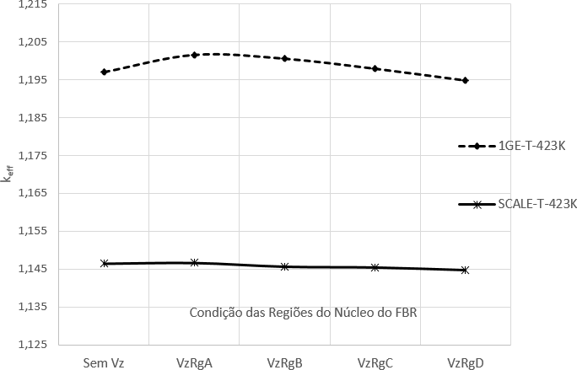
Figure 4 - Multiplication Factor - k_{eff} .

1. The graphs in Figure 5, prepared according to the data in Tables 9 and 10 [1], show that the values of the reactivity coefficient, α, calculated by the FBR1 program, are decreasing positives for regions A, B and C, until it becomes negative for region D, as the void is inserted into the respective regions. For the SCALE software, only the reactivity coefficient calculated in the empty condition in region A is positive, the others are negative. However, it is important to emphasize that the results from the FBR1 program and the SCALE software show the same trend, that is, they are decreasing as the void condition is inserted from the central region (A) to the external region (D) of the core. reactor, expected result for the FBR due to the greater neutron leakage as it moves away from the center towards the outside of the FBR nucleus.
Table 9 - Results of the Reactivity Coefficient Obtained with the FBR1 Program for the FBR Nucleus in Regions A, B, C and D.

 | Void A | Void B | Void C | Void D
αCa | 0,05379 | 0,04186 | 0,01042 | -0,02653

From the results, it appears that the reactivity coefficient decreases according to the location of the void, that is, it is sensitive to its presence.

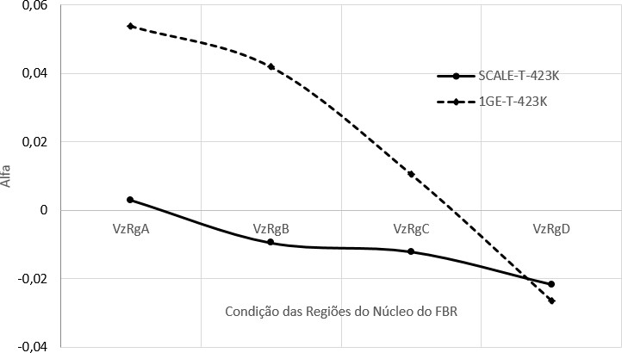
Figure 5 - Reactivity coefficient.

Table 10 - Results of the Reactivity Coefficient Obtained with the SCALE Software for the FBR Nucleus in Regions A, B, C and D.

 | Void A | Void B | Void C | Void D
αSc | 0,00302 | -0,00951 | -0,01211 | -0,02163

2. With the results of the group constants inserted in the MAPLE software, it was possible to trace the curve of Figure 6 that shows the distribution of the radial flow of neutrons to the FBR nucleus.
It is observed in the graph of Figure 6, that the radial neutron flux of the FBR, in the center of its nucleus, has a value of the order of 16.5E-5 neutrons / cm2s and as it moves away from the center it reaches the maximum value, of the order of 19E-5 neutrons / cm2s, in region B and decreases until reaching the value close to zero in region E, specifically in position R = RE, the outer edge of the FBR nucleus.
It is important to note that this is a characteristic of the FBR, in which the maximum flow does not occur in the center, but in a remote position, region B, in compliance with the boundary condition (xi), as shown in the graph in Figure 6. This it is due to the presence of the MOO PuO2, a fissile material, which makes it possible to increase the fission and, consequently, the neutron flow so that it is maximum in this region.

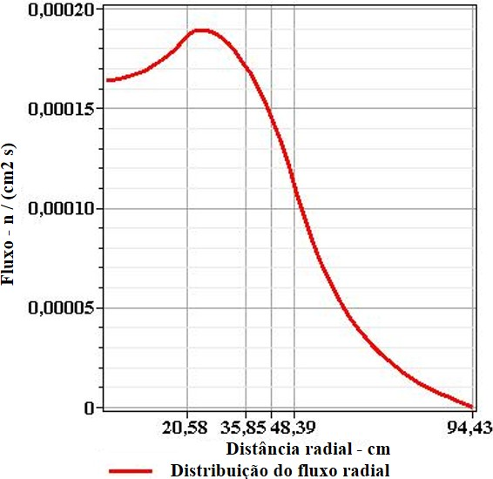
Figure 6 - Distribution of the Radial Neutron Flow of the FBR Nucleus.

The values in this graph are in accordance with those obtained by the FBR1 program; therefore, it shows the consistency of the modeling and the elaborated program.

- – CONCLUSION

The result obtained for the flow contributes to confirm the characteristic of this type of reactor, that is, the maximum neutron flow occurs in region B, far from the center of the FBR nucleus. Neutron absorption is predominant in region E, the outermost region of the FBR nucleus and filled with material consisting of natural uranium (238U), allowing breeding to occur in this region in greater intensity, which is one of the main purposes of this reactor, in addition to energy production. This for the analytical model of the diffusion approach for one and two energy groups.The increase of the keff in relation to the keff without void with the insertion of void in the regions A, B and C results in decreasing positive values ​​of the reactivity coefficient; however, the void in region D results in a negative reactivity coefficient due to the decrease of the keff in relation to the keff without void. This is verified for all simulation conditions performed. This preponderance of the keff with void in region A is a consequence of the predominance of flow and total absorption in the void condition in that region.
The leakage of neutrons increases as the void insertion moves away from the center of the reactor nucleus and this insertion hardens the neutron spectrum thus causing an increase in the average number of neutrons produced by neutron absorbed by the reactor (factor η); therefore, the increase in neutron leakage compensates for the hardening of the neutron spectrum. If neutron leakage did not compensate for this effect, the reactivity coefficient would be positive under any conditions. This positive coefficient occurs with the insertion of a void in the central region of the reactor (regions A, B and C); however, by inserting a void in region D, leakage is dominant, so the reactivity coefficient becomes negative. Although the reactivity coefficient resulting from the analytical model differs in magnitude from that obtained by the SCALE software, its behavior and tendency are similar. The results obtained show the sensitivity of the FBR due to the presence of a void in its core, but also its intrinsic safety. The multiplication factor and the reactivity coefficient are sensitive to the presence of a vacuum; therefore, it is essential to implement mechanisms to control the behavior of the nucleus in such a way that, in addition to allowing the indication of the variation of the keff and of the α, allow its adjustments in order to keep the fission rate of the FBR core stable. The analytical model presented, even with a certain degree of simplicity for an energy group, helps to predict the trend of both the multiplication factor and the reactivity coefficient (positive and negative) that are similar to that of the SCALE software. The diffusion approach and the analytical approach presented in this work provided a simple and fast computational development whose results are consistent with those obtained by the numerical approach of the SCALE software and allow to verify, in detail, the nuclear results obtained in each region of the FBR nucleus. Therefore, we conclude that this approach and approach prove to be a powerful tool for the initial steps of a reactor project in order to verify the behavior of the multiplication factor and the reactivity coefficient of the FBR.

References
- DUDERSTADT, J. J.; HAMILTON, L. J. Nuclear Reactor Analysis. 1. ed. [S.l.]: John Wiley Sons, Inc, 1976. 19, 24.
- LAMARSCH, J. R. Nuclear Reactor Theory. 2. ed. [S.l.]: Addison-Wesley Publishing company, Inc, 1966. 19, 24.
- MEEM, J. L. Two Group Reactor Theory. 2. ed. [S.l.]: Wiley-VCH, 1964. 19, 24.

