Software for Simulation of Fast Reactor Operation in a Closed Nuclear Fuel Cycle (PK RTM-2 software suite)

I.S. Popov
FSUE «RFNC – VNIITF named after Academ. E.I. Zababakhin»
Snezhinsk, Russian Federation
Email: i.s.popov@vniitf.ru

I.R. Makeeva
FSUE «RFNC – VNIITF named after Academ. E.I. Zababakhin»
Snezhinsk, Russian Federation

A.V. Egorov
OAO “Proriv”
Moscow, Russian Federation

E.A. Rodina
OAO “Proriv”
Moscow, Russian Federation

Yu.S. Khomyakov
OAO “Proriv”
Moscow, Russian Federation

Abstract

The work considers PK RTM-2 software suite operation, which is intended for normal operation mode simulation of fast-neutron reactors, being part of closed fuel cycle. PK RTM-2 performs interconnected calculation of the reactor core and fuel cycle stages. It simulates every fuel assembly history from the moment of fabrication to the moment of reprocessing and further reprocessed products recycling. Software suite is used to perform series of uniform calculations in the course of numerical research of various scenarios of fast-neutron reactor fuel cycles.
The paper covers the purpose of the suite, composition, and functionality. Object simulations, as well as simulation scenario, are briefly described.
Key words: fast-neutron reactors, closed fuel cycle, numerical simulation.

INTRODUCTION
“Proryv” project was established in the Russian Federation to develop fast-neutron reactors (FNR) with mixed U-Pu fuel as part of the closed fuel cycle technology [1-2]. The term “closed fuel cycle” implies multiple fuel recycling. At the same time isotopic fuel composition for every reactor campaign will be changing in the course of a long period of time (10-30 years). The fact differentiates reactor operation within closed fuel cycle from the one within one-through fuel cycle, where isotopic fuel composition is almost the same all the time.
Numerical simulation is an important tool to develop new reactor types and nuclear fuel cycle technologies. Numerical simulation allows us to perform comparison of various fuel cycle closing options and assess the impact of the final stage of the fuel cycle on the characteristics of the reactor core. Conducting the investigation implies performing a series of uniform calculations and further results analysis. Variations in the recycled fuel composition induce long-term reactor operation simulation (10-30 years) and the need to take into account the impact of fuel cycle stages. In order to solve these problems PK RTM-2 software suite was developed. It incorporates reactor core calculation and fuel cycle stages simulation.

PK RTM-2 SOFTWARE SUITE INTENDED USE
PK RTM-2 is intended for normal operation mode simulation and fuel cycle stages simulation.
PK RTM-2 simulates every phase of nuclear fuel lifecycle: fuel production at the fabrication module, irradiation in the reactor core, spent nuclear fuel (SNF) cooling before recycling, SNF reprocessing and radioactive waste extraction, further reprocessed products shipping to fabrication module. Nuclear fuel characteristics are monitored separately for each fuel assembly.
PK RTM-2 can solve following problems:

- Critical loads forming of fast breeder reactor core and detailed calculation of neutron-physical characteristics change, fuel consumption and reproduction parameters determination for all the reactor microcampaigns;
- Fast breeder reactor fuel isotopic composition change, fuel reproduction factor optimization and reactivity margin decrease for fuel burn-up;
- Design analysis and justification of various ways of using minor actinides and long-living fission products within fuel cycle;
- Calculation of the amount and characteristics of spent nuclear fuel (SNF), radioactive waste reduction and its potential hazard mitigation.

Software suite components
PK RTM-2 fundamental idea is joined simulation of fast neutron reactor core and of nuclear fuel cycle stages. For this reason the number of calculation modules are integrated within one software suite.
Neutron physical simulation in multigroup diffusion approximation code and nuclear kinetics equation system solver are used to simulate reactor core and SNF characteristics in PK RTM-2. Diffusion approximation calculation allows active calculations to reach acceptable accuracy without high-performance computing. Nuclear kinetics equation system solver is based on “RISK” software suite [3-4] and can use various approximations, reducing the amount of isotopes, which are accounted for in the course of fission fragments calculation. The range can vary from 200 to 1500 isotopes. When it doesn’t matter what is the isotopic composition of fission fragments, the fragment can be treated as an abstract nucleus. The nucleus has an average neutron interaction section with respect to fission fractures, but it doesn’t provide data to calculate characteristics to assess SNF and radioactive waste heat emission and activity.
PK RTM-2 is built on module principle. Any part of PK RTM-2 can be easily replaced for the equal one, which performs similar function without significant change within the initial code.
In PK RTM-2 two interchangeable codes are used for fuel cycle stages simulations .
The first one is PTM-fuel cycle (PTM-FC). The program uses reprocessing module parameters (desorbed components, chemical elements desorption factors, processes duration, productivity), determined on the basis of detailed technological reprocessing scheme simulation, built for BREST-300 reactors using SC “VISART” [5]. The model can take into account reverse material flows (production faults) from fabrication module and agents consumption.
The second code is “PTM - perfect fuel cycle”. In this code chemical elements desorption factors, as well as fuel cycle duration are set by the user. The code is used for many problems where accounting of recycled materials balance is enough for fuel cycle stages simulation.
PK RTM-2 incorporates simulation codes controlled by a system shell, which performs the following functions:

- Provides graphic interface tools to create reactor model consistent with fuel cycle stages;
- Checks initial data correctness. After the check the user is given a list of detected errors and error localisation. As an additional check, the user can display the list of key task parameters, which can not be checked using software (e.g. isotope mass sum, fuel mass, number of fuel assemblies discharged during every recharge);
- Controls simulation codes and formats data while parsing from one code to another;
- Provides monitoring feature during calculations;
- Stores simulation results;
- Displays calculation results in the form of tables, diagrams, and graphic schemes;
- Provides means of simulation results comparison for various problems;
- Performs simulation results processing and sampling in accordance with the user requests with further data representation in the form of tables;
- Exports data on heat irradiation in fuel assemblies for further temperature field simulation, and hydraulic characteristics using external software tools.

PK RTM-2 simulation model
PK RTM-2 simulates normal operation of fast-neutron reactor within closed nuclear fuel cycle. Simulation model PK RTM-2 can be split into the following components:

- Reactor facility core model;
- Fuel cycle stages model;
- Simulation scenario.

Reactor core in PK RTM-2 is represented in the form of a set of cells, forming regular hexagon. Not all the cells of the model represent a real reactor core cells. Boundary cells are artificial and are introduced to simulate boundary conditions. Each cell is filled with homogenized fuel assembly, which is split into geometrical regions along the height (Fig. 1). Temperature and isotopic composition are set for every geometry region. Within one region temperature and isotopic composition don’t depend on the coordinates. One and the same parameters set (isotopic composition and temperature) can correspond to various geometry regions.
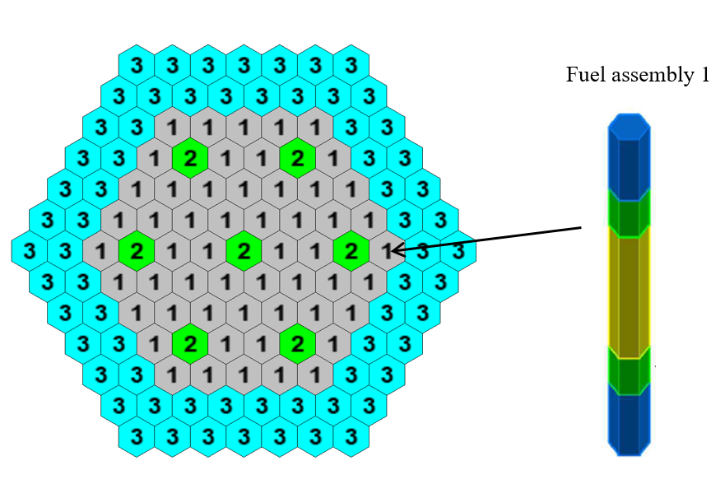
Fig.1. Draft reactor core model representation;
After filling all the model cells separation into calculation layers is performed. Calculation layers are organized in a way that geometry region boundaries correspond to the boundaries of calculation layers. Fig. 2 shows vertical section of one of the rows of the core. Various geometry regions with various parameters sets are colored differently.
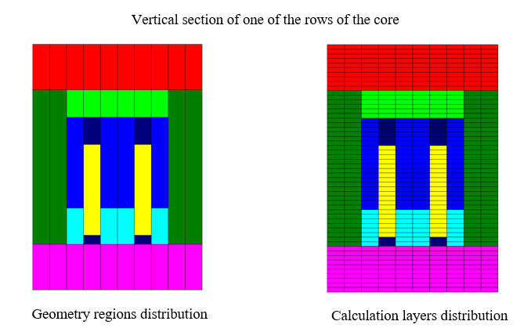
FIG.2. Calculation layers creation scheme

PK RTM-2 provides opportunity to check the isotopic composition evolution for each fuel assembly considering fuel rod splitting into several regions with respect to height.
Irrespectively of the code used to simulate fuel cycle stages, fuel cycle model consists of the following elements:

- SNF storage;
- Reprocessing module;
- Reprocessed products storage;
- Radioactive waste storage;
- Raw materials source storage;
- Structural materials storage;
- Refabrication module;
- New fuel assemblies storage.

Fig. 3 schematically represents fuel cycle model elements.
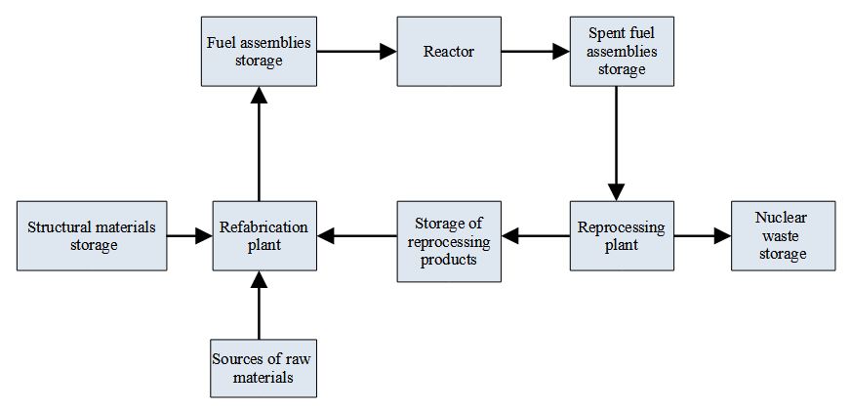
FIG.3. Schematic representation of fuel cycle model elements.
The number of description details and simulation algorithms in these two codes can vary. Further on the purpose of each element within the model is present.
Spent fuel assemblies discharged from the reactor are loaded to SNF storage. For every spent fuel assembly within the storage facility isotopes masses are monitored. Isotopic composition change calculation of spent fuel assemblies in the course of cooling in the SNF storage, residual activity, and heat emission evolution are calculated.
After cooling in SNF storage, spent fuel assemblies are taken to refabrication module. In the course of refabrication fuel assemblies are split into reprocessing products and radioactive wastes.
Reprocessed products storage accounts the delivered and consumed reprocessed products and calculates isotopic composition change in the course of storage.
SNF storage calculates SNF accumulation during the reactor operation and isotopic composition change, activity and heat emission evolution.
Raw materials source storage comprises several sources and accounts the initial raw material consumption. For each raw material source, the user sets isotopic composition, which remains constant in the course of simulation and raw material mass. The model must contain plutonium and depleted uranium sources.
Structural materials sources storage accounts structural materials consumption in the course of fuel assemblies fabrication.
Fabrication module simulates fuel fabrication. At the first load and first several microcampaigns fuel is fabricated of raw materials. Further on, as SNF is reprocessed, raw materials are replaced with the reprocessed products.
New fuel assemblies storage simulates isotopic composition change in these assemblies during storage before loading in the reactor.
Fuel cycle stage parameters setting differentiates RTM-FC from RTM-PFC models.
Thus reprocessing module parameters are set by the user, for example the user sets SNF desorbed fractions and their composition (elements and release fractions). Fuel cycle duration is also set by the user. In the current version of RTM-PFC fuel cycle duration is summed with the cooling time of spent fuel assemblies in the SNF storage, and reprocessing and fabrication are performed instantaneously.
RTM-FC model automatically determines fuel cycle stage parameters on the basis of detailed model of the technological reprocessing lines, created using VISART software suite. In the course of data adaptation from VISART model to RTM-FC model data is generalized: several separate processing units are treated as a single node; for each node material flow transformation factors are established. For each node productivity and process duration are calculated. RTM-FC model takes into account production faults in the fabrication module and returning it back to reprocessing module. If need the model can also account collateral resources expenditure (e.g. chemical agents).
Problem solution scenario takes into account time grid, reload map and isotope composition choice for the loaded fuel.
Time grid is built as described further. The whole lifecycle of the reactor facility is split into microcampaigns. Each microcampaign is split into loading intervals, and these are divided into calculation steps. After each microcampaign reloading is performed.
Reloads are cyclically performed in accordance with the reload map. Reload map is built for reactor core cells (fig. 4), where fuel elements are installed. For each cell the number of microcampaign is determined, when fuel assembly will be unloaded for the first time. On the scheme N stands for the number of microcampaign. After the number of microcampaign each cell gets the number of microcampaigns before the next unloading. On the scheme the number of microcampaigns is R. The model doesn’t support changing installation position of a fuel assembly from one cell to the other, with the exception of taking fuel assemblies to the internal storage. Apart from the map of cyclic reloads the user can also determine individual reloading rules for the chosen microcampaign.
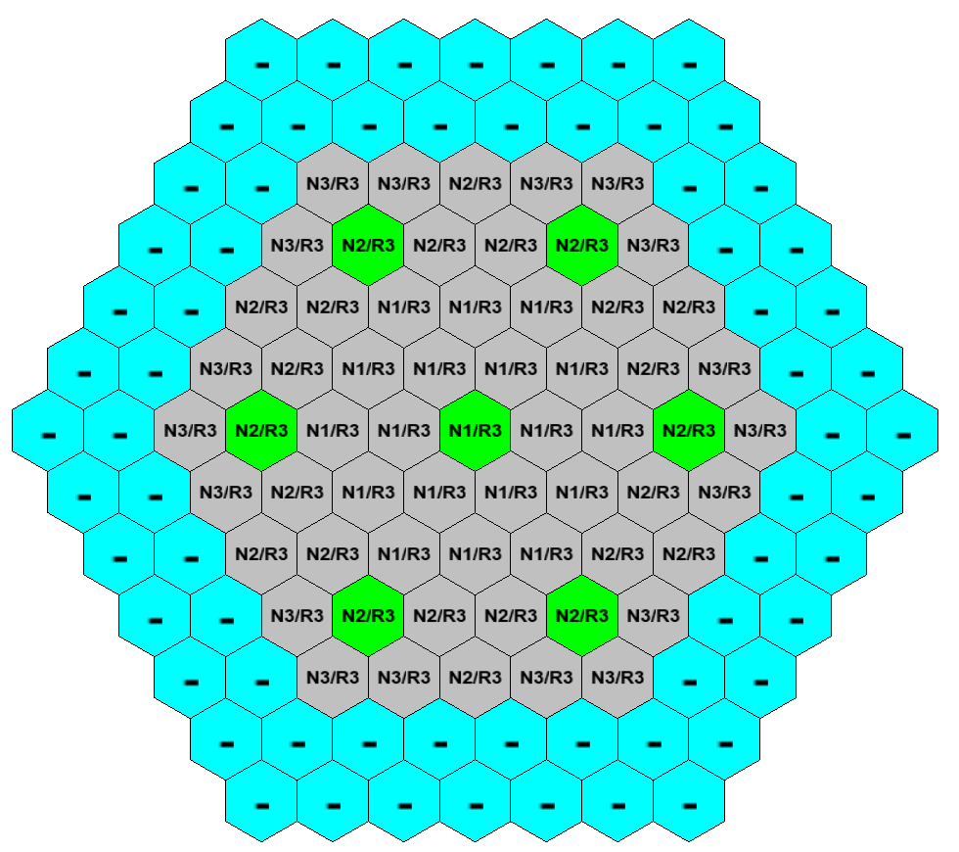
FIG.4. Example of reloading map

Isotopic composition of the loaded fuel is variable, for this reason at each reloading the reactivity margin obtained will be different. In order to influence reactor core state PK RTM-2 has isotope composition choice algorithm. When choosing isotope composition a fraction of fissile material is determined so that the effective multiplication factor is equal to the fixed value. In order to determine fissile materials fracture, equation (1) is solved:
$k_{eff}\left(p\right)-k_{eff0}=0$, | (1)
where $p$, is a fissile material fraction in the loaded fuel assemblies $k_{eff}\left(p\right)$ is neutron effective multiplication factor vs fissile material fraction, $k_{eff0}$ is user-determined value of effective multiplication factor.
The equation is solved using linear-intercept method [6], the dependency of neutron effective multiplication factor on fissile material fraction is determined via neutron physical calculation.
In the course of overload simulation reactor facility model interacts with fuel cycle model. At first unloading calculation is performed, at the same time fuel cycle model gets characteristics of spent fuel assemblies that are shipped to SNF storage. Further on fitting algorithm is used to solve equation 1. The equation is solved iteratively, and the model of the reactor facility forms the request for new fuel assemblies fabrication. The request contains masses of each material in fuel assembly, and fissile materials fraction in the fuel. Fuel cycle model calculates fuel assemblies composition on the basis of the sources used (reprocessing products, initial raw material). In case the fabricated fuel assemblies do not fit the fitting algorithm requirements the request is adjusted and reentered to the fuel cycle model. At each new request fuel cycle objects are brought back to the initial condition. After fitting is over, RTM-2 freezes the obtained state and sends a signal to the fuel cycle model.
Each element of the problem has big number of adjusted parameters, the fact facilitates solution of various problems, that are created with the use of one and the same pattern.
After conducting the main investigation the user can perform additional studies of separate stages. For example the one can export data on heat emission distribution along the fuel assembly in the reactor core and calculate temperature fields using external programs, or calculate some reactivity factors using PK RTM-2 functions.

Conclusion
Numerical simulation is an important tool in studying the problem of closed nuclear fuel cycle. Such complex problems like this require creation of specialized tools.
PK RTM-2 is an integration environment for already developed codes. Considered separately any component is not something new. But integration of the existing solutions into a singular tool creates a product with new qualities.
PK RTM-2 is aimed to solve the problem of closed fuel cycle. The functionality it provides facilitates conduction of multiple calculations of uniform problems. It helps to significantly reduce the number of routine tasks aimed at setting and checking the initial data and results processing. Thus PK RTM-2 improves efficiency and reduces time for simulation studies.
PK RTM-2 is used for simulation studies of closed fuel cycle within the “PRORIV” project [7 - 8].
References
- Rachkov, V.I. et al., “Fast reactor development programme in the Russian Fedaration” Fast Reactors and related Fuel Cycles: Safe technologies and sustainable scenarios FR13 (Proc. Int. Conf., Paris, 2013), IAEA, Vienna (2015).
- Rachkov, V.I., Adamov, E.O., Orlov. A.I. «Scientific and technical problems of CNFC in two-component NPE and their solution in “Proryv” project, IOP Conf. Series: Journal of Physics: Conf. Series 1475 (2020) 012017 IOP Pub-lishing doi:10.1088/1742-6596/1475/1/012017.
- Modestov, D.G., The solution of radioactive decay equations. Issues of atomic science and technique. Part Mathematical simulation of physical processes (2006) 54-59.
- Modestov, D.G., Nuclear kinetics problems solver code. RISK-2014. Preprint of RFNC-VNIITF #243, RFNC-VNIITF, Snezhinsk (2014).
- Makeyeva, I.R. et al., “Modeling technologies of fuel cycles”, Fast Reactors and Related Fuel Cycles: Next Generation Nuclear Systems for Sustainable Development FR17 (Proc. Int. Conf., Yekaterinburg, 2017), IAEA, Vienna (2018), Paper CN245-147.
- Srochko V.A. Numerical methods. Lections, Lan publishing, Saint-Petersburg (2010).
- Khomyakov, Yu.S., Rodina, E.A., Shmidt, O.V., Egorov, A.V., Makeeva, I.R., Popov, I.S., and Sokolov, V.P., Justification and optimization of FNR transition to the closed fuel cycle mode, IOP Conf. Series: Journal of Physics: Conf. Series 1475 (2020) 012017 IOP Publishing doi:10.1088/1742-6596/1475/1/012017
- Egorov A.V., Khomyakov Yu.S., Rachkov V.I., Rodina E.A. Suslov I.R. Minor actinides transmutation in equilibrium cores of next generation FRs, Nuclear Energy and Technology 5(4) (2019) 353–359.

