Research on the Impact of Advanced Rule

Design System on the Digitalization of

Reactor Building Model

JIN WANG
China Institute of Atomic Energy
Beijing, China
Email: 616949084@qq.com

A.N. HONGYI YANG
China Institute of Atomic Energy
Beijing, China

Abstract

This paper proposes a more stringent method for customizing project rules. This method customizes the comprehensive rules of the project and component reference database on the digital plant design platform based on some general design codes, standards and item classification principles in nuclear engineering, digitalization requirements in reactor design, plant layout, project management, material procurement and construction, etc. To improve the correlation between design specifications and digital power plants, enhance the data consistency among different design disciplines, standardize the three-dimensional layout design of nuclear power plants, ensure the consistency between the digital power plant model and the real power plant, the rules are sorted out, analyzed, and transformed systematically in this paper. These rules include the naming and classification principles of items in nuclear power projects, model data composition structure, essential attribute content, component selection filters, material performance, model parameters, output content format, basic requirements for plant layout for reactor design, etc. Through refinement and improvement, this paper finally forms a systematic rule customization scheme, which includes parameters such as process, operating conditions, materials, fluids, specifications, safety, quality assurance, seismic and radioactivity levels, as well as items naming rules, project database, component reference database, three-dimensional modeling, information integration, attribute inheritance, data extraction and other rules. This scheme can make the three-dimensional arrangement more standard, the operation steps more concise, and greatly reduce the attribute range of manual input by the designer. It can effectively promote the accurate and appropriate expression of process and instrumentation process design scheme in the reactor building model. Significantly shorten the project design cycle. Data integration and transmission between rules enable system attributes to be deeply inherited and automatic checking and judging of operating conditions parameters and pressure and temperature limits in physical properties of component materials. This scheme can make the three-dimensional layout more standard, the operation steps more concise, greatly reduce the attributes range of manual input by the designer and obtain better application feedback in automatic drawing and material report. These rules provide more comprehensive data support for coupling experiments, data integration, process simulation and digital handover of different disciplines and depths.

INTRODUCTION
Digital reactor is a new interdisciplinary subject with rapid development. It can form the digital prototype [1] of the reactor based on software by using refined numerical simulation method. It can be used in the whole life cycle of the research, design, construction, and operation decommissioning of reactors. It plays a significant role in optimizing the design and construction of reactor engineering, improving safety, and reducing cost. The integration with virtual simulation and artificial intelligence (AI) is the hot point in the I.T. services. It is spread widely in reactor construction, operation, maintenance, and commissioning [7]. Reactor digital engineering design is an indispensable part of the process from reactor data centre to digital reactor [4]. It is an important design stage to form the data foundation of the digital reactor and smart reactor. Digital engineering design is a design activity based on digital design platform for engineering application. This process mainly solves the key technology research on the transformation of scientific research achievements to engineering application. Digital engineering design platform is an incubator for the commercial application of new reactor technology research. Scientific evaluation [5] and validation can be carried out by pre-designing on the platform. It ensures that a very accurate feasibility analysis [6] report can be obtained for the entire project at an early stage. Multi-specialty plant design is a classic way for the virtual reactor engineering design. This is a system engineering that includes all two-dimensional and three-dimensional designs in the reactor. The layout [10] design of physical items in the reactor building is an important factor affecting the design and construction cost of the reactor. It will directly affect the economic performance of the design scheme of this project. The layout design of all physical items in the reactor is based on the reactor buildings. The digital design of reactor building model is the embodiment of system engineering design based on model.
The virtual reactor buildings [2] always have huge and complex object volumes. All the specific design tasks cover the whole reactor engineering indirectly. There is assignable disparity between the digitalization design environments [3] and application levels of institutes, suppliers, and constructors. As a result, the model digitalization of reactor building keeps a vital important position for a long time. The data cannot reach a high consistence. Hundreds of designers participate in the digital modelling of reactor building as normal. Ten thousand of drawings and reports are generated from the model. The entire design process confronts with the enormous deadline pressure from the procurement and construction. To avoid the heave financial loss from the delaying of schedule, the process implements the project deadline list strictly. It is the top priority part besides the safety and the target function. The sacrifice of digitization and economy performance is inevitable concurrently. The mode will limit the digital upgrading. It is averse to promote the design depth and application level. The solution is customized for the institutes and EPC. It can improve the design quality of the model digitalization and reduce the project management cost.
In the reactor, there are various types of items, such as, equipment, process pipes, instrument, cable, tray, HVAC, steel structure, civil and so on. The types and scale of the items are closely related with the power level of the reactor. For the different items, the parameters of process, condition, material, fluid, class, safety, seismic resistance, and radioactive level show conspicuous difference. The same items in the different buildings differ greatly in the attributes. The participants of the reactor require quite differently for the attributes of the same items. However, all the requirements are unified and reflected organically in the reactor building design. The attributes information of the items in the plant design system are inherited, called, and integrated complicatedly. There is a common plant coding language to describe and analyse the various function items, such as KKS code. A data dictionary is also needed for the characteristics and requires of the items. The digitalization of the reactor plant model can be contrasted with a large symphony. The items (musical instrument) in the rooms (measure) need to achieve the target function. It fits the rigorous and grand style of the reactor standards. Advanced rule design system is a method to spectrum and conform the theme easily. It is based on the digitalization process of domestic pressurised water reactor and fast reactor project building model. It is an exploration for the optimization scheme of the digital research reactor building.
This study focuses on the following issues：
- How can data information be unified with significant differences in the level of digital design?
- How to ensure the design efficiency and quality while achieving the overall goal of digital engineering design?
- How to achieve a single source of data and efficient collaborative design of all disciplines in the reactor plant?
- What is the reason for recommending that the design institute vigorously construct the reactor model database?

Solutions
Before elaborating on the formal content, explore the possible answers to the questions raised above. On the first issue, a part of the proposed solution is that the design institute assumes more responsibility. An important prerequisite is that the design institute at least should be the core of the new reactor engineering design scheme. It needs to assume the role of the commander during the planning or the implement of IPD (Integrated Project Delivery). The digital engineering of reactor needs the full participation of the design institute. The mode can be BIM (Building Information Management) or PIM (Plant Information Management). The Lifelong quality responsibility system of nuclear power project brings a motive power for the better design in the design institute-led model. Another part of the solution is about Digital top-level design and implementation stage. The digital design of the reactor will need to meet the requirements of data granularity for IPD or simulation. It is suggested to start the digital plant design for multi scheme comparison and selection of the reactor engineering in the preliminary design stage. In the earlier stage of reactor scheme design and selection, it is recommended to use the traditional model with better flexibility and development. The main function of digital engineering design is to verify the engineering characteristics of the research scheme. The plant engineering design requires a complete digital engineering design platform. It is the basis of engineering transformation and design verification of new reactor technical scheme. It usually consists of a series of specialised engineering design software, except for the reactor theoretical calculation and analysis. Drawings and reports for construction will be automatically output from the digital model of the reactor building. The platform requires technical support from professionals for project maintenance, database development and platform application. During the project cycle, it is usually necessary to provide continuous and stable financial support and personnel input. Throughout all participants in reactor engineering design, the design institute has good implementation conditions to systematically build a digital engineering design platform. The platform is the basis for efficient completion of project design tasks. Suppliers and builders are the users of design data in the digital engineering design process. Design institutes provide design data to meet their needs, while downstream professional digital design capabilities can be ignored. However, this does not mean that downstream majors will not contribute to the establishment of the rule system. On the contrary, for engineering practice, procurement and builders provide irreplaceable design application experience feedback. The mode led by the design institute requires all participants of the project to jointly formulate the rules and order related to the digital design of the project. It’s including the attribute information of the same items in the reactor buildings. It is necessary to unify digital design specifications and standards and build reference database.
Regarding the second issue, it is recommended to systematically integrate [7] design methods. This method improves data accuracy and reuse rate by controlling a single data source. Through two-dimensional and three-dimensional integrated design, possible inconsistency errors in layout design can be effectively reduced. The scope and depth of integration need to be adjusted appropriately according to the workflow of design institute. This approach solves approximately 50% - 60% of the design changes and clarifications at source. It has good application prospect in construction design stage. Integrated design is a strongly constrained design pattern. The scope and depth of integration will affect the operational efficiency of the entire project. Engineering design is an activity oriented to practical application, not an unparalleled work of art. Economic performance and research time are important indicators for considering a project. Integrated design reduces errors caused by inconsistency of information between specialties by improving overall design quality. It will improve overall project time performance metrics. Integrated design needs a good implementation foundation. It has higher requirements for the management [9] and digital design ability of design institute. This approach can be implemented along with the project life cycle. However, it is not suitable for direct use without strict planning and deployment. It is more applicable to a brand-new project. Integrated design is a medium to long term investment for nuclear power projects. This is not an immediate way to generate revenue. The design and construction cycle of the project is expected to shorten the original construction cycle by 10% - 13%. This approach will also have a positive impact on design process management and business digital transformation.
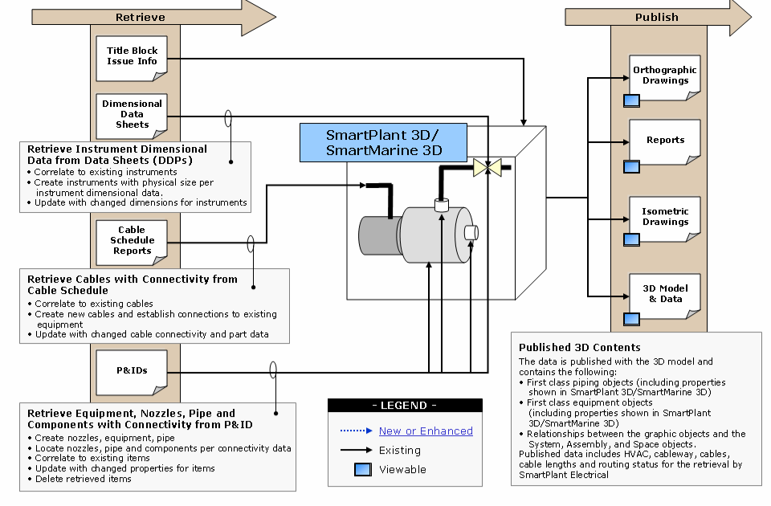
Fig. 1. Integrated design schematics between different digital Engineering design systems (adapted from [11]).
As for the third issue, part of the second question has been answered briefly. Efficient collaborative design is the key to implement the idea of integrated design. It is an important method to ensure the reliability of a single data source and its data. The entire reactor design is a large-scale collaborative design process. The process involves complex and frequent data exchange and iterative design between disciplines. This complex nature makes it impossible for traditional models to develop professional collaboration in a more efficient and standardized way. At present, many projects still use document, offline data exchange and part of collaborative design mode. To solve this problem, it is suggested to start with the integration of design mode, workflow, and design method with digital design platform. Rigorous rules in software systems can standardize and restrict the exchange of design data, document signing and implementation of design processes. Integrated design makes it easier to standardize projects and reduce invalid iterations. It will also enhance the quality and efficiency of cooperation between different specialties.
For the fourth question, the answer needs to go back to the digital reactor itself. Digital reactor has a very rich connotation. Each specialty can have a different interpretation from its own perspective. Generalized summary can be expressed as a comprehensive digital design scheme for research, design, and application in the whole life cycle of reactor based on a variety of professional analysis, calculation, and design software. The design results are displayed in the form of model, with complete verification process and analysis report. The digital reactor model can be used as a reference station for real reactor development. Advanced tools and schemes are important technical means for digital reactor technology to accelerate the development of new reactor configurations. Digital reactor is a system engineering based on model. Reactor model data is the foundation of the entire digital reactor. Data quality and application level of digital technology will directly affect the application scope and depth of digital reactor technology. Reactor model data is the basis for correlating other design parameters, documentation, and analysis reports. It is the data carrier to complete the comparison and analysis of operation [8] and maintenance data and design parameters. The reactor building model is the result of transformation from scientific research results to engineering design. The goal of digital design is to establish a mapping relationship with the real world. Accelerate the application and implementation of new reactor technology through the development of digital reactors. Model based system engineering, numerical reactor, process system design verification and digital plant design are all important components of reactor digital design. It confirms the application research of digital technology in different scales and ranges from demand, calculation, system and engineering. It reflects the practice of digital design technology in reactor demand management, theoretical calculation, system simulation and engineering design.
If the proposed answers to these four questions are classified and sorted out, it will be found that the core is to standardize and guide the reactor digital engineering design method through the integration of rule system and digital design platform, to improve the design efficiency and reduce the design cost. The research and application scope of the advanced rule system should focus on the digital factory design in the reactor building. It is more closely related to the application of reactor engineering design. The implementation of advanced rule design system needs to be closely combined with the overall goal of the project, design process and localization application of digital design platform. Digital design platform is an important implementation environment of advanced rule design system. Digital model of reactor building is the most important part of digital reactor facing engineering application. The combination of advanced rule design system and digital design platform will have a positive impact on digital reactors.
The advanced rule design system is a digital summary and refinement of the design specifications implemented in the digital design of reactor building. Standardize the design process by constantly consolidating mature design experience. Such as design specifications, reference databases and plant design. It provides systematically databases rules customization and application for the various reactor layout schemes. The development solutions for the overall and macro-performance will be guaranteed reliably. In addition, it provides more rigorous data support in specification design, shortening construction cycle and cost reduction. Specifically, it mainly consists of following parts:

Unify Code and Standard for Digital Design
KKS code is widely used in domestic reactor projects. It is the default condition for the unique codes of buildings, systems, components in the reactor as normal. To avoid repetition, it is not described in the article. This paper discusses how to formulate and execute the rules in virtual plant design platform. It is designed to develop and implement high quality the digital plant design.
The task of process and instrumentation drawing will be started after the reactor type design. That means the main parameters and performance indexes for the initial design have been determined. Data integration is the top priority task for the digital plant design at the same time. The permitted design specifications, material& dimension standards, welding and manufacturing processes for the reactor need to plan and evaluate strictly. Naturally they have met the overall requirements and development objectives of the reactor. The process of traditional research reactor digital reactor will be gradually determined and improved with the specific tasks. The traditional design schemes conform to the design process of general project development. It is fatal for projects with high digitalization goals and tight construction periods. The precondition for high efficiency application of virtual design platform is customized rules first and applied strictly. In the traditional mode, the database of the platform must frequently adapt to the changes of projects and design rules. Due to the lack of unified planning and constraints, the application value of standardized selection failed to play a good role. The data integration of the whole rule system failed. The higher execution time cost brings that the initial digitalization goal of the project cannot be completed. In the Initial stage of the scheme design, it is essential to plan and assess systematically the standards and specifications with sufficient manpower and resources. The achievements are the bottom rules for the database development in the virtual design platform, such as project database, data dictionary and reference database of the project.
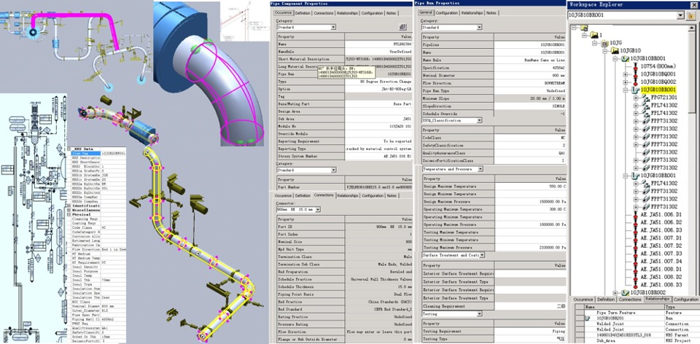
FIG. 2. Attribute integration schematics based on uniform coding rules

Construct Full Attribute Virtual Reference Database
3D design system is the key module for the virtual plant design platform, regardless the platform type. The project reference databases are the design basis for all digital plants concurrently. Component libraries for the reactor are the links for the process design scheme and various objects in the real world. They are the information vehicles for processing, manufacturing, purchasing and installation segments. The accurate exterior dimension database is the basic premise for the static layout design of digital reactor. This is approximately consistent with the real reactor. Related rules and constraints in the reference data, such as material, dimensions and so on, must fulfil the uniform standards identified above strictly. The code rules in the reference data need to satisfy the information requirements of the same item for different specialties. They will be used for component library development, process design, process and manufacture, material procurement, installation, and construction. The code system needs to unify and integrate the item attributes and bottom rules in the platform. The information of location, material, dimension, connection, condition of the items, originates from the digital reactor. They are provided to the owners, clients and constructors by the reactor institutes. The automatic output rules for the filters, drawing and report information in the layout are customized in the platform. They are based on the matching data and the driven rules of the project and reference database strictly.
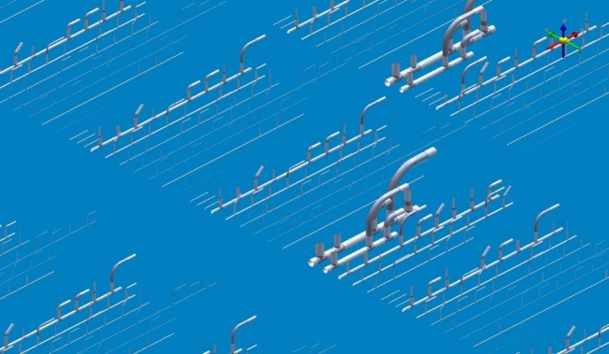
Fig. 3. Schematic results of automatic verification of pipeline element library

Attribute and space integration design
The plant design platform is not independent software, but a comprehensive platform customized by a series of professional design software. It implements the 2D& 3D design, analysis, verification, automatic drawing, and reports for the digital reactor. Advanced rule design system is a comprehensive customized integration design system based on the platform for the project. In addition to the integration of data rules and attributes at the reference database level mentioned above, PBS and KKS are the parts of the bottom rules for the project in the rule systems. The digital reactor buildings are designed by the specialties in the same coordinate system. It is paralleled independently and related partially. One example is the integration of process flow chart design system and virtual factory design platform. The codes and attributes of the related equipment, process lines and valves in process instrument flow chart can be called directly in the 3D design system. In addition, the functions and attributes integration of the process and instrumentation flow chart, layout, instrument control, electrical and other professional software can be developed in the platform. It can greatly reduce the scope of manual input and errors enhance the reusability of data information. The attribute information can be inherited in depth. It is realizable to contrast the operating parameters with the temperature and pressure limits of the process pipeline materials. The process pipeline grades can judge the allowable range and verify the data by the rule system intelligently.
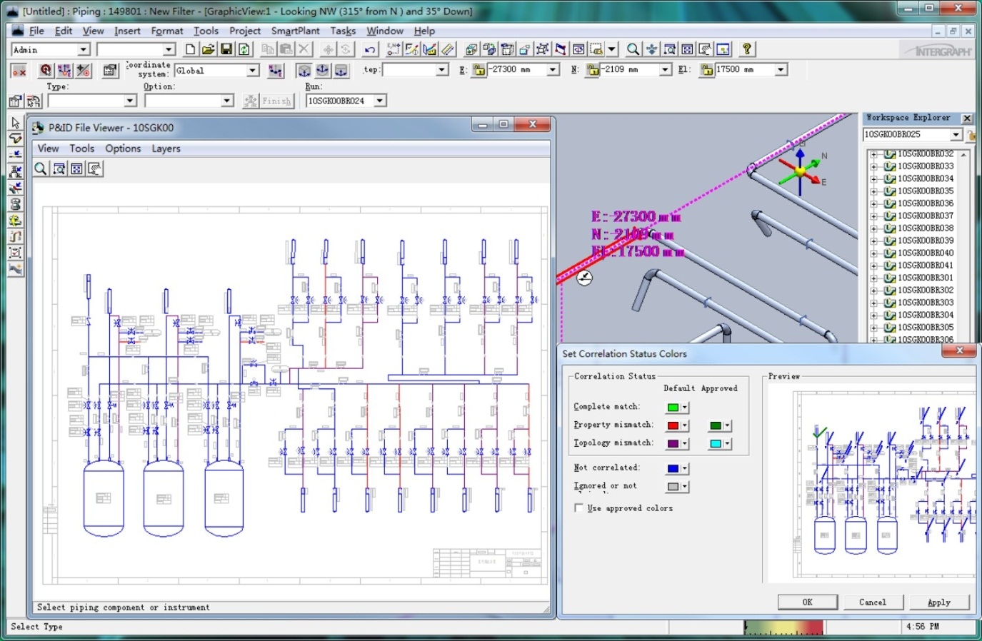
FIG. 4. Rule-based verification schematic for 2D and 3D integrated design
The building design of nuclear reactor and nuclear power plant embodies nuclear safety functions characteristics. The target functions and plans of each link need professional and detailed division of labor. The requirements of space integrated design in the reactor are derived from the process. The virtual factory design platform provides a perfect simulation test environment for the layout scheme. From the project experiences accumulated, the use and allocation of the space will become a long-standing war between design institutes, professionals, and systems, with not explicitly rule constraints. The project implementation plan is strongly correlated with the disciplines of 3D design tasks. It means that the task can be only triggered and started after the predecessors have been completed. The integrated space design needs gradually to practice with the deterministic priorities normatively. It needs to constraint and standardize the layout design also. It is the most creative aspects of the overall reactor design. According to the type and relevant design specifications of the reactor, the space classifications and functional areas are divided strictly. The design requirements of safety and allowance of the project are to be followed. All the items in the reactor are guaranteed to be suitable and permissible locations. The transportation and installation conditions for the real-world items are satisfied simultaneously.

Reactor Building Model Database
The design of the digital reactor building is an important design stage to create the model data in the development stage. The model will coincide closely with the real reactor building. Digital reactor building in D1 design depth can support high-precision evaluation of reactor research reactor scheme and economic evaluation for the project declaration. It is of practical value for the project implementation, material procurement and shortening construction time. The integration of source data information is accomplished in the plant design platform by assembling the requirements of all downstream links. The plant will develop the whole reactor building model database. According to the requirements of the owner and project, the rules will be customized to output target data from the model database. It provides first-hand information for the operation, maintenance and decommissioning of the reactor. The model database of the reactor can be guaranteed for the authenticity and validity of coupling analysis data between the professions, such as professional simulation, scheme analysis, and installation verification and so on.
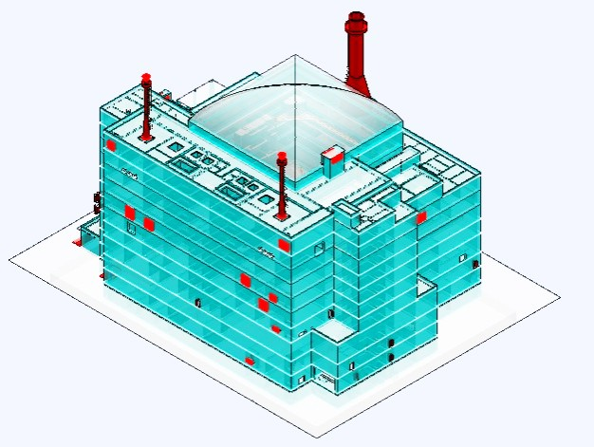
FIG. 5. Schematic diagram of plant model database

Analysis
Whether in model-based system engineering or digital reactors, the document-level design data has obvious weaknesses in data validation and analysis at the parameter level of full-reactor digital simulation verification. Even though data cleaning technology is used to extract parameters, there are still large potential risks in data accuracy and consistency. Data transmission and sharing of discrete design system, building a wider and deeper integration and collaborative design environment are effective methods for system engineering construction of digital reactor engineering projects. With the development of nuclear science and technology, both research and commercial reactors are confronted with nuclear fuel resources and the fear of nuclear facilities from the surrounding residents. Combined with the construction of research-oriented reactor, digital nuclear reactor is built through digital design platform. Through the application and promotion of digital prototype technology, the design mode of design, application and research is realized in a spiral way. Building knowledge base and expert diagnosis system in digital reactor can provide operation and maintenance guidance for real reactor. It can provide more valuable design experience feedback for the study of extending refuelling cycle and improving reactor economic performance.
The digitalization of reactor building model is the key to the transformation of reactor project from scientific research to engineering application. It is the most direct embodiment of digital reactor. The design quality of digital reactor building model will directly affect the quality of digital reactor and output drawings. The granularity of data plays a direct role in whether the model database of reactor building can become the main data of digital reactor. The digitization of reactor building model is a key step to realize the digital transformation of reactor design. It is also an important design activity to practice the concept of digital engineering design. Advanced rules design system is a collection of data based and rules-based design patterns. It contains the work procedures and management regulations governing 2D and 3D design and platform application. Advanced rule design system is a system that integrates traditional design process and design experience and drives the application and implementation of project standards and national regulations by rules and data on digital design platform. This rule system is the application and implementation of traditional design process and design experience based on rules and data on digital design platform. It plays an important role in optimizing digital design scheme of reactor building and improving design efficiency and quality. The advanced rule design system is a dynamic rule base. According to the requirements of business implementation, the platform function and the general design requirements of project digitalization can be supplemented and improved in time. The integration of advanced rule design system and digital platform can provide more standardized and precise design process and environment.
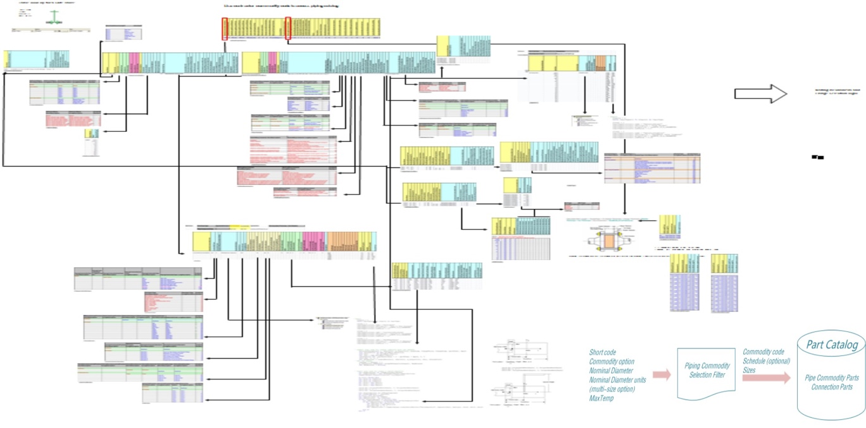
FIG. 6. Application schematic diagram of component library rule system based on digital design platform (adapted from [11]).
The difficulties in digitalizing the research reactor building model are the numerous uncertainties caused by the key equipment of research reactor. They will affect largely the building size and layout design scheme. The virtual design platform is a digital design environment. It needs to pre-set a set of allowable databases for layout scheme simulation in the platform. In the design of the digital reactor building, it is necessary to carry out sufficient in-depth design analysis and scheme evaluation for the overall scheme design. The important details on prophase can avoid the bottom changes at the preliminary and detailed design stages. The virtual reference data is the core and foundation of the whole digital building design. The lack of valid data is the most direct challenge for digital research reactors design. The reference data can inherit and develop to the largest extent the design data from the existing or similar reactor. It is an important design method to accelerate the development of reactor program. The reference database and rules of project and platform should have good compatibility and expansibility. Without the impact of the underlying rules, it is necessary to update and perfect the factory super database timely. It is available to complete the whole factory life cycle customer data service. High-quality digital reactor building database is the basis for the realization of the digital and smart reactors.

Conclusion
The digital model of the reactor is a comprehensive result of the collaborative design of several professions for design institutes in the virtual design environment. It is the product of the collision between the design concept and the real world. All clarifications and changes during the design and construction require rigorous scheme simulation and analysis verification in a virtual design platform. The customized rules of standard specifications, reference databases and space build the rationality basics of the scheme. Thousands of specific tasks for the reactor design will be developed more concise and standardized. The rules system will reduce collision interference and inconsistency of information from the source. This way will bring more revenue about the time, efficiency, and quality, in addition to standardizing material selection and reducing design cost. High-quality model data of the reactor building provides reliable data basis for coupling experiment and simulation verification of downstream specialty. It has good practice and promotion value for improving accuracy of experiment and guiding real reactor installation, construction, operation, and maintenance.
The digitalization of reactor building model is one of the easiest and fastest modes to accelerate the implementation of digitalization transformation of reactor engineering design. Combining the application of advanced rule design system highly matched with localization can help design institutes make a qualitative leap in digital design. The research and development of rule system based on platform function and overall goal of project digitalization will be the key to restrict the application of this method. It is an organic combination of design experience, regulatory standards, and project requirements. In this regard, it is suggested that the design institute should customize its own advanced rule design system based on its own digital design foundation and business characteristics.

References
- Research Progress of China Virtual Reactor (CVR1.0). YANG Wen;HU Changjun;LIU Tiancai;WANG An;WU Mingyu;Division of Reactor Engineering Technology Research,China Institute of Atomic Energy;University of Science and Technology Beijing ，Atomic Energy Science and Technology，Issue 10. 2019. PP 1821-1832.
- Development and application of virtual nuclear power plant in digital society environment，Journal|[J]International Journal of Energy ResearchVolume 43, Issue 4. 2019. PP 1521-1533， Yican Wu，Key Laboratory of Neutronics and Radiation Safety, Institute of Nuclear Energy Safety Technology Chinese Academy of Sciences Hefei Anhui 230031 China，DOI: 10.1002/er.4378
- The Virtual Environment for Reactor Applications (VERA): Design and architecture，Journal|[J]Journal of Computational PhysicsVolume 326, 2016. PP 544-568，John A. Turner; Kevin Clarno; Matt Sieger; Roscoe Bartlett; Benjamin Collins; Roger Pawlowski; Rodney Schmidt; Randall Summers，Oak Ridge National Laboratory, Oak Ridge, TN 37831, USA; Sandia National Laboratories, Albuquerque, NM 87185, USA，DOI: 10.1016/j.jcp.2016.09.003
- The virtual digital nuclear power plant: A modern tool for supporting the lifecycle of VVER-based nuclear power units, Journal|[J]Thermal EngineeringVolume 61, Issue 10. 2014. PP 697-705, G. V. Arkadov; A. P. Zhukavin; A. E. Kroshilin; I. A. Parshikov; S. L. Solov’ev; A. V. Shishov, All-Russian Research Institute for Nuclear Power Plants Operation; General Energy Technologies, DOI: 10.1134/S0040601514100012
- Virtual Reality-Based Ergonomic Modeling and Evaluation Framework for Nuclear Power Plant Operation and Control， Journal|[J]SustainabilityVolume 11, Issue 9. 2019. Hyunsoo Lee; Woo Chang Cha，School of Industrial Engineering, Kumoh National Institute of Technology, Gumi 39177, Korea; chaw@kumoh.ac.kr，DOI: 10.3390/su11092630
- Study on the systematic approach of Markov modeling for dependability analysis of complex fault-tolerant features with voting logics， Journal|[J]Reliability Engineering & System SafetyVolume 150, 2016. PP 44-57g, Kwang Seop Son; Dong Hoon Kim; Chang Hwoi Kim; Hyun Gook Kang， I&C/Human Factors Research Division, Korea Atomic Energy Research Institute, Republic of Korea; Department of Nuclear and Quantum Engineering, Korea Advanced Institute of Science and Technology, Republic of Korea, DOI: 10.1016/j.ress.2016.01.014
- Integrated, Virtual Plant Design and Commissioning Methodology using Digital Manufacturing and Lean Principles, Journal|[J]SAE International Journal of Materials and ManufacturingVolume 2, Issue 1. 2009. PP 368-383, Innoengg, LLC and AAG LLC; Comau, Inc, DOI: 10.4271/2009-01-0609
- An integrated digital framework for the design, build and operation of fusion power plants. Journal|[J]Royal Society Open ScienceVolume 6, Issue 10. 2019. PP 181847, Patterson Eann A; Purdie Sally; Taylor Richard J; Waldon Chris, School of Engineering, University of Liverpool, Liverpool L69 3GH, UK.; Culham Centre for Fusion Energy, Abingdon OX14 3DB, UK.; Dalton Nuclear Institute, University of Manchester, Manchester M13 9PL, UK. DOI: 10.1098/rsos.181847
- Improving collaborative work and project management in a nuclear power plant design team: A human-centered design approach, Journal|[J]Annals of Nuclear EnergyVolume 94, 2016. PP 555-565, Guy André Boy; Gopal Jani; Annalisa Manera; Matthew Memmott; Bojan Petrovic; Yassine Rayad; Lucas Stephane; Neha Suri, Florida Institute of Technology, United States; University of Michigan, United States; Brigham Young University, United States; Georgia Institute of Technology, United States, DOI:10.1016/j.anucene. 2015.12.039
- CONCEPTUAL PLANT LAYOUT OF THE CANADIAN GENERATION IV SUPERCRITICAL WATER-COOLED REACTOR, Journal|[J]CNL Nuclear ReviewVolume 5, Issue 2. 2016. PP 203-219, M. Gaudet; M. Yetisir; A. Sartipi, DOI: 10.12943/CNR.2016.00021
- Smart plant integration user’s guide

