COMPARATIVE ANALYSIS OF CALCULATED
AND EXPERIMENTAL DISCREPANCIES OF
NEUTRON-PHYSICAL CHARACTERISTICS OF BN-800

M.Y. Semenov¹, A.A. Peregudov¹, V.A. Mishin¹, Y.V. Dyachenko¹, S.B. Belov ², A.E.Kuznetsov², V.A. Zheltyshev³, E.P. Lyapin³, G.Y. Dubovoy³

¹JSC «SSC RF – The Institute of Physics and Power Energy», Obninsk, Russia
²JSC «Afrikantov OKB Mechanical Engineering», Nizhny Novgorod, Russia
³JSC «Concern Rosenergoatom» branch, Beloyarsk Nuclear Power plant, Zarechny, Russia

Email contact of corresponding author: vamishin@ippe.ru

Abstract

From 2016 to the present day, the BN-800 reactor with a hybrid core is being commercially operated in Russia. During this time, a large amount of experimental data on basic neutron-physical characteristics of the core has been collected. The loading of the hybrid core was permanently changed during the initial time period: different ratio of fuel assemblies with uranium fuel and MOX fuel and also the number of fuel assemblies of medium- and highly-enriched zones. In 2021 the transition to a full core loading with MOX fuel began, which is planned to be completed in 2022. In order to confirm the reasonability of the calculated prediction of neutron-physical characteristics of the BN-800 core, work has been performed to analyze the methods of computational support for the operation of the reactor and to compare the calculated values of the neutron-physical characteristics with the available experimental data.
The calculations were performed using the MMKC code, which implements the Monte-Carlo method, as well as JARFR and GEFEST800 in the diffusion approximation. The comparison of the calculation results for all codes with measurement results allowed to estimate the methodological error in the calculation of the basic neutron-physical characteristics.
Calculations were performed for the first five micro-companies of BN-800.
The analysis of the following neutron-physical characteristics was performed:
- the value of the reactivity margin at the beginning and the end of the campaign;
- values of subcriticality levels during reload and after SR withdrawal;
- efficiency of single CPS rods and CPS groups;
- temperature-power effect of reactivity.

INTRODUCTION
During the operation of the BN-800 reactor, a large amount of experimental data on basic neutron-physical characteristics of the core has been collected. At the initial stage of operation of the reactor (before the introduction of industrial production of MOX fuel) hybrid core was used. It was formed mainly from fuel assemblies with uranium fuel and partly from fuel assemblies with MOX fuel. The loading of the hybrid core was not permanent: the ratio of fuel assemblies with uranium fuel and MOX fuel, as well as the number of fuel assembles of MEZ FAs and HEZ FAs, changed. In addition, due to the use of a special order of fuel assembly reloads in the initial period of operation of the reactor in order to form a uniformly partial reload scheme, the average fuel burn-up in the core (the average isotopic composition) varied from micro-company to micro-company.
Within the framework of settlement maintenance of the reactor operation, neutron physics calculations of the core are carried out and their results are compared with experimental data. The comparison of the calculation results based on the codes used with the data obtained from the results of measurements during the initial period of operation allowed us to clarify the methodological error in calculating the main neutron-physical characteristics and, suitably, to reduce the uncertainty of their prediction for the upcoming micro-companies. The calculations were performed using the MMKC code [1], which is part of the calculation modules of the code BNcode [2], which implements the Monte Carlo method, as well as JARFR [3] and GEFEST800 [4] in the diffusion approximation.
In this report presents the results of the analysis of the following neutron-physical characteristics:
- reactor reactivity margin;
- values of the reactor subcriticality levels during reload and after the SR withdrawal;
- efficiency of the CPS rods;
- temperature-power effect of reactivity.
The results of the analysis for the first five micro-companies of the BN-800 reactor with hybrid core are presented.

DESCRIPTION OF THE BN-800 CORE
The BN-800 core consists of: fuel assemblies, radial blanket assemblies, rods and liners of CPS rods, steel shielding assemblies (SSAs), boron shielding assemblies (BSAs), waste fuel assemblies of IPS FAs, liners of IPS FAs, which is located in the reactor along a triangular grid with a step of 100 mm. Figure 1 shows a cartogram of the starting configuration of the core [5].

Fig. 1. Cartogram of the starting configuration of the BN-800 core.

During the operation of the hybrid core, its composition changed. After the first micro-company, the permanent reactivity compensators (PRC) were replaced by the LEZ fuel assemblies. Depending on the volume of supplies of fuel assemblies with MOX fuel, their number in the core changed. The change in the share of fuel assemblies with MOX fuel in the core from 1 to 5 MC is presented in Table 1.

Table 1-The fraction of fuel assemblies with MOX fuel in the core of the BN-800 reactor from 1 mc to 5 MC

The number of micro-company | The fraction of fuel assemblies with MOX, %
1 MC | 16
2 MC | 18
3 MC | 18
4 MC | 16
5 MC | 10

THE GEFEST800 CODE
The main neutron physics calculations are calculated in the multi-group (26 groups) diffusion approximation. Neutron-physical constants are prepared using the CONSYST constant preparation system [6] and the ABBN-93 constant library [7]. The multigroup (299 groups) diffusion approximation is used to prepare the constants.
The program archive contains the passport data on the fuel composition in the downloaded fuel assemblies, and also it contains information on the isotopic composition of fuel in irradiated fuel assemblies.
GEFEST800 – BN-800 operation maintenance code (Beloyarsk NPP).

THE JARFR CODE
The JARFR software tool is designed for neutron-physical calculations of fast reactors with a sodium coolant based on the solution of the multigroup (26 groups) neutron transport equation in the diffusion approximation.
JARFR calculations were carried out using the original library of constants ABBN-93 and the system for preparing constants taking into account the composition and spectrum of neutrons CONSYST.
The JARFR code is used by the organization - the general designer of the BN-800 reactor facility – JSC «Afrikantov OKBM» for the development of the core project and maintenance of operation.

mmKC (bnCODE)
The MMKC is precision code that implements the neutron-physics calculation of the reactor the Monte-Carlo method. The MMKC calculations use the estimated neutron data files ROSFOND2010 [8] in the ACE format. To account for the temperature changes in the elements of the reactor core, the PTC module is used. This is a program for taking into account the Doppler-effect in calculations with point-by-point tracking of the neutron energy. The program uses the method of proportional temperature concentrations, which allows to take into account changes in the temperature of nuclides in calculations of the criticality of fast-neutron reactor installations according to Monte Carlo programs using detailed neutron energy tracking. For more information about the method and it`s testing, see [9].
The tasks were prepared using the supervisor's code BNcode. The code of the supervisor to support the operation of the fast sodium reactor is used to determine the most accurate current and forecast design characteristics of the BN-800 reactor, to justify the safety during reload, to justify the balance of reactivity according to the micro-company.
This code is used by the staff of the scientific director of JSC «SSC RF-IPPE» for scientific support of the BN-800 reactor.
Comparative computational and experimental studies based on the results of operation reactor facility BN-800 reactor.

Comparative computational and experimental studies based on the results of operation reactor facility BN-800 reactor.
The text of a paper submitted to this conference must be original with any material from copyrighted works (including illustrations, tables, and text quotations) included with the permission of the copyright holder. The contributor should, therefore, make sure that any permissions and rights required to publish any third-party content have been obtained and that all published material is correctly referenced.
The content of a paper is expected to have been written by the stated authors and the paper itself must not have been published before and be under consideration for publication by another entity (if this is the case please contact the Conference Organizer for further information). All papers will be scanned to ensure originality; if they are found to contain non-original text, only their abstract will be included in the proceedings.
Papers will only be included in the proceedings if the IAEA Form B has been submitted prior to the conference. If the Form B is not received, only the abstract may be included in the proceedings, but this may also be omitted.

4.1 Research of criticality

The research of criticality was conducted using the MMKC precision code for five micro-companies. Figure 2 shows the criticality results obtained with using this code for the "cold" and "hot" states.
Note that the estimated time in the BNcode of a single neutron-physical calculation by the MMKC program with a detailed geometry (the design task is about 50,000 zones) and with a temperature profile in height and radius takes about 3 hours, and the calculation time of a single micro-company is about 12 hours.
As can be seen from Figure 2, the calculation of the critical "cold" and "hot" states of the reactor is predicted with good accuracy (the maximum spread is ±0.1 %), but it should be noted that the difference in the criticality calculations between the "cold" and "hot" states of the reactor is ~0.2%.

Fig. 2. Results of critical states calculations

Calculations of the reactivity margin

Studies of the reactivity margin were also carried out for five micro-companies for three codes of the MMKC, GEFEST800, JARFR. The results of comparing the calculated values of the reactor reactivity margin in «cold» conditions at the beginning and at the end of micro-companies with experimental data are presented in Tables 2 and 3.

Table 2 – Results of calculated and experimental discrepancies of reactivity margin in beginning of MC for «cold» core state, %Δk/k

Code | 1MC | 2MC | 3 MC | 4 MC | 5 MC | The average discrepancies of reactivity margin
MMKC | -0,46 | -0,36 | -0,24 | -0,13 | -0,24 | -0,30 ± 0,12
GEFEST800 | - | -0,58 | -0,60 | -0,44 | -0,46 | -0,54 ± 0,09
JARFR | 0,07 | -0,06 | -0,13 | 0,1 | 0,03 | 0,00 ± 0,10

Table 3 – Results of calculated and experimental discrepancies of reactivity margin in end of MC for «hot» core state, %Δk/k.

Code | 1MC | 2MC | 3 MC | 4 MC | 5 MC | The average discrepancies of reactivity margin
MMKC | 0,09 | 0,02 | 0,26 | 0,28 | -0,14 | 0,10 ± 0,16
GEFEST800 | - | -0,17 | 0,11 | 0,17 | -0,04 | 0,02 ± 0,13
JARFR | 0,17 | -0,06 | 0,03 | 0,07 | -0,21 | 0,00 ± 0,13

From the results presented in Tables 2 and 3, it follows:
- the average deviation of the calculation results from the experiments for the states at the end of the campaign is not large for all codes and does not exceed 0.1 % Δk/k;
- the deviation of the calculation results at the beginning of the micro-company is slightly greater, which is due to the greater depth of immersion of the absorbing rods (the reactivity margin is determined by the efficiency of their submerged part).

Calculations of effectiveness of CPS rods

Studies of the efficiency of the CPS rods were carried out according to the calculated codes of the MMKC, GEFEST800, JARFR. Figures 3-6 show the average values for the groups of CPS of calculated and experimental deviations for all three calculation codes.
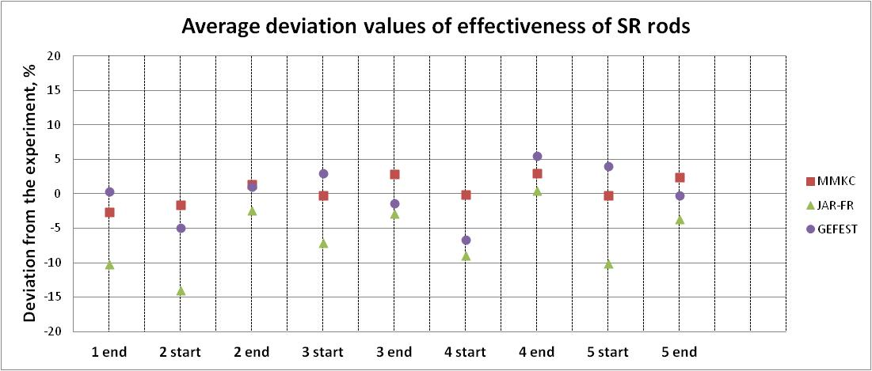
Figure 3 – Average deviation values of effectiveness of SR rods
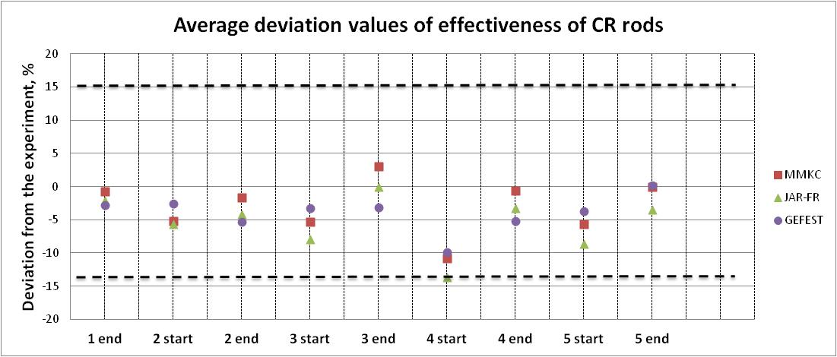
Figure 4 – Average deviation values of effectiveness of CR rods

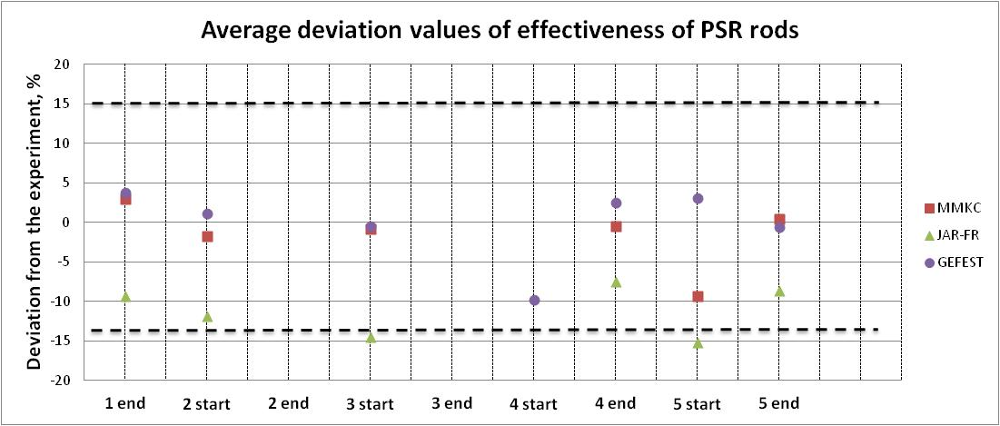
Figure 5 – Average deviation values of effectiveness of PSR rods

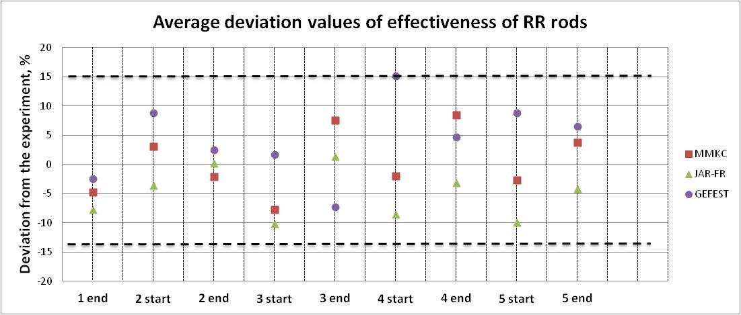
Figure 6 – Average deviation values of effectiveness of RR rods

In each figure, a corridor of ±15% is highlighted, which is drawn according to the maximum observed differences between the averaged values and the experiment. Based on the results presented in Figures 3-6, the following conclusions can be drawn:
- the calculated results for the main groups of CPS (CR and SR) are in good agreement both with each other and with the experimental values;
- the spread of the calculated results for SR at the beginning of the MC is slightly greater than in the end of MC;
- the greatest variation in the calculated results is observed for the «lightest» RR rods both between themselves and with experimental values. However, even in this case, the calculated experimental discrepancies do not go beyond the outlined corridor.

Calculations of the balance of reactivity
Calculated values of reactor subcriticity levels in overload states (not less than 2 %Δk/k) and after withdrawal of the SR rods (at least 1 %Δk/k) for states with the maximum reactivity margin (the beginning of micro-companys) are presented in Tables 4-5. The results are presented for the MMKC and JARFR codes for the first five micro-companys.

Table 4 – The difference in the level of subcriticality of the reactor for five micro-campanys

Code | The difference in the level of subcriticality of the reactor for micro-campanys, %Δk/k
 | 1MC | 2MC | 3 MC | 4 MC | 5 MC
MMKC | 0.28 | 0.45 | 1.82 | 0.09 | 0.62
JARFR | 0.35 | 0.48 | 1.85 | 0.17 | 0.72

Table 5 – The difference in the level of subcriticality after SR withdrawal

Code/experiment | The difference in the level of subcriticality of the reactor for micro-campanys, %Δk/k
 | 1MC | 2MC | 3 MC | 4 MC | 5 MC
MMKC | 0.35 | 0.68 | 0.93 | 0.19 | 0.67
JARFR | 0.41 | 0.66 | 0.88 | 0.22 | 0.71

The calculated values of the reactor subcriticality at withdrawed SR are systematically less than the experiment by ~0.6 %Δk/k, excluding the 3rd MC.
Research of the temperature and power effects of reactivity
Table 6 shows the results of comparing the calculated values of the temperature and power effects of reactivity with experimental values.

Table 6 – Comparison results of the calculated values of the temperature-power effect of reactivity with the experimental ones

Code | Significance of differences in the temperature-power effect of reactivity for a micro-company – (C-E), %Δk/k
 | 1MC |  | 2MC |  | 3 MC |  | 4 MC |  | 5 MC
 | start | end | start | end | start | end | start | end | start | end
TER
ММКС | 0,03 | 0,03 | 0,03 | 0,04 | 0,02 | 0,02 | 0,02 | 0,07 | 0,18 | 0,03
JARFR | 0,02 | 0,02 | 0,03 | 0,04 | 0,02 | 0,01 | 0,02 | 0,06 | 0,18 | 0,02
PER
ММКС | -0,25 | -0,10 | -0,20 | -0,06 | -0,28 | 0,03 | -0,10 | 0,06 | -0,32 | -0,25
JARFR | -0,17 | 0,00 | -0,12 | -0,01 | -0,21 | 0,09 | -0,03 | 0,11 | -0,26 | -0,17
TPER
ММКС | -0,22 | -0,07 | -0,17 | -0,02 | -0,26 | 0,05 | -0,08 | 0,13 | -0,14 | -0,22
JARFR | -0,16 | 0,02 | -0,09 | 0,02 | -0,19 | 0,10 | -0,02 | 0,17 | -0,09 | -0,16

From the results of comparison of the calculated and experimental values of the temperature reactivity effect presented in Table 6, it follows:
– the results of calculating the effect according to the MMKC and JARFR programs are close, the difference does not exceed 0.01 %∆k/k;
– the difference between the calculation results and the experiment for most states of the core does not exceed 0.03 %∆k/k;
– a greater difference between the experimental data and the results of calculations in the states on the end of the fourth micro-company and the beginning of the fifth micro-company is explained by the manifestation of the error of the experiment.
From the results of comparison of the calculated and experimental values of the power effect of reactivity presented in Table 6, it follows:
– the results of calculating the effect according to the MMKC and JARFR programs are close, the difference does not exceed 0.1 %∆k/k;
– the difference between the calculation results and the experiment for most states of the core does not exceed 0.3 %∆k/k.

CONCLUSION
Work was carried out to compare the calculation results for all the involved codes with the measurement results. The resulting estimates are given below.
1) Critical parameter for «cold» and «hot» reactor conditions predicted with accuracy (maximum spread of ±0.1 %). The systematic difference between the criticality calculations between the «cold» and «hot» conditions of the reactor, which is ~0.2%, has been established (according to micro-studies).
2) The maximum reactivity margin is predicted in the range from 0 up to minus 0.5%Δk/k. The deviation of the calculation results at the beginning of the micro-company is slightly greater, which is due to the greater depth of immersion of the absorbing rods (the reactivity margin is determined by the efficiency of their submerged part).
3) The effectiveness of the CPS rods
The calculated results for the main groups of CPS (CR and SR rods) are in good agreement both between themselves and with experimental values. The average spread of the calculated results is 6 %.
4) Reactivity balance
The calculated values of the reactor subcriticality under reload are in good agreement with each other, however, it is systematically lower than the experiment by 0.4 %Δk/k, excluding the third MC. The calculated values of the reactor subcriticity with the SR rods cocked are in good agreement with each other, however, it is systematically lower than the experiment by 0.5 %Δk/k, excluding the third MC. Since the experimental values are based on the efficiency of single rods with introduced interference coefficients, it may be necessary to revise the correction coefficients. This may also apply to the restoration of the experimental value of the maximum reactivity margin.
5) Temperature-power effect
From the results of comparing the calculated and experimental values of the temperature-power effect of reactivity, it can be concluded that the average values of differences are:
- for temperature effect of reactivity ~ 0.04 %∆k/k;
- for power effect of reactivity ~ 0.1 %∆k / k;
- for temperature-power effect of reactivity ~ 0.1 % ∆k/k.

References
- BLYSKAVKA A.A., ZHEMCHUGOV E.V., RASKACH K.F. Pilot version of the MMK program with continuous tracking of the neutron energy / Sb. "Reports of the NEUTRONICS-2012 seminar". - Obninsk: JSC «SSC RF-IPPE», 2012.
- PEREGUDOV A.A., KRYACHKO M.V., SEMENOV M.YU. et al. BNcode - an improved code for scientific support for the launch of BN reactors. // Questions of atomic science and technology. Series: Nuclear Reactor Constants, 2019, Issue 2, 2: 8.
- L.N. YAROSLAVTSEV. JAR software package for calculating the neutronic characteristics of nuclear reactors. - VANT, series "Physics and technology of nuclear reactors", 1983, issue 8 (37), pp.41-43.
- D.S. ASATRYAN, A.A. BELOV, A.A. PEREGUDOV et al. GEFEST800 software package for calculating neutron-physical characteristics of BN-800 in stationary mode. - Atomic Energy, 2015, volume 118, issue No. 6, pp. 303-309.
- KAMAEV A.A., KLINOV D.A., MIKHAILOV G.M. and others. Computational and experimental analysis of neutron-physical characteristics of the BN-800 reactor core at the stages of physical start-up and subsequent development of the design capacity. - International Conference on Fast Reactors and their Fuel Cycles: Next Generation Nuclear Systems for Sustainable Development; Yekaterinburg (Russian Federation); June 26-29, 2017; IAEA-CN245-462
- MANTUROV G.N., NIKOLAEV M.N., TSIBULYA A.M. System of group constants ABNAB-93. Part 1: Nuclear constants for calculating neutron and photon radiation fields; - Questions of atomic science and technology. Series: nuclear constants. - M., 1996. –Vyp. 1.-p. 59.
- MANTUROV G.N., NIKOLAEV M.N., TSIBULYA A.M. CONSYST constant preparation program. Description of the application. Preprint FEI-2828. - Obninsk, 2000.
- ZABRODSKAYA S.V., IGNATYUK A.V., KOSHCHEEV V.N., MANOKHIN V.N., NIKOLAEV M.N., PRONYAEV V.G. ROSFOND - Russian National Library of Evaluated Neutron Data / Coll. “Questions of atomic science and technology. Series: Nuclear Constants ". - Issue. 1-2,. - M., 2007.
- KOSHCHEEV V.N., PEREGUDOV A.A., ROZHIKHIN E.V., SEMENOV M.YU., YAKUNIN A.A. Modeling detailed nuclear data at arbitrary temperature in neutron-physical calculations for Monte Carlo codes // Problems of Atomic and Technique. Series: Nuclear Reactor Constants, 2019, Issue 1, 1:21.

