# Development of the Technical Approach for Research of the Sodium Coolant Current in the Integral Type Reactors

S.A. ROGOZHKIN, D.V. DIDENKO, O.L. NIKANOROV, S.G. USYNINA, S.F. SHEPELEV

JSC “Afrikantov OKBM”

Nizhny Novgorod, Russian Federation

Email: rogozhkin@okbm.nnov.ru

**Abstract**

The paper presents the results of the end-to-end mathematical modeling of the BN reactor with integral equipment layout. The developed approach permits to validate RP characteristics and to study the process of the transfer of the precursor of the delayed neutrons with the primary circuit coolant in the conditions of stratified current.

The approach includes a complex of specially developed models:

* turbulent heat transfer model, permitting to consider the specific character of the liquid metallic sodium coolant in the codes of the computational fluid dynamics;
* model of the transfer of the precursor of the delayed neutrons, going out from FA’s with leaking fuel rods, and considering their radioactive decay.

The results of verification and validation of the technical approach are provided including validation the possibility of modeling of the heat exchanging equipment and the core with simplified structures of these elements.

The developed approach allows solving problems, which are significantly important for validation of the service life and increase of safety of the sodium cooled fast neutron reactors.

## INTRODUCTION

One of the main protection barriers against release of radioactive materials in a reactor is a fuel pin cladding, preventing from release of fission products from fuel to coolant in integral condition. A special system performs a function of monitoring of leak tightness of a fuel pin cladding in the sodium cooled fast neutron reactors, one of its subsystems is a sectoral fuel tightness inspection system (SFTIS). The principle of its operation is based on the registration of irradiation from the precursor of delayed neutrons – short-half-life fission products of fuel. In case of failure of a fuel rod by the type “fuel contact with the coolant”, apart from gaseous fission products (xenon, krypton) and volatile fission products (iodine, cesium) also short-half-life fission products are released in the coolant flowing around the fuel. Then, they flow together with sodium to inlet windows of intermediate heat exchangers, where ionization chambers monitoring the neutron radiation of the coolant are located opposite to the windows and outside the reactor vessel. After reaching the maximum allowed flux density of delayed neutrons and its growth rate the SFTIS generates emergency signals to the control and protection system.

So, fuel assemblies (FA) with failed fuel rods are detected and allocated in the core based on the function of response of SFTIS readings. Experimental determination of response functions of the ionization chamber readings requires expensive research at operating reactor plants. At the same time this task can be solved using modern computer aids and numerical method of analysis. The results of numerical experiment permit to obtain the response of SFTIS readings depending on the location of FA’s with failed fuel rods.

Considering the mentioned above, the present-day task is to develop a methodological approach, which permits to model correctly the transit of the precursor of the delayed neutrons with the primary coolant from FA's to the area of neutron radiation monitoring. To solve it correctly it is required to consider peculiarities of the current of the sodium coolant in reactors with integral layout.

## TEchnical approach

### General provisions

The developed technical approach is based on the application of the methods of computational fluid dynamics (CFD code FlowVision) and deterministic transport code TORT.

The approach includes a complex of specially developed models:

* turbulent heat transfer model, permitting to consider the specific character of the liquid metallic sodium coolant in the codes of the computational fluid dynamics;
* model of the transfer of the precursor of the delayed neutrons, going out from FA’s with leaking fuel rods, and considering their radioactive decay.

There is implemented a possibility to transfer the calculation results of spacial distribution of concentration of the precursors of the delayed neutrons from FlowVision to TORT for calculation of irradiation level to SFTIS sensors.

Joint application of the programs FlowVision and Tort allows carrying out a numerical experiment describing the response of readings of ionization chambers from different sectors of a reactor for the specified order of damage of a fuel rod cladding for a specific spacial location of an FA in the reactor core.

### Turbulent heat transfer model

To model correctly the processes of heat and mass transfer in a fast neutron reactor unit it is necessary to consider peculiarities of heat transfer in the liquid metal sodium coolant. As no adequate model of heat transfer was available, it was required to develop it.

Based on the analysis of models of *-* class there was developed a model LMS (Liquid Metal - Sodium), which includes:

* *-* model (** – half variance of temperature (K2), ** – dissipation rate of the temperature variance (K2/s));
* equation for turbulent Prandtl number (presented at first time and it is an author’s contribution to LMS model);
* algebraic correction in the turbulent heat flux considering gravitational anisotropy (it is supposed that the main source of the heat transfer anisotropy is buoyancy force);
* thermal wall function.

The soft implementation of the developed model of turbulent LMS heat transfer is written using programming language C++, and the created module is included in CFD of the software complex FlowVision.

The LMS model is compatible with all - turbulence models and it can be used both in high Reynolds (with wall functions) and low Reynolds (without wall functions) calculations of sodium flow.

A detailed description of the mathematical model of turbulent heat transfer and the results of its verification are presented in [1, 2].

### Model of transport of delayed neutron precursors

Spreading of delayed neutrons precursors coming out of FA’s with failed fuel rods is descried with variation of their mass concentration in a mixing chamber in time. The modeling is done considering six groups of isotopes with different half-life period.

Total number of atoms of the delayed neutron precursors is small in comparison with the number of sodium atoms. As they are a small admixture, which does not influence the flow and thermal dynamics of the coolant, it can be supposed the their properties are identical to the sodium properties. In this approach the mass concentration of *i* radioactive agent is equal to its molar concentration *Сi*.

The model calculates the mass fraction of isotopes *Сi* in the seven-component mixture consisting of liquid sodium and six groups of isotopes:



During modeling of the delayed neutron precursors in the sodium flow their diffusion is not considered, as it does not influence much on the distribution of concentration of admixtures in fast neutron reactor.

Variation of the concentration of the *i* isotope is calculated with formula:

,

where ρ – sodium density, kg/m3; *V* – velocity of the sodium flow, m/s; μ, μi – molecular and dynamic turbulent viscosity respectively, kg/(m·s); *SC*, *SCT* – Schmidt number and turbulent Schmidt number respectively.

Setting the boundary conditions:

* at the initial moment () in the reactor volume ;
* at the inlet of clean sodium in an FA ;
* at the outlet of an FA with a failed fuel rod , at that .

In this approach the total initial mass concentration of isotopes is artificially overestimated, this is necessary for stable numerical integration of the equation of mass transfer. This is right in view that the model agents of isotopes are identical to the coolant agent. The concentration of the delayed neutron precursors at the outlet of an FA with a failed fuel rod is specified by the program user: the boundary condition “null gradient” is set at the outlet , at all the other boundaries for concentration of isotopes.

The soft implementation of the developed model of the transfer of the delayed neutron precursors is written using programming language C++, and the created module FV-BN is included in CFD of the software complex FlowVision.

Data on the distribution of the concentration of the delayed neutron precursors and their spectral characteristics obtained in the FlowVision software complex are transferred to the TORT code using an algorithm that takes into account the specifics of the spatial grids of the calculation models of both the programs.

## Modeling of the flow of the sodium coolant with the delayed neutron precursors in a reactor

Testing of the developed technical approach is done both on simplified models and on full-scale reactor tasks. The application of the developed approach can be presented with an the example of calculation of transfer of the delayed neutron precursors during failure of FA’s of the BN-600 reactor.

Modeling of the transfer of the delayed neutron precursors in the primary coolant was studied in the conditions of forced circulation during operation of the reactor at power level. In particular, the operation of the reactor at nominal power was considered, with the shortest arrival time of the delayed neutron precursors in the area of the SFTIS location. This leads to higher SFTIS readings.

The geometric model of the flow part of the upper mixing chamber of BN‑600 was prepared taking into account the main structural elements, in particular, the heads of the core FA's and tubes of the in-vessel protection (Fig. 1). The modeling was performed for half of the flow part of the reactor chamber due to the presence of a symmetry plane.



*1 – intermediate heat exchange; 2 – rods of the control and protection system;3 – annular gap; 4 – central rotary column;  
5 – core; 6 – the gap between the reactor throat shell and the sheets of the large rotary plug; 7 – elevator enclosure.*

*FIG. 1. Geometrical model of the BN-600 upper chamber.*

The computational model for determination of the velocity fields, temperature and concentration of the delayed neutron precursors is built on a non-uniform mesh allowing permitting flow in the main part of the structure. In order to model correctly the flow of coolant with precursors of delayed neutrons in narrow channels, the computational mesh is locally refined further (Fig. 2). The number of computational cells is 53 million. The research was done using 128 quad-core processors.



*1 – intermediate heat exchange; 2 – central rotary column; 3 – core; 4 – rods of the control and protection system.*

*FIG. 2. The computational area with magnified fragments near the outlet windows of the intermediate heat exchanger, the holes in its support and the rods of the control and protection system.*

To calculate transfer of particles simulating the delayed neutron precursors, failure of a fuel rod in an FA was simulated with constant and impulsive source. The first source is typical for loss of leak tightness of a fuel rod, when the contact of the fuel with the coolant is maintained. The impulsive source was used for modeling relative variation of SFTIS readings during loss of leak tightness of an experimental FA irradiated in the BN-600 reactor. This loss of leak tightness was characterized with short time peak of SFTIS readings and, most probably, it was caused with peculiarities of the fuel in the experimental FA. The duration of inflow of the delayed neutron precursors in the coolant was taken as 0.1 s. during modeling of impulsive source. A specific concentration of the delayed neutron precursors was set as a source at the place of entry to the head of a failed FA (Fig. 3).

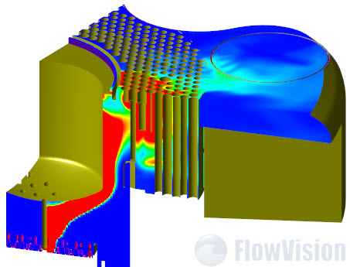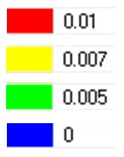

*FIG. 3. Distribution of the concentration of the delayed neutron precursors in the reactor chamber.*

The law of variation in time was defined for the total concentration of the delayed neutron precursors entering for the failed FA in the area of location of the provisional sensors (Fig. 4). It is seen on Fig. 5 that the response time of the SFTIS system to the loss of leak tightness is 5 – 10 s.

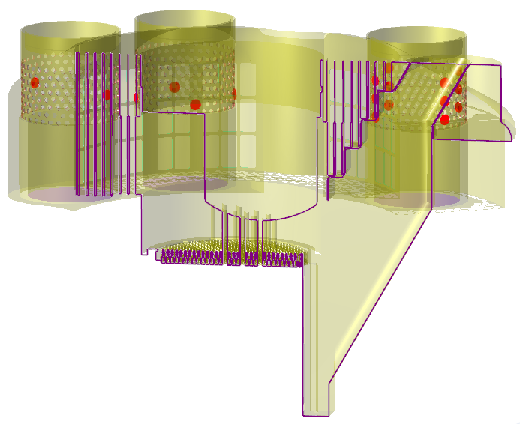

*2*

*3*

*1*

*FIG. 4. Location of the provisional sensors (it. 1, 2, 3) for measurement of the concentration of the delayed neutron precursors.*

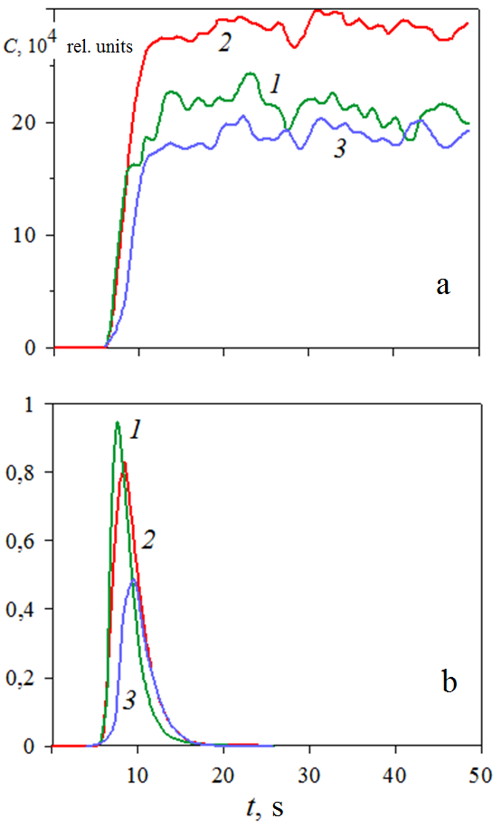

*FIG. 5. Variation in time of the total concentration of the delayed neutron precursors with the constant (a) and impulsive (b) sources for the provisional sensors 1, 2, 3.*

The calculation results of the concentration of the delayed neutron precursors was transferred from FlowVision to TORT for xyz and rθz TORT models of primary circuit (Fig. 6). The density of the neutron flux in the air chamber of the SFTIS detection unit was calculated using TORT code based on the obtained distribution of the concentration of the delayed neutron precursors in the primary coolant with impulsive source. During the calculations it was assumed that the readings of the sensors are directly proportional to the density of the equivalent thermal neutron flux.



*FIG. 6. General view of xyz и rθz TORT model of the primary circuit.*

Comparison of the averaged experimental SFTIS readings with the calculation with TORT code during impulsive failure of a fuel rod in an FA showed their satisfactory matching (Fig. 7). The discrepancy in the width of the pulse amplitude, likely, was caused with uncertainty of the length of exit of the delayed neutron precursors to the coolant. Based on this data and considering of uncertainties and error of calculation of the coolant velocity – 4 % maximum, it may be concluded about correctness of the calculations with the programs FlowVision and TORT.

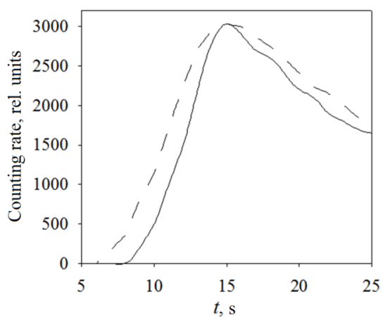

*FIG. 7. Measured (– – –) and calculated (––––) counting rate in the SFTIS detection unit of the BN-600 reactor.*

## Conclusion

The developed technical approach for research of sodium coolant flow in and integral type reactor permits to consider peculiarities of the flow of liquid metal coolant including transfer of the delayed neutron precursors and to do:

* calculation and analysis of mixing of flows with different temperatures in the primary circuit of a reactor;
* calculation and analysis of the transfer of the precursor of the delayed neutrons, going out from FA’s with leaking fuel rods, and considering their radioactive decay, to define the transfer time of the delayed neutron precursors to the entry windows of the intermediate heat exchangers and their concentration in the coolant;
* transfer files with the data about concentration of the delayed neutron precursors from FlowVision to TORT code for further modeling of spacial distribution of sources of delayed neutrons and calculation of their flux.

References

1. ROGOZHKIN S.A., AKSENOVA.A., ZHLUKTOV S.V., OSIPOV S.L., SAZONOVA M.L., FADEEV I.D., SHEPELEV S.F., SHMELEV V.V., Development of the heat transfer model for liquid metal sodium coolant ant its verification, Computational solid mechanics **7** 3 (2014) 306 – 316.
2. ROGOZHKIN S.A., OSIPOV S.L., FADEEV I.D., SHEPELEV S.F., AKSENOVA.A., ZHLUKTOV S.V., SAZONOVA M.L., SHMELEV V.V., Numerical modeling of thermohydraulic processes in the upper chamber of a fast reactor, Nuclear energy **115** 5 (2013) 295–298.