CONCEPTUAL CORE CONFIGURATION FOR

INCREASING POWER OF FAST BREEDER

REACTOR TO 40 MWt

RAGHUKUMAR GANAPATHY, DINESH K., BABU A, SURESH KUMAR KANNANKARA VASUDEVAN
REACTOR FACILITIES GROUP
INDIRA GANDHI CENTRE FOR ATOMIC RESEARCH
KALPAKKAM, TAMILNADU, INDIA
grk@igcar.gov.in

Dr SIVAKUMAR S
EX OFFICIAL,
REACTOR FACILITIES GROUP
INDIRA GANDHI CENTRE FOR ATOMIC RESEARCH
KALPAKKAM, TAMILNADU, INDIA

Abstract

Fast Breeder Test Reactor (FBTR) is operating with PuC-UC fuel in the composition of 70%-30%, respectively with a power output of 32MWt , The high enrichment fuel is imposing restrictions in the expansion of core beyond the present number due to minimum shut down margin (SDM) criterion, stipulated by Technical Specifications, Since the heat removal components of FBTR have been designed for 40 MWt, as per initial design, in order to increase the power to design power of 40 MWt, a concept of introducing poison subassembly in the core, which would, in turn, enable to increase the core beyond the present size, was conceived. The Core expansion would increase the power to the design power of 40 MWt and at the same time the minimum SDM criterion is also respected.

INTRODUCTION
FBTR was designed on the basis of Rapsodie, France is located at Kalpakkam, Tamil Nadu, INDIA. This is a sodium cooled loop type reactor. It was originally designed for 40 MWt, using 70% UO₂ and 30% PuO₂ with uranium enriched to 85% in U²³⁵. However, non-availability of enriched uranium made us look for alternative fuel for FBTR. Pu-rich oxide fuel was not favoured due to poor compatibility with Sodium, the coolant. After the encouraging laboratory results obtained with high Pu-U mixed carbide (70% PuC and 30% UC), it was decided to use the same as the fuel for FBTR. FBTR achieved its first criticality on 18th October 1985. The first criticality was achieved with 22 fuel subassemblies. The reactor has been used as a self-driven irradiation facility for the unique carbide fuel, in addition to testing of materials. The reactor core of FBTR can have a maximum of 85 fuel subassemblies (FSA), occupying the locations in the first five rings. The limitation is due to the availability of sodium temperature monitoring for the first five rings only. A fuel subassembly houses 61 fuel pins. Each fuel pin has a fuel column of length 32 cm. The reactor presently utilizes two types of fuel, referred as Mark I and MOX, with different compositions. The fuel is a mixture of PuC and UC in the ratio 70:30 in Mark I subassemblies (SA) and PuO₂ 46:54 UO₂ in the MOX subassemblies. There are 48 MK I and 8 MOX type SA in the 56 FSA core. There are six symmetrically located control rods (B₄C with 90% B₁₀) in the 4th ring. The active core is surrounded by Nickel reflector (neutron) up to 8th ring. The Thoria blanket sub assemblies 252 in number are loaded from 9th ring to 12th ring. Beyond the twelfth ring, stainless reflectors are provided.

EVOLUTION OF FBTR
For reaching the design power of 40 MWt, 13 MWe, it was decided, in 1995, to go in for a core of 76 MK-II fuel subassemblies, with 55%PuC+45%UC. Subassemblies of this composition were inducted in the core surrounding the MK-I fuel. A progressive expansion of the core, by replacing the MK-I subassemblies after they reach their burn-up limits was foreseen. However, due to the progressive extension of the burn-up limit of MK-I fuel from the initial conservative value of 25 GWd/t to 155 GWd/t based on PIE of the fuel at 25, 50 & 100 GWd/t, delayed the rapid induction of MK-II fuel. Later on it was decided to test MOX FSA and to convert FBTR in to hybrid core comprising 46 MK I in the inner core followed by 56 MOX FSA, with a target power of 40 MWt and hence 8 MOX type FSA were added in 14th irradiation campaign^{[1].}
From the initial critical core of FBTR which had 22 FSA, the core size was gradually increased and in the 27th irradiation campaign FBTR reached the maximum power of 32 MWt with 56 FSA. The lead FSA’s linear power is 400 W/cm. In the just concluded 29th irradiation campaign there were 56 FSA with 48 MK I and 8 MOX FSA, The stipulation of minimum shutdown margin of 4200 pcm has capped the further increase of core size beyond 56 FSA and hence the power. Figure 1 gives the FBTR Core configuration in the 29th irradiation campaign.
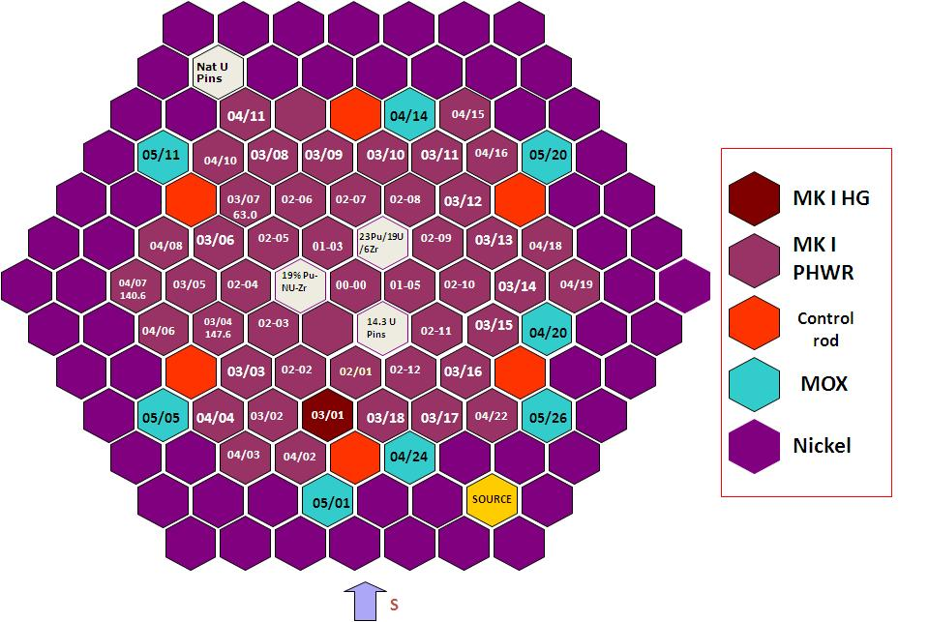
Fig 1 FBTR Core in 29th irradiation Campaign

STUDIES FOR INCREASING THE CORE SIZE
All the engineering systems in FBTR are designed for 40 MWt operations. The only design objective not realized, so far, is attaining the design power. The constraint for increasing the core size and in turn to increase the reactor power to the design power was the minimum shutdown margin criterion stipulated in Technical Specification. Hence, the feasibility of raising the reactor power using alternate methods was studied. In this study by introducing B4C as a poison SA, the core size was increased and hence power without violating the minimum SDM criterion. The theoretical physics parameters were estimated by loading poison SA in different rings. The Table 1 gives the results of the study with the Poison SA containing 65% and 50% enriched B¹⁰ at different locations^{[2].}

TABLE 1: PHYSICS PARAMETERS WITH POISON SA AT DIFFERENT CONFIGURATIONS

Feature | Configuration A | Configuration B | Configuration C | Configuration D
 | B4C Poison SA (65% enriched B10 ) |  |  | B4C(50% enriched B10 )
Poison SA locations | 00-00,02-04,  02-10 | 01-03, 02-04,  02-10 | 02-04, 02-08, 02-12 | 02-01, 02-04,  02-07, 02-10
Number of fuel subassemblies | 67 | 68 | 68 | 70
Power (MWt) | 38.1 | 39.6 | 39.04 | 41.3
Shutdown margin (pcm) | 4776 | 4575 | 4453 | 4928

The above study indicates that the poison SA B4C (enriched to 50% in B₁₀) at four equi-angular locations in the second ring gives the maximum power of 41.3 MW(th) with 70 all MK-1 FSA. The core includes a Test FSA containing 54 pins, where inner most 7 pins have been removed, to enable to inserting a irradiation capsule containing materials to be irradiated in the core centre location. The arrangement of B₄C column in these subassemblies is very similar to that in the control rods (CR), however the CRs contain 90% enriched B₁₀. The diameter of the B4C column is 38 mm, same as that in the control rod. The required column height of B4C is 375 mm. The top of the B4C column is aligned with the top of the fuel column whose length is 320 mm. The remaining 55 mm of B4C column will be below bottom elevation of the fuel column. This additional length serves two purposes. (1) It increases the magnitude of the negative reactivity introduced by these B4C subassemblies, thereby increasing the shutdown margin. (2) The design of B4C poison SAs are like any other SAs and are supported on the grid plate. However, for study purpose, a hypothetical event of ejection of a B4C subassembly from its location was considered. Due to availability of 55 mm of B4C column below the core, the reactivity change in the core is minimized, essentially by ensuring that the fuel column is covered even in the ejected condition. The maximum possible ejection of poison SA is only 70 mm, due to physical location of Core Cover Plate Mechanism, containing thermocouples, at 70 mm above the top of SAs. Based on the calculations, the reactivity addition due to ejection of one B4C subassembly, with CCPM in position, is 30 pcm. The fig 2 gives the configuration for 40 MWt core.
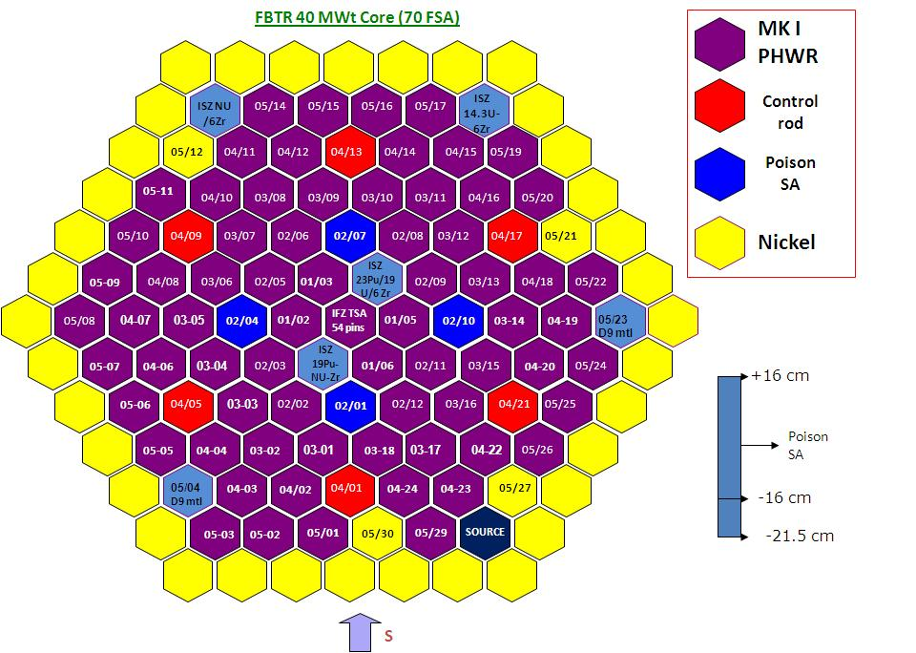
Fig 2 FBTR 40 MW(th) Core

PATH TO safety clearance
This concept was presented to group board. Group board suggested adopting Configuration 4, with 70 FSA with IFZ special test SA at Centre and also to earmark two locations in I ring for continuing the capsule irradiation of metal fuel pins. After incorporating these changes, the concept was presented to Safety Operation Review Committee, a plant level safety committee, for approval and sent to higher level Safety Committee for preliminary approval. After obtaining preliminary approval for the concept from the Safety Committee, preparation of Safety report was commenced. The Safety report was prepared by two agencies viz Reactor Facilities and Reactor Design Groups. The completed Safety Report which was submitted in January 2020, is being reviewed.

PHYSICS parameters of fbtr
In the beginning of every FBTR irradiation campaign, Physics parameters viz Control rod worth, Isothermal Temperature coefficient and Power Coefficient are measured. The flow coefficient was measured once, as it is not envisaged to change due to core changes. The measured Physics parameters in the latest 29th campaign are given in Table 2. The estimated Physics parameters for the 40 MWt core are given in Table 3^{[3]}

TABLE 3 MEASURED PHYSICS PARAMETERS IN 29TH IRRADIATION CAMPAIGN

Parameter | Measured Value
Control Rod worth (pcm) | 9744
Isothermal Temperature Coefficient (pcm/deg C) | -4.08t
Power Coefficient (pcm/MWt) | -8.2
Flow Coefficient (pcm/rpm) | -0.05/rpm
Shutdown Margin | 5500
Burnup loss of reactivity (pcm/MWd) | -0.89

TABLE 4 ESTIMATED PHYSICS PARAMETERS FOR THE 40 MWt CORE

Parameter | Measured Value
Control Rod worth (pcm) | 9805
Isothermal Temperature Coefficient (pcm/deg C) | -1.626
Power Coefficient (pcm/MWt) | -5.744
Shutdown margin (pcm) | 4928

Detailed Event Analysis was done, where the events of “Off Site Power Failure”, “Station Black out” and “One Control withdrawal” were analyzed, without Safety Actions and with Safety Actions. The Event Analysis indicates that the Clad Hot Spot Temperature is below 800ºC and Fuel Hot Spot Temperature is well below the melting point even under “Without Safety Actions” event^{.[4]}
In the hypothetical core disruptive accident (HCDA) study involving Unprotected Loss of Flow Accident (ULOFA), Unprotected Transient Over Power Accident (UTOPA) and Unprotected Loss of Coolant Accident (ULOCA), ULOFA does not lead to core disruptive accident as the power falls below decay heat. The mechanical energy release is 7 MJ, in ULOCA, where the fuel attains boiling point leading to prompt critical state, the mechanical energy release is 11.9 MJ and in UTOPA the mechanical energy release is 0.037 MJ . However under accident conditions the reactor vessel could withstand up to 39 MJ of energy, without failure^{. [5]}.

summary
- FBTR initially designed for plutonium, enriched Uranium Mixed oxide Fuel Core producing 40 MWt
- The Core fuel was changed to world scenario, to Carbide fuel with 70% Plutonium Carbide and highly enriched fuel restricting the core size to 56 fuel sub assemblies and maximum power up to 32 MWt due to constraint in the minimum shutdown margin, a Technical Specification limit
- In order to realize the objective of taking FBTR to designed power level a novel concept was conceived for introducing B₄C subassembly which would serve as poison
- Studies were done to decide on optimum location for the poison subassembly and Boron enrichment
- Based on detailed study, the best option of locating poison subassemblies at equi-angle position in 2nd ring and thus expanding the core to 70 fuel subassembly, producing little above 41.3 MWt while restricting to design power of 40 MWt was decided
- The 70 FSA core has facility to irradiate samples in a special Test Assembly in Central location
- The core safety report indicates that the estimated Physics parameters are negative and safe.
- The Event Analysis Study and HCDA study ensures Safety of the Reactor under accidental conditions

REFERENCES

- S.Sivakumar, G.Raghukumar, C.P.Reddy, Core Evolution and Physics Tests conducted in FBTR, OPENUPP - 2006,National Conference on Operating Experience of Nuclear Reactors and Power Plants, November 2006
- S.SIVAKUMAR & RAGHUKUMAR G, Conceptual Configuration for 40 MW(th) core for Fast Breeder Test Reactor,RFG,IGCAR,2018
- Fast Breeder Test Reactor Safety Report on 40 MW(th) Core, December 2019
- NATESAN.K, KASINATHAN.N. and VELUSAMY.K., Event Analysis of 40 MWt Core Configuration of FBTR, RDTG, IGCAR, September 2019
- SRIVASAN.G.S, ANURAJ.V.L., Hypothetical Core Disruptive Accident Analysis for 70 FSA, 40 MW(th) FBTR Mark I Carbide Core, RDTG, IGCAR, September 2019

