Preliminary Shielding Analysis for the Versatile Test Reactor

T. Fei
Argonne National Laboratory
Lemont, Illinois, United States of America
Email: tfei@anl.gov

The submitted manuscript has been created by UChicago Argonne, LLC, Operator of Argonne National Laboratory (“Argonne”). Argonne, a U.S. Department of Energy Office of Science laboratory, is operated under Contract No. DE-AC02-06CH11357. The U.S. Government retains for itself, and others acting on its behalf, a paid-up nonexclusive, irrevocable worldwide license in said article to reproduce, prepare derivative works, distribute copies to the public, and perform publicly and display publicly, by or on behalf of the Government. The Department of Energy will provide public access to these results of federally sponsored research in accordance with the DOE Public Access Plan. http://energy.gov/downloads/doe-public-access-plan. The work reported in this summary is the result of ongoing efforts supporting the Versatile Test Reactor.

2022 International Conference on Fast Reactors and Related Fuel Cycles
Beijing, China
April 25- 28, 2022

Preliminary Shielding Analysis for the Versatile Test Reactor

T. Fei, F. Heidet
Argonne National Laboratory
Lemont, U.S.A.
Email: tfei@anl.gov

S. Bays
Idaho National Laboratory
Idaho Fall, U.S.A.

Abstract

The Versatile Test Reactor (VTR) is currently under development by the U.S. Department of Energy (DOE). It will provide very high fast neutron flux irradiation capabilities that are currently unavailable in the U.S. Given the increasingly large number of advanced reactor concepts being pursued in recent years, this irradiation testing capability will be essential to support maturation of these concepts. Radiation protection is an important part of the VTR design. High neutron fluxes can pose a challenge for radiation protection of the structures and equipment near the reactor core. The paper provides a summary on the status of the shielding considerations and analysis performed for VTR. The paper focuses on the shielding needs for the secondary sodium flowing through the Intermediate Heat Exchanger (IHX), the air flowing through the Reactor Vessel Auxiliary Cooling System (RVACS), the dose rate above the reactor head access area, the radiation dose and flux in the neutron detectors, and the radiation damage on the reactor vessel wall and the structures near the core. One key challenge for the shielding design of VTR is the activation of the secondary sodium when it flows through the IHX. The IHXs are placed in the primary sodium pool inside the reactor vessel. During operation, neutrons produced in the core can reach the IHXs due to the small absorption cross section of sodium and the large mean free path of fast neutrons. The secondary sodium gets activated inside the IHX and emits photons in the secondary loop outside of the reactor vessel. Activation of secondary sodium needs to be mitigated in order to meet the radiation dose limit sets for personnel working at the plant as secondary sodium circulates outside of the reactor building to the air-dump heat exchangers. Similarly, for the RVACS, the air flowing in the system gets close to the reactor core, and some argon would become activated and released into the atmosphere. Thus, proper shielding is also required to reduce argon activation in the RVACS. The VTR design and development is underway and shielding considerations discussed in this paper will progress with the rest of the reactor. The work reported in this summary is the result of studies supporting a VTR conceptual design, cost, and schedule estimate for the Office of Nuclear Energy of DOE to make a decision on procurement. As such, it is preliminary.

INTRODUCTION
The Versatile Test Reactor (VTR) is currently under development by the U.S. Department of Energy (DOE). It will provide very high fast neutron flux irradiation capabilities that are currently unavailable in the U.S. The goal to achieve high neutron flux also poses a challenge for radiation protection of the structures and equipment near the reactor core. Thus, shielding analysis is an important part of the VTR design work. In this study, dose rate and activities were assessed at different locations of interest. The adequacy of shields required to protect workers and reactor components from damaging radiation sources was evaluated. The major radiation source in VTR during operation is the prompt neutron and photon emitted from nuclear fuel fissions as well as the activated primary coolant. One shielding challenge for a pool-typed Sodium-cooled Fast Reactor (SFR) such as VTR is the activation of the secondary sodium. For a pool-typed SFR, the IHXs are placed in the primary sodium pool inside the reactor vessel. During operation, neutrons produced in the core can reach the IHXs due to the small absorption cross section of sodium and the large mean free path of fast neutrons. The secondary sodium gets activated inside the IHX and carries some of that activity outside of the reactor vessel. This source of radioactivity contained in the secondary sodium needs to be mitigated to meet the radiation dose limit sets for personnel working at the plant. Air activation in the Reactor Vessel Auxiliary Cooling System (RVACS) was also analysed. The air flowing in the system gets close to the reactor core, and some argon would become activated and released into the atmosphere. Workers are expected to have limited access to the Head Access Area (HAA) directly above the reactor vessel. The analysis identified potential radiation streaming path to be blocked in future design.

Method
The MCNP6.2 Monte-Carlo code [1] was employed to perform neutron and photon transport calculation, leveraging its ability to use of continuous energy neutron cross section and to model flexible geometry. The ENDF/B-VII.0 [2] neutron library was employed. For the fission neutron source during reactor normal operation, the eigenvalue mode was first called in MCNP6.2 to generate the volumetric fission neutron source. The subsequent shielding analyses were transformed to solve fixed source problems by using the created volumetric fission neutron source and turning off the neutron production in fission in the active core region.
The main disadvantage of the stochastic codes for deep penetration problems is to accumulate sufficient number of “scores” (i.e. neutron/photon recording) in the regions of interest that are heavily shielded. Due to the nature of the problem, an extremely small fraction of the simulated neutrons is able to reach the IHX in analog MCNP6.2 calculations. Variance reduction techniques, such as the weight window technique, are required for the Monte Carlo calculations to obtain tallies with sufficiently low statistical uncertainties within reasonable computation time. The weight windows needed for the MCNP6.2 calculation were generated by the ADVANTG [3] code. This code calls deterministic method to solve the multi-group adjoint neutron flux of a simplified VTR model. This adjoint flux is then employed to build the importance map (weight window) that is then used by the MCNP6.2 code.
The dose rate was calculated by converting the flux based on the build-in flux-to-dose conversion factors in the MCNP6.2. In general, the shielding analyses performed in this study follow three steps:
- Obtain and specify the radiation source characteristics such as the radiation particle types, the source spatial, spectral, and angular distribution.
- Identify the location of interest for estimating dose rate, activation rate or structural damage evaluation.
- Perform particle transport calculations for various shielding designs and sensitivity studies on the shield dimension (thickness, height, etc.)

Secondary sodium Activation
The objective of the study is to estimate the secondary sodium activity in the secondary loop. The secondary sodium flowing in the IHX is activated by the neutrons streaming from the reactor core by the capture and (n,2n) reaction. Na-23 becomes Na-24 after capturing a neutron. Na-24 decays with a half-life of 14.96 hours and emits two photons of energy 1.368 and 2.754 MeV per decay. Na-22 created in Na-23 (n,2n) reaction also emits a photon of 1.274 MeV when decaying with a half-life of 2.60 years. However, the IHX is far away from the active core, and very few fast neutrons can reach the IHX due to moderations by sodium and to activate Na-23 through (n,2n) reaction. The Na-22 activity is much smaller than Na-24 activity during normal operation.

The calculation takes two steps. First, the MCNP6.2 code was used to evaluate the secondary sodium activation rate in the IHX, i.e., the Na-23 capture rate. Then the capture rate was converted to the equilibrium Na-24 activity by solving the 1-dimensional particle transport equation (1) using the Lagrangian time derivative.

$$\frac{DN\left(t,z\right)}{Dt}=\frac{∂N\left(t,z\right)}{∂t}+v\frac{∂N\left(t,z\right)}{∂z}=S-λN$$ | (1)

Here, $N$ is the total population of the radionuclide of interest (Na-24 in this case), $v$ is the 1-dimensional coolant flow velocity, $λ$ is the decay constant of the radionuclide, and $S$ (the capture rate calculated from MCNP6.2) is the production rate of the radionuclide. We are only interested in the steady state case for this study, which means the Eulerian time derivative is zero. i.e., Eq. 1 becomes

$$v\frac{∂N\left(t,z\right)}{∂z}=S-λN$$ | (2)

For the coolant activation in IHX, the problem consists of two regions. Region 1 lies inside the reactor vessel, and the production rate $S$ is calculated from MCNP6.2. Region 2 is outside the vessel, and $S$ is zero. With continuity at the interfaces of the two regions, the equilibrium activity at the exit of Region 1 can be expressed as

$$λN_{1}=\frac{S\left(1-e^{-λt_{1}}\right)}{1-e^{-λ\left(t_{1}+t_{2}\right)}}.$$ | (3)

where $t_{1}$ and $t_{2}$ are the time spent by the secondary sodium inside and outside the reactor, $λN_{1}$ is the activity of the activated sodium, and $S$ is the production rate of activated sodium.
The preliminary VTR core design is shown in Fig. 1. The secondary sodium activation results obtained are listed in Table 1. Several things were observed.
- The spent fuel in the upper In-Vessel Storage (IVS) location has non-negligible effect on the secondary sodium activation as shown in Fig. 2.
- The number of spent fuel in the lower IVS location around the active core has negligible effect on the secondary sodium activation as listed in Table 1, which shows all the results are within the statistical uncertainty (~4%) of the MCNP6.2 calculation.
- Current in-vessel shield configuration can sufficiently reduce the secondary sodium activity so that no additional shield is required around the secondary loop outside the reactor vessel.

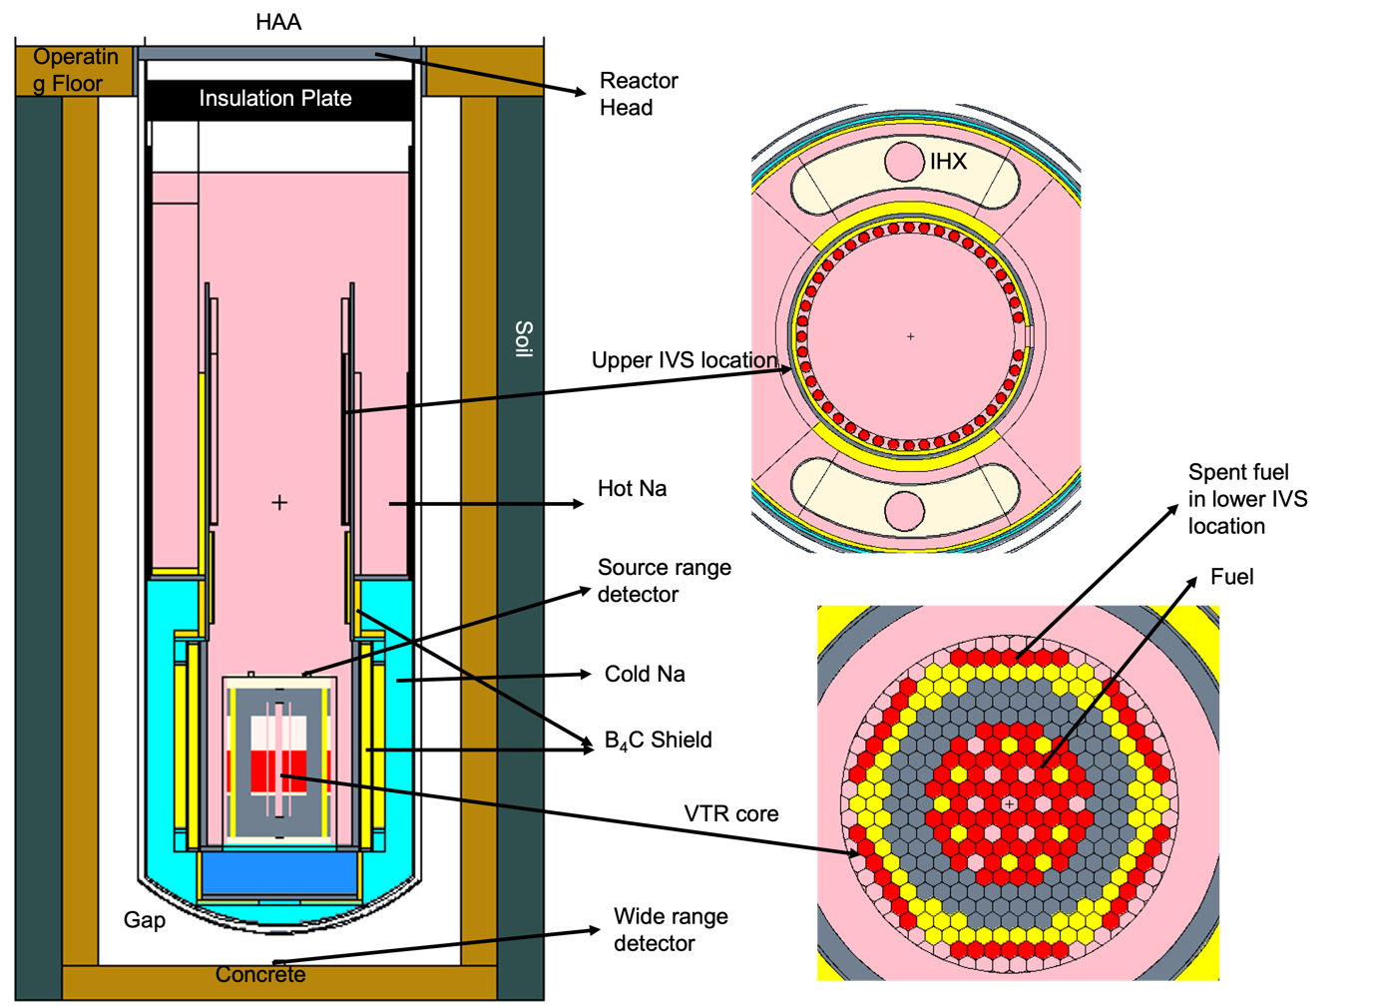
FIG 1 The schematics of the VTR configurations
TABLE 1 Secondary sodium activity.
Description | Secondary sodium activity (µCi/cm³) | Relative error
36 spent fuel assemblies | 4.90E-05 | 3.38%
42 spent fuel assemblies | 5.11E-05 | 4.41%
No fuel assembly spent fuel assemblies | 4.77E-05 | 3.33%

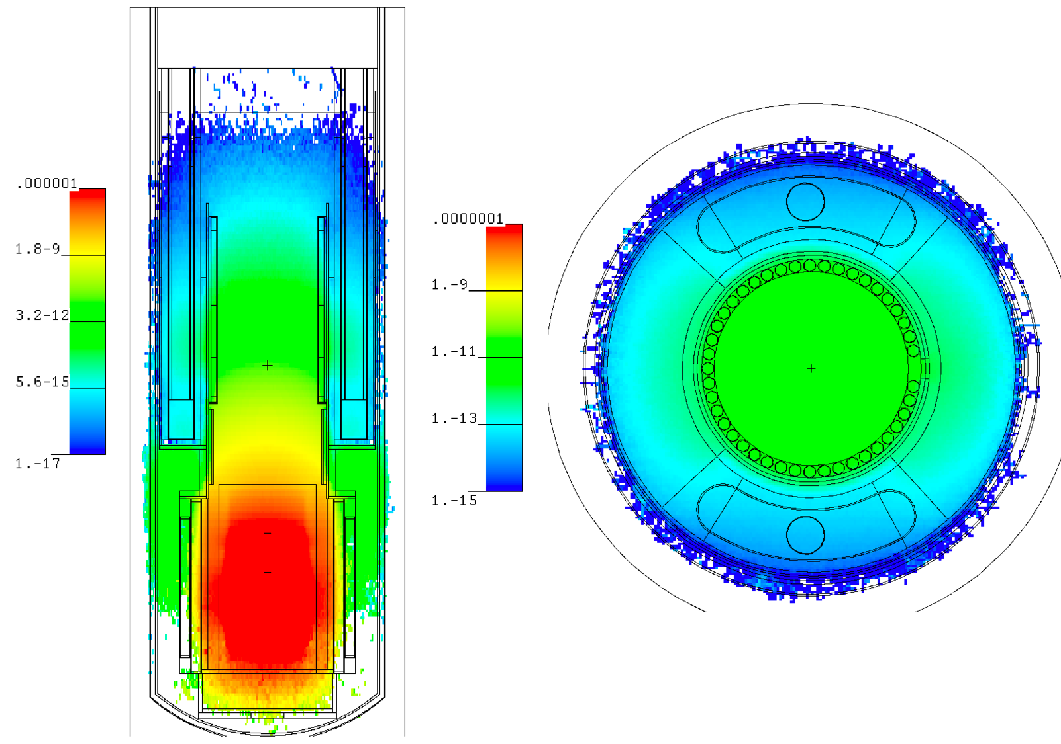
FIG 2 Neutron flux distribution [#/cm²/source] in axial (left) and radial (right) direction.
The relation between the dose rate limit and the secondary sodium activity limit depends on three factors: the sodium pipe thickness, the potential shield (concrete) thickness around the pipe, and the distance from the shield outer surface to the dose rate detecting region. A sensitivity study was performed to investigate this relation. The tentative dose rate limit at the pipe surface was assumed to be 0.35 mrem/hr. This was equivalent to a sodium activity limit of 2E-4 µCi/cm³ based on the relation derived in the sensitivity study. It was found that no additional shield is required for the secondary loop outside the core.

Air activation
The objective of the study is to assess the air activation inside the RVACS of the preliminary VTR design. The Ar-41 activity is predicted to be 6.39x10⁻⁸ µCi/cm³. Air from atmosphere enters the chimney from the top and flow to the bottom of the reactor vessel, where it is heated by the residue heat transferred from the core. The hot air rises to the top of the chimney and is released back to the atmosphere. The natural flow is driven by the reactor residue heat. The air pass near the reactor active core is irradiated. The small fraction of Ar-40 contained in the air is activated and becomes Ar-41 with a half-life of 109 mins. Once the air is released to the environment from the RVACS, this radioactive isotope is also released to the environment. The radioactive isotopes produced and carried along with the air depend on the air composition and the pollutants or particles carried in the air. The air composition used in the study is listed in Table 2. The concentration of pollutants or particles would depend on the actual reactor site, which is unknown at this stage and is not included in the activation analysis.

TABLE 2 Air composition (density used is at 20℃ at atmosphere)
Isotope | Atom %
O-16 | 2.11E-01
O-17 | 8.02E-05
N-14 | 7.81E-01
N-15 | 2.89E-03
Ar-40 | 4.65E-03
Density [kg/m³] | 1.22

Similar to the secondary sodium case, Eq. 2 was solved to calculate the Ar-41 activity at the exist of the RVACS. The only difference is that the air would not come back to the system, i.e., the system is not closed. $S$ now is the production rate of Ar-41, i.e., the Ar-40 capture reaction rate, and this is function of position along the flow path. It was assumed that this production only occurs from the bottom of the vessel to the top. Production in other areas (e.g., in the chimney) is deemed negligible due to their long distance from the neutron source.
Applying the boundary condition (t = 0 corresponds to the entrance into the radiation zone), and solving the equation assuming the production rate is constant over the domain, then the result is

$$N(t)=\left(\frac{S}{λ}\right)(1-e^{-λt}),$$

where $t$ is the time spent by air in the radiation zone (near the reactor), which is usually much smaller than Ar-41 half-life, so at the exit of the radiation zone

$$N≈St.$$

It is recognized that the production rate will vary at different positions along the air flow path. This was not considered in the current analysis. It should also be noted that in practice, the air density would also be changing with temperature and pressure. More sophisticated model would be required instead of the simple Eq. 2. The calculation shows that the Ar-41 activity is on the same order as the limit (1E-8 µCi/cm³) [4]. More detailed design information would be needed to reduce the uncertainties associated with the model.

Head access area dose rate
The objective is to evaluate the dose rate above the HAA and the operating floor adjacent to the HAA. The MCNP6.2 model developed for the IHX secondary sodium activation analysis and the RVACS air activation analysis was expanded to include additional features deemed important to this problem. The calculation procedure has two steps. The first step evaluates the primary sodium activation, which is the major source contributing to the dose rate above the operating floor and the HAA. The second step used the calculated photon source for a fixed source calculation to evaluate the dose rate above the operating floor.
The Na-23 capture, (n,p) and (n,2n) rate were evaluated by MCNP6.2 for hot and cold pool, and the core region. It was observed that the capture rate is several orders of magnitude larger than the (n,p) and (n,2n) reaction, i.e., the Na-24 decay is the major contributor to photon emission during normal reactor operation. This source is assumed to be uniformly distributed in the core, the hot and cold pool. The specific activity of Na-24 was calculated based on the total reaction rate and the sodium volume.
Based on the photon source obtained from the first step calculation, the photon transport calculation was conducted with MCNP6.2. Several cases were calculated with results listed in Table 3. Case 3 – 8 were based on Case 1 assuming no pump closure. The dose rate above the HAA and the operating floor were investigated separately as different weight windows were needed for all the different cases. The statistical error of all the MCNP6.2 calculations was maintained to be lower than 10%. Several things were observed based on this sequence of analyses:
- The streaming paths through the pump and IHX openings are important above the HAA as illustrated in Fig. 3. Pump closures and flanges serve the purpose of blocking the streaming path through the pump as shown in Table 3. The dose rate near the IHX penetration is also around 1000 mrem/hr. Additional 10 – 20 cm steel shield would be needed around the IHX penetrations to block these streaming paths depending on the radiation zone classification. Thus, the next round shielding analysis and reactor design iterations are needed to examine these streaming paths.
- By comparing Case 3 and 4, we observed that the density of the concrete is not an important factor since the major photon streaming path is through the 3-inch-thick gap between the HAA deck and the operating floor as illustrated in Fig. 4. The 3-inch-thick gap was reserved to accommodate potential thermal expansion. The maximum dose rate took place directly above the gap is around 80000 mrem/hr. This means additional iterations between shielding analysis and reactor design would be needed. By filling in the gap (Case 5 – 6), the dose rate on the operation floor is significantly reduced. Fig. 4 compares the dose rate distribution above the reactor head and the operating floor. Both indicate that the major contribution to the dose rate is from the photons streaming through the gap and the IHX penetration.
- After proper shielding of all the streaming path, the density of the operating floor has a significant impact on the dose rate. However, if the radiation zone classification for this region requires a 2.5 mrem/hr limit (based on considerations of exposure time and minimization of total man-rem in the reactor), then the use of regular concrete will still satisfy this limit.

TABLE 3 Dose rate above the HAA and the operating floor.
Case | Location | Description | Dose rate (mrem/hr)
1 | HAA | Without pump closure and flange (base case) | 1412.90
2 | HAA | With pump closure and flange | 0.02
3 | Operating floor | Regular concrete (density = 2.3 g/cm³) | 56.21
4 | Operating floor | High-density concrete (density = 4.0 g/cm³) | 54.41
5 | Operating floor | Gap filled with 1-m-thick SS314 | 0.11
6 | Operating floor | Gap filled with 0.5-m-thick SS314 | 0.28
7 | Operating floor | Shielded streaming path and high-density concrete | 3.84x10⁻³
8 | Operating floor | Shielded streaming path and regular concrete | 0.94

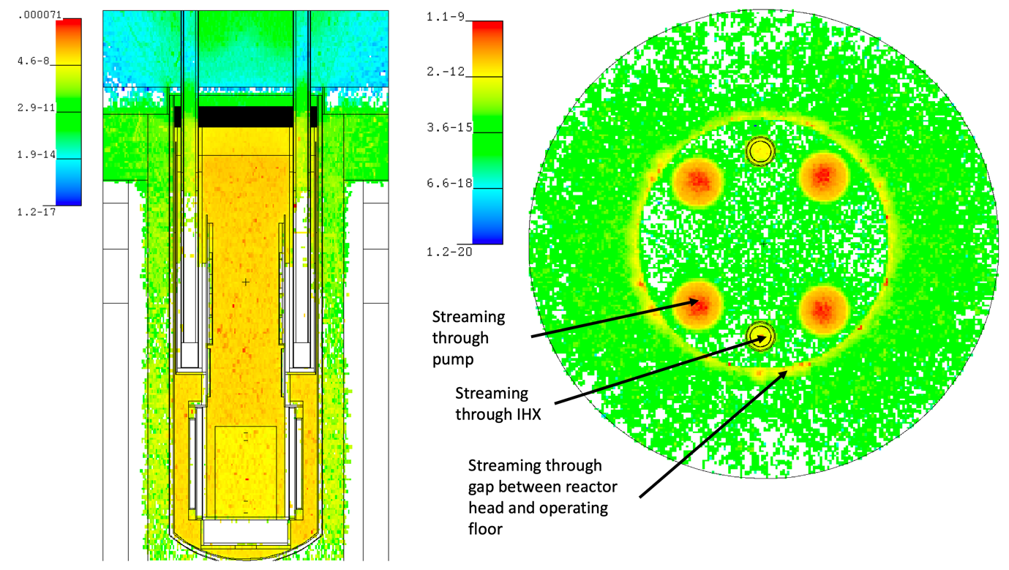
FIG 3 Axial photon flux distribution [#/cm²/source] (left) and the radial photon flux distribution [#/cm²/source] above the HAA (right).

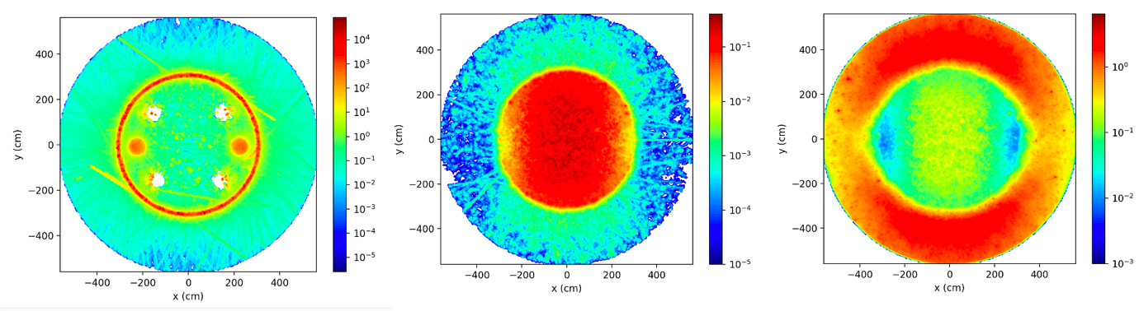
FIG 4 The radial photon dose rate distribution [rem/hr/source] above the reactor head for Case 4 (left), 7 (center) and 8 (right).

Conclusion
The shielding analysis was performed for the “first-round” VTR reactor design. The focus is on the area inside and around the VTR reactor vessel since these will likely affect the in-vessel component locations and shields configuration. Three major areas were investigated including the secondary sodium activation rate in the IHX, the air activation rate in RVACS, and the dose rate in HAA and above the operating floor. Several streaming paths were identified. This provide guidance on future iterations between the shielding analysis and the reactor design for VTR.
ACKNOWLEDGEMENTS
The submitted manuscript has been created by UChicago Argonne, LLC, Operator of Argonne National Laboratory (“Argonne”). Argonne National Laboratory’s work was supported by the U.S. Department of Energy, Office of Nuclear Energy under contract DE-AC02-06CH11357. The work reported in this summary is the result of ongoing efforts supporting the Versatile Test Reactor.
References
- WERNER, C., “MCNP Users Manual - Code Version 6.2”, LA-UR-17-29981, Los Alamos National Laboratory (2017).
- M. B. Chadwick, et al. “ENDF/B-VII.0: Next Generation Evaluated Nuclear Data Library for Nuclear Science and Technology,” Nuclear Data Sheets, 107 (2006), Page 2931 – 3060.
- MOSHER, S. et al, “ADVANTG – An Automated Variance Reduction Parameter Generator,” ORNL/TM-2013/416 Rev. 1, Oak Ridge National Laboratory (2015).
- 10CFR 20 Appendix B—Annual Limits on Intake (ALIs) and Derived Air Concentrations (DACs) of Radionuclides for Occupational Exposure; Effluent Concentrations; Concentrations for Release to Sewerage

