DESIGN & DEVELOPMENT OF CUSTOM SHAPED BACK-UP SEAL IN SILICONE FOR PFBR

SRIRAMACHANDRA AITHAL, JAGRUTI RAMESH MOTE and S. RAGHUPATHY
Indira Gandhi Centre for Atomic Research, Kalpakkam, Tamilnadu, India
Email: saithal@igcar.gov.in

Email contact of corresponding author: saithal@igcar.gov.in

Abstract

In fast breeder reactors, top shield acts as reactor cover in the axial direction and consists of Roof Slab and rotatable plugs. The rotatable plugs, which are mounted over large diameter bearings are rotated to facilitate handling of fuel subassemblies. Since the interface between the rotating and stationary members of the top shield forms boundary for primary radioactive Argon cover gas, the interspace is sealed with an Inflatable Seal as a primary barrier and an elastomeric Back-up seal as a secondary barrier during normal operation of reactor.
Back-up seals are custom made seals of complex geometry. Considering the operating temperature in the reactor, fluorocarbon and silicone were identified as the possible material candidates for the seal. Fluorocarbon has superior properties w.r.t. silicone in respect to gas permeability. However, it is very challenging to work with the material and extrude the seal. Though, on an earlier occasion, the seal was produced with fluorocarbon, the same could not be repeated. Hence, Silicone was chosen as an alternate material for the present development as it is a versatile rubber compound with many industries having experience in working with it.
Prior to taking-up the development, detailed FE analysis of the seal geometry using ABAQUS® was carried out to confirm that tensile stresses at critical locations of the geometry selected are within the material strength. As part of this, initial bench-marking study was carried out to validate the hyperelastic materials modelling. Subsequently, the actual seal analysis was carried out employing marlow model to define hyperelastic properties of the material. Marlow model has been selected among six different choices based on material evaluation performed within commercial software ABAQUS® based on uni-axial tensile test data as input data.
Subsequent to re-confirmation of geometry, developmental activities were initiated. Since, the seals are to be qualified in a test rig under simulated operating conditions as in reactor before production of reactor size seals, dia. 1m test seals were taken-up for development. Though moulding process gives better dimensional accuracy and is suitable for dia. 1m seal, extrusion process was selected for the seal production keeping in mind the requirements of large diameters of actual reactor seals where adopting the moulding method will be not economical. Several challenges were overcome during the process of development and the seals were successfully developed. Subsequently, the seals were successfully tested under simulated conditions. Based on the satisfactory results, the reactor grade seals have been produced and fitted in the reactor.

INTRODUCTION
In Prototype Fast Breeder Reactor (PFBR), top shield acts as reactor cover in the axial direction and consists of Roof Slab, large rotatable plug (LRP) and small rotatable plug (SRP). To enable the rotation of the rotatable plugs to facilitate positioning of in-vessel fuel handling machine over desired fuel subassembly location, they are mounted over large diameter bearings. Since, the interface between the rotating and stationary members of the top shield forms boundary for primary radioactive Argon cover gas, the interspace is sealed with a set of Inflatable Seals as a primary barrier and an elastomeric back-up seal as a secondary barrier (Fig. 1). During rotation, two inflatable seals are used for sealing the gap whereas a combination of one inflatable seal and one back-up seal is used during normal operation of the reactor.
Back-up seal is an elastomeric seal of customized shape. The seal is fixed to the seal holder and the sealing is achieved by pressing the seal holder to the required amount, which in turn presses the seal. These are extruded seals and the seal ends are joined at shop or site to form a ring, which is inserted from the bottom of top & middle ring so that the same can get fixed to seal holder. To start with, back-up seal with fluorocarbon as material was developed, tested and manufactured with the help of an Indian industry [1]. However, owing to the complicated technology of fluorocarbon extrusion, limited supplier’s base and infrequent acquisition, the repeatability of seal production is a challenging one and calls for repeated R&D every time the seal is needed. To overcome this shortcoming of limited supplier with difficult to work material composition, need for developing back-up seal with an alternate material like Silicone, which is a versatile rubber having vast applications was taken-up.
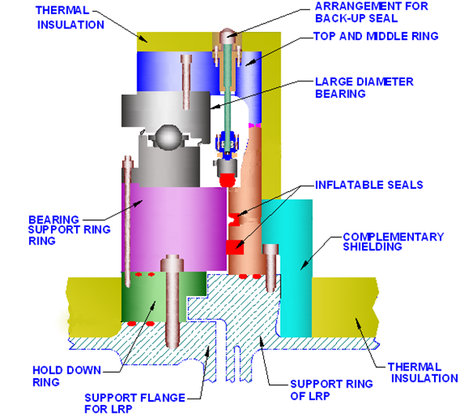
Fig. 1. Sealing arrangement for rotatable plugs in PFBR

DESIGN & MATERIAL SELECTION FOR SEAL DEVELOPMENT
The seal is a custom shaped design to meet the functional requirements. The major functional requirements are as given below:
- The seal should bridge two annular surfaces spaced apart by 5 mm so as to seal the interspace between them. One of the sealing surface is static whereas the other one is rotating. However, during rotation, the seal will be lifted and parked above the sealing surfaces.
- The seal design should consider a gap variation of +/- 2 mm and elevation difference of +/- 1 mm between the sealing surfaces.
- The seal material should be able to withstand an operating temperature of up to 90 Deg. C
- The load required to press the seal for sealing application should be minimum.
- The seal material should be compatible to Argon/Nitrogen as well as atmospheric air.
- The seal design should provide a leak-tightness of 1x10⁻³ scc/s/m circ. of seal.
Based on the above functional requirements, the seal cross section was optimised in previous research work by Sinha N. K. et al. [1] and the same is considered as the reference geometry for the present work also. Figure 2 gives the cross section details of the seal considered for the design verification and development.
In previous attempts, the seal was designed and developed with fluorocarbon as material of construction by Sinha N. K. et al., [2]. As fluorocarbon rubber is a difficult to work rubber and also, limited suppliers exist, as an alternate option, design and development exercise was undertaken with Silicone as material. Further, to enlarge the supplier base, commercial Silicone as per ASTM D2000 [3] is chosen for the development.
Following are specified as targeted properties for the seal material, to be demonstrated in both slab and product stage.
TABLE 1: SPECIFIED MECHANICAL PROPERTIES FOR SEAL MATERIAL

Parameter | Specification (Equivalent to ‘GE’ Class Grade 5 rubber as per ASTM D2000)
 | Unaged | Aged (70 h @ 225 Deg C)
Hardness (Shore ‘A’) | 55±3 | (+)10
Tensile strength (min) MPa | 6 | (-)25%
Elongation at Break (min) % | 150% | (-)30%
Splice strength (min) MPa | 3 | -
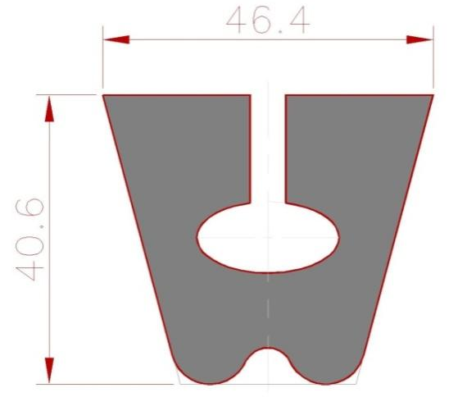
Fig. 2. Cross section details of the custom shaped back-up seal and seal holder [2]

FE ANALYSIS OF SEAL GEOMERTY
Since the existing seal geometry is taken as reference geometry, which was optimised based on extensive analyses [1], performance qualification under simulated operating conditions is considered as the qualifying criteria for the new back-up seal with Silicone as material. However, prior to taking-up the development, detailed FE analysis using ABAQUS^{(R)} was repeated with silicone as material to confirm that tensile stresses at critical locations of the geometry selected are within the material strength. Since, the objective was to extract the stresses at critical locations with Silicone as material and compare it with previously reported stresses with Fluorocarbon as material, the analysis was carried out using the room temperature test properties of the seal material only. As part of this, initial bench-marking study was carried out to validate the hyper-elastic materials modelling. Subsequently, the actual seal analysis was carried out employing marlow model to define hyper-elastic properties of the material. Following paragraphs brings out the works carried out in this direction.

Validation of Analysis Methodology
The back-up seal geometry has been optimized previously [1] for fluorocarbon as material of construction. Hence, as part of qualification of geometry with silicone material, similar finite element analysis has been carried out. Since, back-up seal mainly experiences compression without undergoing a cyclic loading, effects of visco-elasticity which incorporates rate sensitivity and strain history dependence of elastomers, can be ignored [4]. Elastomers are hyperelastic materials and several constitutive theories for large elastic deformations based on strain energy density functions have been developed [5]. Modern commercially available finite element analysis software automate the process of curve fitting experimental lab data to specific hyperelastic formulations. For stress analysis of back-up seal, commercial software ABAQUS^{(R)} is used. Among the various forms of strain energy potentials, Marlow model is selected based on the results of material evaluation performed by the software. This is in line with the recommendation by ABAQUS [6], as only one set of test data (tensile) was available for the material. In this case, a strain energy potential is constructed that will reproduce the test data exactly and that will have reasonable and stable behavior in other deformation modes.
To begin with, a bench marking study to gain confidence in backup seal analysis was carried out. An attempt was made to model and analyze the seal with fluorocarbon material as bench marking study. Results of the analysis were compared with results obtained earlier [1]. Stress strain curve along with the boundary conditions given in [1] were used as input for the analysis. The constants C₀₁ and C₁₀ for Mooney Rivlin model were determined as per the methodology given in [7]. The results of bench marking study matched reasonably well with the reference study and thus the analysis methodology was validated for further analysis of the seal with silicone material.

FIG. 3. Axi-symmetric model of Back up seal with boundary conditions

FEA of back up seal with silicone material
Uniaxial tensile test data was used as input for the analysis (Ref Fig. 4). Marlow model was selected based on the results of material evaluation performed by the software ABAQUS. Axi-symmetric model for back up seal, which was used for bench-marking study (as shown in Fig. 3), was used for analysis. The analysis was carried out for three cases viz. with no mismatch between sealing surfaces, with a mismatch of 1 mm between sealing surfaces and with mismatch of 1 mm between sealing surfaces along with 25 kPa pressure exerted by Argon to the bottom surface of seal. In all cases, seal was given a compression of 5 mm. Results of the third case, being the most critical, are presented here.

FIG. 4. Tensile stress strain curve (obtained as per ASTM D 412) used as input for FEA

(a) Von Mises stress (Pa) distribution (b) Maximum principal stress (Pa) distribution

(c) Minimum principal stress (Pa) distribution (d) Contact pressure (Pa) distribution
FIG. 5. Results for back up seal analysis with Silicone (5 mm seal compression, 1 mm mismatch in sealing surfaces and 25kPa Ar pressure)
As can be seen from above Fig. 5, tensile stress gets induced in the bottom portion of the ellipsoidal cavity when the seal is in compressed condition. This stress gets reduced in case of misalignment between the surfaces to be sealed, to some degree as net compression on one side of the seal gets reduced. Also, this tensile stress increases when argon pressure is applied at the bottom of back up seal. Both the maximum Von Mises stress and principal stress observed (1.413 MPa & 0.463 MPa) in the seal are much less than the material strength specified after ageing (4.5 MPa, Ref. Table 1). Further, as silicone is known for its high temperature resistance (up to 250 Deg. C), a drop of 50-60% in tensile strength is expected at the operating temperature of 90°C [8]. Considering a 60% drop, the tensile strength at 90 Deg. C is 2.4 MPa, which is much higher than the obtained stress values at room temperature and significant change in stress values is not expected at operating temperature. In case of contact pressure, when silicone is used as seal material instead of fluorocarbon, contact pressure is reduced. It further reduces when Argon pressure is applied to the seal. But, the minimum contact pressure in all the cases studied, is more than the threshold requirement of 0.1 MPa. The same trend is also seen in the case of the force required to be applied on the seal to achieve the required amount of compression. Predictably, force required to compress the seal in case with misalignment is less while it increases when argon pressure also comes into picture.

DEVELOPMENT ASPECTS OF SEAL
The development was divided into two stages:
Stage 1:
- Development of seal through extrusion, testing and manufacture of 7 m continuous length of seal in Silicone, meeting the geometrical and technical requirements as per specification;
- Demonstration of end joining meeting the splice strength and other visual quality requirements.
Stage 2:
- Developing 3 Nos. of 1m dia. test back-up seal for qualification at IGCAR.

Process Flow
Following process flow was adopted for the seal development:
Incoming Inspection of raw material Batch mixing as per mixing ration test slab and button preparation test slab and button inspection extrusion trials First off sample inspection Bulk production / Periodic inspection final inspection packing & despatch

Material
Two grades of Silicone base material, Elastosil ® R 401 / 70 S and Elastosil ®R 401 /40S in the ratio of 60:40 was chosen for the extrusion based on acceptable material properties w.r.t. hardness, tensile strength and elongation. Flat dumbbell shaped samples of 2 mm thick were used for checking the tensile properties. Further, heat ageing test on flat samples was carried out as per ASTM D573 after ageing the samples to 70 Hrs @ 225 Deg. C.

Extrusion Trials
Subsequent to finalization of material composition, extrusion trails were taken-up to obtain a stable profile of back-up seal. Extrusion was carried out using a screw feed type extruder (Fig. 6). Since, the extruder was not fitted with a conveyor, seal was extruded continuously with normal feather touch support and rotated in the table with talc powder to avoid sticking. The seal was cured in an Autoclave oven. To check the compliance of extruded shape to geometrical features as per specification, a gauge in Perspex material was machined and fitment trials of extruded seal samples were taken (Fig. 7). At the end of extrusion trial, a single extruded length of 7 m was produced (Fig. 8), which ensures minimum joints in the reactor seals.
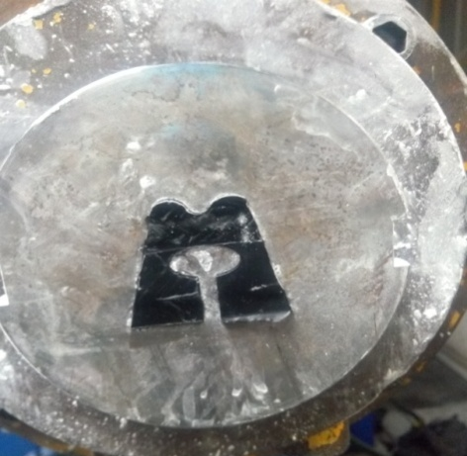
Fig. 6. Back-up seal is being extruded
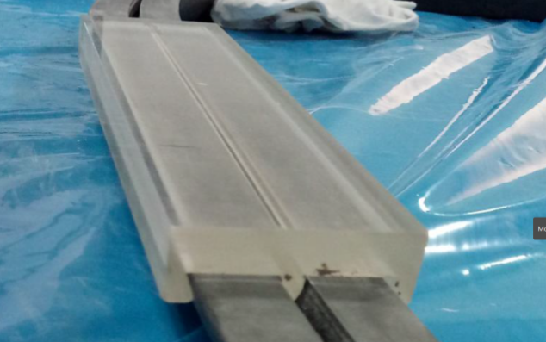
FIG. 7. Checking seal fitment using seal holder gauge in Perspex
FIG. 8. 7 m Continuous length of back-up seal
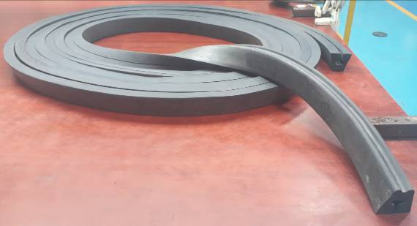

End Joining Qualification
Based on the earlier experiences with fluorocarbon seals, end joining of extruded seal was identified as a next challenging task. Before joining, the joining ends were cut sharply in a 45° orientation using a sharp slicer to ensure maximum joining area (Ref. Fig. 9). The spliced ends were applied with proprietary RTC adhesive. After a curing time of 24 hrs, the spliced joint was subjected to tensile test and ensured that the minimum tensile strength and elongation are meeting the specification requirements.
To check the deterioration of the joint under ageing, spliced joint samples were subjected to heat ageing for 70 Hrs @ 225 Deg C as per ASTM D 573.
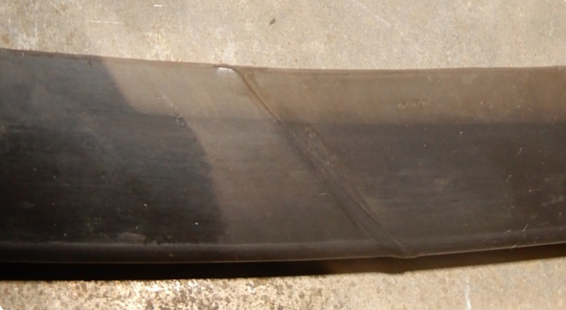
FIG. 9. Joint region of back-up seal

Examination
Following examinations were carried out on extruded seal i.e., both the 7m length of seal as well as 3 Nos. of 1m dia.
- Visual examination of the surfaces for the presence of blisters, cracks, dents etc.
- Dimensional inspection.
- Fitment trials of the extruded seal length with Perspex gauge in a regular interval.

Results & Discussions:
The actual tensile strength properties of seal material obtained before and after ageing with slab samples of 2 mm thick are given below in Table 2. The values are the average of 3 Nos. of samples tested.
TABLE 2: MECHANICAL PROPERTIES OF DEVELOPED SEAL

Parameter | Specification | Achieved on Slab Sample
 |  | Unaged | Aged
Hardness (Shore ‘A’) | 55±3 | 55-56 | (+) 3 Shore A
Tensile strength (min) MPa | 6 | 9.84 | (-)8.69 %
Elongation at Break (min) % | 150% | 248.48 | (-) 22
Splice strength (min) MPa | 3 | 5.46 | 3.97

The results of ageing tests indicate that the changes observed in hardness (+3 Shore A), tensile strength (-8.69%) & % elongation (-22%) are within the permissible limits as per ASTM D2000. Also, the splice strength was 3.97 MPa, which is higher than the minimum splice strength specified.
The visual examination of extruded seal indicated that except for few flow marks generated during handling of the green seal after extrusion (i.e., before curing), the surface was smooth and defect free.

Production of Test Seals:
Subsequent to satisfactory demonstration of seal development as witnessed by the material testing as well as examinations carried out, stage-1 development activities were deemed to be completed. Subsequently, the production trials of seal extrusion was taken-up to produce 3 Nos. of 1m dia. Back-up seal for its qualification under simulated conditions. The seals were successfully extruded and visual examinations and dimensional measurements (Fig. 10) as specified were carried out.
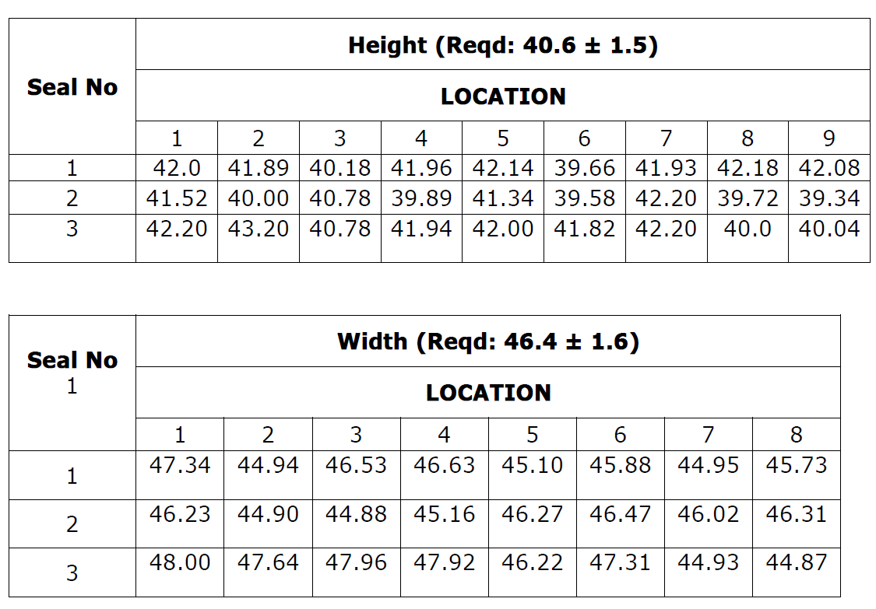
Fig. 10. Critical dimensions in finished 1 m dia. Seals

PRODUCTION OF REACTOR SEALS
After the development of dia. 1m test back-up seals with Silicone as material, performance qualification of the seals were carried out under simulated operating conditions and the seals were qualified for reactor application. The performance qualification of the seal included compressing the seal by 5 +/- 1 mm in a test rig which simulates the actual application and then exposing the compressed seal to a temperature of 110 Deg C for 15 days. During the testing, the leak-tightness of the inter-space between two sealing lips was monitored. At the end of 15 days, the rig was cooled down, opened and seal was inspected for any physical damage and compression set. This test was repeated several times to qualify the seal for a longer duration.
Subsequent to successful testing / performance qualification, necessary actions were taken to update the technical specification for the back-up seal and tender was floated and purchase order was placed with the same industry who had developed the seal, previously. Subsequently, industry took-up the production of the seals. Though, maximum of 3 / 2 joints were originally planned for LRP & SRP seals, respectively, considering that the joints are the weakest link in a seal, discussions were held with the industry to restrict the number of joint to one. This calls for continuous extrusion of ~20 m length seal for LRP and ~14m length seal for SRP. To meet the new requirements, industry commissioned a new extrusion line having in-line curing facilities and the 20 m length seal was successfully extruded after overcoming few difficulties like flow marks on the surface of seals due to mismatch in the extrusion speed and conveyor speed. Fig 11 shows the extruded 20 m length seal lying over measurement table. The seal was subjected to visual / profile / dimensional and hardness inspection and found to be meeting the requirement.
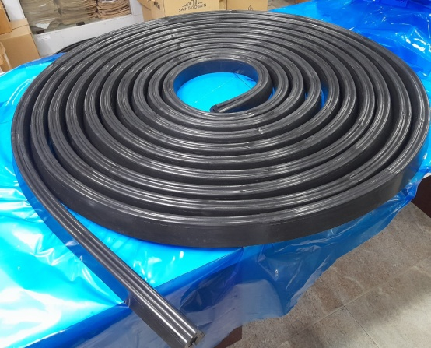
FIG. 11. 20m Continuous length back-up seal

summary
As part of developing multiple supplier base for the supply of back-up seal, design and development activities were taken-up with Silicone as material of construction. The existing seal geometry which was optimised based on extensive analyses and tests was taken as reference geometry and finite element analysis of the reference geometry was carried out with Silicone as material to confirm that the stresses are within the specified material strength, both unaged and aged. The tests conducted over the actual developed material indicated that specified tensile strength properties, both the unaged and aged are met with good margin. Subsequently, extrusion trials were taken-up to produce 7 m length continuous seal as well as dia. 1 m test seal. Based on the performance qualification of the dia. 1 m seal in a dedicated test rig, production of reactor grade seals was taken-up and seals were delivered. Being a versatile rubber and having large industrial experience, Silicone has provided an alternate option to fluorocarbon for the back-up seals to be used fast reactors.
ACKNOWLEDGEMENTS
The co-operation extended by the seal testing team in completing the performance qualification of the seal is sincerely acknowledged.
References
- Sinha N. K., P. Ghosh, A. Saha, R. Mukhopadhyay, Baldev Raj and S. C. Chetal, Design optimisation of backup seal for sodium cooled fast breeder reactor, Materials and Design, 36 (2012) 396-407.
- Sinha N. K., R. Mukhopadhyay, D. Dhupia, S. Das Gupta and, Baldev Raj, Development of fluorocarbon rubber for backup seals of sodium cooled fast breeder reactor, Materials and Design, 32 (2011) 5141-5153
- ASTM D2000-18, Standard Classification System for Rubber Products in Automotive Applications, American Society for Testing and Materials
- Ismail J. Abubakar et al, ‘Constitutive Modeling of Elastomeric Seal Material under Compressive loading’, Modeling and Numerical Simulation of Material Science (2016)
- Alan N. Gent, ‘Engineering with Rubber - How to Design Rubber Components’ - 3rd edition (2012)
- Abaqus user’s manual
- Robert H. Finney, Alok Kumar, ‘Development of Material Constants for Nonlinear Finite Element Analysis’, presented at the meeting of the Rubber Division, American Chemical Society, Cleveland, Ohio (1987)
- Shin- Etsu Silicone Catalog by Shin- Etsu Chemical Co., Ltd., ‘Characteristic Properties of Silicone Rubber’

