DESIGN & ANALYSIS OF A NOVEL ARRANGEMENT FOR COUPLING AND DECOUPLING OF ROTATABLE PLUGS IN PFBR

JAGRUTI RAMESH MOTE, SRIRAMACHANDRA AITHAL, GAGAN GUPTA, AND S.RAGHUPATHY

Indira Gandhi Centre for Atomic Research,
Kalpakkam, Tamilnadu, India

Email contact of corresponding author: jagruti@igcar.gov.in

Abstract

Large and Small Rotatable Plugs (LRP & SRP) form part of top shield and are used to position transfer arm over any required subassembly location during fuel handling. The annular gap between the Roof Slab and LRP as well as between LRP and SRP is sealed with the help of two types of elastomeric seals - Primary inflatable seals and secondary back up seal. These seals have a design life of 10 years and need to be replaced after every 10 years. The procedure to be adopted for replacement of seals involves removal of the hexagonal socket head screws connecting top & middle ring to support ring of LRP/SRP, lowering of the LRP/SRP onto roof slab/LRP respectively and lifting of top & middle ring to gain access to the seals. Similar procedure is applicable for carrying out maintenance of large diameter bearings also. To remove top & middle ring, load on the screws connecting the top & middle ring to rotatable plugs (400 t / 200 t for LRP & SRP, respectively) needs to be relieved and then the plug needs to be lowered onto the Roof Slab. To relieve the load and lower the plug, a novel concept of multiple tie rod & nut arrangement, with each one operating in a sequential way was conceived & implemented. This dedicated arrangement was designed taking into account the space constraints over the Top Shield and the eccentric nature of the loading of the plugs. The paper presents the discussion of design aspects of arrangement conceived for lowering / lifting of LRP/SRP along with the results of structural analysis carried out to confirm the design. The maximum allowable torque and nut turn during each operation in the tie rod is estimated and presented.

INTRODUCTION
Large and Small Rotatable Plugs (LRP & SRP) form part of top shield and are used to position transfer arm over any required subassembly location during fuel handling. Fig. 1 shows the rotatable plug support arrangement for LRP. The annular gap between the Roof Slab and LRP as well as between LRP and SRP is sealed with the help of two types of elastomeric seals - Primary inflatable seals and secondary back up seal. These seals have a design life of 10 years and need to be replaced after every 10 years. The procedure to be adopted for replacement of seals [1] involves removal of the hexagonal socket head screws connecting top & middle ring to support ring of LRP/SRP, lowering of the LRP/SRP onto roof slab/LRP respectively and lifting of top & middle ring to gain access to the seals. To remove top & middle ring, load on the screws connecting the top & middle ring to LRP support ring needs to be relieved and then the LRP needs to be lowered onto the Roof Slab.
The paper discusses details of the novel arrangement conceived for lowering / lifting of LRP/SRP along with the results of structural analysis carried out to confirm the design. The maximum allowable torque and nut turn during each operation in the tie rod is estimated and presented.
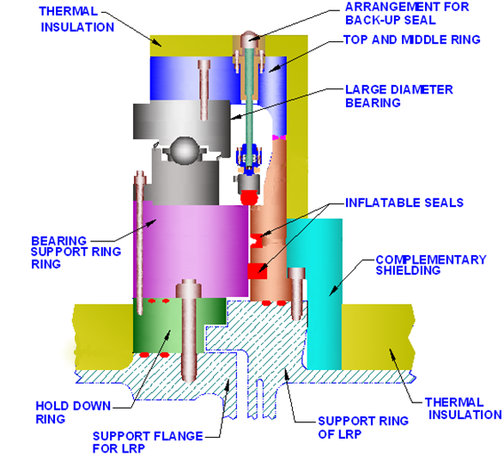
FIG. 1. Support arrangement for LRP

ARRANGEMENT FOR RELIEVING PLUG LOAD ACTING ON FASTENERS
The rotatable plugs are supported over large diameter bearings through a circular ring called Top & Middle Ring (TMR). The plug is connected to TMR through large number of fasteners. In order to facilitate the seal replacement, the TMR needs to separated from plug and hoisted to gain access to the seals. For this, after unscrewing the fasteners, the LRP & SRP are to be made to rest directly over the roof slab / LRP, respectively. With the de-coupling of plug load on the TMR, the same becomes free for further hoisting. Since, the fasteners are of ‘V’ thread type, to unscrew all the fasteners, the load of the plugs acting on these fasteners needs to be relieved and transferred directly to TMR through a temporary arrangement. Towards this, a novel arrangement consisting of long length tie rods connecting & transferring the plug load to a ring plate provided at the top of TMR is conceived. The arrangement works like a manual jack arrangement. Fig. 2 shows the schematic of this arrangement deployed to transfer the load.
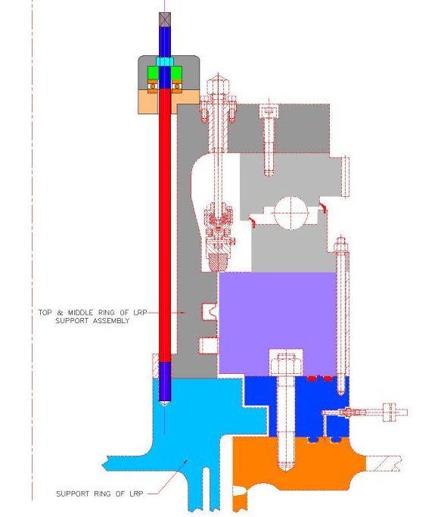
FIG. 2. Manual arrangement for relieving the load acting on fasteners

In this arrangement, for relieving the load on the fasteners, each screw will be replaced one by one with tie rod and nut assembly, made of high strength steel. The tie rod is provided with ‘V’ type threads at one end whereas trapezoidal threads at the other end. The V threaded end engages with the corresponding threaded holes in LRP/SRP support ring while the trapezoidal threaded end will be assembled with a nut. The nut will be placed on top of a cylindrical washer which in turn will be resting on a thrust bearing. By rotating the nuts, tie rods moves up/down depending on direction of rotation of the nut, thus lifting/lowering the plug respectively. With sufficient pre-tightening of the tie rod at the ‘V’ threaded end, the rotary motion of the tie rods is arrested during the rotation of the top nut engaged with trapezoidal threads. The nut transfers the plug load through thrust bearing to a circular ring. The circular ring, which will be supported on the Top and Middle ring, directly transfers the plug load to the bearing. Because of the limited space available to introduce & assemble the large diameter circular ring through the opening in top shield platform, it is manufactured in parts and bolted together at site.
Static structural analysis of the circular ring along with tie rods has been carried out for both LRP as well as SRP, to size the structural members like ring and tie rod. The maximum force obtained in the tie rods is used for further estimation of limiting torque during nut rotation to raise or lower the plug. Since there is very less overlap between bearing and standard Tr 24 nut (OD 36 mm), a cylindrical washer is provided between the bearing and the nut.

STATIC STRUCTURAL ANALYSIS AND RESULTS
Total load of 400 t and 200 t acting on LRP and SRP, respectively were considered for analysis. Finite element analysis of plug lifting/lowering arrangement was carried out for both LRP and SRP using commercial software ABAQUS^{(R)}. The maximum force experienced by tie rods due to eccentric nature of loading is obtained from the FEA results. Theoretical calculation to check the strength of rod and threads are performed using this force value.

Design code, materials and allowable stresses
IS: 800 [2] has been used as the applicable design code for designing the threaded members of the arrangement whereas the concept of primary membrane & membrane + bending stress as per ASME Sec. VIII Div. 1 [3] has been used for designing structural member i.e., circular ring. Further, allowable stresses have been worked out as per IS: 800 under different loading conditions. Since, fasteners are not supposed to be subjected to bending stresses, the allowable stress under combined membrane + bending in fasteners as well as threads is taken same as S_{m}.

Finite element analysis of lifting and lowering arrangement for LRP
Eccentric location of SRP with respect to LRP leads to non uniform loading of the tie rods. Hence, to take into account the effect of eccentricity, entire assembly of circular ring with tie rods was modelled along with a carbon steel cylinder equivalent to LRP. Keeping radius same as that of the LRP, height of the equivalent cylinder is adjusted such that its weight is same as that of actual LRP (Refer Fig. 3 for loaded structure). Penetration corresponding to the SRP was introduced such that the effective eccentricity will be approximately 181 mm [4]. Minimum mesh size of 7 mm was used for meshing with solid continuum elements such that at least 4 elements are present across thickness in the regions of interest. Maximum stresses in the arrangement were found and are listed in Table 1. The distribution of stress and deflection in the circular ring are as shown in Fig. 4 & 5 respectively. Since the analysis was performed with 3D solid elements, the stress contours include local or peak stresses as well [5]. The maximum membrane and membrane + bending stress (excluding the local effect) induced in LRP circular ring are extracted. These are 21.26 MPa and 60.22 MPa respectively, which are well within limits. The ring, predictably, shows downward deflection on the ID side, of 0.13 mm which is negligible. Due to eccentricity of loading, the tie rods nearer to SRP location show maximum stress and deflection. Stresses obtained (after excluding local effects) in most heavily stressed tie rod are also listed in Table 1. Stress distribution and resulting deflection plot for most heavily stressed tie rod are as shown in Fig. 6 & 7. The maximum stress values and the deflection values in tie rods are well within acceptable limits.
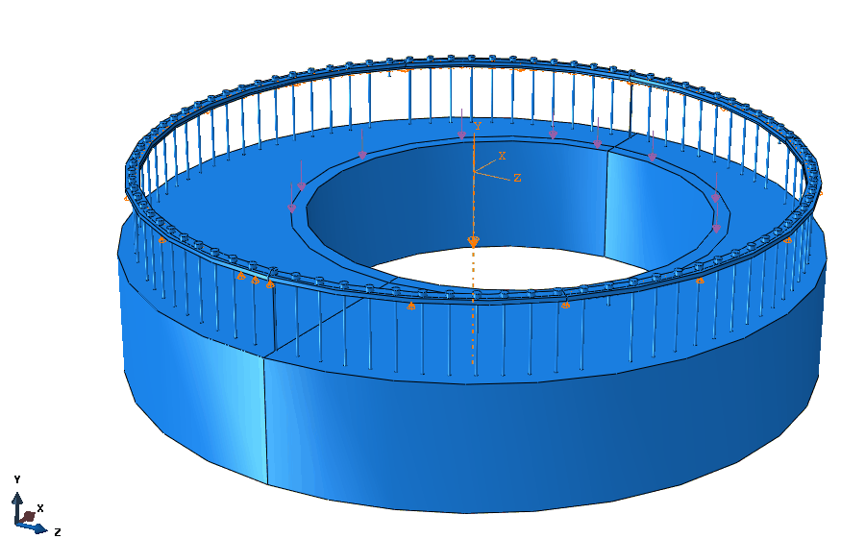
FIG. 3. Ring with Tie rods and cylinder equivalent of LRP (with eccentric SRP load)

FIG. 4. Maximum stress (MPa) in Ring of LRP arrangement

FIG. 5. Maximum downward deflection (U2)(mm) in Ring of LRP

FIG. 6. Maximum stresses (MPa) in rod (LRP)
FIG. 7. Maximum downward deflection (mm) in rod (LRP)

The cylindrical washer that is placed between the bearing and the rotating nut was also analyzed. Maximum force induced in the rod was applied as pressure on the top surface of the washer while the bottom surface was given a boundary condition of being simply supported (Refer Fig. 8). The maximum principal stress distribution in washer is as shown in Fig. 9. Area of the washer near the inner diameter experiences bending stresses, however these are found to be within acceptable limits.
FIG. 8. Solid model of cylindrical washer with load and boundary condition (for LRP load)

FIG. 9. Maximum Principal stress (MPa) in conical washer of LRP arrangement

Finite element analysis of lifting and lowering arrangement for SRP
Eccentric location of Control Plug (CP) and Transfer Arm (TA), results in non-uniform loading of the tie rods for SRP arrangement. Analysis has been carried out taking into account these factors. Entire assembly of circular ring and tie rods was modelled along with a carbon steel cylinder equivalent to SRP. Keeping radius same as that of the SRP, height of the cylinder was adjusted such that its weight is same as that of actual SRP (Refer Fig. 10). Penetration for CP and TA was introduced to achieve effective eccentricity of approximately 38 mm [4]. This structure was analyzed and the resulting stresses and deflection in the circular ring are shown in Fig. 11 & 12. Fig. 13 & 14 show the stress and deflection for most heavily stressed rod. Values of membrane stress and membrane + bending stress (after excluding the local effects) are extracted from the results and tabulated in Table 1. These stresses are within allowable limits. No separate analysis of the cylindrical washer is performed for SRP loading as the loads induced are less than the case of LRP. Hence, the cylindrical washer analysis with LRP loading is considered as enveloping case for both.

Table 1. Maximum Stress in the circular ring and Tie Rod (MPa)

Sl. No. | Location | P_{m} | Allowable | (P_{m}+P_{b}) / (P_{L}+ P_{b}) | Allowable
1 | LRP Circular Ring | 21.26 | 138 | 60.22 | 207
2 | SRP Circular Ring | 14.64 | 138 | 41.4 | 207
3 | LRP Tie Rod | 121.05 | 371 | 132 | 371
4 | SRP Tie Rod | 89 | 371 | 94 | 371

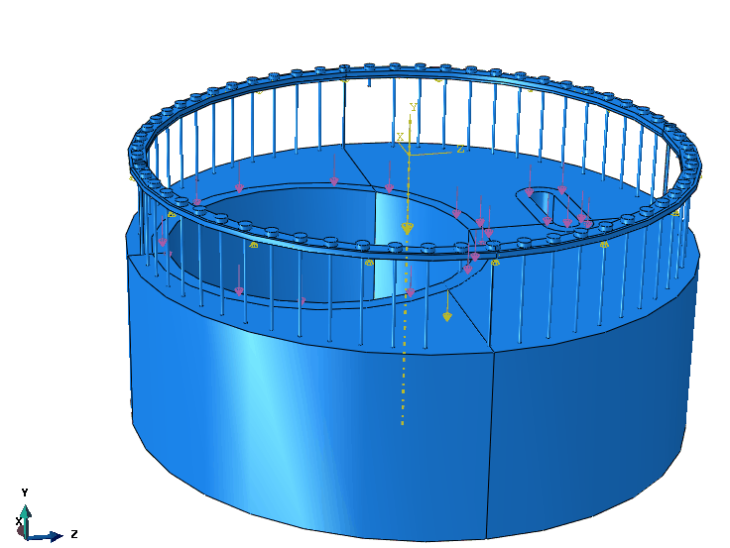
FIG. 10. Ring with Tie rods and cylinder equivalent of SRP (with eccentric Control Plug and TA load)

FIG. 11. Maximum stress (MPa) in Ring of SRP arrangement

FIG. 12. Maximum deflection Downward (U2)(mm) in Ring of SRP

FIG. 13. Maximum stress (MPa) in rod ( for SRP )
FIG. 14. Maximum deflection (mm) in rod (for SRP)

Theoretical analysis for tie rods and threaded connections
Loads induced in the tie rods during lifting of the plugs are considered in the analysis as this is a more critical case. A fixed number of nuts will be rotated each time, in a sequential manner as it is not possible to rotate all the nuts simultaneously. This rotation will induce some stretch in the tie rods and thus, will result in additional load besides the static load of LRP/SRP. Initially, when the LRP/SRP is resting on Roof Slab (RS)/LRP as the case may be, most of the load is transferred to the later through direct contact. When all the nuts are rotated and plug is lifted by some amount, entire plug load (LRP/SRP) is transferred to the RS/LRP through the tie rods. The tie rods are then subjected to tensile load, distributed non-uniformly due to eccentric location of components. The maximum force experienced by tie rods due to eccentric nature of loading is obtained from the finite element analysis. In this loaded condition, when nuts are further rotated, it will result in additional stretch of the tie rods. Using simple stiffness correlation, tensile load resulting from the stretch is calculated. This force along with the force obtained from finite element analysis are used in the further calculations for checking the strength of the threads (trapezoidal and V- threads). Theoretical calculations were performed and it was found that the stresses induced in the threads were within allowable limits. Limiting torque for nut rotation is also found from this resultant force. Details of the threaded connection at the top are given in Table 2.

Table 2. Details of threads at the top and bottom end of tie rods

Sl. No. | Description | Value
1 | Thread type at bottom | M24 x 3
2 | Thread type at top | TR 24 x 3
3 | Height of the nut at top (mm) | 36

Permissible nut rotation at a given time was arrived at to be 30 Deg., after parametric studies for various angles of rotation in order to keep stresses in the tie rod within limits. As the threaded rod is subjected to both direct tension and torsion, it was checked for combined stresses as well. As per IS 800 [2], sum of ratios of actual stresses (tension and shear) to corresponding allowable stresses should be less than 1.4. It was ensured that the arrangement satisfied this criterion.
Maximum limiting torque for lifting of the plug was found to be ~196 Nm taking into account 10% uncertainty when using torque wrench. Similar analysis was carried out for lowering of plug and limiting torque while lowering was found to be approximately 100 Nm.
The stresses induced in the tie rods for SRP are less than that of the LRP (ref. Table 1) and hence the strength analysis carried out for most heavily stressed LRP tie rod is considered as enveloping case for SRP as well.

CONCLUSION
In order to relieve the load on screws connecting rotatable plugs to their support assemblies, a novel arrangement has been designed. The arrangement consists of circular ring, thrust bearings, washer, nut and connecting tie rods. The maximum allowable torque and permissible rotation of nut during each operation in the tie rod is estimated. Structural analysis of the arrangement has been performed to ensure that the stresses induced in various parts involved are within allowable limits.

References
- SRIRAMACHANDRA AITHAL, S. RAGHUPATHY, Procedure for Replacement of Rotatable Plug Seals, Internal report, Indira Gandhi centre For Atomic Research, Kalpakkam (2004)
- IS 800: 1984 (Reaffirmed in 1998), Indian Standard, Code of Practice for General Construction in Steel
- ASME Section VIII Division 1, Rules for Construction of Pressure Vessels
- SRIRAMACHANDRA AITHAL, S. RAGHUPATHY, Speed Selection and Torque Estimation for Rotatable Plug Drives, Internal report, Indira Gandhi centre For Atomic Research, Kalpakkam (2001)
- ABAQUS User’s manual.

