THE “ALFRED WHITE BOOK”:
A BUSINESS CARD OF THE PROJECT

F. LODI¹, G. GRASSO¹, G. FIRPO², D. DIACONU³, M. CARAMELLO², A. ALEMBERTI², M. TARANTINO¹, I. TURCU³, M. NITOI³, M. CONSTANTIN³, D. GUGIU³, M. FRIGNANI²

¹Italian National Agency for New Technologies, Energy and Sustainable Economic Development (ENEA), Bologna, Italy
²Ansaldo Nucleare S.p.A. (ANN), Genova, Italy
³Institute for Nuclear Research (RATEN ICN), Mioveni, Romania

Email contact of corresponding author: francesco.lodi@enea.it

Abstract

The European-wide research on the Lead-cooled Fast Reactor (LFR) has been steadily advancing the technology readiness level at a point where, for further targeting industrial maturity, the need of a demonstrator has risen. The Advanced Lead-cooled Fast Reactor European Demonstrator (ALFRED), along with its support research infrastructure, is the missing link of the innovation chain being conceived for demonstrating the viability of the LFR technology propelling it beyond the research frontier which has been hitherto. Given the elevated level of maturity the ALFRED Project has currently reached, and foreseeing its inclusion in the Romanian strategy for competitiveness as a Major Project, the Fostering ALFRED Construction (FALCON) consortium, in charge of all activities advancing the ALFRED Project, has identified the need to organize and refine the presently available material in an organic, harmonized and complete way. The results of this effort brough to the drafting of a comprehensive document presenting an exhaustive and effective overview of the entire Project: the ALFRED White Book. A first step of knowledge of the Project – including the ALFRED demonstrator and its associated research infrastructure – is presented in the White Book, addressing its main elements under all the relevant points of view to provide an exhaustive (although qualitative) picture of the proposal and the expected benefits underneath. This includes mostly: the Project vision and mission, the scientific and technological relevance, the technical description, the supporting R&D programme and the operation strategy, the key safety and licensing elements, the socio-economic benefits, and the proposed deployment strategy and project implementation (including financial and managerial aspects). The White Book is thus conceived as a “business card” of the ALFRED Project, meant for distribution to different stakeholders with a potential interest for involvement, including research institutes, universities, industries, safety authorities, policy makers as well as national and European administrations and local communities.

INTRODUCTION
Besides the exploratory programs started in the 1950s in the former Soviet Union, the Lead-cooled Fast Reactor (LFR) technology has gathered considerable attention in the worldwide scientific and industrial arenas since its inclusion, in the early 2000s, by the Generation IV International Forum (GIF) among the breakthrough technologies capable of expanding the current boundaries of the nuclear field in the economic, sustainability and safety areas.
This interest has been practically translated as a steady advancement of the LFR chain technical maturity, qualitatively measured by the so-called Technology Readiness Level (TRL) [1]. Thanks to cutting-edge results and know-how stemming from the design, construction and operation of more than 70 dedicated experimental facilities [2], LFRs are now at the gate of the research frontier where, for further closing in on commercialization, having an operational demonstrator is a necessity. In the European context this mission has been embodied in the Advanced Lead-cooled Fast Reactor European Demonstrator (ALFRED) Project, including the reactor itself along with its support research infrastructure (see Fig. 1).

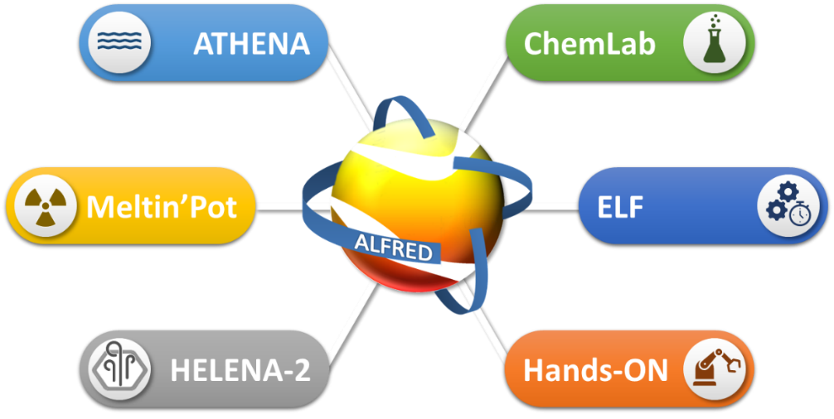
FIG. 1. The ALFRED reactor along with its support research infrastructure.

The idea of ALFRED materialized in the conception of the EU co-founded LEADER collaborative endeavour [3] following which Romania expressed its will to be the hosting country for the Project facilities. Since then, the Romanian financial and political commitments to the Project have been constantly increasing to the point where ALFRED is foreseen to be included in the country agenda for competitiveness as a Major Project, a steppingstone for disclosing an even higher regional and European financial support.
In preparation for this step, and given the all-around level of maturity the ALFRED Project has currently reached, in tandem with the vast amount of material produced for both technical and dissemination purposes, the Fostering ALFRED Construction (FALCON) consortium, in charge of all activities advancing the Project, has identified the need to organize and refine the presently available material in an organic, harmonized and complete way. The results of this effort have been materialized in the drafting of a comprehensive document presenting an exhaustive and effective overview of the entire Project: the ALFRED White Book [4].
The White Book (see Fig. 2) provides a holistic presentation of the Project with the objective of being informative rather than technical and clear rather than detailed. The document addresses all the Project relevant elements providing a complete (albeit qualitative) picture of the proposal – mainly in terms of the underlying vision and the foreseen technical and financial implementation strategy – and the ensuing benefits, from scientific, technological and socio-economical points of view.

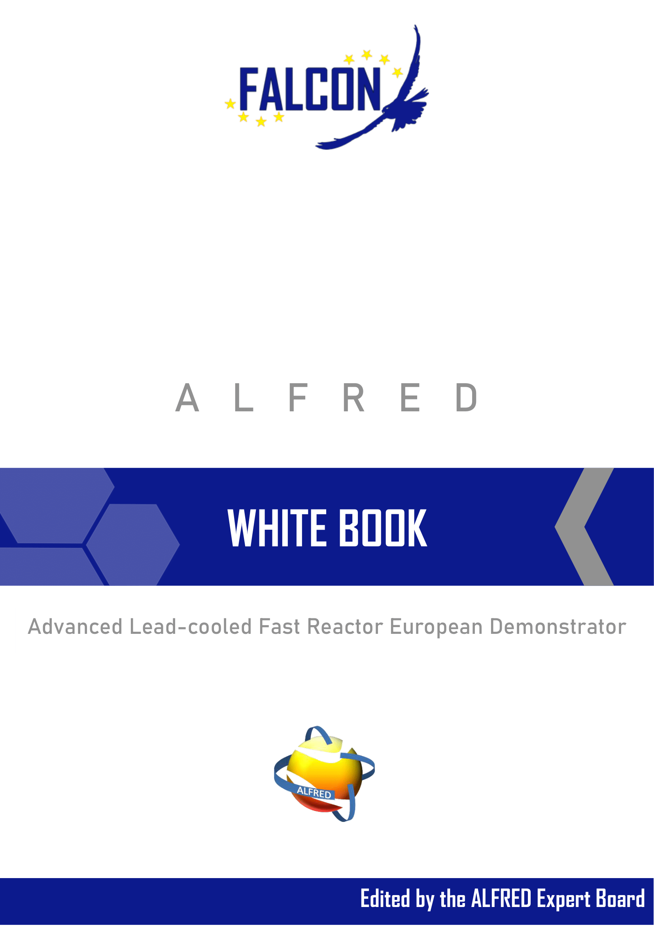
FIG. 2. Cover page of the ALFRED White Book.
The White Book is therefore a sort of “business card”, an entry point in which all interested stakeholders can learn what opportunities the Project discloses for them and also more about the general vision and structure of the Project itself. In the following, the key messages contained in the White Book for each audience type are summarized, so to give a hint on the main take-away points, along with a quick peek of the overall outline of the Book in order to better clarify the nature of the document and its actual content.

Stakeholders takes AWAY
Due to the wide framework and complexity on one hand, and to the diverse beneficial ramifications it unfolds, on the other, the ALFRED Project potentially involves manifold stakeholders’ categories like research institutes, universities, industries, safety authorities, utilities, policy makers as well as national and European administrations and local communities. Each audience can possibly have interest in, or even more, it can benefit and contribute to different facets of the Project, so that various takes away are contained in the White Book.

Research organizations
The ALFRED Project, with its demonstration objectives, embodies, by its very foundation, a scientific and technological mission for excellence that is a unique driver for novel and innovative research in many areas, acting as natural centre of attraction for European and worldwide research institutions involved in the nuclear field or other cross-cutting sectors related to heavy liquid metals. Enlarging the role of ALFRED, along with its supporting experimental facilities, the availability of such infrastructure would provide the research community with a world-class platform for maximizing the quality and outreach of basic research on the chemical and physical properties related to the heavy liquid metal technology at large, as well as an innovation incubator for novel advanced solutions to exploit further the potential of the technology in a real-world use. Overall, the ALFRED project aspires to excel as an open infrastructure for research and development.

Universities
Standing on the universities role in forming the future generations of nuclear specialists, a privileged access to the ALFRED infrastructure offers a one-of-a-kind opportunity for deploying unparalleled education and training programs, elevating the involved universities among the most relevant worldwide, while boosting smart specialization for economic growth. From the scientific production standpoint, similarly to other large scale international collaborative projects, manifold links and possibilities for enlarging the partnership portfolio will seamlessly be available, further boosting the benefits in partaking in the ALFRED endeavour.

Industrial companies
ALFRED, inherently with its demonstration and Small Modular Reactor (SMR) prototypic nature, offers the possibility to be at the forefront of technological innovation in the nuclear sector, acquiring a leading position in the future market. As a promoter of leadership and expander of technological outreach, the ALFRED research infrastructure grants numerous one-of-a-kind services encompassing equipment- and components-related development up to full qualification, innovative procedures testing and hands-on training of the involved personnel.
Considering that the ALFRED reactor and its supporting infrastructure are just a gate for closing in on the LFR chain commercialization, a double-layered interest and involvement from industrial enterprises is foreseen disclosing opportunities for engineering, procurement and construction activities not only for ALFRED itself, but also for the future commercial units.

Safety authorities
LFRs are promoters of a paradigmatic shift in nuclear safety having the potential for reaching unparalleled figures of merit, which are pursued by the European LFR community. As the first reactor sought in this perspective, ALFRED entails novel approaches, concepts and features that will prove the claimed potential, and additional means to secure that ALFRED will ultimately be a vehicle for continuously upgrading the safety performances of future nuclear power plants, thereby shaping future safety standards. The Project infrastructure will provide a pioneering hub not only for analysing such novelties, but also for their prototypical testing, verification and qualification so to substantiate safety claims and protocols. The engagement of safety authorities will give them the head in contributing to the vision of such safety revolution and its technical interpretation that will characterize future nuclear installations while acquiring, first-hand and independently, the necessary know-how.

Utilities
The ALFRED Project aims at disclosing LFRs as desirable systems for the safe, sustainable and competitive production of nuclear energy. Even though ALFRED, having the main role of demonstration and due its prototypic nature, will not be in itself an endeavour targeting the financial profit, but rather an intensive scientific and technological knowledge, which is invaluable by definition, it will be the key for proving the commercial profitability, and the public acceptability, of the follow-on units, thereby opening the door to a commercial fleet of SMRs or large-sized reactors that can overcome the current concerns relating to nuclear energy use, and thus exploit the full potential for a massive deployment.

National policy and decision makers
Romania has, since the beginnings of the LEADER project, largely realized the manifold opportunities disclosed by implementing ALFRED and its research infrastructure like:

- contribution to the medium- and long-term climate targets;
- the mastering of an effective technology for long-lasting safe, secure, sustainable and economic energy availability;
- the reduction of the social and economic disparities among regions;
- the disposal of an effective tool for opposing to brain drainage existing trends;
- the elevation of the national reputation and its ingress in the club of advanced nuclear technology developers.

ALFRED will indeed become a flagship and a mark for Romania ambitions in pursuing ever higher environmental and socio-economic objectives for its future generations, promoting the country as a leading actor in the scientific and technologic future panorama.

European policy and decision makers
The Project has been, since its conception, a pan-European effort of a diversified pool of actors who recognized, together with the European Sustainable Nuclear Industrial Initiative (ESNII) [5], part of the Sustainable Nuclear Energy Technology Platform (SNETP) [5], the potential outreaches of the LFR technology. Endorsing, politically and financially, ALFRED is indeed an effective means permitting the European scientific and technical nuclear communities to assume a leading role in advanced nuclear technologies, while preserving the role of unparalleled safety champion, with the associated international export possibilities.

Local communities
For the communities in the proximity of the site, ALFRED and its infrastructure will be a natural creator of direct high-level jobs and also of indirect ones via the induced activities, while contributing to jobs security by diversification with the (presently almost total role of the) car industry in the South Muntenia region, in general, and Mioveni, in particular. To avoid a perception of all above opportunities as compensations for hosting ALFRED, and aiming instead at a vision for nuclear power intimately embedded with its social ramifications and perception, engagement of the local communities is an integral asset of the Project. Establishing a shared environment will also set a role model for future interaction with the population for advance nuclear installations, including the local communities themselves among the assets increasing the visibility of the Project.

The white book ELEMENTS
Covering the globality of the Project’s many facets, ranging from technical to socio-economical aspects, the White Book is foreseen to be of interest for a wide range of audiences, although possibly more sensitive to dissimilar levels of detail. To cope with this contrasting need the document has been structured in a matryoshka style so to:

- provide the key elements of the Project in few pages for those interested in an overview,
- guide in a logical path the reader interested in a deeper understanding of the overall framework,
- drive the specialized reader directly towards the section covering his/her field of interest/expertise.

In the following, the document structure is presented so to better explain the actual content of the Book for an even easier consultation.
At the beginning, an executive summary was created, responding to the need of giving “at a glance” a comprehensive summary of the White Book in a very concise manner to put on the “essence” of the document without providing fine details (see Fig. 3). The executive summary describes, in few pages, the background information and objectives of the Project, the international and European framework context in which the project is developing, the scientific and technological mission, the key benefits, the financial requirements, the time schedule as well as main conclusions.

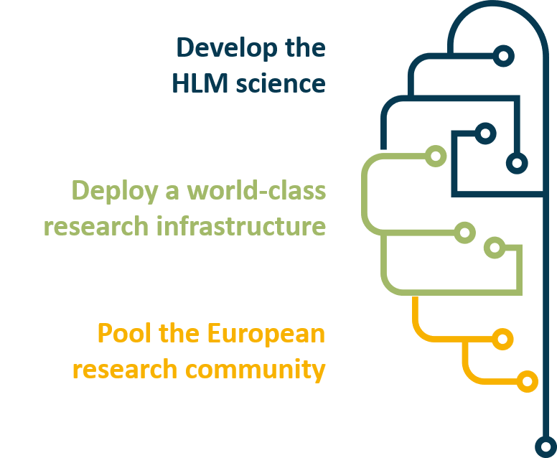 | 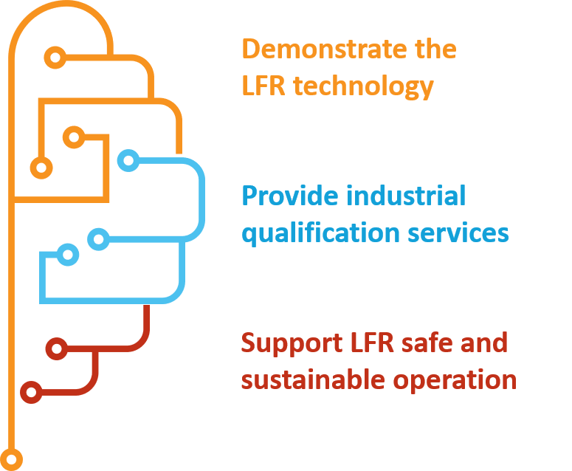
FIG. 3. Example of information “at a glance” concerning ALFRED scope in the executive summary.

ALFRED Project
This chapter is best seen as an entry point of the White Book, shaped so to provide key information in answering the basic questions that readers could ask themselves:

- what is the meaning of the Project?
- why is the Project being proposed?
- who will deliver the Project, how and when?

Each sub-section is oriented at providing “in a nutshell” answer to these fundamental questions so that ALFRED’s primary goal, that is, to demonstrate the viability of the LFR concept, is clearly depicted alongside the envisaged deployment and implementation strategies proposed by the FALCON consortium to make it a reality. This chapter also provides links to subsequent chapters to orient the reader throughout the document, where further details are added.

The Vision
This chapter reports any information relevant to support the rationale of the Project and its implementation, focusing on ALFRED’s long term vision that certainly is to become the world’s best user facility to utilize LFR technology for the advancement of nuclear engineering and applications in many areas of societal relevance.
The chapter proceeds for successive focuses, starting from the general role of nuclear energy in a framework of increasing concerns for climate change, passing through the role of innovative technologies and LFRs specifically, so to arrive at the breakthrough vision at the core of the ALFRED Project which combines the (long-term) fuel cycle closure demonstration objectives with the (short-term) prototypic SMR ambitions.

The Concept
Firstly, this chapter provides a comprehensive description of the demonstrator in its conceptual design state in order to provide detailed information about the layout, operation, licensing and safety principles to potentially interested parties. The description is of a high-level, informative nature that introduces the logics and rationales but does not enter into the technical and scientific details of the reactor. Then, the chapter reports a critical overview analysis on the maturity stage of the technical and scientific bases underpinning the Project, and delineates the technological roadmap to bridge the remaining gaps.

Scientific and Technological Innovation
This Chapter delineates all the scientific and technological innovation potential arising from the Project implementation allowing Europe to maintain a leading position in terms of manufacturing, materials, procedures, standards, safety, etc. The basic science achievements (e.g., HLM physics and chemistry, materials science, etc.), innovation boosting (e.g., components and instrumentation development and testing, systems qualification, etc.) and unique services provided to extend the scope of the above (e.g., neutron source, large and representative testing environments, etc.), including e.g., the update of codes and standards as well as verification and validation of computational tools are discussed. The potential impacts in multidisciplinary sciences (e.g., fusion, solar power, hydrogen production, industrial applications or aerospace applications, etc.) of the planned facilities for Research and Development (R&D) in fields other than LFRs are also overviewed.

Project Implementation
A general overview of the Project implementation plan is given, articulating from the current preparatory phase to construction and operation. The chapter delineates the short-term organization, identifying the main principles and the possible long-term evolution of the governance structure to manage the Project in its different phases, tackling also how the proper human resources will be gathered and how access to facilities and demonstrator will be managed for the participants to the Project and the external users. Alongside, a financial overview is presented, describing:

- the preliminary cost estimate of identified facilities and reactor;
- the assessment of potential revenues from facilities and demonstrator;
- the presentation of the phased financial scheme, based on an evolving mix of national support and European Regional Development Fund (ERDF).

A risk assessment with associated preventive and mitigation countermeasures is also given so to better contextualize and substantiate the proposed implementation strategy in terms of timeline and budget.

Socio-Economic Impacts
This chapter evidences the economic profitability of the Project including also social and environmental benefits. It delineates the background of the main features of the Romanian region in which ALFRED will be hosted, together with a detailed socio-economic characterization, oriented to quantify the extent to which the area would benefit from the Project. The widespread impacts are also outlined at the more general Romanian and European level so to better grasp the Project outreaches.

LESSONS LEARNED IN WRITING The white book
Conveying a wide range of information to several possible stakeholders with different levels of interest and technical knowledge is the main challenge faced when writing a white book for a complex project.
From the beginning, clearly stating beforehand the salient points to convey for better showcasing the project vision and the nature of the target audiences is an instrumental step for allowing a shared vision in drafting a white book. Indeed, given the manifold points of view necessary for giving a holistic description of a complex project, encompassing the realms of economics, management, engineering and many more, typically requires the involvement of several expertises to properly tackle each aspect. The background of the various authors could also be different among members, for example, of research institutions or industries, making continuous dialog between the involved contributors of pivotal importance to ensure efficient communication of the project vision avoiding unnecessary overlapping of efforts.
Specifically, when drafting the ALFRED White Book its overall outline, a brief description of the expected content was promptly defined at the level of chapters and sections, and then each part was assigned to the most knowledgeable person. A supervisor was also present ensuring the link between authors was functioning, boosting drafting effectiveness.

Conclusions
As a recognized cornerstone in the further development of the LFR technology, the ALFRED Project has been steadily advancing under the guidance of the FALCON consortium. To put to fruition the great amount of work performed, also in view of ALFRED foreseen promotion as a Major Project for Romania, and to ease the Project dissemination to the possibly interested stakeholders, the ALFRED White Book was conceived.
Tackling the Project in all its many facets like the underlying vision and mission, the scientific and technological relevance, the technical description, the supporting R&D programme and the operation strategy, the key safety and licensing elements, the socio-economic benefits, and the proposed deployment strategy and project implementation (including financial and managerial aspects), the White Book covers the main reasons and advantages that the different stakeholders could gain by actively supporting or simply endorsing the Project vision.
The document is structured in successive levels of detail so to indulge on the different needs of the manifold readers categories while still providing the globality of the information needed for actually grasping the Project positive added value. This is practically achieved via “at a glance” and general executive summary, then a first overview chapter answering the basic, journalist-like, questions readers might have, to the finer, yet informative rather than technical, level of detail of the successive chapters to address specific aspects for a more thorough understanding/assessment of the Project.
The ALFRED White Book is available by contacting the corresponding author of this paper.
ACKNOWLEDGEMENTS
The ALFRED White Book was elaborated under the PRO ALFRED Project, coordinated by RATEN ICN, which has received funds from the Romanian Ministry of Education and Research trough the contract no. 5/18.09.2019.

References
- EUROPEAN COMMISSION, Horizon 2020 Work Programme 2014-2015, European Commission Decision C (2014)4995 of 22 July 2014.
- INTERNATIONAL ATOMIC ENERGY AGENCY, Catalogue of Facilities in Support of LMFNS, Overview of experimental facilities in support of Lead/LBE-cooled Fast Reactors (LFR) (2020), https://nucleus.iaea.org/sites/lmfns/Pages/overviewlfr.aspx.
- EUROPEAN COMMISSION, CORDIS, Lead-cooled European Advanced Demonstration Reactor (2019), https://cordis.europa.eu/project/id/249668.
- FALCON CONSORTIUM, The ALFRED White Book, PRO ALFRED L7.9 (2020).
- SNETP SUSTAINABLE NUCLEAR ENERGY PLATFORM, home page (2020), https://snetp.eu/.

