# Simple Design Comparison of uranium nitride

# pin cell assembly and CERMET fuel assembly

# for a Lithium Cooled Fast Reactor SPACE-power ENGINE

R. PINEDA

Harbin Engineering University

Harbin, China

Email: tanqueraul111@outlook.com

ZHIGANG ZHANG

Harbin Engineering University

Nangang, Harbin, Heilongjiang, China

**Abstract**

This paper presents the results of a numerical simulation of thermal-hydraulics processes in a liquid lithium cooled fast reactor core, for a 2.5MW space reactor engine. Two types of fuel configuration were studied: pin cell assembly and cermet fuel assembly, the designs have the same power output, fissile material, and coolant; with all requirements regarding safety conditions observed. Temperature distributions along the center cooling channel and distributions in the radial direction were prepared, comparing the temperature difference of the fuel, structural material and coolant of both reactor designs.

## INTRODUCTION

The main goal of this research is to compare the thermal hydraulics of two different designs of a 2.5MWt space reactor engines. Both reactors will use the same fissile material, highly enriched uranium mononitride; the structure material is mainly molybdenum and rhenium and is cooled by liquid lithium. In both reactors the cooling system is made of tubes where liquid lithium is flowing, therefore removing heat from the reactor, and those tubes are dispersed homogeneously in the reactor. The purpose of the paper is to compare the heat transfer and the axial temperature distribution of the coolant, structure and fuel in the center reactor array.

The space reactor engine’s specific mass (mass per unit of power) should be as low as possible. The manufacturing and development costs of the engine should be as low as possible. There is a high probability that the power of the engine must operate above thousands of hours [1] with little to nonhuman attention, under different high-risk circumstances. Under no predictable circumstances should the crew or the earth's populace be endangered by radioactivity. Power-engine characteristics must not require unreasonable restrictions on spacecraft design or operation.

For this research the reactor designs were based on experimental space reactors engines; the size of the reactor was changed to comply with the energy requirements: the number of fuel pins; extension of the fuel bundle and the active height can be changed to obtain the desired engine power, 2.5MWt. The cermet fuel didn’t differ from the NERVA Rover project literature [2][3]. Keeping most of the dimensions provided by their research. The fuel pin reactor design was based on the Safe Affordable Fission Engine (SAFE-400) reactor [4], the number of pins and height of the reactor was modified to accomplish a power of 2.5MW.

### Fission Space Reactor Engines

There are two main engine designs for a nuclear fission reactor-powered space vessel NTP and NEP. Nuclear Thermal Propulsion (NTP) is a simple engine to understand, the substance that creates thrust for the engine is called propellant. The stored propellent moves through pumps, enters the reactor, gets heated and is released through the nozzle to create propulsion [5]. The propellant material must have two physical qualities: high kinetic energy (higher temperature) and lower mass. Most of the nuclear reactor propellant in literature is Hydrogen, which is the lightest element and gives impulses in order of 900s. Lithium is also a light material and a good candidate as a propellant having an impulse lower than hydrogen but, higher than any other propellant candidate, between the 600s and 900s [6]. Lithium can reach a gaseous state, but the scope of this paper is to compare both reactors cooled in a single-phase liquid metal.

Nuclear Electric Propulsion (NEP) is the type of propulsion where the nuclear reactor inside the vessel is used to power an electrical thruster, that also has a highly efficient specific impulse for thrust. The NEP engine functions as a conventional fast reactor whose main purpose is to produce electricity, it can reach that goal by different means, the one with more experience in spacecrafts is thermoelectric generation [9]. It can also be used the conventional reactor thermodynamic cycle, which easily can be cooled by radiators that dissipate the excessive heat to space. The purpose of this research is to analyze which fuel configuration will be a good candidate for either space reactor system. The objective is to increase the coolant temperature, where the limit is the safe operation and integrity of the fuel and structure material, and the coolant remains in a liquid state.

### Materials

The main difference between a fast and thermal reactor is the presence of a moderator. The fast reactor does not have any moderator, only the fuel and structure material with highly inelastic scattering properties to preserve the energy of the neutrons. Most NTP designs have thermal rectors, therefore using a moderator, usually graphite because it can withstand high reactor temperatures. The main purpose of the research is to study the temperature distribution of two fuel designs in a fast space reactor.

Cermet Fuel is especially common for small reactors, where the fuel is a heterogeneous mix of a uranium ceramic fuel into another material that will keep its structure and conduct the heat of the element, which is the heat-generating material. It consists of individual ceramic particles heterogeneously dispersed within a metallic matrix, resulting in a heat conduction process that is more complex than the heat conduction in an alloy metal. The thermal conductivity of the fuel element is dependent upon the size, shape, and orientation of the particles as well as the relative amounts and properties of the materials used [11]. The composition of the Cermet fuel for this research is individual ceramic particles of Uranium Mononitride in a Tungsten matrix, the cermet composition will be 45% fuel, 45% metal matrix, and 10% void [2]. Because of the high enrichment of this reactor, the burnup will release a great number of fission gasses, therefore the void will be filling over time with these gasses and will give structural security to the reactor while is working.

The fuel pin reactor design will use ceramic fuel, the same as other commercial reactors, therefore there is more experience about its properties. For the reactor design, the fuel was Uranium Mononitride, the design assumptions were based on the irradiation experience, the maximum suggested density in a He-bonded pin is 85 %TD. The fuel pellets, characterized by large pores, should be irradiated at linear ratings less than 75 kW/m, to reduce swelling and fragmentation-induced mechanical fuel pin failure. Ideally, a burn-up higher than 15 % is foreseen [12]. The temperature dependence of thermal conductivity used in this work was for uranium nitride with high enrichment levels above 97% and 85% theoretical density [13] to reduce swelling and fragmentation-induced mechanical fuel pin. A review of detailed uranium nitride fuel thermophysical properties can be found in Ross S.B. work [14].

Uranium Mononitride can reach a maximum fuel temperature of 2850 K [13], there are only six elements exist with a melting temperature above 2800 K: Mo (2897 K) Ta(3290 K) Os (3310 K), Re (3438 K), W (3695 K), and C (4300 K). These elements are mostly transition metals, except for carbon, which as graphite sublimes at 4000 K [15]. Makes the selection of the materials relatively easy. As mentioned, to follow the designs of the Rover/Nerva project and the SAFE 400 reactor. The only metals used were molybdenum and rhenium, which have high-temperature melting points, absorb very few neutrons, and have a high elastic cross-section.

The thickness of the shield depends on the material that stops most of the fast neutron and radiation leakage from the reactor core, it is more dependent on the type of particle or radiation that must be contained. In the literature, small space reactors of different fuels and power generation (1MW – 3MW) utilize the same thickness and therefore the same shield mass of 1590kg [16] The SAFE-400 reactor has a radial BeO reflector (7.1-9.9 cm thick)[4] that surrounds the hexagonal vessel, an external axial BeO reflector (4 cm thick) at the rear, and an axial BeO reflector (4 cm thick) on the opposite side. The main purpose of the reactor is to analyze the thermodynamics of the inner core.

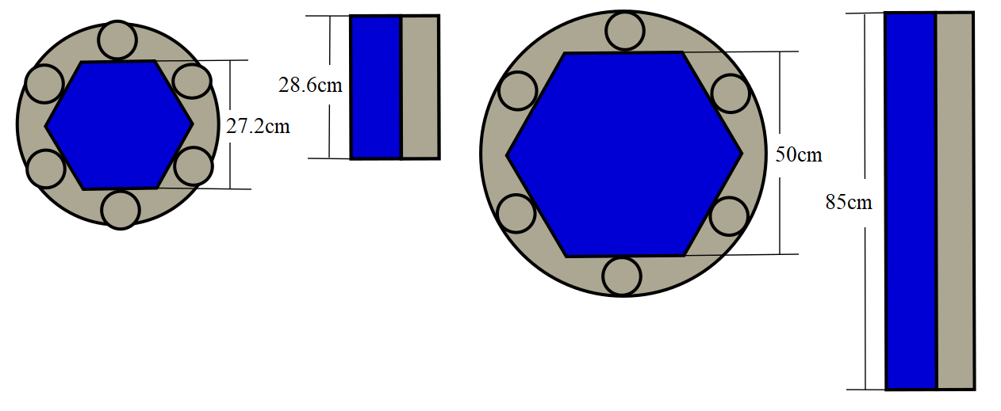

*FIG 1. Transversal and Axial cut of the Cermet fuel design (Left) and fuel pin design (right), where blue represents the reactor core and gray the reactor core shielding.*

## METHODOLOGY



### Reactor Modification

The Cermet fuel reactor design is the same as proposed at NASA Technical Note from Preliminary Considerations for Fast-Spectrum [2], a small reliable 2.5MWt reactor that operates at 20 000 hours, cooled by liquid lithium, the dimensions proposed are shown in Table 1. The Fuel Pin design is a modification of the SAFE 400 reactor. The SAFE development program started with the microreactor SAFE 20kWe Surface that proved this sort of design works. The microreactor was cooled with the Stirling system [17], in which they used heat pipes, a proven technology that can transport low quantities of energy from a small fission reactor [18]. Heat pipes won’t be used to transport the reactor heat, because it won’t be sufficient to remove all the thermal energy of the reactor, instead of heat pipes; coolant tubes containing a flowing fluid will remove the reactor heat [19]. The swap of cooling systems from Stirling to coolant tube can be seen in scalations of the SAFE program. Where the 20 kWe Surface reactor and SAFE-300 100 kWe[19], reactors that must be developed and verified in phase 1 of the SAFE 400 program, are a Stirling engine system and Brayton cooled system respectively. Phase two of the SAFE reactor program the reactor power was expanded by adding more fuel pins. To increase the power, the fuel pin diameter decreases from 1.7cm, but the number of fuel pins expands, reaching the reactor power proposal of 4MW with around 3000 pins. [19].

TABLE 1. BASIC ASSUMPTIONS AND DESIGN PARAMETERS

|  |  |  |
| --- | --- | --- |
| Basic Design | Cermet Fuel | Fuel Pin |
| Core Power | 2.5 | 2.5 |
| Core Diameter, cm  Core Height, cm | 28.6  28.6 | 52.5  85 |
| Fuel type | Cermet UN | UN |
| Enrichment | 97% | 97% |
| Number of array holes | 217 | 1951 |
| Number of coolant holes | 217 | 469 |
| Coolant hole diameter, cm | 0.75 | 0.68 |
| Hole spacing pitch, cm | 1.8 | 1.105 |
| Coolant fraction | 0.16 | 0.08 |
| Coolant flow rate, kg/s | 3.2 | 5.9 |
| Coolant velocity, m/s | 7.3 | 0.26 |
| Coolant inlet temperature, K | 1400 | 1400 |
| Average heat flux, W/cm2 | 167 | 22.4 |
| Maximum heat flux, W/cm2 | 284 | 46.3 |

The design proposed by the SAFE reactor has a difference from the most recent one. The fuel was changed from uranium oxide to uranium nitride; therefore, the fuel pin diameter is slightly different from 1.27cm to 1.1cm. The previous proposal had around ~400 Fuel pins, but the most updated SAFE 400 had a total number of 381 fuel pins [20]. This research had the following assumptions: One, the number of reactor fuel pins can be expanded to get the desired engine power, therefore the reactor radial size expanded by the addition of new cell pins. Two, the reactor shares the same design schematics and layout, except the axial components, which expanded the same proportion as the radial dimension was expanded.

The expansion has the same layout as the original reactor, for every coolant space, there will be six fuel pins next to it. There is no coolant space adjacent to another coolant space, and for any fuel pin, there are always adjacent to a coolant hole FIG. 2. The outer pins, in the boundary of the reactor, are composed of a fuel pin and a reflector pin that interchange between each other. The objective is to compare the temperature distribution of the center coolant hole, the structure, and adjacent fuel pins because it contains the highest temperatures in the reactor.

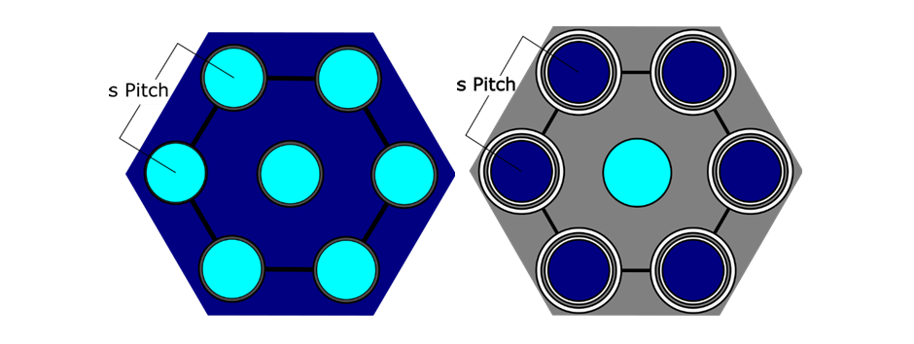

*FIG 2: The geometry of a single reactor cooling channel of the cermet fuel and fuel pin reactor respectively, the darker color represents the fuel, the lighter one represents the coolant. The gray color represents the structural material.*

### Basic Design

The geometry of the fuel pin and matrix fuel was set before the analysis. The lattice selected is Hexagonal, due to greater energy transfer per area of heat flux [21] and is the preferred array in most fast reactors. The similarities of both reactors are that both possess coolant holes where liquid lithium flows, but in the fuel pin design, the heat transfer moves through an intermediate structural material, molybdenum, and then to the coolant. While in the cermet fuel it goes directly to the coolant. For the fuel pin reactor design, the dimensions were adopted from SAFE-400[4] and SP-100[22]: fuel rod active length, pin diameter, cladding thickness, gas gap thickness, structural material array pitch and the coolant hole diameter. The cermet fuel reactor data was based on NASA’s work in the NERVA project. Where the hole diameter, pitch and active length and diameter dimensions were obtained from there [2][3]. The geometrical arrangement is presented in Fig. 2 and Table 1.

There are two coolant inlet parameters assumptions: temperature and velocity. In the literature, to have a reasonable safety margin, velocities of 0.73 m/s [2] and 0.26 m/s [22][23] for the cermet and pin cell were used respectively. It can be observed a difference in coolant flow velocities, being the fuel pin design double of the cermet fuel, but it also can be seen that the flow rate is double because the number of coolant wholes each design has, 469 in the pin cell design far exciding the 217 [2] of its counterpart.

The next parameter to be determined was the maximum heat flux. Conventionally the linear power density is sufficient to calculate the heat transfer in a conventional cell pin reactor. In this work is being compared a cermet matrix fuel, which is a solid object with coolant holes against a pin fuel reactor, most of the energy will release on the surface of the holes. The average heat flux can be calculated as the total reactor power between the Number of tubes×πDchH, where Dch is the coolant tube surface diameter, H is the active reactor core height.

The axial power profile was approximated by a chopped cosine, as it is for neutron flux distribution in a reflected core with an oxide beryllium reflector. Extrapolation length was set to 7.36cm as a reasonable approximation [24]. There are many reactors where the axial reflector is above 7cm [25]. Knowing the reactor diameter and active height, and the average heat flux, the Maximum peak factor radially and axially can be calculated. For the cermet fuel with holes, it has a peak factor of 1.2 and 1.2 (because the diameter and height are almost the same); for the fuel pin reactor, the peak factors are 1.24 and 1.36.

The coolant inlet temperature was 1400K, this temperature is far away from solidification. Because the coolant is a high-temperature alkaline metal, it was required that the structural material wouldn’t chemically react with it, and also have other properties such as high melting point and high thermal conductivity, therefore the metals selected were Rhenium and Molybdenum, for the cermet and pin fuel respectively. The fuel pin coolant hole assumptions and the design parameters are presented in Table 2 [22]. The heat flux distribution in the center coolant hole surface is presented in Fig. 3, both design heat flux described by a chopped cosine function, but in the case of hole fuel reactor design, there is a higher heat flux because the reactor is shorter and needs to release the same power but in a shorter distance.

TABLE 2. FUEL PIN DESIGN ASSUMPTIONS

|  |  |
| --- | --- |
| Fuel Pin Design | Dimensions |
| UN Fuel Pellets, cm | 0.836 cm OD |
| Fuel/Clad Gap, cm | 0.0025 cm (He filled) |
| Mo clad, cm | 0.942 cm OD / 0.051 cm thickness |
| Mo clad/Mo Wall Gap, cm | 0.005 cm (He filled) |
| Mo Wall, cm | 1.105 cm OD |

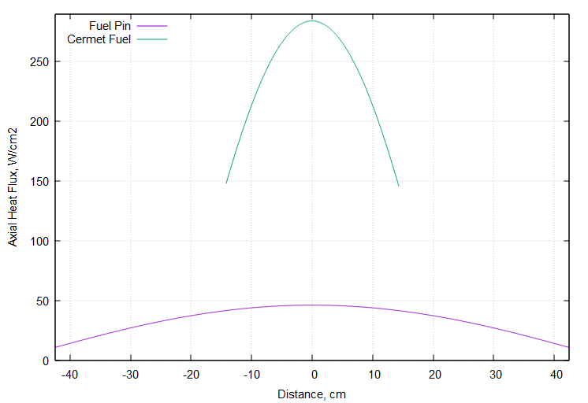

*FIG 3. Axial heat flux of Fuel pin and cermet fuel*

### Thermohydraulic model

The calculations performed in this research were for an isolated subchannel. This simple methodology is used generally for preliminary calculations. As been mentioned the computational method is to calculate axial the temperature distribution in the center coolant and the adjacent fuel parts (where the maximum fuel temperature is located) [26]. The entire assembly analysis with subchannel codes and/or additional three-dimensional Computational Fluid Dynamics (CFD) analysis should be performed.

The temperature dependence of thermal conductivity used in this work was for Uranium Mononitride with high enrichment levels above 97% and 85% theoretical density [14] in order to reduce swelling and fragmentation of the fuel pin. A review of detailed uranium mononitride fuel thermophysical properties can be found in the IAEA Collection of Data [13]. The thermal conductivity of the Molybdenum structure material was taken from Abu-Eishah[27]. As previously discussed, the fuel is made of cermet, a composition of individual ceramic particles Uranium Mononitride in a Tungsten matrix. It will be assumed that cermet composition will be 45% fuel, 45% metal matrix and 10% void [2]. Because of the high enrichment of this reactor, the burnup will release a great number of fission gasses, therefore the void will be filling over time with these gasses providing structural security to the reactor while is working. The thermal conductivity of the fuel element is dependent upon the size, shape, and orientation of the particles as well as the relative amounts and properties of the materials used [11]. This work will use the basic particle configuration of spherical particles occupying 45% of the reactor volume, utilizing the analytical formula to calculate the uranium mononitride matrix fuel thermal conductivity [28].

The heat transfer between the fuel-cladding gap and cladding-structure gap are: radiation, conduction and convection. The heat transfer coefficient will be presume of 6000 W/m2K, which is a rather conservative value suggested by Sobolev [29]. The gas gap heat transfer changes due to fuel irradiation and temperature effects, but its changes are too small. The composition of the gas changes with the reactor burn up, and with this type of highly enriched reactor, the gasses released are greater. Gaseous fission products have lower thermal conductivity and might cause the gas gap thermal conductivity to decrease. But another effect that counteracts this decrease is the fuel swelling, the gas gap slowly disappears and subsequently the heat transfer between the fuel and cladding changes.

The typical coolant temperatures in a space reactor core inlet are in the region of 1200 K and for core outlet 1600K [7]. The melting point of lithium at atmospheric pressure is 453.7 K [7], and its boiling point is 1608 K, the recommended minimum coolant temperature is about above 1000 K [1] because in space with radiators it is relatively easy to dissipate heat and there is a higher chance for the coolant to solidify, the. solidifying temperature at atmospheric pressure is 453.7 K, and can freeze even faster in a vacuum. The liquid lithium properties used in this model were taken from Compilation of Thermophysical Properties of Liquid Lithium [7] [30]. Heat transfer coefficients were obtained by Nusselt number correlation for liquid metal flow through a tube. Discussion of the various liquid metals heat transfer correlations can be found in Mikityuk’s work [31]. Working temperatures for both reactors designs are very similar therefore it will be used the same inlet temperature of around 1400 K. The Molybdenum metal cladding and structural material can only reach maximum temperatures of 2,623 K [32] so there is no concern of melting, the dilatation of the molybdenum structure and cladding doesn’t generate a surface contact between the structure and fuel, and thick enough that during the operation the cladding won’t have an embrittlement rupture due to the neutronic atomic displacement.

The thermal-hydraulics model created was set for one-dimensional, single-phase and steady-state conditions focusing on the coolant center channel. The mathematical model was based on the one described in Todreas thermal-hydraulics formulas [33]. The first goal was to compute temperature distribution along the cooling channel calculating the inner bulk temperature and the coolant–tube surface interface temperature to assess its performance. The second goal was to compute temperature distribution in the radial direction – cladding, structure, fuel for the given coolant bulk temperature. To obtain the axial temperature profile for the coolant, the channel was divided into 100 control volumes of equal length. All necessary equations were coded in FORTRAN.

(1)

Due to the assumption of a constant flow through the channel with area A, it leads to constant mass flux W. Eq. 1 gives the possibility to calculate flow velocity (*u*) based on the liquid metal density which is a function of temperature and changes from node to node. The momentum equation was not solved in this model because the pressure drops were not analyzed. The simple energy equation was considered in the following form:

(2)

Where πD represents the perimeter of the tube that touches the liquid metal, and the volume of coolant that heats longitude dx. As the coolant moves along the fuel, it absorbs heat; as a result, its temperature continually increases. However, the temperature does not increase at a constant rate, as mentioned the energy is released as a proportion of the reactor flux, which is in the form of the chopped cosine:

(3)

where He is extrapolation length and φmax is maximum heat flux that is located in the middle of the reactor in the axial axes. The energy equation was solved for every node by integration of Eq. 4. Enthalpy change between nodes: (hi+1-hi)W was equal to power qi transferred from the nuclear fuel to the coolant:

(4)

In order to obtain the temperature, increase according to the known enthalpy increase in a single control volume, the following integral can be solved iteratively for T:

T (5)

Those methods make it possible to obtain temperature distribution along the reactor cooling channel. Every node interval integration is computationally inefficient, but is easier to code, for this simple design comparison. There are analytical and more efficient approaches to find those distributions. It was assumed that there is no axial heat transfer in the fuel element. For every axial control volume, inner iterations for radial temperature distribution were performed and coolant bulk temperature (Eq. 6) was used in order to couple thermally the cladding with the coolant, by using Newton’s law of cooling:

(6)

where Dch is the coolant tube inner diameter and φmax is the heat flux on the surface. The Nusselt number provides heat transfer coefficient Eq. 7 [31] The Nusselt number is a function of the Peclet number only, which is specific for liquid metals [34]

(7)

(8)

The inner assembly and molybdenum structure temperature were computed by the typical solution of the heat conduction equation between two tube surfaces and nodes i and i+1; where the molybdenum outer tube surface diameter is the molybdenum mechanical diameter [33]. The molybdenum located between the hexagonal array Fig. 2, won’t include the space where the fuel pin or the coolant hole are located. To calculate the equivalent diameter the molybdenum area and coolant hole area, are transformed into the area of a circle with radius Deq . Using Deq as the cylinder outer perimeter and Coolant hole, Dch, as the inner perimeter; to solve the heat transfer equation for a cylindrical geometry Eq. 9. Using the information in Tables 1 and 2, the equivalent diameter of 1.49cm, therefore a Molybdenum tube wall of 0.4cm of thickness. Because of the high thermal conductivity of the structural material, the temperature gradient is small.

(9)

For the fuel pellet temperature profile and fuel centerline temperature. Was assumed that the volumetric heat generation is a function of the reactor power distribution. As in Eq. 3 the function was the chopped cosine function, but instead of being multiplied by heat flux, is multiplied by the maximum volumetric power density, which will be represented with egen. The fuel thermal conductivity is in function of the temperature, using the previous node temperature to calculate the thermal conductivity, starting from the fuel surface temperature. The maximum fuel temperature can be obtained by the analytical solution of the conductivity integral. [14]

(10)

The cermet fuel is a contained metal cladding as you can see in Fig.2 the rhenium clad/coating thickness is 0.0046cm [35]. This material temperature distribution was not calculated because the thickness is so small the temperature gradient is extremely small. To calculate the distribution of the coolant holes of diameter Dch and spacing s, the semiempirical equation of Sparrow Eq. 11 [21] is used

(11)

## rESULTS and conclusion



*FIG 4. Axial temperature distribution inside the coolant tube (left) maximum axial temperature of the structure, clad, and fuel(right)*

TABLE 3. RESULTS OBTAINED FROM THE NUMERICAL CALCULATIONS

|  |  |  |
| --- | --- | --- |
| Design | Cermet Fuel | Fuel Pin |
| Coolant outlet temperature, K | 1560 | 1499 |
| Max. inner tube temperature, K | 1587 | 1501 |
| Max. Mo structure temperature, K | - | 1505 |
| Max. clad temperature, K | - | 1532 |
| Max. fuel temperature, K | 1678 | 1574 |

The results obtained seem compatible with the data presented in NASA’s NERVA Rover project [2][3]. The main characteristic of the cermet fuel is its high-power density, the matrix structure gives it better heat removal capabilities, a heat flux around five times greater than the fuel pin, Fig. 3. At a height of 28.6 cm was able to heat up the liquid lithium 60K more than the fuel pin design, with a coolant outlet temperature of 1560 K and 1500 K respectively. The coolant bulk localized in the center array tube, and its respective tube surface is quite small around twenty degrees for the cermet fuel design and even smaller for the fuel pin one, as observed in Fig. 2

The fuel pin design has an extra layer where heat must traverse, the molybdenum structure. The temperature difference between the center coolant tube clad and the molybdenum equivalent diameter distance, is small around 12 K, which was expected because molybdenum is a metal with good heat conductivity properties. The cermet fuel maximum temperature is about 105K higher than the fuel pin. This is because the fuel pin design contains a higher number of fuel pins and coolant tubes, extending the total fuel surface increasing the rate of heat transfer to the molybdenum structure and eventually to the coolant. The cermet fuel being only one structure the maximum temperature in its hottest point (around the central coolant tube array) is 107 K higher than the closest cermet fuel surface in the same axial position. The maximum temperatures reached by the two reactors are found in Table 3.

TABLE 4. FUEL DESIGNS WEIGHTS

|  |  |
| --- | --- |
| Cermet Fuel | Fuel Pin |
| Fuel UN 89.1 kg | Fuel UN 874.3 kg |
| Fuel Mo Matrix 80.6 kg | Cladding 241.9 kg |
|  | Mo Structure 639.9 kg |
| Total 169.7 kg | Total 1756.2 kg |

Fuel pin design reactor is heavier than the cermet fuel reactor, with a difference of 1756kg against 170kg respectively, one order of magnitude bigger. Due to the molybdenum structure occupying 35.1% of the reactor volume, and 36.5% of the total reactor weight. Both reactors are experiencing the same nuclear fission rate to generate the same power, releasing the same amount of fission gasses. The fuel pin design has a bigger volume, therefore, more space to amass the fission gases. The confined space of the cermet fuel, making the matrix swell and brittle more in comparison, needing a more responsive system that vacuums the excess fission gases, before the cermet fuel burst. There is a lot of experience in handling this kind of transients in the fuel pin design compared to the more recent cermet fuel.



References

1. CULVER D., KOLGANOV V., ROCHOW R., Low thrust, deep throttling, US/CIS integrated NTRE, in: Space Nuclear Power and Propulsion: Eleventh Symposium, AIP, Albuquerque, NM, USA, 1994.
2. LAHTI G.P., LANTZ E., MILLER J.V., Preliminary Considerations for Fast-Spectrum, Liquid-Metal Cooled Nuclear Reactor Program for Space-Power Applications. Lewis Research Center Cleveland, Ohio. NASA TN-4315, March 1968
3. FINSETH, J. L. Rover nuclear rocket engine program: Overview of rover engine tests. Sverdrup Technology, Inc. Huntsville, AL, United States. NASA-CR-184270 September 6, 2013.
4. POSTONA D.I., KAPERNICKA R.J., GUFFEEB R.M., Design and Analysis of the SAFE-400 Space Fission Reactor Nuclear Systems Design Group, Engineering Sciences and Application Division Los Alamos National Laboratory, Los Alamos, New Mexico. IP Conference Proceedings 608, 578 (2002)
5. ROBBINS W.H., FINGER H.B., An Historical Perspective of the NERVA Nuclear Rocket Engine Technology Program, Sverdrup Technology, Inc. NASA Lewis Research Center Group Brook Park, Ohio, NASA Contractor Report 187154 AIAA-91-3451 July 1991
6. BENENSKY K., Tested and Analyzed Fuel Form Candidates for Nuclear Thermal Propulsion Applications, University of Tennessee Department of Nuclear Engineering and Material Science and Engineering Department of Nuclear Engineering MSE 580 – Technical Review and Assessment Fall 2016
7. DAVISON H.W., Compilation of Thermophysical Properties of Liquid Lithium. Lewis Research, Center Cleveland, Ohio. NASA TN D-4650, July 1968
8. The Role of Nuclear Power and Nuclear Propulsion in the Peaceful Exploration of Space. International Atomic Energy Agency Vienna, (2005)
9. ROWE D.M., Applications of nuclear-powered thermoelectric generators in space, Applied Energy, Volume 40, Issue 4, (1991), Pages 241-271, ISSN 0306-2619,
10. POLK J.E., GOEBEL D.M., SNYDER J.S., SCHNEIDER A.C., JOHNSON L.K, SENGUPTA A., A high power ion thruster for deep space missions, Review of Scientific Instruments 83, 073306 (2012).
11. MILLER J.V., Estimating Thermal Conductivity of Cermet Fuel Materials for Nuclear Reactor Application, Lewis Research Center Cleveland, Ohio. NASA TN D-3898 April 1967
12. PUKARI M., Experimental and theoretical studies of nitride fuels, Doctoral Thesis, KTH School of Engineering Sciences Lindstedtsvägen 5SE-100 44 Stockholm Sweden, June 2013
13. Thermophysical Properties of Materials for Nuclear Engineering: A Tutorial and Collection of Data IAEA, Vienna, IAEA-THPH ISBN 978–92–0–106508–7 (2008)
14. ROSS, S. B., EL-GENK, M. S., & MATTHEWS, R. B. Thermal conductivity correlation for uranium nitride fuel between 10 and 1923 K. Journal of Nuclear Materials, 151(3), 318–326. doi:10.1016/0022-3115(88)90026-8 (1988).
15. SHABALIN, I.L., Ultra-High Temperature Materials I: Carbon (Graphene/Graphite) and Refractory Metals.: Springer Netherlands (2014).
16. LAWRENCE T.J., Nuclear Thermal Rocket Propulsion Systems, U.S. Air Force Academy Department of Astronautics, Colorado, USA IAA White Paper. March 2005
17. GIBSON M.A., BRIGGS M.H., SANZI J.L., BRACE M.H., Heat Pipe Powered Stirling Conversion for the Demonstration Using Flattop Fission (DUFF) Glenn Research Center, Cleveland, Ohio Conference: Nuclear and Emerging Technologies for Space NASA/TM-216542 (2013)
18. ] POSTON D.I., MCCLURE P.R., DIXON D.D, GIBSON M.A., MASON L.S. Experimental Demonstration Of A Heat Pipe–Stirling Engine Nuclear Reactor, Los Alamos National Laboratory Nuclear Technology 188(3):229-237 (2014) DOI:10.13182/NT13-71
19. DYKE M.V., HOUTS M., HRBUD I., MARTIN J., DICKENS R., WILLIAMS E., HARPER R., FANT G., GODFROY T., PEDERSEN K. ROMAN J., SALVAIL P,. The Safe Affordable Fission Engine (SAFE) Test Series. Advanced Space Propulsion Workshop NASA/JPL/MSFC/UAH 12th Annual April 3 - 5, 2001
20. POSTONA D.I., KAPERNICKA R.J., GUFFEEB R.M. Design and Analysis of the SAFE-400 Space Fission Reactor Nuclear Systems Design Group, Decision Applications Division Design Engineering Group. AIP Conference Proceedings 608, 578 (2002); https://doi.org/10.1063/1.1449775
21. SPARROW E. M., Temperature Distribution in an Internally Cooled, Heat-Generating Solid. Paper No. 60-SA-15, ASME, June 1960
22. BUDEN, D, Summary of space nuclear reactor power systems, Idaho National Engineering Lab., Idaho Falls 10. symposium on space nuclear power and propulsion, Albuquerque, NM (United States),10-14 Jan 1993
23. GREENSPAN E., Solid-Core Heat-Pipe Nuclear Battery Type Reactor, University of California, Department of Nuclear Engineering Berkeley, September 30, 2008
24. GROTENHUIS M. Lecture Notes on Reactor Shielding International School of Nuclear Science and Engineering ANL-6000 Reactors –AEC Research and Development Report General (TID-4500. 14th Ed.) March 1959
25. SCHNITZLER B.G., BOROWSKI S.K., FITTJE J.E. 25,000-lbf Thrust Engine Options Based on the Small Nuclear Rocket Engine Design, Glenn Research Center, Cleveland 45th AIAA/ASME/SAE/ASEE Joint Propulsion Conference & Exhibit, August 2009.
26. WU Y. W., LI X., YU X., QIU S. Z., SU F., TIAN W., Subchannel thermal-hydraulic analysis of the fuel assembly for liquid sodium cooled fast reactor, Progress in Nuclear Energy 69 (2013) 65–78.
27. ABU-EISHAH S. I., Correlations for the Thermal Conductivity of Metals as a Function of Temperature International Journal of Thermophysics, Vol. 22, No. 6, November 2001
28. WEBB J.A., CHARIT I., Analytical determination of thermal conductivity of W–UO2 and W–UN CERMET nuclear fuels. University of Idaho, 405D McClure Hall, Moscow, ID 83844-3024, USA Journal of Nuclear Materials 427 87–94 (2012)
29. SOBOLEV V., MALAMBU E., ABDERRAHIM H. A., Design of a fuel element for a lead-cooled fast reactor, Journal of Nuclear Materials (385) 392–399 (2009).
30. AGAZHANOV A. SH., ABDULLAEV, R. N., SAMOSHKIN D. A., STANKUS S. V., Thermal conductivity of lithium, sodium and potassium in the liquid state. Physics and Chemistry of Liquids An International Journal Volume 58, - Issue 6 (2020)
31. MIKITYUK K., Heat transfer to liquid metal: Review of data and correlations for tube bundles Laboratory for Reactor Physics and Systems Behaviour, Paul Scherrer Institute, CH-5232 Villigen PSI, Switzerland Nuclear Engineering and Design 239 680–687, (2009)
32. THURNAY K., Thermal Properties of Transition Metals Institut für Neutronenphysik und Reaktortechnik Projekt Nukleare Sicherheitsforschung. Forschungszentrum Karlsruhe GmbH, Karlsruhe (1998)
33. TODREAS N., KAZIMI M. S., Nuclear Systems: Vol. I, Thermal Hydraulic Fundamentals, Taylor & Francis, 1990.
34. MOCHIZUKI H., Consideration on Nusselt numbers of liquid metals flowing in tubes, Laboratory for Advanced Nuclear Energy, Institute of Innovative Research, Tokyo Institute of Technology, 2-12-1 Ookayama, Meguro-ku, Tokyo 152-8550, Japan. Nuclear Engineering and Design Volume 351, Pages 1-19 (2019)
35. MARK E. M. STEWART, A Historical Review of Cermet Fuel Development and the Engine Performance Implications VPL, LLC at NASA Glenn Research Center, Cleveland