Preserving and transferring knowledge in the field of fast reactor technologies. Experience of the Obninsk Institute of Nuclear Power Engineering MEPhI

A.V. NAKHABOV
National Research Nuclear University MEPhI (Obninsk Institute for Nuclear Power Engineering)
Obninsk, Russian Federation
Email: AVNakhabov@mephi.ru

D.S. SAMOKHIN
National Research Nuclear University MEPhI (Obninsk Institute for Nuclear Power Engineering)
Obninsk, Russian Federation
Email: DSSamokhin@mephi.ru

Abstract

Obninsk Institute for Nuclear Power Engineering has been realizing education and training of specialists for nuclear industry since establishing in 1950s. Educational programs are developed for nuclear power plants as well as for research and development institutions of Russian Federation and abroad. Due to close connections with scientific Institute of Physics and Power Engineering named A.I. Leipunsky and other organizations of the Rosatom State Corporation a lot of professors and researchers in Obninsk branch of MEPhI university have experience in operation and research in fast nuclear reactors such as BN-350, BN-600, BN-800 and others.
The paper describes experience in teaching, preserving and transferring knowledge in fast reactor technologies for more than 60 years. Nowadays the specific of fast reactors can be taught in separate sections of courses (for example, fast reactor physics as a part of general Nuclear Reactor Physics course), separate courses (like liquid metal coolants) and finally in specially tailored master’s program like Physics and technologies of fast reactors. The different ways of preserving and transferring knowledge are considered such as inviting famous specialists as professors, joint publications, providing laboratory practice and practical training (including preparing graduation thesis) for students on the base of Rosatom’s companies.

EDUCATION AND TRAINING IN FAST REACTOR TECHNOLOGIES
The task of preserving and transferring knowledge in the field of nuclear power engineering and nuclear technologies is crucial for further development in this direction. In this area significant efforts have been made at the level of individual countries as well as by IAEA. For fast reactor technologies this task is even more complicated due to some specific features of this direction of reactor technology:
- due to the complexity of the technology for all the years of development in the world, a very small number of power units with fast reactors were built and put into operation in comparison with other types of reactors. Nowadays there are only 3 operating power units with fast reactors in the world (two of them are located in Russia), 8 reactors have been shut down;
- in the 1990s and early 2000s, for various reasons in many countries involved into research and development activities in fast reactors, there was a long break in development of this technology (moreover, in a number of countries these programs were generally terminated). Of course, it made the problem of preservation and transfer of knowledge even more serious. For example, in the Russian Federation as long as 35 years have passed between the commissioning of power units with BN-600 and BN-800 reactors;
- for various reasons, much of the information on fast reactor technologies is confidential or classified.
The Institute for Nuclear Power Engineering (INPE) was established in the 1950s in Obninsk, Kaluga region (100 km away from Moscow), where the world's first nuclear power plant was put into operation. Initially the institute was a branch of the Moscow Engineering Physics Institute, leading Soviet and Russian university in nuclear field. Right from the beginning the Obninsk institute was closely connected with Institute of Physics and Power Engineering named after A.I. Leipunsky. The Institute of Physics and Power Engineering is one of the leading scientific organizations in Russia and in the world in the field of fast reactors, so it led to a close connection between science and education in this field. In 1985 the Obninsk Institute for Nuclear Power Engineering became independent, gone through stage of Technical university in the early 2000s and in 2010 it was returned in the National Research Nuclear University MEPhI.
From the point of view of preserving and transferring knowledge in the field of fast reactor technologies, the following aspects can be distinguished by the example of INPE NRNU MEPhI:
- due to the small number of operating fast reactors (on nuclear power plants, research reactors and facilities), there is no need to create separate educational programs in this area. Instead, the main training programs for engineers in the design and operation of nuclear power plants, the design of nuclear reactors, electronics and automation are focused on training specialists for all three main types of power reactors in the Russian Federation – VVER (pressurized water reactors), RBMK (light water graphite moderated reactors) and BN (fast sodium cooled reactors). At the same time, the training of foreign students for the needs of their national nuclear programs is focused on VVER-type reactors, which are the main export product of the Rosatom state corporation, and on centers of nuclear science and technologies;
- for specialization in the fast reactor technology the master’s program in physics and technologies of fast reactors was established;
- the education of students in the first two years of bachelor's (4 years) and specialist (5.5 years) programs is maximally unified for various specialties and does not have a specific focus in terms of the type of reactors, because it is focused on fundamental knowledge in the field of natural sciences;
- starting from the 3rd year, in many academic courses of general engineering training, separate sections are considered that are important specifically for fast reactor technologies. For example, when studying the fluid mechanics and heat and mass transfer courses liquid metal coolants are considered alongside with traditional water;
- in major courses on NPP commissioning and decommissioning, operation, reactor physics, automated control systems, etc., issues related to power units with fast reactors are considered in details. In the NPP operation course there is a practical part realized with functional NPP simulator, it can be configured for all three types of reactors, namely VVER-1000, RBMK-1000 and BN-600 (Fig. 1). It is worth to say that consideration is not limited to the sodium coolant technology, attention is also paid to power installations with lead and lead-bismuth coolants;
- the most important component of the success of this educational model is that for many years the teachers and professors have been invited from the industry (primarily from the State Scientific Center of the Russian Federation – Institute of Physics and Power Engineering), which are engaged in experimental or design works in the field of research, transport and power fast reactors. Some of the teachers have extensive practical experience at nuclear power plants with fast reactors (BN-350 and BN-600) and they took high positions of operating personnel. This vast experience is certainly reflected in the content of educational courses;
- those students who want to specialize in the field of fast reactors have such an opportunity. First of all, this intention could be realized through passing various kinds of internships or practical training, starting from 2-3 years of study. A logical continuation of such an educational track is the preparation of final qualification work in a specialized scientific, R&D or operating organization.
Besides books, charts, specialized software there are several models of different elements of BN power installation. So there is a large scale model of BN-600 reactor which is used in different courses and serves as must see point for delegations and visitors (Fig. 2).
Many graduates of the Obninsk Institute for Nuclear Power Engineering, already in recent history, have taken an active part in the experimental research, commissioning and operation of the newest 4th power unit of the Beloyarsk NPP with the BN-800 reactor as well as CEFR reactor in China.

PRESERVING AND TRANSFERRING KNOWLEDGE: EXAMPLE OF SPECIALIZED MASTER’S PROGRAM
As stated above the specialized master’s program Physics and technologies of fast neutron reactors was established in 2011. Professor Dr. Yuri Kazansky was appointed as a scientific supervisor of the program, who had been working in the Institute of Physics and Power Engineering for many years and took position of chief for physical start-up of BN-600 fast reactor at Beloyarsk NPP.

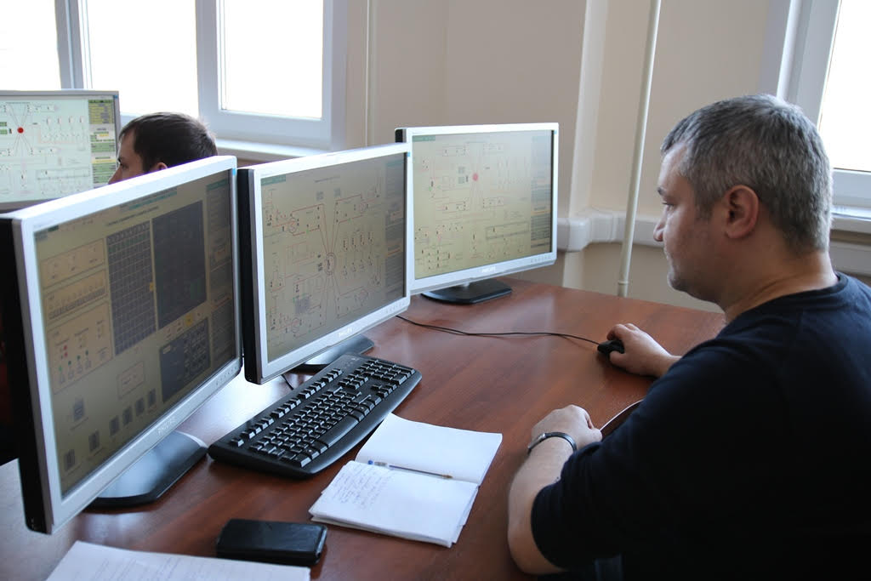
Fig. 1. Using of the functional simulator of reactor installation for vocational training.

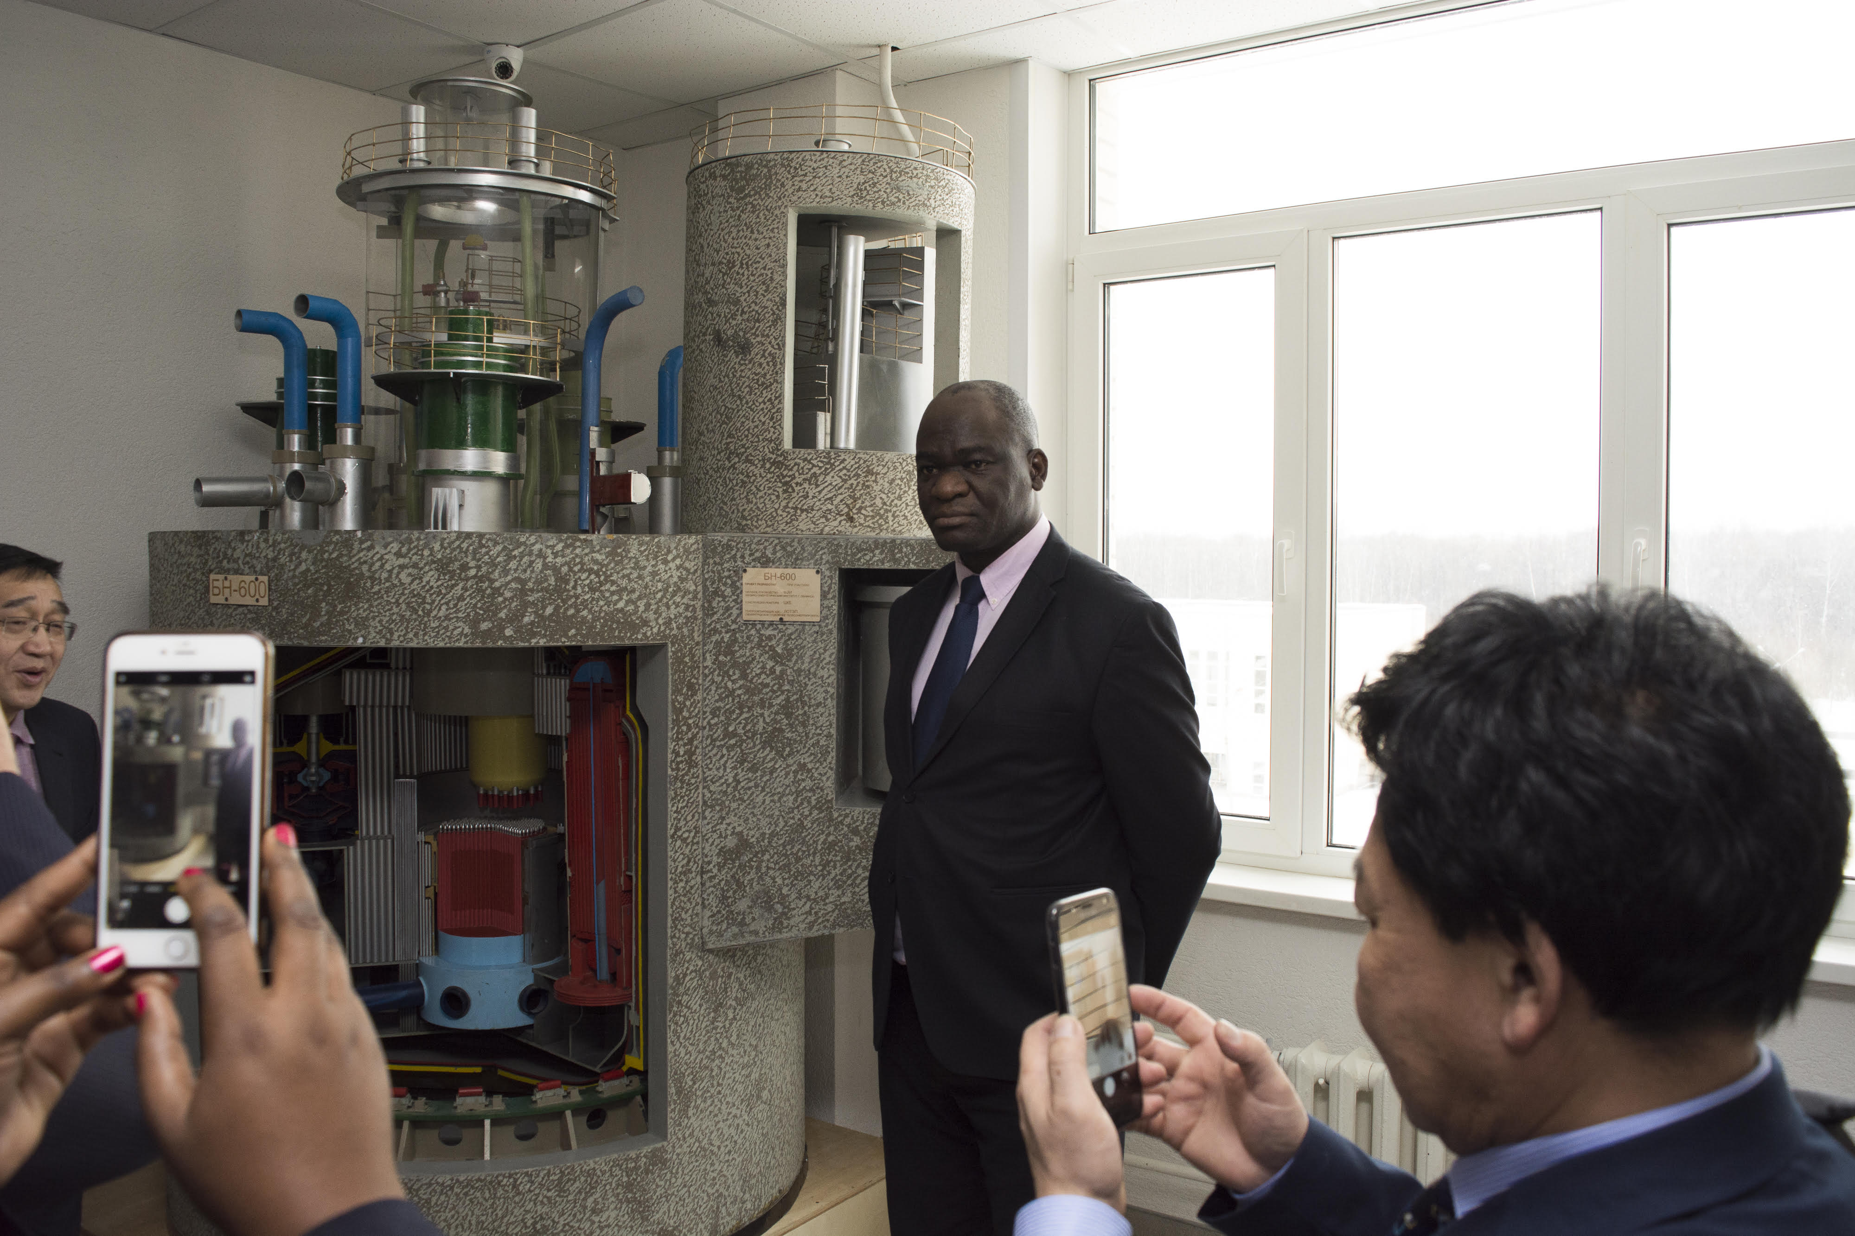
Fig. 2. The model of BN-600 reactor installation is used for education as well as for demonstration purposes.

The main courses in the program’s curriculum cover issues regarding first of all fast reactors as well as traditional ones like VVER and RBMK and listed below:
- Nuclear technologies (with historical review of fast reactor technologies);
- Emergency and transient processes on NPPs;
- Nuclear data libraries (with emphasis on data for fast neutrons);
- Nuclear reactor physics calculation;
- Fundamentals of control for nuclear installations;
- Economics of nuclear power (discussing two-component nuclear power with VVER and fast reactors);
- Modelling of NPP states;
- Liquid metal coolant technologies (for actual coolants like sodium, lead, lead-bismuth as well as other options);
- Shielding calculation;
- Fundamentals of nuclear non-proliferation and safe nuclear materials handling;
- Experimental reactor physics (with practical training on BFS fast research stands in Institute of Physics and Power Engineering);
- Research reactors (and experimental installations);
- Reactor control and protection systems (and overall I&C system for nuclear power unit).
For knowledge transfer it is very important that many leading researchers and specialists in fast reactor technology participated in this educational program and other ones in the university. Many textbooks were published regarding all aspects of sodium fast reactor technology and operation issues [1], [2], [3], and reactors with lead-bismuth coolant [4].
During their education students have a practical training and internships in leading scientific centers and organizations of Russian Federation and their master theses regard to operating units like BN-600 and BN-800 as well as power and research reactors under construction like MBIR, SVBR-100, BREST-300, BN-1200.
As a summary, in the Obninsk Institute for Nuclear Power Engineering of the National Research Nuclear University MEPhI vast experience has been gained for many years in preserving and transferring of knowledge in fast reactors technologies through education and training of students and specialists. The success of this approach is based on the Institute of Physics and Power Engineering nearby, leading researchers and specialists from nuclear industry involved in educational process in the university, special designed and modified educational programs and finally on permanent updating and improvement of specific knowledge in educational process.
References
- BAKLUSHIN, R.P., “Technology of nuclear power units with sodium coolant”, Obninsk (2012) [in Russian]
- BAKLUSHIN, R.P., “NPP commissioning”, textbook in 2 vol., Obninsk (2015) [in Russian]
- BAKLUSHIN, R.P., “NPP operating modes”, textbook, Moscow, MPEI Publishing House (2012) [in Russian]
- TOSHINSKY, G.I., “Talks about nuclear engineering, reactor physics and technology of modular fast reactors with lead-bismuth coolant”, Sarov (2017) [in Russian]

