VISUS ACOUSTIC IMAGING SYSTEM FOR SODIUM-COOLED FAST REACTORS

LESYUKOV D.N.
JSC “Afrikantov OKBM”
Nizhny Novgorod, Russia
Email:dl_nnov@mail.ru

GUBYRIN M.A.
VORONTSOV V.E.
JSC “Afrikantov OKBM”
Nizhny Novgorod, Russia

Abstract

Creation of the Visus acoustic imaging system is aimed at enhancing safety of the sodium-cooled BN-type reactors power unit during its operation. Using the Visus system will enable to prevent damage to the devices passing through the CPS (Control and protection system) column, as well as to the core elements when rotating the rotating plugs.
The system is designed to register and determine the coordinates of foreign objects located in the space between the ends of the core assemblies heads and the lower limit marks of the devices passing through the reactor CPS column prior to the reactor reloading and, if necessary, during reloading by using the ultrasonic scanning method.

Introduction
During the operation of the BN reactor plants, including the BN-600 type, abnormal operation events have been detected associated with the presence of foreign objects in the area above the core. Unscheduled shutdowns during the reactor operation to eliminate the consequences of these deviations have caused electricity undergeneration resulting in significant financial losses.

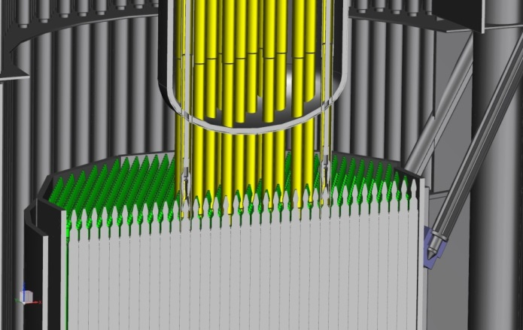

FIG. 1. Area above the core in the BN reactors

Development of the acoustic imaging system for the BN-800 reactor.
Currently, the Visus acoustic imaging system design based on the method of ultrasonic scanning of the area above the core is being implemented at the BN-800 reactor. The system is incorporated by two identical manipulators which are installed into special penetrations of the reactor vessel, control cabinet and operator's workplace. The manipulator is designed to deliver the ultrasonic transducer (UST) to the monitored area and guide the ultrasonic beam to the ultrasonic signal reflectors (USR) located along the perimeter of the core. The manipulators are installed into special penetrations in the reactor vessel. The geometrical separation of the two Visus system manipulators allows monitoring to be performed in the entire area above the core with the mirror-shadow and echo methods being used jointly. The reflected signals are sent to the control system and provide data as to the presence of foreign objects in the monitored area.

1 - core sector where monitoring is done jointly by UST1 and UST2 (within the red lines);
2 - core sector which is covered by UST2 only (within the blue lines);
3 - core sector which is covered by UST1 only (within the blue lines);
4 - area where echo method can be used by UST1 (within the green lines);
5 - area where echo method can be used by UST2 (within the green lines);
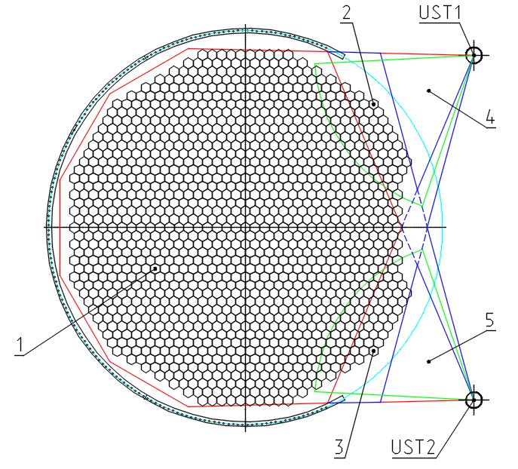

FIG. 2. Coverage of the area above the core from two UST locations

OPERABILITY VERIFICATION
In the course of the technical design development, tests of the acoustic imaging system were conducted at the water test facility simulating the reactor core at a 1:1 scale, where the UST was tested for operability in the given geometric dimensions of the reactor core and the main characteristics of the UST were measured. The secondary equipment was debugged and fine-tuned.

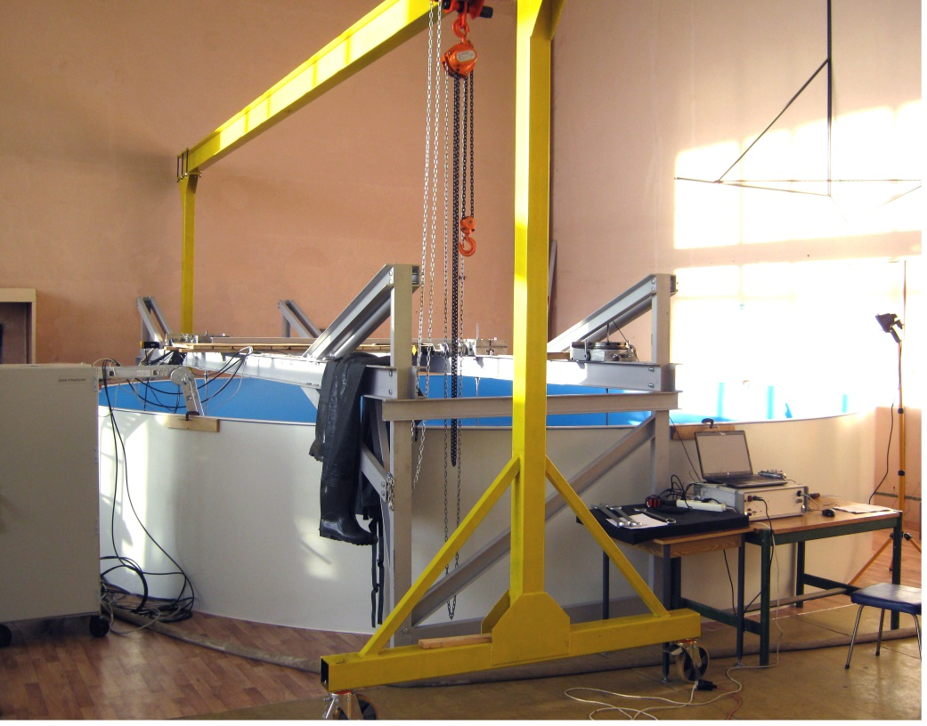
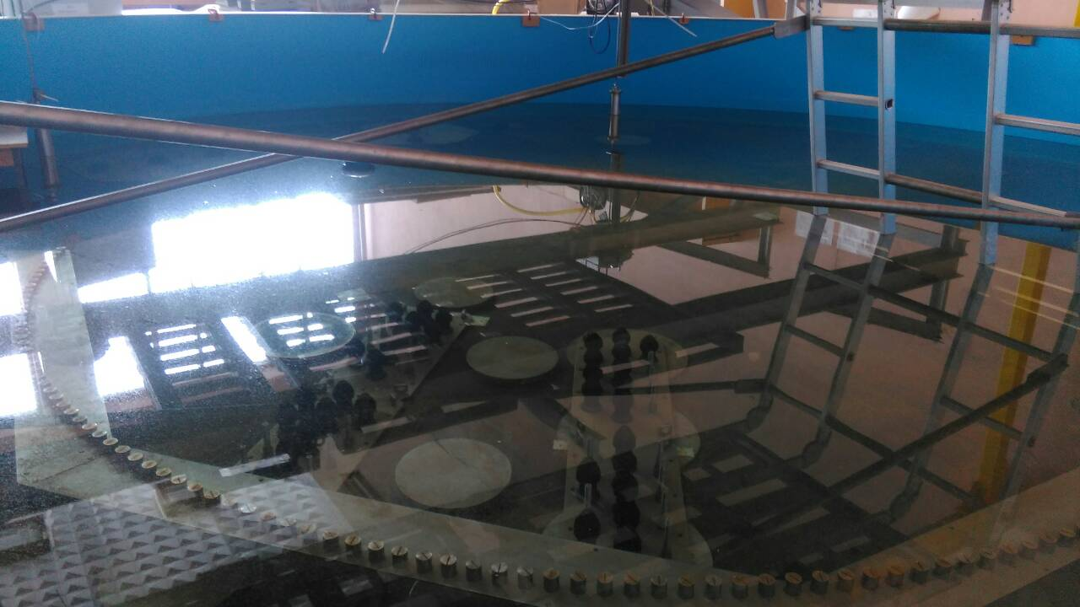

FIG.3. Water test facility simulating the reactor core

Another stage involved confirming operability of the UST mockup samples in sodium at a temperature of 230-250 deg. corresponding to that in the BN-800 reactor reloading mode, studying operability of protective coatings of the emitting surface and selecting the best options for mockup samples.

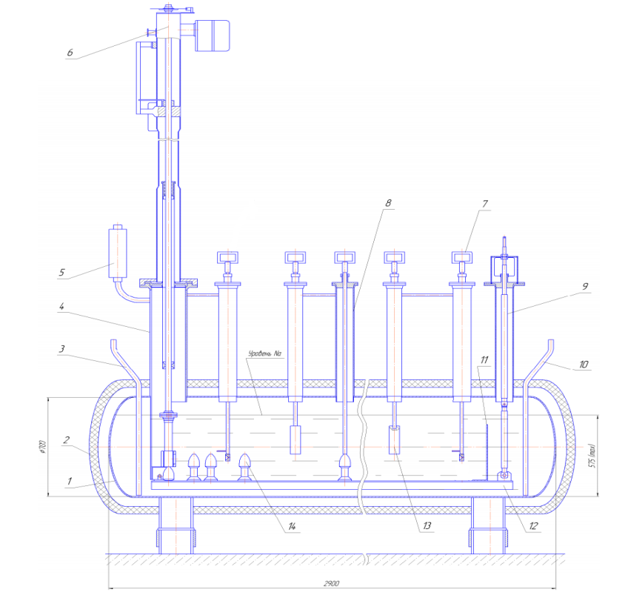

1 - tank filled with liquid sodium; 2 - thermal insulation; 3 - pipe for filling the tank with sodium; 4 - manipulator (UST displacement mechanism) installation nozzle; 5 - sodium vapor trap with argon supply pipe; 6 - manipulator (UST displacement mechanism); 7 - control reflectors displacement shaft; 8 - reflectors installation nozzle; 9 - plate displacement pull rod; 10 - sodium drain pipe; 11 - flat ultrasound reflector; 12 - plate on which the FA heads dummies are mounted; 13 - CPS dummies; 14 - FA heads dummies.

FIG. 4. Scheme of a sodium test facility for validation of UST mockup samples

Conclusion
The implementation of the Visus acoustic imaging system at the BN reactors will allow to enhance safety of the power unit operation by reducing the risk of abnormal (emergency) situations that cause the unit downtime associated with significant financial losses.

