CORROSION HYDROGEN MASS TRANSFER IN FAST REACTOR STEAM GENERATORS OF THE SODIUM-WATER TYPE

V.B. Smykov, PhD
IPPE JSC
Obninsk, Russian Federation
Email: smykov@ippe.ru

K.G. Legkikh
IPPE JSC
Obninsk, Russian Federation

S.V. Kanukhina
IPPE JSC
Obninsk, Russian Federation

Abstract

The operating experience of sodium-water type steam generators demonstrates that the main source of hydrogen in the secondary circuit sodium is the hydrogen depolarization process of the cathodic process of pearlite surfaces’ electrochemical waterside corrosion:

3Fe + 4H₂O → Fe₃O₄ + 4H₂
2H₂O + 2e⁻ → H₂ + 2OH⁻

The generation of hydrogen and its concentration in water and sodium increases in the course of chemical washing and steam generator startup, since the metal corrosion rate in this case increases significantly. Determination of the predominant direction of hydrogen transport is required for assessment of the hydrogenation in steam generator tube steel.

INTRODUCTION
On account of the use of liquid sodium in the intermediate circuit, the main requirement for the steam generator is to ensure the inter-circuit density throughout the life cycle. For timely and prompt detection of steam generator depressurization in the secondary circuit, the hydrogen content is continuously monitored as a sodium-water interaction product:
2Na + 2 H₂O → 2NaOH + H₂
However, it is not only the above process that contributes to the total hydrogen content in sodium. Corrosion processes occurring on the heat exchange surfaces from the tertiary circuit side, are the main source of hydrogen:

3Fe + 4H₂O → Fe₃O₄ + 4H₂
The rate of hydrogen entry into the aqueous medium and into sodium increases in the course of some process operations and steam generator operating modes (start-up and power ascension, operational chemical cleaning (OCC)), since in this case the metal corrosion rate of the steam-generator tubes increases significantly. Operation requires constant monitoring of hydrogen in the sodium loop of the steam generator [1].

1. MECHANISM OF WATER PERMEABILITY in METALS

The classical permeability scheme proposed by Wang was used to describe the mechanism of hydrogen permeability for steam generator walls. This scheme consists of five stages:
1) dissociation of gas molecules and chemical adsorption of atoms on the surface,
2) surface-to-subsurface transition of gas atoms, i.e., absorption,
3) transport of atoms through the tube wall from the inlet side to the outlet side, which in the simplest case is described by diffusion,
4) transition of subsurface atoms to the surface on the outlet side,
5) recombination of atoms on the surface and desorption of molecules from it on the outlet side of the membrane.
Metal is considered as a membrane, in our case it is a tube wall. An illustration of the Wang scheme in relation to the task at hand is shown in a simplified form in Figure 1. In addition to the classical process of dissociative adsorption on the surface, sometimes consideration is given to the processes of direct absorption of atoms after dissociation and direct recombination of subsurface atoms, avoiding the chemisorbed state; however, the need to introduce these processes is justified only at extremely high pressures. Under equilibrium conditions, the Wang scheme leads to the well-known Langmuir isotherm for surface adsorption and Sieverts’ law for volume absorption.
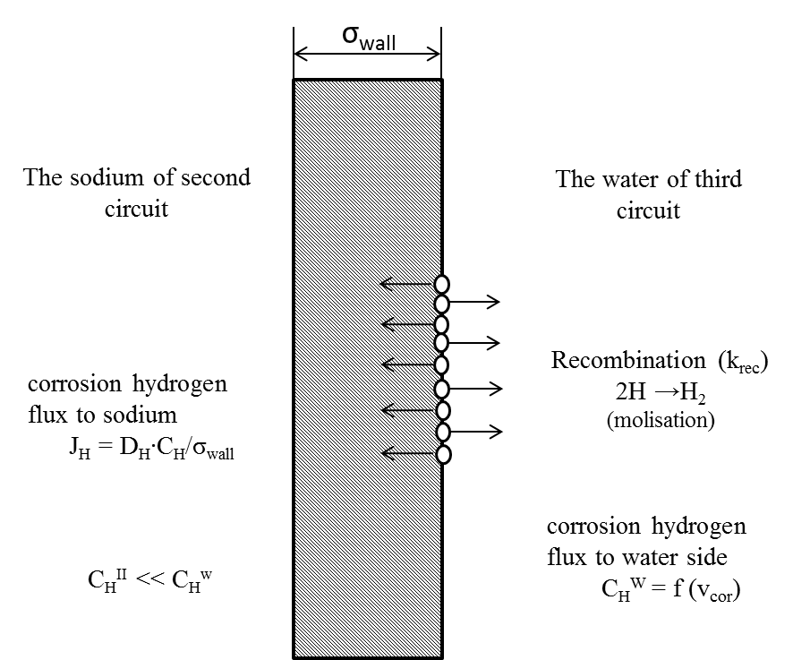
Figure 1. Wang scheme as applied to mass transfer of hydrogen for the BN-600 tertiary circuit to the secondary circuit (adapted from [2])

In permeability problems, the particle fluxes are assumed to be thermally activated to a large extent, i.e. they depend on the size of the energy barriers the particles have to overcome (in the course of steel crystal lattice diffusion), and on the temperature. The movement of hydrogen atoms in crystal structures is considered as random jumps performed by an atom from one equilibrium interstitial position to another through a certain barrier called the activation energy for diffusion Ed.
A joint mathematical description of the permeability dynamics with regard to these five stages is rather problematic in a number of cases; therefore, it is normal practice to introduce the condition of local equilibrium between the chemisorbed state on the surface and the absorbed state immediately below the surface. This allows the desorption rate to be written as a certain effective recombination coefficient (K_{rec}) of the absorbed atoms multiplied by the subsurface atoms concentration (c) squared:
$$J_{des}=k_{rec}∙c^{2}$$ | (1)

Permeability is often described in the one-dimensional approximation, since it is the simplest way to analyze the basic regularities, which also remain qualitatively valid for more complex geometries. In this approximation, permeability will depend on solubility, diffusion and surface effects (absorption and desorption). In the steady-state case, when the permeability of a certain time transient has reached its maximum, a constant depth gradient of concentration is established in the membrane, together with the diffusion coefficient it determines the value of the penetrating flow [2]. With a change in the system parameters (temperature, hydrogen concentration growth in the tertiary circuit), an increase in the hydrogen content is observed in the medium with its lower concentration (in our case in sodium):
$$τ=\frac{σ_{wall}^{2}}{6∙D_{H}},$$ | (2)
where τ –delay time for the appearance of hydrogen in the secondary sodium;
σ_{wall} – tube wall thickness, m;
D_{H} –temperature-dependent hydrogen diffusion coefficient in 10Kh2M steel, m²/s.

In view of the fact that the content of free hydrogen in sodium (it is chemically bonded to form sodium hydride NaH) is much less than the hydrogen content in water, the permeability is limited by hydrogen diffusion, and other stages can be neglected. Then the flow of hydrogen into the secondary circuit sodium can be represented as follows:
$$J_{H}^{II}=\frac{D_{H}∙∆C}{σ_{wall}}, where ∆C= C_{H}^{w}-C_{H}^{Na}$$ | (3)

Then the rate of hydrogen desorption into water can be represented as:
$$J_{H}^{III}=k_{rec}∙{(C_{H}^{w} )}^{2}$$ | (4)

Let the recombination constant be defined:
$$k_{rec}= k^{0}∙\sqrt{\frac{T^{1}}{T}} ∙e^{(\frac{-E}{RT})}$$ | (5)
where К⁰ = 1.8∙10⁻¹⁸; Т¹ = 500К;
Е = 24.8 kJ/mol;
R = 8.314 J/mol∙К = 0.008 kJ/mol∙К

Taking into account equations (3) and (4), let the tertiary circuit hydrogen concentration be expressed:
$$С_{H}^{w}= \sqrt{\frac{J_{H}^{III}}{k_{rec}}}$$ | (6)

Let the hydrogen flow be represented as:
$$J_{H}^{III}= \frac{v_{cor}}{{Eq}_{{Fe}^{2+}}}, where {Eq}_{{Fe}^{2+}}= \frac{M_{Fe}}{z}=28$$ | (7)
Eq – chemical equivalent of iron
z – iron II valence.

Then, via substitution into equation (6), we obtain the hydrogen concentration in the near-wall region:
$$С_{H}^{w}= \sqrt{\frac{v_{cor}}{{Eq∙k}_{rec}}}$$ | (8)
Since the hydrogen content in the tertiary circuit is much higher than the hydrogen content in the secondary circuit, expression (3) can be written in the form:
$$J_{H}^{II}= \frac{D_{H}}{σ_{wall}}\sqrt{\frac{v_{cor}}{{Eq∙k}_{rec}}}$$ | (9)

With a knowledge of the hydrogen flows in the tertiary and secondary circuits, let the fraction of hydrogen that has passed into sodium be determined:
$$ω_{H}=\frac{1}{1+ \left(\frac{v_{cor}∙ σ_{wall}}{Eq∙D_{H}∙C_{H}^{w}}\right)}$$ | (10)

2. cAlculation results
The calculation was carried out on the basis of operational data obtained from the Beloyarsk NPP over the period of OCC from 1981 to 2020. The general view of the dependences for the coefficient and rate of corrosive hydrogen ingress into the secondary circuit sodium during OCC are shown in Figures 2 and 3.
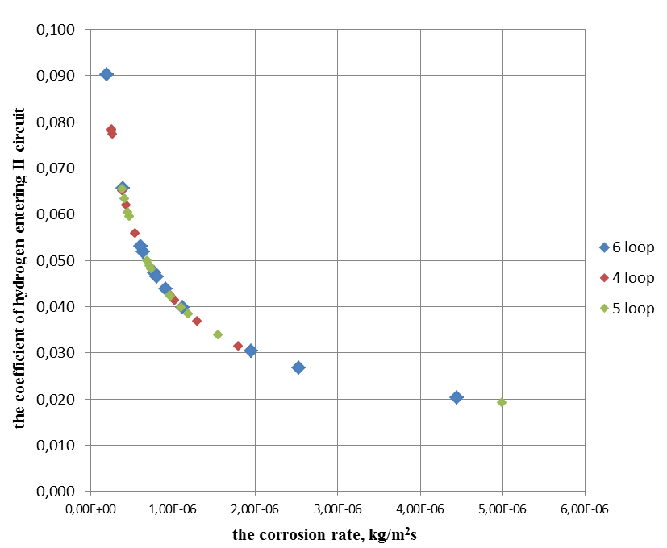
Figure 2. Dependence of the coefficient of corrosive hydrogen entry into the secondary circuit sodium during OCC
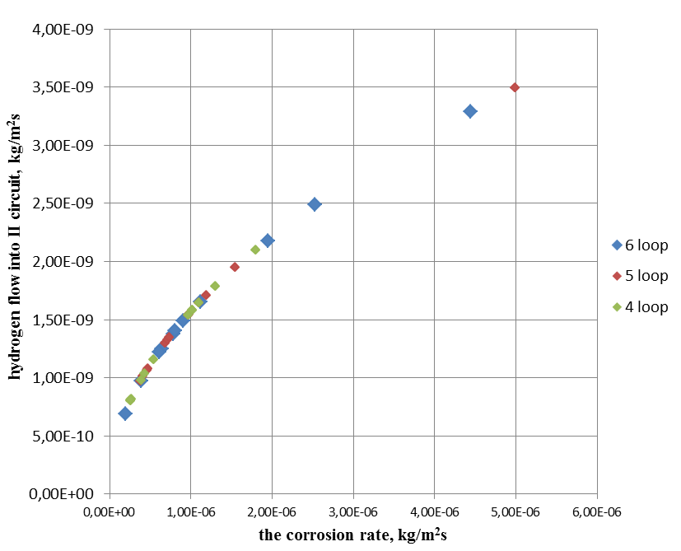
Figure 3. Dependence of the rate of corrosive hydrogen entry into the secondary circuit sodium during OCC

The presented diagrams show that the hydrogen flow into the secondary circuit sodium is extremely small, which is indirectly demonstrated by a rather low value of the diffusion coefficient ~ 3∙10⁻⁹ m²/s. On average, about 4% of hydrogen is transferred to the secondary circuit sodium, which is a low value that CTO (cold trap of oxides) can effectively cope with.
For the nominal operating mode of the steam generator evaporator at a temperature of 673K, the hydrogen flow rate into the secondary circuit sodium was 3.72∙10⁻¹¹ kg/m²∙s; the coefficient of hydrogen entry was 0.65. This difference between the nominal mode and the OCC mode (J_{H}^{II} (max) ^{OCC} = 3.49∙10⁻⁹ kg/m²∙s; ω (max) ^{OCC} = 0.09) is due to the temperature difference, in other words, the higher the temperature, the more hydrogen enters the secondary circuit. Consequently, the OCC mode does not make a tangible contribution to the total hydrogen flow over the entire operation life of the steam generator. And the rate of hydrogen ingress into sodium corresponds to the natural corrosion process during OCC and is indicative of the steam generator’s safe operation.

3. ASSESSMENT OF STEEL hydrogenation
Hydrogenation is introduction of hydrogen into metal from aqueous solutions or a gas-saturated aqueous medium that contains a hydrogenating agent, affected by direct current (galvanostatic mode) or constant electrode potential (potentiostatic mode) or by corrosion processes.
The overall reaction of hydrogen evolution (1) includes several stages: discharge (2), recombination (3), and electrochemical desorption (4).
H₃O⁺ + e⁻ → H₂ + H₂O | (1)
H₃O⁺ + e⁻ → H_{ads} + H₂O | (2)
H_{ads} + H_{ads} → H₂ | (3)
H_{ads} + H₃O⁺ + e⁻ → H₂ + H₂O | (4)
Based on numerous studies, hydrogen can be deemed to dissolve in octo- and tetrapores of the crystal lattice of metals in the atomic state, to accumulate in pores and other crystal lattice defects in the molecular form, and to go into chemical interaction with various elements and phases present in the metals and alloys, as well as to be adsorbed inside the metal on the surfaces of microcavities, pores, microcracks and other imperfections of the crystal lattice.
Hydrogen embrittlement under conditions of static loading of the metal results in a decrease in its long-term strength. Hydrogenation does not always end in metal destruction. The presence of hydrogen in the crystal lattice leads to the loss of metal plasticity (i.e. to brittleness), however, only sufficiently large tensile loads or significant internal stresses can cause its cracking, which normally proceeds as a transcrystalline process. After metallurgical remelting and anti-flake treatment, the pearlite steel contains approximately 1cm³/100g of metal dissolved in the metal matrix [3, 4].
Hydrogenation of the 10Kh2M steel in the PGN-200M BN-600 evaporator tube bundle during OCC was determined by the maximum value of the hydrogen flow into the secondary sodium J^{II}_{H} = 3.49∙10⁻⁹ kg/m²s. Let ΔC representing the hydrogen concentration in steel be expressed from the hydrogen permeability equation (2):
$$C_{H}^{steel}= \frac{J_{H}^{II}∙σ_{wall}}{D_{H}}$$ | (11)

Direct substitution yields 2.57∙10⁻³ kg/m³. Now let the mass fraction of hydrogen in steel (ρ_{steel} = 7800 kg/m³) be determined:
$$g_{H}= \frac{C_{H}}{ρ_{steel}}= 3.3 ∙{10}^{-8}\frac{kg}{100g(steel)}$$ | (12)

Let us pass on to the accepted unit of measurement cm³/100g (steel):
$$\frac{g_{H}∙ V_{m}}{M_{H}}= 0.4\frac{{cm}^{3}}{100g(steel)}$$ | (13)

The permissible range of values for steel hydrogenation is 1-2 cm³/100g (steel). Consequently, in the OCC mode, no dangerous accumulation of hydrogen in the steel occurs.
References
- YERMOLAEV N., SMYKOV V. Mass Transfer of Corrosive Hydrogen in a Sodium-Water Type Steam Generator. VANT, issue 1 (24), 1987, p. 3-13.
- PISAREV A., TSVETKOV I., MARENKOV E., YARKO S. Hydrogen Permeability through Metals. Moscow MEPhI, 2008.144 p.
- VOLGINA N., ILIUKHINA M., KOROLEV M., The Study of Changes in Physical and Mechanical Properties, Hydrogenation and Cracking Topography of Steel in the Process of Retesting the Pipelines with Stress-Corrosion Damage. International Scientific-Practical Conference on Pipeline Safety. Moscow 1995. p. 165-179.
- Physical Materials Science: In 6 volumes / under general editorship of KALINA B. Moscow MEPhI, 2007.

