Sustainability of nuclear and non-nuclear
power generation options under Russian
conditions: a comparative evaluation
study

A.A. ANDRIANOV¹, S.A. KVIATKOVSKII¹, P.B. PTITSYN¹, I.S. KUPTSOV¹

¹ Center for Analytical Research and Developments (CARD), Private Enterprise “Science and Innovation”, SC ROSATOM, Russian Federation

Email contact of corresponding author: AnAAndrianov@rosatom.ru

Abstract

This article provides the results of a case study on a comparative evaluation and ranking of six power generation technologies including 2 nuclear, 2 fossil fuel and 2 renewable power generation options. The performed analysis was based on the combination of the approaches proposed within the project New Energy Externalities Development for Sustainability (the NEEDS project) and the INPRO/IAEA KIND collaborative project (so-called the integrated NEEDS & KIND framework). The set of key indicators (36 key indicators arranged in a four-level objectives tree) along with approaches for their assessment including relevant databases were borrowed from the NEEDS project and adapted for the present study. The approach for judgments aggregation is based on the IAEA/INPRO approach to carrying out comparative evaluations (the KIND approach representing a sort of MCDA-based evaluation framework). Also, the study includes the results of the advanced sensitivity/uncertainty treatment with respect to weighing factors and key indicators using relevant tools developed within the INPRO/IAEA CENESO collaborative project. The presented results demonstrate the outstanding performances of nuclear power technologies (especially fast reactor technologies) for meeting sustainable energy development goals in the case of Russia whose performance even better than the performance of renewable energy sources.

INTRODUCTION
A multi-criteria framework for a comparative evaluation of the performance of energy technologies is becoming more popular with each passing year due to the possibility of a comprehensive consideration of the situation throughout the life cycle, where not only purely economic factors play an important role, but also factors that cannot be represented in economic categories characterising by multiple environmental and social criteria [1–4]. When carrying out this kind of analysis and ranking of competing energy technologies at the technological level as part of the multi-criteria decision analysis, it is necessary to solve the following main problems [5–8]:
- to specify a set of key indicators characterising economic, environmental and social aspects and to arrange them into an appropriate multi-level hierarchical structure;
- to collect relevant information for the formation of databases specifying the technical characteristics along with the economic, environmental and social impacts of the considered options for evaluating the selected set of key indicators reflecting different sustainability dimensions;
- to develop a decision support model using the multi-criteria decision analysis framework based on objective evaluations and subjective judgments expressed by the decision-maker, subject matter experts and stakeholders; and;
- to apply this decision support model including an uncertainty/sensitivity analysis to identify merits and demerits associated with each option in order to highlight the most preferred options for different perspectives and to provide final recommendations regarding the most attractive alternative for real-world deployment.
When performing multi-criteria comparisons of nuclear vs non-nuclear power generation options, it is necessary to overcome the same challenging points so as to meet the basic requirements, such as selected key indicators that should be applied in a balanced way both for nuclear and non-nuclear options; relevant databases should be formed that will provide representative evaluations of all the performance criteria for all the options with appropriate accuracy (it especially refers to social indicators) and correct interpretation of ranking results assuming that the final objective of the study is not to select the most preferable options for deployment but to highlight merits and demerits associated with each option [9–13]. Given these points, the present case study attempted to conduct a comparative evaluation and ranking of different power technologies, which are considered for future deployment in the Russian power sector. The following are short descriptions of priorities in the Russian energy sector long-term development and a validated conceptual base for the formation of the criteria set for performing the comparative evaluation of the options considered in this study.

Priorities in the Russian energy sector long-term development
The energy strategy of the Russian Federation up to 2030 is aimed at maximising the use of domestic energy sources, implementing the energy sector potential to sustain economic growth and stimulating strategic development throughout the country. The energy strategy outlines the following key priorities: improving energy efficiency, reducing environmental impact, enhancing sustainable development, developing technology as well as increasing effectiveness and competitiveness [14, 15]. The energy strategy of the Russian Federation, initially earmarked to last till 2030, was extended to 2035 to implement the governmental decisions. The revised energy strategy is less ambitious with regard to the policy tasks, forecasts of the domestic energy demand, and the development of Russia’s electric power [16, 17].
As for various power sectors, the electric power industry will become more intense due to the technologies for noncarbon energy production and storage. Thermal power plants will hold the lead in electricity production, although their share will slightly decrease. The share of nuclear power plants will be preserved and the total share of hydropower plants and nonconventional and renewable energy sources will increase accordingly. Additionally, it is expected that the market competitiveness of nuclear power will be supported by the increasing fuel prices for thermal power plants. Advancements in the projects for the nuclear power industry will also contribute to their market competitiveness. However, with regard to the nonconventional and renewable energy sources in Russia and the costs of their integration into a power system, the renewable sources in the centralised power supply zone will have remained noticeably more expensive by the end of the period as compared to thermal power plants. Thus, the entire spectrum of promising power generation technologies is considered for electricity generation in the Russian Federation. Therefore it is important to highlight the merits and demerits of each technological option through the lens of sustainable development concepts and identify the most preferred alternative for different stakeholder priorities.

The NEEDS project: scope, approaches and deliverables
The New Energy Externalities Development for Sustainability (NEEDS) project is a research project funded within Framework Programme 6 (FP6) of the European Commission for Research, Technological Development and Demonstration (the project duration is 2004–2009) [18, 19]. The project was intended to provide direct, usable inputs to the formulation and evaluation of energy policies in the overall framework of sustainability, taking into account their economic, environmental and social aspects.
As part of the NEEDS project, 26 generation technologies were considered, including 2 nuclear (1 PWR and 1 SFR), 16 fossil (10 coal & lignite, and 6 natural gas) and 8 renewable (3 biomass, 4 solar and 1 wind) technologies. Energy technologies can be compared by applying different evaluation methodologies and a variety of criteria. Although the concept of generalised cost is commonly accepted as reasonable and providing inputs that are directly relevant to policy, the question arises as to whether it fully managed to cover many facets of sustainability appraisal. Policy-makers (as well as representatives of civil society) from time to time argue that a purely monetary quantification of all costs and benefits fails to reliably cover selected specific phenomena and their real significance. This may be due to the nature of these phenomena that intrinsically cannot be quantified/monetised, or/and to the objective difficulty of calculating the corresponding values. Complementary approaches, notably based on balanced systems of sustainability indicators, can be included in the sustainability assessment framework, to generate a more comprehensive picture of the overall compared performance of individual technologies. As a result of the systematic process, a set of criteria and indicators was determined for evaluating the sustainability of electricity supply technologies. Table 1 provides evaluation criteria used in the NEEDS project (this set of criteria is also applied in the present study). The structure of the set is based on the three pillars of sustainability, i.e. environment, economy and society. These three dimensions have four hierarchical levels. The final set includes 36 indicators, i.e. 11 environmental, 9 economic and 16 social ones (of which 12 are related to ecology). Then this set was used in comparative evaluations of the sustainability of the technological options based on Multiple-Criteria Decision Analysis (MCDA) in view of sustainable development.
TABLE 1. EVALUATION CRITERIA USED IN THE NEEDS PROJECT
High-level objectives | Areas | Sub-areas | Short title of key indicator | Description | Unit
ENVIRONMENT  Environment related criteria | Resources  Resource use  (non-renewable) | Energy  Energy resource use in whole life-cycle | Fossil fuels | This criterion measures the total primary energy in the fossil resources used for the production of 1 kW·h of electricity. It includes the total coal, natural gas and crude oil used by each complete electricity generation technology chain. | MJ/kWh
 |  |  | Uranium | This criterion quantifies the primary energy from uranium resources used to produce 1 kW·h of electricity. It includes the total use of uranium for each complete electricity generation technology chain. | MJ/kWh
 |  | Minerals  Mineral resource use in whole life-cycle | Metal ore | This criterion quantifies the use of selected scarce metals used to produce 1kWh of electricity. The use of all single metals is expressed in antimony-equivalents, based on the scarcity of their ores relative to antimony. | kg(Sb-eq.)/kWh
 | Climate  Potential impacts on the climate |  | GHG emissions | This criterion includes the total for all greenhouse gases expressed in kg of CO₂ equivalent. | kg(CO₂-eq.)/kWh
 | Ecosystems  Potential impacts to ecosystems | Normal operation  Ecosystem impacts from normal operation | Land use | This criterion quantifies the loss of species (flora & fauna) due to the land used to produce 1 kW·h of electricity. The “potentially damaged fraction” (PDF) is multiplied by land area and years. | PDF·m²·a/kWh
 |  |  | Ecotoxicity | This criterion quantifies the loss of species (flora & fauna) due to ecotoxic substances released to air, water and soil to produce 1 kW·h of electricity. The “potentially damaged fraction” (PDF) of species is multiplied by land area and years. | PDF·m²·a/kWh
 |  |  | Acidification/Eutrophication | This criterion quantifies the loss of species (flora & fauna) due to acidification and eutrophication caused by the production of 1 kW·h of electricity. The “potentially damaged fraction” (PDF) of species is multiplied by land area and years. | PDF·m²·a/kWh
 |  | Severe accidents  Ecosystem impacts in the event of severe accidents | Hydrocarbons | Quantification of large accidental spills of hydrocarbons (at least 10000 tonnes) which can potentially damage ecosystems. | t/kWh
 |  |  | Land contamination | This criterion quantifies land contaminated due to accidents releasing radioactive isotopes. The land area contaminated is estimated using Probabilistic Safety Analysis (PSA). Note: only for the nuclear electricity generation technology chain. | km²/kWh
 | Waste  Potential impacts due to waste |  | Chemical waste | This criterion quantifies the total mass of special chemical wastes stored in underground repositories due to the production of 1 kW·h of electricity. It does not reflect the confinement time required for each repository. | kg/kWh
 |  |  | Radioactive waste | This criterion quantifies the volume of medium and high-level radioactive wastes stored in underground repositories due to the production of 1 kW·h of electricity. It does not reflect the confinement time required for the repository. | m³/kWh

TABLE 1. EVALUATION CRITERIA USED IN THE NEEDS PROJECT (cont.)
High-level objectives | Areas | Sub-areas | Short title of key indicator | Description | Unit
ECONOMY  Economy related criteria | Customers  Economic effects on customers |  | General cost | This criterion gives the average generation cost per kilowatt-hour (kWh). It includes the capital cost of the plant, fuel, and operation and maintenance costs. It is not the end price. | €/MWh
 | Society  Economic effects on society |  | Direct jobs | This criterion gives the amount of employment directly related to building and operating the generating technology. | Person-years/GWh
 |  |  | Fuel autonomy | Electricity output may be vulnerable to interruptions in service if imported fuels are unavailable due to economic or political problems related to energy resource availability. This measure of vulnerability is based on expert judgements. | Ordinal
 | Utility  Economic effects on utility company | Financial  Financial impacts on utility | Financing risk | Utility companies can face a considerable financial risk if the total cost of a new electricity generating plant is very large compared to the size of the company. It may be necessary to form partnerships with other utilities or raise capital through financial markets. | €
 |  |  | Fuel sensitivity | The fraction of fuel cost to overall generation cost can range from zero (solar PV) to low (nuclear power) to high (gas turbines). This fraction therefore indicates how sensitive the generation costs would be to a change in fuel prices. | Factor
 |  |  | Construction time | Once a utility has started building a plant, it is vulnerable to public opposition, resulting in delays and other problems. This time indicator therefore gives the expected plant construction time in years. Planning and approval time is not included. | Years
 |  | Operation  Factors related to a utility company’s operation of a technology | Marginal cost | Generating companies “dispatch” or order their plants into operation according to their variable cost, starting with the lowest cost base-load plants up to the highest cost plants at peak periods. This variable (or dispatch) cost is the cost of operating the plant. | €cents/kWh
 |  |  | Flexibility | Utilities need forecasts of generation they cannot control (renewable resources like wind and solar) and the necessary start-up and shut-down times required for the plants they can control. This indicator combines these two measures of planning flexibility, based on expert judgments. | Ordinal
 |  |  | Availability | All technologies can have plant outages or partial outages (less than full generation), due to either equipment failures (forced outages) or maintenance (unforced or planned outages). This indicator shows the fraction of the time during which the plant is available to generate power. | Factor

TABLE 1. EVALUATION CRITERIA USED IN THE NEEDS PROJECT (cont.)
High-level objectives | Areas | Sub-areas | Short title of key indicator | Description | Unit
SOCIAL  Social related criteria | Security  Social Security | Political continuity  Political continuity | Secure supply | Market concentration of energy suppliers in each primary energy sector that could lead to economic or political disruption. | Ordinal scale
 |  |  | Waste repository | The possibility that storage facilities will not be available in time to take waste deliveries from the entire life-cycle. | Ordinal scale
 |  |  | Adaptability | Technical characteristics of each technology that can make it flexible in implementing technical progress and innovations. | Ordinal scale
 | Political legitimacy  Political legitimacy |  | Conflict | Conflicts based on historical evidence. This criterion is related to the characteristics of energy systems that cause conflicts. | Ordinal scale
 |  |  | Participation | Requirement for public participative decision-making processes, especially for construction or operating permits. | Ordinal scale
 | Risk  Risk | Normal risk  Normal operation risk | Mortality | Years of life lost (YOLL) for the entire population. | YOLL/kWh
 |  |  | Morbidity | Disability-adjusted life years (DALY) suffered by the entire population from normal operation compared to no technology. | DALY/kWh
 |  | Sever accidents  Risk from severe accidents | Accident mortality | Number of fatalities expected for each kW·h of electricity that occurs in severe accidents with 5 or more deaths per accident. | Fatalities/kWh
 |  |  | Max. fatalities | Reasonably credible maximum number of fatalities in a single accident for an electricity generation technology chain. | Fatal/accident
 |  | Perceived risk  Perceived risk | Normal operation | Public fear of negative health effects due to normal operation of the electricity generation technology. | Ordinal scale
 |  |  | Perceived acc. | Public perception of risk characteristics, personal control over risk, scale of potential damage, and familiarity with the risk. | Ordinal scale
 |  | Terrorism  Risk of terrorism | Terror-potential | Potential for a successful terrorism attack (combining vulnerability, potential damage and public perception of risk). | Ordinal scale
 |  |  | Terror-effects | Potential maximum consequences of a successful terrorist attack, specifically for low-probability high-consequence accidents. | Exp. fatalities
 |  |  | Proliferation | Potential for misuse of technologies or substances present in the nuclear electricity generation technology chain. | Ordinal scale
 | Residential environment  Quality of the residential environment |  | Landscape | Overall functional and aesthetic impact on the landscape of the entire technology and fuel chain. Note: Excluding traffic. | Ordinal scale
 |  |  | Noise | The amount of noise caused by the generation plant as well as transport of materials to and from the plant. | Ordinal scale

Inputs, methods and assumptions

Power generation options under consideration
In the present study, based on technology-level considerations, 6 power generation technologies that are planned to be used for electricity production in the Russian Federation were considered, including 2 options for using nuclear fuel, 2 options for using fossil fuels and 2 options for using renewable energy sources. Below are brief descriptions of these six technologies: nuclear power plants with pressurised water reactors (PWR), nuclear power plants with sodium-cooled fast reactors (SFR), pulverised coal power plants (CPP), gas turbine combined cycle power plants (GTCC), solar photovoltaic power plants (SPV), and wind power plants (WPP).

Key indicators and the objectives tree
All the 36 evaluation criteria proposed in the NEEDS project were used for the comparative evaluation of the six considered power generation technologies in the present study, namely:
- 11 environmental indicators, including indicators characterising the consumption of energy and non-energy resources (3 indicators), impacts on climate change (1 indicator) and ecosystems (5 indicators), and wastes (2 indicators);
- 9 economic indicators specifying the impacts on customers (1 indicator), overall economy (2 indicators) and utility (6 indicators);
- 16 social indicators (12 of which are related to ecology) addressing security/reliability of energy provision (3 indicators), political stability and legitimacy (2 indicators), social and individual risks (9 indicators) and quality of life (2 indicators).
All the key indicators were arranged in the objectives tree in the same manner as it was done in the NEEDS project (see Fig. 1): this objectives tree is a four-level one with the three high-level objectives, 11 areas and 17 sub-areas. The goals (scale directions for indicators) for all the key indicators are similar to the goals in the NEEDS project, excluding the “Direct job” indicator which was changed to the “min” (in the NEEDS project it was specified as a stakeholder-dependent indicator).
Economic evaluations of power generation technologies were taken from the publications of the Energy Research Institute of the Russian Academy of Sciences (ERI RAS) [17, 20, 21]. In the absence of Russia-specific data on some indicators, either the NEEDS project data were used (if there were no significant differences in the evaluations of such indicators among the countries participating in the project) or it was decided to assign to such indicators the same zero-values for all the options (if the NEEDS project data spreads for the relevant indicators were significant). The final normalised key indicator values for the considered options are presented in Fig.2.

Fig. 1. Objectives tree.

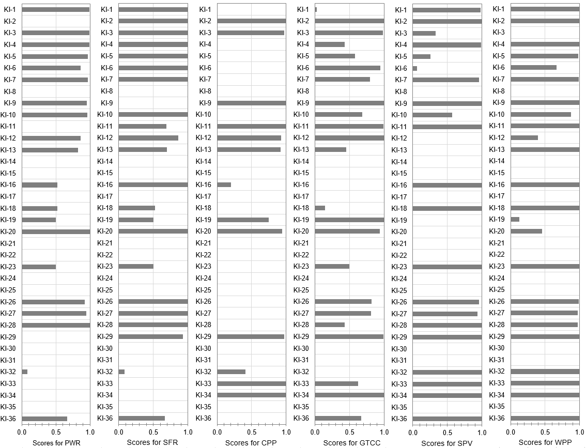
FIG. 2. Normalised key indicator values.

Weighting options
Any judgment aggregation framework requires a selection of appropriate criteria weights reflecting the decision/policy makers’ preferences and characterising the relative importance of criteria, evaluation areas and high-level objectives. The ‘equal weights’ option was used as a starting point for the analysis, based on the assumption that all the factors at each level of the objectives tree had the same relative importance. This approach can be applied when there is no information from experts and decision makers or when available information about the relative importance of the criteria is insufficient [22, 23]. However, even if there is no detailed information on weights, the ‘equal weights’ evaluation approach, combined with a detailed sensitivity/uncertainty analysis, makes it possible to conclude about the potential of the considered options from different perspectives.
Three other weighting options different from the ‘equal weight’ option were also considered with particular emphasis on the environmental criteria, economic criteria and social criteria, respectively (Fig. 3). This approach is suitable to examine the impact of different perspectives on options’ ranking order and is widely used in numerous studies. For illustrative purposes, the ratio of 20:80 is applied here for the three weighting options, assigning the weight of 0.8 to an emphasised objective and the weights equal a halve of 0.2 to the two remaining high-level objectives. Note that, the weight set chosen at each lower hierarchy level represents, due to the normalisation condition, equal partial weight values.

Judgement aggregation procedure
The IAEA/INPRO tools (namely, the KIND-ET tool and its extensions) for comparative evaluations of NES options and sensitivity/uncertainty analyses regarding key factors important for decision making [1, 24, 25] were adapted for comparisons and rankings of the considered power generation options. The comparative evaluation and ranking of the considered power generation options were carried out using the Multi-Attribute Value Theory implemented in KIND-ET: it involved the additive form of the multi-attribute value function and linear functions for single-attribute value functions for all the evaluation criteria specified for the local domains as the basic assumptions regarding the judgement aggregation procedure [1]. The performed analysis also includes the advanced uncertainty treatment in regard to weighing factors, single-attribute value function forms and key indicators using relevant tools (Overall Score Spread Builder, Ranks Mapping Tool, Uncertainty Propagation tool [25]).
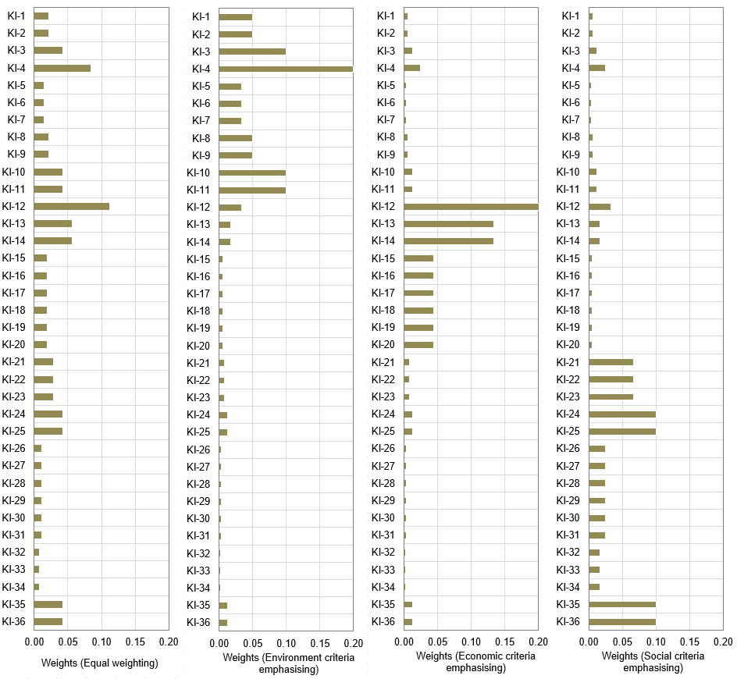
FIG. 3. Weighting options.

Ranking results and analysis

Ranking results for different weighting options
Screening for dominance performance demonstrates that all the options are non-dominated, i.e., among the entire set of options, there are no options that would be absolutely worse for at least one of the remaining ones. It means that each alternative can occupy the first place in ranking if the relevant conditions (priorities) permit.
It is to be expected that taking into account non-monetised social, environmental and economic factors and indicators will result in the ratings of options obtained within the MCDA-based evaluation framework that is significantly different from the ratings based on the assessments of the levelised cost of electricity for the same alternatives. Thus, according to the assessment based on the levelised cost of electricity criterion for the situation considered in this study, the most attractive option is GTCC, being followed by CPP, PWR and SFR, WPP, SPV [17].
Figure 4 shows the ranking results for the considered weighting options, including the decomposition of the overall scores into high-level objectives scores. As one can see, the multi-criteria approach favours nuclear and renewable energy sources. It should be noted that, in contrast to the results presented in the NEEDS project, in this study, given the differences between the Russian and European assessments of some social and economic indicators, nuclear technologies as a whole seem to be more attractive power generation options than renewable energy sources. At the same time, Generation IV fast reactors (SFR) are a more effective and attractive alternative than Generation III pressurised water reactors (PWR).
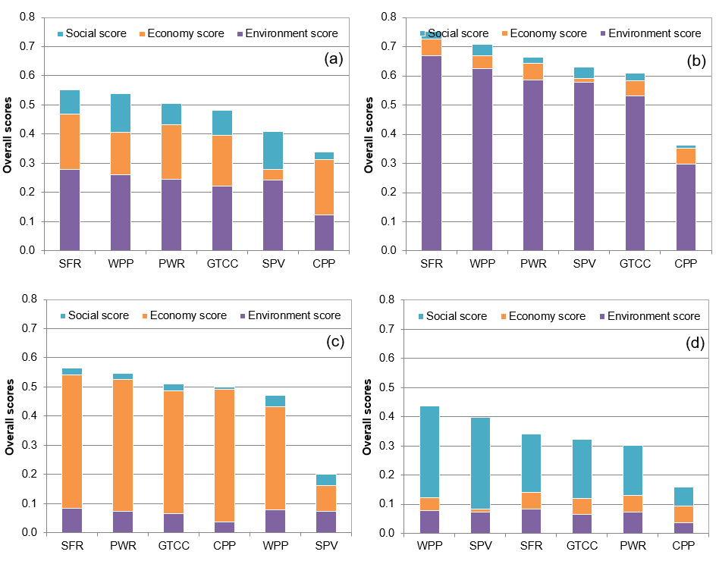
FIG. 4. Ranking results with breakdown of the overall scores into high-level objectives scores: equal weighting (a), environment criteria emphasising (b), economy criteria emphasising(c), social criteria emphasising (d).
The inclusion of a wide range of social criteria leads to a general downgrade of nuclear technology and an increase in the attractiveness of renewable energy sources, of which WPP seems to be more attractive than SPV. CPP is less effective in the framework of the MCDA-based comparison than the other options, while GTCC ranks close to nuclear technology. In general, the following trend is observed: an emphasis on the environmental criteria reduces the attractiveness of fossil energy sources compared to other technologies, an emphasis on the economy criteria reduces the attractiveness of renewable energy sources, and an emphasis on social criteria reduces the attractiveness of nuclear technology.

Merits and demerits of the considered power generation options
While interpreting the ranking results, it is not enough to indicate that one option is more attractive than the other one: it is necessary to explain the reasons for this. A possible way to meet this requirement is to decompose the overall scores into specific components in accordance with the structure of the objectives tree. This enables all parties interested in the results of the analysis to observe the contribution of each individual aspect to the final scores of alternatives. Such decomposition can be in some detail performed at various levels of the objective tree.
Figure 5 highlights the merits and demerits of the power generation options in terms of the area scores for the weighting option #1: the higher the area score, the better performance of the option for relevant aspects. To simplify the perception of quantitative data on the area' scores, the ‘conditional formatting’ technique displaying simple icons was used: good (green), acceptable (orange), bad (red). Such representation shows in a user-friendly manner the strong and weak points of each technological option. To avoid misinterpretation of the evaluation results, one should remember what kind of indicators are included in each area and what weighting option at the lower levels of the objectives tree was applied (in this case — equal weighting at the lower levels of the objectives tree). In particular, it can be seen that both SPV and WPP have the highest scores for the social evaluation areas, being followed by SFR, GTCC, PWR, and CPP. For the environment evaluation areas, the area scores for SFR and WPP are the most attractive, while CPP is less attractive in this regard. For the economy evaluation areas, PWR, SFR, CPP, GTCC demonstrate similar highly attractive performances, while SPV performance is rather low.
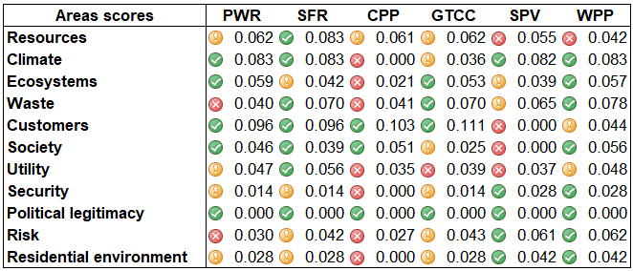
FIG. 5. Merits and demerits of the power generation options.
The performed analysis on highlighting the merits and demerits of the power generation options in terms of the area scores confirms the observation of the NEEDS project [18, 19]; thus, the technological performance profile plays a decisive impact on the rating of the technologies under consideration. This effect is especially pronounced for technologies that have a highly differentiated performance profile: it means that such technological options have high values for some indicators while other indicators have low values. Nuclear technologies are the most representative example of such technologies: with equal importance of environmental, economic and social aspects and emphasis on protecting the climate and ecosystems, minimising risks and accessibility for consumers, nuclear energy technologies take the highest places in the ranking. On the other hand, emphasising to the criteria associated with radioactive waste and contamination of the territory as a result of potential accidents as well as aversion to the risks of terrorist threats and the potential for conflict reduce the attractiveness of nuclear technologies.

Uncertainty and sensitivity analysis

Global uncertainty analysis with respect to weights
The ranking results described above were obtained for the four predefined different weighting options to demonstrate general MCDA-based evaluation trends. At the same time, it is obvious that there is considerable uncertainty in the priorities of the energy sector deployment in the long term, and, as a result, the weighting factors are characterised by significant uncertainty if the long-term perspective is considered. Therefore, examining how the uncertainties in the weights will affect the overall scores of the options under consideration is of great interest. Thus, it is required to rank options in the absence of information on the development priorities (the relative importance/ weights of key indicators) and determine the probability of a certain option preference.
The applied approach simulates a situation when independent expert groups with different views on the relative importance of key indicators and development priorities ranking options, and relevant information (overall scores and ranks) is presented in the form of statistical distributions using the box-and-whiskers plot. Based on this information, it is possible to identify the most promising option, assess its stability and the probability for its preference.
The following two cases of uncertainties in the weights were considered within this approach:
- Case I assumes that all the weights were uncertain, including high-level objectives, area, sub-areas and key indicators weights;
- Case II assumes that only the high-level weights were uncertain, while the other weights at the lower levels of the objective tree were specified based on the equal weighting concept.
The spreads in the overall scores and ranks for the options considered for both cases of modelling uncertainties in the weights are shown in Fig. 6 (the mean values: 5th, 25th, 75th, and 95th percentiles). The number of analysed weight combinations was 10 000, assuming that all the weights were uniformly distributed within [0,1], provided that the sum of the weights for each combination was unity.
Case I shows that, given the highest level of uncertainties in priorities, all the options can potentially take the first place in the ranking, but some of them are the most likely to be found in the first place, while others are less likely to. WPP is a technological option that is the most likely to take the first place in the ranking followed by SFR for this case (the case of the highest level of uncertainties in priorities). At the same time, SPV, CPP and PWR are less likely to take the first place for the considered case of modelling uncertainties in weights.
Case II, characterised by reduced uncertainties because only the high-level weights were uncertain, shows that the most attractive technologies which can be found in the first place in the ranking are only SFR (most likely) and WPP (less likely). The other technological options cannot be in first place at all. It is interesting to note that SFR in this case can take only upper places in the ranking (not lower than 4). The highest spread in ranks is demonstrated by SPV (from rank #2 to rank #6) while GTCC shows the lowest spread (from rank #3 to rank #5).
The overall conclusion that can be made based on the results of comparing the spreads in the overall scores and ranks for the considered two cases of modelling uncertainties in the weights is that, by involving national subject-matter experts and eliciting stakeholder preferences in order to specify the relative importance of aspects under consideration, we can significantly reduce uncertainties in overall performance score and make more sharpened conclusions regarding the potential of each option.
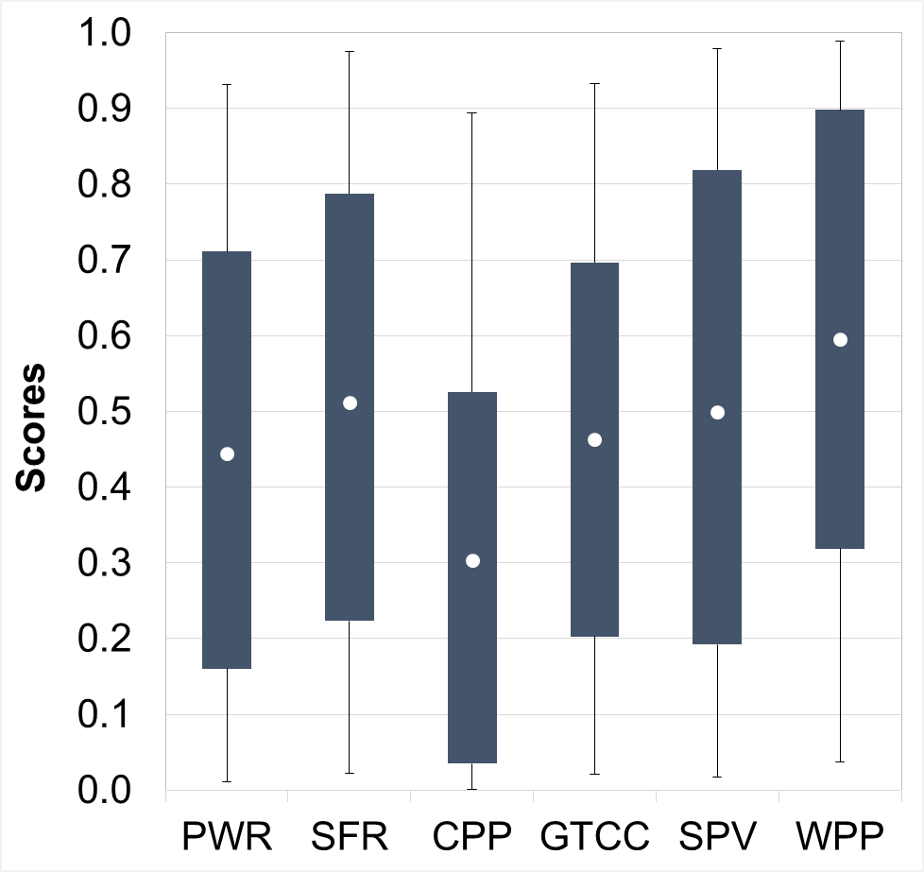  a) | 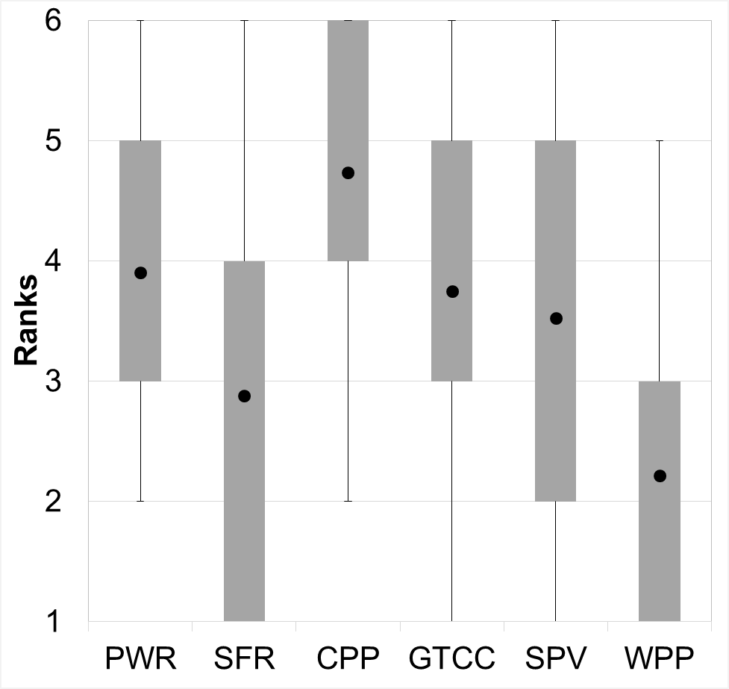  b)
Case I – All the weights are uncertain
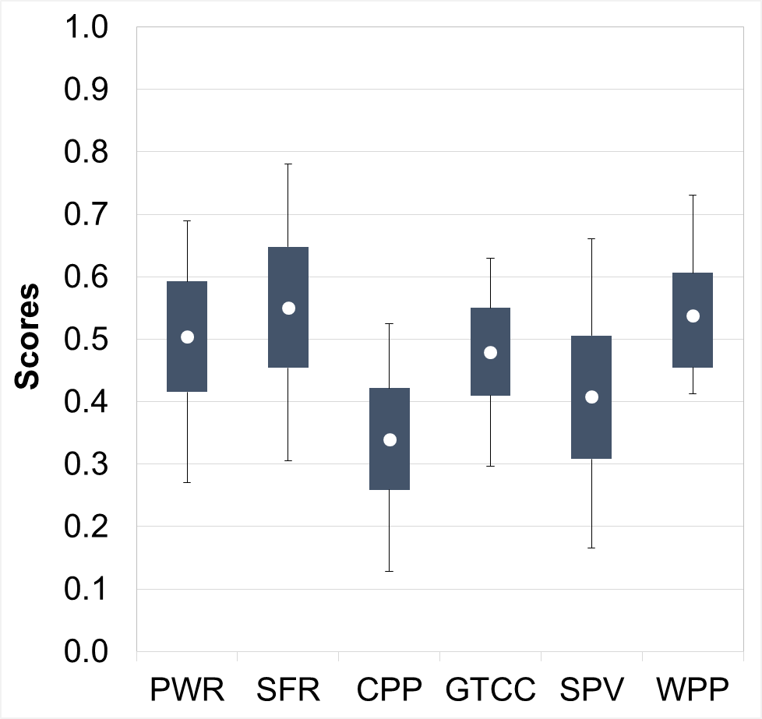  a) | 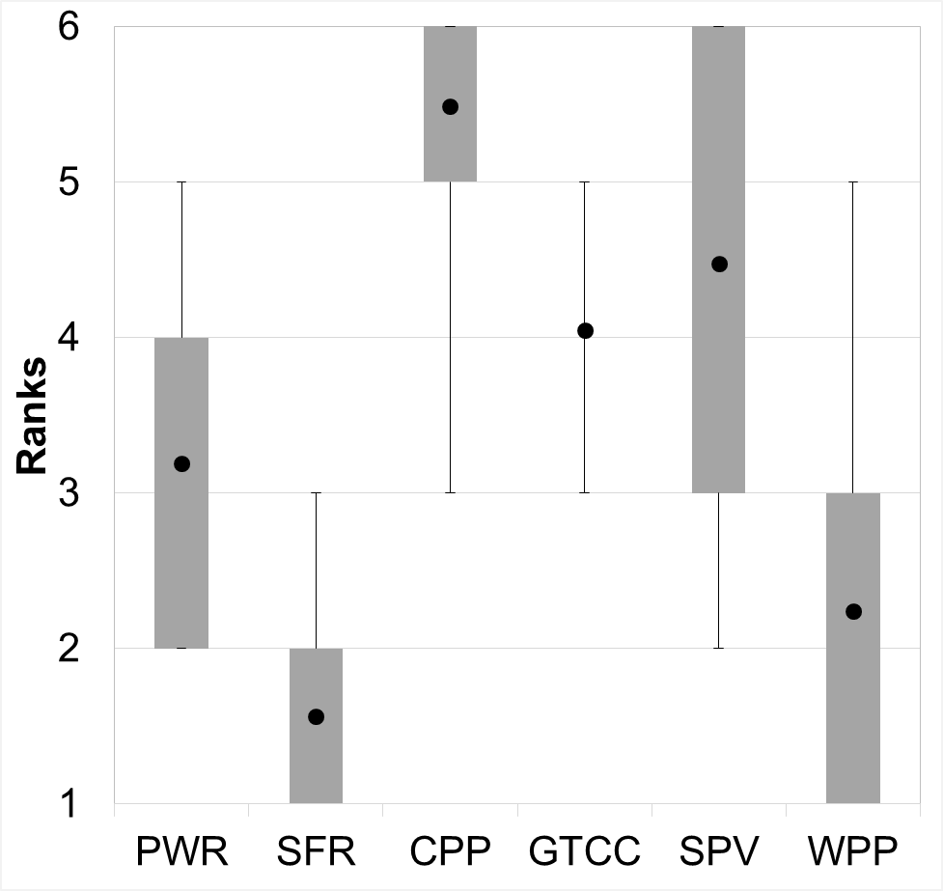  b)
Case II – Only the high-level objectives weights are uncertain
FIG. 6. Spreads in the overall scores (a) and ranks (b).

Global sensitivity analysis with respect to the high-level objectives weights
The global sensitivity analysis with respect to the high-level objectives weights was performed in order to identify alternatives that could potentially occupy the first place in the ranking (this was assumed to be the equal weighting option at the lower levels of the objectives tree). The performed analysis indicates the weight ranges of the high-level objectives for which a certain option can take the first place in the ranking (the so-called ‘map of preferences’, see Fig. 7: the abscissa axis shows the possible weight values for the ‘Environment’ high-level objective; the ordinate axis shows the possible values for the ‘Economy’ high-level objective weight; the applicate axis corresponds to the possible values for the ‘Social’ high-level objective weight (the applicate axis is assumed to be directed at the reader); the sum of these weights is equal to unity). This diagram demonstrates that only SFR and WPP can take the first place in ranking, if only the high-level objectives are varied, and the equal weights approach is applied for the lower levels of the objectives tree: WPP is the most attractive option if the social high-level objective is dominant over the others, whereas SFR becomes the most promising alternative in the cases when the economy and environment high-level objectives are highly important.
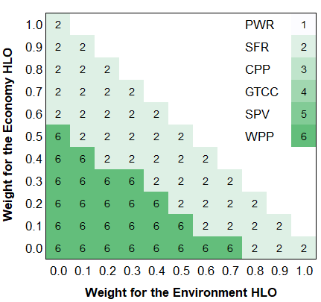
FIG. 7. Mapping the first-rank options.

Discussion
In general, this study shows that the comparative evaluation of the sustainability and attractiveness of various power generation technologies based on the MCDA-based framework is feasible and can serve as the basis for structuring discussions on future energy supply and supporting informed decision-making. Relevant decision support models allow us to conclude about the most promising options for different priorities, including those specified based on the sustainable energy development concept, which provides a harmonious combination of social, economic and environmental factors.
The evaluation results indicate that, if the power generation technologies are compared on the basis of only economic indicators without considering other sustainability dimensions and objectives, we can see a one-sided picture where preference is given to the fossil fuel power generation options. The multi-criteria decision analysis framework for comparing and ranking alternatives offers solutions which are different from those obtained by using the approaches based on purely economic criteria, such as the levelised cost of electricity: preferences are given to the energy production options which have the highest system efficiency taking into account the requirements of the sustainable development concept. In the present case study, these are nuclear technologies and renewables.
Moreover, it is worth mentioning that this approach allows us to fully take into account national priorities in the energy sector deployment and specific performance data on power generation technologies that can significantly change the ranking results for similar problems but different conditions. Thus, in contrast to the results of the European analysis performed in the NEEDS project, where the highest rankings were taken by renewables followed by nuclear technologies, in the present study considering Russia-specific conditions, one can observe the inverse situation: the highest rankings are taken by nuclear technologies followed by renewables. The performed evaluation clearly indicates the significant advantages of nuclear technologies, especially fast reactors, for the Russian Federation as the power generation technologies with enhanced sustainability that allows for the large-scale energy system development in accordance with the sustainable development goals. Based on these technologies, it is possible to implement low-carbon development scenarios that are of high importance for the Russian energy sector in the face of growing environmental challenges and make the energy sector more social-oriented.
On the whole, the study performed demonstrates that MCDA methods allow us to determine the most promising power generation alternative from a set of available ones based on multiple evaluation criteria at the system level. MCDM considers the criteria, taking into account their conflicting nature, which characterise technical efficiency, resource requirements and economic indicators along with other performance metrics. The use of these methods ensures that the decision-making process will be consistent, comprehensive, transparent, reproducible, and verifiable.
The main benefit of aggregating expert judgements based on formalised mathematical methods is that they allow one to structure discourse and organise effective examination to identify the most promising options among those available, with a quantitative demonstration of the advantages and disadvantages of the compared options. This helps to provide well-reasoned conclusions about the attractiveness of the options under consideration, which can be used to justify the final decision to be made.
To reinforce the use of the multi-criteria analysis results as the basis of highly-responsible strategic management decisions affecting the interests of various groups, it is advisable to involve supporters of different points of view on the problem as well as take into account their visions of its solution. This will help to develop a single set of performance indicators to evaluate the options and assumptions used. Particular attention should be paid to the impact of uncertainties (both objective and subjective) on the ranking results. Conducting such an examination, we can, at least, achieve a clear understanding of the strengths and weaknesses of each of the possible options based on a quantitative analysis. At most, if the participants of the examination will have a constructive attitude, they will be able to select the most acceptable compromise option.
The obtained results are quite illustrative: it would make sense to consider much more possible prospective power generation technologies, to refine relevant performance databases adapting them for Russia-specific conditions. It should also be taken into account that some technologies can be used in a multi-purpose way (e.g. sodium-cooled fast reactors, which can be used not only for commercial production of electricity but for burning off minor actinides and producing isotopes for their subsequent use in medicine and industry). Extensions enabling considerations along with power generation technologies, applications involving heating systems as well as to carry out comparative evaluations of energy scenarios should be welcomed. Export potentials of power generation technologies are also important factors to be involved in the decision making process at the national level.
Future work should take into account feedback from MCDA applications at the national level, facilitate communication with national subject-matter experts and initiate the elicitation of stakeholder preferences. Building capacities in the Russian Federation to promote the comprehensive and consistent application of state-of-the-art judgment aggregation methods and tools in the energy sector is of high importance. Customising existing and developing new tools (including formation and utilisation of the Life Cycle Assessment and Life Cycle Inventory Analysis based databases, adapting the advanced assessment approaches based on the concept of sustainability indicators, approaches to stakeholder preferences assessment as well as advanced frameworks for simulating the deployment of energy systems) for operationalising new evaluation methodologies to support decision making are systematically needed at the national level in the Russian energy sector.

CONCLUSION
The presented results delineate some preliminary conclusions about the most effective ways of enhancing the national power generation system sustainability based on the multi-criteria evaluation paradigm that assumes a harmonious combination of social, economic and environmental factors. The need for such considerations is due to the results of the comparison of the power generation technologies on the basis of only economic indicators, without considering other sustainability dimensions and objectives, show a one-sided picture giving preference to the fossil fuel power generation options. The multi-criteria decision analysis framework for comparing and ranking alternatives offers solutions different from those obtained by using the approaches based on the economic criteria: preferences are given to the energy production options which have the highest system efficiency taking into account the requirements of the sustainable development concept.
The results also show the outstanding performances of nuclear power technologies (especially fast reactors) for meeting sustainable energy development goals in the case of Russia — their overall performance is even better than that of renewable technologies. In particular, it was presented that the focus on the environment reduces the attractiveness of the fossil power technologies in comparison to the other technologies. The focus on the economy decreases the attractiveness of renewables. The focus on social aspects reduces the attractiveness of nuclear technology.
ACKNOWLEDGEMENTS
The authors would like to acknowledge the INPRO/IAEA section coordinating the KIND and CENESO collaborative projects on the MCDA application to comparative evaluations of nuclear energy system options for the software tools provided to carry out the present study.
References
- ESPEN, L., Use of multicriteria decision analysis methods for energy planning problems, Renewable and Sustainable Energy Reviews, 11 7 (2007) 1584-1595.
- SIKSNELYTE, I., ZAVADSKAS EK, STREIMIKIENE D, SHARMA D, An Overview of Multi-Criteria Decision-Making Methods in Dealing with Sustainable Energy Development Issues, Energies, 11 10 (2018) 2754.
- GRECO F.S., EHRGOTT M, editors, Multiple Criteria Decision Analysis: State of the Art Surveys, Springer, New York (2005).
- CORRENTE S, FIGUEIRA J.R., GRECO S, SŁOWIŃSKI R., “Multiple Criteria Decision Support”, Handbook of Group Decision and Negotiation. Cham, Springer, (2020).
- ANDRIANOV A, KUPTSOV I, KUZNETSOV V, FESENKO G, SCHWENK-FERRERO A., Innovative nuclear energy systems: state-of-the art survey on evaluation and aggregation judgment measures applied to performance comparison, Energies, 8 (2015) 3679-3719.
- ANDRIANOV A, KUPTSOV I, KUZNETSOV V, FESENKO G., INPRO activities on development of advanced tools to support judgement aggregation for comparative evaluation of nuclear energy systems, Science and Technology of Nuclear Installations, 2014, 15 (2014) 910162.
- ROTH S, HIRSCHBERG S, BAUER C, BURGHERR P, DONES R, HECK T, SCHENLER W., Sustainability of electricity supply technology portfolio, Annals of Nuclear Energy, 36 (2009) 409–416.
- WANG J.J., JING Y.Y., ZHANG C.F., ZHAO J.H., Review on multi-criteria decision analysis aid in sustainable energy decision-making, Renewable and Sustainable Energy Reviews, 13 9 (2009) 2263–2278.
- CHATZIMOURATIDIS A.I., PILAVACHI P.A., Sensitivity analysis of technological, economic and sustainability evaluation of power plants using the analytic hierarchy process, Energy Policy, 37 (2009) 788–798.
- STAMFORD L., AZAPAGIC A., Sustainability indicators for the assessment of nuclear power, Energy, 36 (2011) 6037–6057.
- STREIMIKIENE D., BALEZENTIS T., KRISCIUKAITIE I., BALEZENTIS A., Prioritizing sustainable electricity production technologies: MCDM approach, Renewable and Sustainable Energy Reviews, 16 (2012) 3302–3311.
- MINISTRY OF ENERGY OF THE RUSSIAN FEDERATION, Energy Strategy of Russia for the period up to 2030 approved by Decree # 1715-r of the Government of the Russian Federation dated 13 November 2009, (2010).
- MINISTRY OF ENERGY OF THE RUSSIAN FEDERATION, The energy industry of Russia: a look into the future, Substantiating Materials for the Energy Strategy of Russia for the Period until 2030, IATs Energiya, (2010).
- MINISTRY OF ENERGY OF THE RUSSIAN FEDERATION, Project of the Energy Strategy of the Russian Federation for the Period until 2035, (2020), http://minenergo.gov.ru/node/1920. [Accessed December 08, 2020]
- MAKAROV A.A, VESELOV F.V., MAKAROVA A.S. et al., Strategic prospects of the electric power industry of Russia, Therm., Eng., 64 (2017) 817–828. https://doi.org/10.1134/S0040601517110064.
- THE NEEDS PROJECT,The NEEDS website, http://www.needs-project.org [Accessed April 29, 2021]
- RICCI A., Policy use of the NEEDS results, http://www.needs-project.org/docs/Needs.pdf [Accessed April 29, 2021]
- VESELOV F.V., EROKHINA I.V., MAKAROVA A.S., AND KHORSHEV A.A., Comprehensive assessment of the effective scope of modernization of thermal power plants to substantiate the rational structure of the generating capacities for the future until 2035, Therm, Eng., 64 (2017) 161–169, doi 10.1134/S0040601517030107.
- VESELOV F.V., MAKAROVA A.S., NOVIKOVA T.V., TOLSTOUKHOV D.A., ATNYUKOVA P.V., NPP competitive prospects as to developing low carbon profile of Russian energy industry, Nuclear energy: new challenges and strategic priorities, 3 (2017) 68-77.
- ZARDARI N.H., AHMED K., SHIRAZI S.M., YUSOP Z.B., Weighting methods and their effects on multi-criteria decision-making model outcomes in water resources management, Springer International Publishing, (2015).
- ANDRIANOV A, SCHWENK-FERRERO A, “Comparison and screening of nuclear fuel cycle options in view of sustainable performance and waste management”, Sustainability, 9 9 (2017) 1623.
- INTERNATIONAL ATOMIC ENERGY AGENCY, User instructions for KIND-ET (KIND-Evaluation Tool) version 2.0, The INPRO/IAEA project on Comparative evaluation of nuclear energy system options (CENESO), IAEA, Vienna (2020).
- INTERNATIONAL ATOMIC ENERGY AGENCY, User instructions for extensions of KIND-ET, The INPRO/IAEA project on Comparative evaluation of nuclear energy system options (CENESO), IAEA, Vienna (2020).

