# NEXT GENERATION NUCLEAR POWER:

# RADIOLOGICAL SUSTAINABILITY AND

# ECOLOGICAL ADVANTAGES

V.K. IVANOV

JSC “Proryv” (Breakthrough)

Moscow, Russian Federation

Email: ivk@proryv2020.ru

E.O. ADAMOV

JSC “Proryv” (Breakthrough)

Moscow, Russian Federation

A.V. LOPATKIN

JSC “Proryv” (Breakthrough)

Moscow, Russian Federation

E.V. SPIRIN

JSC “Proryv” (Breakthrough)

Moscow, Russian Federation

V.M. SOLOMATIN

JSC “Proryv” (Breakthrough)

Moscow, Russian Federation

**Abstract**

Currently the large-scale nuclear power system, based on the two-component technology platform, is developed in Russia in the frames of the scenario of the sustainable development of Russia’s nuclear power in the 21st century. The technology implies the spent fuel to be safe to human health if radiotoxic effects of the fuel and natural uranium raw material to be equivalent. We present modeling-based study of the development of Russia’s nuclear energy in the 21st century from the year 2100. According to the scenario Russian nuclear energy of the 21st century is based on simultaneous operation of fast (FR) and thermal reactors (TR) until depletion of 5.42×105 tons of natural uranium; for the period of the reactors exploitation 7.52×103 tons of long-lived radioactive waste (RW) will be produced. With the account of ratio of natural uranium mass to RW mass the equivalence of committed effective doses to the public from the natural uranium and RW (radiation equivalence) will be achieved in 287 years. After ending RW generation, radiation-associated lifetime attributable risks (LAR) will be equivalent (radiological equivalence) in 99 years after ending RW generation. If the time of RW storage is longer than 100–150 years 241Am becomes the dominating contributor to radiation dose and radiation risk. The share of all americium radioisotopes in the RW mass is 0.23%. If the Am fraction in the waste mass increases by 10 times, radiation equivalence will not be achieved even after 1000-year storage, while radiological equivalence will be achieved after 414 years, that is 315 years more than needed to achieve radiological equivalence for the RW of unmodified composition, 99 years. So, sepa­ration of americium from RW will result in the reduction of the time of radiological and radiation equivalence achievement. Radiological equivalence principle may be used to justify substantial reduction of the RW storage time. If nuclear energy system is based on thermal reactors only, radiological equivalence may be achieved after more than 20,000 years of RW storage.

## INTRODUCTION

Nuclear power is an environmentally friendly technology and does not contribute to air pollution. Despite advantages of nuclear power, among them the highest energy density of all practical fuel sources and high efficiency of energy production, there are challenges and risks associated with irradiated nuclear fuel management and the need to ensure high level nuclear and radiation safety. The technology refinement requires significant investment.

However, it is possible to speed the nuclear power development with advanced, environmentally sustainable, ecologically balanced, socially acceptable, and cost-effective technology and the improved approach to all stages of management of radioactive waste (RW) that poses potential danger to the public health and the environment development. This work will result in the creating the program of refinement of the Russia’s nuclear power system. Recently the closed nuclear fuel cycle-based technology with simultaneous operation of thermal and fast reactors has been developed in Russia. Application of this approach makes it possible to use plutonium as the fuel for fast reactors and reduce the potential hazardous effects of high-level radioactive waste (HLW) on human health and environmental development. The technology implies the spent fuel to be safe to human health provided that radiotoxic effect of the fuel is equivalent to the effect of natural uranium raw material.

Potential risk from radionuclides intake may be evaluated as committed effective dose or as lifetime attributable risks (LAR) of cancer associated with internal radiation. Our purpose is to determine, how much time would be needed to achieve the equivalence of potential radiotoxic effects of HLW and natural uranium. There are two ways to do this. The first option is to evaluate the time interval from the ending generation of RW in the year 2100 to the time of radiation equivalence achievement, i.e. the equivalence of committed effective doses from HLW and natural uranium [1]. The second option is to determine the time interval from ending generation of RW to the time of radiological equivalence achievement, i.e. the equivalence of LAR associated with intake of radionuclides contained in HLW and natural uranium.

To design the program of Russia’s nuclear power system development in the 21st century, Scenario of Sustainable Development of the nuclear power in the next century was designed. Scenario-based simulation approach was used in the study [2]. The model source data are: ending RW production up to 2100; calculated uranium resources for nuclear fuel is 5.42×105 tons, the amount of HLW, that will be accumulated before 2100 – 7.52×103 tons; Russian thermal reactors used in the study – WWER, RBMK, the reactors operate until modeled uranium resources depletion; Russian fast reactor used in the study – BREST-1200, fast reactors use plutonium separated from the spent uranium nuclear fuel (SNF); the generating capacity will be 107 GWt before 2100 (Fig. 1); annually 1 fast reactor will be put into exploitation, provided that necessary amount of Pu is available; by year 2100 fast reactors only will operate in Russian NPPs; after reprocessing of used nuclear fuel the waste will contain no more than 0.1% of the original amount of U, Pu, minor actinides, Sr, Cs, Tc and I in the fuel. Change of composition of radionuclides contained in the radioactive waste is taken into account [3].

FIG. 1. Generating capacity of thermal and fast reactors. According to Strategy of Russia’s nuclear power development [2], its generating capacity will be 43.7 GWt in 2030 and 100 GWt – up to 2100.

## Radioactive waste management: radiation and radiological equivalence

It has been mentioned above that adverse effects of RW on human health and the environment sustainable development is possible to measure as committed effective doses and lifetime attributable risk. Committed effective dose is the internal dose to the whole body from radionuclides intake for the whole life. The source data used for radiation equivalence are committed effective doses from dominating radionuclides contained in RW and from natural uranium at different times after ending waste production. The data were resulted from the simulation-based study of the development of nuclear power system until year 2100.

Radiological equivalence is the equivalence of lifetime attributable risk of cancer occurred for the whole life following radiation exposure and LAR of cancer from natural uranium.

Fig. 2 presents curves of dynamic changes of impacts of radiological hazards contained in closed nuclear fuel cycle generated RW (CNFC RW) and in natural uranium (horizontal curve) over the years after ending RW generation. The point of curves crossing indicates the time of radiation equivalence achievement. It will be achieved in 287 years after ending RW production in 2100.

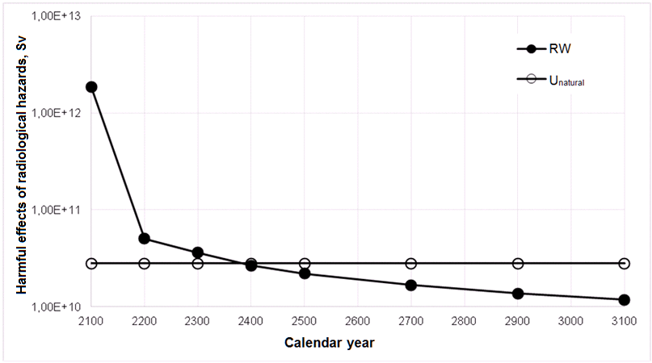

FIG. 2. Harmful effects of radiological hazards (Sv) contained in RW from closed nuclear fuel cycle (CNFC RW) and corresponding amount of natural uranium in different calendar years after 2100. The curves will cross in 2387.

Fig. 3 presents contribution of dominating radionuclides contained in CNFC RW to radiological harmful effects (Sv) in different calendar years after ending RW production in 2100. Of the radionuclides contained in RW, each of the dominant radionuclides contributes more than 1% to the total annual effective dose at least once in 1000 years. Though mass-related fraction of 241Am is 0.23% in 2100, in about 100 years after ending RW production in 2100 the radioisotope will become the dominating radionuclide.

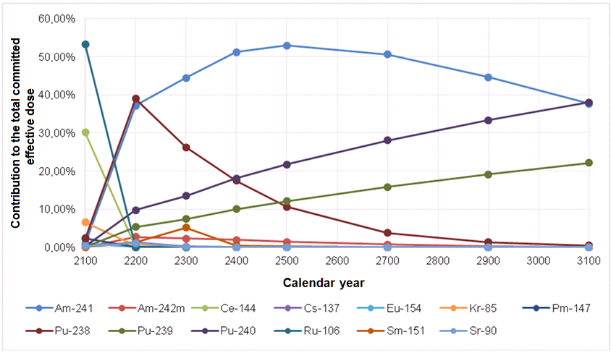

FIG. 3. Contribution (%) of dominating radionuclides contained in CNFC RW to potential harmful effects on the public.

Fig. 4 presents curves of dynamic change of LARs from dominating radionuclides contained in CNFC RW and the permanent LAR from natural uranium. The point of the curves crossing indicates the time of radiological equivalence achievement, it will be in the year 2199, i.e. in 99 years after ending RW generation in 2100. Radiological equivalence will be achieved 188 years earlier than radiation equivalence.

Fig. 5 presents contribution of dominating radionuclides contained in CFNC RW to integrated average LAR in different years after 2100. After a certain time 241Am will become the dominating contributor to LAR.



FIG. 4. Lifetime attributable risk from CNFC RW and the correspondent amount of the natural uranium (per 1 mSv). The year of the curves crossing is 2199.



FIG. 5. Contribution (%) of dominating radionuclides contained in CNFC RW in different years after ending of RW generation in 2100.

Fig. 6 illustrates LARs from SNF generated by thermal reactors in different years after ending SNF generation and LAR from correspondent amount of natural uranium. Radiological equivalence is achieved in 20,513 years after 2100.

Fig. 7 illustrates contribution of dominating radionuclides contained in SNF to the total averaged LAR in different calendar years after 2100. In the beginning period the highest contribution is made by 241Am, later dominating contributors are 240Pu and 239Pu.

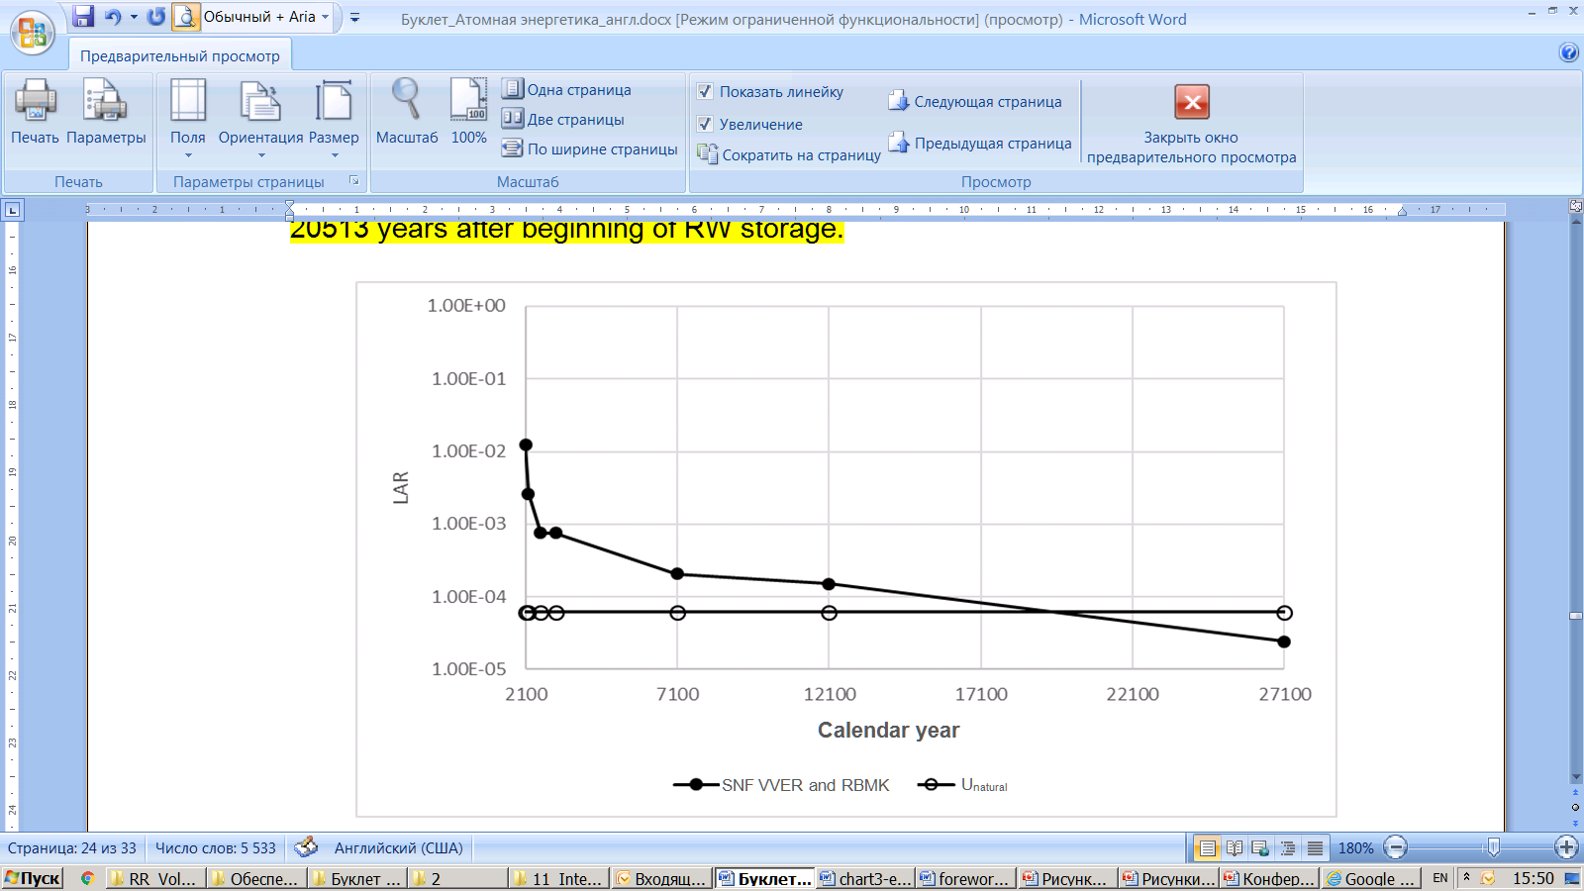

FIG. 6. LARs from spent nuclear fuel generated by thermal reactors and natural uranium, the risk was estimated in relation to normalized to 1 mSv of radiological impact of the uranium ore; the curves will cross, as defined with the use of linear interpolation, in 20,513.



FIG. 7. Contribution of dominating radionuclides from spent fuel to lifetime attributable risk.

## Conclusions

In the scenario of sustainable development of the large-scale Russia’s nuclear power in the 21st century based on thermal and fast reactors simultaneously operating in the mode of closed nuclear cycle, the results of this work show that, before 2100, 5.42×105 tons of raw uranium will be used for nuclear fuel fabrication and 7.52×103 tons of long-lived radioactive waste will be accumulated. With account of the mass ratio the equivalence of committed effective doses from the radioactive waste and raw uranium will be achieved after 287-year hold-up, the equivalence of lifetime attributable risks will be achieved after 99-year hold-up. Radiological equivalence will be achieved 188 years earlier than radiation equivalence.

If a hold-up period exceeds 100–150 years isotope of 241Am becomes the dominating contributor both to dose and radiation risk.

So, due to separation of americium from the waste the time of radiation and radiological equivalences achievement will be reduced. The principle of radiological equivalence provides stronger argument to justify the need to cut the time of waste hold-up.

In the presented scenario of sustainable development of the nuclear power with the use of thermal reactors only, the radiation equivalence is unachievable and radiological equivalence will be achieved in 20,000-year storage.

References

1. IVANOV, V.K. et al., Radiation and radiological equivalence of nuclear waste for the dual-component nuclear power, Radiation and Risk **28** 1 (2019) 5–25 (in Russian).
2. ADAMOV, E.O. et al., Conceptual framework of a strategy for the development of nuclear power in Russia to 2100, Atomic Energy **112** 6 (2012) 391–403.
3. IVANOV, V.K., ADAMOV, E.O., Nuclear power of new generation: radiological sustainability and environmental advantages, Publisher “Pero”, Moscow (2019) (in Russian).