THE FLUID-STRUCTURE INTERACTION OF NARROW GAPS BETWEEN THIN-WALL COAXIAL STRUCTURES IN FAST REACTORS

Y. LIU^{1, 2}, C. ZHANG¹, H. QIU¹, D. LU¹, D. LI¹, D. DUAN¹, Y. HUANG¹

¹ School of Nuclear Science and Engineering, North China Electric Power University, Beijing, China
² Beijing Key Laboratory of Passive Safety Technology for Nuclear Energy, North China Electric Power University, Beijing, China

Email contact of the corresponding author: appleplanter@ncepu.edu.cn

Abstract

To protect the key equipment from high temperature in a fast reactor, main pumps and the main vessel is shielded by single or multiple thermal shields, forming narrow fluid gaps. However, these fluid gaps bring some difficulties in seismic analysis by introducing the fluid-structure interaction effect. Added mass, a simplified but important parameter of a fluid-structure interaction effect, is much larger than the structure's mass itself especially when the gap between two coaxial cylinders is narrow. Moreover, the 2D beam-model-based added mass formula generally used in engineering design is over-conservative, making the structure burden large extra mass, however, there is no specific added mass guideline for such thin-wall and narrow-gap structure available. To study the fluid-structure interaction of main pumps and the main vessel with their thermal shield, a series of dynamics/seismic experiments of coaxial cylinders are carried out. The fluid pressure and acceleration distribution of such structures under different modal shapes are measured. A data processing method is established to transfer experimental results to the added mass. Finally, the correlation between added mass and circumferential wave number is obtained, which can be useful in the structural assessment of key equipment with a fluid-structure interaction effect.

INTRODUCTION
The reactor body of the pool-type fast reactor contains a large volume of liquid metal, and the wall thickness of the reactor body container is significantly smaller than that of the pressurized water reactor pressure vessel under the same power level. When an earthquake occurs, the liquid metal and the reactor body are coupled to each other, and the fluid-structure interaction effect will significantly affect the structural dynamic characteristics of the structure and affect the structural safety of the reactor body. Accurately accounting for the added mass of the fluid-structure interaction in the seismic calculation of the reactor body, and obtaining its dynamic characteristics has important practical significance for the structural integrity evaluation of the reactor body under the action of earthquakes and the long-term reliable operation of the equipment. It is the focus of the research on the seismic technology of the pool-type sodium-cooled fast reactor body^{[1]}.
Due to the high operating temperature of the fast reactor, to prevent excessive thermal stress in the reactor body container, a thermal shield is generally installed on the inner side of the reactor body container. The diameter of the thermal shield is slightly smaller than that of the container, and there is a narrow gap between it and the container, which is filled with fluid. However, due to the existence of thermal shields and fluid slits, its fluid-structure interaction characteristics are significantly different from those of pressurized water reactors. There is no formula for fluid added mass that can accurately calculate the fluid-structure interaction of such thin-walled coaxial shells.
There are many research results on the added mass and dynamic characteristics of the coaxial cylindrical shell coupled by the gap fluid under the action of the earthquake ^{[2-5]}. For an infinitely long cylinder in immersion fluid, FRITZ ^{[6]} gave the formula for the added mass of the cylinder, which was adopted by ASME and widely used in industrial design. However, there are certain limitations in the application of this formula: this formula is suitable for cylinders with relatively large height and diameter. But it is too conservative for coaxial cylinders with small height and diameter ratios, so it is not suitable for direct use.
Due to the lack of experimental research on such a narrow coaxial thin shell, this paper carried out a shaking table test for the model, measured the mode of the system, measured the acceleration and pressure, and the added mass of the circumferential wave number modes of each order is obtained. This research is of great significance for fast reactor earthquake resistance.

Theory and Method

2.1 The modal shapes of coaxial cylindrical shells
Since there are many shell-type vibration modes of cylinders, it is necessary to briefly introduce the description method of shell-type vibration modes. The cylindrical shell structure is a common component in the aviation and machinery industries. The research on thin cylindrical shells has been developed very maturely, and there are many related theories. As illustrated in FIG. 1, the vibration modes of cylindrical shells are very complex and can be divided into the following categories by using the three-dimensional description method: (1) Radial mode. The characteristic of this mode is that the cross-section of the cylindrical shell in the axial direction maintains the same shape, and the cross-section remains flat and perpendicular to the central axis of the cylindrical shell. The number of axial nodes m=0. (2) Radial shear mode. This mode no longer maintains the same shape of the cross-section along the axial direction, the cross-section no longer remains flat, the bus bars are not parallel to each other, and they are no longer straight when m≥2. (3) Telescopic mode (also called breathing mode). The deformation of this mode along the circumferential direction is axisymmetric, and the circumferential wave number is always n=0. Axial wavenumbers can be obtained by conventional projection methods. (4) Circumferential mode. In this mode, some elements are elongated and some are shortened along the circumferential direction, and the points in the element with no circumferential displacement are nodes.

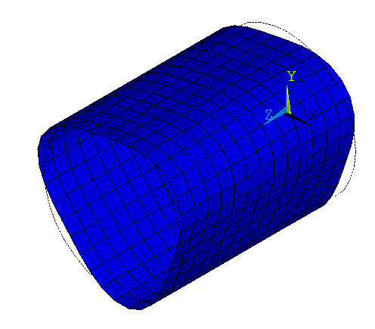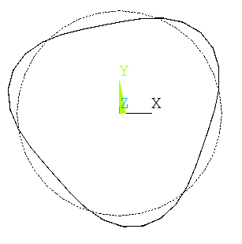
(I) Axonometric view (II) front view (III)right view
(a) Radial mode n=3, m=0

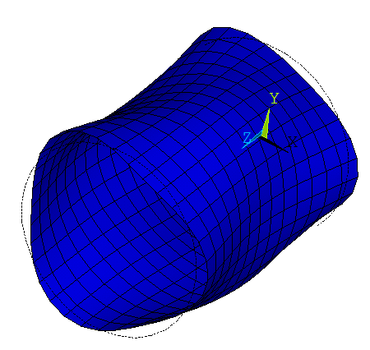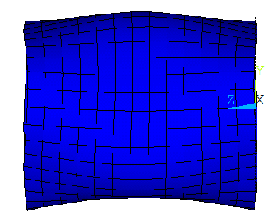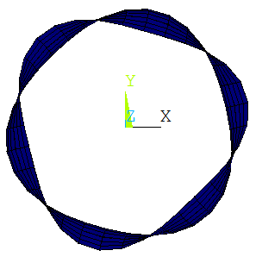
(I) Axonometric view (II) front view (III)right view
(b) Radial shear mode n=3, m=2
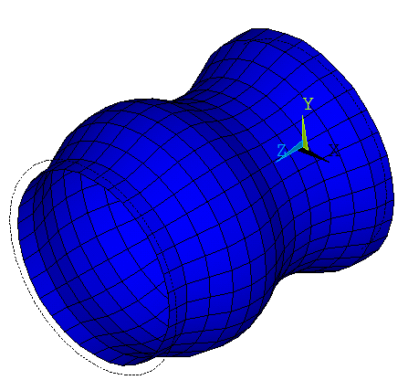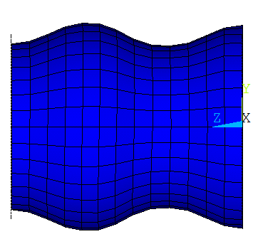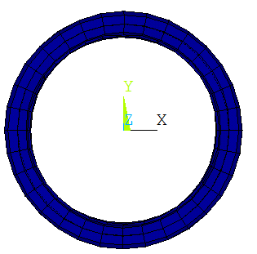
(I) Axonometric view (II) front view (III)right view
(c) Breathing mode n=0, m=3

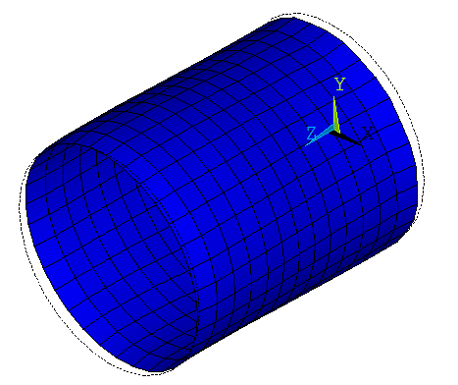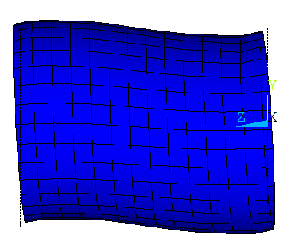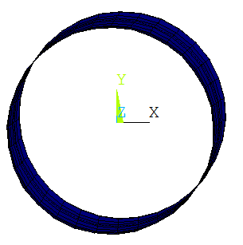
(I) Axonometric view (II) front view (III)right view
(d) Circumferential mode n=1, m=2
FIG. 1. Typical four shell-type vibration modes: (a) Radial mode (b) Radial shear mode (c) Breathing mode (d) Circumferential mode

The fluid-structure interaction of coaxial cylindrical shells
According to Au-Yang's paper ^{[2]}, for a certain vibration mode, the displacement of the α mode shape can be expressed as:
(1)
In the above formula, w_{α} is the normal displacement of the α vibration mode, W_{α} is the generalized coordinate, and Ψ_{α} is the normal mode.
Assuming that the potential function of pressure is the same as that of vibration, the pressure on the wall of the structure can be expressed as:
(2)
Among them, the projection of the pressure on the potential function can be further expressed as:
(3)
Due to the large stiffness of the outer cylinder, the term of the above formula about β can be ignored, so for any first-order vibration mode α, the pressure on the wall satisfies:
(4)
According to Formula (2) and Formula (5), we can get:
(5)
According to the above formulas, the added mass of the position can be obtained only by knowing the pressure, displacement, and vibration angular frequency of the point on the cylinder. That is to say, the added mass of the structure in the fluid is the ratio of the fluid pressure on the structure to the acceleration of the structure under the effect of resonance.
For the coaxial cylinder experiment and large ring domain adjacent cylinder experiment, the pressure has been obtained from all parts of the cylinder surface, and the distribution of the added mass can be obtained when the structure acceleration is known. It is worth noting that when the position is close to the fixed constraint end, the denominator of the above formula tends to 0, so the above formula does not apply near the fixed constraint end.

Wavelet analysis
The wavelet transform is a mathematical technique that can decompose a signal into multiple lower resolution levels by controlling the scaling and shifting factors of a single wavelet function (mother wavelet). Wavelet transform is a mathematical approach widely used for signal processing applications. It can decompose special patterns hidden in the mass of data. Wavelet transform can simultaneously display functions and manifest their local characteristics in the time-frequency domain. Wavelet transforms are mainly divided into two groups: continuous wavelet transform (CWT) and discrete wavelet transform (DWT). In CWT, if the scale and displacement parameters are continuous, CWT will be a very slow transform with extra and useless data due to overlapping features and duplicity of neighboring data. Thus, DWT is used in this paper. Eqs. (6) and (7) express CWT and DWT, respectively^{[7]}.
CWT:
(6)
where a is the scale parameter, b is the transform parameter, and φ is the mother wavelet.
DWT:
(7)
where T is signal length, transform and scale parameters are a function of integer values (a=2^{m}, b=n2^{m}). Stephane Mallat's multi-decomposition theory has been often used in the literature to employ DWT. This method comprises two basic steps: decomposition and composition. FIG. 2 depicts decomposition and composition steps. In the first step, a signal is decomposed into two high and low-frequency components. Then, high frequencies are retained; while, low frequencies are decomposed again into two high and low frequencies. High frequencies are called signal details and low frequencies are an approximation of the signal. In the composition step, the decomposition process is done in reversed fashion. The set of wavelet basic functions (such as Morlet, Haar, and Mexican hat) is also named family. Within this family. Daubechies has had better results. In this paper, second-order Daubechies (db2) is used as the mother wavelet. FIG. 2 illustrates the general decomposition steps and composition steps by Stephane Mallat's multi-decomposition theory.

FIG. 2. Depicts (A) decomposition step and (B) composition step in Stephane Mallat’s multi-decomposition theory

3 Experiments

3.1 Experimental setups
The model diagram of the coaxial cylinder is shown in the figure below, and the model parameters are shown in the figure below. The experimental model is designed to study the fluid-structure interaction effect of the double-layered cylinder in the narrow gap of the reactor vessel-radial thermal shield structure.

D₁=3000 mm
D₂
Gap=15 mm
FIG. 3. Coaxial double-layered cylinder model

TABLE 1 Coaxial double-layered cylinder (length-diameter ratio less than 2) test model parameters
Model | The fast reactor prototype structure | Inner diameter/mm | Gap/mm | Height/mm
Inner layer | Radial inner heat shield | 3000 | 15 | 1200.00
Outer layer | Reactor body | 3080 | - | 1200.00

3.2 Experimental conditions
The experiment uses a shaking table to excite the model. As shown in the table below, two typical operating conditions were carried out: sweep frequency condition and standing wave condition.

TABLE 2 Experimental cases
No. | Condition | Frequency range/Hz
CBZ-1 | Sweep frequency test | 1 to 30
CBZ-3 | Standing waves | 7.0

4 Results and Discussions

4.1 Modal frequency and vibration mode of each order
Since the model with an aspect ratio less than 2 has more measurement points than the model with an aspect ratio greater than 2, the modal shapes concerned are more complex (models with an aspect ratio less than 2 are mainly shell-type vibration mode with n=6, n=7, n=8, and n=9). The frequency and vibration mode are shown in the table below. The results show that the low-order modes are all shell-type vibration modes, and no beam-type vibration mode is found within 33Hz. The lowest frequency is the shell-type vibration mode with a circumferential wave number of 7.

TABLE 3 Frequencies of mode shapes
No. | Experimental frequency/Hz | Mode shapes
1 | 6.57 | (1,7)
2 | 7.98 | (1,6)
3 | 8.64 | (1,9)
4 | 10.83 | (1,3)

4.2 Decomposition of transient acceleration based on wavelet transform
For acceleration data, we use 24 measuring points to obtain 360°acceleration distribution. For the double-layer cylinder with a height-diameter ratio of less than 2, its processing and installation are difficult, and the acceleration mode shapes of circumferential measuring points can not be identified by conventional methods. To solve the problems, we use a wavelet to analyze the circumferential vibration mode of the inner cylinder. According to the input of condition 2, we obtained the response spectrum amplitude of the signal at 7Hz. We use the db4 wavelet for three-level decomposition and draw it in the figure below. As can be seen from the figure below, after three layers wavelet decomposition, the a3 layer data contains 1 cycle; the d3 layer data contains 3 cycles; the d2 layer data contains 6 cycles; the d1 layer data contains about 10 cycles. It can be found that the circumferential acceleration is composed of several orders of waves with different periods, and the typical components include n=1; n=3; n=6; n=10.

FIG. 3 Circumferential acceleration spectrum after wavelet decomposition (original =a3+d3+d2+d1), the horizontal axis is the angle, and the difference of each measuring point is 15°
The following figure shows the circumferential distribution of acceleration in polar coordinates.

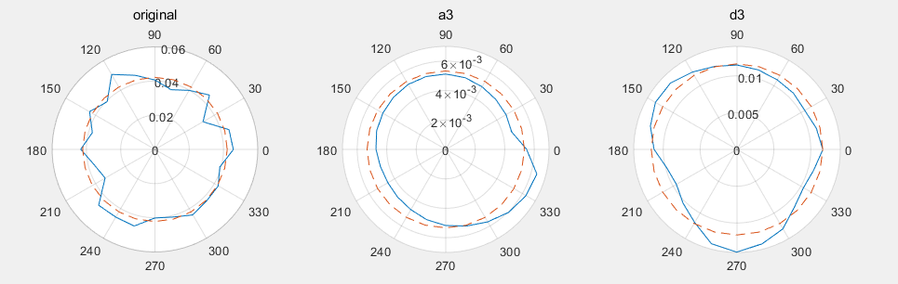
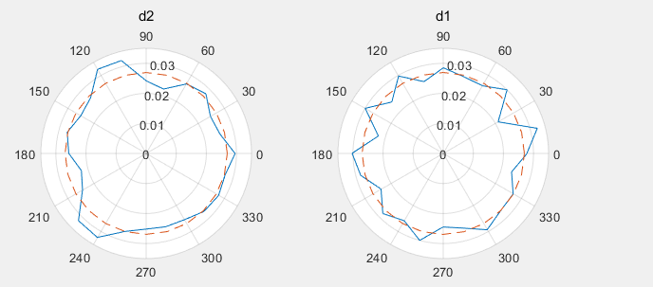
FIG. 4 Polar diagram after decomposition of acceleration wavelet
For the pressure data, we measured 13 measuring points and obtained a pressure distribution of 180°. Similarly, we use the wavelet transform to separate the pressure amplitudes in the circumferential direction of the inner cylinder, as shown in the figure below. As can be seen from the figure below, after three layers of wavelet decomposition, the a3 layer data contains 0.5 cycles; the d3 layer data contains 1.5 cycles; the d2 layer data contains 3 cycles; the d1 layer data contains about 5 cycles. Corresponding to the circumferential distribution of acceleration n=1; n=3; n=6; n=10.
FIG. 5 Circumferential pressure spectrum value after wavelet decomposition (original =a3+d3+d2+d1)

4.3 Added mass distribution of shell-type vibration under typical transient excitation (1,6)
In the CBZ-3 condition, 24 acceleration measuring points are uniformly distributed in the cylinder. According to the circumferential wave number obtained by wavelet transform in the previous section, the fitting function of acceleration measurement points is determined as follows: $a_{1}*sin\left(1*x+b_{1}\right)+a_{3}*sin\left(3*x+b_{3}\right)+a_{6}*sin\left(6*x+b_{6}\right)+a_{10}*sin\left(10*x+b_{10}\right)+d$.

TABLE 4 Acceleration, pressure fitting coefficient and added mass corresponding to main mode shape under 7Hz main frequency (mode shape n=7) under CBZ-3 working condition*
 | Acc.(g) | Pressure(kPa) | Added Mass(kg)
$$a_{1}$$ | 0.002655 | 0.202 | 7608
$$a_{3}$$ | 0.01229 | 0.2218 | 1804
$$a_{6}$$ | 0.01488 | 0.1273 | 855
$$a_{10}$$ | 0.01487 | 0.1011 | 679
*Fitting function: a1*sin(1*x+b1)+a3*sin(3*x+b3)+a6*sin(6*x+b6)+a10*sin(10*x+b10)+d

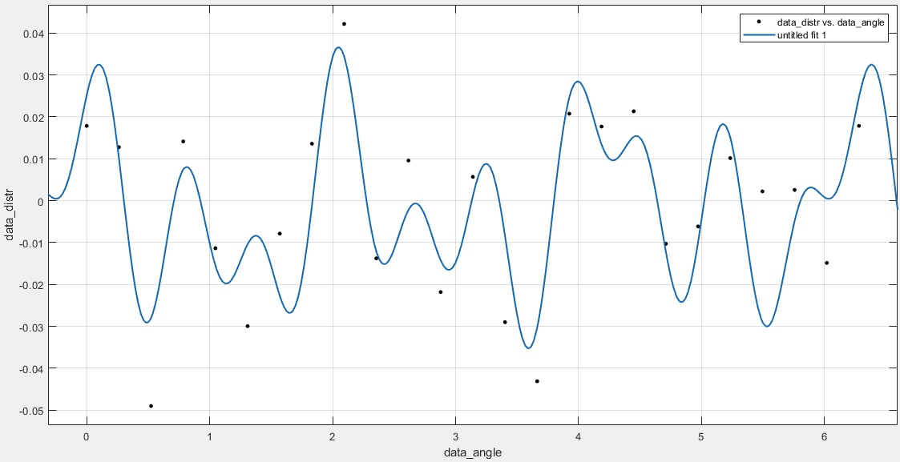
FIG. 6 Fitted acceleration-angle curve
The figure below shows the curve of inner cylinder acceleration versus fluid gap pressure as a function of circumferential angle. For this working condition, the excitation signal is closest to the mode shape of n=6, and the coefficient with the largest response amplitude of each order is a₆=0.01488. In the pressure data, the maximum pressure response is a₆=0.2218 (n=3). And a₃=0.1273 is not the maximum pressure response.
According to the content of Section 2.2, the areal density of the added mass at the measuring point on the outer wall of the inner cylinder in the middle layer is obtained by dividing the fluid pressure by the acceleration of the inner cylinder (as shown in TABLE 4). The results show that the added mass areal density of each mode decreases with the increase of circumferential wave number, which is consistent with the law of finite element^{[8]}.

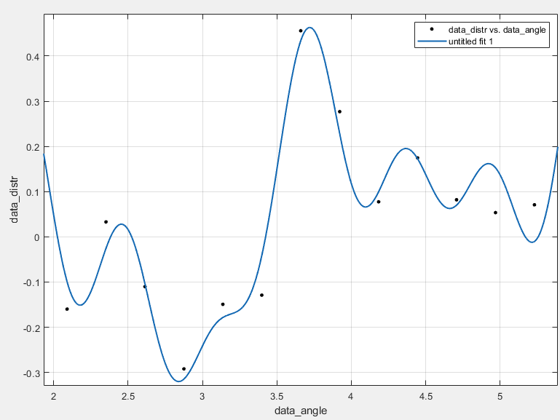
FIG. 7 Fitted pressure-angle curve

5 Conclusions
In this paper, a shaking table experiment of fluid-structure interaction is carried out for the main container of a fast reactor and the double tube structure of the thermal shield. The results are as follows:
- The low-order vibration mode of the double-layer tube with the height-diameter ratio less than 2 is mainly the shell-type vibration mode, and the beam-type vibration mode is not measured in the low-order range below 33Hz;
- For typical standing wave excitation, the acceleration response in the circumferential direction is the superposition of several circumferential wave numbers. The pressure response has the same law;
- The added mass of each vibration mode is different, and the areal density of the added mass decreases with the increase of the circumferential wave number.
ACKNOWLEDGEMENTS
Thanks to experts from the China Institute of Atomic Energy and the Shanghai Nuclear Engineering Research and Design Institute for their inspiration and help.
This work is supported by the National Key Research and Development Program of China (2020YFB1902102).
References
[1] Liu Q, Liu Y, Wang M, Lu D, Liu X. Analysis on Added Mass of Fluid-coupled Coaxial Cylindrical Shells [J]. Chinese Journal of Solid Mechanics, 2021.
[2] Au-Yang M K. Generalized Hydrodynamic Mass for Beam Mode Vibration of Cylinders Coupled by Fluid Gap[J]. Journal of Applied Mechanics, 1977, 44(1): 172–173.
[3] Au-Yang M K. Free Vibration of Fluid-Coupled Coaxial Cylindrical Shells of Different Lengths[J]. Journal of Applied Mechanics, 1976, 43(3): 480.
[4] Zhang X M, Liu G R, Lam K Y. Coupled vibration analysis of fluid-filled cylindrical shells using the wave propagation approach[J]. Applied Acoustics, 2001, 62(3): 229–243.
[5] Chen S S. Flow-induced vibration of circular cylindrical structures[M]. ARGONNE NATIONAL LABORATORY, Berlin, Germany: Springer1985.
[6] Fritz R J. Effect of liquids on the dynamic motions of immersed solids[J]. J Eng Ind Trans ASME, 1972, 94 Ser B(1): 167–173.
[7] Esfetanaj N N, Nojavan S. The Use of Hybrid Neural Networks, Wavelet Transform and Heuristic Algorithm of WIPSO in Smart Grids to Improve Short-Term Prediction of Load, Solar Power, and Wind Energy[M]. Operation of Distributed Energy Resources in Smart Distribution Networks, Elsevier Inc.2018.

