Neutronic Calculation of CEFR Core using

Different Nuclear Data Libraries

A. MOISE
Institute for Nuclear Research Pitesti
Mioveni, Romania

I.VIȘAN
Institute for Nuclear Research Pitesti
Mioveni, Romania
Email: iulianaelena.visan@gmail.com

Abstract

The uncertainties of evaluated nuclear data represent one of the most important sources of uncertainty in the reactor physics simulation. The improvement of these data is required for the development, safety assessment and licensing process of a reactor. It is generally recognized the need for further investigation (experimental included) regarding the uncertainties on some main cross-sections (e. g. ²³⁸U, ²⁴²Pu, minor actinides, etc.). The paper deals with the investigation of k_{eff} discrepancies induced by the differences among the cross-sections from ENDF/B-VIII.0, JEFF-3.3 and JENDL-4.0 libraries. For this study, a benchmark neutronic calculation for the first criticality of China Experimental Fast Reactor core configuration has been performed using the Continuous-energy Monte Carlo Reactor Physics Burn-up Calculation Code - SERPENT 2, version 2.1.31. The reactor reached the first criticality for a load of 72 fuel subassemblies at cold state (250°C±5°C) with only one regulating rod inserted at a certain position; all other control rods have been withdrawn out-of-core position. The results of SERPENT 2 code show a relatively large variation in the k_{eff} values obtained with different libraries, as follows: ENDF/B-VIII.0 library yields an excess reactivity of 98 pcm while JEFF3.3 and JENDL-4.0 yield excess reactivity of 243 pcm and 627 pcm, respectively.

INTRODUCTION
The development of fast reactors requires validation of the computational tools used to support the licensing process. To address this problem, appropriate computational codes and nuclear data should be used.
The China Experimental Fast Reactor (CEFR) is the first Chinese fast spectrum, pool-type, sodium-cooled reactor with a thermal power of 65 MW_{t} (20 MW_{e}) [1]. The operation of the CEFR involves two phases: starting and refueling of the reactor. In the first stage, the reactor was fuelled by uranium oxide fuel, with a ²³⁵U enrichment of 64.4 wt%. The physical start of the reactor was performed at zero power and several start-up tests were conducted after reaching the first criticality to provide experimental data for fast reactor physics studies. The experimental data obtained during the starting tests of the CEFR represent the basis of the International Atomic Energy Agency (IAEA) coordinated research project (CRP) proposed by the China Institute of Atomic Energy (CIAE).
The purpose of the IAEA research contract is to improve the analytical capabilities used in the design and simulation of fast reactors by validating and qualifying the available numerical models and evaluated nuclear data files through benchmark studies based on experimental data obtained by CIAE in 2010-2011 during the CEFR start-up tests. Another important goal is to identify the best methods for quantifying the uncertainties of the results obtained using the available neutronic analysis codes applied to liquid metal-cooled fast reactors. It is known that the accuracy of the integral parameters obtained from reactor physics analysis is an important nuclear safety-related aspect for both normal operation and accident conditions.
Reliable knowledge of uncertainties depends on the calculation algorithms, the detailed description of the geometry and materials and the accuracy of nuclear data. The impact of the uncertainties in the evaluated nuclear cross-sections, as well as the ones due to the statistical nature of the Monte Carlo method, represents the main source of uncertainty for neutron transport calculations.
The accuracy of nuclear data (e.g. cross-sections) from different data files is evaluated by studying the impact of neutron cross-section uncertainty on the most significant integral parameters related to the core. Evaluated nuclear data are collected in the Evaluated Nuclear Data Files (ENDF) and have been separately released by several countries, the most common libraries, being the following: ENDF/B (USA), JEFF (Europe), JENDL (Japan), CENDL (China) and BROND (Russia) [2].
In the recent years, many studies have been focused on the nuclear cross-section evaluations [3], [4], [5] which have shown large discrepancies among the available nuclear data [6]. The current study focuses on the influence of nuclear data uncertainties on the results of neutron transport calculations, more precisely, the multiplication factors for criticality experiments, widely used to validate neutronic codes along with the nuclear data libraries.

Description of the MODel
The work scheme of the present study regarding the impact of the evaluated nuclear data uncertainties on the neutronic parameters of a fast neutron system consists of the following steps:

- The continuous energy Monte-Carlo code SERPENT 2 [7] along with the latest versions of three general nuclear data libraries were used to perform numerical simulations of the CEFR clean-core configuration. The term "clean core" refers to the state in which the criticality is reached with a minimum number of fuel assemblies and, except a single control rod which is in a certain position to compensate the small positive reactivity remaining due to the loading of the last fuel assembly, all the control systems are withdrawn from the active core. The following nuclear data libraries were used:
- ENDF/B-VIII.0 released in February 2018 [8] which includes many improvements like the new IAEA standards and the CIELO project evaluations;
- JEFF-3.3 released in November 2017 [9] that contains improvements of the neutron, decay data, fission yields, dpa and neutron activation libraries;
- JENDL-4.0 released in May 2010 [10] which includes an update of fission product and minor actinide data;
- In addition to the simulations performed using the libraries with original data, calculations have been also performed by replacing certain nuclides data with those from another library. The results are then compared to the experimental values for the effective multiplication factor obtained by CIAE during the CEFR start-up tests.

To reduce the standard deviation of the results due to the statistical nature of the Monte Carlo method, each SERPENT 2 calculation was performed using 5∙10⁵ neutron histories per cycle, 1000 active cycles and 500 inactive. In these calculation conditions, the standard deviation is ~4.3 pcm.
Only a few modifications have been done to simplify the model: the nozzle section for all assemblies and the supporting plug of the fuel rod were not represented, the spacer wire mass was integrated into the clad radius and an equivalent radius has been calculated for each rod while the spring of the fuel assembly was represented as a cylinder. Some representative cross-sectional views obtained with SERPENT 2 for the entire core and the fuel assembly are shown in Fig 1.

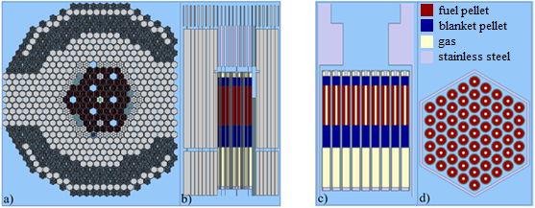
FIG. 1 SERPENT 2 cross-sectional view of CEFR core (left) and fuel assembly (right): a) core radial view, b) core axial view, c) fuel axial view, d) fuel bundle radial view.
Information on material characteristics and geometry of each assembly at installation state (20°C) are given in Ref. [11]. At the cold-state temperature (250 °C), both radial and axial thermal expansion were evaluated.
Prior to the reactor start-up tests, the active core was loaded with 81 mock-up fuel assemblies. The first criticality was achieved by gradually replacing the mock-up assemblies with fuel assemblies, according to the fuel loading scheme (after that, the core becomes super-critical and as a consequence one of the two regulating assemblies was used to compensate for the excess reactivity). At the end of this process, the CEFR clean-core configuration contains 72 fuel assemblies, 7 mock-up fuel assemblies, 8 control assemblies and 1 neutron source, while being surrounded by 394 stainless steel reflector assemblies and 230 boron shielding assemblies. The reactivity control systems comprise 8 control assemblies of 3 different types:

- 2 regulating rods with natural ¹⁰B used for regulation of small reactivities.
- 3 shim rods with 92% enriched ¹⁰B used to compensate the large reactivity change.
- 3 safety rods with 92% enriched ¹⁰B used for emergency shutdown.

To compensate the excess reactivity of the fresh fuel at the first loading, the last two mock-up fuel assemblies were replaced with two reflector assemblies (Type I) located in the central area of the active core. The core configuration for the first fuel loading is shown in Fig. 2.

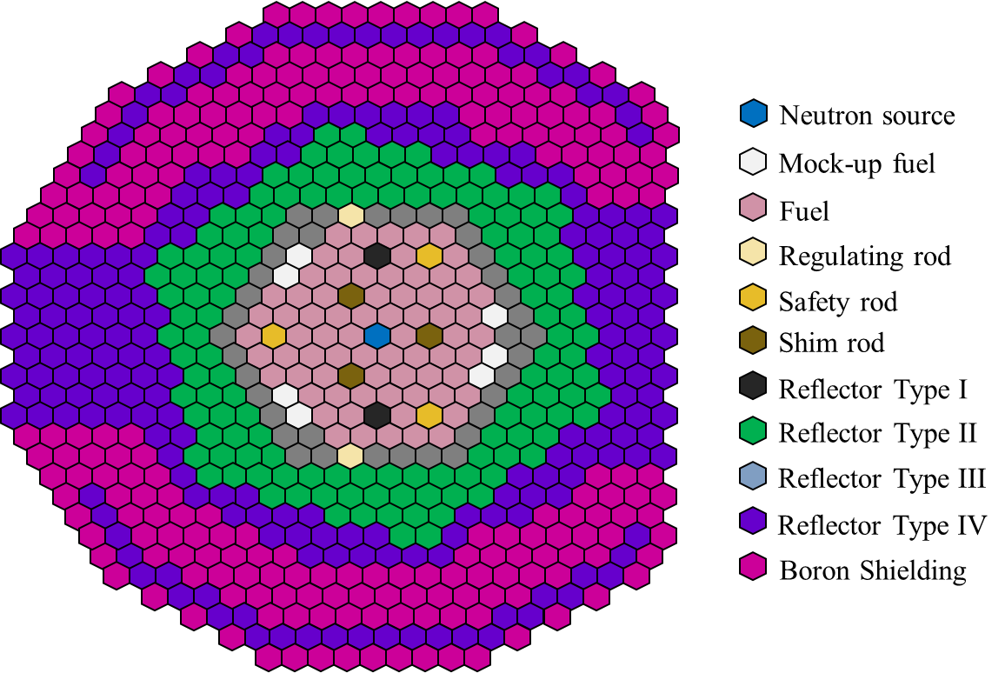
FIG. 2 CEFR core layout at first fuel loading.

RESULTS AND DISCUssIONs
Reliable reactor modeling and simulation codes are essential tools in the design safety assessment and licensing of nuclear systems. For this reason, an accurate characterization of nuclear data and their uncertainties is necessary for a wide range of calculations, especially for advanced systems. The effects of the libraries on the effective multiplication factor values and a comparison between the experimental and calculated results for CEFR are presented in Table 1.

TABLE 1: The effective multiplication factor values obtained using various libraries.
Nuclear data library | k_{eff} | Std. dev. [pcm] | Δρ [pcm]
ENDF/B-VIII.0 | 1.00098 | 4.40 | 98
JEFF-3.3 | 1.00244 | 4.29 | 243
JENDL-4.0 | 1.00631 | 4.27 | 627
Experimental | 1.00000 | - | -
It should be noted that all the results show higher values than the expected ones. The highest value of k_{eff} is obtained using JENDL-4.0 library and the lowest one is provided by ENDF/B-VIII.0. The overestimation was between 98 and 627 pcm.
ENDF/B-VIII.0 library contains the newest evaluations carried out in the frame of the CIELO project which include isotopes like ¹H, ¹⁶O, ⁵⁶Fe, ²³⁵U, ²³⁸U, and ²³⁹Pu [12]. Significant differences were observed for ²³⁵U and ²³⁸U fission and capture cross-sections, respectively [4], a comparison between JEFF-3.3 and JENDL-4.0 being shown in Fig. 3. In the case of ²³⁵U, JENDL-4.0 shows lower capture cross-sections than JEFF-3.3 and ENDF/N-VIII.0 in the fast region and significant differences are observed in the resonance region between ENDF/B-VIII.0 and JENDL-4.0 for both fission and capture cross-sections. In the case of ²³⁸U, all three libraries show notable differences in the resonance region for fission cross-sections as well as in the fast energies domain for the capture cross-sections.
In this context, previous studies [13], [14] for integral k_{eff} experiments have shown a good performance of ENDF/B-VIII.0 library for the fast spectrum. However, due to the impact of the new evaluations included in ENDF/B-VIII.0 further investigations considering more isotopes and addressing different nuclear systems are needed.

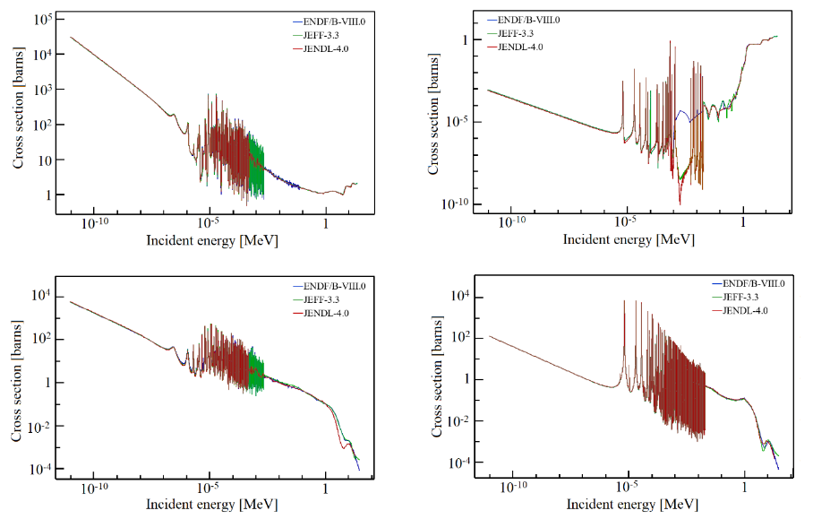
²³⁵U(n,f)
²³⁵U(n,γ)
²³⁸U(n,γ)
²³⁸U(n,f)
FIG. 3. ²³⁵U and ²³⁸U fission and capture cross sections comparison among libraries.

To have a better understanding of the impact of different libraries, the neutron cross sections from JEFF-3.3 and JENDL-4.0 were replaced with those from ENDF/B-VIII.0 for some specific isotopes. Taking into account that CEFR is fuelled with uranium-based fuel (in the form of UO₂), the corresponding nuclear data of ²³⁵U and ²³⁸U isotopes were considered the main contributors in the k_{eff} discrepancies. The reactivity excess resulting from the replacement of ²³⁵U and ²³⁸U in JEFF-3.3 and JENDL-4.0 are shown in Table 2 and Table 3, respectively. In Table 2 the label JEFF-3.3 - ENDF/B-VIII.0 (²³⁵U) means the replacement of ²³⁵U nuclear data from JEFF-3.3 with the corresponding ones from ENDF/B-VIII.0 library, while label JEFF-3.3 - ENDF/B-VIII.0 (²³⁸U) represents the replacement of ²³⁸U. A similar description is used for the JENDL-4.0 library in Table 3.

TABLE 2: The effect of ²³⁵U and ²³⁸U replacement in JEFF-3.3 library by ENDF/B-VIII.0 data.
 | k_{eff} | Std. dev. [pcm] | Δρ [pcm]
JEFF-3.3 – ENDF/B-VIII.0(²³⁵U) | 1.00779 | 4.17 | 530
JEFF-3.3 – ENDF/B-VIII.0(²³⁸U) | 1.00085 | 4.30 | -158

The use of nuclear data from ENDF/B-VIII.0 for the two main isotopes of uranium, ²³⁵U and ²³⁸U (along with JEFF-3.3 data for all other materials) induced a positive reactivity of 530 pcm and a negative reactivity of -158 pcm in the case of ²³⁸U, respectively. The change in reactivity can be explained by the fission to capture ratio of ²³⁵U which favors the fission, being higher with around 0.73% than that of JEFF-3.3 when using ²³⁵U cross-sections from ENDF/B-VIII.0. In the case of ²³⁸U, the fission to capture ratio of ²³⁸U favors the capture with around 0.25% when using ²³⁸U cross-sections from ENDF/B-VIII.0.

TABLE 3: The effect of ²³⁵U and ²³⁸U replacement in JENDL-4.0 library by ENDF/B-VIII.0 data
 | k_{eff} | Std. dev. [pcm] | Δρ [pcm]
JENDL-4.0 – ENDF/B-VIII.0(²³⁵U) | 1.00991 | 4.26 | 354
JENDL-4.0– ENDF/B.VIII.0(²³⁸U) | 1.00695 | 4.27 | 63

When ²³⁵U and ²³⁸U are replaced in JENDL-4.0 by the corresponding data from ENDF/B-VIII.0, it is observed that k_{eff} increases for both isotopes, the induced positive reactivity being of 354 pcm and 63 pcm, respectively. Similar to previous cases, the positive change in reactivity can be explained by the ratio fission to capture, (n,f)/(n,g), which favors the fission for both isotopes with around 0.87% and 0.15% for ²³⁵U and ²³⁸U, respectively.

CONCLUSIONS
Assessing uncertainties in the neutron transport calculations and tracking these uncertainties for specific nuclides is an important aspect of nuclear safety. This analysis can identify the area where more reliable information is needed in the data files and thus, a guide for further cross-sections evaluations.
Three nuclear data libraries were used in SERPENT 2 calculations during benchmark activities related to CEFR start-up tests. The calculations performed using any of the nuclear data libraries involved in the study tend to estimate a higher k_{eff} value. The best agreement with the experimental results was obtained using ENDF/B-VIII.0, while JENDL-4.0 and JEFF-3.3 show a higher k_{eff} value. The impact of different nuclear data libraries on the k_{eff} calculations with SERPENT 2 has been shown to be significant since the JENDL-4.0 library overestimates the k_{eff} by ~390 up to ~530 pcm compared to the ENDF/B-VIII.0 and JEFF-3.3 libraries.
Uncertainties induced by each isotope can be significant, but their cumulative effect can minimize the total difference between the results. For this reason, the replacement of individual isotopes between nuclear data libraries may be useful for the qualitative identification of the isotope influence. When the nuclides contribution to the k_{eff} variation was analyzed only for JEFF-3.3 with ²³⁵U from ENDF/B-VIII.0, a reduction of 158 pcm has been observed. The largest reactivity increase, of 530 pcm, was observed in the case of ²³⁵U replacement in JEFF3.3.
The comparative study performed in this paper shows that in the case of a fast neutron spectrum there are relatively large differences between the interaction cross-sections of different nuclear data libraries; even if the main contributors (²³⁵U and ²³⁸U) have been replaced, large variations among the k_{eff} results still remain.
ACKNOWLEDGEMENTS
This work was supported by the coordinated research project on “Neutronics Benchmark of CEFR Start-Up Tests”, under the coordination of the International Atomic Energy Agency.
REFERENCES
[1] | YANG, X.ET AL., "The first criticality test of CEFR," in Proceedings of the 2013 ²¹st International Conference on Nuclear Engineering, Chengdu, 2013.
[2] | A. TRKOV and D. A. BROWN, "ENDF-6 Formats Manual: Data Formats and Procedures for the Evaluated Nuclear Data Files," BNL-203218-Brookhaven National Laboratory, 2018.
[3] | D. ROCHMAN, A. J. KONING and J.-C. SUBLET, "A statistical analysis of evaluated neutron resonances with TARES for JEFF-3.3, JENDL-4.0, ENDF/B-VIII.0 and TENDL-2019," Nuclear Data Sheets, vol. 163, pp. 163-190, 2020.
[4] | CAPOTE, R. ET AL., "IAEA CIELO evaluation of neutron-induced reactions on ²³⁵U and ²³⁸U targets," Nuclear Data Sheets, vol. 148, pp. 254-292, 2018.
[5] | A. G. NELSON, M. K. RAMEY and F. HEIDET, "Impact of nuclear data libraries on predicted fast reactor performance," EPJ Web of Conferences, vol. 247, 2021.
[6] | BOSTELMANN, F. ET AL., "Nuclear Data Performance Assessment for Advanced Reactors," Oak Ridge National Laboratory, 2019.
[7] | LEPPANEN, J. ET AL., "The Serpent Monte Carlo code: Status, development and applications in 2013," Annals of Nuclear Energy, vol. 82, pp. 142-150, 2015.
[8] | BROWN, D. A. ET AL., "ENDF/B-VIII.0: The 8th major release of the nuclear reaction data library with CIELO-project cross sections, new standards and thermal scattering data," Nuclear Data Sheets, vol. 148, pp. 1-142, 2018.
[9] | PLOMPEN, A. J. M. ET AL., "The joint evaluated fission and fusion nuclear data library, JEFF-3.3," The European Physical Journal A, vol. 56, no. 181, 2020.
[10] | SHIBATA, K. ET AL., "JENDL-4.0: A new library for nuclear science and engineering," Journal of Nuclear Science and Technology, vol. 48, no. 1, pp. 1-30, 2011.
[11] | XINGKAI, H. ET AL., "Technical specifications for neutronics benchmark of CEFR start-up tests (CRP-I31032) V7.0," CIAE, unpublished data.
[12] | A. G. NELSON, M. K. RAMEY and F. HEIDET, "Impact of nuclear data libraries on predicted fast reactor performance," EPJ Web of Conferences, vol. 247, 2021.
[13] | GRISERI, M. ET AL., "Nuclear data uncertainty propagation on a sodium fast reactor," Nuclear Engineering and Design, vol. 324, pp. 122-130, 2017.
[14] | S. OHKI and T. JIN, "Dependence of fast reactor fuel burnup characteristics on nuclear data libraries," Journal of Nuclear Science and Technology, vol. 42, no. 4, p. 390–397, 2005.

