Experience of Using CFD Models

for Development of High-Temperature

Furnace Equipment for Fabrication of

Mixed Nitride Uranium-Plutonium

Fuel Pellets

A.Yu. Leshchenko, V. P. Smirnov, S.V. Pavlov, I. V. Kuzmin, R. N. Shamsutdinov
Sosny R&D Company
Dimitrovgrad, the Russian Federation
Email: lay@sosny.ru

M. I. Ilyashik
PRORYV JSC
Moscow, the Russian Federation

Abstract

CFD modeling has been extensively used for the development of high-temperature furnaces for the carbothermal synthesis of uranium and plutonium nitrides and a furnace for the sintering of mixed nitride uranium-plutonium fuel pellets. This equipment is intended for use at the Pilot Demonstration Energy Complex (PDEC) under construction in Seversk, Russia. The СFD-model of the carbothermal synthesis furnace was developed with the SolidWorks Flow Simulation software to obtain a three-dimensional temperature distribution both inside the furnace and in the bulk material charged, as well as typical gas flow patterns and a gas velocity distribution throughout the furnace. The CFD model was verified using experimental data on the temperature profile at three points inside the furnace measured during heating, isothermal exposure, and cooling within a temperature range from 20 to 1650 °С during acceptance tests of the manufactured equipment. The CFD model was used to verify the engineering solutions selected and formulate recommendations on the operation modes of the furnace. In particular, the modeling results demonstrated a wide range of process parameters, such as the heater temperature, the gas temperature and flow rate, that ensure the temperature of 1650±50 °С throughout the bulk material required for the carbothermal synthesis of uranium and plutonium nitrides. It is shown that the maximum difference in temperature throughout the bulk material does not exceed 62 °С. A horizontal pusher-type sintering furnace was developed, wherein mixed nitride uranium-plutonium fuel pellets successively move through heating, sintering, and cooling zones with different gas media. The CFD model of the furnace channel was developed with the Ansys Fluent software and underwent benchmark testing on a specifically built bench for gas-dynamic investigations using a full-size channel model. The engineering solutions proved to ensure the sustainable operation of three gas zones (argon-nitrogen-argon) in the furnace channel at a sintering temperature of ~1950 °C. Application of the CFD models reduced the time of developing the high-temperature furnace equipment and facilitated the justification of the engineering solutions. The developed models allow simulations of various operation modes, including possible emergencies, and will be used to support the operation of the high-temperature furnaces.

INTRODUCTION
Experimental validation of new engineering solutions and selection of operation conditions for the developed furnace require significant time and financial resources. CFD modeling addresses research and technical challenges, such as prediction and optimization of simulated thermophysical processes. The paper describes the experience in CFD modeling of high-temperature furnaces for (U, Pu)N carbothermal synthesis and (U, Pu)N pellets sintering. This equipment makes part of the PDEC Fabrication/Recycling Facility (FRF) in Seversk, Russia [3].

HIGH-TEMPERATURE FURNACES FOR FABRICATION OF (U, Pu)N FUEL PELLETS
The basic operations of the (U, Pu)N fabrication line at the PDEC FRF are:
- mix UO₂ and PuO₂ powders and add carbon and zinc stearate binder,
- press the powders to form discs,
- conduct carbothermal synthesis to produce (U, Pu)N,
- crush and grind the discs to powder, press the powder to make fuel pellets, sinter the pellets.
Fig.1 is a 3D model of a batch retort furnace for (U, Pu)N carbothermal synthesis; the design and the carbothermal synthesis are described in paper [5]. The retort has a three-section heater on its both sides and five rectangular boxes (boats) with the material inside of it.

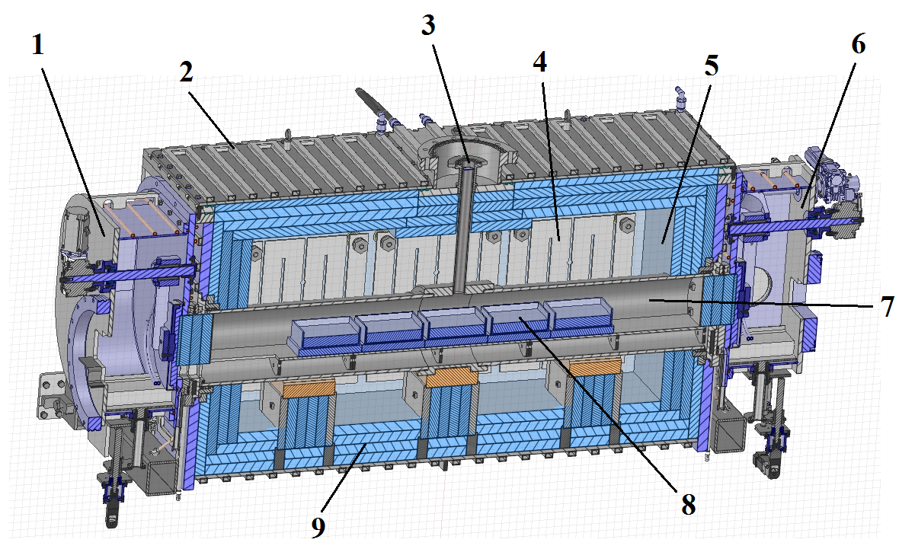
Fig. 1. A 3D model of the furnace for (U, Pu)N carbothermal synthesis: 1, 6 – inlet and outlet airlocks, 2 – water-cooling jacket, 3 – gas outlet pipe, 4 – electric heaters,
5 – furnace housing, 7 – retort, 8 – boats with material, 9 – insulation bricks [5].

The (U, Pu)N sintering occurs in a horizontal pusher-type furnace where the material moves through heating, sintering, and cooling zones (Fig. 2) [6].

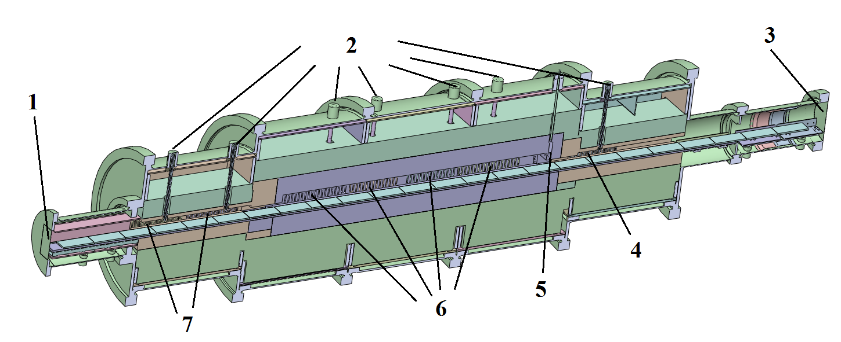
Fig. 2. A 3D model of the (U, Pu)N sintering furnace: 1,3 – argon inlet, 2 – thermocouples,
4 – cooling zone heaters, 5 – nitrogen-hydrogen mixture inlet, 6 – sintering zone heaters,
7 – heating zone heaters.

Refractory ceramic bricks insulate the furnace channel, and the electric heaters run along the side walls of it. The boats with the material sit on the trays that prevent contact between them when they move inside the channel [7].

Technical requirements for high-temperature furnaces
In modeling the high-temperature furnaces for the carbothermal synthesis and sintering, we followed strict temperature and gas composition requirements:
- during the carbothermal synthesis, the material was kept at 1650±50 °C first in nitrogen, and afterwards in the nitrogen-hydrogen mixture, whereas heating and cooling occurred in argon [4, 5, 8],
- during the sintering, the material underwent heating and cooling in argon with a content of nitrogen less than 0.1% vol.; the sintering took place at 1850-1950 °С in the argon-nitrogen-hydrogen medium with a content of nitrogen higher than 50% vol. [3, 4, 6, 7].
Maintaining the required gas compositions in the high-temperature furnace in the above temperature ranges prevented production of unusable higher U nitrides [4].

CFD MODELS OF HIGH-TEMPERATURE FURNACES
In developing the high-temperature furnaces, we encountered several challenges that were resolved by CFD modeling.

Furnace for (U, Pu)N carbothermal synthesis
In designing the batch retort furnace, we followed the heating/cooling rates and isothermal temperature requirements for the charged material. For a simpler and more robust design, we came up with indirect temperature measurements of the product in the retort during the carbothermal synthesis by measuring the temperature of the heaters. The designing included a feasibility study and determination of the operating conditions for the heaters to ensure a uniform temperature distribution throughout the material.
The validation of the thermophysical operating conditions, the analysis of the temperature profile in the product, and the gas flows in the carbothermal synthesis zone under isothermal conditions required CFD modeling of the furnace. The CFD model was developed with SolidWorks Flow Simulation and validated during experiments in the carbothermal synthesis furnace [8, 9]. The numerical analysis of the validated CFD model determined the temperature distribution throughout the material as a function of the heater temperature, the gas flow rate and temperature in the retort. The numerical analysis provided the temperature variations for the heaters, the gas temperature and flow rates in the retort to ensure the temperature profile of 1650±50 °С throughout the material.
Also, the CFD model analyzed operation of the furnace under emergency conditions. Possible deviations from the design basis conditions in case of an emergency affect the temperature profile in the furnace and the material. This required assessing the impact of emergency conditions on the operating conditions.
The thermophysical conditions were analyzed for the following emergencies:
- failure of one or two out of three heater sections,
- partial or full outage of the water cooling system,
- partial or full outage of the gas supply.

(U, Pu)N fuel sintering furnace
Metallurgy and other industries have used proved gas composition control solutions [10, 11]. For example, dampers, partitions, or screens close the furnace channel and separate the internal volume into several temperature zones with specified gas media. Additional design requirements associated with using the nuclear fuel do not allow existing engineering solutions. In addition, gas sampling from the furnace for control and monitoring of the thermophysical processes is hard because of high operating temperatures (up to ~1950 °C). So, our decision was to ensure the required gas compositions with new justified engineering solutions making the design simple and robust. We came up with designing barriers (“bottle necks” in the channel) and gas inlet/outlet units. Also, we determined the in-channel conditions (a temperature profile, flow rates for argon and the nitrogen-hydrogen mixture, and gas pressure) that separated the gas media [7]. Calculations and experiments (Fig. 3) validated the proposed engineering solutions [6].

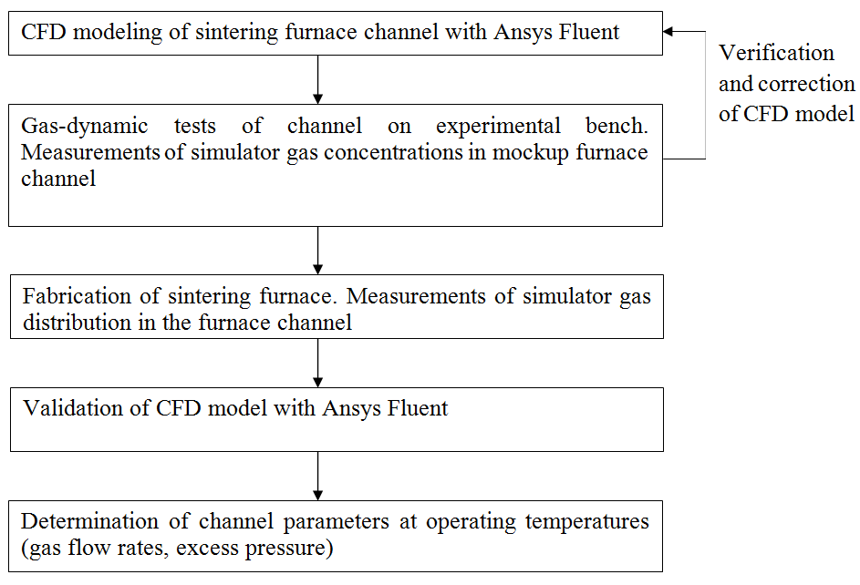
Fig. 3. Validation of the engineering solutions for the furnace channel.

Following the above procedure, we developed a CFD model of the furnace channel and validated the proposed engineering solutions with Ansys Fluent. The simulator gas concentrations at ambient temperature introduced corrections to the CFD model. We received the data from the experiment in the mockup furnace channel that made part of the gas-dynamic experimental bench (Fig. 4) [7]. The mockup is a full-scale furnace channel.

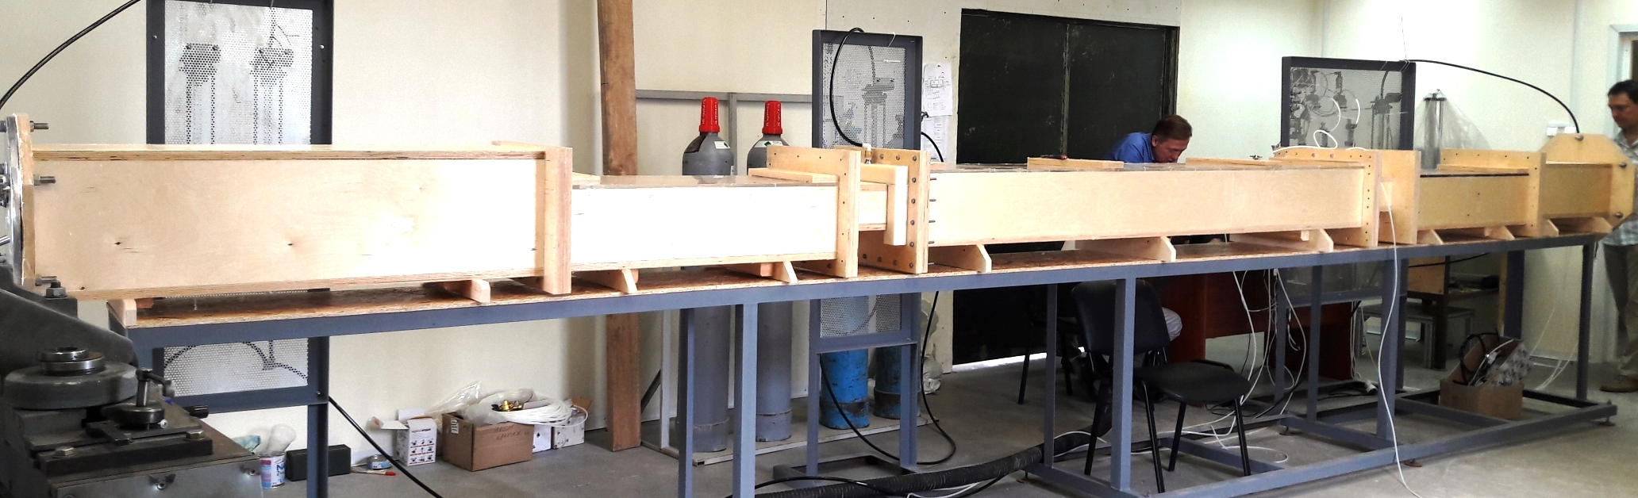
Fig. 4. Experimental bench for gas-dynamic tests [7].

The mockup channel implemented the proposed engineering solutions and gave experimental data on the gas simulator concentrations at ambient temperature. The data validated the CFD model that, in its turn, allowed determining the conditions (gas flow rates and excess pressure at the specified temperature of the heaters) for maintaining the required gas compositions in the furnace channel at operating temperatures.
As with the carbothermal synthesis furnace, the sintering furnace did not provide direct temperature measurements. The temperature was determined through the temperature of the heaters. Monitoring the heating/cooling rates involved a risk of possible damage to the heaters and ceramic insulation. The risk arose from the strictly limited heating/cooling cycles; so, this process required designing a mockup high-temperature furnace module. The insulating covers at both ends of the mockup module simulated the thermal conditions in the real module (Fig. 5). Also, we modeled a CFD module with SolidWorks Flow Simulation to support the designing and operation of the mockup furnace module.

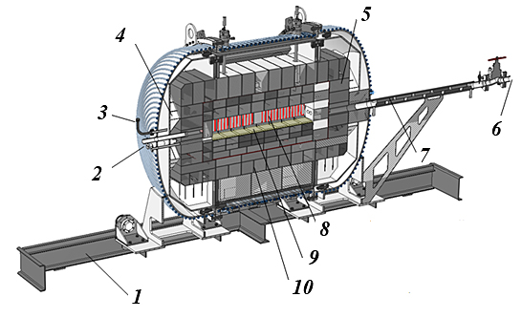
Fig. 5. Design of the mockup module of the sintering furnace: 1 – support frame; 2 – gas inlet; 3 – pressure transmitter adapter; 4 – insulated cover; 5 – insulated cover; 6 – gas outlet; 7 – heat exchanger;
8 – heater; 9 – hearth; 10 – insulation bricks.

results OF CFD modeling of high-temperature furnaces

Furnace for (U, Pu)N carbothermal synthesis
The experimental data validating the CFD model included the product temperature profiles for the end and central boats during heating, under isothermal conditions, and cooling in the temperature range from 20 to 1650 °С. The relative discrepancy between the calculated and experimental temperatures in the end and central boats under isothermal conditions was 0.7% and 0.1%, respectively (Fig. 6). The maximum relative deviation of the calculated average rate of the material heating and cooling did not exceed 7.6% and 10%, respectively [8].

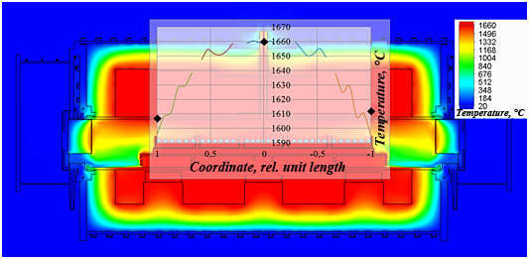
Fig. 6. Temperature profile over the surface of the material under isothermal conditions:
▬▬ – calculated; ♦ – experimental [11].
The CFD model verified the design solutions and identified operating conditions for the carbothermal synthesis furnace. According to the modeling results, the existing range of controlled parameters, including the temperature (power) of the heaters, the inlet gas temperature and flow rate, maintained the temperature of 1650±50 °С in the material required for the (U, Pu)N carbothermal synthesis. Fig. 7 shows the calculated temperature on the upper surface of the material along the longitudinal axis of the retort for the temperature of the heaters from 1670 to 1720 °С, the flow rate of 7 m³/h and argon temperature of 20 °С. The calculations showed that the maximum difference in temperature in the material did not exceed 62 °С.

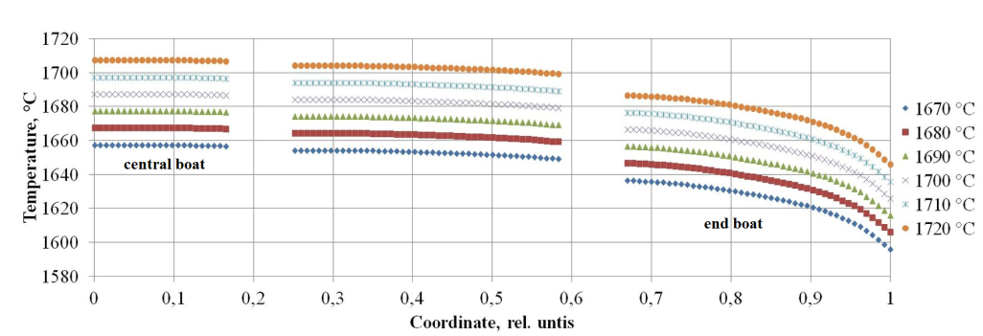
Fig. 7. Temperature profile throughout the material at the inlet gas rate of 7 m³/h
and different temperatures of the heaters.

Analysis of the gas flows in the retort showed that argon and the nitrogen-hydrogen mixture blew over the entire amount of the product in the reaction zone (Fig. 8).

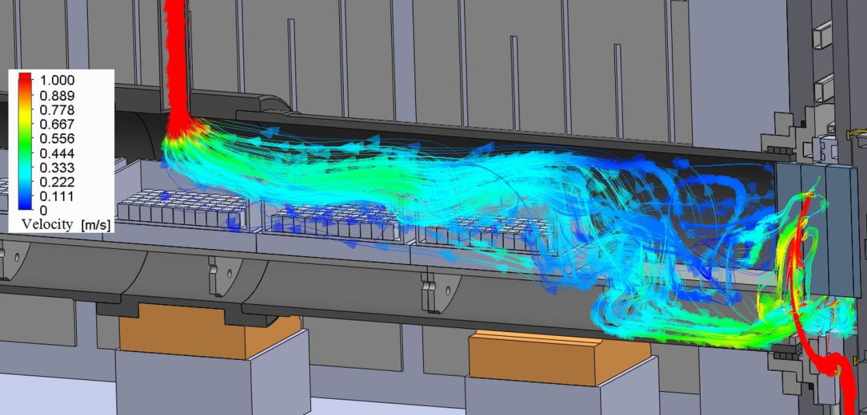
Fig. 8. Typical gas flows in the reaction zone of the carbothermal synthesis furnace.

In addition, we used the CFD model to analyze hypothetical beyond design-basis accidents for the carbothermal synthesis furnace. For example, when the central pair of heaters was off and the side heaters maintained the desired temperature, we observed the temperature on the central pair of the heaters first reducing continuously for a short time, and then reaching a steady-state value. With a slight delay, the temperature of the product in the central boat reduced continuously by 11 °C and reached a steady-state value, too. The temperature change in the end boats was insignificant.

(U, Pu)N sintering furnace
We built an experimental bench to verify and correct the developed CFD model. The relative deviation of the measured volumetric concentrations of the simulator gas from the calculated values at sampling points of the mockup furnace channel at an ambient temperature was satisfactory and did not exceed 17%. The numerical analysis and experiments proved the adequacy of the modeling, good performance of the barriers and gas inlet/outlet units, ensuring the required gas compositions in the sintering furnace channel. We implemented and verified these engineering solutions in the real sintering furnace channel. Fig. 9 presents the calculated and measured volumetric concentrations of the simulator gas in the sintering furnace channel for one of the test options [6].

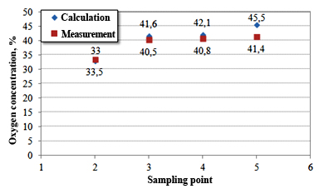
Fig. 9. Calculated and measured volumetric concentrations of the simulator gas in the sintering furnace channel [6].

The maximum relative discrepancy of the calculated and measured volumetric concentrations of the simulator gas was below 12% under all test conditions. Thus, the developed CFD model justified conditions (a temperature profile of the channel, a flow rate of argon and the nitrogen-hydrogen mixture, inner gas pressure) for maintaining the gas compositions in the furnace channel at operating temperatures.
The chosen geometry of the furnace channel and the determined parameters satisfy the gas composition requirements for different temperature zones. Fig. 10 shows the area in the sintering furnace channel where the nitrogen concentration was higher than 50 vol.% at the operating temperature in the sintering zone.

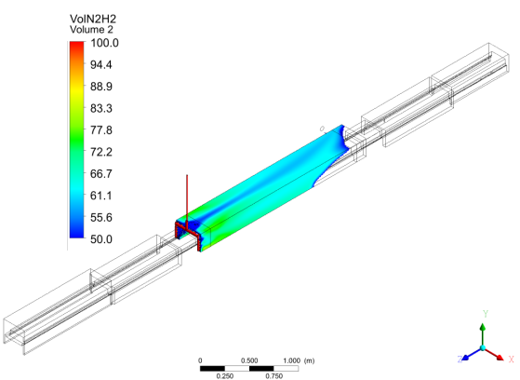
Fig. 10. Nitrogen profile at operating temperature in the sintering furnace channel (the volumetric concentration of nitrogen is higher than 50 vol.%) [6].

The calculations and the experiments on the mockup high-temperature module of the sintering furnace enabled us to get temperature-time dependencies for the locations of the material and on the standard thermocouples. Fig. 11 shows the calculated and measured temperatures on the standard thermocouples.

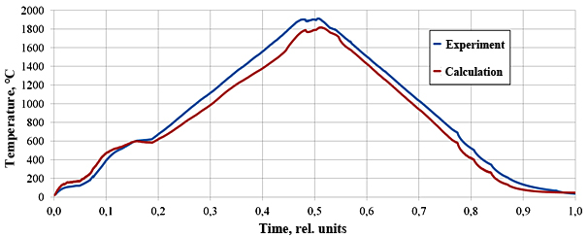
Fig. 11. The temperature on the standard thermocouples of the mockup high-temperature module.

The maximum relative deviation of the measured temperatures from the calculated values around the product and on the standard thermocouples was less than 7.6% under isothermal conditions. The analysis of the CFD model of the mockup high-temperature module showed that the hearth temperature around the product was higher than on the standard thermocouples by 50-80 °C.

Conclusions
The CFD models justified new engineering solutions for the high-temperature furnaces for the (U, Pu)N fuel fabrication and gave recommendations on the operating conditions. In particular:
- The developed and validated CFD model of the furnace for (U, Pu)N carbothermal synthesis showed that the range of controlled parameters (the temperature (power) of the heaters, the inlet gas temperature and flow rate) maintained the temperature throughout the material at 1650±50 °С making the carbothermal synthesis possible. The maximum temperature non-uniformity did not exceed 62 °С. The analysis of the gas flows in the retort showed that argon and the nitrogen-hydrogen mixture flew all over the product in the reaction zone. We simulated the beyond design-basis emergencies and found out that they did not affect the temperature of the material.
- We used the developed and validated CFD model of the sintering furnace channel to justify new engineering solutions that set up and maintained three gas zones in the furnace channel: 1) argon, 2) argon-nitrogen-hydrogen, and 3) argon. The barriers, gas inlet/outlet units, and operating conditions (the temperature distribution throughout the channel, the flow rate of argon and the nitrogen-hydrogen mixture, inner gas pressure) separated the gas media in the furnace channel well.

The developed CFD models allowed various operation simulations, including emergencies, and can support the operation of the high-temperature furnaces. The experience in CFD modeling can help designing different high-temperature furnace equipment.

References
- Silva J., Teixeira J., Teixeira S., Preziati S., Cassiano J., CFD modeling of combustion in biomass furnace, Energy Procedia Vol. 120 (2017), 665-672.
- Arkhazloo N.B., Bouissa Y., Bazdidi-Tehrani F., Jadidi M., Morin J.B., Jahazi M., Experimental and unsteady CFD analyses of the heating process of large size forgings in a gas-fired furnace, Case studies in thermal engineering Vol. 14 (2019), 100428.
- Denisov A., et. al., “Key features of design, manufacturing and implementation of laboratory and industrial equipment for Mixed Uranium-Plutonium Oxide (MOX) and Nitride fuel pellets fabrication in Russia”, International conference on fast reactors and related fuel cycles: next generation nuclear systems for sustainable development FR17 (Proc. Int. Conf., Yekaterinburg, 2017), IAEA, Vienna (2018), Paper IAEA-CN245-563.
- Alekseev S., Zaytsev V., Nitride fuel for nuclear industry, Tekhnosfera, Moscow (2013).
- Smirnov V., et al., Carbothermal synthesis facility for mixed nitride uranium-plutonium fuel materialion, Atomnaya Energiya Vol. 125 (2018), 284-287.
- Shamsutdinov R., et al., Theoretical and experimental justification of the furnace channel design for sintering of mixed nitride uranium-plutonium fuel pellets, V international scientific and technical conference “Innovative designs and technologies of nuclear power” Int. Conf., Moscow, 2018), JSC NIKIET, Moscow (2018).
- Kuzmin I., et al., Experimental bench for gas-dynamic investigations of the furnace channel for a nuclear fuel sintering, Izvestija vuzov. Yadernaya energetika, Issue 4 (2018), 53-63.
- Shamsutdinov R., et al., Development and verification of the CFD model of the carbothermal synthesis furnace for uranium and plutonium nitrides, Izvestija vuzov. Yadernaya energetika, Issue 4 (2019), 130-141.
- Sobachkin A., Dumnov G., Numerical basis of CAD-embedded CFD, Dassault systems, Waltham (2014).
- Silva G.R.C., et. al., Techniques and tips to optimize, control and stabilize the atmosphere inside a continuous sintering furnace, Materials science forum V. 727-728 (2012), 404-411.
- Feldbauer S.L., “A review of the fundamentals of stainless steel brazing in a continuous style, controlled atmosphere brazing furnaces”, 3rd International brazing and soldering conference (Proc. Int. Conf., San Antonio, 2006), ASM Intrenational, San Antonio (2006).
- Ansys Inc., Ansys Fluent theory guide, Ansys, USA (2011).

