Integral code COMPLEX for radiation

safety assessment of reactor and

nuclear fuel cycle facilities

A.A. BELOV¹, V.P. BEREZNEV¹, G.S. BLOKHINA¹, D.A. KOLTASHEV¹, V.S. POTAPOV¹, K.S. KHACHATRIAN¹, O. I. CHERTOVSKIKH¹, A.V. SHERSHOV¹

¹Nuclear Safety Institute of the Russian Academy of Sciences, Moscow, Russian Federation

Email contact of corresponding author: bvp@ibrae.ac.ru

Abstract

The computational code COMPLEX [1] for radiation safety substantiation of reactor and nuclear fuel cycle facilities is a set of programs combined by exchange data files and a pre- and post-processing system. The code is under development at the Nuclear Safety Institute of the Russian Academy of Sciences (IBRAE RAN) in frame of «Breakthrough» (or Proryv) project. The code includes the following modules:
- reactor core calculation modules based on diffusion approximation (DOLCE VITA [2]) and discrete ordinates method (CORNER [3]);
- nuclide kinetics module (BPSD [4]);
- radiation sources calculation module (RASTAS_M [5]);
- radiation shielding calculation module based on finite element method (ODETTA [6]);
- reactor core and radiation shielding calculation module based on Monte Carlo method (MCU-FR [7]);
- group constants system (CONSYST/ABBN-RF [8]).
These modules are certified (except RASTAS_M) in Rostechnadzor and are used for nuclear and radiation safety calculated substantiation of liquid metal coolant reactors and nuclear fuel cycle facilities in various organizations of the nuclear industry in Russia. The development of an integrated code based on existing and widely used modules allows providing of various neutron processes simulation at different steps of nuclear facilities design and operating with unified user interfaces, nuclear data libraries, pre- and post-processing systems.

Code description in brief
The field of application for integrated code COMPLEX includes storage and transport facilities for fresh and spent assemblies, reactor core, reactor facility, nuclear power plants equipment and premises, closed nuclear fuel cycle facilities.
Figure 1 presents a block diagram of code operation.
The most complete calculation procedure of COMPLEX code includes the following steps:
- At the first step neutron flux distribution is calculated (for fuel assembly, control rod, other design elements);
- At the second step fuel/absorber burn-up and constructed materials activation are calculated with option of iterative modules operation (in steps of burn-up);
- At the third step sources of ionizing radiation for materials, assemblies or assembly types are calculated;
- At the fourth stage, the transport problem with source term is solved and the equivalent dose rate is calculated for detecting points.
The shortest calculation procedure includes two steps. At the first step the source is calculated using pre-prepared material model (or imported). At the second step the transport problem with source term is solved using ODETTA or MCU-FR for equivalent dose rate calculation.

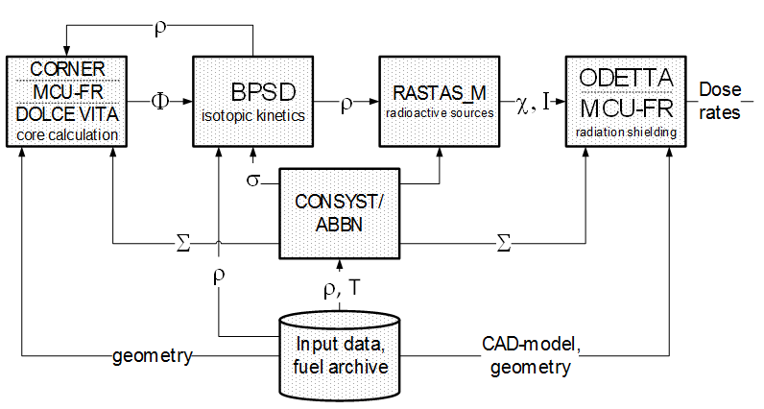
Fig. 1. Block diagram of code operation

Calculation modules description
The CORNER core calculation module is designed for fast breeder reactors (FBR) and their models on critical stands in stationary and non-stationary states under the normal operating conditions and violations of normal operation in three-dimensional hexagonal (HEX-Z) geometry using nested grids. The module provides the solution of direct and conjugate homogeneous stationary problem using the power method and non-stationary problem using the adiabatic approximation or implicit time scheme. The energy dependence is represented by a multi-group approximation using the CONSYST-RF constant preparation system with the ABBN-RF nuclear data library. Every group equation is solved by a fixed point iteration method. The discrete ordinates method is used to approximate the angular dependence. Anisotropic scattering is represented by Legendre polynomials up to the 5th order. For spatial approximation weighted diamond finite-difference schemes with a zero fixup are used. MPI and OpenMP parallel technologies are implemented in the module.
The DOLCE VITA module is designed for neutronic calculations of fast reactor cores in structured cells of HEX-Z geometry in the diffusion approximation. As objects of modelling, the cores of fast reactors with fuel assemblies and control rods and their elements (fuel and absorbing rods, ducts) are considered. The module provides the ability to set the geometry from assembly-by-assembly to pin-by-pin, accurately modelling a detailed description of both the macro- and microstructure of the reactor and allowing reducing the calculated uncertainties when evaluating the neutron functionals. The module implements neutronic models that make it possible to simulate stationary states at permitted power levels, transient states, including bringing a shutdown reactor to a critical state, raising power to a minimum controlled level, raising power to an energy level, controlled change in reactor power, planned and emergency shutdown of the reactor, emergency modes associated with a single failure of normal operation systems with, in addition, a single failure of safety systems.
The BPSD module of nuclide kinetics, activity and decay heat calculation solves the following tasks: calculation of changes in fuel composition; calculation of the fission-product build-up; calculation of changes in the composition of the absorber; calculation of the coolant and structural materials activation taking into account impurities; calculation of the irradiated materials activity for subsequent decay heat calculation. The following objects of modelling are considered: fuel, absorbing and structural materials of fuel assemblies, control rods, core assemblies with impurities; liquid metal coolants with impurities; radiation shielding elements, reactor vessel and other elements under the neutron irradiation; targets of materials placed in the core and exposed to neutron irradiation. The module provides the calculation of the functionals and characteristics determined by it for the simulated object under normal operating conditions, including the subcritical state, and violations of normal operation.
The RASTAS_M module of ionizing radiation source calculating is designed to calculate the yield and spectrum of neutrons formed as a result of (α, n)-reaction on nuclei of light elements and neutrons of spontaneous fission; calculation of the yield and spectrum of X-ray bremsstrahlung generated by conversion electrons and β-particles; calculation of the photon radiation intensity emitted during the α- and β-decays of radioactive nuclides. An integral part of RASTAS_M is a set of libraries with data required for calculation.
The ODETTA module is designed for numerical simulation of neutron and photon transport in stationary states of nuclear facilities. Area of application is shielding compositions of fast breeder reactors with liquid metal coolant and fuel cycle facilities. The stationary multigroup transport equation is solved by the discrete ordinates method and discontinuous linear finite element method on unstructured tetrahedral meshes. Anisotropic scattering is represented by a Legendre polynomial up to the 5th order. It is possible to use triangular quadratures and product type quadratures. Zero (vacuum), mirror, periodic and albedo boundary conditions are implemented in the module. First and last collision techniques are also implemented. The CONSYST-RF constant preparation system with the ABBN -RF nuclear data library is used. To calculate linear flux functionals, spatial interpolation over the vertices of the tetrahedra is used. The calculation code supports the OpenMP interface for parallel computing. The open integrated platform SALOME is used for the construction of unstructured tetrahedral meshes and work with CAD-models.
The MCU-FR module based on Monte Carlo method is designed for core and radiation safety calculations. The module can simulate neutron, photon and electron transport in three-dimensional geometry by analog and non-analog (weight) Monte Carlo methods based on estimated nuclear data. The MCU-FR belongs to the 6th generation of the MCU project programs, which has been developing at the National Research Center "Kurchatov Institute" since 1982. The code includes the MDBFR60 databank based on the ROSFOND estimated neutron data files [9].

The cask model calculation
The cask ТУК-11БН designed for BN-600 SFA transportation was taken as a model for the calculation.
The cask fundamental elements are the vessel and the head. The vessel of the cask is represented as the thick-wall weld-fabricated cylindrical cage made of structural steel. The can 14У is set up in the cask in axial alignment. The can 14У is a cylinder containing 35 tubes for the SFA placement. The tubes are located on the radius of the cylinder at 210 mm (5 tubes), 390 mm (10 tubes), 600 mm (20 tubes). Size of the tubes is 159x4,5. There is the tube Ø159x4,5 designed for hookup with a crane in the center of the can. A 10 mm tube plate is located at the top of the can. The vessel and the head of the cask are made of steel 20. The can and its tubes are made of steel 12X18H10T. The model cavities are filled with nitrogen. The SFA are placed in the tubes. High of the fuel assembly is 3500 mm, can tubes – 3560 mm.
The cask in a cutaway view is presented on the figure 2. Each SFA was homogenized in area of the can cylindrical tube, in which it was placed, but the tube plate wasn’t simulated.
BN-600 experimental fuel assembly filled by BN-1200 fuel elements with mixed nitride uranium-plutonium fuel (U, Pu)-N and nitride-uranium fuel is implemented as a fuel assembly model. Fuel element cladding is designed from steel ЭК164, its diameter is 9,3 mm. There are 61 fuel elements in the fuel assembly. Fuel elements are located in the triangular grid nodes, mesh size is 10,35 mm. The top and the bot of the fuel column are filled by nitrogen. The fuel assembly model was simplified: hexagonal can was closed from above and below by the 5 mm heads, top nozzle and follower of the fuel assembly was simulated as a solid cylinder; clad gap wasn’t simulated.
The main fuel assembly and fuel element sizes are presented on figure 3.
The core filled homogenized fuel assemblies was calculated by the module DOLCE VITA. At the result neutron flux density distribution in 26 energy groups was received. The calculation was conducted by the time of the burning interval start.
Then the fuel burnup was calculated by the module BPSD. The neutron flux density and captures received by CONSYST/ABBN-RF were used as inputs. 47 actinides and 428 fission products nuclides were kept in the calculation. But the reactor shutdowns between burnup intervals wasn’t simulated. Overall irradiation time of the fuel assemblies is 592 effective days. After that fuel assembly was placed to in-vessel storage for 160 days (to decrease activity/afterheat). In the end the fuel assembly placement in the fuel pond for 100 days was simulated.

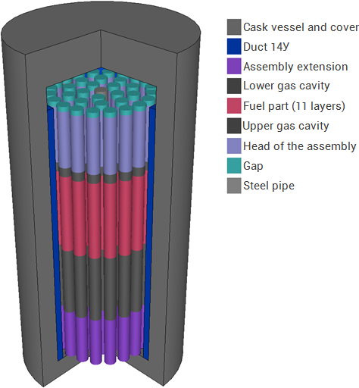
Fig. 2. The cask model (cutaway view)

Fig. 3. The main fuel assembly and fuel element sizes, mm

The nuclei concentrations axial distribution of the nitrogen and effective fission products at the end of the fuel cycle was presented in table 1.

TABLE 1. THE NUMBER DENSITIES OF THE NITROGEN AND EFFECTIVE FISSION PRODUCTS AXIAL DISTRIBUTION AT THE END OF THE FUEL CYCLE, BURNUP AT 852 DAYS

№ | Axial thickness, mm | Comment | N,  cm⁻³⋅10²⁴ | FP35,  cm⁻³⋅10²⁴ | FP39,  cm⁻³⋅10²⁴ | burnup, % h.a.
11 | 93,6 | Сore,  (U,Pu)-N fuel | 2,712E-02 | 1,338E-04 | 6,590E-04 | 2,8
10 | 93,6 |  | 2,712E-02 | 1,669E-04 | 8,189E-04 | 3,5
9 | 93,6 |  | 2,712E-02 | 1,914E-04 | 9,477E-04 | 4,1
8 | 93,6 |  | 2,712E-02 | 2,084E-04 | 1,045E-03 | 4,5
7 | 93,6 |  | 2,712E-02 | 2,164E-04 | 1,089E-03 | 4,7
6 | 93,6 |  | 2,712E-02 | 2,154E-04 | 1,084E-03 | 4,7
5 | 93,6 |  | 2,712E-02 | 2,054E-04 | 1,029E-03 | 4,4
4 | 93,6 |  | 2,712E-02 | 1,860E-04 | 9,285E-04 | 4,0
3 | 93,6 |  | 2,712E-02 | 1,549E-04 | 7,884E-04 | 3,4
2 | 93,6 | blanket, UN fuel | 3,13E-02 | 1,399E-04 | 1,059E-04 | 0,8
1 | 87,3 |  | 3,13E-02 | 8,171E-05 | 6,665E-05 | 0,5

Then ionizing radiation source was calculated by the module RASTAS_M. The neutron and photon sources rates for irradiated uranium-nitride and (U, Pu)-N fuel respectively in full burnup are presented on the figure 4 and 5.

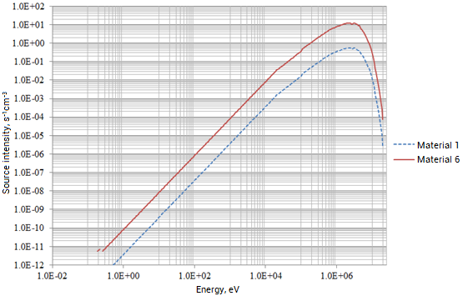
Fig. 4. Neutron source intensity

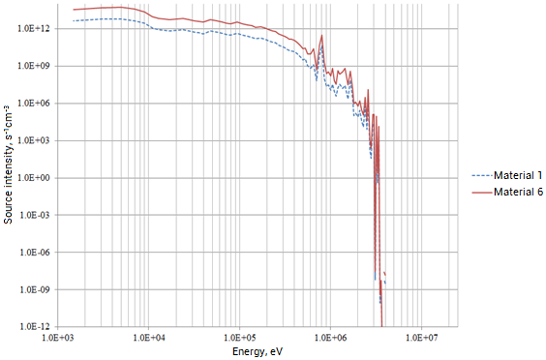
Fig. 5. Photon source intensity

On the final step shielding calculations were conducted by module MCU-FR and the dose equivalent rate on the cask surface was calculated. The main contribution in the dose equivalent is made by primary photon emission (fig. 6).
Махimum total calculation levels of the emission are:
- no more than 4,6 mSv/h on the cask surface, that doesn’t exceed the limit 10 mSv/h under the conditions of the exclusive use;
- no more than 1,4 mSv/h at a distance of 1 m from the cask surface;
- no more than 0,6 mSv/h at a distance of 2 m from the cask surface.

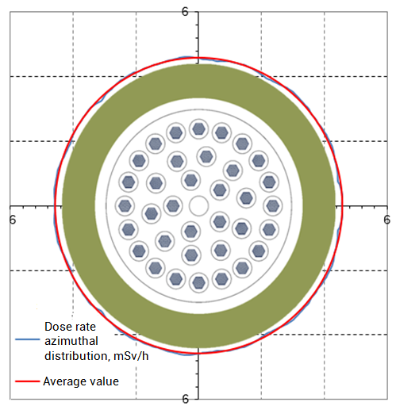
FiG. 6. Primary photon dose equivalent rate distribution on the cask surface

CONCLUSIONS
The paper includes the description of COMPLEX integrated code with its modules, demonstrates calculation capabilities on the example of radiation level assessment model problem for a transport container with spent fuel assemblies.
At present the verification and validation matrix for COMPLEX integrated code has been developed. Basic verification and validation calculations will be completed in 2021. Code COMPLEX submission for Rostechnadzor certification is planned on 2022.
Integrated COMPLEX code will provide radiation safety calculated substantiation of nuclear facilities – storage and transportation facilities for fresh and spent assemblies, reactor core, reactor facility, nuclear power plants equipment and premises, closed nuclear fuel cycle facilities using modern numerical simulating capabilities.

References
- BELOV, A. et al., Programmnyy kompleks rascheta radiatsionnoy bezopasnosti, Voprosy atomnoy nauki i tekhniki. Yaderno-reaktornyye konstanty 2 (2019) 243–255.
- SELEZNEV, YE. et al., DOLCE VITA, Voprosy atomnoy nauki i tekhniki. Yaderno-reaktornyye konstanty 1 (2018) 157–168.
- BEREZNEV, V., Razrabotka neytronno-fizicheskogo koda CORNER dlya analiza statsionarnykh I nestatsionarnykh protsessov v reaktorakh na bystrykh neytronakh. Dissertatsiya na soiskaniye uchenoy stepeni kandidata tekhnicheskikh nauk, Moskva, 2017.
- SELEZNEV, YE. et al., Modernizatsiya programmy rascheta zadachi nuklidnoy kinetiki BPSD, Izvestiya vuzov. Yadernaya Energetika 4 (2018) 115–126.
- KHOMYAKOV, YU., VLASKIN G., Svidetel'stvo o gosudarstvennoy registratsii programmy dlya EVM. Programma RASTAS po raschetu istochnika pronikayushchikh ioniziruyushchikh izlucheniy radioaktivnykh materialov. Data registratsii: 26.09.2019.
- BELOUSOV, V. et al., Nekotoryye rezul'taty verifikatsii koda ODETTA dlya neodnorodnykh zadach, Voprosy atomnoy nauki i tekhniki. Fizika yadernykh reaktorov 3 (2018) 46–53.
- GUREVICH M. et al., Kharakternyye osobennosti MCU-FR, Voprosy atomnoy nauki i tekhniki. Ser. Fizika yadernykh reaktorov 5 (2016) 17–21.
- KOSHCHEYEV V. et al., Biblioteka gruppovykh konstant BNABRF dlya raschetov reaktorov i zashchity. Izvestiya vuzov. Yadernaya energetika 3 (2014) 93–101.
- ZABRODSKAYA S. et al., ROSFOND – rossiyskaya natsional'naya biblioteka neytronnykh dannykh, Voprosy atomnoy nauki i tekhniki. Yadernyye konstanty 1–2 (2007) 3–21.
- BELOV, A. et al., Otsenka radiatsionnoy bezopasnosti transportnogo konteynera pri perevozke otrabotavshego nitridnogo uran-plutoniyevogo topliva BN-600 s ispol'zovaniyem programmy MCU-FR, Voprosy atomnoy nauki i tekhniki. Yaderno-reaktornyye konstanty 2 (2020) 85–95.

