Calculation of the materials activation
with BPSD code

A.A. Belov, M.V. Kryachko, O.I. Chertovskikh
Nuclear Safety Institute of the Russian Academy of Sciences (IBRAE RAN)
Moscow, Russia
Email contact of corresponding author: belov@ibrae.ac.ru

Abstract

The isotopic kinetics code BPSD for activity and decay heat calculation is intended to calculate variations in fuel isotopic composition, structural materials, absorber, coolant under the fast reactor neutron flux and the following radioactive nucleus decay. Results of the structural materials (steel) irradiation by the fusion neutrons spectrum in experiment at the FNS facility calculations and its comparison with the results calculated by FISPACT-II are presented in the paper.

INTRODUCTION
The isotopic kinetics code BPSD [1] is developed by IBRAE RAN in “Codes of New Generation” subproject of “Proryv” project. The BPSD code solves fuel, absorber (boron carbide, dysprosium hafnate) transmutation, coolant (lead, sodium) and steel activation problems. Moreover, it carries out activation inventories and decay heat. The BPSD code is intended to model materials, applied in fast reactors with sodium and lead coolants and closed nuclear fuel cycle facilities.
BPSD is one of the modules of the integral multiphysics EUCLID code used to simulate the liquid metal cooled fast neutron reactor systems under normal operating conditions, anticipated operational occurrences, design basis and severe accidents. Also, BPSD is included in the integral code COMPLEX for radiation safety assessment of reactor and nuclear fuel cycle facilities.
The isotopic kinetics problem is solved for cases with the fixed transmutation chains. Each chain accords to its material. Steel chain contains 501 nuclides, lead chain – 201 nuclides, boron carbide chain – 115 nuclides, dysprosium hafnate – 99 nuclides. The materials impurities were taken into account in the chain design. Two linked transmutation chains (actinide chain and fission products chain) are used in the isotopic kinetic problem solution.
The problem is solved by an iterative method. It enables to calculate any type of transmutation chains and to exclude negative solution appearance. In addition to calculation of the nuclide concentrations, the problem of their uncertainty (caused by input data uncertainty – initial material composition, decay constant, reaction rate) estimation – is solved.
Transmutation chains realized in BPSD code are built on the base of the ROSFOND database [2]. The CONSYST-RF/BNAB-RF [3] system intended to calculate nuclear constants is also used in the code. Well-known experiments to measure fission products by uranium and plutonium isotopes decay heat were used to validate fuel irradiation calculation. In addition, benchmarks based on experiments such as irradiation of the ampoules contained fissile materials and the fuel assemblies with the mixed oxide fuel in the BN-350 core, irradiation of the experimental combined fuel assemblies contained fuel elements with the mixed uranium-plutonium nitride fuel in the BN-600 core were used.
During the validation of the non-fuel materials irradiation authors had some difficulties – lack of the available experimental data related to fast reactors. In the paper results of the structural materials irradiation by the fusion spectrum calculation are presented.

benchmark description

FNS facility
Material samples irradiation experiments were carried using the FNS (Fusion Neutron Source) facility [4] at the Japan Atomic Energy Agency JAEA. Neutron flux was generated by deuterons beam impinging on a stationary tritium-bearing titanium target. The total neutron flux at the sample location, for this experiment, is in the range of 1010 n 〖cm〗^(-2) s^(-1). Thin samples, 25x25〖 mm〗^2 in area, and typically 10 µm thick, have been used, either as metallic foil or powder sandwiched between tape. Use of a thin sample minimises the self-absorption of β rays emitted in the sample itself and allows their measurement. A total of 74 different materials have been used across the different phases of the experiment.
The decay energy in each irradiated sample was measured in the Whole Energy Absorption Spectrometer (WEAS), which comprises two large bismuth-germanate BGO scintillators in a geometric arrangement, provides almost 100 % detection efficiency for both β and γ-rays. The WEAS provides high sensitivity and the wide turndown: from 1 pW to 1 mW.
Correction factors need to be applied for effects such as the self-absorption and the decay heat due to the plastic tape used for the powder samples. The overall experimental uncertainty totals between 6 to 10% in most cases, which is valuable for measurement of some nuclides with long half-lives.

The FISPACT-II code
The FISPACT-II [5, 6] code is developed under the office of United Kingdom Atomic Energy in Culham Science Centre. The FISPACT-II code is a set of the multi-physics codes, solving particle interaction with the materials problem based on the relevant and comprehensive data. The code solves nuclear fusion problems. There are numerous tools to evaluate an uncertainty in the code. Nuclide kinetics problem for fast reactors is a subset of the problems, solved by FISPACT-II. The FISPACT-II code provides calculations, using the nuclear data libraries: TENDL-2017, GEFY-6.1, HEIR-0.1, EAF-2010, ENDF/B-VIII.0, JEFF-3.3, JENDL-4.0 и CENDL-3.1. The FISPACT-II versions are available in the data bank OECD-NEA.

Experiment conditions
Authors were guided by the report [6].
There are 2 experiment series, differing by irradiation time:
- a 5-minute irradiation rapidly followed by a time dependent series of decay power measurements from tens of seconds up to one hour of cooling;
- a 7-hour irradiation, followed by the series of decay power measurements spanning from half a day up to a year of cooling.
In addition, the experiments were conducted in different time periods.. Originally in 1996, 32 relevant materials were irradiated. Additionally, in 1998-99, 74 samples were irradiated.
In the FNS irradiation different sample positions relative to the neutron source were used. After 5-min irradiation a sample were transported from the irradiation zone to the WEAS measurement areas by means of pneumatic tubes. In the 7-hours experiment delivery speed wasn’t so important, thereby other positioning device were used.
The samples irradiation experiments calculated in the project are presented in table 1.

TABLE 1. THE SAMPLES LIST FOR THE SIMULATION MODEL

Sample | Sample form | Experiment
 |  | 5-min irradiation | 7-hours irradiation
Iron | metallic foil | + | +
Chromium | metallic powder | + | +
Nickel | metallic foil | + | +
SS-304 | metallic foil | + | +
SS-316 | metallic foil | + | +

Conditions of the samples irradiation calculation by BPSD code
The spectrum of the 299-group neutron flux (BNAB) used in the BPSD calculations is presented in the figure 1.

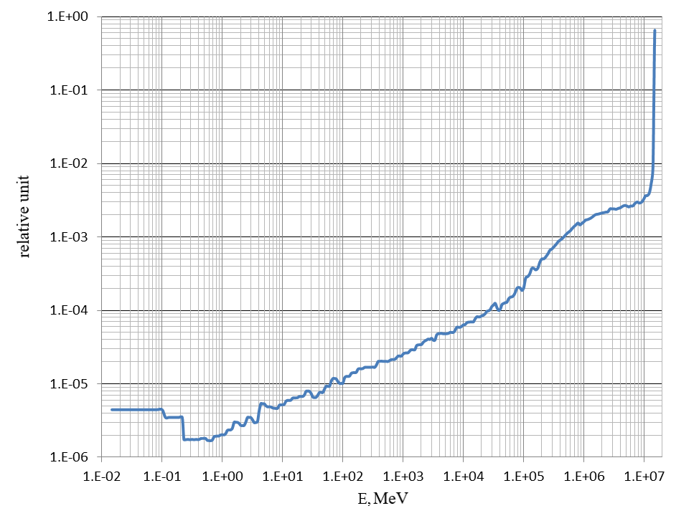
Fig. 1. Spectrum of the neutron flux density.

The neutron flux value for the 5-min irradiation experiment is 1.135·10¹⁰ n·sm⁻²s⁻¹, for the 7-hours experiment – 1.050·10¹⁰ n·sm⁻²s⁻¹.
Any impurity in the samples wasn’t taken in account in FISPACT-II calculations. It’s expected that, the materials are “clear” – only the main chemical elements – components of the matter were calculated. The same was expected in the BPSD code.
The BPSD code can use the shielding microscopic cross sections prepared by the CONSYS/BNAB-RF system. In this case, the thick material samples were simulated, so non-blocked microscopic cross sections taken from 309 section of the nuclear library called BNAB-RF-2020 were used. This set of the microscopic cross sections is used in the BPSD code by default.
The calculation is performed in 2 steps. At the first step the irradiation calculation is performed, at the second – the decay calculation. The internal step was selected through the comparison with the calculated nuclear concentrations of the basic isotopes. The step values for the irradiation and decay calculations are presented in table 2.

TABLE 2. STEP VALUES ADOPTED FOR THE CALCULATIONS

Value | Experiment type
 | 1 | 2
Irradiation time | 5-min | 7-hours
Measurement time | 1hour | 1 year
Irradiation calculation step | 0.01 s | 1 s
Decay calculation step | 1 s | 10000 s

During the comparison with the experiment values and the FISPACT-II calculation values calculated by BPSD were converted to micro-W/g.

Calculation results
Results of the decay heat calculation of the iron sample (5-min irradiation and 7-hours decay) are presented in the figure 2. The nuclides made the main contribution in the decay heat are presented in the figure. The decay heat values under 7-hour irradiation are shown in the tables 3 and 4.

a) 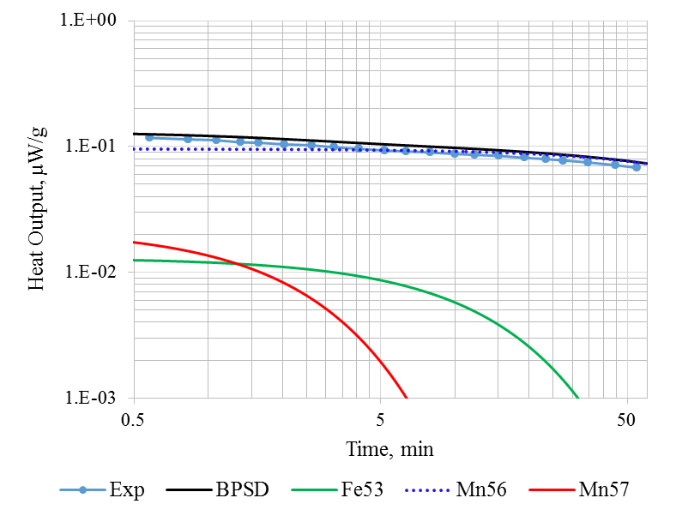 b)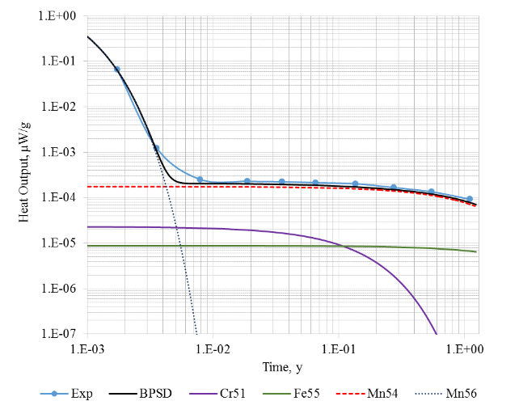
Fig. 2. Fe sample decay heat under 5-min (a) and 7-hours (b) irradiation.

TABLE 3. DECAY HEAT CALCULATION DEVIATIONS FROM EXPERIMENT. IRON 7-H IRRADIATION

Times, days | FNS exp., µW/g | FISPACT-II |  | BPSD
 |  | µW/g | С/Е | µW/g | С/Е
0.63 | 6.58E-02±5% | 6.85E-02 | 1.041 | 6.74E-02 | 1.024
1.3 | 1.23E-03±5% | 1.17E-03 | 0.951 | 1.08E-03 | 0.876
2.88 | 2.53E-04±6% | 2.17E-04 | 0.858 | 2.05E-04 | 0.810
6.89 | 2.30E-04±6% | 2.13E-04 | 0.926 | 2.01E-04 | 0.875
12.88 | 2.25E-04±6% | 2.08E-04 | 0.924 | 1.96E-04 | 0.872
23.89 | 2.14E-04±6% | 1.99E-04 | 0.930 | 1.88E-04 | 0.878
49.72 | 2.03E-04±6% | 1.82E-04 | 0.897 | 1.72E-04 | 0.849
99.91 | 1.67E-04±7% | 1.59E-04 | 0.952 | 1.51E-04 | 0.902
200.13 | 1.35E-04±7% | 1.27E-04 | 0.941 | 1.20E-04 | 0.891
402.95 | 9.24E-05±11% | 8.23E-05 | 0.891 | 7.83E-05 | 0.848

Iron decay heat calculation uncertainty is 15%, the sign and the deviation rate correspond to the FNS calculation.
Results of the decay heat calculation of the chromium sample (5-min irradiation and 7-hours decay) are presented in the figure 3.

a)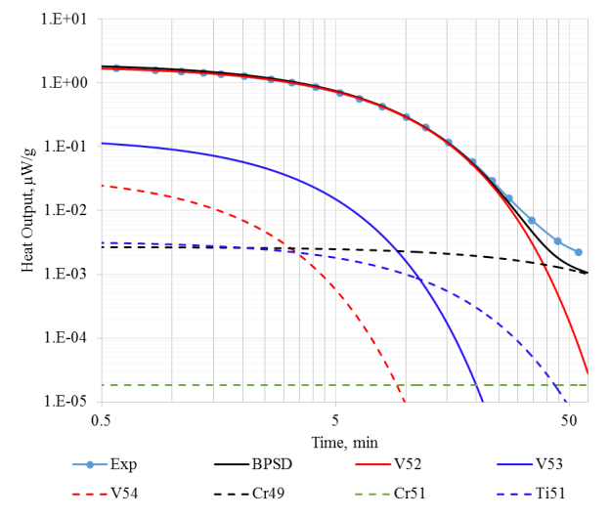 b)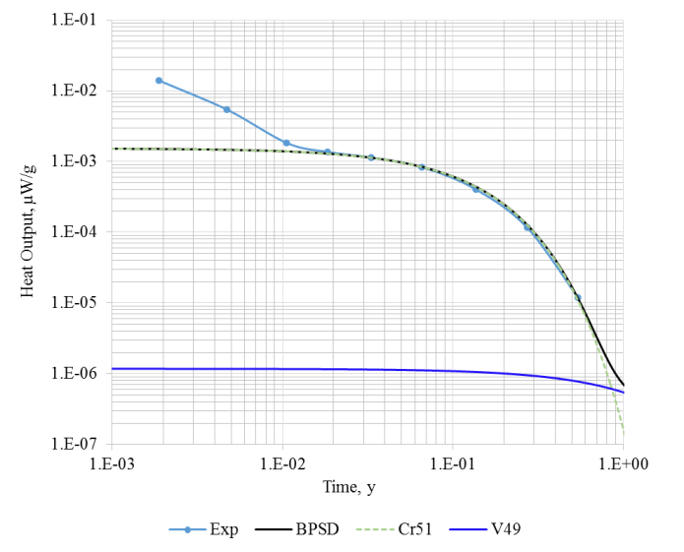
Fig. 3. Cr sample decay heat under 5-min (a) and 7-hours (b) irradiation.

TABLE 4. DECAY HEAT CALCULATION DEVIATIONS FROM EXPERIMENT. IRON 7-H IRRADIATION

Times, days | FNS exp., µW/g | FISPACT-II |  | BPSD
 |  | µW/g | С/Е | µW/g | С/Е
0.69 | 1.40E-02±6% | 1.46E-03 | 0.104 | 1.51E-03 | 0.108
1.74 | 5.39E-03±6% | 1.43E-03 | 0.265 | 1.47E-03 | 0.273
3.89 | 1.83E-03±6% | 1.35E-03 | 0.738 | 1.39E-03 | 0.762
6.75 | 1.37E-03±6% | 1.26E-03 | 0.920 | 1.30E-03 | 0.947
12.2 | 1.14E-03±6% | 1.10E-03 | 0.965 | 1.13E-03 | 0.993
24.21 | 8.31E-04±6% | 8.12E-04 | 0.977 | 8.39E-04 | 1.009
49.96 | 4.03E-04±6% | 4.18E-04 | 1.037 | 4.41E-04 | 1.094
100.09 | 1.15E-04±6% | 1.11E-04 | 0.965 | 1.26E-04 | 1.099
197.96 | 1.18E-05±26% | 1.04E-05 | 0.881 | 1.16E-05 | 0.984

The deviations from experiment at the start of time interval (7-h irradiation fig. 3 b)) is most likely caused by the impurities occurrence in the sample. This conclusion was made by authors of [6]. On the other interval sections the deviation C/E is about 10%.
Results of the decay heat calculation of the nickel sample (5-min irradiation and 7-hours decay) are presented in the figure 4.

a)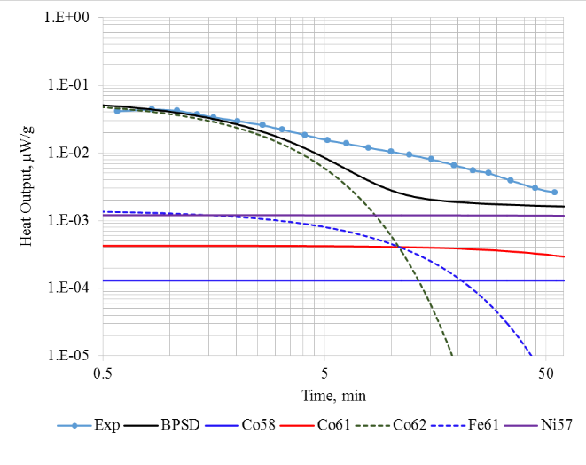 b)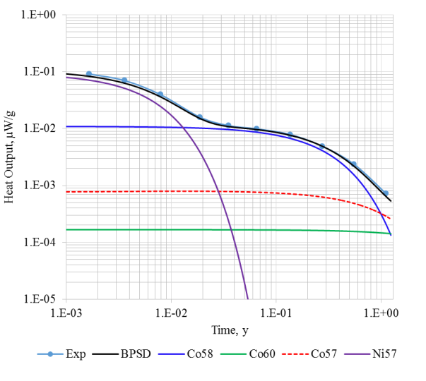
Fig. 4. Ni sample decay heat under 5-min (a) and 7-hours (b) irradiation.

TABLE 5. DECAY HEAT CALCULATION DEVIATIONS FROM EXPERIMENT. NICKEL 7-H IRRADIATION

Times, days | FNS exp., µW/g | FISPACT-II |  | BPSD
 |  | µW/g | С/Е | µW/g | С/Е
0.6 | 9.17E-02±5% | 9.67E-02 | 1.055 | 8.33E-02 | 0.909
1.31 | 7.01E-02±5% | 7.15E-02 | 1.020 | 6.31E-02 | 0.900
2.89 | 3.96E-02±5% | 3.99E-02 | 1.008 | 3.61E-02 | 0.913
6.86 | 1.59E-02±5% | 1.59E-02 | 1.000 | 1.51E-02 | 0.949
12.85 | 1.13E-02±5% | 1.12E-02 | 0.991 | 1.09E-02 | 0.963
23.85 | 9.92E-03±5% | 9.87E-03 | 0.995 | 9.64E-03 | 0.972
49.7 | 7.87E-03±5% | 7.83E-03 | 0.995 | 7.64E-03 | 0.970
99.89 | 4.92E-03±5% | 5.07E-03 | 1.030 | 4.92E-03 | 1.000
200.11 | 2.37E-03±5% | 2.30E-03 | 0.970 | 2.19E-03 | 0.924
402.94 | 7.27E-04±6% | 7.10E-04 | 0.977 | 6.48E-04 | 0.891

There are no cobalt metastable isotopes (Co-58m, Co-60m and Co-62m) in the transmutation chain realized in the BPSD. It leads to decreasing of the decay heat values under the small irradiation and decay times. At the decay time equal to 12 hours the deviation C/E is about 10%.
Results of the decay heat calculation of the steel SS-304 sample (5-min irradiation and 7-hours decay) are presented in the figure 5.

a)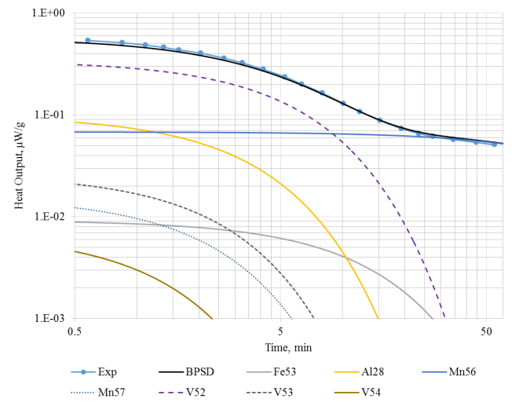b)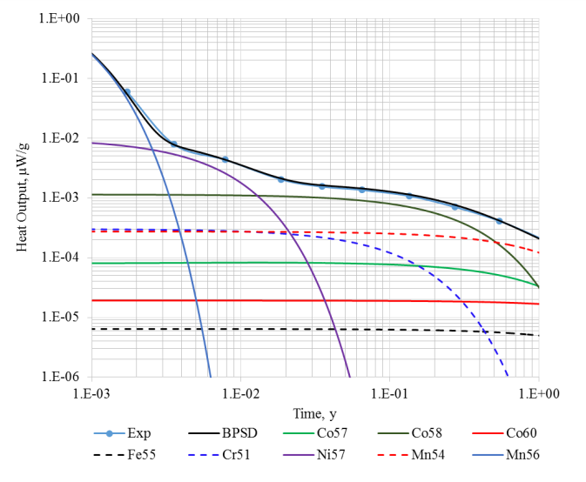
Fig. 5. SS-304 sample decay heat under 5-min (a) and 7-hours (b) irradiation.

TABLE 6. DECAY HEAT CALCULATION DEVIATIONS FROM EXPERIMENT. STEEL SS-304 7-H IRRADIATION

Times, days | FNS exp., µW/g | FISPACT-II |  | BPSD
 |  | µW/g | С/Е | µW/g | С/Е
0.63 | 5.90E-02±6% | 5.47E-02 | 0.927 | 5.70E-02 | 0.966
1.3 | 7.85E-03±5% | 7.51E-03 | 0.957 | 7.78E-03 | 0.991
2.88 | 4.32E-03±5% | 4.05E-03 | 0.938 | 4.34E-03 | 1.004
6.85 | 2.02E-03±5% | 1.90E-03 | 0.941 | 2.10E-03 | 1.042
12.84 | 1.54E-03±5% | 1.44E-03 | 0.935 | 1.63E-03 | 1.056
23.84 | 1.35E-03±5% | 1.27E-03 | 0.941 | 1.44E-03 | 1.063
49.69 | 1.07E-03±5% | 1.00E-03 | 0.935 | 1.13E-03 | 1.058
99.88 | 7.03E-04±5% | 6.71E-04 | 0.954 | 7.62E-04 | 1.084
200.1 | 4.08E-04±5% | 3.66E-04 | 0.897 | 4.12E-04 | 1.010
402.93 | 1.94E-04±7% | 1.65E-04 | 0.851 | 1.86E-04 | 0.956

The derivation C/E is within 10% at the all times. The BPSD calculation result fits in well with the result made by FISPACT-II.
Results of the decay heat calculation of the steel SS-316 sample (5-min irradiation and 7-hours decay) are presented in the figure 6.

a)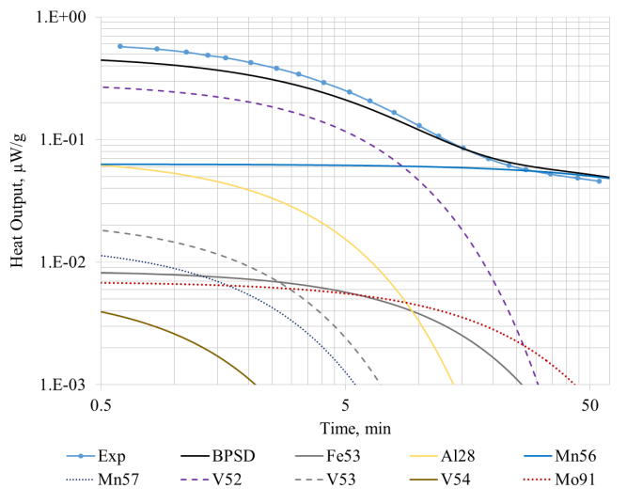b)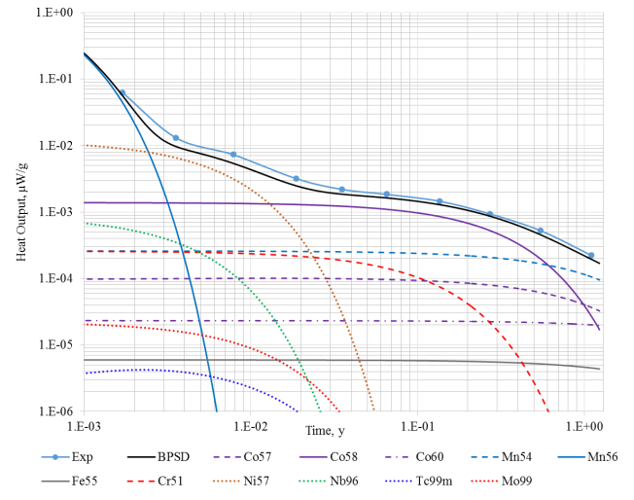
Fig. 6. SS-316 sample decay heat under 5-min (a) and 7-hours (b) irradiation.

From the time equal 10 min decay the result fits with the experiment within 10%. The deviations are caused by the Al-28 concentration uncertainty. There weren’t such deviations for the SS-304 case, which may be explained by the SS-316 elemental composition inaccuracy.

TABLE 7. DECAY HEAT CALCULATION DEVIATIONS FROM EXPERIMENT. STEEL SS-316 7-H IRRADIATION

Times, days | FNS exp., µW/g | FISPACT-II |  | BPSD
 |  | µW/g | С/Е | µW/g | С/Е
0.62 | 6.24E-02±6% | 6.20E-02 | 0.994 | 5.87E-02 | 0.940
1.3 | 1.30E-02±5% | 1.21E-02 | 0.931 | 9.67E-03 | 0.744
2.88 | 7.24E-03±5% | 6.81E-03 | 0.941 | 5.36E-03 | 0.741
6.85 | 3.17E-03±5% | 2.99E-03 | 0.943 | 2.47E-03 | 0.780
12.84 | 2.19E-03±5% | 2.05E-03 | 0.936 | 1.86E-03 | 0.848
23.83 | 1.84E-03±5% | 1.74E-03 | 0.946 | 1.63E-03 | 0.886
49.69 | 1.45E-03±5% | 1.36E-03 | 0.938 | 1.29E-03 | 0.888
99.88 | 9.31E-04±5% | 9.02E-04 | 0.969 | 8.62E-04 | 0.926
200.1 | 5.23E-04±5% | 4.66E-04 | 0.891 | 4.53E-04 | 0.867
402.93 | 2.22E-04±7% | 1.92E-04 | 0.865 | 1.94E-04 | 0.876

In general, the calculation result fits in well with the experiment, decreasing in the middle is caused by the lowered Ni-57 content.

Conclusions
For the structural materials calculations with a small amount of the metastable isotopes the BPSD code calculation fits in well with the experiment. The transmutation chains were designed on the base of the ROSFOND and BNAB-RF nuclear data libraries. There aren’t ground and metastable production channel division for some nuclides in the libraries, particularly in the case where the isotope half-life time less than 1 hour and the main production channel is an isomeric transition to the ground state. For the isotopic kinetic of the reactor simulation with the time intervals equal months and years this approach fits in well. But short intervals simulation using these libraries can lead to the significant calculation deviations from an experiment.
References
- SELEZNEV E.F., BELOV A.A. Solution of nuclide kinetics problem with full matrix of nuclides. //Izvestiya Rossijskoy Akademii Nauk. Energetika. 2013, iss. 3, 27-40.
- ZABRODSKAIA S.V., IGNATIUK A.V., KOSHCHEEV V.N., MANOKHIN V.N., NIKOLAEV M.N. PRONIAEV V. G., ROSFOND – The National Library of evaluated neutron data. Voprosy atomnoj nauki i tehniki. Ser. Yadernye konstanty. 2007, iss. 1-2, 2007.
- KOSCHEEV V., MANTUROV G., NIKOLAEV M., TSIBOULYA A., ABBN-RF group constants library for nuclear reactor and shielding calculations//Izvestiya Rossijskoy Akademii Nauk. Energetika. 2014, №3, p. 93.
- F. MAEKAWA et al., “Data collection of fusion neutronics benchmarking experiment conducted at FNS/ JAERI,” Tech. Rep. JAERI-Data/Code 98-021, JAEA, 1998.
- The FISPACT-II User Manual, Tech. Rep. UKAEA-CCFE-R(18)001, CCFE, 2018.
- GILBERT M. R., SUBLET J-CH., «Fusion decay heat validation, FISPACT-II & TENDL-2017, EAF2010, ENDF/B-VIII.0, JEFF-3.3, and IRDFF-1.05 nuclear data libraries», Tech. Rep. UKAEA-CCFE-R(18)002, CCFE, 2018.

