МODELING OF WATER LEAK INTO SODIUM IN

THE BN-600 STEAM GENERATOR
O.I. MIAZDRIKOVA¹, S.V. PEREVOZNIKOV¹, A.A. KAMAEV¹, G.N. PAZIN¹, O.A. MIRZEABASOV¹, V.V. BORISOV¹, I.A. PAKHOMOV¹

¹"State Scientific Centre of the Russian Federation – Leypunsky Institute for Physics and Power Engineering, Joint-Stock Company" (IPPE JSC), Obninsk, Russia

Email contact of corresponding author: okorzun@ippe.ru

INTRODUCTION
The paper presents the results comparing the calculated data with the indications of water-to-sodium leak detection system and hydrodynamic parameters in the second sodium circuit, observed during the water-to-sodium leak incident in the superheater module of the BN-600 unit on January 19, 1982 and presented in [1].
It should be noted that the reconstruction of events in [1] was mostly performed on the basis of post-accident analysis data, which is rather desultory (с точки зрения динамики процесса) and does not describe the occurring processes accurately enough. However, this reconstruction can be used for the comparative analysis.
The calculations were performed using two codes designed to analyze the efficiency of the steam generator protection system in case of small leaks and the secondary circuit protection system against overpressure large leaks. The use of two calculation codes made it possible to simulate the operation of the BN-600 steam generator protection system in case of water leak in the steam generator, taking into account its leak evolution from small to large.
The SLEAK code [2] was used to calculate the indications of the small leak monitoring sensors in the BN-600 steam generator such as: IVA-1 – hydrogen in sodium meter, KAV-7 – hydrogen in gas meter; ITI and ISHIT are the detectors of gas phase in the sodium flowing.
The LLEAK-3C 1.0 [3] code was used to calculate the indications of the large leaks monitoring sensors in the BN-600 steam generator, such as the pressure sensors, the magnetic flowmeters, level meter.
The obtained data can be used for verification of physical and mathematical models in the SLEAK and LLEAK-3C 1.0 codes.

Steam generator of the BN-600 NPP and safety system in case of water leaks
The steam generator (SG) of the BN-600 NPP is once-through sectional heat exchanger. The steam generator consists of eight parallel sections. Each section consists of three modules: an evaporator (EP), superheater (SH) and reheater (RH), as well as piping strapping for sodium, steam and water. The inlet and outlet sodium and steam-water pipelines of each SG section are provided with shut-off valves in order to isolate the failed section and continue to operate on the rest ones.
The ET is equipped with 2 rupture disk devices to protect against overpressure.
The scheme of the second sodium circuit BN-600 is shown in Figure 1.
The following devices are used to monitor an inter-circuit leak (Figure 2):

- IVA-1 – hydrogen in sodium meter installed at the outlet of each section of the steam generator;
- KAV-7- hydrogen in gas meter at the ET;
- ITI and ISHIT - the detectors of gas phase in the sodium flowing through the SG relief pipelines and IVA-1 inlet sodium pipeline;
- pressure sensors indicating pressure rise in the ET;
- level meter in the ET;
- magnetic flowmeters indicating the increase of the sodium flow rate at the section outlet.

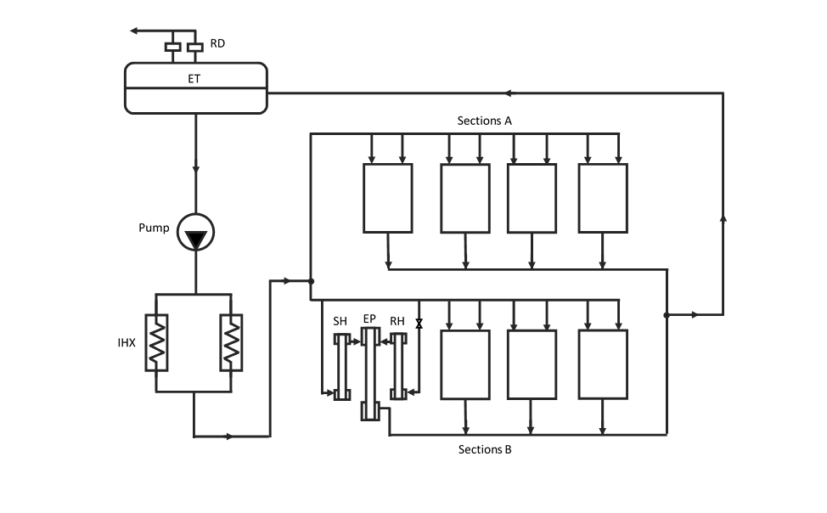

Fig. 1. The scheme of the second sodium circuit BN-600

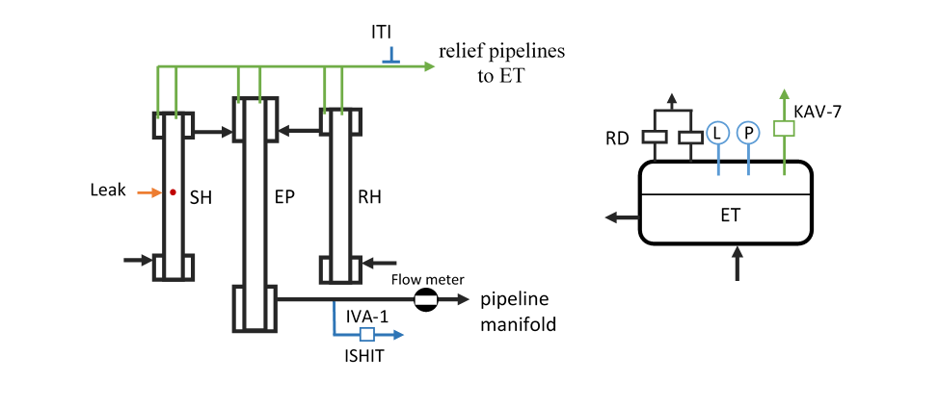
Fig. 2. Location of water-to-sodium leak monitoring devices

Description of the incident with leak in the superheater module NNP BN-600 on January 19, 1982
The materials specified in [1] were used to describe the incident with the leak of water into sodium.
Damage of the heat exchange surface of the BN-600 steam generator occurred mainly in the first years of NPP operation (1980-1985). The incident described took place on January 19, 1982.
By the time of the leak all three loops were in operation, the unit power was equal to 93.6%. The sodium flow rate in the second circuit was 1920 kg/s.
Characteristics of steam generator No. 5 at the time of leak:
- sodium temperature at SG inlet 492 °C;
- sodium temperature at SG outlet 298 °C;
- superheated steam pressure 11.2 MPa;
- superheated steam temperature 489 °C;
- SG steam capacity 463 t/h.
All water-to-sodium leak monitoring devices were keeping functioning well. Background values of the hydrogen concentration in sodium and in the protective gas were accordingly 0.08 - 0.15 ppm and 0.016% vol. Reheater module of 5B1 section of the steam generator was shut down.
The chronology of incident based on the operational data and the results of post-accident analysis are shown in Table 1.

TABLE 1. TIMELINE OF THE BN-600 INCIDENT ON JANUARY 19, 1982

Time,  h: m | Event | Post-accident (Retrospective) analysis
16:10 |  | The beginning of the water leak in the SH module of section 5B1 (steam flow  rate 1 -1.7 g / s), reduction of sodium flow rate at the 5B1 section outlet by 2%
16:11 | Increase of IVA-5B1 readings Checking the status of IVA-5B1 (staff action) |  | Increase of steam flow rate to 8.3 g/s  Reduction of sodium flow rate at the 5B1 section outlet by 8-16.5%  Increase in sodium flow rate through other 5SG sections by 3%
16:12 |  | ITI-5B1 indicated "leak"
16:13 | IVA-5B1 indications – 0.22 ppm
16:15 | A sharp increase in the indications of all IVA 5SG
16:20 |  | ITI-5B1 indicated "leak" twice
16:23 | ISHIT-5B1 showed "leak"  ET pressure increase started
16:23:30 |  | Steam flow rate rapid increased to 250 g/s  Increase of sodium flow rate at the 5B1 section outlet by 35%  Increase in sodium flow rate through other 5SG sections by 10%  Rupture disc burst spontaneously at 0.18 MPa pressure value
16:24 | Start of 5SG shutdown  (staff action)
16:30 | KAV-7 indications reached the maximum (5% vol.)
16:32 | IVA-5B1 indications – 8,7 ppm  IVA 5SG indications – (3-5) ppm  ISHIT-5B1 indicated "leak"

According to the results of the post-accident analysis, the amount of water that entered the second sodium circuit was estimated 20.3 kg, including 5.4 kg of water received during the first 13 minutes after the leak began, and the remaining 14.9 kg were received during the SG shutdown. The results of the module inspection identified 7 heat exchange tubes of the steam generator with through faults.

Modelling of the incident using SLEAK and LLEAK-3C 1.0 codes
The calculations were performed using the SLEAK and LLEAK-3C 1.0 codes. The use of two calculation codes made it possible to simulate the operation of the BN-600 steam generator protection system in case of water leak in the steam generator, taking into account its leak evolution from small to large.
SLEAK code is designed for efficiency analysis of the small water leaks monitoring subsystem of the steam generator safety system. SLEAK technique includes the calculation of dissolved and gaseous products of the sodium water reaction, shown in [4].
The evolving of the small leak with a water flow rate up to 8.3 g/s occurred within 13 minutes. Figure 3 shows the water flow rate taken into account in SLEAK code and the derived concentrations of hydrogen in sodium at the outlet of the failed and non- failed sections in case of a small leak. The evolution of a small leak does not occur monotonously, the water flow rate increases skippingly as the nearest pipes burn through. According to the calculation results, a good match was obtained with the indications of the IVA-1 on the failed section.

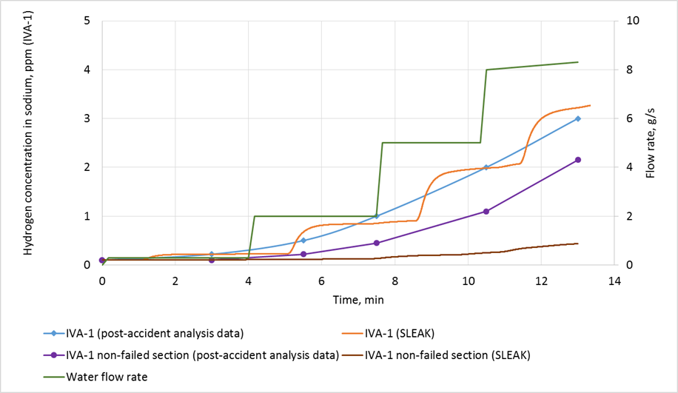

Fig. 3. Water flow rate and concentrations of hydrogen in sodium at the outlet of failed and non- failed sections with a small leak

SLEAK code also helped to obtain the values of the volume content of hydrogen gas in sodium at the failed section outlet (ISHIT) and in the protective gas of the ET (KAV-7). The calculated indications of the ISHIT and KAV-7 devices correspond to the data of the post-accident analysis and are shown in Figure 4. It is known from [1] that the ISHIT detector in the failed section showed "leak" 13 minutes later from the beginning of the leak, while the volume content of hydrogen exceeded the emergency set point of 5% after 12 minutes, according to calculated data. The indications of the KAV-7 monitor installed on the ET, reached 5% vol. by 20 minutes from the beginning of the leak. Such a long time is associated with a long delivery time of the gas sample to the device.

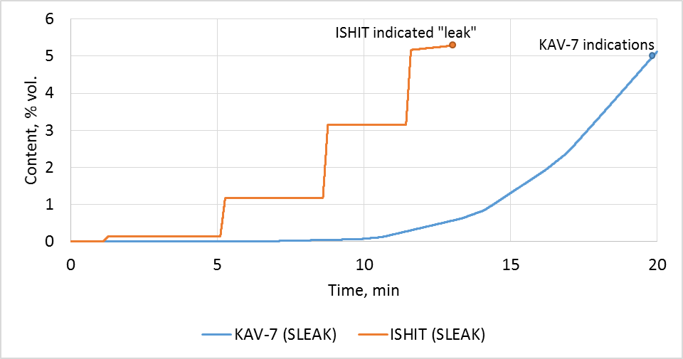

Fig. 4. Calculated indications of the ISHIT and KAV-7 devices

At 16:23, 13 minutes after the leak started (according to the post-accident analysis), the flow rate sharply increased to 250 g/s. This led to the rapid formation of hydrogen bubble in the module and pushing sodium into the headers. Sodium flow rate at the failed section outlet increased by 1.35 times; sodium level in the expansion tank increased by 250 mm. One of the rupture disks devices installed on the ET burst spontaneously at 0.18 MPa pressure value at 16:23:30. After that, at 16:24, "large leak" automatic algorithm was initiated, both SG and secondary loop were shut down and SG was dried out.
The calculation of the hydrodynamic parameters of the BN-600 secondary circuit with a large leak was performed using LLEAK-3C 1.0 code [3]. The code is meant for analyzing the effectiveness of the steam generator and second sodium circuit protection system against overpressure. The processes with water-to-sodium leak that occur in the sodium circuit are described with a one-dimensional, one-speed physical and mathematical model of a thermally nonequilibrium three-component gas-liquid flow (sodium, hydrogen, sodium hydroxide). Hydrodynamic parameters of the second sodium circuit such as pressure, flow rate, and temperature of all components are calculated. See [5] for a more detailed description of the code.
The dependence of the steam flow rate took into account in the calculation is shown in Figure 5. The maximum value of water flow rate was reduced to 200 g/s (compared to 250 g/s [1]), while the total mass of incoming water within large leak corresponds to the post-accident analysis – 14.9 kg.

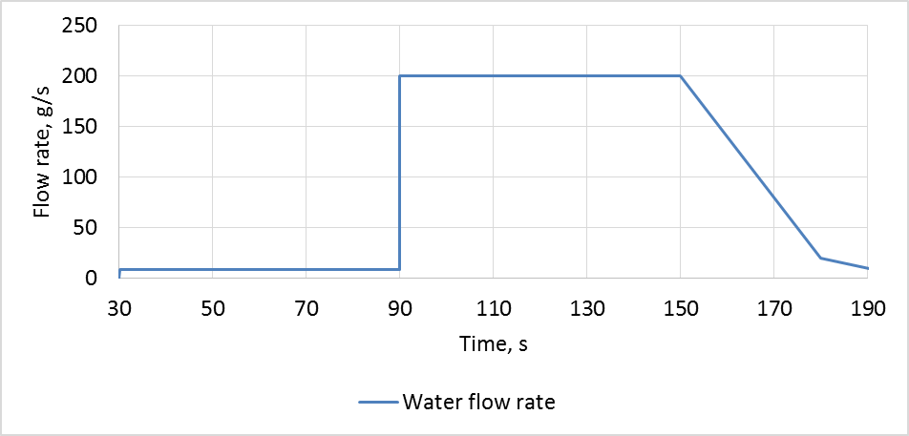

Fig. 5. Water/steam flow rate

Figure 6 shows the pressure at the area of sodium-water reaction. A sharp increase of water flow rate (at 90 s of estimate time) leads to a short-term pressure surge in the area of sodium-water reaction. The pressure increase continues until the rupture disk is busted at the ET (at 115 s of estimate time), after which the pressure in the second circuit decreases.
Figures 7-9 show the comparison of the calculated data and indications of water-to-sodium leak monitoring devices (data from post-accident analysis). In general, the hydrodynamic parameters derived the LLEAK-3C 1.0 code describe securely the processes in the second circuit of the BN-600 with a large water-to-sodium leak and do not contradict the data of the post-accident analysis of the incident. The results obtained confirm the correctness of the physical and mathematical models implemented in the LLEAK-3C 1.0 code: model of the sodium-water reaction, model of the rupture disk, the point model of the expansion tank, etc.
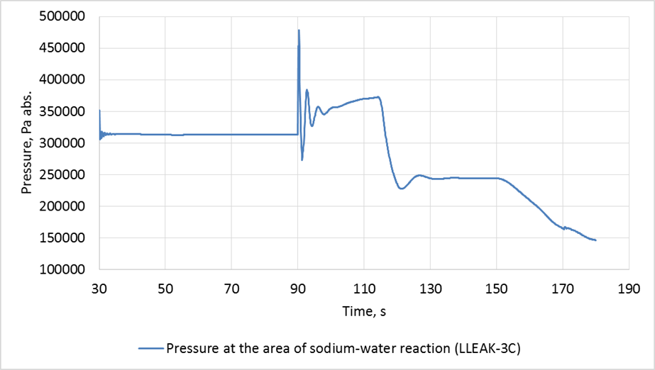

Fig. 6. Pressure at the area of sodium-water reaction

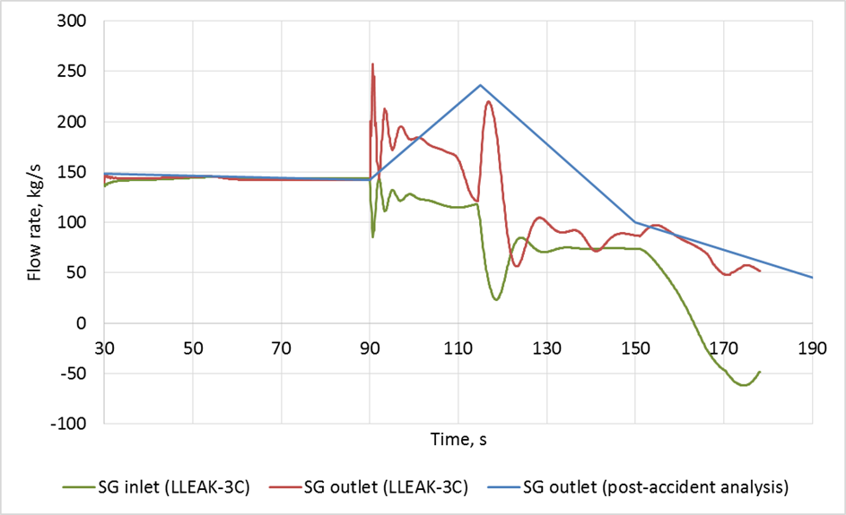

Fig. 7. Sodium flow rate at the failed SG section

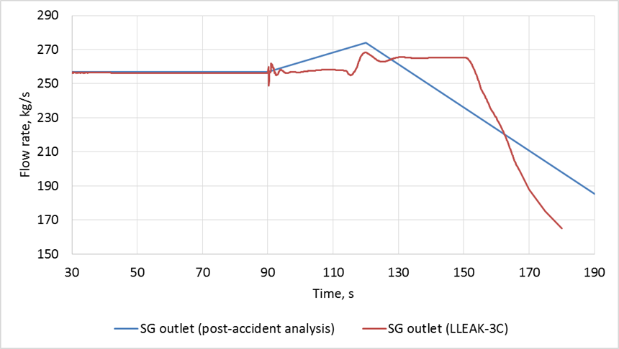

Fig. 8. Sodium flow rate at the outlet of the non-failed SG section

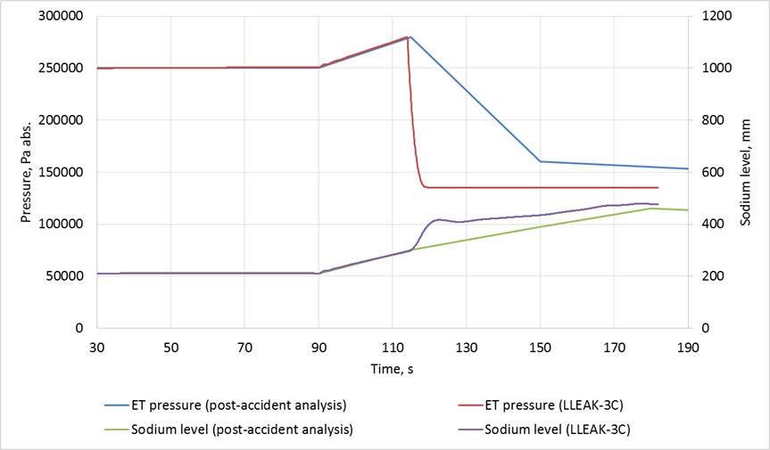

Fig. 9. Pressure and sodium level in the ET

Table 2 shows the comparison between the post-accident analysis data and the calculation results performed by the LLEAK -3C 1.0 code.

TABLE 2. THE COMPARISON BETWEEN THE POST-ACCIDENT ANALYSIS DATA AND THE CALCULATION RESULTS USING LLEAK -3C 1.0 CODE

Parameter | Post-accident analysis | LLEAK -3C 1.0 calculation, max value
Increase of sodium flow rate at the outlet of the failed section, % | 35 | 45
Increase of sodium flow rate through non-failed sections, % | 10 | 7,5
Increase of sodium level in the ET, mm | 250 | 267

Conclusion
The use of two codes SLEAK and LLEAK-3C 1.0 made it possible to simulate the processes that occurred in the second circuit of the BN-600 reactor in case of the water leak incident in the steam generator on January 19, 1982.
The application of SLEAK code based on the small leak calculations helped to obtain a good match between the calculated data and the indications of IVA-1 in the failed section.
The values of hydrodynamic parameters obtained using the LLEAK-3C1.0 code describe securely the processes in the second circuit NNP BN-600 with a large water-to-sodium leak and do not contradict the data of the retrospective analysis of the incident.
The results of computational modelling of the real incident on the BN-600 confirm the correctness of the physical and mathematical models implemented in the SLEAK and
LLEAK-3C 1.0 codes.

References
- Y.M. Ashurko, R.P. Baklushin et al. Fast reactor operating experience gained in Russia: analysis of anomalies and abnormal operation cases. Unusual occurrences during LMFR OPERATION, IAEA-TECDOC-1180, IAEA, Vienna (2000) 117-144
- Certificate of state registration of the computer program SLEAK No. 2018661619, Russian Federation, 2018.
- Certificate of state registration of the computer program LLEAK-3C 1.0 No. 2020662541, Russian Federation, 2020.
- Poplavskiy V.M., Kozlov F.A. Bezopasnost' parogeneratorov natriy-voda (Sodium-Water Steam Generators Safety). Moscow, Energoatomizdat (1990).
- Perevoznikov S., Shvetsov Y., etc. Modeling of hydrodynamic processes at a large leak of water into sodium in the fast reactor coolant circuit. Nuclear Engineering and Technology. (2016). n. 48. № 5. 1162-1173.

