VERIFICATION AND VALIDATION OF THE CEFR

SERPENT MODEL FOR THE GENERATION OF

REFERENCE SOLUTIONS AND CROSS SECTIONS

DATABASE FOR THE DETERMINISTIC CODE

AZNHEX

Juan Galicia-Aragon, Roberto Lopez-Solis, Armando Gomez-Torres, Javier Palacios-Hernandez
National Institute for Nuclear Research (ININ)
State of Mexico, Mexico
Email: jgaliciaa87@gmail.com

Edmundo del Valle-Gallegos
National Polytechnic Institute (IPN)
Mexico City, Mexico

Abstract

The National Institute of Nuclear Research (ININ) of Mexico participates in the IAEA-CRP on Neutronics Benchmark of the Chinese Experimental Fast Reactor (CEFR) Start-Up Tests, which was proposed by China Institute of Atomic Energy (CIAE).The Mexican participation in this Benchmark is focused in two main goals: the first one, the use of the SERPENT code for the generation of reference solutions and a Macroscopic Cross Sections (XS) database and, the second one, the use of the previously generated XS to verify and validate AZNHEX, a deterministic domestic code, now under-development, devoted to Fast Reactors calculations, that is part of the Mexican platform AZTLAN for nuclear reactor analysis. The Benchmark exercises include the following tests: fuel loading and approach to criticality, control rod worth measurements, sodium void reactivity, temperature reactivity, reactivity change due to fuel subassembly position swap, foil activation and integral reactivity coefficients. The paper shows a complete Verification and Validation (V&V) process for each one of the exercises mentioned above by comparing the numerical results by using SERPENT v2.1.30 with the experimental data available. The temperature and thermal expansion effects in all the materials are considered for an accurate representation of the model. The assumptions taken into account for the thermal expansion are also mentioned. Several scripts were created, and are briefly described, to simplify and automate input generation considering the control rods position and for the generation of the XS database. The V&V of AZNHEX code with Serpent is presented in another dedicated paper.

INTRODUCTION
As a result of the start-up tests of the China Experimental Fast Reactor (CEFR), a benchmark was proposed by the China Institute of Atomic Energy (CIAE) based on the experimental activities that were carried out physically in the reactor. These activities include: 1) criticality experiments, 2) measurement of control rod worth, 3) measurement of reactivity coefficients and 4) foil activation measurements. Several Institutes and Universities around the world participated in the reactor core modeling employing both stochastic and deterministic nuclear codes, to obtain the neutronic parameters established in the benchmark. The National Institute for Nuclear Research (ININ) together with the National Polytechnic Institute represent Mexico to perform this task employing the Monte Carlo code Serpent [1] and the domestic neutron diffusion code AZNHEX [2], which is part of the AZTLAN platform, a Mexican project devoted to the development of domestic software for nuclear reactors analysis. The AZNHEX code was developed for the design and analysis of reactor cores with hexagonal-z geometry elements such as VVER and fast reactors.
The reasons of using Serpent for the benchmark calculations were, first, due to its capability to generate Macroscopic Cross Sections (XS) that can be employed to feed deterministic codes such as AZNHEX, which gives the opportunity to verify and validate this code simulating more realistic scenarios and demonstrate its calculation capabilities and, second, because the Serpent code is widely used in reactor calculations due to its highly precision in 3D simulations and great capabilities and advantages over other Monte Carlo codes which allows to obtain sound reference solutions.

CEFR core description
Figure 1 shows a cross-section of the reactor core, including the color identifiers of the total in-core materials. A total of 72 fuel Subassemblies (SAs) are required to reach criticality according to the reactor specifications. In cold conditions, the fuel rods have a height of 269.2 cm with an active region of 45 cm. The enrichment of ²³⁵U is about 64.4%. Mock-Up Fuel SAs are initially inside the core occupying some fuel SAs positions at the moment of the fuel loading process. In the core, there are also 8 control rods SAs (3 safety rods, 3 shim rods and 2 regulating rods), 338 stainless steel SAs, 230 shielding SAs and 1 neutron source SA placed in the center of the core.
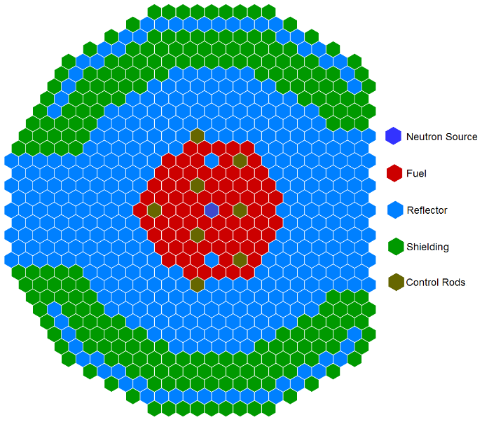

Fig. 1. CEFR core layout
Since the experiments are carried out at different temperatures, thermal expansion effects have an impact on the materials and it should be considered in the simulations. The methodology employed to take into account the radial and axial thermal expansions is described in the following section. A more detailed description of the geometry and material definition can be found in reference [3].

CEFR core modelling
The 3D model of the CEFR reactor core was build employing the Serpent code v2.1.30 with the ENDF/B-VIII library, taking into account the material specifications contained in the benchmark such as the type of geometry of the modeled elements, their dimensions, the isotopic composition of the materials, etc. To simplify the thermal expansion calculations, it was assumed that all the materials of the reactor core have the same linear expansion coefficient of 1.8x10⁻⁵/°C, which is the value of the stainless steel [3] and it is present in all the SAs, and corresponds to the highest coefficient of the materials present in the core. In order to keep the same masses, the density of all the materials was smeared except for the sodium, which its density was always obtained using the following equation:

$$ρ=950.0483-0.2298T-14.604x{10}^{-06}T^{2}+5.6377{x10}^{-09}T^{3} (1)$$

,where T is the temperature expressed in °C and ρ is the density in kg/m³.
The axial divisions in all the SAs were done axially dividing the fuel elements into 10 axial nodes and the rest of the SAs in 5. This methodology was considered in order to obtain the XS in each node and build a simplified model with AZNHEX once the benchmark exercises are validated with Serpent.
A radial division of the core by rings was also assumed, as it can be seen in Figure 2; this was considered to have average values of the XS for the same kind of material that belongs to the same ring reducing considerably the amount of data handled.

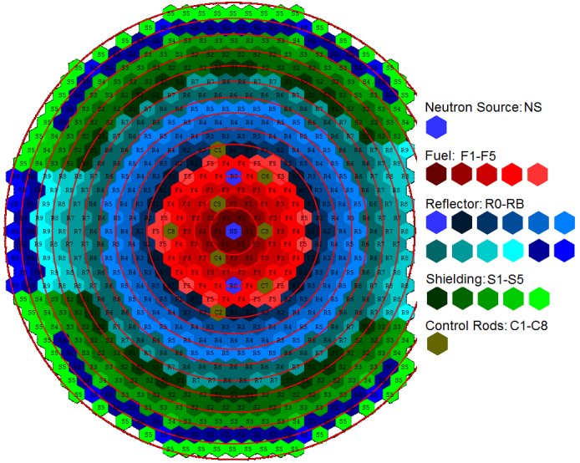

Fig.2. Radial division of the core in rings
Due to the large number of tests to perform, it was decided to automatize the procedure by creating a program written with the programming language C. This facilitated the elaboration of the inputs and avoided any possible errors doing the inputs by hand. For the XS’s energy structure to be used in AZNHEX, seven energy groups [4] were used in the simulations. The energy bins structure used is shown in Table 1.

TABLE 1. NEUTRON ENERGY GROUPS EMPLOYED IN THE CALCULATIONS
Group | Energy (MeV)
1 | 2.00000x10¹
2  3  4  5  6 | 1.35340x10⁰  5.23400x10⁻¹  6.73790x10⁻²  3.35460x10⁻³  7.48520x10⁻⁴

BENCHMARK EXERCISES AND RESULTS
In this section, the exercises of the benchmark are briefly described and the final results obtained with for each exercise are shown. In order to keep the paper short the reader is encouraged to go to reference [3] for a detailed description of the exercises.

Fuel loading and criticality
This exercise consists in loading a certain number of fuel SAs into the core until reaching criticality. The first 10 steps of fuel loading are done with all the control rods fully withdrawn up to 71 Fuel SAs inserted and subsequently, once the 72th Fuel SA is inserted, the RE2 rod is inserted until reaching criticality at a position of 70 mm. The results obtained for the supercritical and critical part along with the standard deviation (SD) and including the comparison with experimental data, are shown in Table 2.

TABLE 2. RESULTS AND COMPARISON OF THE SUPERCRITICAL AND CRITICAL STEPS

Step | RE2 rod position (mm) | Serpent Calculations  k_{eff} SD(pcm) ρ (pcm) | Exp.Measurement  ρ (pcm) | Difference  (pcm)
11 | 190 | 1.00048 3.5 48 | 40 | 8
12  13  14 | 170  151  70 | 1.00041 3.3 41  1.00028 3.1 28  1.00004 3.4 4 | 34  25  0 | 7  3  4
As it can be seen in the previous table, the results calculated with Serpent are in very good agreement with those obtained experimentally. The k_{eff} value of 1.00004 only has an excess reactivity of 4 pcm and the reactor can be considered critical with 72 fuel SAs with the RE2 rod at a height of 70 mm.
Figure 3 shows the normalized radial power distribution and the assemblies where the power was calculated when the reactor is critical. The curve follows the expected behaviour, having the maximum value in the center of the core.
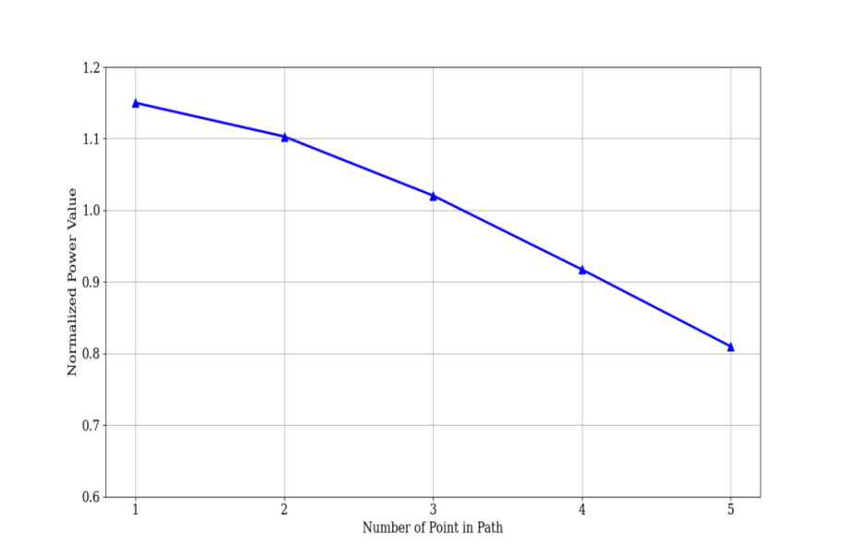
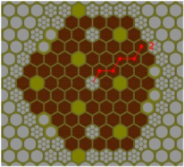

Fig.3. Normalized radial power distribution

Control rod worth
This exercise is divided in three parts; the first one consists in obtaining the k_{eff} values when the control rods are withdrawn and subsequently, one or more control rods are fully inserted obtaining a new k_{eff} value and the rod worth. The second part is similar to the first one with the difference that the control rods are inserted at different heights ant the third part, consists in the insertion of each control rod by steps of 50 mm from the fully withdrawn position to the fully inserted position; the k_{eff} values are obtained for each insertion step and with these results, the integral and differential control rod worth are obtained. Table 3 shows the results for the second part of this exercise and the comparison with the experimental data.
According to the results shown in Table 3, it can be seen that the numerical values have minimum differences in all cases compared with those obtained experimentally, being the case 4 the one with the highest discrepancy (178 pcm). However, all the values calculated with Serpent for all cases are within standard deviation reported from experiment in each case, which confirms that a proper simulation for all cases was done.

TABLE 3. RESULTS AND COMPARISON FOR THE SECOND PART OF EXERCISE 2
Case | Control rods |  | Serpent calculations  k_{eff} SD(pcm) ρ(pcm) | Exp. Measurement  ρ(pcm) SD(pcm) | Difference  (pcm)
1 | RE1  RE2 | Before  After  Before  After | 1.00202 6.5 144  1.00058 6.6  1.00213 7.0 157  1.00056 6.5 | 150 9  149 9 | -6  8
2  3  4  5  6  7  8  9 | SH1  SH2  SH3  SA1  SA2  SA3  3*SH + 2*RE  SH2 + SH3 +2*RE  3*SA  SA1 + SA2  2*RE + 3*SH + 3*SA  2*RE + SH2 + SH3 + 3*SA | Before  After  Before  After  Before  After  Before  After  Before  After  Before  After  Before  After  Before  After  Before  After  Before  After  Before  After  Before  After | 1.000996.6 1925  0.98207 6.6  1.001486.8 1862  0.98315 6.2  1.001376.3 1864  0.98302 6.7  1.001996.7 909  0.99295 7.1  1.001766.6 877  0.99304 6.1  1.001976.8 968  0.99235 6.6  1.001916.8 3055  0.97215 6.4  1.001116.6 1002  0.99117 6.8  1.002056.5 2896  0.97379 6.8  1.001836.6 1816  0.98393 6.7  1.002006.7 6080  0.94446 6.6  1.001006.4 3944  0.96298 6.7 | 2019 250 -94  1839 225 23  1839 226 25  945 100 -36  911 100 -34  946 98 22  2877 335 178  881 76 121  2981 395 -85  1950 226 -134  6079 989 1  3899 551 45

Figures 4 and 5 shows the normalized integral rod worth for RE and SH rods respectively obtained numerically and experimentally. Since no experimental data was available for SA rods, the integral worth for those rods is not shown.
For the RE rods, it can be seen that an irregular behaviour is obtained for both RE1 and RE2 compared to the experimental curve; this is related to the natural proportion of ¹⁰B in these rods, causing that the effect in each insertion step was really low and the standard deviation of the results can be of the same order. This could be fixed by increasing the number of neutron histories. On the other hand, a very good agreement between numerical and experimental curves can be observed for SH rods with negligible differences.

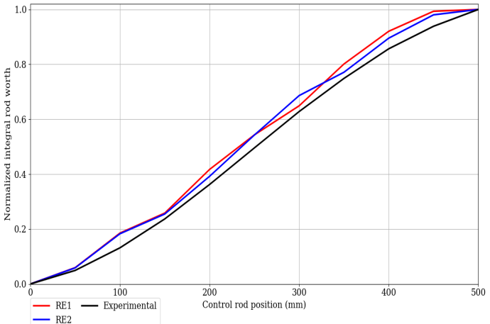  fig.4. Normalized integral rod worth for RE rods | 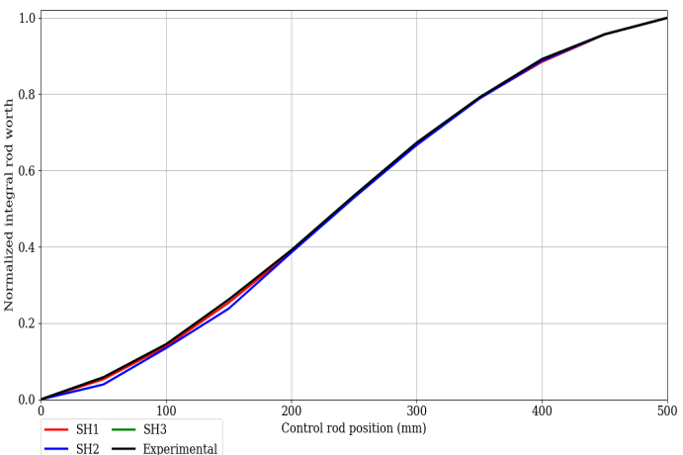  fig.5. Normalized integral rod worth for SH rods

Sodium void reactivity
This exercise consists in the replacement of a fuel SA by one specially designed voided-sodium fuel SA to measure the sodium void reactivity. This special fuel SA has a vacuum sealed by welding the sodium inlets to simulate the sodium void. A total of 5 different fuel SA locations were considered to perform this exercise. The calculations were carried out considering a direct method, which assumes no control rod movement and an indirect method, where the control rods are moved to compensate the loss of reactivity. Table 4 shows the results obtained with Serpent for this exercise and their comparison with the experimental data.

TABLE 4. RESULTS AND COMPARISON OF THE SODIUM VOID REACTIVITY EXERCISE

Position |  | Exp. Measurement  ρ(pcm) Err(pcm) | Serpent (Indirect)  k_{eff} SD(pcm) ρ + CR (pcm) ρ(pcm) diff (pcm) | Serpent (Direct)  k_{eff} SD(pcm) ρ(pcm) diff (pcm)
(2-4) | Original | -39.2 5.8 | 1.00213 3.3 -2.987 -44.116 -4.916 | 1.00213 3.3 -44.000 -4.800
(3-7)  (4-9)  (5-11)  (6-13) | Voided  Original  Voided  Original  Voided  Original  Voided  Original  Voided | -43.4 5.9  -40.5 5.7  -40.1 5.5  -32.9 5.5 | 1.00210 3.4  1.00211 3.4 -2.987 -44.700 -1.300  1.00208 3.1  1.00204 3.1 10.954 -30.737 9.763  1.00215 3.3  1.00205 3.4 9.958 -32.078 8.022  1.00215 3.2  1.00225 3.4 -7.965 -31.669 1.231  1.00217 3.6 | 1.00169 3.3  1.00211 3.4 -41.000 2.400  1.00170 3.4  1.00204 3.1 -36.000 4.500  1.00168 3.5  1.00205 3.4 -35.000 5.100  1.00170 3.4  1.00225 3.4 -38.000 -5.100  1.00187 3.1

As it can be seen in the previous table, the void reactivity values of both indirect and direct methods are very similar between them having the best results in the direct method with differences below 6 pcm in all cases with respect to those obtained experimentally. This is related to the integral rod worth of the RE rods in which the curve has some irregularities and hence, the values of the indirect method have higher differences compared to the experimental results.

Temperature reactivity
In this exercise, the temperature of the reactor core is changed to a certain value in order to measure the temperature reactivity feedback. The measurement was conducted at 5 temperature levels by both increasing the temperature from 250 (which is the temperature at which the rest of the experiments were done) to 300 °C and decreasing the temperature from 300 to 250 °C.As the previous exercise, the calculations were performed considering indirect and direct methods called Experimental Method, which takes into account the control rod movement to compensate the effect of reactivity and 3-step Method, which assumes that the control rods are not moved, respectively. Table 5 shows the final results and their comparison with the experimental data. It can be seen that the 3-Step Method have very similar values with those obtained experimentally with negligible differences in both increasing and decreasing temperature cases. For the Experimental Method, the results obtained are also in good agreement also but with higher differences with respect to the experimental data and it is related to the integral rod worth values obtained previously.

TABLE 5. RESULTS AND COMPARISON OF THE TEMPERATURE REACTIVITY EXERCISE

Step | Temperature (°C) | Exp. Measurement  (pcm/°C) Error (%) | Serpent (Exp. Method)  k_{eff}SD ρ(pcm) ρ(pcm/°C) diff (pcm) | Serpent (3-Step Method)  ρ(pcm) ρ(pcm/°C) diff (pcm)
1 | 250 |  | 1.00285 4.3 0.0 | 0.0
2  3  4  5  6  7  8  9  10 | 250  275  275  283  283  293  293  302  300  300  290  290  281  281  270  270  250 | -3.76 13.5  -4.38 14.0 | 1.00377 4.9  1.00279 4.5 -94.37  1.00292 4.5  1.00263 4.6 -132.08 -3.959 -0.199  1.00283 4.6  1.00248 4.5 -177.11  1.00293 4.7  1.00261 5.2 -200.54  1.00203 4.6 0.0  1.00231 4.4  1.00272 4.7 53.94  1.00162 4.5  1.00206 4.7 86.02 -3.770 0.610  1.00156 4.8  1.00208 4.5 127.15  1.00115 4.5  1.00196 4.6 192.64 | -97.36  -126.20 -3.710 0.050  -161.01  -192.84  0.0  40.79  84.63 -4.395 -0.015  136.44  217.19

Subassembly swap reactivity
With this exercise, a possible accident of fuel loading error is simulated by swapping fuel SAs with Type-I SS SAs in 8 different positions of the core this is, a fuel SA is taken out of the core and it is replaced by a SS SAs. No more than 79 fuel SAs are used in order to keep the reactor critical. Two cases are considered in this exercise by doing the same SA swaps with the difference that in the first case, multiple control rods are moved while in the second one, only one rod is moved. As the previous exercises, besides the indirect method of calculation also a direct method calculation was done. The results obtained for the first case of this exercise (multiple rods movement) and their comparison with the experimental data are shown in Table 6.

TABLE 6. RESULTS AND COMPARISON FOR THE MULTI-RODS CASE

Position |  | Exp. Measurement ρ(pcm) Uncertainty  (pcm) | Serpent (Indirect)  k_{eff}SD ρ + CR (pcm) ρ(pcm) diff (pcm) | Serpent (Direct)  k_{eff} SD(pcm) ρ(pcm) diff (pcm)
(2-6) | Original | -985.98 128.17 | 1.00236 4.7 32.83 -848.48 137.50 | 1.00236 4.7 -882.61 103.37
(3-11)  (4-17)  (5-23)  (6-29)  (5-22)  (7-31)  (5-19) | Swapped  Original  Swapped  Original  Swapped  Original  Swapped  Original  Swapped  Original  Swapped  Original  Swapped  Original  Swapped | -879.57 114.34  -777.26 101.04  -634.24 82.45  -474.08 61.63  -590.23 76.73  209.72 27.26  582.16 75.68 | 1.00269 4.5  1.00228 4.7 15.92 -760.46 119.11  1.00244 4.6  1.00231 4.6 34.83 -667.78 109.48  1.00266 4.7  1.00225 4.9 8.96 -526.81 107.43  1.00234 4.5  1.00235 4.5 208.58 -373.30 100.78  1.00445 4.8  1.00844 4.8 -1046.57 -522.41 67.82  0.99791 4.5  1.00445 4.8 32.70 194.74 -14.98  1.00478 4.8  1.00234 4.4 230.38 521.92 -60.24  1.00466 4.8 | 0.99357 4.6  1.00228 4.7 -786.59 92.98  0.99444 4.7  1.00231 4.6 -695.62 81.64  0.99537 4.9  1.00225 4.9 -560.62 73.62  0.99665 4.4  1.00235 4.5 -399.72 74.36  0.99835 4.8  1.00844 4.8 -489.15 101.08  1.00349 4.5  0.99835 4.8 194.26 -15.46  1.00029 4.5  0.99665 4.4 555.64 -26.52  1.00220 4.7

It can be seen in the previous table a good approximation of the numerical values to the experimental results, mainly those obtained with the Direct Method since the effect of the control rods is not taken into account. The higher discrepancy can be observed in the first calculation which is the position (2-6), for both Indirect and Direct Method but still acceptable since the difference not exceed 150 pcm in the Indirect Method and is around 100 pcm in the Direct Method. Important is to stress that all numerical differences are inside the error band given by the reported experimental error value. The results obtained for the second case (single rods movement) and their comparison with the experimental data are shown in Table 7.

TABLE 7. RESULTS AND COMPARISON FOR THE SINGLE-ROD CASE

Position |  | Exp. Measurement  ρ(pcm) Uncertainty  (pcm) | Serpent (Indirect)  k_{eff}SD ρ + CR (pcm) ρ(pcm) diff (pcm) | Serpent (Direct)  k_{eff}SD ρ(pcm) diff (pcm)
(2-6) | Original | -984.44 127.98 | 1.00235 4.9 62.67 -817.52 166.92 | 1.00235 4.9 -889.41 95.03
(3-11)  (4-17)  (5-23)  (6-29)  (5-22)  (7-31)  (5-19) | Swapped  Original  Swapped  Original  Swapped  Original  Swapped  Original  Swapped  Original  Swapped  Original  Swapped  Original  Swapped | -875.12 113.76  -771.63 100.31  -639.46 83.13  -476.43 61.93  -585.77 76.15  209.90 27.29  581.86 75.64 | 1.00298 4.8  1.00222 4.7 41.80 -732.14 142.98  1.00264 4.8  1.00226 4.8 53.73 -649.90 121.73  1.00280 4.7  1.00223 4.6 11.95 -533.11 106.35  1.00235 4.4  1.00215 4.3 221.55 -353.87 122.56  1.00438 4.4  1.00816 4.8 -1034.60 -517.76 68.01  0.99775 4.9  1.00438 4.8 36.66 182.07 -27.83  1.00475 4.8  1.00235 4.5 238.31 537.51 -44.35  1.00475 4.9 | 0.99349 4.8  1.00222 4.7 -789.92 85.20  0.99435 5.0  1.00226 4.8 -710.33 61.30  0.99518 4.6  1.00223 4.6 -552.69 86.77  0.99671 4.5  1.00215 4.3 -386.03 90.40  0.99829 4.8  1.00816 4.8 -486.44 99.33  1.00324 4.6  0.99829 4.8 185.49 -24.41  1.00014 4.4  0.99671 4.5 556.67 -25.19  1.00227 4.9

The results for the single-rods case follow the same behaviour of the multi-rods case having the most accurate results applying the Direct Method with differences below 100 pcm for all the calculations with respect to the experimental values and well inside the experimental uncertainty in reported measurements.

Foil activation
Different materials were considered in this exercise to perform neutron activation calculations obtaining both radial and axial reaction rate distributions. The reactions that are considered for the materials are the following: 1) Al-27 (n, α), 2) Ni-58 (n,p), 3) Au-197 (n,γ), 4) Np-237 (n,f), 5) U-238 (n,f), 6) U-235 (n,f).For radial reaction rate distribution, the 6 foils are placed in a special fuel SA when the irradiation is taking place in the fuel section and in a special SS SA when the foils are irradiated in the reflector zone. A total of 8 positions were considered for this part. Figures 6 to 11 show the radial distribution rate obtained for all the materials employing Serpent in conjunction with the experimental curve for comparison.

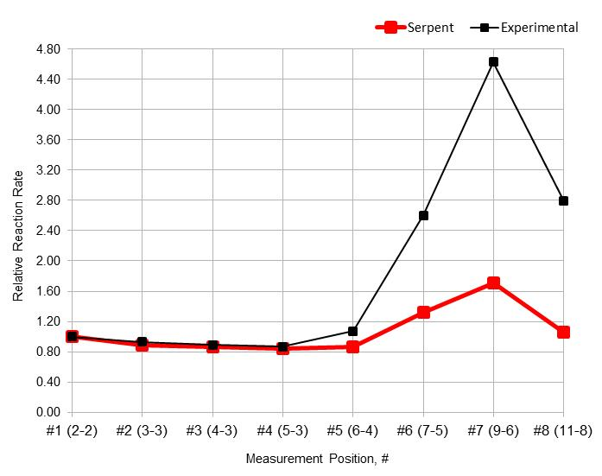  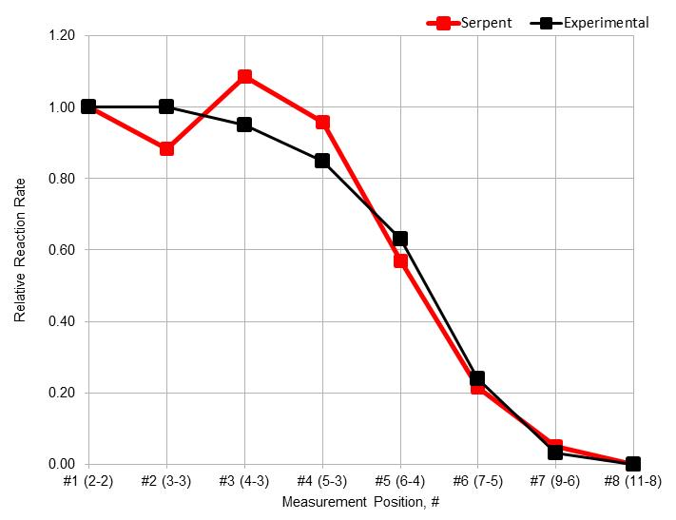  fig.6. Normalized radial reaction rate for Al-27 (n,α) | 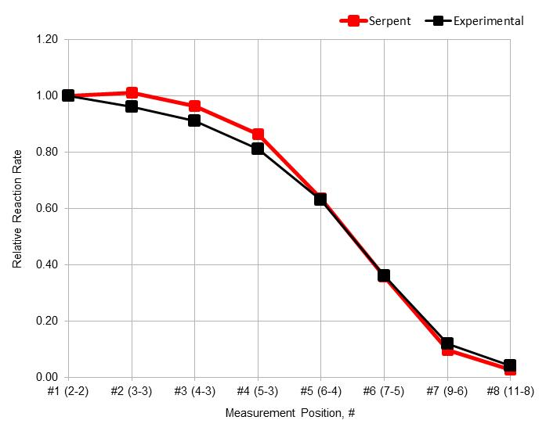  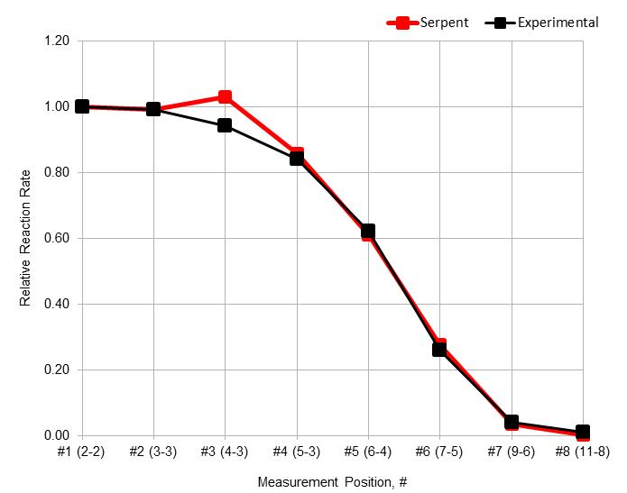  fig.7. Normalized radial reaction rate for Ni-58 (n,p)
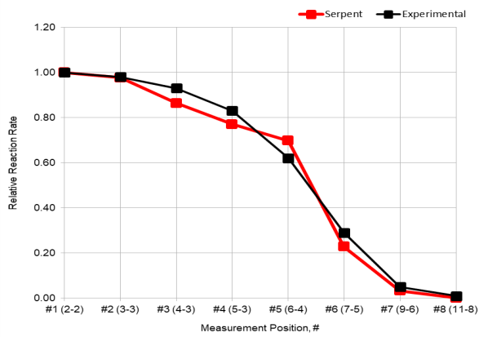  fig.8. Normalized radial reaction rate for Au-197 (n,γ)  fig.10. Normalized radial reaction rate for U-238 (n,f) | 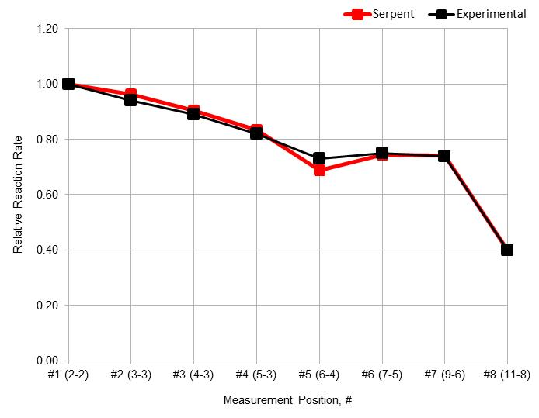  fig.9. Normalized radial reaction rate for Np-237 (n,f)  fig.11. Normalized radial reaction rate for U-235 (n,f)

It is possible to observe the expected behaviour for all the cases and a very good agreement of the numerical calculations with respect to the experimental results having in some cases minimum discrepancies. Figures 12 to 17 show the axial distribution rate obtained with Serpent and their comparison with the experimental curve.

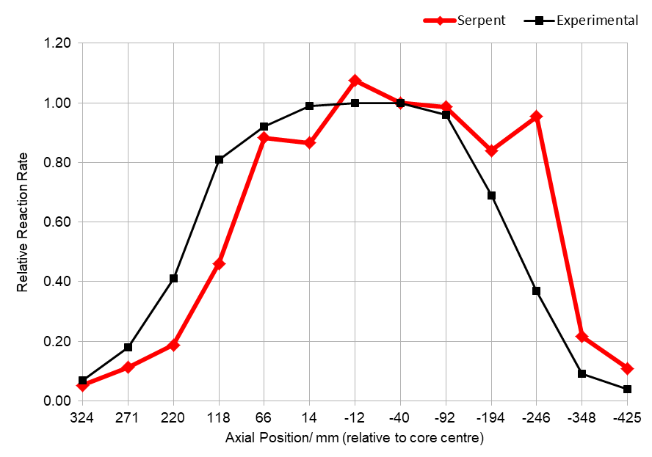  fig.12. Normalized axial reaction rate for Al-27 (n,α) | 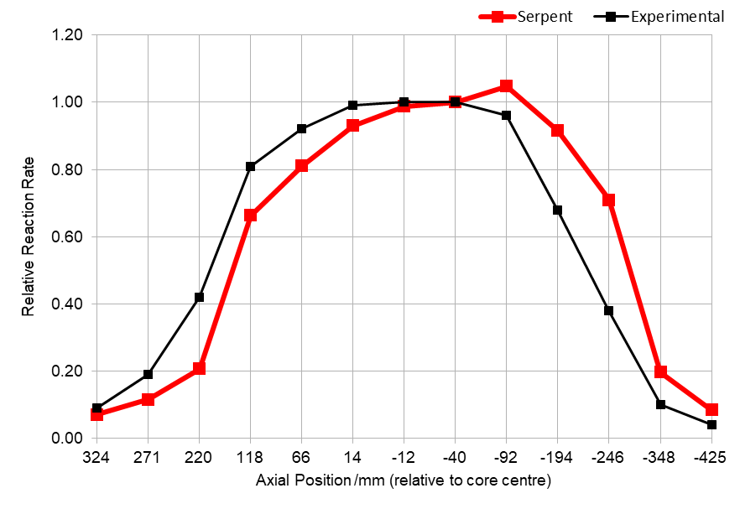  fig.13. Normalized axial reaction rate for U-238 (n,f)
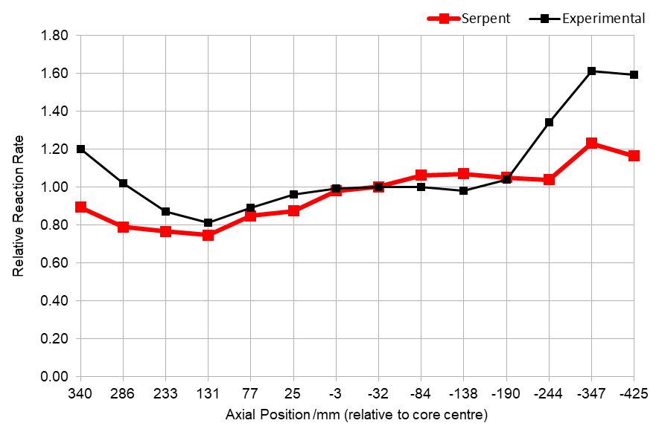  fig.14. Normalized axial reaction rate for Au-197 (n,γ) | 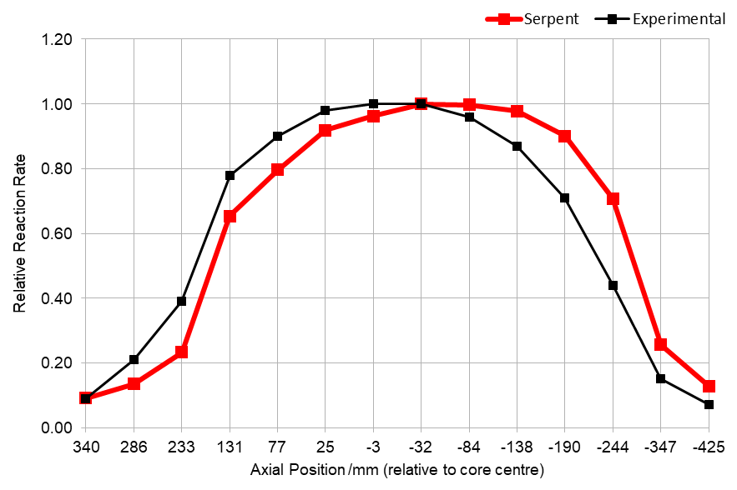  fig.15. Normalized axial reaction rate for Np-237 (n,f)
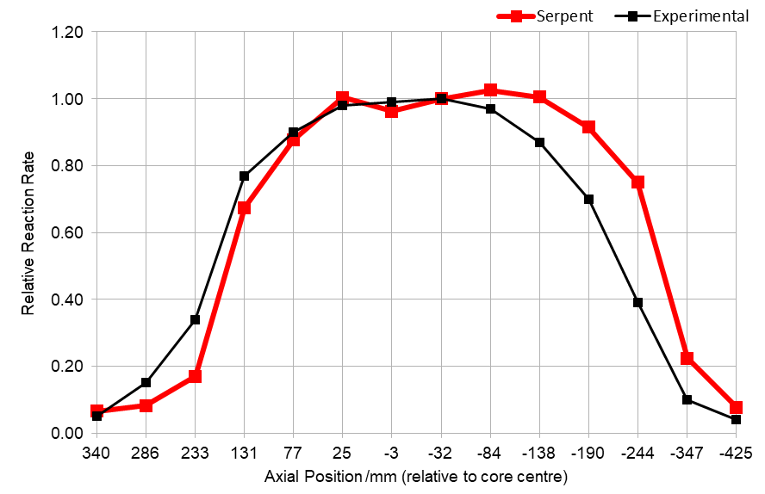  fig.16. Normalized axial reaction rate for Ni-58 (n,p) | 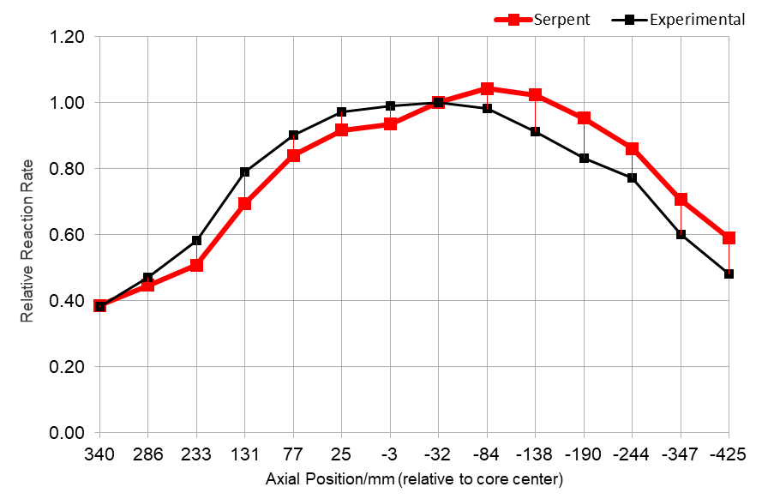  fig.17. Normalized axial reaction rate for U-235 (n,f)

It can be seen that the axial distribution for all cases follow the expected behaviour having some discrepancies, especially in the edges which correspond to the top and bottom regions. For the Aluminium foil case, we can observe major irregularities in the curve obtained with the Serpent calculations This was related, first, for the size of the foil and second, for its low (n,α) cross section which reach a maximum value of approximately 0.1 barns for energies above 8 MeV [5].

Integral reactivity coefficients
The cases considered in this exercise are the following: 1) axial expansion reactivity coefficient; 2) radial expansion reactivity coefficient; 3) density reactivity coefficient of steel, sodium and fuel; 4) Doppler constant for normal and voided core and 5) control rod expansion reactivity coefficient. Table 8 show the final results.

TABLE 8. RESULTS OBTAINED FOR THE INTEGRAL REACTIVITY COEFFICIENTS

Reactivity  Coefficient | Units | Serpent Calculations  ρ (cm) STD
Axial expansion | pcm/% expansion | -352 6.86
Radial expansion  Fuel density  Steel density  Sodium density  Doppler (normal)  Doppler (voided)  RE CR expansion  SH CR expansion | pcm/% expansion  pcm/% density increase  pcm/% density increase  pcm/% density increase  pcm/fuel temp. change  pcm/fuel temp. change  pcm/cm insertion  pcm/cm insertion | -885 6.65  570 7.00  35.6 6.86  34.05.64  -0.17 5.64  -0.09 6.79  -8.3 6.72  -153.3 6.65

The previous results were compared with the average value of those obtained by other participants and are in very good agreement for all the cases.

CONCLUSIONS
The script written in C to automatize the input generation was appropriate in order to reduce considerably the time of elaboration and the human errors that appear in the process since a lot of information was handled for all the exercises. The final results obtained with Serpent show, in general, a very good agreement while comparing with the experimental values for all the exercises having negligible differences in most of the cases. For exercise 2, the calculated integral rod worth for both RE rods have an irregular distribution but as explained before, this can be fixed increasing the number of neutron histories or active cycles in order to reduce the standard deviation associated and have a better approximation since the results follow the expected behavior. This happens also for exercise 6, in which some numerical results have discrepancies with those obtained experimentally. It is clear that the CEFR models done with Serpent brings accurate results which indicates that these models are done correctly and can be employed to generate the XS data for AZNHEX and also reference solutions to have an appropriate comparison of results to Verify and Validate AZNHEX. As it is demonstrated in another paper also presented in this conference, the use of 7 neutron energy groups for XS generation and further use in the deterministic code AZNHEX reduced the amount of data to handle without losing confidence in the obtained values, thus, a consistent methodology has been defined for feed the deterministic code with Serpent XS’s to simulate CEFR.
ACKNOWLEDGEMENTS
To the sectorial fund of Energy Sustainability CONACYT-SENER for the financial support for the development of the strategic project No. 212602 (AZTLAN Platform)
References
- Jaako Leppänen, Maria Pusa, Tuomas Viitanen, VilleValtavirta, Toni Kaltiaisenaho. The Serpent Monte Carlo code: Status, development and applications in 2013, Annals of Nuclear Energy, Vol. 82, (2015) 142-150
- A. M. G. Torres. et al., “AZTLAN: Mexican Platform for Analysis and Design of Nuclear Reactors”, (Proceedings of ICAPP 2015), Nice, France (2015).
- X. Huo, et.al., Neutronics Benchmark of CEFR Start-up Test – Tech. Rep. China Institute of Atomic Energy (CIAE), Beijing, China, 2019
- G. Palmiotti, M. Salvatores, M. Assawaroongruengchot, M. Herman, P. Oblozinsky, C. Mattoon. Nuclear Data Target Accuracies for Generation-IV Systems Based on the Use of New Covariance Data, Journal of the Korean Physical Society, Vol. 59, (2011) 1264-1267.
- Korea Atomic Energy Research Institute, Nuclear Data Center at KAERI
Table of Nuclides (kaeri.re.kr)

