MSR Fuel Cycle and Thermo-Dynamics Simulations

J. DIETZ

Paul Scherrer Institute

Villigen, Switzerland

Email: jonathan.dietz@psi.ch

J. KRepel

Paul Scherrer Institute

Villigen, Switzerland

S. NICHENKO

Paul Scherrer Institute

Villigen, Switzerland

**Abstract**

Molten salt reactors are being explored as an option for the future of nuclear energy and were selected as one of the advanced designs by the Generation IV International Forum. While research is being done in terms of the neutronics and design aspects of the molten salt reactor, the chemistry of the system is as crucial. Not only is chemistry an important aspect which requires more research, it is also key to couple such analysis to the neutronic and reprocessing simulation, as these aspects majorly influence each other.  
The paper makes use of the EQL0D and GEMS codes, where the former simulates the molten salt reactor neutronics and material evolution, whereas the latter uses the elemental composition to compute the speciation as well as aspects such as vapour pressure of the system. For GEMS, the HERACLES database is validated and extended, and equilibrium salt compositions are analysed. In EQL0D, simplified cases are created to handle the combinations of different fertile and carrier salt options.  
With respect to GEMS, the extension of the HERACLES database added new species as well as adjusted interaction parameters to be accurate even outside of the eutectic region. Additionally, the procedure of creating phase diagrams, both binary and ternary, was explored and used in order to validate the accuracy of the underlying data. While EQL0D mostly took on a supporting role in providing equilibrium elemental compositions for use with GEMS, the created cases provide valuable insight into the behaviour of various salts.   
The approach described in the paper has proven to be promising for the combination of neutronic and chemical considerations, however it is still in its infancy. Further additions to the HERACLES database will extend the capability of GEMS, while more intricate EQL0D cases will provide elemental compositions that are truer to real designs.

## Introduction

One of the crucial design quantities of the Molten Salt Reactor (MSR), which is one of the proposed Generation IV reactors, is the initial salt composition and its development as the reactor operates. The simulation of such a material evolution is not only difficult from a numeric point of view, but it also becomes computationally expensive very quickly, as the necessary routines and number of considered isotopes expands. In order to address the different aspects of the fuel cycle of an MSR, a combination of two main tools is used in the process. The main goal of the present work is to capitalize on the combination of multiple previously existing tools in order to gain a deeper understanding of the chemical behaviour of MSR.

On the neutronic and material treatment side, EQL0D v3 procedure [1] was applied, which uses the Serpent 2 code [2] to tackle neutronics combined with MATLAB [3] to compute the material evolution as well as reprocessing streams. EQL0D outputs both isotopic as well as elemental fuel compositions at each user-defined time step. Typically between 1600 and 2000 nuclides are considered in this simulation according to the selected cross-section library.

As one of the main points of research for an MSR relates to its chemistry, a second tool is added (see Fig. 1A) to convert the elemental composition as printed by EQL0D into a chemical equilibrium composition. This task is handled by the combination of the GEMS code [4–6] with the HERACLES [7] database. While GEMS was initially created to be used for geochemical research, the HERACLES database allows it to extend its use cases to include nuclear applications such as solid-fuelled as well as molten salt reactors. The extension and validation of the available dataset, especially pertaining to molten salts, is part of the work presented herein.

## Methodology

### MSR Concept Description and Simulation Steps

In order to represent the basic options of homogeneous fast MSRs, four cases were created. These four cases cover two of the basic carrier salt options, being 7LiF and Na37Cl, along with the two fertile nuclide options in 232Th and 238U. To ensure comparability between the cases, a cylindrical, MSFR-like geometry together with the 3GWth power is employed for all four cases. The blankets are, nonetheless, replaced by Hastelloy and the entire setup being scaled to achieve criticality. A graphical representation of the core geometry is found in Fig. 1B. The fission products treatment is adopted from the EVOL benchmark [6] and are virtually identical for all four cases, with only the carrier salt ions as well as the fertile refill being changed.

The size of the cylindrical cores is determined by criticality if an iso-breeding salt composition and the volumes are adopted from [8], where however, simple cylindrical geometry with reflector was used. The equilibrium salt composition is recalculated in this study for the actual MSFR-like geometry. The size and volume of the active core is illustrated in Fig. 3. The volumes does not include the salt outside of the active core, which is needed for heat transport.



A B

*FIG. 1. A: Schematic representation of the succession of codes and databases employed in this work, where green segments indicate the main added value provided. B: Axial and radial cross-section of the simplified MSFR-like geometry, where yellow is fuel salt, light grey is Hastelloy and dark grey is B4C*

### EQL0D v3 Procedure

Written by Boris Hombourger and being inspired by EQL3D and previous EQL0D versions [9], EQL0D v3 [1] is a MATLAB and Serpent-based routine which computes the evolution of materials as they are used in an MSR. Unlike the predecessors v1 and v2 [9], the third version simulates the fission products in detail. It uses Serpent to establish the geometry as well as to extract reaction rates for use with the burn-up calculations. Conveniently, most Serpent output files are easily compatible with MATLAB. For the purposes of calculations in this paper, the ENDF/B-VII.0 nuclear data library was used and circa 1700 nuclides simulated. While there are newer versions available, the change of database requires EQL0D modifications, which was beyond the scope of this work and available firstly after this work was finished [15].

For the simulation presented in the paper, the main application of EQL0D pertains to the computation of equilibrium compositions for subsequent use with the GEMS / HERACLES system. There are a total of four cases created and run, of which only one will be analysed more specifically with respect to its chemical properties. The operating scheme of the routine and the role of EQL0D within it is outlined in a simplified manner in Fig. 1A.

### GEMS

The Gibbs Energy Minimization Software GEMS is an open-source tool developed at Paul Scherrer Institute (PSI) since 2003. While originally intended for use with geochemical data, it can be immensely powerful when applied to molten salts. GEMS can compute the chemical speciation of a system based on input parameters such as elemental composition and temperature. This is especially relevant to the investigation of Molten Salt Reactor (MSR) fuel salts, as both their equilibrium composition as well as the releases from accident scenarios are still a matter of research and discussion. In the scope of the present work, GEMS finds use extensively not only to produce results, but also as the interface of choice when working with the HERACLES database.

### HERACLES Database and its Extension

HERACLES is a thermodynamic database designed to contain data for nuclear-relevant species for use with GEMS. It was initially designed for LWR analysis; however, a push has been made to include more species relating to MSRs. This pertains especially to the inclusion of chloride species, which tend to be less prevalent in MSR literature.

The extension effort made as part of this work targets the most important fission products and actinides to be able to make a baseline representative salt of an equilibrium MSR composition. In addition, since LWRs care primarily about the solid and gaseous phases, many fundamental species are missing their liquid phases.

Where possible, literature data is taken as is and introduced into the HERACLES database. In the case of interaction parameters, some literature values are reported using different models and thus need to be transferred to Redlich-Kister. Basic thermodynamic data is generally taken as is, unless otherwise required based on incorrect results from further GEMS computations. A summary of the added species is recorded in Table 1.

TABLE 1: SUMMARY OF SPECIES ADDED TO THE HERACLES DATABASE

|  |  |
| --- | --- |
| Species | Notes |
| PuCl3 | Adjusted to match literature melting point |
| ThCl4 | Taken from Landolt-Börnstein[10] |
| AmF3 | Liquid phase was adopted from similarity to UF3 and  the cp curve for the solid was adjusted |
| UCl3 | Liquid phase data matched from literature melting and boiling points |
| UCl4 | Taken from Landolt-Börnstein[10] |
| ZrF4 | Taken from Landolt-Börnstein[11] |
| NdCl3 | Taken from Landolt-Börnstein[11] |
| Np | Taken from Landolt-Börnstein[12] |
| NpF3 | Liquid phase constructed from similarity to UF3 and literature phase change points |
| Pr | Taken from Landolt-Börnstein[12] |
| PrCl3 | Taken from Landolt-Börnstein[11] |
| PrF3 | Taken from Landolt-Börnstein[11] |
| Na2ThCl6 | Created in GEMS function ReacDC |

Should no reference values for a certain parameter be available, the data can be approximated based on individual literature datapoints and assumed similarity to other elements and compounds. The accuracy of such a prediction can be monitored using the RTparm feature of GEMS, which can display the Gibbs’ energy of a species as a function of temperature. In case the lack of data concerns the liquid-liquid interaction parameters, they can be constructed by optimizing the binary phase diagram of the according species pair. An example progression of such an optimization is shown in Fig. 1 below, using the NaCl-ThCl4 system.

As is evident by the first image of Fig. 2, literature data is not able to be directly adapted into HERACLES. In order to obtain a more accurate representation of the non-ideal mixture, the literature interaction parameters are changed significantly, both in terms of strength of interaction as well as shape of the excess Gibbs’ energy curve. Once the interaction parameters are optimized enough to reproduce a literature phase diagram reliably, the interaction parameters are recorded and added to the HERACLES database.

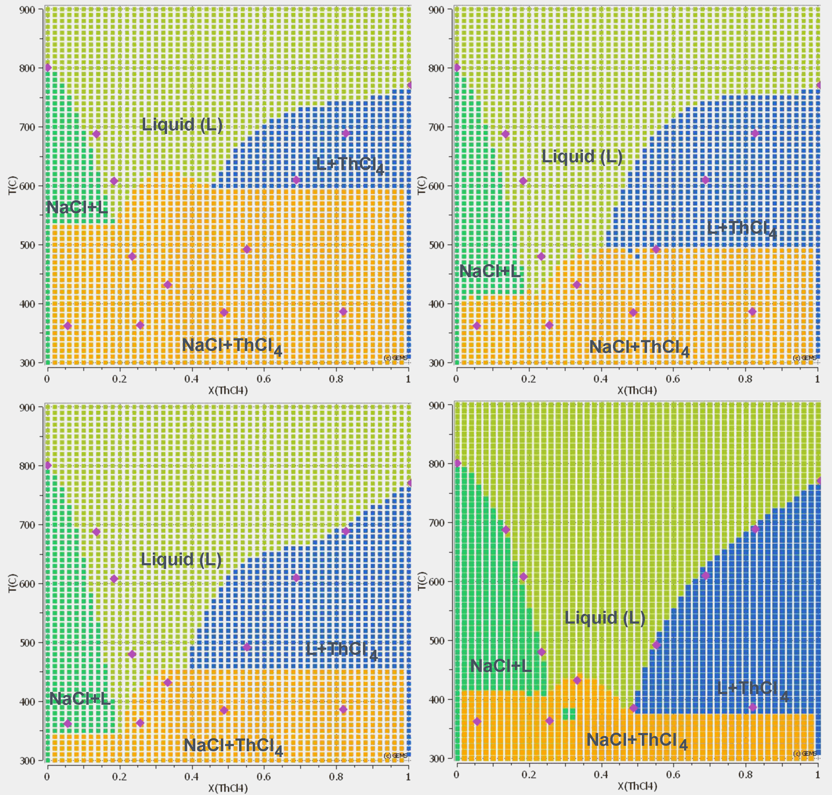

FIG. 2. Snapshots of the NaCl-ThCl4 phase diagram progression, from top left (initial literature interaction parameters)   
to bottom right (current result), where changes were made not only to the shape of the excess Gibbs’ energy   
curve to move the eutectic, but also the strength of the interaction.to match the temperature.   
Values from literature [18] are indicated by pink rhombus.

### cGEMS

cGEMS is a code based on the interaction of GEMS with the release code MELCOR. By exchanging the elemental composition and vapor pressures between GEMS and MELCOR at a time interval of 200 seconds, the comparatively basic chemical treatment of MELCOR can be reinforced using GEMS while retaining the powerful release analysis capabilities. In this work, a previously run case [13] in cGEMS was recreated using the updated HERACLES database. The results thereof are presented in Figure 7 below.

## Results

### Equilibrium Core Volume and Fuel Composition

Results obtained from EQL0D are in the form of critical core dimensions (see Fig. 3) and isotopic and elemental equilibrium compositions of the four aforementioned cases. In Table 2 below, the different elemental compositions are given. While the general order and occurrence of the most prevalent elements are as expected, there are some differences between the cases.



*FIG. 3. Comparison of the critical core sizes of the four cases*

TABLE 2: ELEMENTAL EQUILIBRIUM COMPOSITION OF THE FOUR REPRESENTATIVE CASES

|  |  |  |  |
| --- | --- | --- | --- |
| Fluorides/Thorium | Fluorides/Uranium | Chlorides/Thorium | Chlorides/Uranium |
| F: 5.15E-02 | F: 4.87E-02 | Cl: 2.21E-02 | Cl: 2.15E-02 |
| Li: 2.43E-02 | Li: 2.01E-02 | Na: 4.62E-03 | Na: 8.88E-03 |
| Th: 5.51E-03 | U: 5.60E-03 | Th: 3.77E-03 | U: 3.46E-03 |
| U: 1.05E-03 | Pu: 1.59E-03 | U: 4.60E-04 | Pu: 6.74E-04 |
| Pu: 2.64E-04 | Am: 5.79E-05 | Pu: 2.33E-04 | Am: 1.74E-05 |
| Zr: 3.90E-05 | Cm: 2.88E-05 | Am: 3.94E-05 | Zr: 1.57E-05 |
| Am: 3.14E-05 | Zr: 1.76E-05 | Np: 1.08E-05 | Nd: 1.24E-05 |
| Cm: 2.53E-05 | Nd: 1.43E-05 | Zr: 7.28E-06 | Cm: 1.05E-05 |
| Nd: 2.07E-05 | Ce: 1.12E-05 | Cm: 6.63E-06 | Ce: 9.66E-06 |
| Ce: 1.88E-05 | Np: 6.65E-06 | Nd: 4.29E-06 | Pr: 3.99E-06 |
| Pa: 1.30E-05 | Pr: 4.56E-06 | Ce: 3.86E-06 | Np: 3.57E-06 |

### GEMS/HERACLES Validation and Application

#### Chemical Thermodynamics of Two-Component Systems

The above-mentioned program GEMS is a powerful tool for thermodynamic computations. It does not, however, have the innate capability of generating phase diagrams given a material composition and temperature range. Therefore, it was necessary to develop a small script to address this lack. It works by scanning through both the temperature as well as composition scale in defined intervals and checking at each point what phases the substances are present in. This affords a phase diagram not of the classical variety showing lines denoting phase transitions, instead one that gives for each point on the temperature versus composition space an indication of what phases are present. While the resulting plot is somewhat unusual looking and rather dependent on the coarseness (or lack thereof) of the chosen scanning grid, it is a good way of making GEMS work in a way that it is not originally intended for.

In the following, resulting binary phase diagrams employed during the optimization of the liquid-liquid interaction parameters will be presented. Note that, while a lot of work has been done, there is still room for improvement not only in the quality of the fit, but also clearly in the extensiveness of binary data availability within HERACLES.

#### NaCl – PuCl3

The NaCl - PuCl3 phase diagram is relatively simple, with a single eutectic point at a molar fraction of PuCl3 of around 0.38. The interaction parameters for the liquid phase were adapted from Beneš and Konings [7]. The current iteration in HERACLES is shown in Fig. 4A below. Within it, the PuCl3 phase is represented in blue, NaCl in orange and the liquid in green. Pink rhombi indicate literature values.

The NaCl-PuCl3 diagram is rather unique in the fact that it required little to no adjustment to the literature interaction parameters. Conversely, even other simple diagrams like that of NaCl-UCl3 above take some effort to accurately match, even though the initial fit tends to be better for simpler diagrams. Crucially, relying on literature interaction data also requires the thermodynamic data for the compounds themselves to be the same to even have a chance of getting a good result immediately. This is a rather unlikely thing, as a lot of data for both reference diagrams as well as the HERACLES database used in the scope of this work are not necessarily based on scientific data. Instead, a considerable portion of the data, especially for compounds only relevant to nuclear research, lacks a solid experimentative foundation and is therefore in need of adjustment or an educated guess in order to complete the dataset.

#### LiF – ThF4

The extensions of the HERACLES database are not limited to chloride-based systems. In the following, a fluoride-based example will be discussed as a contrast to the NaCl - PuCl3 example above. The LiF-ThF4 system produces a very complex diagram due to the large number of compounds other than the pure elemental fluorides. In addition to adjusting the interaction parameters to make the diagram, there are temperature dependencies as well as the changing of the thermodynamic parameters of compounds. The initial set of interaction parameters was taken from Capelli et al. [8]; however, there is little resemblance left with what the system is based on now. In Fig. 4B, the produced phase diagram is displayed, where, in addition to the pure compounds in yellow and dark blue, there are Li7Th6F31 in light orange, LiTh2F9 in green and LiTh4F17 in light blue. The liquid is shown in dark orange.

While the general shape of the phase diagram in Fig. 4B is rather accurate, there are still a number of inaccuracies. Especially the liquidus line to the right of the eutectic is neither perfectly aligned with literature parameters nor especially stable. On top of that, literature diagrams suggest that there should be two separate eutectics with a small liquidus bump in between. The two literature eutectics are displayed as the two pink rhombi at the same temperature, around 0.25 on the molar fraction scale.

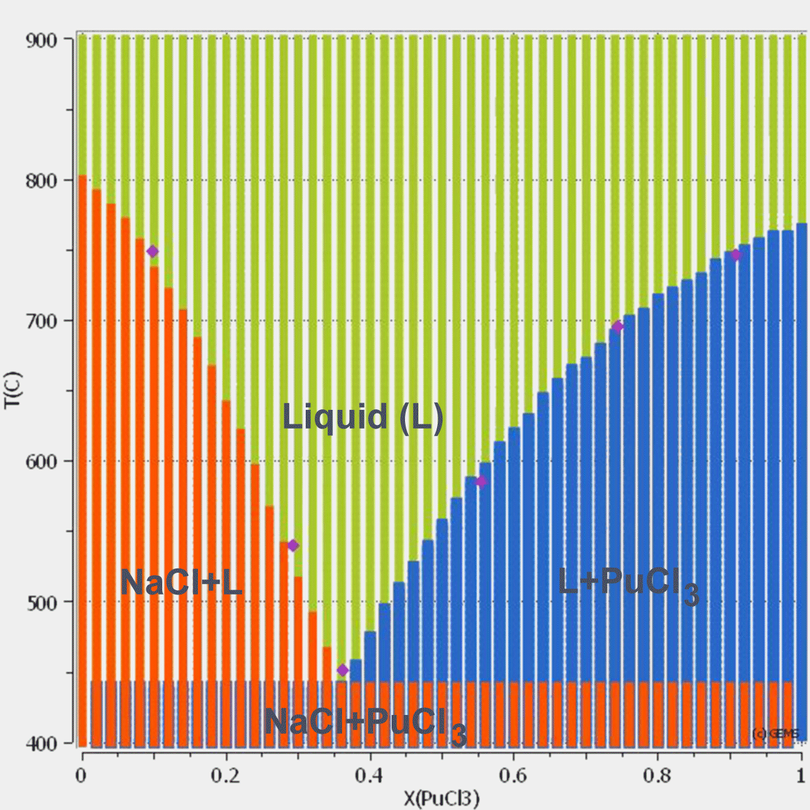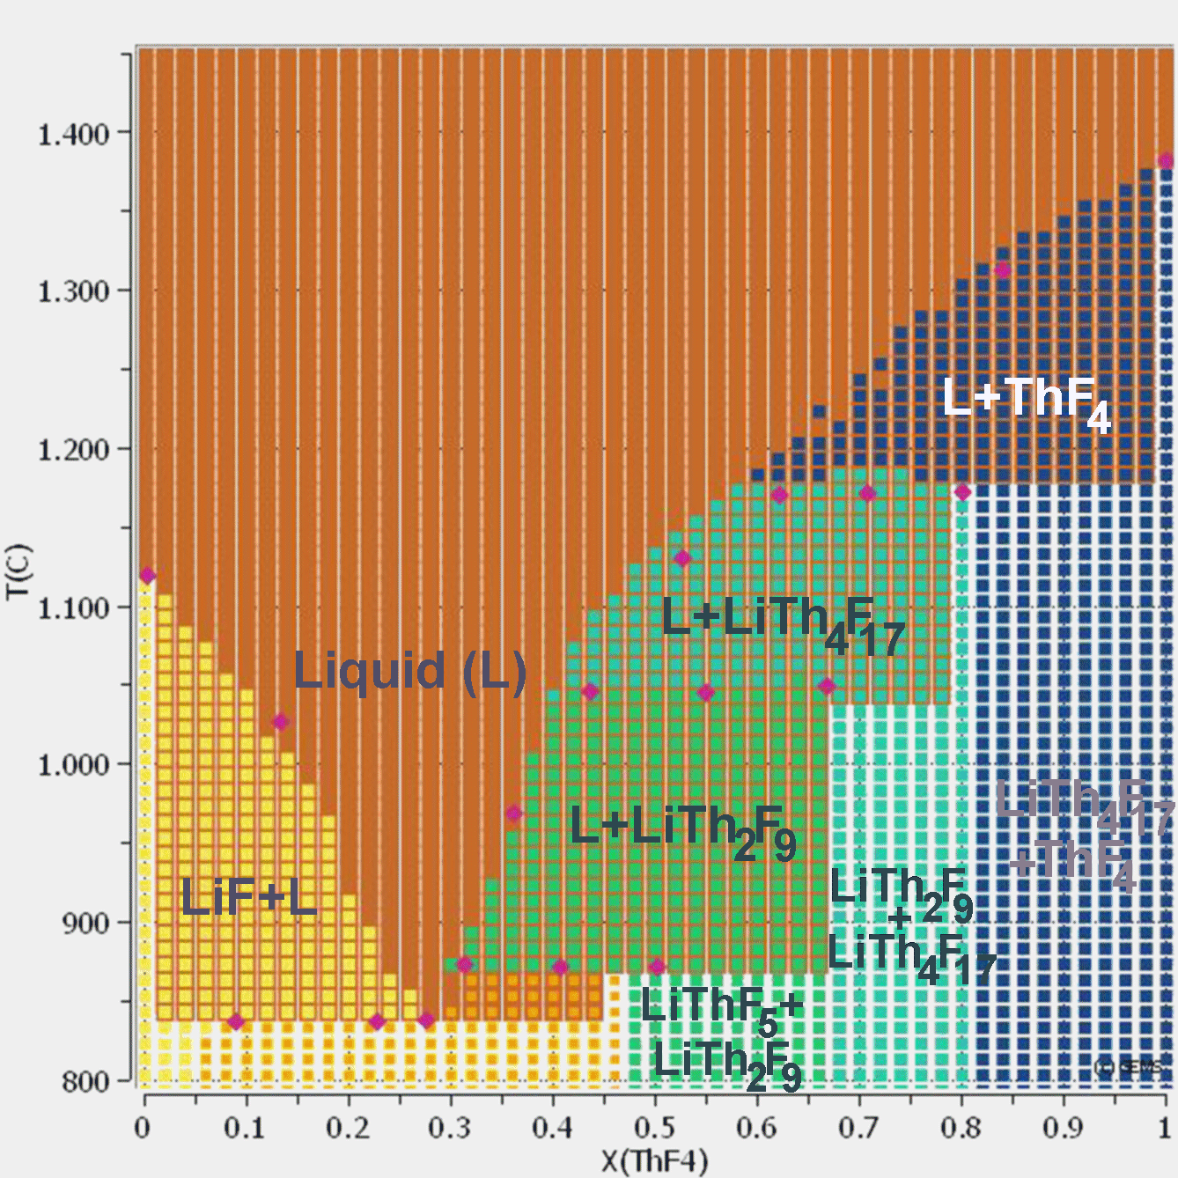

A B

FIG. 4. Binary phase diagram of the NaCl – PuCl3 system (A) and of the LiF – ThF4 system (B). Values from literature [19, 20] are indicated by pink rhombus.

#### Chemical Thermodynamics of Ternary Systems

Ternary diagrams tend to be a lot more unstable, which makes any optimization in terms of parameters more difficult.

In addition to being more difficult to make, it is also quite a challenge to properly understand when a ternary diagram made in GEMS comes close to a literature reference. This is due to GEMS ternary diagrams being made for a specific temperature, rather than having the isotherms and crystallization fields commonly found in literature.

As part of this work, the CsF – LiF – ThF4 ternary diagram was created for a temperature of 500°C, the result of which is displayed in Fig. 5. This combination of elemental halides was chosen, as it was comparatively easy to find a literature reference as well as good availability of the required thermodynamic data in HERACLES.

It is comparatively difficult to verify the correctness of this diagram, as its makeup deviates significantly from traditional literature diagrams [14]. Rather than showing isotherms, it is created for one specific temperature, which subsequently rules out certain species from being stable at any composition.

While the overall placement of the phases which are present seem correct, a more in-depth investigation would be necessary to make changes to the database based on deviations in ternary diagrams.

### Speciation of Representative Equilibria

Outputs from the neutronic and material analysis performed by EQL0D contain every element up to and including Fermium, which would be impossible to model within GEMS due to the lack of available data. To combat this issue, a considerable restriction on not only the number of available elements but also the number of according species needs to be put in place. This will generate a base salt, which covers the most important elements and their options in terms of valency.

Not only are the ten most prevalent elements responsible for over 90% of the makeup of the equilibrium salt, but this also allows for the investigation of lesser elements and their interactions with the bulk of the salt. By being able to investigate the effects of the addition of individual elements, an enormous amount of time invested in data collection can be saved, as elements of particular interest can be selected.

Since only the most prevalent elements are considered in the initial salt setup, the halogen content needs to be adapted accordingly. In the scope of this work, the assumption of stoichiometry is made with respect to the base salt, however an investigation into the effects of halogen content will be presented below. A basic equilibrium calculation of the base salt yielded the equilibrium composition of fluoride salt in Table 3, where compounds in the gaseous and liquid phases are present in their expected valences and states of matter.

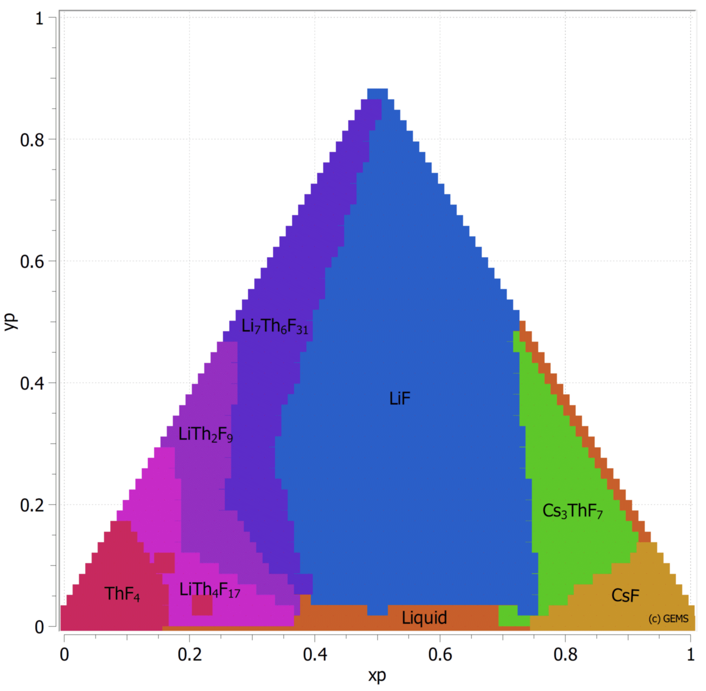

FIG. 5. Plot of the ternary phase diagram of the CsF – LiF – ThF4 system at 500°C.

TABLE 3: RESULTS OF FIRST BASIC INVESTIGATION OF EQUILIBRIUM COMPOSITION

|  |  |
| --- | --- |
| Phase | Molar Content |
| Gas | 0.010003045 |
| Liquid | 0.02744012 |
| NpF4 | 6.5268866E-06 |

As expected, the system at its intended, stoichiometric setup is almost entirely in the liquid phase. The only outlier is the presence of NpF4 in its solid state. This is unexpected in two ways, as Neptunium was assumed to naturally take its trivalent form. This means that not only does there seem to be a small amount of solid forming, but also that there will necessarily be another deviation from expected valency elsewhere to make up for the formation of NpF4. Because, in chemical thermodynamics, everything is in equilibrium, there are a lot of elements which have a small part of their speciation be in a lower-valency state. This means that it is hard to pinpoint where exactly the reason for the generation of tetravalent Neptunium lies.

In order to investigate the impact of halogen content on the aggregate state as well as speciation of the base salt, many cases were run at varying fluorine content scaling from zero to stoichiometry. The results are presented in Fig. 6 A and B.

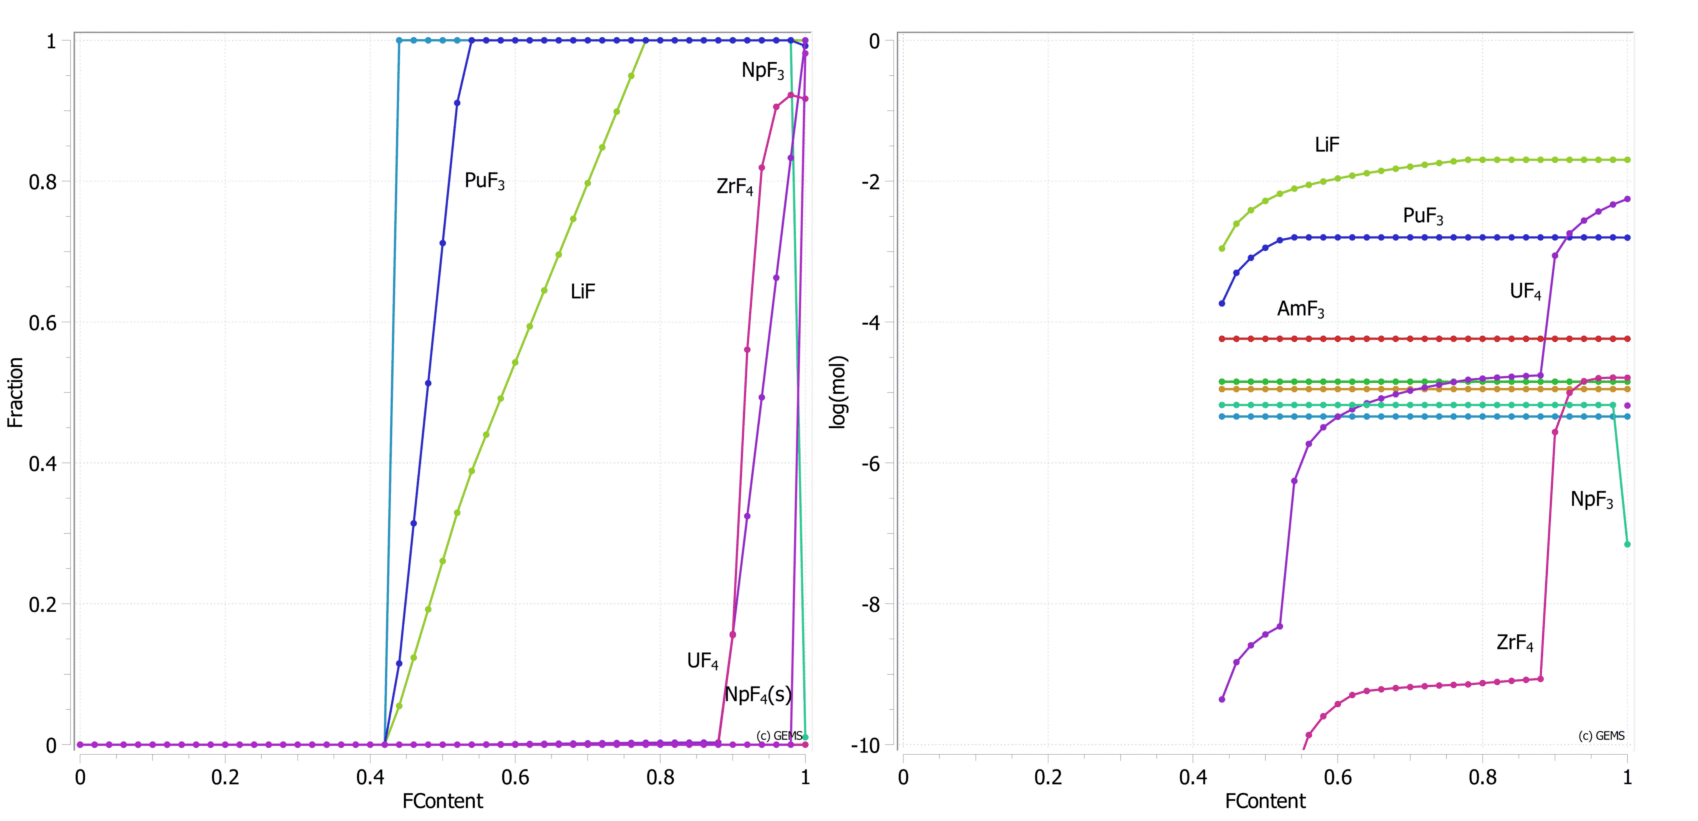

A B

FIG. 6 A: Fluorinated species present in the liquid phase as a function of the fraction of stoichiometric fluorine content  
B: Same information depicted as in A, however logarithmic to resolve some of the overlap

It is quite clear from the results that there is a hard minimum for fluoride species to be transferred into the liquid phase, which seems to lie at just over 40% of the presumed stoichiometry. Most of the elemental components immediately become available once that point is reached; Only ZrF4 starts to liquidize at a later point. The last thing of note is the aforementioned generation of NpF4, which can be observed as a drop in NpF3 just before the mixture reaches stoichiometry.

### Release Analysis with cGEMS

cGEMS is a code based on the interaction of GEMS with the release code MELCOR (see Fig. 1A). By exchanging the elemental composition and vapor pressures between GEMS and MELCOR at a time interval of 200 seconds, the comparatively basic chemical treatment of MELCOR can be reinforced using GEMS while retaining the powerful release analysis capabilities.

In this work, a previously simulated case [13] in cGEMS was repeated using the updated HERACLES database. The results thereof are presented in Figure 7 below.

As the input needs to align with what was previously published, it was not possible to use the compositions generated using EQL0D as part of this work. Instead, the values in Table 4 are employed.

Table 4: Representative fuel composition for release analysis

|  |  |
| --- | --- |
| Species | Content [mol%] |
| LiF | 78.8 |
| ThF4 | 16.9 |
| UF4 | 4.2 |
| Cs | 9.8E-03 |
| I | 5.8E-05 |

The results of the release analysis presented below take the form of an integral release curve as a function of time (and, therefore, temperature). In order to be comparable, the case setup including geometry as well as temperature curve are taken from the previous publication.

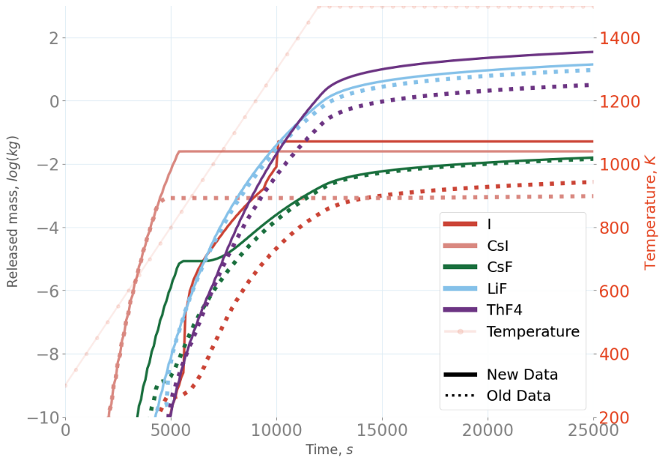

FIG. 7. Cumulative release of various substances as a function of time

Because only some of the species within HERACLES received considerable changes, not all species displayed in Figure 7 differ greatly from the original run. The most affected compounds are CsF as well as ThF4. As the LiF-ThF4 liquid-liquid interaction has changed considerably as part of this work, the effects on both of the according species are expected; however, since they are the main constituents of the salt, the changes propagate to affect other elements and their salts as well.

## Conclusion

EQL0D is an extremely complex code with a large variety of user-definable parameters, meaning the decisions made in the process of creating the case have a significant impact on the results, as well as any results which are subsequently created from them. It is therefore important to be aware that any choices made within the neutronic simulation can cause errors in the predicted salt properties through no fault of the chemical modelling.

In terms of data collection, a considerable part of the issue comes with respect to the availability of the data. As is already mentioned within the main text, research relating to MSRs often prefers fluorides over chlorides due to them being the seemingly easier version of the concept to realize. Consequently, nuclear-relevant fluorides are generally more well-characterized and investigated. This fact also extends to more involved data, such as interaction parameters for mixtures or information about possible designs for reactors. Future work on the database is planned, since there are still some holes in the availability of thermodynamic data which need to be filled.

When it comes to the application of collected data, especially concerning the creation of phase diagrams, issues arise due to the inherent instability of some GEMS systems. It becomes difficult to reach a sufficient accuracy considering the sheer number of possible adjustments that can be made to a system at any given time. This is not only concerning the actual thermodynamic parameters, but also the influence of the calculation parameters themselves, such as error tolerance or number of iterations.

Overall, the herein presented first steps towards a method for more accurate prediction of salt conditions based on an MSR design show promise, however with certain caveats relating to the availability of experimental data as well as restrictions in the accuracy of the neutronic model. Since the conference, as well as the publishing of this paper was delayed by one year, more detailed results of this study have been already published [16, 17].

**REFERENCES**

[1] HOMBOURGER, B., KREPEL, J., PAUTZ, A., The EQL0D fuel cycle procedure and its application to the transition to equilibrium of selected molten salt reactor designs, Ann. Nucl. Energy **144** (2020) 107504.

[2] LEPPÄNEN, J., PUSA, M., VIITANEN, T., VALTAVIRTA, V., KALTIAISENAHO, T., The Serpent Monte Carlo code: Status, development and applications in 2013, Ann. Nucl. Energy **82** (2015) 142.

[3] MATLAB version 9.3.0.713579 (R2017b), The Mathworks, Inc., Natick, Massachusetts (2017).

[4] WAGNER, T., KULIK, D.A., HINGERL, F.F., DMYTRIEVA, S.V., GEM-SELEKTOR GEOCHEMICAL MODELING PACKAGE: TSolMod LIBRARY AND DATA INTERFACE FOR MULTICOMPONENT PHASE MODELS, Can. Mineral. **50** 5 (2012) 1173.

[5] GEM Software Main Page, http://gems.web.psi.ch/.

[6] KULIK, D.A. et al., GEM-Selektor geochemical modeling package: revised algorithm and GEMS3K numerical kernel for coupled simulation codes, Comput. Geosci. (2012).

[7] GEMS specific HERACLES v.0.2. database for U, TRU and FP speciation, Paul Scherrer Institut (PSI), https://www.psi.ch/en/heracles/gems-specific-heracles-database.

[8] HOMBOURGER, B.A., Conceptual Design of a Sustainable Waste Burning Molten Salt Reactor, Dissertation, École Polytechnique Fédéral Lausanne, Lausanne (2018) 169 pp.

[9] KREPEL, J., LOSA, E., Closed U-Pu and Th-U cycle in sixteen selected reactors: Comparison of major equilibrium features, Ann. Nucl. Energy **128** (2019) 341.

[10] Pure Substances. Part 3 _ Compounds from CoCl3_g to Ge3N4 · References: Datasheet from Landolt-Börnstein - Group IV Physical Chemistry · Volume 19A3: “Pure Substances. Part 3 _ Compounds from CoCl3_g to Ge3N4” in SpringerMaterials (https://doi.org/10.1007/10551582_2), Springer-Verlag Berlin Heidelberg.

[11] Pure Substances. Part 2 _ Compounds from BeBr_g to ZrCl2_g · References: Datasheet from Landolt-Börnstein - Group IV Physical Chemistry · Volume 19A2: “Pure Substances. Part 2 _ Compounds from BeBr_g to ZrCl2_g” in SpringerMaterials (https://doi.org/10.1007/10705961_2), Springer-Verlag Berlin Heidelberg.

[12] Pure Substances. Part 1 _ Elements and Compounds from AgBr to Ba3N2 · References: Datasheet from Landolt-Börnstein - Group IV Physical Chemistry · Volume 19A1: “Pure Substances. Part 1 _ Elements and Compounds from AgBr to Ba3N2” in SpringerMaterials (https://doi.org/10.1007/10652891_2), Springer-Verlag Berlin Heidelberg.

[13] KALILAINEN, J., NICHENKO, S., KREPEL, J., Evaporation of materials from the molten salt reactor fuel under elevated temperatures, J. Nucl. Mater. **533** (2020) 152134.

[14] CAPELLI, E., BENEŠ, O., KONINGS, R.J.M., Thermodynamics of soluble fission products cesium and iodine in the Molten Salt Reactor, J. Nucl. Mater. **501** (2018) 238.

[15] KREPEL, J., et al., Extension of dedicated MSR fuel cycle procedure EQL0D, GLOBAL 2022 conference  
 Reims, France, July 2022.

[16] KALILAINEN, J., NICHENKO, S., DIETZ, S., LIND, T., Aerosol Formation and Filtration in Accidental  
 Conditions, Deliverable D3.5, EU project SAMOSAFER, 2021.

[17] NICHENKO, S., KALILAINEN, J., LIND, T., MSR Simulation With cGEMS: Fission Product Release  
 And Aerosol Formation, Journal of Nuclear Engineering, 2022.

[18] OYAMADA, R., Phase Diagrams of ThCl4 Systems Containing NaCl, KCl and LiCl and the Limitation of   
 the Congruently Melting Compounds Formation, Denki Kagaku oyobi Kogyo Butsuri Kagaku 1971.

[19] SOOBY, E. et al., Molten Salt Considerations For Accelerator-Driven Subcritical Fission To Close The  
 Nuclear Fuel Cycle, AIP Conference Proceedings 2013, 1525, 230–235.

[20] BENEŠ, O., KONINGS, R. J. M., Thermodynamic properties and phase diagrams of fluoride salts for   
 nuclear applications, Journal of Fluorine Chemistry, Fluorine & Nuclear Energy, 2009, 130, 22–29.

**Acknowledgements**

This work has received funding from the Euratom research andtraining programme 2019-2023 under grant agreement No847527.