Eddy Current Flow Meter flow rate measurements in liquid Sodium at the SUPERFENNEC loop
N. KRAUTER
Helmholtz-Zentrum Dresden-Rossendorf
Dresden, Germany
Email: n.krauter@hzdr.de

K. PAUMEL
CEA, DES, IRESNE, Nuclear Technology Department
Cadarache F-13108 Saint-Paul-Lez-Durance, France

M. GIRARD
CEA, DES, IRESNE, Nuclear Technology Department
Cadarache F-13108 Saint-Paul-Lez-Durance, France

S. ECKERT
Helmholtz-Zentrum Dresden-Rossendorf
Dresden, Germany

G. GERBETH
Helmholtz-Zentrum Dresden-Rossendorf
Dresden, Germany

Abstract

The Eddy Current Flow Meter is an inductive flow rate sensor which can be used in many liquid metal applications and is well suited for operation in liquid metal cooled fast reactors. There it can be used as part of the safety instrumentation in order to detect a loss of flow in the reactor core. To further qualify the Eddy Current Flow Meter for use in liquid metal cooled reactors, measurements with a high temperature prototype of the sensor have been performed at the sodium loop SUPERFENNEC for sodium temperatures between 200 °C and 300 °C and flow velocities of up to 2.5 m/s. By measuring the magnitude or phase shift of the output voltage of the sensor, the flow rate or velocity of the liquid sodium in a certain volume around the sensor can be determined. Depending on the frequency of the excitation current, the sensitivity of the sensor is changing. Therefore, measurement results for different frequencies and temperatures are presented as well as the results of a frequency sweep for determining the optimal excitation frequency of the sensor.

INTRODUCTION
Because of its simple design, the Eddy Current Flow Meter (ECFM) is a reliable and robust inductive sensor that can be applied to applications with harsh environmental conditions such as extreme temperatures or in chemically aggressive materials. The basic operating principle is based on a patent from 1948 by Lehde and Lang where a device for flow rate measurements in electrically conductive fluids was presented [1]. In the decades that followed, many different configurations of the sensor were developed and used for a wide range of applications [2,3]. Although the physical and chemical properties of liquid metals such as their opacity, high melting temperatures and chemical aggressiveness make flow measurements a challenging task, many measurement techniques have been and are still developed for liquid metal applications. The ECFM is part of the inductive flow rate sensors, which also include other sensors like the Permanent Magnet Electromagnetic Flowmeter [4], Phase Shift Flowmeter [5], Permanent Magnet Rotary Flowmeter [6] or measurement techniques like the Lorentz force velocimetry [7] and Contactless Inductive Flow Tomography [8-11], which allows the reconstruction of complete three dimensional flows. The recently developed Transient Eddy Current Flow Meter aims at negating one of the most prominent disadvantages of the ECFM, namely the need for calibration of the sensor [12-14]. In addition to these inductive measurement techniques, ultrasound Doppler velocimetry (UDV) [15-17] is another option for acoustic flow measurements in liquid metals.
The ECFM is used to measure the mean flow rate or flow velocity in a certain volume around the sensor. Its operating principle is based on the induction of eddy currents in materials with high electrical conductivities such as liquid metals. As soon as there is relative movement between the sensor and the electrically conductive material, additional velocity-dependent eddy currents are induced, the magnitude or phase shift of which can be used to infer the velocity [18]. There is a linear relationship between the magnitude or phase of the eddy currents and the velocity [19]. The most common configuration of the ECFM consists of three solenoid coils positioned vertically one above the other. The primary coil in the centre generates the so-called magnetic excitation field, which leads to the induction of eddy currents in the surrounding material. These in turn influence the excitation field of the primary coil. The two secondary outer coils detect these changes in the excitation field, which can be quantified by using the output voltage of the two coils. In order to be able to assign a velocity to a certain output voltage, the ECFM must be calibrated. Usually this can be done by simultaneous measurements with a different sensor, such as UDV sensors or other inductive flow rate sensors. Depending on the application, the ECFM can be immersed in a pool of liquid metal to measure the mean flow velocity around the sensor or it can be positioned around a pipe [20] to measure the average flow through that pipe. The frequency f of the excitation current determines the measurement depth of the ECFM. Due to the skin effect, the magnetic field cannot penetrate deeply into the liquid metal at high frequencies. Therefore, at low frequencies, a larger volume can be covered by the ECFM. The penetration depth δ can be calculated according to equation (1), where σ stands for the electrical conductivity of the metal and f for the frequency of the magnetic field.
$$δ=\frac{1}{\sqrt{πμ_{0}σf}}$$ | (1)
For the ECFM there have been various nuclear applications in the past such as void detection at liquid metal cooled fast reactors [21] or general flow measurements in fast reactors [22]. In this paper, measurement results with a high temperature prototype of the ECFM at the SUPERFENNEC sodium loop are presented. At first a frequency sweep is performed in order to identify the optimal range of excitation frequencies, subsequently measurements are performed with selected frequencies at sodium temperatures of 200 °C, 250 °C and 300 °C.

Experimental Setup
The experiments took place at the SUPERFENNEC sodium loop at CEA Cadarache in France. The loop went into operation in 1980 and is designed to introduce trainees to the operation of a sodium loop. In parallel it is used for scientific purposes. It has a total Na inventory of 150 litres and can be operated at temperatures between 150 °C and 450 °C. There are two test sections, a sodium pot with a volume of 60 litres and a dynamic test section which is located between two flanges that are about 1 m apart [23]. This is where the experiments with the ECFM are taking place. A simplified scheme of the relevant part of the test section can be seen in Fig. 1: The test section basically consists of two pipes that are made of stainless steel. The inner pipe has a wall thickness of 1 mm, the ECFM is inserted into this pipe and therefore protected from direct contact with the liquid metal. The magnetic field is able to penetrate the stainless steel wall, however, this reduces the signal strength and sensitivity of the sensor. The outer pipe separates the thermal insulation of the loop from the liquid metal.

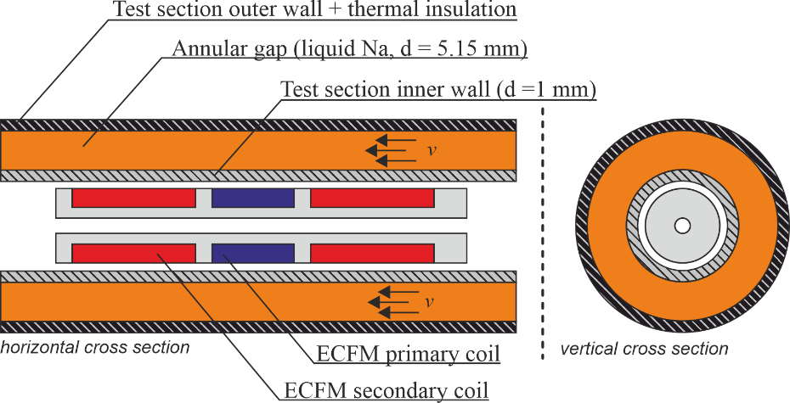
Fig. 1. Cross sections (not to scale) of the centre part of the test section where the ECFM is located. The test section has a total length of 70 cm, liquid Na is flowing through an annular gap with a width of 5.15 mm. Direct contact between liquid metal and ECFM is prevented by an inner stainless steel pipe with a wall thickness of 1 mm.
Between inner and outer pipe there is an annular gap with a width of 5.15 mm, this is where the liquid Na is located. There are multiple thermocouples distributed throughout the test section to monitor the temperature distribution during the experiments. The ECFM sensor is made of temperature resistant materials and consists of three magnetic coils. The coils are wound on a Macor coil holder, which is a special kind of ceramic that is more easily machinable than conventional ceramic. There are one active primary coil for the generation of the excitation field and two passive secondary coils that are used to detect velocity induced changes in the excitation field. The primary coil has a height of 10 mm and 125 turns, the secondary coils each have a height of 16 mm and 250 turns.
Since the sensor has to withstand temperatures of up to 650 °C, conventional copper wire cannot be used for the construction of the coils. Instead ceramic insulated nickel plated copper wire with a diameter of 0.25 mm is used. An excitation current with an rms of 500 mA and frequencies f between 200 Hz and 4 kHz is applied to the primary coil. The sensor has a total length of 50 mm and an outer diameter of 10.6 mm. The output signal of the ECFM is the voltage difference ΔU_{s} between both secondary coils, which has a linear dependency to the average flow velocity in the volume around the sensor. It has the same frequency f as the excitation current. Since the relevant signals are sinusoidal with a single frequency, a Lock-In Amplifier is used for recording the measurements. It has the advantage that all signals with frequencies other than f are filtered out and therefore electromagnetic disturbances have a considerably smaller impact on the measured signals. This results in an increased overall measurement accuracy. The excitation current is generated with a signal generator in combination with a power amplifier in current source mode, such that the excitation current is kept constant even when the resistance of the coil wires is slightly changing because of temperature variations.
In Fig. 2 the measurement setup is displayed. The signal generator is used to supply a sinusoidal signal to the current source which is generating the excitation current of 500 mA (rms) for the primary coil of the ECFM. The induced voltages in the secondary coils are first subtracted by the lock-in amplifier and the resulting voltage difference ΔU_{s} is then measured. This has the advantage that ΔU_{s} can be measured more accurately since both U_{s1} and U_{s2} are much higher than ΔU_{s} and would require a higher measurement range with lower accuracy. From ΔU_{s}, the magnitude ΔR and the phase shift with respect to the sinusoidal signal of the signal generator Δφ are obtained and recorded by the lock-in amplifier. In previous measurements and numerical simulations it was shown that both ΔR and Δφ increase or decrease linearly with the flow velocity of the surrounding liquid metal. Measurements were conducted at Na temperatures of 200 °C, 250 °C, 300 °C and velocities between 0 m/s and 2.5 m/s. Unfortunately there was a problem with the original current source (PA2024C) during the measurement campaign, therefore the measurements at 300 °C had to be performed with a replacement current source (TOE 7621).

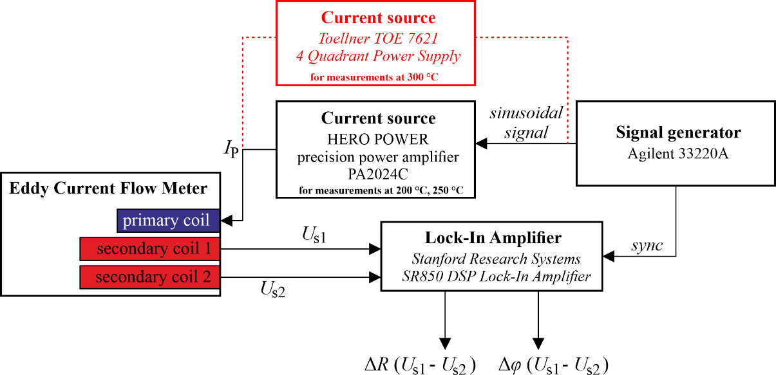

Fig. 2. Simplified scheme of the measurement setup. Due to technical difficulties, the measurements at 300 °C were performed with a different current source.

Measurement Results

Frequency sweep
Before the actual measurements with varying velocities, a frequency sweep for ΔR and Δφ was performed in order to obtain the sensitivity of the ECFM depending on the frequency of the excitation current and to identify the frequencies that will be used in the subsequent measurements. In order to obtain the respective sensitivities S_{R} and S_{φ}, measurements were performed at two different flow velocities v = 0.5 m/s and v = 1.5 m/s and frequencies f of the excitation current I_{P} between 200 Hz and 4 kHz. The two resulting ΔR and Δφ for each frequency were then subtracted to eliminate the offsets in magnitude and phase that are caused by slight asymmetries in the position of the secondary coils. After the subtraction, only the sensitivity without the influence of the offset remains. In Fig. 3 the results for ΔR and Δφ are displayed. It can be seen that the maximum of S_{R} is shifting to higher frequencies when the temperature is increasing (or the electrical conductivity of the liquid Na is decreasing). Here a shift from f_{max} = 600 Hz to f_{max} = 800 Hz can be observed.

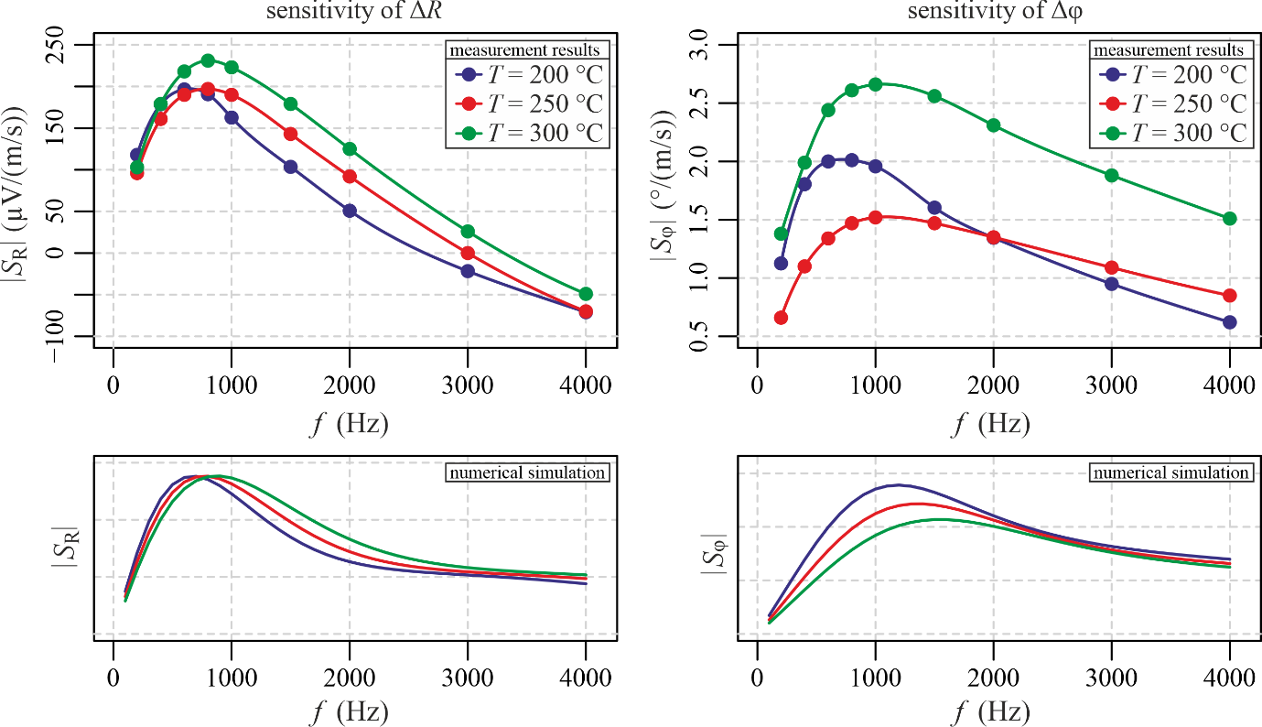
Fig. 3. Frequency sweep for the absolute values of the sensitivities of magnitude |S_{R}| and phase shift |S_{φ}| of the ECFM at three different temperatures. Due to technical difficulties, the measurements at 300 °C were performed with a different current source. Below the measurement results, the results of the numerical simulation under idealised conditions are displayed.
Despite best efforts, it was not possible to reproduce the exact conditions for the measurements at 300 °C because there was a problem with the original current source during the measurement campaign and the measurement setup had to be changed. The current source was replaced by a different model and since the new current source has different electrical parameters like inductivity and internal resistance compared to the other current source, the experimental results at 300 °C are significantly different because both amplitude and phase of the measured voltages are influenced by these parameters. Due to the small time frame of availability of the experimental facility, the measurements at 200 °C and 250 °C could not be repeated with the replacement current source. Therefore, the results at 300 °C can only be compared qualitatively to the results at the other temperatures. For 300 °C there is no visible shift of f_{max} for S_{R} compared to the measurements at 250 °C but it is possible that the shift is smaller than the step between two measurement points of 200 Hz and therefore not visible. In previous measurements with the same ECFM and in numerical simulations f_{max} keeps shifting to higher frequencies with increasing temperatures, while the maximum sensitivity remains constant. Due to the new current source, the amplitudes of ΔR and Δφ at 300 °C cannot be directly compared to the experimental results of the two lower temperatures, as can be seen in Fig. 3 where the maximum sensitivity of ΔR at 300 °C is clearly higher than for the two lower temperatures which have a maximum at nearly the same level.
For S_{φ} a similar behaviour to S_{R} can be observed (see Fig. 3): The point of maximum sensitivity is also shifting to higher frequencies when the Na temperature is increasing. Generally the frequency with maximum sensitivity is slightly higher for S_{φ} than it is for S_{R}. Here f_{max} lies at 800 Hz for 200 °C and at 1 kHz for 250 °C and 300 °C. Again, the behaviour of S_{φ} at 300 °C is different than expected due to the replacement current source. In previous measurements with the same ECFM and in numerical simulations the maximum of S_{φ} is decreasing for higher temperatures while f_{max} is increasing. Based on these measured values, three frequencies (600 Hz, 1.2 kHz and 2.4 kHz) were selected for the subsequent, more detailed measurements.

Results for varying flow velocity, temperature and excitation frequency
The measurement results of ΔR and Δφ are displayed in the same diagram, one for each of the nine combinations of temperatures T and frequencies f. For data regarding ΔR the colour blue and for Δφ the colour red is used. Each data point represents the mean value of 60 s of continuous measurements at a constant flow velocity v, temperature and frequency. Since it is known that there is a linear relationship between ΔR and v as well as Δφ and v their optimal relation is calculated from the data points via linear regression. The dashed lines in each diagram indicate the result of the linear regression.

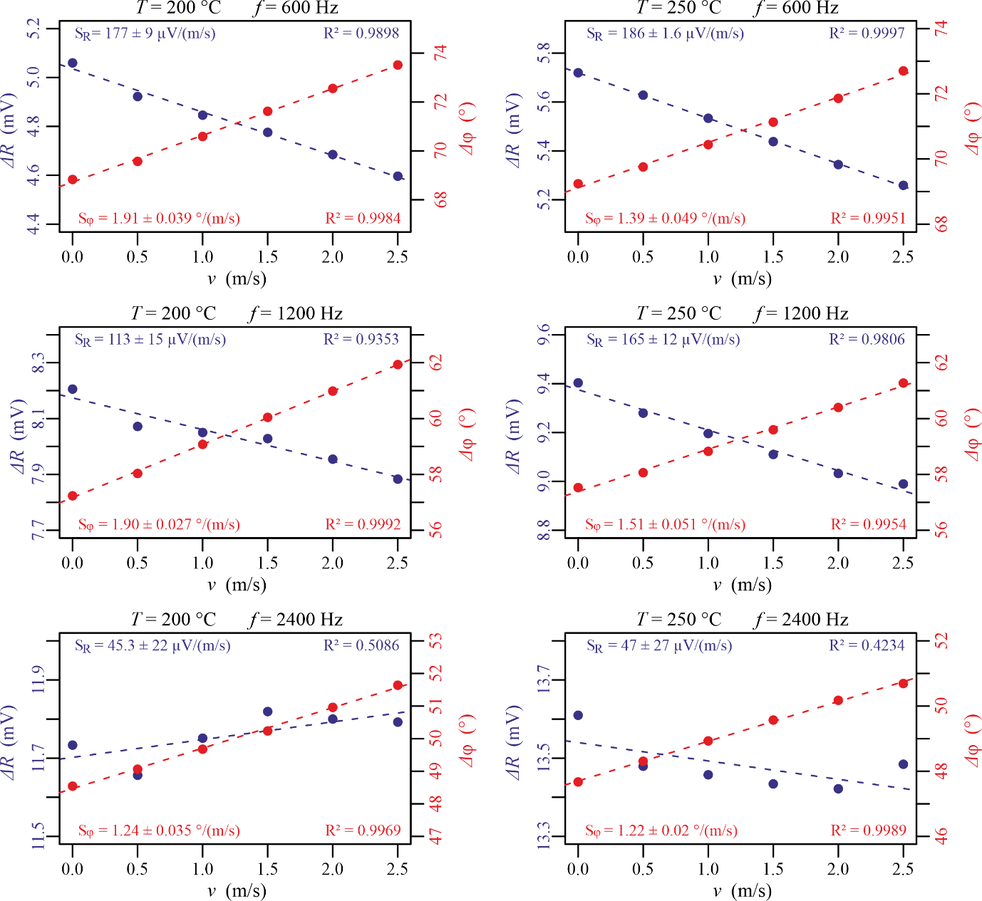
Fig. 4. Measurement results for ΔR (blue) and Δφ (red) at T = 200 °C and T = 250°C. Measurements are represented by dots, the dashed line shows the linear regression of the results. For every temperature T and excitation frequency f, the sensitivity S and the coefficient of determination R² of the linear regression are displayed.

Additionally the slopes of the linear regression lines, which correspond to the sensitivities S_{R} and S_{φ} of the ECFM, their interval of certainty as well as the respective coefficient of determination R² are included in each diagram. The coefficient of determination R², which can assume values between 0 and 1, represents how well the measured values for ΔR and Δφ can be described with a linear function of v. For R² = 1 there would be an ideal linear relationship, whereas R² = 0 would indicate that there is no linear relationship at all.
The interval of certainty is calculated from the standard deviation of the slope of the linear regression line and depicts how accurate the velocity can be obtained from a given measurement of ΔR or Δφ when using the regression line as a reference. A smaller interval of certainty means a better resolution and smaller error for determining the flow velocity of the liquid metal.
For a Na temperature of 200 °C (see Fig. 4) the following observations have been made: The results for ΔR are getting worse with increasing f, regarding sensitivity as well as linearity. The reason for this is the relatively sharp sensitivity maximum around 600 Hz, which is rapidly decreasing for higher f (see Fig. 3). At 2.4 kHz no clear linear dependency between ΔR and v can be observed because of the low sensitivity at this frequency. The results of Δφ show a good linearity for all three frequencies. Because of the wide sensitivity maximum the results for 600 Hz and 1.2 kHz are almost the same. Overall, the measurement results of Δφ are superior to ΔR at a temperature of 200 °C.

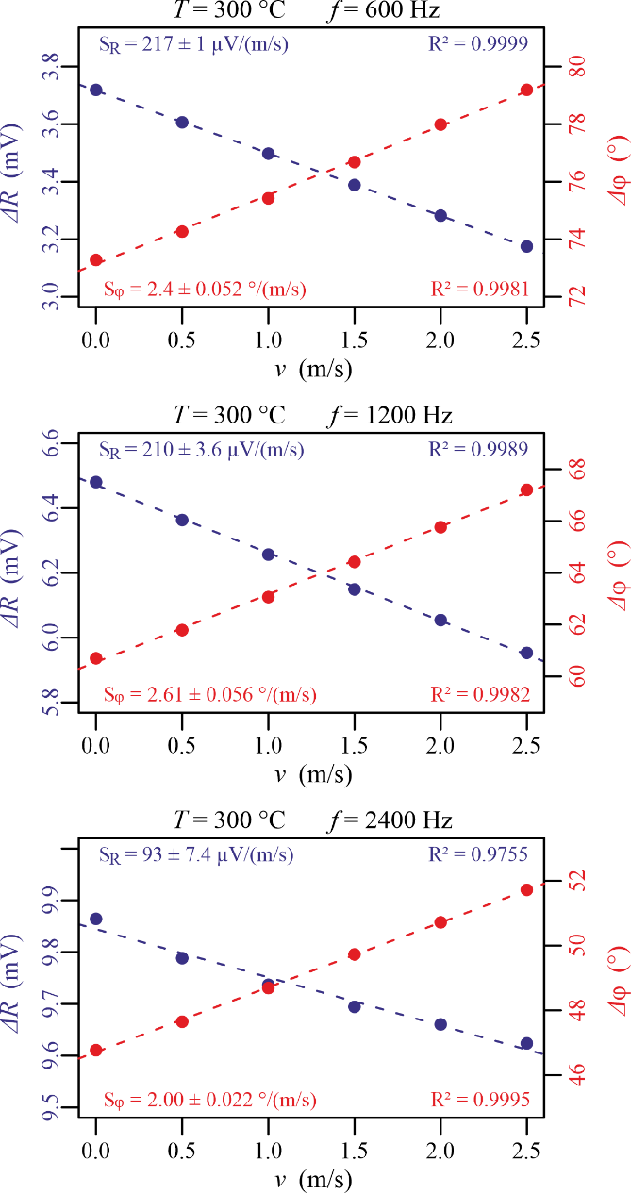
Fig. 5. Measurement results for ΔR (blue) and Δφ (red) at T = 300 °C.

For a Na temperature of 250 °C (see Fig. 4) the following observations have been made: The behaviour of ΔR is similar to the results at 200 °C, with the best linearity and sensitivity at 600 Hz which are rapidly decreasing for higher f. For Δφ the sensitivity dropped significantly compared to the results at 200 °C, which can also be seen in Fig. 3 and corresponds to the results of previously performed numerical simulations of the ECFM. This seems to have no impact on the linearity of the results which is again very good for all three frequencies.
For the measurements at 300 °C (see Fig. 5) the original current source had to be replaced by a different current source because of technical problems. By changing the current source some electrical parameters (inductivity and resistivity of the source, rms of the primary current) changed, therefore only a qualitative comparison to the previous results will be possible: Overall, at 300 °C the best results for both ΔR and Δφ were obtained. Linearity and sensitivity of ΔR are again decreasing for higher f, for Δφ all three frequencies yield very good results.

Conclusions
Measurements with the ECFM in liquid Na were performed successfully, the linear dependency between output voltage of the sensor and flow velocity have been observed. The measurement results have shown that the voltage magnitude ΔR yields the best results for frequencies around 600 Hz to 800 Hz whereas Δφ is generally more accurate over a wide range of frequencies. This effect is caused by the different responses of the sensitivity to changes in the excitation frequency. Depending on the application and the desired measurement volume, one or multiple frequencies can be chosen accordingly for the measurements. When comparing the results at different temperatures, both ΔR and Δφ become more accurate and linear with increasing Na temperatures. The best results of this measurement campaign regarding ΔR were obtained at 300 °C and 600 Hz, here the measurements represent almost a perfect linear dependency between ΔR and the flow velocity. However, this could be in part caused by the replaced current source. Qualitatively the results are in good agreement with the numerical simulations that were performed prior to the measurements. It can also be seen that ΔR has a negative slope, while Δφ is increasing with the flow velocity. This must not always be the case, for example when a different ECFM is used which has a different offset for ΔR and Δφ. This offset is caused by slight asymmetries in the coil distances due to manufacturing tolerances. Which slope is positive or negative is also determined by the way how the voltage difference ΔU_{s} is calculated: either by subtracting the voltage of the upstream from the downstream secondary coil or vice versa. To avoid mistakes, one could also use the absolute values for ΔR and Δφ.
In a different measurement campaign, measurements with angled flows and an array of multiple ECFM sensors for the detection of blocked SAs have been performed. In the future, the further qualification of the ECFM with additional measurements in liquid Na at even higher temperatures and flow velocities is planned.

ACKNOWLEDGEMENTS
The authors would gratefully thank Jérémie Fache (data acquisition system management), Gwendal Blévin and Bruno Morassano (facility operation), who were essential for preparing and conducting the experiments.

References
- LEHDE, H., LANG, W. T., “Device for measuring rate of fluid flow”, Patent No. US2435043A, 1948
- SHERCLIFF, J. A., “The Theory of Electromagnetic Flow-Measurement”, Cambridge University Press, Cambridge, United Kingdom, 1962.
- BEVIR, M. K., “The Theory of Induced Voltage Electromagnetic Flowmeters”, J. Fluid Mech., 43(3), pp. 577–590.
- BUCENIEKS, I., “Electromagnetic induction flowmeter on permanent magnets” Proc. 5th Int. PAMIR Conf., Ramatuelle, France, Vol. II, pp. 103–105, 2002.
- PRIEDE, J., BUCHENAU, D., GERBETH, G., “Contactless electromagnetic phase-shift flowmeter for liquid metals”, Meas. Sci. Technol., 22, 055402, 2011.
- PRIEDE, J., BUCHENAU, D., GERBETH, G., “Force-free and contactless sensor for electromagnetic flowrate measurements”, Magnetohydrodynamics, 45, pp. 451–458, 2009.
- THESS, A., VOTYAKOV, E. V., KOLESNIKOV, Y., “Lorentz force velocimetry”, Phys. Rev. Lett., 96, 164501, 2006.
- STEFANI, F., GERBETH, G., “Velocity reconstruction in conducting fluids from magnetic field and electrical potential measurements”, Inverse Prob., 15, pp. 771–786, 1999.
- STEFANI, F., GERBETH, G., “On the uniqueness of velocity reconstruction in conducting fluids from measurements of induced electromagnetic fields” Inverse Prob., 16, pp. 1–9, 2000.
- STEFANI, F., GERBETH, G., “A contactless method for velocity reconstruction in electrically conducting fluids” Meas. Sci. Technol., 11, pp. 758–765, 2000.
- WONDRAK, T. et al., “Contactless inductive flow tomography for a model of continuous steel casting”, Meas. Sci. Technol., 21, 045402 2010.
- FORBRIGER, J., STEFANI, F., “Transient Eddy Current Flow Metering”, Meas. Sci. Technol., 26(10), 105303, 2015.
- KRAUTER, N., STEFANI, F., “Immersed Transient Eddy Current Flow Metering: A Calibration-Free Velocity Measurement Technique for Liquid Metals”, Meas. Sci. Technol., 28(10), 105301, 2017.
- LOONEY, R., PRIEDE, J., “Alternative Transient Eddy-Current Flowmetering Methods for Liquid Metals,” Flow Meas. Instrum., 65, pp. 150–157, 2019.
- BRITO, D. et al., “Ultrasonic Doppler velocimetry in liquid gallium”, Exp. Fluids, 31, pp. 653–663, 2001.
- ECKERT, S., GERBETH, G., “Velocity measurements in liquid sodium by means of ultrasound Doppler velocimetry” Exp. Fluids, 32, pp. 542–546, 2002.
- ECKERT, S., GERBETH, G., MELNIKOV, V. I., “Velocity measurements at high temperatures by ultrasound Doppler velocimetry using an acoustic wave guide”, Exp. Fluids, 35, pp. 381–388, 2003.
- SHARMA, P. et al., “Performance Prediction of Eddy Current Flowmeter for Sodium,” Proceedings of the COMSOL Conference, Bangalore, India, 2009.
- POORNAPUSHPAKALA, S., et al., “An Analysis on Eddy Current Flowmeter—A Review”, Recent Advances in Space Technology Services and Climate Change (RSTS & CC-2010), Chennai, India, pp. 185–188, 2010.
- PAVLINOV, A., KHALILOV, R., MAMIKYN, A., KOLESNICHENKO, I., “Eddy Current Flowmeter for Sodium Flow,” IOP Conf. Ser.-Mater. Sci. Eng., 208, 012031, 2017.
- NAKAMOTO, K. et al., “Application of an Eddy-Current Type Flowmeter to Void Detection at the LMFBR Core Exit”, Nucl. Eng. Des., 82(2–3), pp. 393–404, 1984.
- SURESHKUMAR, S. et al., “Utilization of Eddy Current Flow Meter for Sodium Flow Measurement in FBRs”, Nucl. Eng. Des., 265, pp. 1223–1231, 2013.
- GASTALDI, O., Profile SFR-26 France – SUPERFENNEC (2021),
https://nucleus.iaea.org/sites/lmfns/Facility%20Country%20Profiles1/Profile%20SFR-26%20France%20-%20%20SUPERFENNEC.pdf

