EXPERIMENTAL TEST FACILITY TO TEST A PROTOTYPE OF THE AIR HEAT EXCHANGER GATE FOR THE ADVANCED BN REACTOR PLANT. DESIGN AND CONSTRUCTION ITEMS

GRUSHKO M.E.
JSC “Afrikantov OKBM”,
Nizhny Novgorod, Russia
Email: grushko_me@okbm.nnov.ru

GUSEV D.V.
RUKHLIN S.V.
JSC “Afrikantov OKBM”,
Nizhny Novgorod, Russia

Abstract

A reactor plant is provided with an emergency heat removal system for increase its safety. One of its main elements is an air heat exchanger equipped with an air regulating device with passive principle - a gate.
To validate functionality of the gate a high temperature experimental test facility was designed and built in JSC “Afrikantov OKBM”, the test facility permits to carry out tests of the pilot gate in the conditions similar to the standard ones (temperature higher than 50 ^{о}C).

Introduction
Development of the design of the advances fast neutron reactor plant is associated with ensuring enhanced safety of equipment and systems, and implementation of safety functions using passive systems.
In this view, an outlet gate of the air heat exchanger was designed during development of the design of the advanced fast neutron reactor plant. To check the functionality of the pilot gate there was required to create a high temperature experimental test facility.

DEVELOPMENT OF THE EXPERIMENTAL TEST FACILITY
During development of the test facility there were considered the operation conditions of the air heat exchanger, and the tasks were placed to check functionality of mechanisms, reliability of units and seals of the pilot gate, and to define hydraulic resistance and air leaks in the closed position of the gate.
To solve these tasks the questions of creation of the design, layout and equipment of the test facility were examined.
To meet the requirements for the specific conditions for the testing equipment, the following requirements came upon the test facility:
- providing heating of the equipment and heating of the working medium (air) higher than 500 ^{о}C;
- providing removal of hot air;
- control of the electrical power of electric heaters;
- being in hot state for long time;
- reducing of heat losses;
- possibility to define hydraulic resistance;
- providing on-line monitoring of the parameters;
- remote control of the equipment;
- accessibility to the placed equipment, valves and instruments during mounting/dismounting.

The basic diagram of the available test facility is given in Fig. 1.

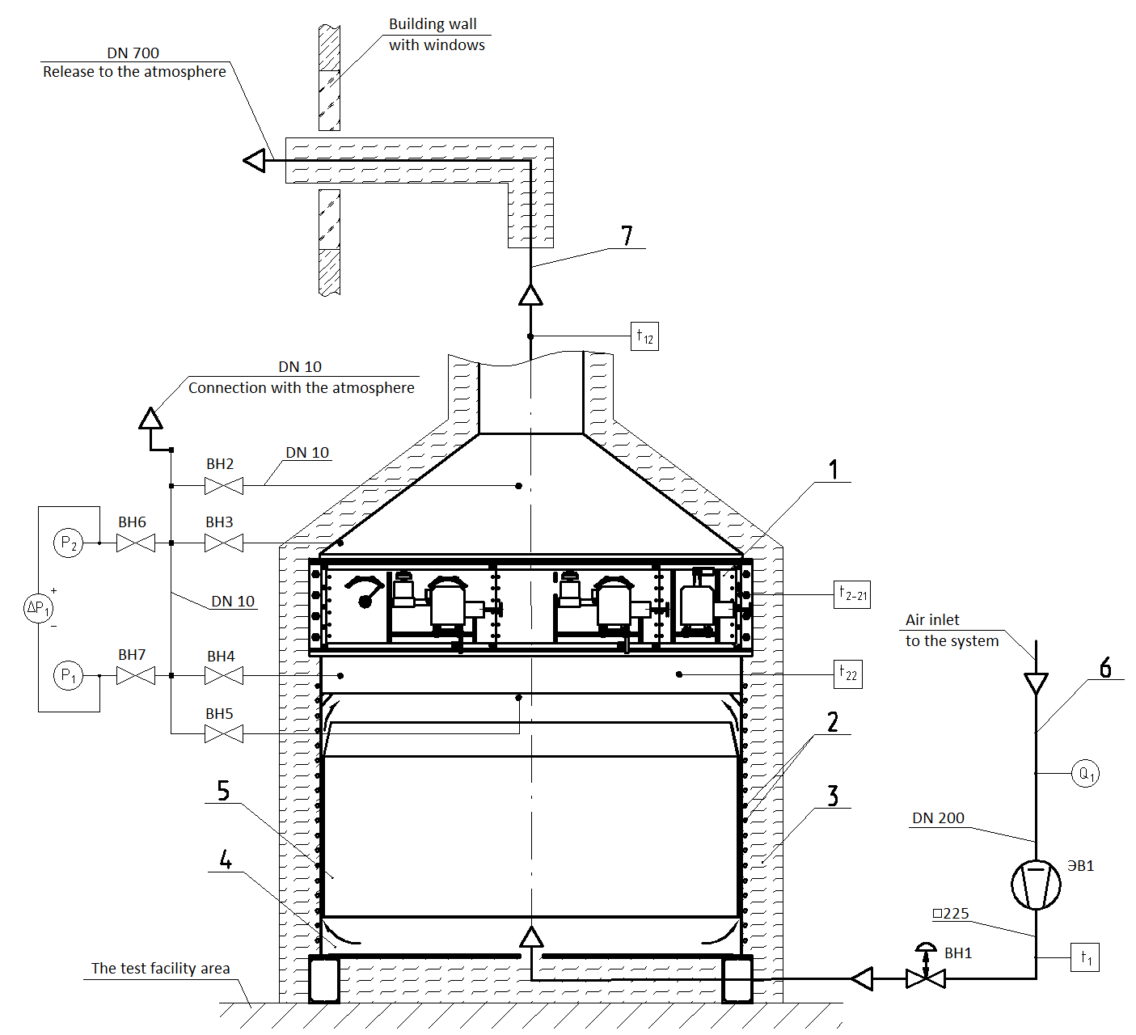

1 - pilot gate; 2 - electric heaters; 3 - heat insulation; 4 - vessel; 5 - spacer; 6 - inlet air pipe ;
7 - outlet air pipe.

FIG. 1. Basic diagram of the test facility

This design of the test facility ensures solving of issues related to the number of the measured parameters (temperature, pressure, flow rate, etc.), layout of respective sensors, and obtaining the measured information, its registering and storage.
There are primary transducers for measurement of the facility walls, spacer temperature, air temperature under the gate and pressure in the top part of the vessel. There are primary transducers for measurement of the spacer bottom temperature at the bottom part of the vessel. And there are temperature primary transducers for measurement of the air temperature at the gate out let at the bottom part of the outlet air pipe. Also there are primary transducers for measurement of pressure drop ∆Р1 and pressures Р2, Р3 with shutoff valves ВН2-ВН7 in the testing facility.
Air intake is done with the fan ЭВ1 from the area of the facility location. The valve ВН1 is installed after the fan for regulating of isolation of air flow. There is a primary transducer for measurement of flow rate Q1 in the pipe before the fan. And there is a primary transducer for measurement of temperature at the inlet of the facility vessel after the valve ВН1.
Considering the same, an information and measurement system was designs for on-line registering of the test facility parameters and saving the information on a PC, also it is possible to control the test facility automatically and remotely with programs.
The composition and the number of the parameters of the experimental test facility are given in table 1.

TABLE 1 THE COMPOSITION AND THE NUMBER OF THE PARAMETERS OF THE EXPERIMENTAL TEST FACILITY

Parameter | Number of the measurement instruments
Temperature | 36
Pressure | 2
Pressure drop | 1
Flow rate | 1
Totally: | 40

SOLUTIONS OF THE TEST FACILITY DEVELOPMENT
The 3D model of the test facility (heat insulation is not shown) is given in Fig.2.

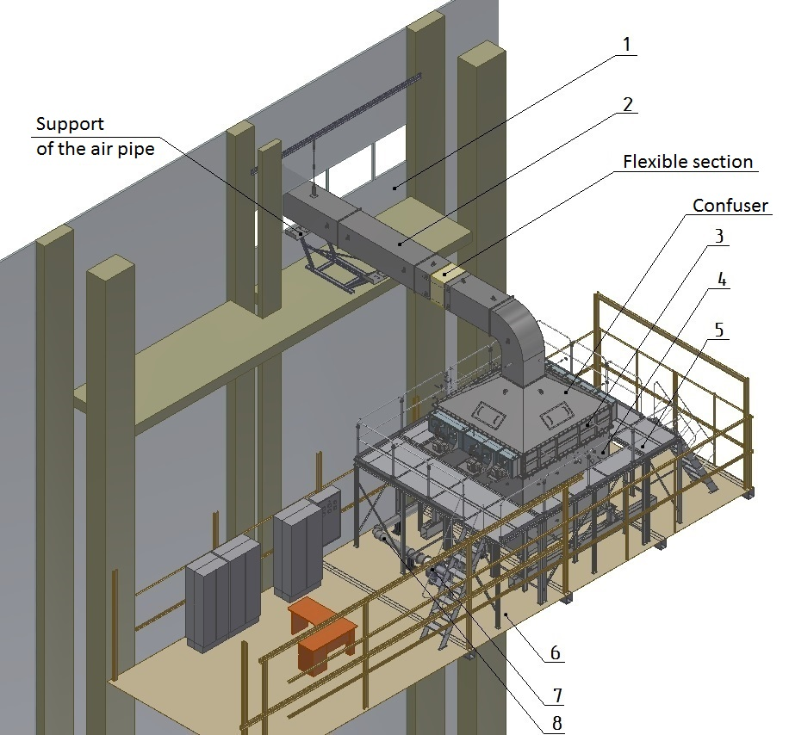

FIG. 2. The 3D model of the test facility
The developed test facility is located in the area pos. 6. To ensure safety the air exhaust is made at 17 m height from the floor of the building, where the test facility is located. The main elements of the test facility:
- vessel pos. 4 fro installation of the gate pos. 3 accommodating the spacer (not shown in the picture);
- fan pos. 7 providing delivery of the working medium (air) to the gate pos. 3 through the DN200 pipe pos. 8 to the bottom part of the vessel and releasing it to atmosphere through the DN700 pipe pos. 2 passing through a window of the building pos. 1.
Maintenance of the gate during the tests is done from the specially designed platform pos. 5.
During creation of the test facility the task was solved of ensuring heating of the equipment to the required high temperatures, and considering the same, the optimal design of the test facility was worked out. Heating systems and their calculation (power, type, number, and length) were selected to heat and maintain the required temperatures. Finally a precision alloy wire was selected with high electric resistance and ceramic insulators (ref. Fig. 3) providing 170kW of electrical power, the wire was supposed to be placed from the outer side of the vessel along the whole perimeter, on the internal walls and bottom of the spacer and to be fastened with special clamps at specified pitch. Before installation the wire with insulators was wrapped with silica cloth for the whole length.

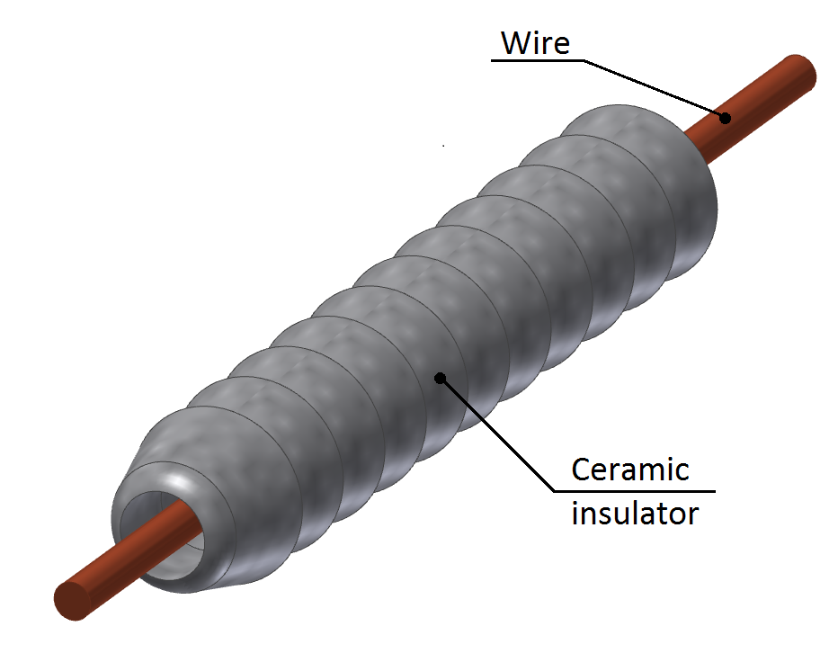

FIG. 3. Heating system element

The vessel is a metallic cube, and a spacer was necessary to be placed in the vessel to ensure heating of air and equalizing the current in the area of the pilot gate. A procedure and technological tools were manufactured to provide the required linear gap between the vessel and the spacer of the test facility during tests. The spacer elements were installed according to the mentioned above. Sealing covers are provided on the vessel and the spacer to prevent from releasing of the hot air through the holes in the area of the spacer elements. This unit is presented in Fig. 4.

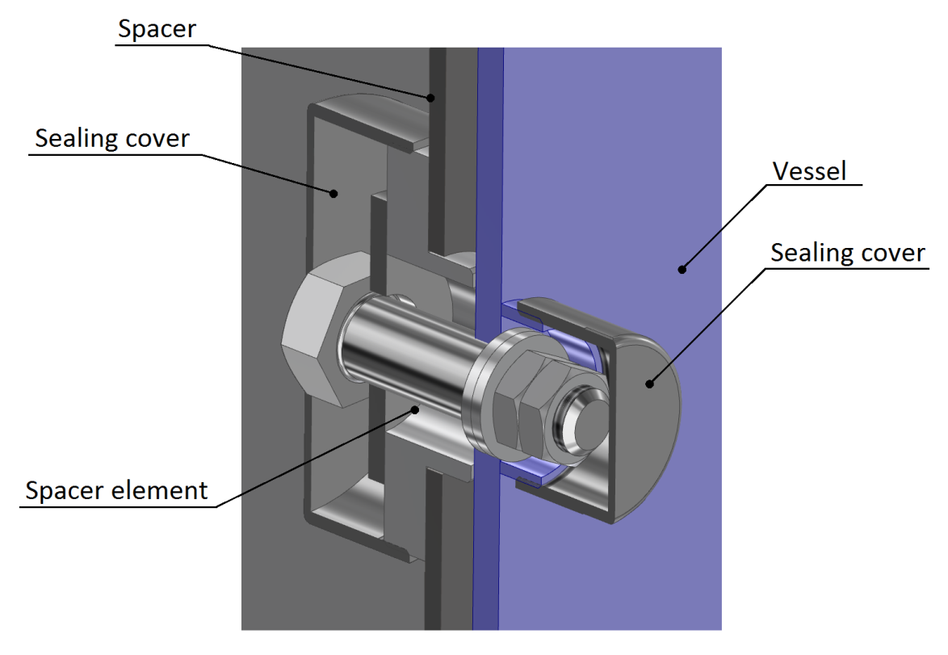
FIG. 4. The unit with the spacer element

The fan provided the required parameters were selected considering the defined hydraulic resistance and leaks. Accordingly the task for design of the air tracks with the necessary valves was solved.

To transfer to the release air pipe after the gate a confuser was installed, which is like metallic cone with four sight holes (Fig. 5) required for monitoring smoothness and uniformity of opening of the blades of the pilot gate during testing without heating provided with the testing procedure of the gate.

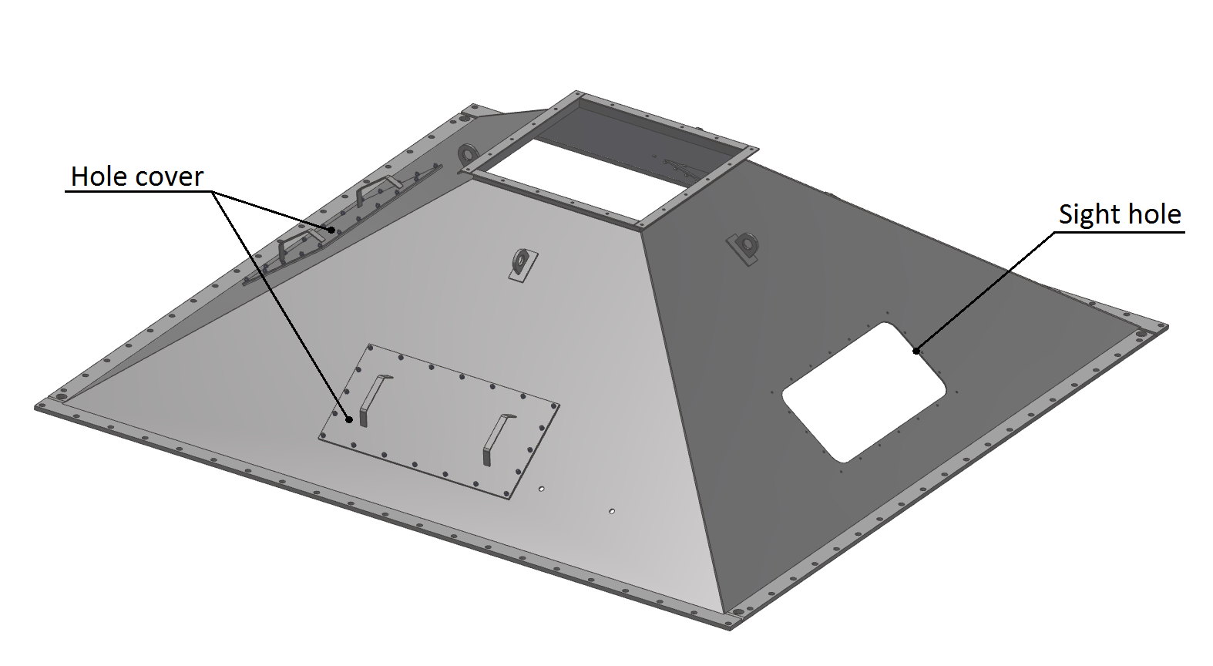
FIG. 5. Confuser

Initially, there was studied a closed system of circulation of the working medium providing air cooling system after passing the gate. But considering significant overall characteristics, height and accessibility of the test facility, flow rate, high temperature of air, it was not possible to implement this scheme.
Accordingly the air circuit was opened, and there was provided air pipe exit outside the building, and a valve is installed on the cold part of the air pipe after the fan, which prevents back draft of hot air in case of stopping the fan.

To compensate temperature displacement of the air exhaust pipe a flexible section of the pipe from silica cloth (Fig.6) is provided, and a special torch was installed on the exhaust Fig.7 to prevent form streaming of hot air on the glasses of windows and damaging the face of the building. A protective mesh was installed to avoid ingress of foreign objects and birds between the torch exhaust and a section of the air pipe.
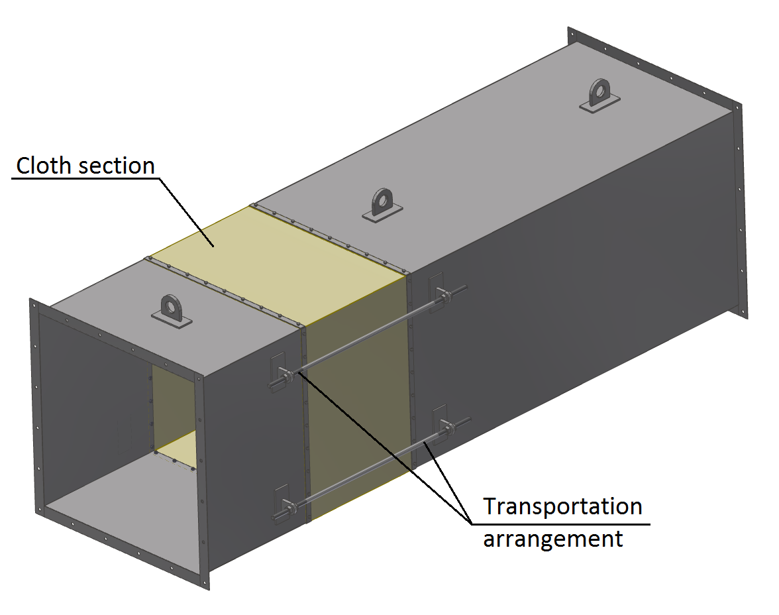
FIG. 6. Flexible section of the air pipe

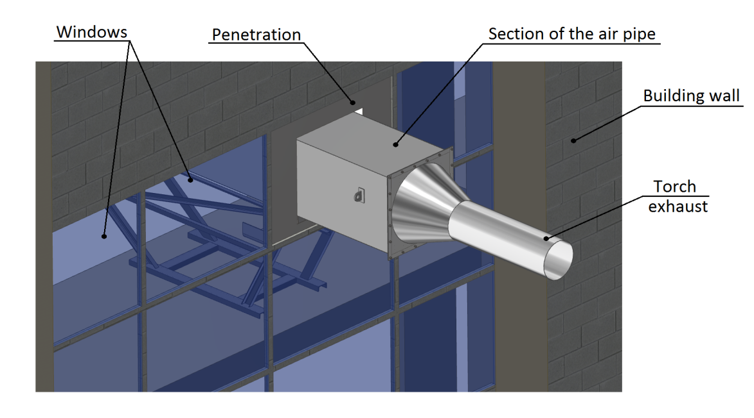
FIG. 7. Torch exhaust

Long presence of the some parts of the test facility in hot condition for providing heating of air and heating of the gate to the operation temperatures and its keeping in the zone of high temperature lead to the necessity to use materials ensuring functionality of these parts of the test facility in these conditions. Due to this the vessel, the spacer, confuser and the exhaust air pipe were manufactured from austenitic stainless steel.
High temperature insulation was used to minimize the heat losses and ensure safe work on the test facility. The task was solved by selection of special materials, development of their layout schemes and their fastening. Several layers of mats are placed on all “hot” surfaces parts of the test facility, the mats are made from basalt linen covered with silica cloth of total thickness 250 mm. Also a procedure was developed to simplify mounting of the heat insulation. The mats are mounted on special rods and fastened with these rods. To reduce heat losses each subsequent layer of the mats is overlapping the longitudinal and transversal joints of the previous layer. The joint of the mats were sewn with silica tape between each other. After mounting the heat insulation the vessel was covered with silica cloth.

MANUFACTURE AND MOUNTING ISSUES
Considering that the test facility is located at an elevation, there appeared a difficulty to deliver its components and parts and prepared electric heaters.
The electrical heating system was mounted according to the developed procedure of fastening and scheme of placing the heating wire (Fig. 8). Considering that the length of the heating element was more than 40 m, the tasks were solved with respect to its forming, inserting the wire in the ceramic insulators ant their further insulating with cloth.

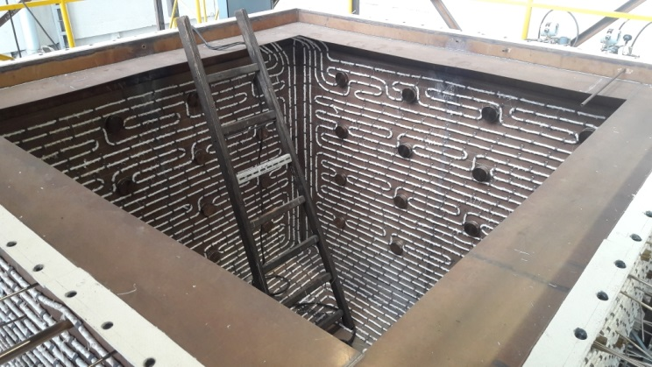

FIG. 8. Installation of the heating elements of the test facility

After installation of the electrical heating the gate was mounted and tuned, then the confuser was installed on the gate (Fig. 9).

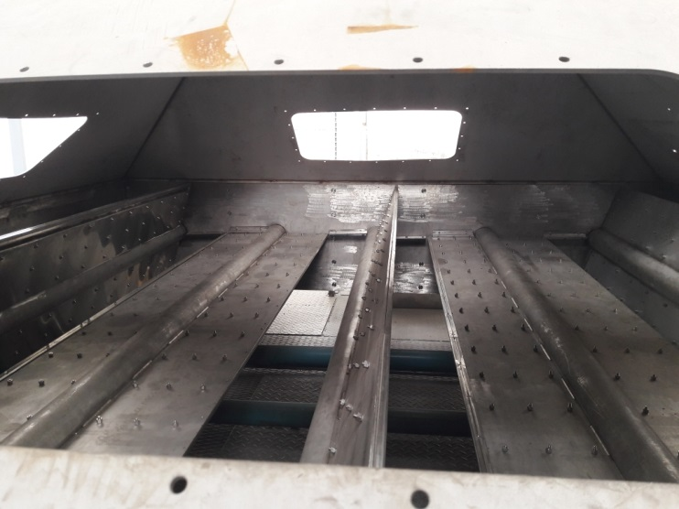

FIG. 9. Installation of the confuser

After completion of installing of the metallic structures the heat insulation was installed on the required parts of the test facility. Heat insulation was installed between the foundation of the vessel and the floor of the site, and on all the outer surfaces of the vessel, the gate and the exhaust pipe.
(Fig. 10 -11).
Considering that the removable insulation must be in the area of sight windows, additionally pillows were sewn (mullite and silica wool covered with silica cloth) and, to simplify their spindling on the rods, special technological pikes were manufactured.

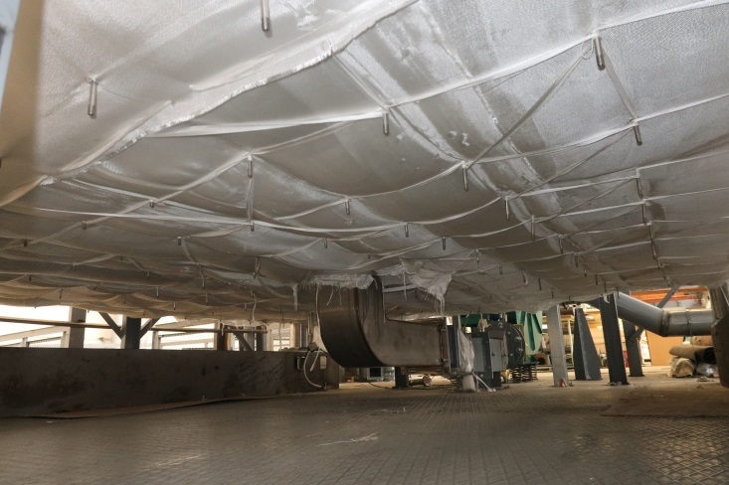

FIG. 10. Heat insulation of the vessel

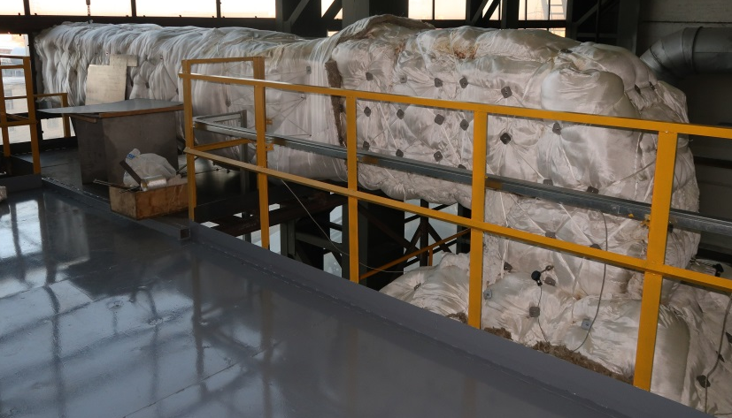

FIG. 11. Heat insulation of the exhaust pipe with the confuser

CONCLUSION
The works related to the creation of the high temperature experimental test facility were caused with the necessity to carry out experimental research and validate functionality of the pilot gate in the conditions similar to the actual ones.
Solving all the assigned and arose tasks during development and mounting permitted to create a high temperature experimental test facility meeting all the projected requirements and providing all the conditions for testing of the pilot gate.

