Simulation and experimental investigation of the fluid-structure interaction effect between adjacent equipment support in a fast reactor

Donghao Li^{1,2}, Daogang Lu^{1,2},Dexuan Duan^{1,2}, Yu Liu ^{1,2}*

¹ School of Nuclear Science and Engineering, North China Electric Power University, Beijing 102206, China
² Beijing Key Laboratory of Passive Safety Technology for Nuclear Energy, North China Electric Power University, Beijing 102206, China
Email contact of corresponding author Yu Liu ^{1,2}: appleplanter@ncepu.edu.cn

Abstract
Under seismic conditions, many supporting cylinders in the loop region of the fast reactor body may be damaged due to the fluid-structure interaction with the fluid in the loop region. Therefore, the evaluation of fluid-structure interaction effect (usually represented with additional mass) is an important aspect of fast reactor structure safety evaluation. ASME gives an additional mass formula for a single-cylinder immersed in an infinite fluid domain, but this formula does not apply to the complex arrangement for the supporting cylinders of the equipment in the ring domain of the main vessel. To study the influence of various equipment supporting cylinders in the loop of fast reactor body on the additional mass of main pump supporting cylinders, a simplified fast reactor model including supporting cylinders of some equipment (e.g. main pump, DHX, and IHX) is designed in this paper. Different working conditions are calculated by finite element software. Meanwhile, the vibration frequencies of the model in water and air were measured by exciting the test model, and the calculation results of the finite element software were verified. The experimental results provide a reference and basis for the arrangement of equipment support cylinder in the annular region of the fast reactor and the modification of additional mass formula.

INTRODUCTION
There are a large number of equipment support cylinders in the annular region of the pool-type fast reactor body, which are arranged relatively closely. The main pump support cylinder, main vessel, heat exchange support, and other structures are mostly large-size and thin-walled cylinder structures. These structures are arranged relatively closely in the annular region of the reactor body filled with fluid. During an earthquake, the fluid-solid coupling effect is caused by the cylinder and fluid, the vibration of adjacent cylinders will also affect each other, which changes the inherent vibration characteristics of the structure. It is different from the fluid-structure coupling effect of a single cylinder in the infinite fluid domain. Therefore, the fluid-structure interaction effect between adjacent cylinders in the ring region of the fast reactor body needs further evaluation and research.
At present, the fluid added mass method is generally used to calculate the fluid-structure interaction in the fluid gap at home and abroad. Based on the potential flow theory, the fluid force on the structure is simplified as the inertial force related to the acceleration of the structure, and the coefficient of the inertial force term is called the added mass. It can be understood that when the accelerating structure is partially or completely in the fluid, its dynamic response will change due to the inertia of the fluid surrounding it. The dynamic effect of this fluid on the structure can be attributed to the fluid mass added to the structure, that is, the additional mass [1], which is also known as the additional mass effect. Fluid added mass effect is very important in engineering design, and scholars at home and abroad have carried out a lot of related research. Fritz gives the additional mass formula for the infinite cylinder completely immersed in a fluid, which is also adopted by ASME and widely used [2-4]. However, there are some limitations to the formula. For example, it is more suitable for the cylinder with a large height diameter ratio, and maybe more conservative for the coaxial cylinder with a small height diameter ratio, such as the support cylinder of fast reactor equipment; The formula is based on the beam vibration of the cylinder, so it can't calculate the added mass of thin-walled shell vibration mode; This formula is too conservative when it is used to calculate the structure with a very small fluid gap.
In this paper, the mechanical APDL component of ANSYS software is used to simulate the vibration of various support cylinders in the annulus of a fast reactor. The high-order and multi-node element fluid220 are used to simulate the fluid in the annulus. The scaled model of each cylinder in the annulus is mainly used to calculate the vibration frequency of the main pump support cylinder under various working conditions. Finally, the accuracy of the finite element method is verified by experiments.

Model description
The adjacent cylinder model of the experimental fast reactor is based on the simplified model of the demonstration fast reactor, and the ratio of the experimental model to the original model is 1:5. Because the supporting cylinder and other structures in the demonstration fast reactor body annulus are symmetrical, half of the reactor body annulus and internals are selected as the experimental objects to reduce the cost. One main pump support cylinder, two intermediate heat exchanger support cylinders, and two independent heat exchanger support cylinders are reserved, as shown in Figure 1. The five cylinders are fixed in a closed sector area with an included angle of 180 degrees according to the placement relationship in the fast reactor body. The sector area is half of the ring area surrounded by the radial heat shield inner layer and the core shield outer layer. The sector area is full of water and the cylinder model material is aluminum alloy. The radial heat shield and the core heat shield model material are stainless steel. The schematic diagram is shown in the figure below. The middle cylinder is the main pump support cylinder, and the two cylinders with symmetrical positions on both sides are the intermediate heat exchanger support cylinder (DHX support cylinder), and the two cylinders far away are the independent heat exchanger support cylinder (IHX support cylinder). The specific dimensions of the model are shown in TABLE 1.
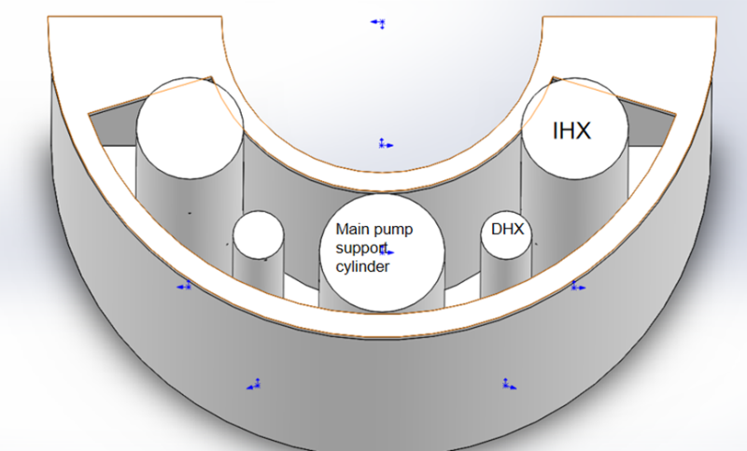
- Figure 1Diagram of Geometric Model

TABLE 1 MODEL PARAMETER SETTING
model | inner diameter/mm | wall thickness/mm | height/mm | material | number
main pump support cylinder | 570 | 2.5 | 2000 | aluminum alloy | 1
IHX support cylinder | 490 | 2.5 | 2300 | aluminum alloy | 2
DHX support cylinder | 230 | 2.5 | 2200 | aluminum alloy | 2
Radial thermal shield | 3100 | 5 | 1200 | stainless steel | 0.5
reactor thermal shield | 1500 | 5 | 1200 | stainless steel | 0.5
Water | 3100 |  | 1200 | water

Finite element model of multiple support cylinders in the large loop domain of fast reactor.

Geometry, Grid, and Boundary Conditions
According to the experimental model of the large circle, a 1:1 finite element model is established in ANSYS software as shown in the figure below. In the finite element model, due to the thin-walled structure of the large-circle domain entity, the solid SHELL281 element is used for meshing, and the water body meshes with the FLUID220 element. In some numerical studies based on ANSYS software to analyze the fluid-structure coupling characteristics of similar coaxial cylindrical shell structures, the fluid is mostly simulated by the FLUID30 element [7,8]. However, the fluid unit is a linear unit, which has certain uncertainties in the simulation accuracy of three-dimensional models such as coaxial cylindrical shells, and there are also certain restrictions on the geometric dimensions of the model in the calculation.Fluid220 is a high-order three-dimensional 20-node solid element with secondary pressure characteristics. When this element is used in the modeling of fluid medium and interface in fluid-structure coupling problems, it will show a better effect than the linear element in structural analysis. Considering the coupling between the sound pressure and the structure motion at the interface, the acoustic governing equation, namely the three-dimensional wave equation, is discretized. Each node has four degrees of freedom, which are three displacement degrees of freedom and one pressure degree of freedom of node in XYZ direction. After mesh division for solid and fluid, the number of Shell281 units of the structural grid is 8437, and the number of Fluid220 units of water grid is 13600.
The material parameters are set as follows: the five supporting tubes have the same material, and the material parameters are: Young's modulus E = 69GPa, Poisson's ratio V = 0.33, and density ρs = 2750 kg/m3.The material parameters in the sector region of the large ring domain are as follows: Young's modulus E = 206GPa, Poisson's ratio V = 0.3, and density ρs = 7850 kg/m3.The material parameters of water are as follows: kinematic viscosity coefficient VF = 1 mm2/s, density ρ F = 1000kg/m3, sound velocity C = 1400 m/s.
Boundary condition setting: since the large-ring model is fixed on the ground through nuts, the bottom surface of the finite element model is fixed and constrained. At the same time, the wall surfaces of the five supporting cylinders contacting with water are all set as the fluid-structure coupling interface, and the contact surface between water and air is set as the free liquid surface.
The following figure is the schematic diagram of the finite element model:
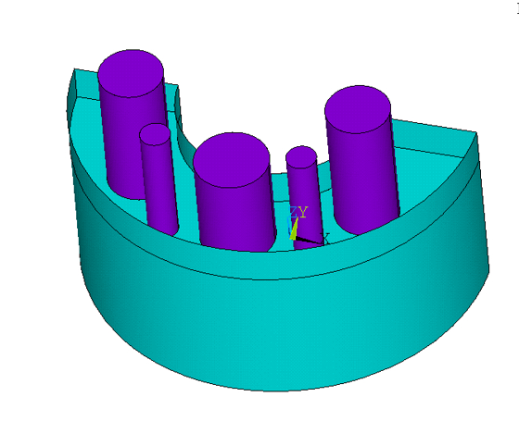
Figure 2 finite element model
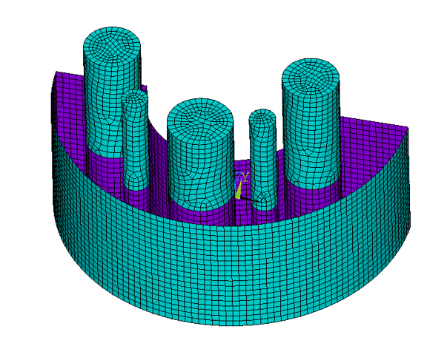
Figure 3 Part of the cylinder is meshed
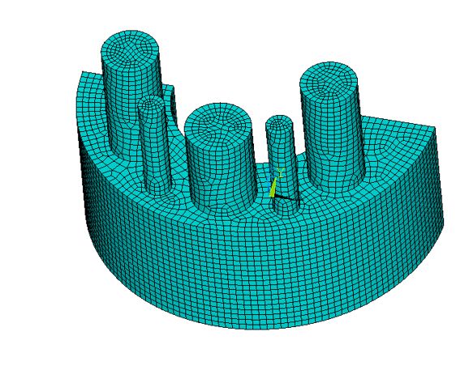
Figure 4 Finite element model meshing
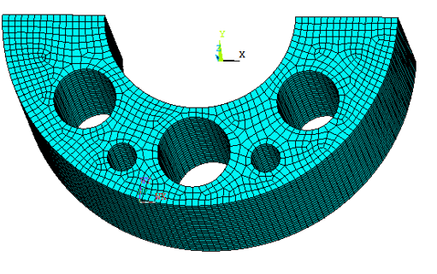
Figure 5 Fluid section meshes

Setting of working conditions
In this finite element calculation, since the main vibration mode of the supporting cylinder of the main pump under earthquake action is mainly beam-type vibration (Figure 6), the additional mass of beam-type vibration is mainly studied. Two working conditions with or without other reactor components and three working conditions with different liquid levels were designed to explore the fluid-structure coupling effect of the main pump support cylinder. In addition, no water condition is also designed to compare with it.
Figure 6 Sketch of beam-type vibration
TABLE 2 CONDITIONS SET
Test condition | Presence of water | main pump | IHX | DHX | Liquid level height /m
1 | ○ | √ | ○ | ○ | ○
2 | √ | √ | ○ | ○ | 1.2
3 | √ | √ | √ | √ | 1.2
4 | √ | √ | √ | √ | 1.8
5 | √ | √ | √ | √ | 0.6

Calculation method of additional mass
To calculate the additional mass of the three-dimensional model, the surface density $ρ_{ma}$ of the additional mass on a certain height of the model can be first calculated, and the overall additional mass M can be obtained by integrating its surface area along the direction of height, as follows:
$$M=\int_{0}^{H_{0}}{ρ_{ma}}dA$$ | (1)

In the formula, H₀is the maximum height of the model, and dA is the unit surface area of the model. The added mass of the fluid on a point on the solid can be considered as the ratio of the force of the fluid on the solid to the acceleration of the solid, as shown below:
$$m_{a}=\frac{F_{M}}{\ddot{x}}$$ | (2)
Where $m_{a}$ is the additional mass of a point, $F_{M}$is the force of the solid on the fluid, and $\ddot{x}$is the acceleration of the solid. Since in the beam-type vibration, the shell is vibrating in the same direction of acceleration and by the fluid force, the additional mass surface density for a certain height of the model can be expressed as the ratio of the combined force of the pressure P along the vibration direction at its nodes to the acceleration x ̈. The formula is as follows:
$$ρ_{ma}=\frac{\sum{p}}{\sum{\ddot{x}}}$$ | (3)

Measurement experiment of beam-type vibration of supporting cylinder of the main pump in the large loop region

Experiment settings
The experimental model has the same structure as the finite element model, and the experimental model is shown in Figure 7. In the modal measurements of this experiment, four acceleration measurement points were arranged in each layer of the lower part of the main pump support cylinder model, and a total of two layers were arranged. The measurement points are evenly arranged along the circumference of the cylinder wall, and the measurement points are arranged as shown in Figure 8. This experiment uses a force hammer to excite the main pump support cylinder device in the large-loop domain experimental model. By using the DASP software for data reception and modal processing, the frequencies of the beam-type vibration patterns of the main pump support cylinder under waterless and watery conditions are finally determined by modal fitting.
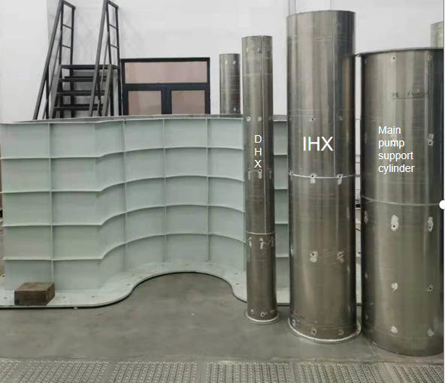
Figure 7 Field drawing of experimental model

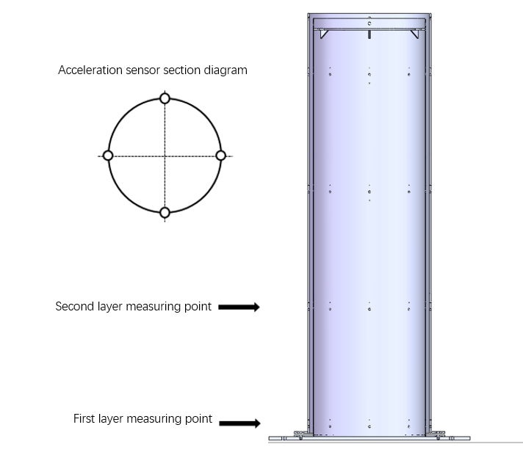
- Figure 8 Acceleration sensor layout

Tables must be numbered consecutively and include a table heading. There is no full stop at the end of the heading. IAEA style is to uses table borders and lines sparingly. Tables must be mentioned (called out) in the text and should be inserted following the end of the paragraph in which they are mentioned, or on the next page if there is not enough space. Tables are formatted in Times New Roman 9 point regularly. For an example, see Table 1.

Experimental conditions
This experiment mainly carried out confirmatory experiments on the finite element model. Working conditions 1 and 3 in the finite element model were selected for experimental verification. Specific experimental conditions are shown in the table below:

TABLE 3 EXPERIMENTAL CONDITION
Test conditions | Presence of water | main pump | IHX | DHX | Liquid level height /m
1 | ○ | √ | ○ | ○ | ○
3 | √ | √ | √ | √ | 1.2

Results and discussion

Comparison between experiment and numerical simulation
After the finite element model is constrained, the modal analysis of the model is carried out to obtain the frequency of clan mode of the beam of the main pump support cylinder. The following figure shows the beam-type vibration displacement of the finite simulated beam in working conditions 1 and 3:
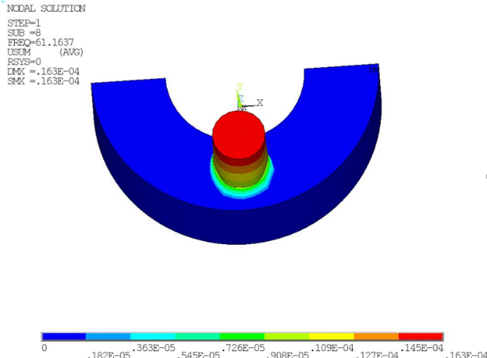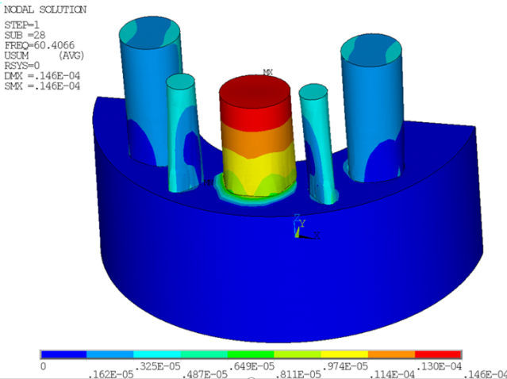
Figure 9 the beam-type vibration displacement of the finite simulated beam in working conditions 1 and 3
After the geometric model experiment, DASP software can be used to process the vibration mode frequency of the main pump support cylinder under the excitation condition. After screening the experimental data, the beam vibration mode frequency of the main pump support cylinder can be obtained. The comparison between the two is shown in the following table:

TABLE 4 EXPERIMENT AND FINITE ELEMENT COMPARISON
 | Experimental frequency | Finite element calculation frequency | Error
Conditions 1 | 84.207 | 82.3755 | 0.022
Conditions 3 | 61.630 | 60.4066 | 0.020
It can be seen that the frequency obtained by the experiment is close to that of the finite element model, which can explain the accuracy of the finite element simulation calculation. This shows that the subsequent finite element calculation should be more reliable.

Influence of other supporting drums on additional mass
Through finite element calculation, the beam beam-type vibration frequency of the main pump support cylinder in various working conditions is calculated. The specific frequency is shown in the table below:
TABLE 5 CALCULATION OF BEAM-TYPE VIBRATION FREQUENCY IN WORKING CONDITION
Test condition | Presence of water | main pump | IHX | DHX | Liquid level height /m | Frequency/Hz
1 | ○ | √ | ○ | ○ | ○ | 82.3755
2 | √ | √ | ○ | ○ | 1.2 | 61.1637
3 | √ | √ | √ | √ | 1.2 | 60.4066
4 | √ | √ | √ | √ | 1.8 | 34.1098
5 | √ | √ | √ | √ | 0.6 | 95.6288

To calculate the additional mass of the finite element calculation results, firstly calculate the additional mass of a certain height of the model. In ANSYS software, the pressure P and displacement X of each node on a plane can be extracted. Since the displacement changes with time as shown in Formula (4), the derivative to obtain the acceleration x ̈ should be taken as shown in Formula (5).
$$x=\sin\left(ωt\right)$$ | (4)

$$\ddot{x}=-ω^{2}\sin\left(ωt\right)$$ | (5)
The cylinder immersed in a liquid is evenly divided into 6 parts, and the added value surface density of each height is calculated respectively. Finally, the added value surface density can be obtained by integrating the added value surface density according to the height, as shown in the table below:
Test condition | Presence of water | main pump | IHX | DHX | Liquid level height /m | Frequency/Hz | Additional mass density/kg/m^3 | Additional mass /kg
1 | ○ | √ | ○ | ○ | ○ | 82.3755
2 | √ | √ | ○ | ○ | 1.2 | 61.1637 | 134329.352 | 3.17
3 | √ | √ | √ | √ | 1.2 | 60.4066 | 142055.1953 | 3.35

It can be found from the above table that each support cylinder in the large loop domain has less influence on the additional mass of the main pump support cylinder (working condition 3) than the additional mass in the loop domain (working condition 2), but there is still some influence. When evaluating the additional mass of the main pump support cylinder, the influence of other reactor components on the main pump support cylinder should be considered.

Influence of liquid level on additional mass
According to the above method, the additional mass of different liquid levels is calculated, and the specific calculation results are shown in the table below:
Test condition | Presence of water | main pump | IHX | DHX | Liquid level height /m | Frequency/Hz | Additional mass density/kg/m^3 | Additional mass /kg
3 | √ | √ | √ | √ | 1.2 | 60.4066 | 142055.1953 | 3.35
4 | √ | √ | √ | √ | 1.8 | 34.1098 | 139470.3597 | 4.93
5 | √ | √ | √ | √ | 0.6 | 95.6288 | 89811.96376 | 1.06
Through the above calculation, it can be found that when the liquid level rises, the additional mass of the fluid on the support cylinder of the main pump gradually increases, but its additional mass density per unit volume remains unchanged. When the liquid level drops, the added mass of the fluid decreases obviously, and the density of the added mass also decreases obviously. Therefore, the drop of liquid level has a great effect on the added mass.

conclusions
(a) By comparing finite element simulation calculation and experimental frequency calculation, finite element modeling has a better reduction degree and higher accuracy, and this modeling method can be used for other models.
(b)Through the calculation of the additional mass in the first three working conditions, it is found that other support drums in the reactor have a certain influence on the main pump support drum, which should be taken into account in the calculation of the additional mass.
(c) By calculating the added mass of different liquid levels, it is found that when the liquid level rises, the added mass gradually increases, but the density of the added mass remains unchanged. When the liquid level drops, the added mass significantly decreases. Therefore, it can be inferred that the decrease of the liquid level has a greater impact on the added mass.
ACKNOWLEDGEMENTS
I am very grateful to the teachers and classmates in the project team for their help during this time, especially my tutor Professor Lu and my teacher Liu Yu. Thanks to Dexuan Duan for helping me in processing the data. Without team building with them, there would be no this paper.
References
- AUYANG M K. Free Vibration of Fluid-Coupled Coaxial Cylindrical Shells of Different Lengths[J]. Journal of Applied Mechanics, 1976, 43(3): 480-484.
- FRITZ R J. The Effect of Liquids on the Dynamic Motions of Immersed Solids[J]. Journal of Engineering for Industry, 1972, 94(1): 167.
- CHEN S S. Flow-induced Vibration of Circular Cylindrical Structures[M]. Washington: Hemisphere Pub Corp, 1978.
- HORÁCEK J, TRNKA J, VESELÝ J, et al. Vibration Analysis of Cylindrical Shells in Contact with an Annular Fluid Region[J]. Engineering Structures, 1995, 17(10):714-724.
- Dexuan Duan, Daogang Lu, Yu Liu. The Investigation on Fluid Structure Interaction Characteristics of Narrow Gaps between Coaxial Cylindrical Shells[C]. The 16th National Reactor Thermal Fluid Academic Conference and the 2019 Academic Annual Meeting of the China Nuclear Nuclear Reactor Thermal Hydraulic Technology Key Laboratory.
- X.M. Zhang and G.R. Liu and K.Y. Lam. "Coupled vibration analysis of fluid-filled cylindrical shells using the wave propagation approach." Applied Acoustics (2001).
- Li, X. . "Li, X.B.: Study on free vibration analysis of circular cylindrical shells using wave propagation. J. Sound Vib. 311, 667-682." Journal of Sound & Vibration 311.3(2008):667-682.

