The influence of isotopic composition of plutonium in fast reactor fuel on the reactivity margin

YULIA KARAZHELEVSKAIA
National Research Nuclear University MEPhI
Moscow, Russian Federation
YEKarazhelevskaya@mephi.ru

ANNA TEREKHOVA
National Research Nuclear University MEPhI
Moscow, Russian Federation

Email contact of corresponding author: YEKarazhelevskaya@mephi.ru

Abstract

In Russia there are projects of fast reactors with U-Pu fuel. Plutonium will be extracted from the spent nuclear fuel (SNF) of various types of reactors. The isotopic composition of power plutonium can be different due to different storage periods and different burnup rates of spent nuclear fuel. It is almost impossible to obtain a uniform isotopic composition. The plutonium in the storage has a different content of the ²³⁹Pu isotope with a difference of more than 15%. This difference will affect the neutronic characteristics of the fuel in the reactor.

INTRODUCTION
Plutonium used in nuclear power is a part of the spent nuclear fuel (SNF). Different reactor types and different irradiation regimes present different plutonium composition in SNF. Table 1 shows the content of plutonium isotopes in irradiated fuel for various reactor tupes such as VVER-440, VVER-1000 and RBMK-1000, after 10 years of holding period [2]. Burnout comprised between 25 and 30 MW*day/kg. The Table 1 shows that the SNF of the VVER and RBMK reactor distinguish significantly. The main contribution to fission is made by the isotope ²³⁹Pu, its content in VVER SNF is one and half times as large as in its content in RBMK.

TABLE 1. THE CONCENTRATION DISTRIBUTION OF PLUTONIUM ISOTOPES IN SNF IN VARIOUS REACTORS AFTER 10 YEARS OF EXPOSURE, %

Isotope | VVER-440 | VVER-1000 | RBMK-1000
²³⁸Pu | 0,85 | 0,54 | 1,53
²³⁹Pu | 63,02 | 67,10 | 39,76
²⁴⁰Pu | 22,73 | 21,60 | 39,11
²⁴¹Pu | 9,15 | 7,97 | 7,68
²⁴²Pu | 4,25 | 2,78 | 11,91

This paper is devoted to the analysis of the influence of the isotopic composition of plutonium on the reactivity excess of a fast reactor. Calculations were carried out for the BREST-OD-300 and RBETS-M reactors.

PLUTONIUM
For the calculations, the isotopic composition was selected so that the plutonium enrichment of the fuel corresponded to the design values. At the same time, for the isotopic compositions of plutonium, deviations were used only for the ²³⁹Pu and ²⁴⁰Pu isotopes. These isotopes make up the majority of plutonium and their deviations make significant changes in the neutron-physical characteristics of a fast reactor. The isotopes ²³⁸Pu, ²⁴¹Pu and ²⁴²Pu are presented in small amounts on other isotopes, so their deviation will be imperceptible and they can be ignored. In the core, all the plutonium was made up of two baskets. The composition of each basket was selected with concentration symmetrical with respect to the initial composition in paper work.

TABLE 2. PLUTONIUM CONTENT RANGE [3]

Isotope | Energy content and composition | Composition in the project of the RBEC core | Composition in the project of the BREST-OD-300 core
²³⁸Pu | 0.5÷3.0 | 1.33 | 1.2
²³⁹Pu | 57÷75 | 60.45 | 68.3
²⁴⁰Pu | 15.5÷26.4 | 24.22 | 23.2
²⁴¹Pu | 2.0÷13.4 | 8.28 | 2.4
²⁴²Pu | 1.0÷7.0 | 4.90 | 4.2
²⁴¹Am | 0.1÷13.0 | 0.81 | 0.7

Different isotopes of plutonium have different properties. The nuclear properties of plutonium isotopes are shown in Table 3.

TABLE 3. NUCLEAR PROPERTIES OF ISOTOPES

Isotope | Half life, years | Activity, Cu/g | Type of decay | Relative energy value (²³⁹Pu = 1) | Critical mass
²³⁸Pu | 87,74 | 17.3 | α-decay, spontaneous fission | +0.5 | 7.8 kg
²³⁹Pu | 24110 | 0.063 | α-decay | 1.0 | 5.425 kg
²⁴⁰Pu | 6537 | 0.23 | α-decay, spontaneous fission | +0.2 | -
²⁴¹Pu | 14,4 | 104 | β - decay | 1.4 | 260 g
²⁴²Pu | 376000 | 0.004 | α-decay, spontaneous fission | +1.4 | -

The main neutron-physical properties of the ²³⁹Pu, ²⁴⁰Pu, ²⁴¹Pu are considered in Table 4.

TABLE 4. MICROSCOPIC INTERACTION CROSS SECTIONS THE OF FAST NEUTRONS WITH PLUTONIUM NUCLEI

Isotope | Fission cross-section, barn | Radiation capture cross-section, barn
²³⁹Pu | 1,92 | 0,016
²⁴⁰Pu | 1,67 | 0,05
²⁴¹Pu | 1,59 | 0,03

The table shows that the ²³⁹Pu in the reactor makes the greatest contribution to the change in the multiplying capacity of the system.
The deviation value in the BREST reactor was selected based on the range of isotope content in energy plutonium. Based on the minimum and maximum content of the ²⁴⁰Pu isotope of 23.2% and 26.4%, respectively, we assume a possible deviation of ±3.2% for it. The deviations of plutonium in the fuel used are shown in Table 5. The value of the isotopic composition in the RBEC reactor in extreme cases was taken similarly to the BREST reactor.
The accepted deviations and the resulting plutonium isotopic compositions are as follows: "+ "- positive deviation for the ²³⁹Pu isotope; " - " - negative deviation for the ²³⁹Pu isotope.

TABLE 5. THE PROPORTION OF PLUTONIUM ISOTOPES IN THE FUEL OF THE BREST-OD-300 AND RBEC-M REACTORS, % [7]

Isotope | Deviation ²³⁹Pu и ²⁴⁰Pu
 | - | +
²³⁸Pu | 1.2 | 1.2
²³⁹Pu | 65.1 | 71.5
²⁴⁰Pu | 26.4 | 20
²⁴¹Pu | 2.4 | 2.4
²⁴²Pu | 4.2 | 4.2
²⁴¹Am | 0.7 | 0.7

For comparison, 5 plutonium placing options were considered for each type of reactor:
For BREST-OD-300 reactor:
Option 0. Start fuel loading;
Option 1. Fuel assemblies in the reactor core with a negative deviation;
Option 2. Fuel assemblies in the reactor core with a positive deviation;
Option 3. Fuel assemblies with a negative deviation in the central part of the core, and fuel assemblies with a positive deviation are located on the peripheral part;
Option 4. Fuel assemblies with a positive deviation in the central part of the core, and fuel assemblies with a negative deviation are located on the peripheral part.
For RBEC reactor:
Option 0. Start fuel loading;
Option 1. Fuel assemblies in the reactor core with a negative deviation;
Option 2. Fuel assemblies in the reactor core with a positive deviation;
Option 3. Fuel assemblies with a negative deviation in the central part of the core, and fuel assemblies with a positive deviation are located on the middle part;
Option 4. Fuel assemblies with a positive deviation in the central part of the core, and fuel assemblies with a negative deviation are located on the middle part.

MODELLING
If you need to subdivide the sections of your paper, use the headings shown below. You can use second and third level paper headings. To subdivide further, please use lists numbered (a), (b), and so on, but this is usually not necessary in a paper of normal length.

Program complex serpent
The calculations were carried out in the PC Serpent.
Serpent is a multi-purpose three-dimensional continuous-energy Monte Carlo particle transport code, developed at VTT Technical Research Centre of Finland, Ltd. The development started in 2004, and the code has been publicly distributed by the OECD/NEA Data Bank and RSICC since 2009. Serpent started out as a simplified reactor physics code, but the capabilities of the current development version, Serpent 2, extend well beyond reactor modeling. The applications can be roughly divided into three categories [5]:
1) Traditional reactor physics applications, including spatial homogenization, criticality calculations, fuel cycle studies, research reactor modeling, validation of deterministic transport codes, etc.
2) Multi-physics simulations, i.e. coupled calculations with thermal hydraulics, CFD and fuel performance codes
3) Neutron and photon transport simulations for radiation dose rate calculations, shielding, fusion research and medical physics.

Model of the RBEC reactor core
In considered paper, the studies were carried out for the core of the RBEC reactor [1].
The aim of the RBEC project was creation of a nuclear steam-generating power plant on the basis of Russian experience in design and operation of fast reactors and liquid-metal technology. High self-protection level should be provided by inherent core safety properties, thermal-physical properties of lead-bismuth coolant, use of natural circulation for emergency core cooling, application of passive safety systems along with traditional active ones, qualitative factory fabrication of the equipment.
The RBEC-M core is a 900 MW(th) lead-bismuth cooled fast reactor concept developed by the Russian Research Centre, “Kurchatov Institute” (RRC KI) .The fuel cycle length is 1800 effective full power days. Mixed uranium-plutonium nitride fuel (U0.863+Pu0.137)N is used, which is composed of reactor-grade plutonium recovered from typical light water reactor spent fuel and depleted uranium with 0.1 wt. % of ²³⁵U. The core zones are surrounded by lateral (radial) blankets and the coolant material is lead-bismuth eutectic.
Geometry of the calculation model of the RBEC-M reactor is shown in [8]. The model includes 12 physical zones, differing from each other by volume fractions and temperatures of materials (Fig.1).

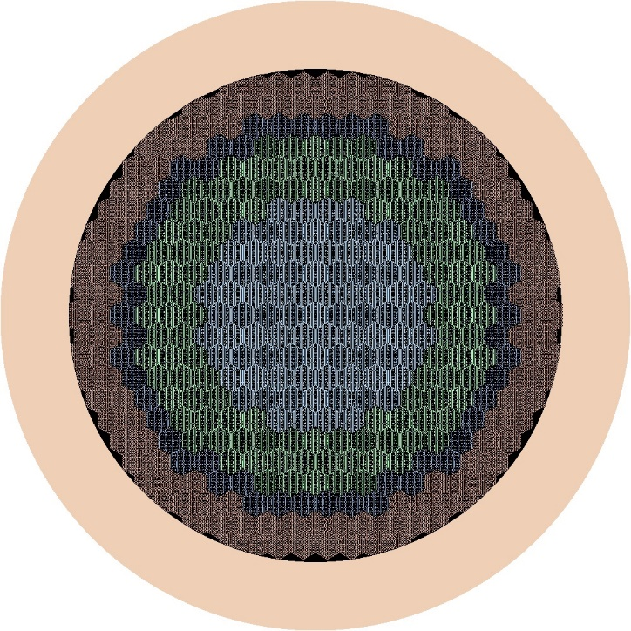
Inner Core
Middle Core
Downcomer
Outer Core
Fig. 1 The RBEC reactor core in the PC Serpent

Model of the BREST-OD-300 reactor
A simplified model of the BREST-OD-300 reactor core model is prepared. The simplified model means that all elements of the core had the simplest three-dimensional geometry without detailed elements. The placement of fuel assemblies in the core is performed symmetrically. It’s considered that during the reactor life, nuclear fuel assemblies do not change their position. The volume fractions of materials in the reactor core of the BREST-OD-300 are presented in Table 2. The calculation model uses nitride uranium- plutonium fuel (U-Pu)N consisting of 83% UN and 17% PuN. The BREST-OD-300 reactor project uses waste uranium (²³⁸U – 99.8%, ²³⁵U – 0.2%) as fuel [6]. The operation period is 5 years. Figure 2 shows cross-sectional plans of the BREST-OD-300 reactor model with an average plutonium composition [7].

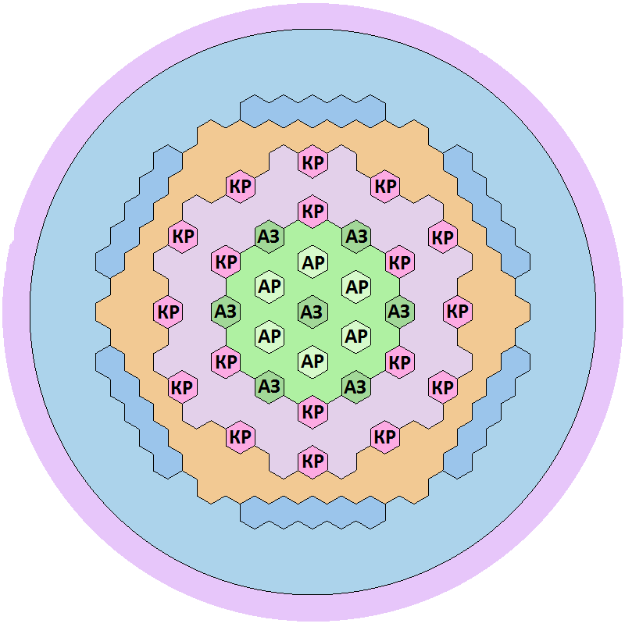
Peripheral part
Central part
Steel suction head
Side reflector
FIG 2. Horizontal section of the core model of the BREST-OD-300 RC: green and purple – the central zone; orange and blue-the peripheral zone; AР-automatic control rods; AЗ-automatic protection rods; KР-reactivity compensation rods

CALCULATION OF NEUTRON-PHYSICAL CHARACTERISTICS OF THE INITIAL LOADING OF THE BREST-OD-300 REACTOR AND RBEC-M REACTOR
Calculations of the burnout parameters of the RBETS-M reactor with different plutonium composition were carried out. To analyse the effect of changes in the plutonium composition on the safety parameters and neutron-physical characteristics of the reactor, 5 different configurations were modelled at different ratios of ²³⁹Pu and ²⁴⁰Pu. In Figure 3, you can see the change in the effective multiplication factor of neurons from the time of operation. The graph shows that the calculation with the deviation of the ²³⁹Pu value in the positive direction has the highest K_{eff} value at the beginning of the campaign in both the central and middle parts of the active zone. The smallest excess of reactivity for burnout was obtained in the case of a decrease in ²³⁹Pu in the central and middle part of the reactor core. The behaviour of the reactor at the deviation of ²³⁹Pu for scenario 3 and 4 is insignificant from the standard parameters of the reactor. For all plutonium compositions, the effective neutron multiplication factor at the end of the campaign is approximately the same.

FIG 3. Dependence of the effective neutron multiplication factor on the burnup time in the RBEC reactor
A similar analysis was carried out for the calculation of the BREST-OD-300 reactor. Figure 4 shows that, as in the previous calculation, the highest value of the effective neutron multiplication factor at the beginning of the campaign is for the case with a positive deviation of ²³⁹Pu. The lowest K_{eff} value for a scenario with a deviation of ²³⁹Pu in the negative direction. It can be concluded that the reactivity excess for burnout is much less than for the case of calculations of the RBEC reactor.

FIG 4. Dependence of the effective neutron multiplication factor on the burnup time in the BREST-OD-300 reactor

The effective delayed neutron fraction depends on the fuel composition, we will find it for each of the considered options for placing Pu in the RBEC reactor (Table 6). For the BREST-OD-300 reactor, the effective delayed neutron fraction is close in value and is 0.7 %.

TABLE 6. THE EFFECTIVE DELAYED NEUTRON FRACTION OF RBEC

 | Option 0 | Option 1 | Option 2 | Option 3 | Option 4
β_{eff}, % | 0.672 | 0.745 | 0.711 | 0.674 | 0.711

Figures 3 and 4 and Table 6 point to the conclusion that the amount of the reactivity excess for burnout for 2 types of fast reactors (Table 7). With respect to the reactivity excess of the standard fueling of the BREST-OD-300 doesn’t exceed the value 1βeff of the time between refueling, as a result when the plutonium composition is changed, there will be a narrow distinction in the reactivity excess over the campaign, and, as Table 7 shows, considered amount won’t exceed the value 1β_{eff} during the time between refueling. As for reactor RBEC, the amount of the initial reactivity excess in a standard version of the placing the fuel is about 14 β_{eff}.
When the deviation of ²³⁹Pu content in the fuel composition is positive, the reactivity excess becomes more than 15β_{eff}. For such a reactor, it is necessary to take this into account the existence of positive deviation of ²³⁹Pu in the design of control and protection system (CPS).

TABLE 6. REACTIVITY MARGIN FOR FUEL BURNUP RBEC-M AND BREST-OD-300, β_{eff}

 | Option 0 | Option 1 | Option 2 | Option 3 | Option 4
RBEC-M | 13.919 | 10.789 | 15.04 | 14.082 | 13.17
BREST-ОD-300 | 0.318 | 1.490 | 1.459 | 0.726 | 0.447

CONCLUSION
The different composition of Pu in SNF may be due to different reactor types, different burnup, and different holding times. Calculations have shown that using a different composition of plutonium in the fuel assemblies manufacturing for fast reactors, it has a different effect on the reactivity excess, depending on the type of reactor. For the BREST-OD-300 reactor, the differences in the composition of plutonium are caused by a slight change in the reactivity excess. This is due to the fact that the design of the BREST-OD-300 reactor is designed so that the reactivity during fuel burnup remains within the neutron. And the RBETS-M reactor has a large reactivity excess for burnout in the design isotope composition. Consequently, the deviation of the ²³⁹Pu content in the fuel composition in the positive direction leads to an increase in the reactivity excess by more than 1β_{eff}. Such an increase brings a change in the design of the core and an increase in the CPS.

References
- ALEKSEEV P.N., VASILIEV A.V., MIKITYUK K.O. Lead-bismuth fast reactor RBEC-M: optimization of conceptual solutions. - M.: Ros. scientific. center "Kurchat. Institute" (2001).
- KOLOBASHKIN V.M., RUBTSOV P.M., RUZHANSKIY P.A., SIDORENKO V.D. Radiation characteristics of irradiated nuclear fuel: Handbook /. - M.: Energoatomizdat (1983).
- KOROBEYNIKOVA L.V., ELISEEV V.A., MAKULIN P.A. et al. “On the need to equalize the isotopic composition of plutonium for the launch of fast reactors”, Report (Proc. the International Scientific and Technical conference "Innovative projects and technologies of nuclear power" JSC "NIKIET"), Moscow, Russia (2014).
- LEPPÄNEN J., PSG2 / Serpent – a Continuous-energy Monte Carlo Reactor Physics Burnup Calculation Code. Methodology, User’s Manual (2009).
- Official internet page of Serpent code http://montecarlo.vtt.fi/
- MOISEEV A.V. Reactor plant BREST-OD-300 The main results of calculation and experimental justification of safety, Report (Proc. the conference project direction "BREAKTHROUGH”), Moscow, Russia (2015).
- KARAZHELEVSKAYA Y.E., LEVON M.A., TEREKHOVA A.M., ZLOBIN A.S. Irregularity of plutonium isotopic composition of the BREST-OD-300 initial load, Article (Proc. Journal of Physics: Conference Series), Moscow, Russia (2020).
- DUDINIKOV A., SEDOV A., RBEC-M Lead-Bismuth Cooled Fast Reactor Benchmarking Calculations, IAEA CRP on the Development of Small Reactors Without On-site Refuelling (2000).
- KOROBEINIKOV. V.V., KARAZHELEVSKAYA Yu.E., KOLESOV V.V., TEREKHOVA A.M. Investigation of the possibility of AM-241 incineration and transmutation in ameritium-fueled reactor, J. Izvestiya Wysshikh Uchebnykh Zawedeniy, Yadernaya Energetika, 2 (2019) 153–163.

