R&D on recovery and separation of americium and curium under "Proryv" project

V.L. Vidanov^{1,2}, А.Y. Shadrin^{1,2}, М.V. Logunov², L.I. Tkachenko³, N.А. Goletsky ³, P.V. Parabin², О.А. Streltsov², М.G. Dmitriev⁴, V.Y. Davydov⁴

¹ JSC PRORYV, Moscow, Russia
² Bochvar Institute, Moscow, Russia
³ JSC V.G. Khlopin Radium Institute, Saint Petersburg, Russia
⁴ RIAR, Dimitrovgrad, Russia

Email contact of corresponding author: vvl@proryv2020.ru

Abstract

Within the framework of the PRORYV project, extraction systems based on Zr-salt of DBPA (acidic zirconium salt of dibutyl phosphoric acid), CMPO (Octylphenyl N,N- diisobutylcarbamoyl - methylene phosphine oxide), TBP (tributyl phosphate), Dyp-7 (N,N'-diethyl-N,N'-di(para-hexyl-phenyl)-diamide-2,2'-dipyridil-6,6'-dicarbonic acid), ATP (2,6-bis(1-( aryl)-1,2,3,4-tetrazol-5-yl)-pyridine ) – CCD (chlorinated cobalt dicarbollide) (UNEX-T) and TODGA (N,N,N’,N’- tetraoctyl-diglycolamide) were studied and dynamically tested. Hydrocarbons (isopar-M, kerosene) and metanitrobenzotrifluoride (F-3) were used as diluents for the systems. Using TODGA - F-3 from PUREX-process raffinate from WWER-440 SNF reprocessing, a deep recovery of Am and Cm (99.9% of initial content) was demonstrated. Chromatographic separation experiments of Am and Cm by high performance liquid chromatography and displacement elution column chromatography methods were performed using MA (Minor Actinides) concentrate and heavy REE. Am fractions suitable for further fuel fabrication were obtained. Mathematical models of both the process itself and control were developed for all studied processes.

1. Introduction
A number of countries, including Russia, are currently developing a closed nuclear fuel cycle technologies, including fast-neutron reactors (FR). During the operation of FR there is a possibility of transmutation of Am isotopes, which prevents the need for their long-term storage. For these purposes it is necessary to organize reprocessing of spent (irradiated) nuclear fuel (SNF) so that as a result of reprocessing a pure fraction of Am can be added to the composition of a newly fabricated fuel element.
In the process of considering a possible technology for reprocessing SNF to obtain pure Am for transmutation, a method of Am recovery should be chosen. The possibility of Am recovery from the waste generated during irradiated fuel reprocessing and preparation it in a chemical form that can serve as a starting material for the fabrication of fresh nuclear fuel is considered.
In hydrometallurgical reprocessing of FR SNF Am and Cm remain almost entirely in the highly active raffinate in the trivalent state. Close in chemical properties to Am (+3) are the rare-earth elements REE, also remaining in the highly active raffinate.
The currently existing separation methods can be divided into two main groups. The first one is selective extraction of Am directly from PUREX-process raffinate. A number of modern extraction technologies based on the use of new extractants as well as the combination of newly synthesized with already known organic compounds are being developed for this purpose. Despite the large number of process variants, none of them has reached the stage of industrial scale use and further development is required for their implementation. The second direction is two-step technological schemes - first, Am and Cm are separated (separated from the main mass of REE), and then they are separated from each other.
As part of the developed technology a two-stage flow sheet of Am separation for its further burning was adopted.
Currently in Russia a facility for Am and Cm separation is planned to be set up within the framework of the PRORYV project area at the spent nuclear fuel reprocessing module of experimental and demonstration energy complex (RP EDEC) [].

2 Extraction processes
A series of laboratory studies and dynamic tests of a number of extraction systems for the intergroup separation of REE and MA were performed. The following extraction systems were tested:
- Acidic zirconium salt of dibutyl phosphoric acid (Zr-salt DBPA) – tributyl phosphate (TBP) – kerosene;
- N,N'-diethyl-N,N'-di(para-hexyl-phenyl)-diamide-2,2'-dipyridil-6,6'-dicarbonic acid (Dyp7) – metanitrobenzotrifluoride ( F-3);
- Octylphenyl N,N- diisobutylcarbamoyl - methylene phosphine oxide (CMPО) – TBP –F-3;
- TBP – kerosene;
- 2,6-bis(1-( aryl)-1,2,3,4-tetrazol-5-yl)-pyridine (ATP) – chlorinated cobalt dicarbollide (CCD) – F-3;
- N,N,N’,N’- tetraoctyl-diglycolamide (TODGA) – isopar-M – decanol;
- TODGA – F-3 []
Based on the results of laboratory studies and preliminary tests on simulated solutions, the TODGA - F-3 system was chosen as the main extraction system for further study. Dynamic tests of partitioning technology based on TODGA were carried out in 2014 and 2015 at the Production Association Mayak laboratory facility. The model solution simulated the raffinate of the first extraction cycle of SNF reprocessing and contained up to 4.2 g/l REE, and also ²⁴¹Am in trace amount. Flow sheet shown in Fig. 1 consisted of 4 block of mixer-settler extractors with total number of stages 51. As a result of the tests the recovery of Am from simulated solution was not less than 99.97 %, and REE (except lanthanum) - more than 99.99 %. At the stage of MA stripping the degree of purification of Am from REE reached 100 [].

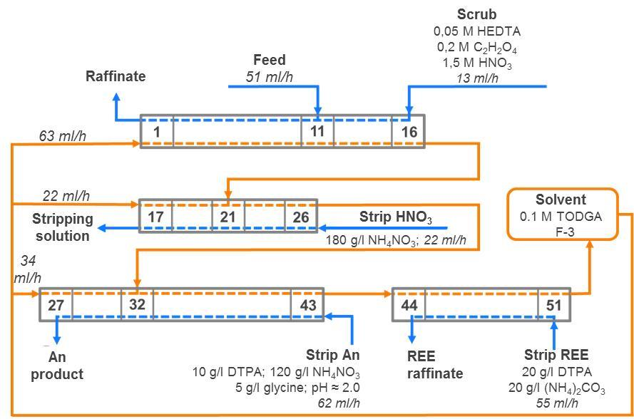

Fig.1 Flow sheet of the dynamic test extraction system based on TODGA – F-3 (DTPА - diethylene triamine-pentaacetic acid)

To confirm the possibility of the TODGA – F-3 extraction system recovery of macroquantities of MA, a simplified batch-test was performed. The batch-test of the fpartitioning technology consisted of the following consecutive stages: extraction from the simulated solution, washing of the extract with chelate, nitric acid stripping, Am stripping, REE stripping. A model PUREX-process raffinate containing 2 g/l Am [] was used in the experiment. The check flow sheet is shown in Fig.2.
Verification of the partitioning flow sheet with macro quantities of MA showed that as a result of 3 consecutive contacts there is a saturation of the organic phase and a gradual displacement of light lanthanides from it by heavy and Am. At the same time the distribution coefficients of Am remain quite high. Nitric acid is fully enough streeped into the salting-out solution. At the stage of selective stripping of MA, Am quantitatively passes into the aqueous phase with partition coefficients of Am/REE not worse than 5.
Simplified batch-test has shown the performance of the system and the ability to achieve the targets.

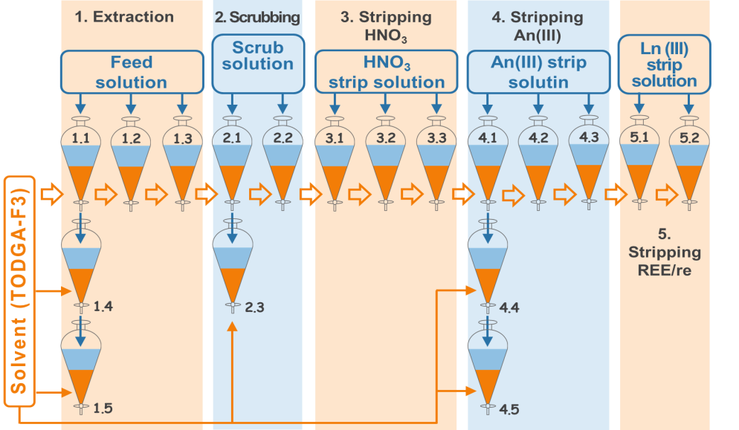

Fig.2 Flow sheet of the TODGA – F-3 extraction system end-to-end check with macro quantities of MA

During the processing of radioactive solutions containing MA, extraction systems are subjected to significant radiation exposure. Radiolysis can lead to changes in the physicochemical and extraction properties of the system (distribution and partition coefficients, capacity, kinetic characteristics, density, viscosity, etc.). Resistance to radiolysis is one of the criteria for the selection of extraction systems.
To determine the limits of stable operation of the TODGA – F-3 extraction system, its degradation under the action of external irradiation was carried out. The irradiation was carried out by accelerated electrons. Doses absorbed by the extraction system were 5; 10; 50; 100; 400 kGy. Further, without regeneration process, extraction/stripping of key elements (Am, REE, Zr, Pd) was checked on the irradiated extraction system according to the scheme similar to that presented in Fig. 2. A PUREX-process raffinate simulant solution containing 0.7 g/l Am was used for testing. It was demonstrated that doses up to 50 kGy had no significant effect on metal distribution. At higher absorbed doses, the effect of radiolysis on extraction becomes noticeable. During extraction from a strongly acidic solution (3-4 M), the distribution coefficients of Am gradually decrease with increasing dose, while during stripping in a weakly acidic medium (pH 2), the inverse dependence of distribution coefficients of Am from the absorbed dose is observed. This may be due to the formation of acidic products of radiolysis during irradiation, the effect of which becomes noticeable when the acidity of the aqueous phase decreases to pH levels.
а) b)
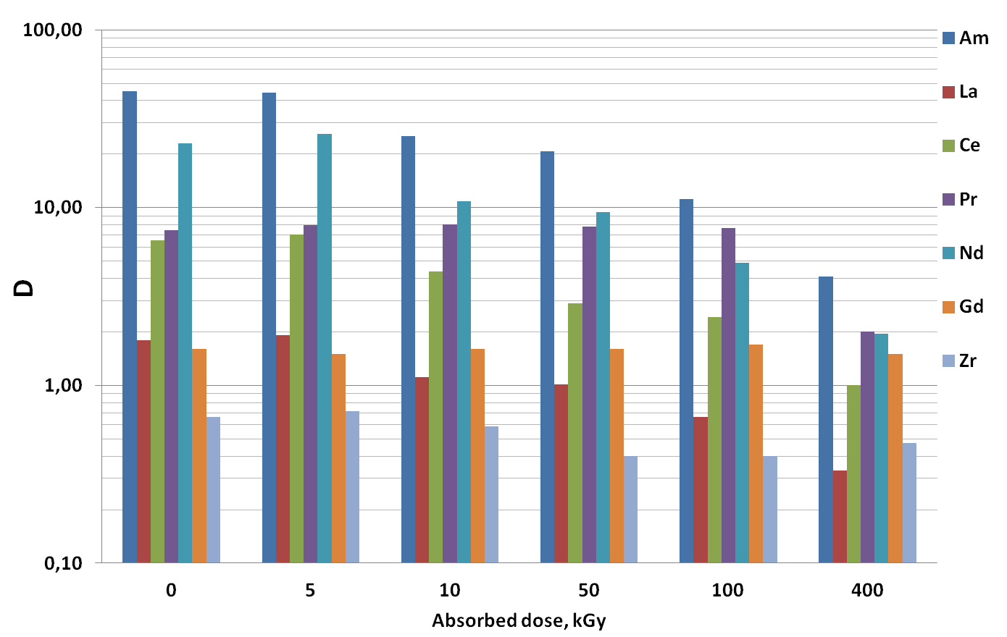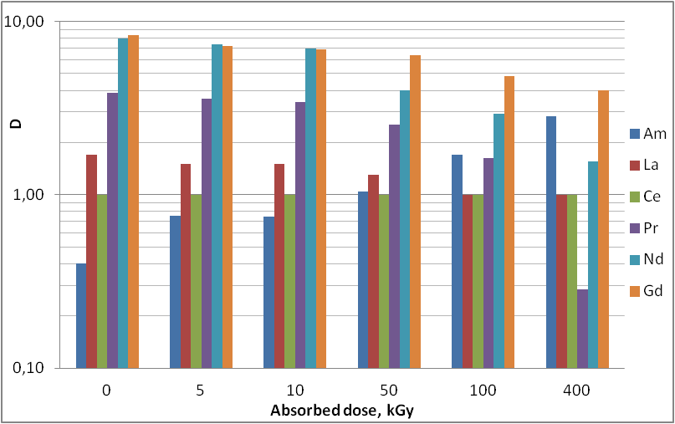
Fig. 3 Distribution coefficients of major elements at a) extraction stage; b) Am stripping stage.

During the experiment formation of precipitates, third phase, interphase films and stable emulsions were not observed, as well as there was no deterioration of phase separation even at the maximum dosage of the extractant.
The diluent used in the TODGA – F-3 extraction system significantly increases the capacity of the extraction system compared to conventional hydrocarbons and prevents the formation of the third phase []. But this diluent contains fluorine atoms, as a result of radiolysis of F-3 can form fluoride ions, which are quite strong corrosive agents. In the subsequent evaporation of secondary solutions generated during high level waste (HLW) processing, high concentrations of fluoride ions can present a very serious problem.
The effect of external ionizing radiation and internal alpha irradiation on the degree of degradation of the TODGA/F-3 – 3 M HNO₃ biphasic system was studied. The sources of ionizing radiation used were ²⁴⁴Cm, ²³⁸Pu, ⁶⁰Co and accelerated electrons. As a result of the work performed it was found that the total yield of fluoride ions in α-radiolysis was about 5.5 mg/(l∙kGy) (2 atoms/100 eV), in β-, γ-radiolysis – 2 mg/(l∙kGy) (0.7 atoms/100 eV). The concentration of fluoride ions in irradiated aqueous solutions containing dissolved F-3 did not exceed 4 mg/l [].
At PA Mayak hot dynamic tests of Am and Cm extraction technology from the evaporated HLW from the BN-600 SNF and the VVER-440 SNF reprocessing using TODGA-based extraction system were performed at the research bench. The duration of plant operation on real HLW in continuous mode was more than 70 h. Extraction of MA from HLW was achieved more than 99.2 %. It was confirmed that the technological process provides MA and REE recovery at the extraction stage and separation of MA and REE at the stripping stage.

3 SORPTION-CHROMATOGRAPHIC PROCESSES
Ion-exchange and chromatographic processes can be an alternative to extraction processes. Two types of fixed phases are widely used for chromatographic processes: ion-exchange resins and solid extractants. In contrast to the ion-exchange chromatography method, which uses a non-selective sorbent, the use of solid extractants has a number of advantages, the main of which is the possibility of selective extraction of components from solutions.
The possibility of using solid extractants with inorganic matrices for chromatographic separation of Am and Cm was considered. Synthesized solid extractants with 40 wt % phosphine oxide with different radicals (POR) on matrices silica gel (SCG) and carrier for gas chromatography chezasorb. The separation on these extractants was compared with the separation on solid extractants with POR solid extractant with styrene divinylbenzene (SDVB) matrix under static and dynamic conditions.It was shown that when eluting with the same chelating agent, the height of the equivalent theoretical plate (HETP) of solid extractant with hezasorb matrix is significantly lower than that of solid extractants with SCG or SDVB matrix. Among the chelating agents considered under the conditions of the experiments performed, diethylenetriaminepentaacetic acid (DTPA) has the highest partition coefficient of 1.32-1.36 under dynamic conditions.When working with solid extractants with inorganic matrices, the partition coefficients do not change after at least four cycles of sorption-desorption, which would probably satisfy the real conditions of their application.
The ion-exchange chromatography method is one of the most important methods of preparative isolation and separation of elements with similar properties in order to obtain radionuclides with a high degree of chemical and radiochemical purity. The method was developed by Spedding in the 1950s and was originally intended for the separation of natural REE []. In the 1960s, Wheelwright began using this method to isolate promethium and separate radioactive elements, including MA [].
The Mayak Production Association unit tested a two-stage ²⁴⁴Сm and ^{241,243}Аm extraction technology from REE and MA concentrate obtained from aqueous-tailings solution from VVER-440 SNF extraction processing using sulfocation cations.
At the first stage, columns filled with sulphocationite (KU-2-8 in Ni²⁺ - form, with granule size 0,1-1 mm) were used for the operation of "rough" cleaning and accumulation of the Am-Cm fraction. Sodium salts solution of 10 g/l diethylene triaminepentaacetic acid (DTPA) + 10 g/l nitrile-acetic acid (NTA) was used as an elution agent,
рН = 7-8.
Refining operations were performed on columns filled with sulfocationite “Tocem- 308” (220 mkm) in Ni²⁺ and Ni²⁺-Zn²⁺- forms. As an eluent we used 20 g/l aqueous solution of sodium salt DTPA with рН 7,5.
The REE and MA concentrate obtained by oxalate precipitation from evaporated PUREX-process raffinate from VVER 440 SNF processing was used as an initial solution. The ratio Am:REE in the stock solution was 1:30 and Cm:Am was 1:10.
As a result of these operations, 2.5 l of the enriched Cm fraction was obtained with a total content of ²⁴⁴Cm of about 9 g, i.e., 64% of the total Cm contentя. Eight liters of Am-enriched fraction with ^{241,243}Am content of about 65 g were isolated. Comparison of calculated and experimental data (Fig. 5.) shows quite good convergence of mathematical description of Am-Cm pair separation process and poor convergence of Am-Eu pair separation process.

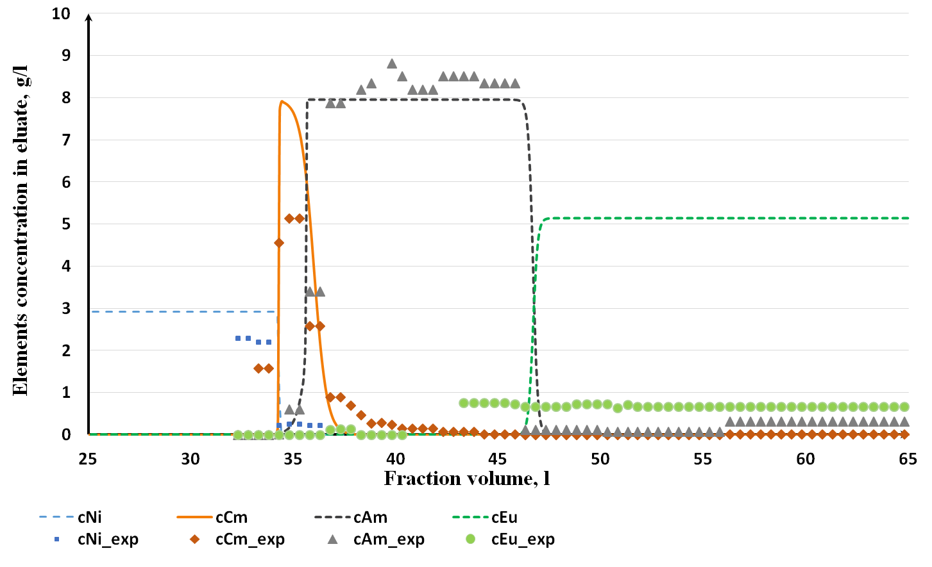
Fig. 5. Comparison of calculated and experimental data of the chromatographic separation process
Cm, Am and REE.

At Bochvar Institute the high pressure liquid chromatography (HPLC) technology of ²⁴⁴Cm and ^{241,243}Am extraction was tested using sulfocationite (produced by Technosorbent LLC). To carry out the process, REE - MA oxides concentrate from VVER-1000 SNF reprocessing at PA Mayak was used. Mass of REE and MA concentrate was 3.45 g, mass fraction of radionuclides ²⁴¹Am, ²⁴³Am was 41 %, mass fraction of radionuclide ²⁴⁴Cm was 3.7 %. Initial solution was prepared by dissolving the REE and MA concentrate in nitric acid with a concentration of 6 M. when heated to 60°C. After dissolution, the acidity of the solution was corrected by denitration with formic acid. The volume of the solution was brought to 500 ml, the final pH value was 0.94. A solution of 20 g/l DTPA, pH = 6.8, was used as an eluent.
For the chromatographic separation process, we used a setup consisting of three chromatographic columns connected in series with a total volume of 159 ml made of stainless steel of AISI321 analogue. The columns are equipped with water heating. The characteristics of the columns are given in Table 1.

Table 1. Characteristics of chromatographic columns

Column number | Inner diameter of the column, cm | Height of the packed part of the column, cm | Full volume, ml
1 | 1,20 | 100 | 113
2 | 0,7 | 100 | 38,5
3 | 0,3 | 100 | 7,1
Total |  |  | 158,6

The curve of the Am-Cm elution process is shown in Figure 6. It is obvious that Cm, Am, and europium are eluted sequentially with rather small mixing zones. The maximum concentration of Cm was 4 g/l. The amount of Cm was insufficient to form a "plateau" on the output curve. The concentration of Am at the plateau was 7.2 g/l. The yield of Am fractions with purity greater than 99.9 % was at least 96 % of the initial yield. Am yield in Cm fraction did not exceed 2.6% of the initial.

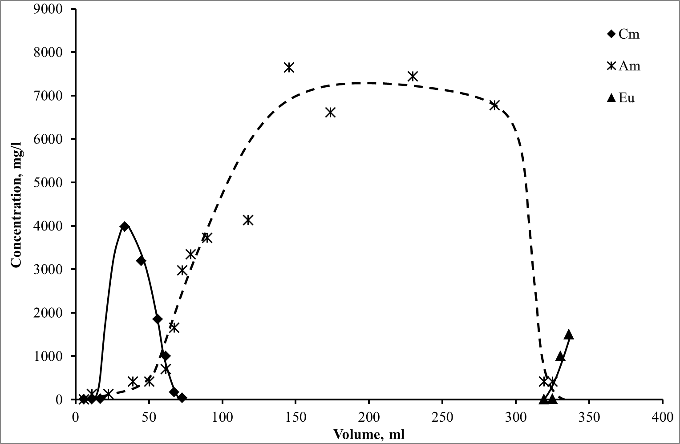
Fig. 6. Elution curve of the sorption-chromatographic separation of Cm, Am, and REE

4. CONCLUSION
To recover the Am fraction from the PUREX-process raffinate, a two-stage scheme including two technological processes was developed. At the first stage in extraction partitioning there is a separation of MA and part of REE from the main mass of fission products. At the second stage as a result of sorption-chromatographic process the pure fraction Am.
Within the framework of the PRORYV project, the DBPA, CMPO, TBP, Dyp-7, ATP-CCD (UNEX-T) and TODGA-based extraction systems were investigated and dynamically tested. Isopar-M, kerosene and methanitrobenzotrifluoride (F-3) were used as diluents for the systems. TODGA – F-3 was chosen as the main extraction system for subsequent implementation. For the system TODGA – F-3 the studies of the influence of ionizing radiation on the distribution of the main components were carried out. The system showed high hydrodynamic and radiation resistance.
Deep recovery of Am and Cm (99.9 % of the initial) was demonstrated using TODGA – F-3 from PUREX-process raffinate from VVER-440 SNF reprocessing. Using MA and heavy REE concentrate, experiments on HPLC separation of Am and Cm was performed. Am fractions suitable for further fuel fabrication were obtained. For all investigated processes mathematical models of both the process itself and control have been developed.
Thus, the technology of separation and separation of Am and Cm for the purposes of MA involvement into the nuclear fuel cycle of fast reactors was developed and verified using real products of SNF reprocessing.

5. FURTHER INFORMATION
This article was prepared by a team of authors of JSC PRORYV (107104, Russia, Moscow, Malaya Krasnoselskaya, 2/8) and Bochvar Institute (123098, Russia, Moscow, Rogova st, 5А).
CREDITS
The work was performed as part of the PRORYV project area managed by Rosatom State Corporation.
REFERENCES

About PRORYV project (https://proryv2020.ru/en/o-proekte/#id)
A.Yu. Shadrin, K.N. Dvoeglazov, O. A. Ustinov / Radiochemistry, 2016, 58 (3), pp. 234-241.
M.Yu. Alyapyshev, V. A. Babain, E.V. Kenf, L. Tkachenko, M.V. LogunovYu.A. Voroshilov, R.N. Khasanov, A.Y.u. Shadrin, V.L. Vidanov / Patent RU 2603405 С1, 27.11.2016;
. L. Tkachenko, E. Kenf, V. Babain, et al. / International Conference on Fast Reactors and Related Fuel Cycles, 26–29 June 2017, Yekaterinburg, Russian Federation, paper CN245-228.
V.L. Vidanov, L.I. Tkachenko, M.G. Dmitriev, Proc. Int. Conf. ISEC 2017, Miyazaki, JAPAN, 2017, р. 76.
M. Alyapyshev, V. Babain, I. Eliseev, E. Kenf, L. Tkachenko / New polar fluorinated diluents for diamide extractants // J. of Radioanalytical and Nuclear Chemistry, 2016, 310(2), 785-792.
V.L. Vidanov, L.I. Tkachenko, A.Yu. Evsyukova, A.Yu. Shadrin / 18th Radiochemical Conference, Marianskie Lazni, Czech Republic, 13-18.05.2018, Book of Abstracts, RadChem 2018, p. 91.
Spedding F.G., Powell J. Separation of rare-earth elements by ion exchange. Quantitative theory of the leaching mechanism with dilute citrate solutions. In the book: rare earth metals. M .: Foreign literature. 1957.420 s. S. 202-215.
Wheelwright E.G. A сomprasion of eluting agents for the ion-exchange purification of prometium. // J.Inorg.Nucl.Chem. 1969. V.31. № 10. P.3287-3293;

