Integrating safety at the first design stages: a new methodology for safety-oriented SFR core design

J.B. DROIN (corresponding author)
CEA Cadarache
F-13115 Saint Paul Lez Durance, FRANCE
Jean-baptiste.droin@cea.fr

N. MARIE
CEA Cadarache
F-13115 Saint Paul Lez Durance, FRANCE
Nathalie.marie@cea.fr

F. BERTRAND
CEA Cadarache
F-13115 Saint Paul Lez Durance, FRANCE
Frederic.bertrand@cea.fr

X. MANCHON
CEA Cadarache
F-13115 Saint Paul Lez Durance, FRANCE
Xavier.manchon@cea.fr

Abstract

Within the framework of the Generation IV Sodium-cooled Fast Reactor (SFR) R&D program of CEA (French Alternative Energies and Atomic Energy Commission), a methodology is proposed to early consider safety requirement in the undergoing reactor design process. Before the use of mechanistic tools (CATHARE, SIMMER, EUROPLEXUS, etc.) whose input deck elaboration requires an advanced knowledge of the reactor design, the methodology proposed in this paper involves several physical tools simulating phenomena likely to govern the choice of design parameters. These tools are mostly based on low-dimensional modeling (mostly 0D and 1D) and are validated versus experimental results. They are gathered in a platform that covers all kind of accidental phenomenology, from the initiator (pump trip, reactivity insertion, local flow blockages, etc.) until the reach of a stable and coolable state after corium relocation. Thus, enabling a large number of simulations in a reasonable computational time, it makes possible the characterization of some major accident transient bifurcations (such as boiling onset, boiling stabilization, primary power excursion, molten fuel vaporization, corium axial relocation in transfer tubes, etc.), in terms of probability of occurrence and of consequences on the transient evolution. It also enables to identify the main physical parameters causing the bifurcations in order to allow a straight feedback on the core design and to give some orientation for future R&D studies. In this paper, a focus is firstly made on some scenario bifurcations to illustrate the platform capabilities. The boiling onset and possible reactor state stabilization are studied. The possibility of primary power excursion depending on the core design is also addressed, and the fuel vaporization possibilities are finally assessed. Depending on these results, a global estimation of the core safety features could be provided for both prevention and mitigation features, at an early reactor design stage. This allows a rapid comparison between core concepts or design options in order to facilitate the design of safety-oriented SFRs.

INTRODUCTION

Context
The main objective of the French Generation IV project, carried out in the frame of the French Act dated from 28 June 2006 on sustainable management program for radiative materials and waste [1], is to design advanced reactor concepts based on improved technologies in terms of safety and reliability. Among other promising nuclear technologies selected by the GEN-IV International Forum [2], the Sodium-cooled Fast Reactor (SFR) is highlighted for its ability to secure the nuclear fuel resources and to manage radioactive waste by minor actinides transmutation.

These advanced reactor designs generally involve major innovations aiming at increasing the safety and a forgiving natural behaviour of the reactor in terms of probability of occurrence and of potential radiological consequences. For instance, for the ASTRID (Advanced Sodium Technological Reactor for Industrial Demonstration) concept, the core is featured by a very low (even negative) sodium void worth. This feature is expected to have a strong stabilizing impact on some severe accident sequences [3] especially regarding the power evolution, the materials heat-up, sodium boiling possibilities and more globally on the core behaviour when facing core degradation transients.

In order to demonstrate the good accidental behaviour of such advanced reactors provided by the aforementioned features, and more generally in order to ensure a robust safety demonstration, prevention and mitigation studies have been carried out. In particular, these safety analyses aim at:
- Assessing the range of possible effects induced by an initiator;
- Defining some prevention or mitigation devices in order to reduce the occurrence probability or the consequences of an accidental sequence;
- Providing a preliminary safety study (based on the quantification of the design and safety margins during normal operation).

Early safety consideration in the design process
It is necessary to include safety considerations all along the reactor conceptual studies (that means during several years or decades). However, an early consideration of safety in the design process enables an effective design review possibility toward intrinsically safe concepts and enables to get rid of a complex safety architecture. This is why a methodology is proposed at CEA in order to facilitate this early consideration. This methodology is based on three main phases illustrated in figure 1:
- Phase 1: at the very beginning of the project, the knowledge of the reactor design and specificities is low enough to allow fast design review options, based on some estimators’ calculations. As exhaustively detailed in [4], these simple estimators related to accidental behaviour of the reactors aim at assessing, among others, the main physical thresholds to exceed in order to have a core degradation, the time scale of the accident, etc. This estimation step enables to underline the weak and strong points of each investigated reactor concepts in terms of severe accident prevention and mitigation, and thus to select the main set of initial options in the light of safety aspects.
- Phase 2: once the concept and main options are selected, a set of fast-running tools allowing to quickly evaluate the behaviour of the core designs when facing accidental sequences, are used to help the designers for improving their reactor concept regarding severe accident management possibilities.
- Phase 3: once the core design and the primary architecture is converged thanks to preliminary evaluations, it is possible to assess more precisely the reactor safety through the use of mechanistic tools, such as CATHARE, SIMMER, etc. The safety study becomes more accurate, but the design retrofitting process becomes nevertheless less easy and efficient than during the two previous phases.

In this paper, a focus is made on the fast-running tools platform that enables the early consideration of safety in the undergoing design process during phase 2.

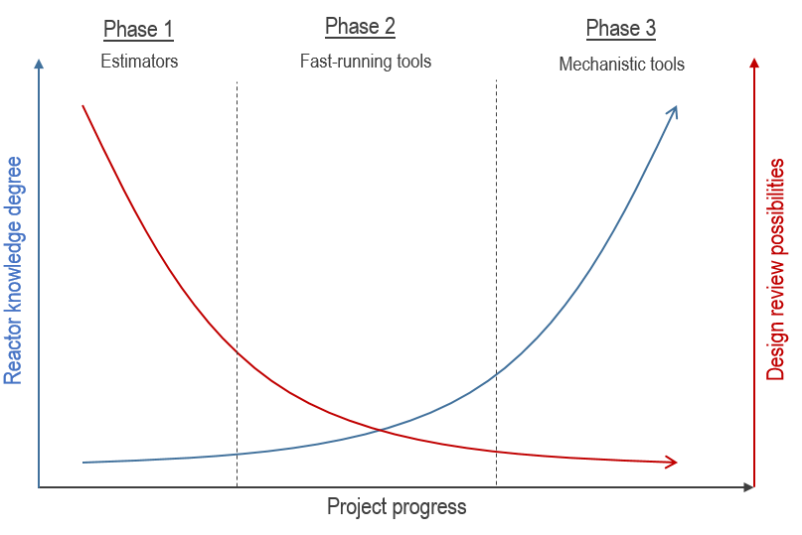
Figure 1: Schematic view of the reactor knowledge degree and the design review possibilities in function of the design project progress, and associated severe accident studies strategy.

the Severe accident fast-running tool platform
In order to assess the accidental behaviour of innovative SFRs, several fast-running tools have been developed at CEA over the past years. These tools are gathered in a platform that mainly aims at:
- Studying the causes and consequences of some bifurcations of accidental sequences (boiling, melting, material propagation, detection, etc.) and assessing their occurrence probability ;
- Assessing and comparing several reactor concepts (or design options) regarding safety;
- Facilitating an early design review based on safety studies.

On the contrary to mechanistic tools which require longer CPU time (such as the multi-physics codes SAS-SFR [5] and SIMMER-III [6]), the fast-running capacity of a simulation tool is of great interest, especially during the first conceptual design phases during which many core features might rapidly change. In this context, low-dimensional but yet accurate fast-running tools are valuable owing to the need for flexibility, reduction of CPU time consumption as well as large sensitivity analysis studies for quantifying design or safety margins when designing a new reactor concept.

International consensus
In the past, the need of such an approach based on low-dimensional physical modelling has already been highlighted. Indeed, in the eighties, an international consensus was reached that, the mechanistic approach is not sufficient to assess safety demonstration due to the complexity of severe accidents phenomenology [7]. In France, the safety demonstration of nuclear reactors is based on a deterministic approach completed by PSA (probabilistic safety assessment) studies. An approach combining physical events modelling with uncertainties treatment has been developed for PWR (Pressurized Water Reactor) severe accident analysis [8,9]. In Japan, the methodology development review of Level 2 PSA for SFR [10,11] also underlined the need to consolidate these studies with analytical methodologies. An analogous approach has been followed by the IGCAR (Indira Gandhi Centre for Atomic Research) to investigate the core damage due to the Total Instantaneous Blockage (TIB) of a SFR fuel subassembly (SA) [12]. The authors concluded that, for the elaboration of parametric studies, simplified and robust models that capture the essential features of the event progression are a good complement to mechanistic tools. This is why fast-running physical tools were developed at CEA in order to complete the deterministic SFR safety demonstration with exhaustive sensitivity studies and uncertainties propagation analyses, which also favours an early safety consideration in the design process.

Transient phenomenology
For the reasons developed in the previous section, significant phenomena were identified and modelled for each boundary accidental sequence, mainly based on literature analysis and test reports, in order to build the severe accident fast running tool platform. Three main initiators may lead to severe accident conditions in a SFR core: reactivity insertions, local subassembly faults and loss of the core cooling. For readability reasons, only the phenomenology related to the unprotected loss of flow (ULOF) is reported in figure 2 and described in this section. But all the sequences potentially induced by the three types of initiators are computable with the platform.

General overview of the sequence
The ULOF sequence with all the possible bifurcations is illustrated in figure 2. From the nominal state and depending on the initiator, the loss of flow may affect the whole core (global loss of flow) or a single subassembly (local loss of flow). In the latter case dealing with one subassembly, the loss of flow may be total (in case of a Total Instantaneous Blockage) or partial.
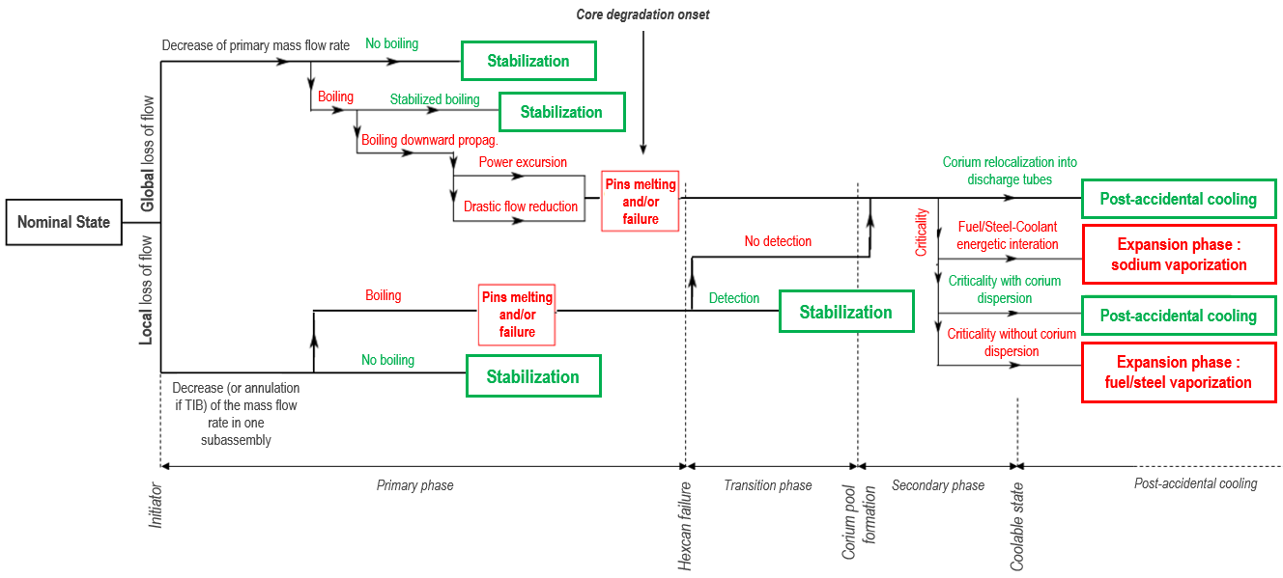
Figure 2: Schematic event tree for loss of flow transient in a SFR [13]

Global loss of flow
The unprotected loss of flow is assumed to be initiated by the primary pumps trips. Shutdown systems are supposed to fail and the transient starts at nominal power. As a consequence, the primary sodium flow rate is highly and progressively reduced, leading to a global core temperature increase, and to the global core power decrease due to negative reactivity feedback effects. Then, depending on the transient and the reactor features, the accidental sequence may evolve in different ways (transient bifurcations):
- If the power is low enough at the boiling onset, the boiling could either be avoided or stabilized in the upper part of the SAs. In such a regime, no flow excursion occurs in the subassemblies (SAs) even if sodium has reached the saturation temperature, thus preventing core degradation. This stabilization of boiling in the uppermost part of the core is of great interest for safety reasons.
- On the contrary, if the power decreases too slowly, boiling would be unstable. In this case, the occurrence of a flow excursion would lead to the downward progression of the boiling front within the core, as investigated in [14], in the positive void effect regions. This is likely to induce a subsequent power increase, and thus leads to pins failures and/or to fuel and clad melting in several SAs. In this case :
  - The materials (fuel and cladding) melting processes and their relocation (upwards by vapor flow entrainment, downwards by gravity, or due to fission gas release in case of irradiated fuel) may result in the formation and axial motion of molten pools in the concerned degraded SAs. The primary phase of the severe accident sequences ends with the first hexcan failure in the core.
  - Then, radial propagation of melted materials during the transition phase may create large pools in the core regions (secondary phase). Then, depending on the severe accident management strategy, the corium may be delocalized in the core catcher through some transfer tubes, until a stable and coolable configuration is reached. If not, fuel-coolant interaction or fuel vaporization induced by recriticality may induce large mechanical energy releases, which might damage the primary vessel.

Local loss of flow
In case of a local default, as analysed in [15,16], two main bifurcations may rule the transient sequence:
- If the blocked section is low enough, the faulted subassembly will stay in a coolable configuration without any coolant boiling occurrence.
- On the contrary, in case of a large blockage (for instance for a Total and Instantaneous Blockage of a subassembly), coolant boiling onset will occur rather quickly, resulting in an early clad and fuel melting in the faulted SA.
  - Then, if the degraded situation is rapidly detected thanks to thermocouples or delayed neutron detectors located above the core, the emergency shutdown may stop the accidental sequence early enough and lead to a coolable and stabilized core configuration.
  - If not, the core melting region may radially expand in the core (transition phase) until the formation of large corium pools (secondary phase). Then, the phenomenology and bifurcation tree is then the same as the one aforementioned for the global loss of flow transient.

Presentation of the CEA platform
As mentioned in the previous section, whether this is for loss of flow transient or reactivity induced ones, the sequence is ruled by many bifurcation possibilities, each one being governed by several physical phenomena, transient parameters, core design features, etc. The main phenomena are modelled in low-dimensional tools of the CEA platform.

General overview
Several tools were developed, each one being focused on a specific accidental sequence or a common part of these sequences. In figure 3, always taking the ULOF sequence as illustration, the range of application of each tool is illustrated upon the sequence displayed in figure 2. These models, which are briefly described in the next sections, are generally based on mostly 0D and 1D modelling written in MATLAB, and are carefully validated versus experimental results. Most of them only require a few minutes to run. These fast running tools are described in the next paragraphs.

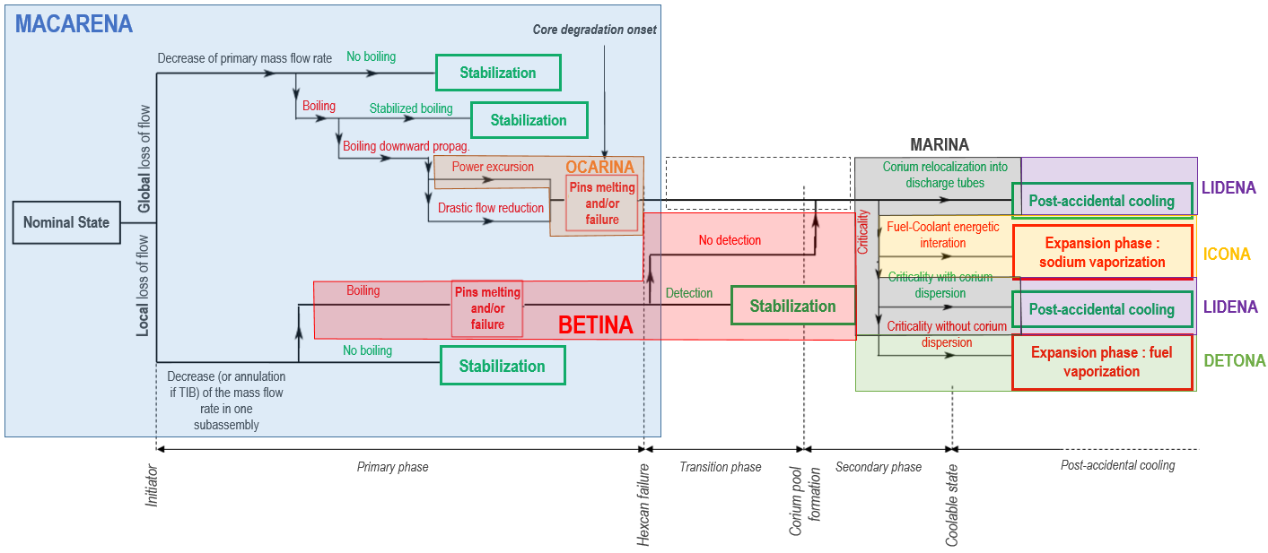
Figure 3: Illustration of the fast-running tools range of application

MACARENa
MACARENa is specifically dedicated to the primary phase of unprotected loss of flow transients (i.e. before the first hexcan degradation). It mainly handles the coupled resolution of thermalhydraulics and neutronics equations. More precisely, it involves:
- a two-dimensional transient heat equation in the solid materials of the SA;
- an one-dimensional mass, momentum and energy balances on the sodium flow along the SA height (homogeneous two-phase flow modelling adapted to sodium flow with a drift velocity correlation);
- a zero-dimensional momentum balance on each representative SA, to evaluate the inlet flow rate at its bottom;
- a zero-dimensional neutron kinetics system to compute the global core power evolution during the transient.
The MACARENa results were also shown to be in very good agreement with SIMMER-III mechanistic simulation results and with experimental results (GR19 for thermal-hydraulics, SCARABEE for degradation transients). More details could be found in [17].

BETINA
BETINA is a fast-running tool aiming at simulating a TIB transient occurring in a SFR. It is an analytical tool based on the coupling between a 1D modelling for pins and on a 0D modelling for each steel and fuel molten pool, enabling the energy balance equations resolution in each material of the SA. One representative fuel pin is modelled through an axial 1D nodalization. Owing to the small conductive heat transfer characteristic time in the pin in comparison to the duration of the transient, the heating-up of the blocked SA is justified to be quasi-adiabatic. Due to the localised degradation, the influence of the transient on the global core neutronic power evolution is neglected. For validation purpose, simulation results were successfully compared against SCARABEE tests results in [15].

OCARINA
OCARINA is dedicated to the simulation of the primary phase of a power excursion up to clad failure. It involves a heat transfer and thermal-hydraulic time-implicit solver chained with a mechanical model in order to provide clad failure predictions and the calculation of the molten fuel mass and temperature in the fuel pin during the transient. It handles:
- one-dimensional radial transient conduction in the solid materials;
- one-dimensional axial transient mass and energy balances in the coolant;
- mechanical model based on analytical formulations;
- von-Mises criterion for the prediction of clad failure.
This physical tool is validated against separated test-cases using CESAR test loop facility results, several CABRI transients and a benchmark with SIMMER-III (about 10% of relative error regarding validation data). More details could be found in [18].

MARINA
This tool is dedicated to mitigation. These models are based on physical evidences and conservation balances. This 0D tool handles heat transfers from molten (possibly boiling) pools, fuel crust evolution, phase separation/mixing of fuel/steel pools, radial thermal erosion of mitigation tubes, discharge of core materials and associated axial thermal erosion of mitigation tubes. All the modules are coupled with a global neutronics evolution model of the degraded core. This physical tool is used to study and to define mitigation features (function of tubes devoted to mitigation inside the core, impact of absorbers falling into the degraded core...) to avoid energetic core recriticality during a secondary phase of a potential severe accident. More details could be found in [19].

ICONA
This 1D tool evaluates the mechanical energy release during the fuel-coolant interaction. It calculates the immediate contact of a certain mass of coolant with a mass of hot liquid fuel. The fuel, in the form of spherical particles, is supposed uniformly distributed inside the sodium. By the heat transferred from the fuel to the sodium, the volume of the sodium changes either in a single-phase state due to the heating of the liquid or in two-phase state by vaporizing the sodium. After an acoustic period, the constraint is of an inertial nature pushing the unheated liquid sodium column toward the free expansion surface and the core vessel. More details could be found in [20].

DETONA
DETONa computes the mechanical energy release and the pressure impulse during the expansion phase of an energetic SFR severe accident. It is written in a modular way that allows activating several separated models in order to verify their effect. In particular, the effect of liquid sodium vaporization caused by its entrainment in the fuel vapour expanding bubble is considered. DETONa’s modelling implies several phases modelled in a spherical 1D multi-zone geometry. These phases are liquid fuel, fuel vapour, liquid sodium, and argon. In order to compute the argon compression energy, DETONa solves with an Euler explicit scheme the fuel mass and enthalpy balances, as well as the sodium momentum balance. When the heat exchange between fuel and sodium is neglected, the modelling is called adiabatic but a non-adiabatic situation could be also considered. DETONa’s computations showed good results when compared to the EXCOBULLE tests. More details could be found in [21].

LIDENA
This 1D tool under development is dedicated to debris bed cooling evaluation. It simulates the thermal-physical evolution of a debris bed (temperature and phase flow variations). It enables to study when the bed coolability limit is exceeded.

Example of bifurcations studies
The severe accident simulation platform which gathers the tools presented in section 2.3 has been used for many safety-informed design and stability analyses of fast reactor systems, allowing to emphasize main dominant phenomena and significant trends for safety assessment, or to assess the relevancy of some design options regarding severe accident behaviour. In order to illustrate such kind of capabilities, several examples of bifurcation studies are provided in this paper:
- Bifurcations related to sodium boiling onset and potential boiling stabilization,
- Bifurcations related to power excursion occurrence during the primary and secondary phase,
- Bifurcations related to fuel melting and relocation,
- Bifurcations related to fuel vaporization.
Only a brief overview of these application cases and of the main outcomes is given here. For more details, please have a look at the given references.

Bifurcations related to boiling onset and possible boiling stabilization
The first example deals with a statistical study performed in order to assess the bifurcations related to potential boiling onset and to potential boiling stabilization. A panel of 2000 unprotected loss-of-flow simulations were run with MACARENa, in an ASTRID-like core, and 26 input parameters were considered as uncertain, dealing with:
- the initial core conditions uncertainties (power, irradiation cycle, etc.);
- the transient scenario uncertainties (primary and secondary pumps halving time, etc.);
- the complexity of physical phenomena and/or modelling of their coupling (neutronics feedback coefficients, Nusselt adimensional numbers, sodium quality at dry-out, overheating temperature, etc.).
More details about these parameters, the estimation of the probability density functions and the sampling method can be found in [17, 22].

To illustrate this methodology, a panel of 100 simulations results is displayed in figure 4, it illustrates the obtained core power evolutions. The mechanistic SIMMER-III result, obtained considering the mean value of each uncertain variable, is also plotted in this figure (red curve). The main outputs of this study are summarized below [17, 22]:
- boiling is observed for most of the simulated transients (around 90%).
- there is a strong impact of the modelling of reactivity feedback due to thermal expansion of solid material (including control rods and vessel dilatation) on the resulting core degradation during an unprotected loss-of-flow. By taking them into account (i.e. closer to real conditions), the sequences leading to core degradation (i.e. sequences without flow excursion) are reduced from 78% to 25%, cf. figure 5. For these more realistic neutronics situations, the sequences mainly result in stabilized boiling transients (around 70%) and even, more rarely (around 10%), to stabilized transients without any boiling onset.
- this study also highlighted the main scenario or modelling parameters impacting the transient evolution and leading to boiling. They are, regarding the boiling onset time, the primary pumps halving time and the pressure loss in the primary circuit (in the intermediate heat exchanger). Concerning the occurrence of the core degradation, the most influent parameters are shown to be the two-phase modelling (Lockhart-Martinelli pressure drop factor), the pressure loss in the primary circuit and the fuel irradiation cycle.
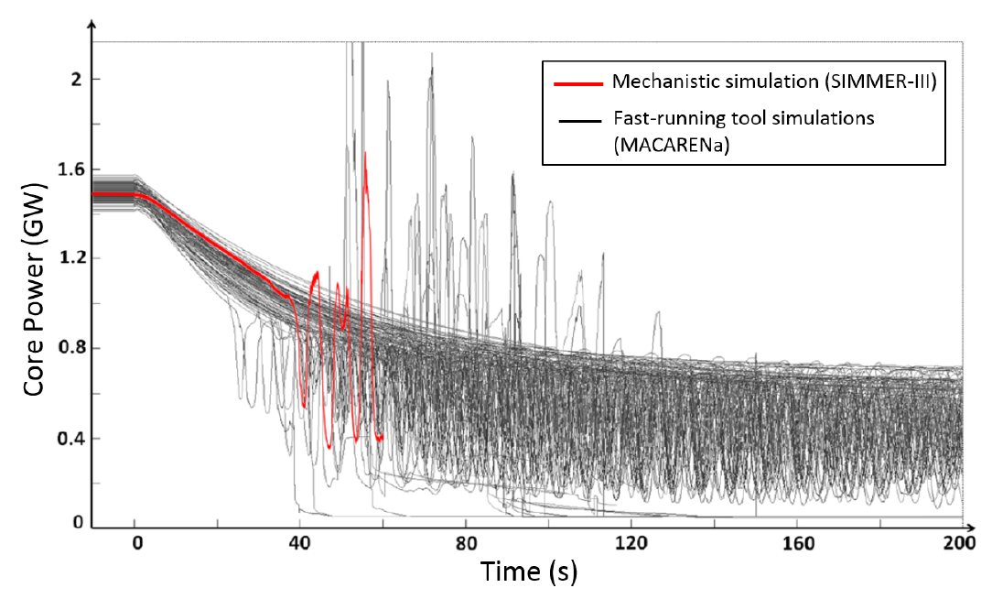
Figure 4: Illustration of the approach applied to study the bifurcations related to boiling onset and stabilization [17]

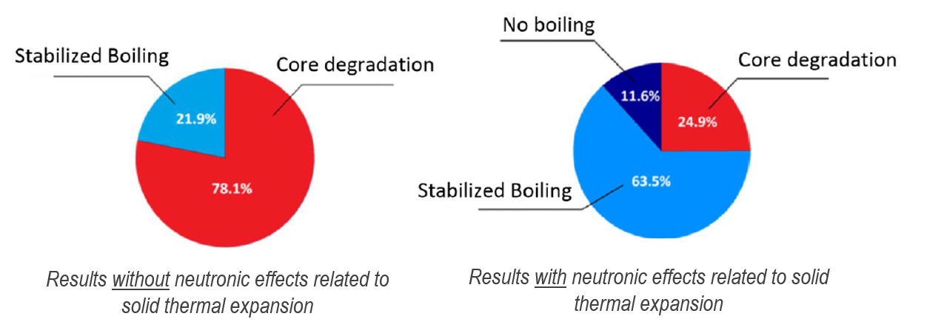
Figure 5: Results of the unprotected loss of flow statistical analysis in terms of probability of boiling and degradation occurrence (without neutronic effects related to solid expansion on the left, and with these effects on the right) [17].

Bifurcations related to primary power excursion occurrence
After the boiling occurrence, if boiling is unstable, the boiling front may progress downward, in the positive void regions. It can be shown that the behaviour of a SFR during such a transient mainly depends on the sodium void worth distribution in the core. In particular, it may rule the possible occurrence of a primary power excursion and its magnitude. This second study reported in this paper, carried out with the CEA fast-running platform, aims at characterizing more precisely the dependence of this power evolution with the core design features such as the void effect distribution.

In a core with a sodium plenum, the sodium void worth can be separated into two components, a lower one corresponding to the fuel region and an upper one located in the structures above the core. By modifying the core geometrical design, it is possible to modify each of these components separately or simultaneously and thus to cover a wide range of possible core designs. The behavior of many of these core designs when facing loss of flow transients has been investigated with the platform, and they were classified depending on the occurrence of a power excursion or of stabilized boiling conditions. Results are illustrated in figure 6 [23].
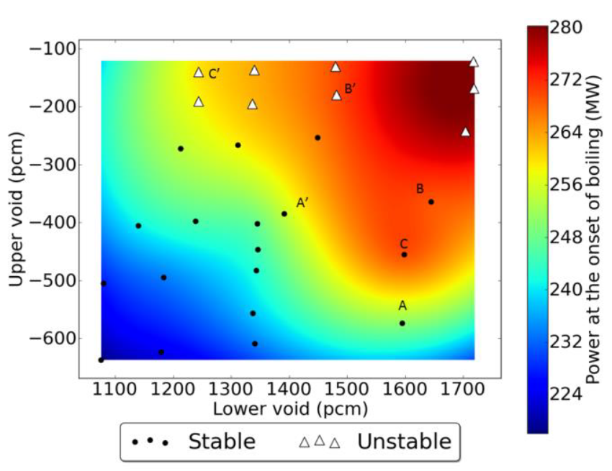
Figure 6: Power at boiling onset for several cores with different void effect distributions. The dots correspond to cases where stabilized boiling is achieved, the triangular one to the cases where a power excursion is observed [23]

This study has shown that either the integral sodium void worth or the power at the onset of boiling could not be used to characterize the core behavior. An estimator based on the ratio of the upper to the lower sodium void contributions seems preferable. For instance, as displayed in figure 7, it was shown that, for the type of cores considered and for the considered transient (primary halving time of 10s), the upper sodium void has to be greater than 20 % of the lower sodium worth to prevent a primary power excursion during the transient. Furthermore, for the cores undergoing a power excursion, it is observed that the time to the power excursion is also a function of this ratio.
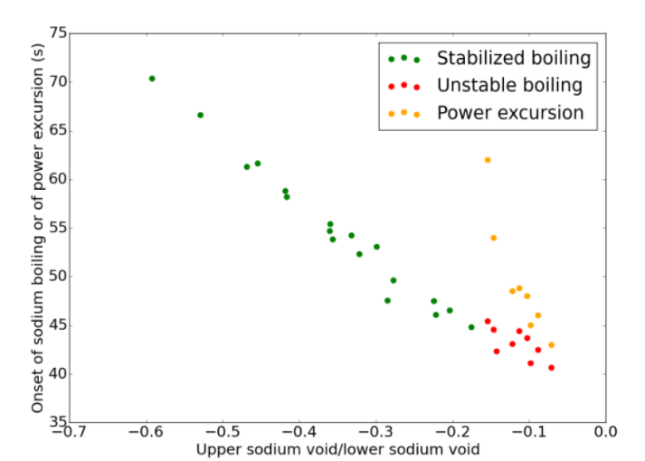
Figure 7: Boiling onset and primary excursion time with regards to the ratio of lower over upper sodium void worth [23]

Bifurcations related to pins disruption
The primary power excursion, if it occurs, engenders fuel melting in many pins and generally leads to some clad failures. To study this bifurcation, an application case with OCARINa is proposed in [24].

It consists in the study of the potential consequences of an external ramp of reactivity insertion around 3$, corresponding to a core support plate rupture accident in a traditional SFR core concept. Considering various power transients around this reference value, the variability of the main results of interest (time of clad failures, fuel mass ejected inside the sodium, etc.) has been investigated for each type of pin in the different subassemblies. The main goal is to determine the first pin rupture (time and location) and to calculate the intensity of the consequent fuel-coolant interaction when molten fuel is ejected inside the sodium channel under the gas fission pressure motion and the associated reactivity effects resulting from these liquid fuel movements.

Table 1 presents the results related to the first two pin failure event occurrences in the core. If the 3$ are inserted in 0.25 s, prompt criticality occurs at 0.84 s, and there is no pin failure prior to this. Then, in any case, the pins in the outer core located just above the inner core periphery (“derivation 9”) fail first. Another important result is the maximum mechanical energy obtained in every case due to fuel-coolant interaction: it is quite low, less than 1 MJ, which is far below the safety criterion.

Table 1: Sensitivity Study Results regarding the impact of the power ramp on the clad failure instant and location [24]
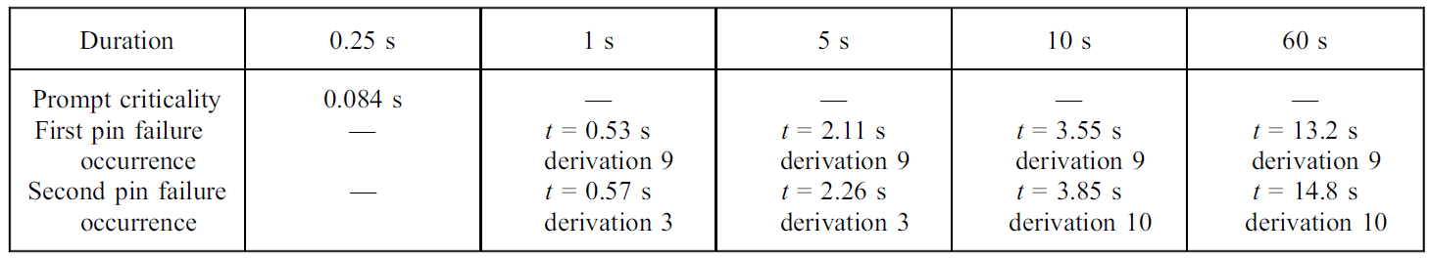

Bifurcations related to fuel vaporization
During the potential secondary phase, after the fuel melting and the formation of molten pools in the core, sodium and/or fuel vaporization may occur and result in a large mechanical energy release on the primary vessel. This energy release depends on several parameters, including the mass of molten fuel, its temperature, and the heat transfer between fuel and sodium during the expansion phase.

Some DETONa calculations were performed aiming at quantifying the influence of these parameters on the mechanical energy release. All these cases involve the expansion of one ton of fuel initially heated at 4000 or 4500 K. Three different sodium heat exchange models are tested: the adiabatic one, and two non-adiabatic ones, involving a fuel-sodium exchange; either under a Rayleigh-Taylor instability occurring at the sodium interface or under a fragmentation of sodium droplets into the fuel vapour, depending upon a critical Weber number criterion. An example of results are provided in figure 8 [21].

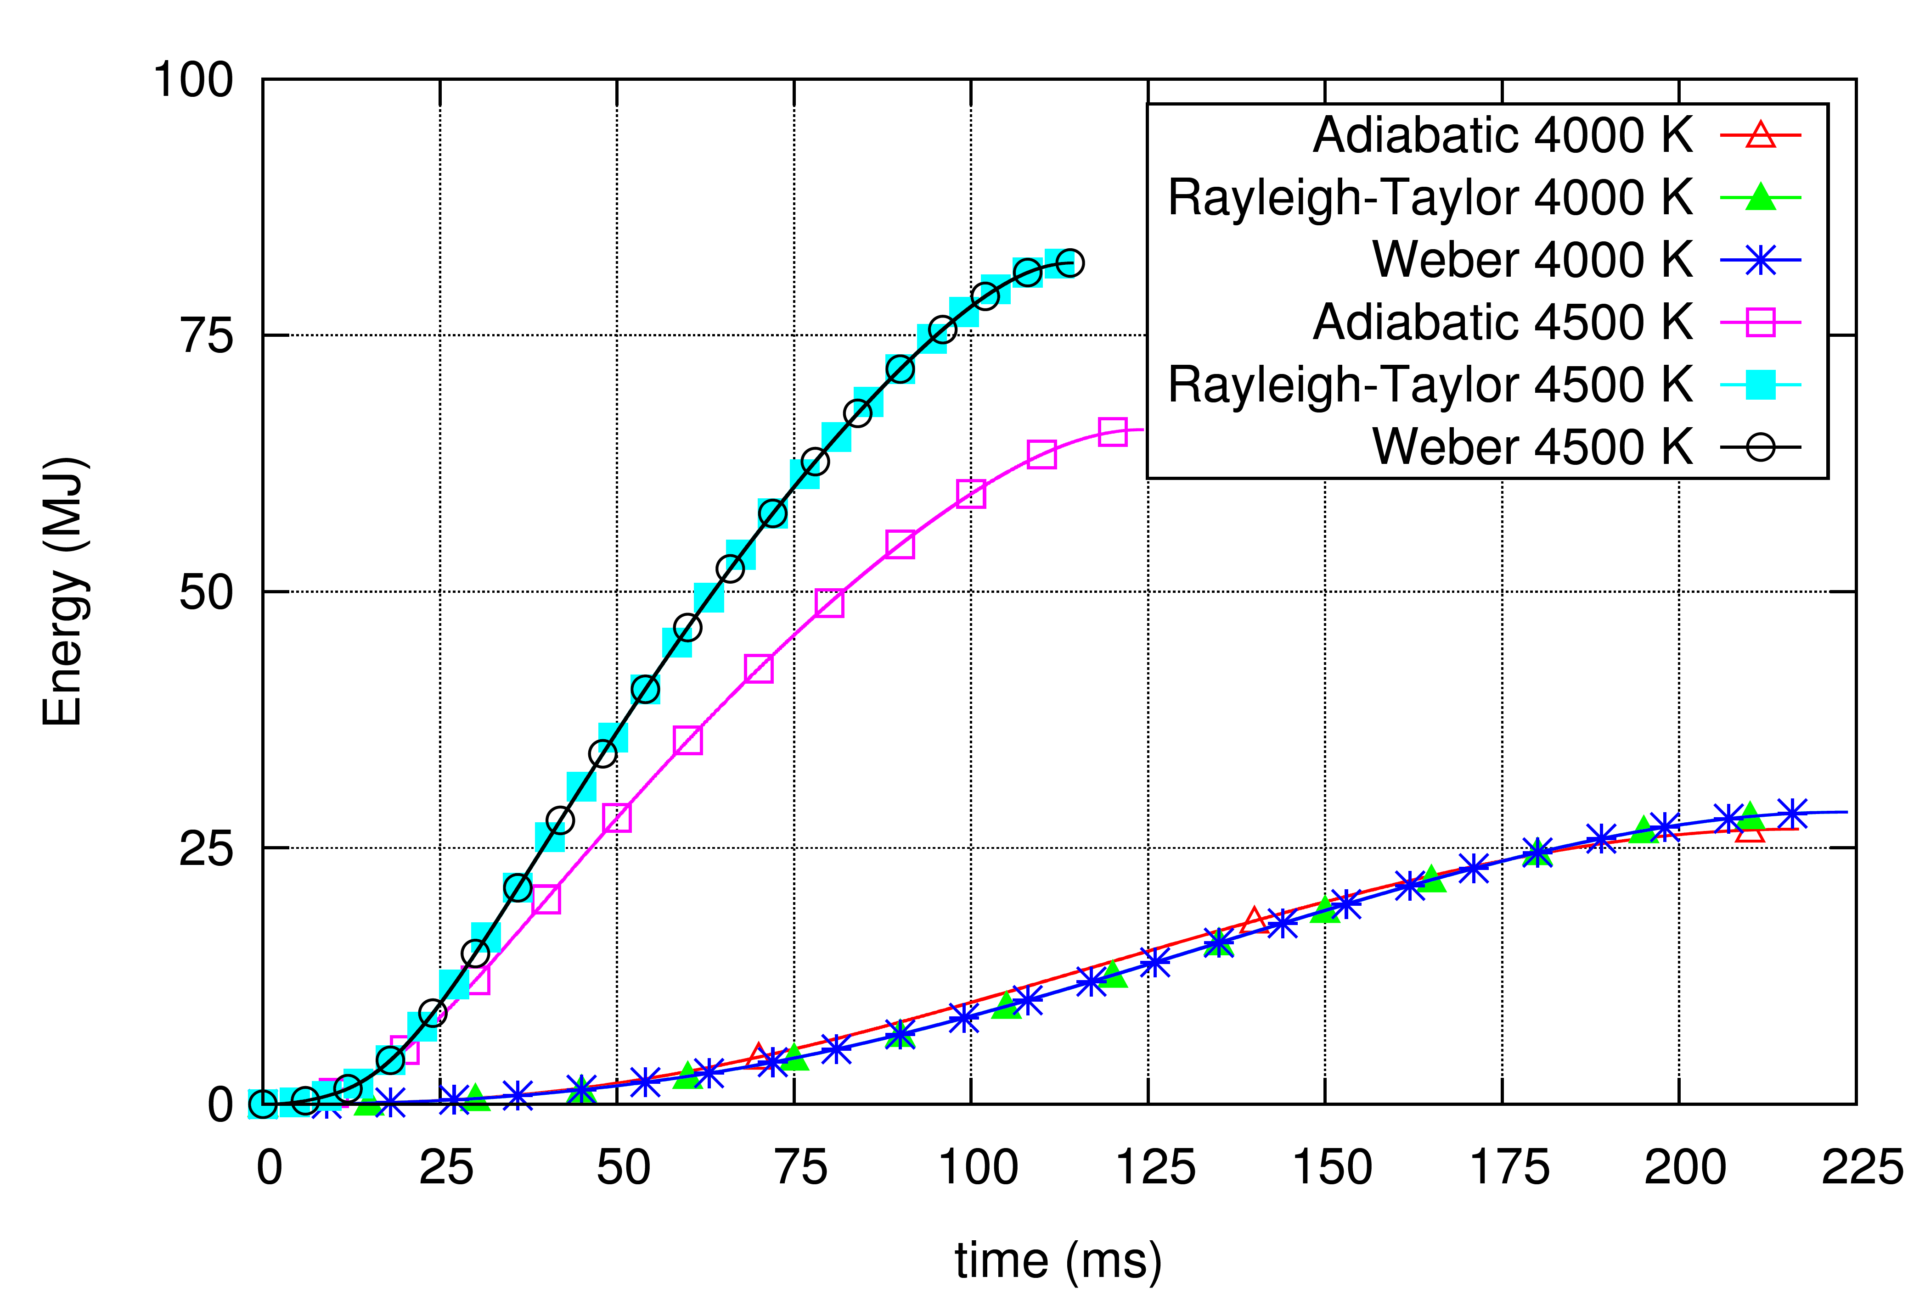
Figure 8: Mechanical energy release under the vaporization and expansion of one ton of fuel at different initial temperatures, for various fuel-sodium heat exchange models [21]

These outputs highlight the impact of non-adiabatic modelling at high temperatures, where the sodium vaporization caused by its mixing with the hot fuel vapour increases the final mechanical energy. For a smaller initial fuel temperature, the sodium vaporization effect is negligible, because the fuel vapour is not hot enough.

Based on these considerations and through a chaining between several tools:
- MACARENa to compute the core evolution until the power excursion,
- OCARINA to compute the amount and temperature of molten fuel induced by the power excursion,
- DETONA to compute the mechanical energy released by the vaporization of this fuel vaporization,
it is possible to assess several core designs regarding potential mechanical energy releases at the end of the transient. Such an example is given in figure 9. In this figure, the core #1 is an ASTRID-like heterogeneous core (with an inner fertile plate) of 400 MWth. Core #2 is a homogeneous core with the same fuel pins than core #1. Core #3 is homogeneous with thinner pins (SuperPhenix pins design). Among the considered 3 core design, the ASTRID-like core clearly shows a better behaviour with mechanical energy releases under 5MJ. But the three considered core designs are far below the 80 MJ safety criterion regarding the primary vessel integrity.

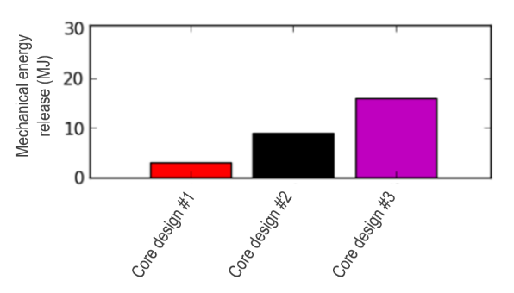
Figure 9: Mechanical energy release under the vaporization and expansion of one ton of fuel (considering different temperatures and various fuel-sodium heat exchange models)

Conclusions and prospects
Within the framework of the Generation IV Sodium-cooled Fast Reactor (SFR) R&D program of CEA (French Alternative Energies and Atomic Energy Commission), a methodology is proposed to early consider safety requirement in the undergoing design process. Indeed, this early consideration of safety in the design process enables an effective design review possibility toward intrinsically safe concepts. Among other tools (estimators at the very beginning of the design process, and mechanistic tools once the reactor knowledge is sufficient), the proposed methodology relies on several fast-running tools which are mostly based on low-dimensional modelling (mostly 0D and 1D) and are carefully validated versus experimental results. On the contrary to mechanistic tools which require longer CPU time (SAS-SFR, SIMMER-III), the fast-running capability of these tools is of great interest, especially during the first conceptual design phases during which many core features might rapidly change.

These tools are gathered in a platform that covers all kind of accidental phenomenologies, from several kinds of initiators (pump trip, reactivity insertion, local blockages, etc.) until the reaching of a stable and coolable reactor state. This makes possible the characterization of some major accident transient bifurcations in terms of probability of occurrence, of identification of the governing parameters or of consequences on the transient evolution. To illustrate the capabilities of the platform, a few studies of some main transient bifurcations are summarized in this paper. They deal with the boiling onset, the boiling stabilization, the power excursion possibly induced by boiling, the fuel melting induced by the power increase, and eventually the possible fuel vaporization that may affect the primary vessel integrity. Through these examples, it has been shown that the fast-running tool platform is a very efficient way to proceed to parametrical or statistical studies involving sensibility analysis and to realize safety-oriented design studies quite early in the design stages.

For the application presented in this paper, the physical tools are chained and not coupled. This is why developments are ongoing to proceed to a more refined coupling between these tools (such as in [25]) and to extend their range of capability. This work is carried out in the frame of the PROCOR-Na platform development, aiming at gathering these tools in a more formal way. As a prospect, a new tool dedicated to the transition phase is also missing for now (as illustrated in figure 3 in the dashed line rectangle) and should be subject to a dedicated work in the incoming years, in order to complete the simulation of the range of physical phenomena possibly induced by an accidental sequence in SFR.
References

[1] Loi 2006-739 du 28 juin 2006 de programme relative à la gestion durable des matières et déchets radioactifs (1), French Government, 2006.
[2] A technology roadmap for Generation IV nuclear energy systems, USDOE and the Generation IV International Forum, 2002
[3] Lemasson, D., Bertrand, F., 2014. Simulation with SAS-SFR of a ULOF transient on ASTRID- like core and analysis of molten clad relocation dynamics in heterogeneous subassemblies with SAS- SFR, ICAPP’14, Charlotte, USA
[4] F. Bertrand, N. Marie, A. Bachrata, J.B. Droin, X. Manchon, T. Le Meute, E. Merle, D. Heuer, 2021, Simplified criteria for a comparison of the accidental behaviour of Gen IV nuclear reactors and of PWRS, Nuclear Engineering and Design 372 (2021) 110962
[5] Kruessmann, R., Ponomarev, A., Pfrang, W., Struwe, D., Champigny, J., Carluec, B., Schmitt, D., Verwaerde, D., 2015. Assessment of SFR reactor safety issues: Part II: Analysis results of ULOF transients imposed on a variety of different innovative core designs with SAS-SFR. Nucl. Eng. Des. 285, 263–283.
[6] Kondo, S., Morita, K., Tobita, Y., Kamiyama, K., Brear, D., Fischer, E., 1996. SIMMER-III: a computer program for LMFR core disruptive accident analysis. O-arai Engineering Center, Power Reactor and Nuclear Fuel Development Corporation.
[7] Luck, L., Bell, C., 1985. The case of integral core – disruptive accident analysis. ANS/ENS Fast Reactor Safety Meeting, Knoxville, TN, USA.
[8] Iooss, B., Gaudier, F., Marques, M., Spindler, B., Tourniaire, B., 2009. Uncertainty assessment in severe nuclear accident scenarios. First International Conference on Advances in System Simulation 94–99.
[9] Le Tellier, R., Saas, L., Payot, F., 2015. Phenomenological analyses of corium propagation in LWRs: the PROCOR software platform, The 7th European Review Meeting on Severe Accident Research ERMSAR-2015, Marseille, France.
[10] Nakai, R., Suzuki, T., Yamano, H., Seino, H., Ishikawa, H., 2009. Development of severe accident evaluation technology (Level 2 PSA) for Sodium-cooled Fast Reactor (1) Overview of evaluation methodology development, ICAPP’09, Tokyo, Japan.
[11] Yamano, H., Sato, I., Tobita, Y., 2012. Development of technical basis in the initiating and transition phases of unprotected events for Level-2 PSA methodology in sodium cooled fast reactors. Nucl. Eng. Des. 249, 212–227.
[12] Ravi, L., Velusamy, K., Chellapandi, P., 2013. A robust thermal model to investigate radial propagation of core damage due to total instantaneous blockage in SFR fuel assembly. Ann. Nucl. Energy 62, 342–356
[13] X. Manchon : Contribution à la prédiction du déroulement de scénarios d'accidents graves dans un RNR-Na. University of Lyon, PhD thesis, 2017.
[14] Bertrand, F., Manchon, X., Marie, N., Droin, J., Schmitt, D., Lance, M., Sciora, P., 2012. Flow stability simplified criterion in a SFR core taking into account flow rate and power variations. Nucl. Eng. Des.
[15] Marie, N., Marrel, A., Seiler, J.-M., Bertrand, F., 2016. Physico-statistical approach to assess the core damage variability due to a Total Instantaneous Blockage of SFR fuel sub-assembly. Nucl. Eng. Des. 297, 343–353.
[16] Rahm, T., Droin, J.B., Marie, N., Bertrand, F., Marrel, A., Analysis of the Total Instantaneous Blockage accident consequences in the innovative inherently-safe CADOR SFR core, Nuclear Engineering and Design 348 (2019) 78–89
[17] Droin, J.B., Marie, N., Bertrand, F., Marrel, A. Bachrata, A., Design-oriented tool for Unprotected Loss Of Flow simulations in a Sodium Fast Reactor: Validation and application to stability analyses, Nuclear Engineering and Design Volume 361, May 2020, 110550
[18] Herbreteau, K., Marie, N., Bertrand, F., Seiler, J.-M., Rubiolo, P., 2018. Sodium-cooled fast reactor pin model for predicting pin failure during a power excursion. Nucl. Eng. Des. 335, 279–290.
[19] Marie, N., Bachrata, A., Seiler, J.M., Barjot, F., Marrel A., Gossé, S., Bertrand, F., A physical tool for severe accident mitigation, Nuclear Engineering and Design 309 (2016) 224–235.
[20] Caraghiaur, D., Marie, N., Bertrand, F. and Kudinov P, Simplified models dedicated to vapour explosion applicable for ASTRID pre-conceptual design, the 13th International Conference on Multiphase Flow in Industrial Plants, Sestri Levante (Genova), Italy, 17-19 September 2014.
[21] Manchon X., Bertrand F., Marie N., Lance M. and Schmitt D.: Modeling and analysis of molten fuel vaporization and expansion for a sodium fast reactor severe accident. Nuclear Engineering and Design, 322:522 535, 2017. ISSN 0029-5493.
[22] Droin, J.-B., 2016. Modélisation d’un transitoire de perte de débit primaire non protégé dans un RNR-Na, Ph.D. thesis, Grenoble-Alpes University, in french (defended on the 26th September 2016).
[23] A.Jardel, T.Kooyman, J.B. Droin, P.Sciora, A design criterion for SFR behavior during loss of primary flow transients, Proceedings of ICAPP 2020 15-19 March 2020 – Abu Dhabi (UAE)
[24] Marie, N., Marrel, A., Herbreteau, K., 2019. Statistical methodology for a quantified validation of sodium fast reactor simulation tools. J. Verific., Validation Uncertainty Quantif. 4 031002-15.
[25] Jeannin, M., Pascal, V., Blanc, V., Droin J.B., Buiron, L., Rubiolo, P., First Approach To Analyse Control Rod Withdrawal Transient In Sfr With A Multi-Physics Methodology, Ans M&C 2021 - The International Conference On Mathematics And Computational Methods Applied To Nuclear Science And Engineering, Raleigh, North Carolina, October 3–7, 2021

With one radial mesh per material (fuel, clad, coolant, hexcan, outer-sodium).
This value of 20 % for the separation between stable and unstable cases should not be taken at face value, as it is expected to depend from many parameters, most notably the transient features (primary pumps halving time). Additional calculations were carried out with a half-time of 28 s, which corresponds to a situation where primary pumps are equipped with flywheels, and the criterion on the upper sodium void to the lower one fell to 13%.

