# Study on Sodium Fire PSA Methodology for Pool-Type Sodium cooled Fast Reactor

WANG Jing

China Institute of Atomic Energy

Beijing, China

Email: wangj07@163.com

YAN Han

China Institute of Atomic Energy

Beijing, China

JIANG Jingke

China Institute of Atomic Energy

Beijing, China

YANG Chen

China Institute of Atomic Energy

Beijing, China

**Abstract**

According to the sodium cooled fast reactor (SFR) operation experience, about 100 sodium leakage accidents have happened in history. Sodium fire is a typical hazard in SFR, which is also one of the main reasons for its unavailability, and may be one of the main contributors to the total core melting risks. Study on sodium fire PSA methodology can not only quantitatively evaluate the sodium fire risk in SFR, but also identify the weakness of sodium fire prevention and improve the safety of SFR. Based on the specific technique and process of NUREG/CR-6850 LWR fire PSA methodology, considering the design characteristics and sodium fire characteristics of pool type SFR, a sodium fire probability safety assessment methodology for pool type sodium fast reactor is proposed. Then, an example of study on the sodium fire in secondary loop sodium pump room of China Experimental Fast Reactor (CEFR), which shows the sodium fire event sequences and its frequency of core damage, is presented. After that, several key issues which need to be further researched for sodium fire PSA in the future were discussed.

## INTRODUCTION

Liquid metal sodium, which has great fire risk because of its strong chemical activity, is used as coolant in sodium cooled fast reactor. It can react directly with non-metallic elements such as oxygen, sulphur, nitrogen and halogen. When liquid sodium is exposed to air, it will burn and produce sodium aerosol. Compared with light water reactor (LWR), sodium fire is one of the typical accidents in sodium cooled fast reactor, and it’s also a special internal hazard in sodium cooled fast reactor.

According to the sodium cooled fast reactor operation experience，sodium fire accidents are common. According to incomplete statistics, more than 100 sodium leakage accidents occurred in sodium cooled fast reactor operation history. During the performance test of Monju in December 1995, a fire accident was caused by the leakage of liquid sodium from the secondary coolant system. Since then, it has been shut down for a long time. Sodium fire accident not only affects the safety of the reactor, but also reduces the economy of the reactor. Therefore, it is not only necessary to apply the deterministic method to qualitatively evaluate the safety of reactor under sodium fire accident，but also to quantitatively evaluate the risk of sodium fire in sodium cooled fast reactor nuclear power plant by using probabilistic safety assessment method, identify the weak links of sodium fire protection, and provide effective suggestions for the improvement of sodium fire protection design.

## Sodium fire probabilistic safety assessment method

After Fukushima accident, PSA evaluation of external events has been widely concerned in the world. At present, the fire PSA methodology for light water reactor has become more and more mature in China and other countries. Many standards, technical methods and guidelines have been published, but there is a lack of research on probabilistic safety assessment methodology for sodium fire. Based on NUREG / CR-6850 fire probabilistic safety assessment methodology, combined with the safety characteristics and coolant characteristics of sodium cooled fast reactor, this paper presents the sodium fire probabilistic safety assessment methodology and process, as shown in Fig. 1.

Compared with conventional fire, sodium fire is caused by the leakage of coolant sodium into the environment and the interaction with air. Therefore, compared with conventional fire PSA, the analysis range of sodium fire PSA is different, and the latter only needs to be analysed in the scope of the sodium system in the nuclear power plant. In addition, the frequency of sodium fire is obtained by evaluating the probability of damage and leakage of equipment or pipeline, which is different from that of conventional fire.



Fig. 1. Flow chart of sodium fire probabilistic safety assessment methodology.

The PSA process includes 15 tasks and 2 support tasks. Each task does not represent a simple series relationship in the analysis time sequence, there are many overlaps and iterations between each other, which is a complex analysis process. This paper mainly lists the analysis contents and related requirements of several main tasks which are different from common fire PSA, as follows.

(a) sodium fire source analysis

This task requires that each sodium fire zone be divided to identify potential sodium fire sources, such as component (piping, valves, pumps, sodium containers, etc.) located in the area that are connected to the fluid system (sodium as coolant). For each potential sodium fire source, the mechanism that will cause sodium leakage should be determined, including failure mode of pipeline, valve, sodium tank and heat exchanger.

Sodium fire can be divided into pool fires, spray fires and combined fires according to the combustion mode. Different forms of sodium fire will lead to different consequences. The influence factors for sodium fire combustion mode mainly include the geometry, size and location of the leakage hole, as well as the temperature, flow rate and velocity of sodium coolant.

When the sodium flow itself only partially burns or does not burn, and the main energy is released by the formed sodium pool, the pool type sodium fire will occur. The combustion rate of sodium pool is the main parameter affecting energy release. The combustion rate increases with the surface area of sodium pool, and stops growing after reaching a certain value. A typical sodium fire is the pipeline rupture or large leakage. At this time, the insulation is quickly destroyed, and the sodium can flow out without interference. The typical pool type sodium fire has three stages:

1. In the first few minutes, the surrounding air is heated violently until it approaches the highest temperature in the combustion process. The heating of sodium depends on the conditions of sodium container (such as material, insulation layer, etc.) and the thickness of sodium pool;
2. The second stage is close to normal temperature, and its temperature depends on the size of the sodium tank, the volume of the sodium container and the heat transfer through the wall;
3. In the third stage, the hot residue in the sodium pool gradually cools down.

The characteristic of spray sodium fire is that sodium immediately reacts in air, and there is no or almost no formation of sodium pool. Sodium fire may be formed when the jet sodium flow disperses at the break or by obstacles. Its energy release is directly related to sodium flow. The flow rate of sodium leakage and the total amount of sodium leakage are the most important factors affecting the consequences of spray sodium fire. But flow is not the only important parameter. Other factors include the geometry and shape of the sodium jet. Generally speaking, the jet sodium fire will produce a pressure peak in the early stage of the accident, while the pool sodium fire will form a temperature peak in the long time of the accident.

The mixed sodium fire is similar to the combination of pool sodium fire and spray sodium fire. Its behavior mainly depends on the characteristics of the sodium jet between the crack and the surface of the sodium pool. If the sodium jet is not disturbed and only depends on the hydraulic effect, it will release less energy than the sodium pool. It is also possible that the energy release is determined by the behaviour of the sodium jet rather than the sodium pool. The interference of sodium jets (such as obstacles) can lead to the consequences of sodium spray.

(b) Analysis of initiating events caused by sodium fire

The identification of internal initiating events caused by sodium fire are mainly considered as follows:

1. Does sodium fire cause reactor scram?
2. Does sodium fire cause unavailability of safety related component?
3. Will sodium fire directly lead to the initiating event analysed in internal event level 1 PSA?

The basic assumptions are usually considered in determining the internal initiating events caused by sodium fire：

If the unit is not available for a certain time (such as 24 hours) after the start of fallback in the technical specification, it is considered that the unit will be manually shut down, that is, it is considered to cause transient; Other initiating events such as loss of off-site power (loop) occurring simultaneously with sodium fire are not considered.

(c) Sodium fire event frequency analysis

This task is to calculate sodium fire event frequency, including the frequency of sodium fire caused by the rupture of pipes, component and containers.

The failure rates of pipelines, components and vessels are obtained from general database and operation experience of specific nuclear power plants, and the sodium fire event frequency is calculated according to the failure rates.

(d) Sodium fire scenario analysis

This task is to make a detailed analysis of the sodium fire scenario for the compartment after qualitative and quantitative screening. The occurrence, development and spread patterns of sodium fire are analysed, and the possibility of sodium fire being successfully extinguished before the specific target component is damaged by sodium fire is evaluated.

Conventional fire scenario analysis tools include FDT (fire dynamic tool), CFAST, PyroSim, etc. Conventional fire scenario analysis can calculate the temperature of the smoke layer in the fire compartment, the damage range of the ignition source, the temperature of the target (i.e. the target) location, the flame and the fire plume. Through the correlation analysis, the temperature, visibility, smoke, harmful substance concentration, radiant heat, flame range and other information can be obtained.

At present, the analysis software of sodium fire accidents at home and abroad include: pool sodium fire calculation software BOX, PYROSI, SPOOL, etc. Spray sodium fire calculation software PULSAR, FEUMIX, SSPRAY and so on. However, most of the software are one-dimensional programs, which can only calculate the average temperature and pressure changes of the room after sodium fire, and lack the ability to analyse the flame range, target position and temperature. The three-dimensional calculation software of sodium fire analysis is still in the development stage, and the relevant experiments and data are relatively scarce. Therefore, it is necessary to further develop and improve the sodium fire accident scenario simulation software.

## Case analysis

In this section, the sodium fire probabilistic safety assessment methodology is used to analyse the reactor risk caused by sodium fire in the secondary loop sodium pump room of China Experimental Fast Reactor (CEFR). The model in this paper is completed in Risk Spectrum PSA.

CEFR secondary loop sodium pump room is an independent fire zone, so it can be considered as a sodium fire compartment. The layout of the sodium fire compartment is shown in Fig. 2. In the compartment, there are sodium pump, sodium pipes and cables supplying power to the sodium pump. The floor of the room is laid with sodium leakage receiving inhibition disk, equipped with fire damper, sodium fire detector, manual graphite fire extinguisher and trolley graphite fire extinguisher.

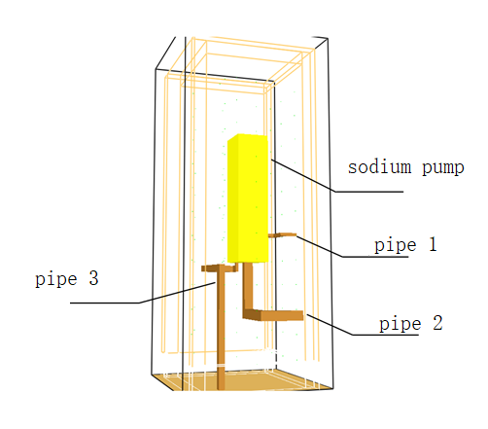

Fig. 2. Simplified diagram of CEFR secondary loop sodium pump room

### Sodium fire frequency analysis

The sodium fire in secondary loop sodium pump room is mainly caused by the leakage of sodium pump, large leakage of pipeline and small leakage of pipeline. In order to evaluate the sodium fire frequency in the room, the fault tree method is used, referring to the rupture or leakage failure data of pipeline and sodium pump in Idaho general database (see Table 1), and the sodium fire frequency in secondary loop sodium pump room is calculated as 3.22E-02/reactor year, as shown in Fig. 3.

TABLE 1. MECHANICAL COMPONENT (SODIUM WORKING FLUID) RECOMMENDED FAILURE RATES

|  |  |  |
| --- | --- | --- |
| COMPONENTS | FAILURE MODE | FAILURE RATES |
| Pips | LEAKAGE (PER FOOT) | 3.0E-09/H |
| RUPTURE (PER FOOT) | 3.0E-10/H |
| Pumps | EXTERNAL LEAKAGE | 3.0E-06/H |
| EXTERNAL RUPTURE | 5.0E-07/H |

Here, leakage means small release of sodium to area outside of pipe. Rupture means large, rapid release of sodium to area outside of pipe.



*Fig. 3. Fault tree*

### Sodium fire PSA model and risk quantification

The sodium fire-induced risk model is established, as shown in Fig. 4-6. By calculating the fire scenario frequency and the corresponding core damage condition probability, the core damage frequency caused by sodium fire in secondary loop sodium pump room can be obtained.

In the sodium fire-induced PSA model, the following conservative assumptions are considered:

* 1. Put out sodium fire in time: the secondary sodium pump room is only equipped with manual fire extinguisher, so it is not considered to put out sodium fire in time;
  2. Sodium fire consequence: once the sodium fire compartment is on fire, all component in the compartment will be damaged;
  3. Sodium fire consequence: the nuclear power plant shutdown due to sodium fire, corresponding to the internal event secondary main pipe leakage;
  4. Human factors consideration: the screening value (increased by 10 times on the basis of internal event analysis) is adopted for the failure probability of human action involved in the scenario and in the internal event model;
  5. Considering fire spread to the next room conservatively (the most serious consequences, the spread probability is assumed to be 0.1), once it spreads, conservatively considered that all component in the next room will be damaged.

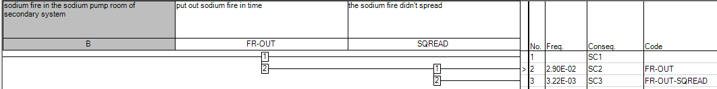

*Fig. 4. Sodium fire-induced risk model (1/2)*

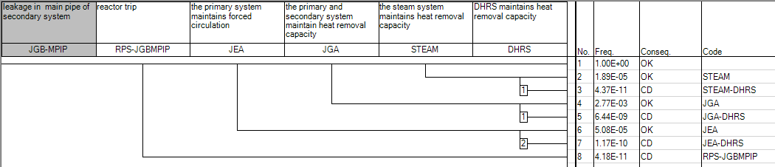

*Fig. 5.* *Sodium fire-induced risk model (2/2)*

According to figure 4, the sodium fire scenarios SC1, SC2, and SC3 are presented. According to the assumption (a), the frequency of SC1 is 0. SC2 is that the sodium fire was not put out in time, and didn’t spread, resulting in damage to all equipment in the room, that is, a secondary circuit sodium pump is damaged, which is resulting in reactor shutdown. The subsequent accident sequence is the same as the leakage of the main pipe of secondary system of the internal event. After the reactor shutdown caused by this event, the residual heat can be removed through another intact main heat transfer system or through the decay heat removal system. SC3 is that the sodium fire was not put out in time and spread to the next room, such as accident discharge tank room. But SC3 will not affect the availability of the other loop of secondary circuit. And the subsequent accident sequence is the same as SC2.

According to the calculation, the conditional failure probability of SC2 and SC3 are 6.64E-09. Therefore, the core damage frequency caused by sodium fire in secondary loop sodium pump room is 2.14E-10/ reactor year.

## Conclusion

Based on the conventional fire probabilistic safety assessment methodology in pressurized water reactor, this paper explores the sodium fire probabilistic safety assessment methodology in sodium cooled fast reactor, constructs the PSA methodology process for sodium fire, and focuses on the analysis contents and requirements of several technical elements which are quite different from the conventional fire PSA methodology, such as sodium fire source analysis, sodium fire frequency and sodium fire scenario analysis. Taking CEFR secondary loop sodium pump room as an example, the sodium fire PSA methodology is used for brief analysis, and the frequency of core damage caused by sodium fire is calculated.

Compared with the conventional fire scenario analysis tools, the sodium fire three-dimensional calculation program is still in the development stage, and the relevant experiments and data are relatively lacking. The subsequent development and improvement of sodium fire accident scenario simulation program are needed.

References

1. EPRI/NRC-RES Fire PRA Methodology for Nuclear Power Facilities: Volume 1: Summary and Overview. Electric Power Research Institute (EPRI), Palo Alto, CA, and U.S. Nuclear Regulatory Commission, Office of Nuclear Regulatory Research (RES), Rockville, MD: 2005. EPRI - 1011989 and NUREG/CR-6850.
2. Final safety analysis report of China Experimental Fast Reactor, internal report, China Institute of Atomic Energy, Beijing, 2008.
3. Steven A. Eide., Stefan V. Chmielewski., Tammy D. Swantz., Generic Component Failure Data Base for Light Water and Liquid Sodium Reactor PRAs, Abb J. February 1990 page 15-18.