Evaluation of an increase of the power
density for the French commercial Sodium
Fast Reactor and optimization study
at 1100 MWe with the SDDS tool

D GÉRARDIN
EDF R&D
Palaiseau, France
Email: delphine.gerardin@edf.fr

S. POUMEROULY
EDF R&D
Palaiseau, France

L. ANDRIOLO
EDF R&D
Palaiseau, France

Abstract

In order to enhance the competitiveness and to reduce the construction costs of the future French commercial Sodium cooled Fast Reactors (SFR), several options are explored which need further R&D studies or design assessment. Among them, the reduction of the core diameter and the increase of the power density have been investigated by the R&D department of EDF. To this end, the in-house multi-physics optimization tool SDDS has been used. The basis of the method is to predict the performances of a large number of core designs using surrogate models. The surrogate models are themselves created using the results of a parametric calculation scheme based on the codes: ERANOS for the neutronic, MAT5DYN for the thermal-hydraulic transients and GERMINAL for the thermomechanical fuel performance. Following a first SDDS study performed to define a compact core design for the 1000 MWe French commercial SFR, the paper focuses on a second SDDS study performed on a 1100 MWe power reactor in order to evaluate the impact of an increase of 10% of the nominal power. The analysis of the results shows that the main trends (e.g. large pellet, large fertile plate height, etc.) are the same as the ones observed in the previous study. However, a degradation of the safety performances is observed and impacts both the behaviour in case of Unprotected Loss of Service Station Power and in case of Unprotected Control Rod Withdrawal.

INTRODUCTION
A French commercial Sodium Fast Reactor (SFR) is under study at EDF and first requirements and functional description have been defined. In order to enhance its competitiveness and to reduce its construction costs, several options have been identified which need further R&D studies or design assessment. Among them, the possibility to reduce the size of the reactor vessel through the reduction of the core diameter [1] and the increase of the power density have been investigated by the R&D department of EDF.
A first optimization study meant to define a compact core design for the 1000 MWe French commercial SFR was performed with the in-house SDDS tool [1][2]. As a result, two optimized core designs were selected as they offered a good compromise between safety criteria and a low core diameter: a twelve Sub-Assembly (SA) rings core with a smaller core diameter (than the thirteen SA rings core) and a thirteen SA rings core with better safety margins in Unprotected Loss of Service Station Power (ULOSSP) conditions (than the twelve SA rings core).
Following this study and still with the objective to reduce SFR costs, the impact of a 10% increase of the nominal power on these 2 optimized core designs was evaluated with the calculation scheme implemented in SDDS. It leads to the degradation of the safety performances both in ULOSSP and in case of Unprotected Control Rod Withdrawal (UCWR). With the 10% increase of the nominal power, the sodium temperature in ULOSSP exceeds 1000 °C for the 12 SA rings core and the fuel melting in ULOSSP is no longer avoided for the 13 SA rings core.Therefore, a second SDDS study has been performed at 1100 MWe with the objective to find a new optimized core design and to determine whether:
- The trends of the previous study (e.g. best designs have large pin, large fertile plate, etc.) are still the same at 1100 MWe.
- It is possible to find a better compromise between safety performances and core diameter at 1100 MWe than the previously selected cores: notably a 12 SA rings core with a lower sodium temperature in ULOSSP and a 13 SA rings core with a positive margin to melting in UCWR.
This study is the focus of the current paper. First, the SDDS method and its application is described in section 2. In section 3, the results of the SDDS study at 1100 MWe are analysed and compared to the previous study at 1000 MWe. Finally, some complementary studies were performed to investigate further improvement routes; their results are summarized in section 4.

SDDS Method

General overview of the method
SDDS is a method meant to help SFR core designing and optimisation developed at EDF-R&D for more than 10 years [2][3]. It provides designers with an overall view of cores performances on a parametric space. The main steps of the method are presented in FIG. 1 and are detailed hereafter.

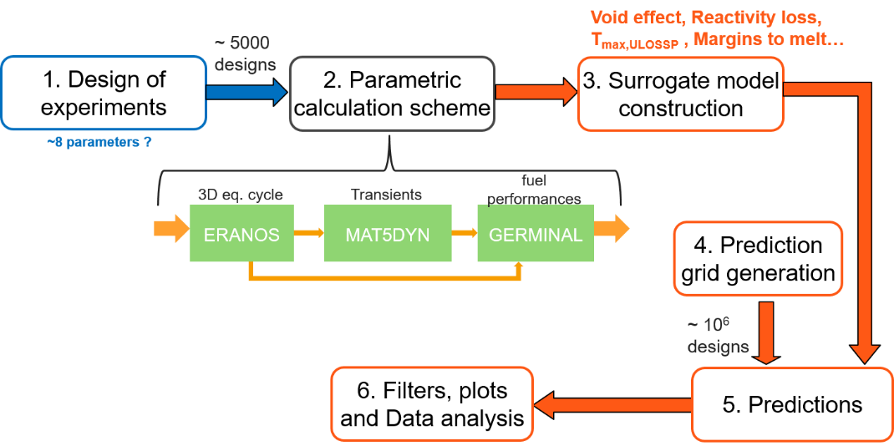
FIG. 1. Main steps of the SDDS method

Step 1: a design of experiments (which consists of a few thousand core designs) is generated in the studied space (defined by the variation of some geometric parameters such as the pin radius, the fissile fuel height, etc.).
Step 2: the performances of each core of the design of experiments are evaluated thanks to a parametric calculation scheme including the codes: ERANOS [4] for the neutronics, MAT5DYN [5] for the accidental transients calculation and GERMINAL [6] for the pin thermo-mechanics. ERANOS is used to perform 2D and 3D neutronics calculation. In particular, it is used to adjust the plutonium content in the inner and outer cores, to simulate fuel depletion until equilibrium and to study the equilibrium cycle. The modelling takes into account the control rods insertion and the core loading scheme. ERANOS is used to determine performances such as the reactivity feedback effects, the reactivity loss during one cycle or the breeding ratio. It also transfers data to GERMINAL regarding the accidental scenario of Unprotected Control Rod Withdrawal (UCWR). GERMINAL computes the thermo-mechanical behaviour of the fuel pin in nominal and accidental states. It is used to determine margin to fuel melting in nominal condition or in the accidental case of UCWR. MAT5DYN uses a multi-channel description, a simplified pin thermal evaluation, and a point kinetics neutronics model to simulate several transients such as Unprotected Loss of Service Station Power (ULOSSP). It allows to determine the sodium temperature at core outlet during those transients. It is worth mentioning that MAT5DYN is based on a single-phase description of the coolant and an extrapolation of the coolant temperature after reaching the boiling temperature. This approximation is considered acceptable here as we only perform comparative analysis.
Step 3: A few performances of interest are selected among those evaluated in step 2 (e.g. the sodium temperature in ULOSSP, the fuel margin to melting in UCWR, etc.). For each of them, a surrogate model is computed using the kriging interpolation method [7]. The results of step 2 are used as a reference data basis for the surrogate models computation.
Step 4: a prediction grid (which consists of a few million points) is generated as a fine mesh over the studied space.
Step 5: for each design of the prediction grid, the selected performances are predicted with the surrogate models. This produces a database with the characteristics and performances of all the core designs in the prediction grid.
Step 6: the results of the prediction are analysed. They can be used to determine general trends over the entire design distribution or to perform an optimisation in order to select a specific core. The application of this method to our study is described in the next section.

Application of the method to the optimisation study at 1100 MWe
The fixed parameters of the study and the loading scheme are the same as for the study at 1000 MWe (see [1]). Only the nominal power has been increased from 1000 to 1100 MWe (i.e. 10% increase). The variable parameters are given with their variation range in TABLE 1. They are illustrated in FIG. 2. The variable parameters and their variation range define the design of experiments of the study (see FIG. 1).

TABLE 1. VARIABLE PARAMETERS OF THE STUDY AND ASSOCIATED VARIATION RANGES
Parameter | Range
Inner clad radius (cm) | [0.35 ; 0.5]
Pellet/cladding gap (cm) | [0 ; 0.011]
Outer core height (cm) | [90 ; 110]
Outer/inner core height gap (cm) | [0 ; 20]
Fertile plate position (% of inner core height) | [0 ; 50]
Fertile plate thickness (cm) | [0 ; 20]
Number of pins per sub-assembly | {217 ; 271}
Number of fuel sub-assembly rings | {12 ; 13}

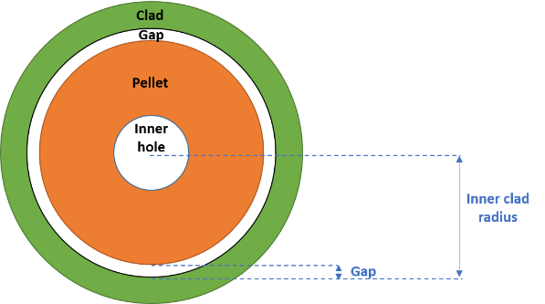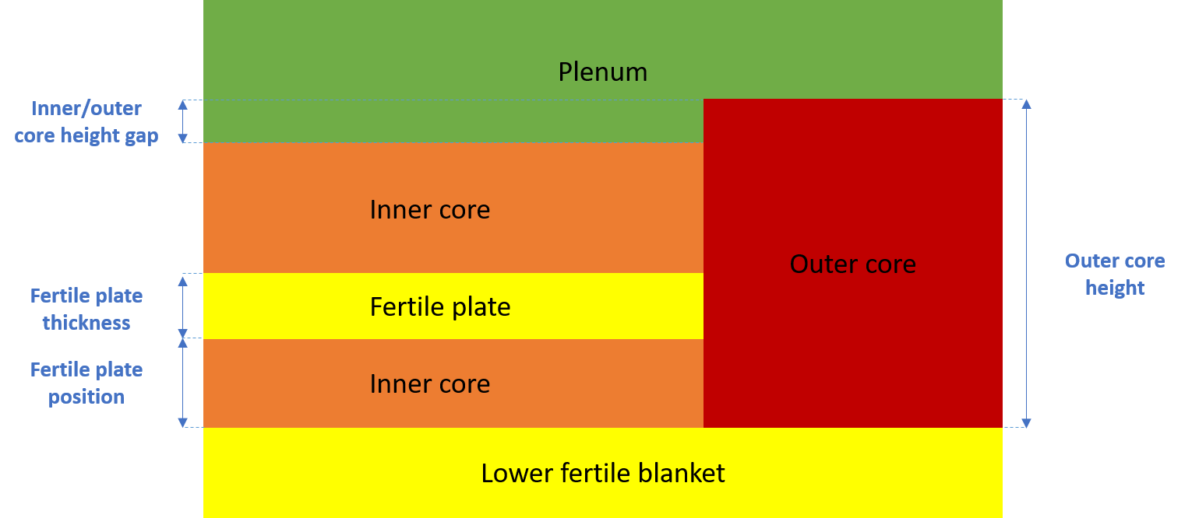
FIG. 2. Radial pin structure (left) and axial core structure (right) of the studied designs

The cores of the design of experiments have been computed with the parametric calculation scheme (see FIG. 1) in order to evaluate their performances. Two additional constraints have been taken into account before the creation of the surrogate models and are listed in TABLE 2. Firstly, only the cores with a power density in the range [250; 375] W/cm³ have been selected to fulfil the specifications of the commercial SFR (i.e. a core with a high power density). Secondly, the non-viable designs (i.e. a margin to fuel melting condition below zero in nominal conditions) have been discarded. Then, surrogate models have been created on the basis of the remaining designs for the performances listed in TABLE 3. The standard deviation (σ) of the prediction error distribution is given for each performance. Those values should be kept in mind when analysing the results in the next section.

TABLE 2 : CRITERIA APPLIED FOR THE CREATION AND THE PREDICTION OF THE SURROGATE MODELS
Performance | Accepted values
Power density (W/cm³) | [250; 375]
Margin to fuel melting in nominal conditions (°C) | >0

TABLE 3. STANDARD DEVIATION FOR THE PERFORMANCES EVALUATED WITH THE METAMODELS
Parameter | 12 | 13
Margin to melt in nominal conditions [°C] | 27 | 36
Margin to fuel melting in UCRW conditions [W/cm] | 7 | 10
Asymptotic sodium temperature in ULOSSP situation [°C] | 3.5 | 4
Doppler constant [pcm] | 3 | 4
Total sodium void effect [pcm] | 2.5 | 3
Reactivity loss during one cycle [pcm] | 19 | 21
Breeding ratio [%] | 0.08 | 0.18

Among the performances evaluated in this study and listed in TABLE 3, the margin to fuel melting during UCRW and the sodium temperature in ULOSSP have been specifically analysed. The margin to fuel melting in UCRW is computed with GERMINAL. One UCRW computation is performed for each rod individually. The performance given in this paper corresponds to the margin to fuel melting for the more constraining case. The margin to fuel melting in UCRW should be positive and as high as possible to enhance the safety. The asymptotic sodium temperature in ULOSSP is evaluated with MAT5DYN. It corresponds to the maximal core outlet temperature achieved at the end of the simulated ULOSSP transient. The ULOSSP accident consists in an unprotected loss of the primary flow and the secondary flow. The loss of the primary flow is simulated by a hyperbolic decrease where 50% of the nominal flow is reached after 25 seconds of transient and the residual flow at the end of the transient is fixed at 12% of the nominal flow. The sodium temperature in ULOSSP should be below sodium boiling point and as low as possible to enhance the safety.

Results of the sdds study at 1100 MWe

Prediction of the surrogate models
The filters applied on the prediction of the surrogate models are recalled in TABLE 2. The results are given hereafter (from FIG. 3. to FIG. 7.) in the space (Margin to fuel melting during UCRW, sodium temperature in ULOSSP). The best designs from the safety point of view are the ones that minimise the sodium temperature in ULOSSP and maximise the margin to fuel melting in UCRW. They are located on the Pareto front, which corresponds in this space to the bottom-right front of the design distribution. The colour of each point is indexed on the mean value of the studied geometric parameter. Some differences should be noted when comparing the results with the ones of the 1000 MWe study in [1]: a filter on the power density (to select the range [250; 375] W/cm³) is applied on the graphs and the graphs for the 12 SA rings cores are separated from the ones for the 13 SA rings cores.
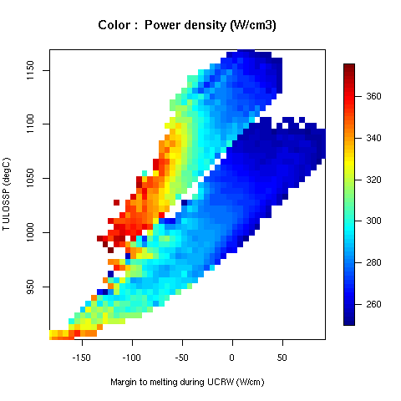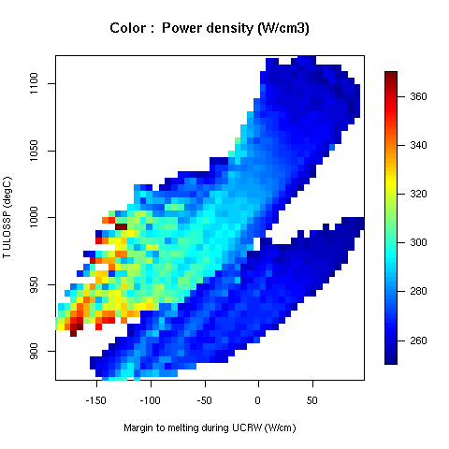
FIG. 3. Power density for the cores with 12 assembly rings (on the left) and with 13 assembly rings (on the right) in the space (Margin to fuel melting during UCRW, sodium temperature in ULOSSP)
The power density of the predicted designs is given in FIG. 3. As it could be expected, the designs on the Pareto front have mainly a low power density, which is close to the limit of 250 W/cm³ for the cores with a positive margin to melt in UCRW. It can be noted that the filter on the power density suppresses a large number of designs that would have been on the Pareto front (it leads to a shift of the Pareto front).
The number of pins per assembly of the predicted designs is given in FIG. 4. Two distinct distributions can be seen for the designs with 217 and with 271 pins per assembly. The designs on the Pareto front have a higher number of pins per assembly (i.e. 271 in our case). This can be explained by the flattening of the core geometry (decrease of the ratio height over diameter) and the decrease of the power density when the number of pin increases.

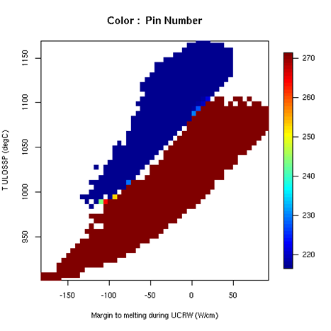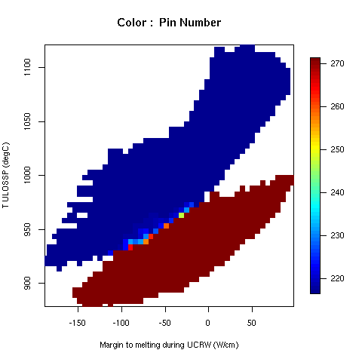
FIG. 4. Pin number for the cores with 12 assembly rings (on the left) and with 13 assembly rings (on the right) in the space (Margin to fuel melting during UCRW, sodium temperature in ULOSSP)

The outer fuel pin radius of the predicted designs is given in FIG. 5. The designs on the Pareto front have a small outer fuel pin radius (between 0.4 and 0.42 cm). This result is due to the application of the filter cutting the designs with a low power density; without this filter designs with a large outer fuel pin radius and a low power density would appear on the Pareto Front.

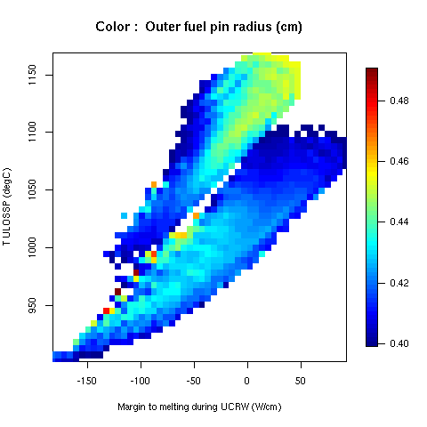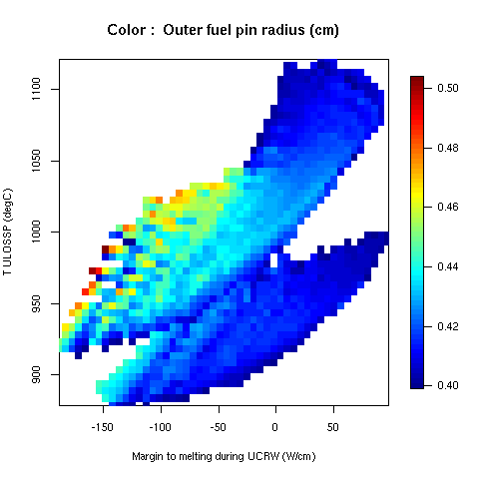
FIG. 5. Outer fuel pin radius for the cores with 12 assembly rings (on the left) and with 13 assembly rings (on the right) in the space (Margin to fuel melting during UCRW, sodium temperature in ULOSSP)
The outer core height of the predicted designs is given in FIG. 6. The gradient is collinear to the Pareto front. The designs have either a low outer core height to enhance the behaviour in ULOSSP or a large outer core height to enhance the behaviour in UCRW.

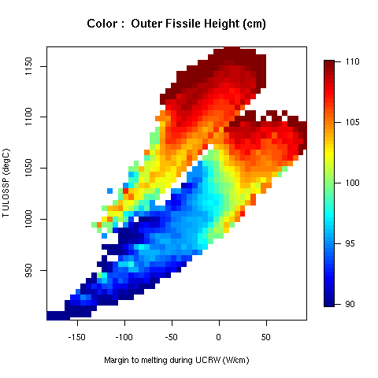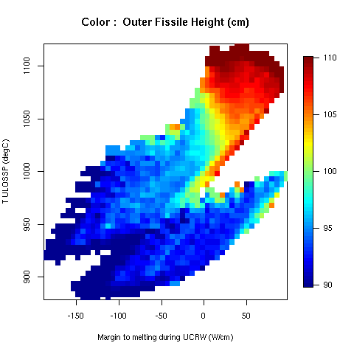
FIG. 6. Outer fissile height for the cores with 12 assembly rings (on the left) and with 13 assembly rings (on the right) in the space (Margin to fuel melting during UCRW, sodium temperature in ULOSSP)

The outer/inner core height gap of the predicted designs is given in FIG. 7. The results are complementary with the ones on the outer core height. Generally, large outer/inner core height gap favour the behaviour in ULOSSP but degrade the behaviour in RIB. The designs on the Pareto front have a small outer/inner core height gap (between 0 and 5 cm) except for the 13 SA rings cores with 271 pins per assembly.

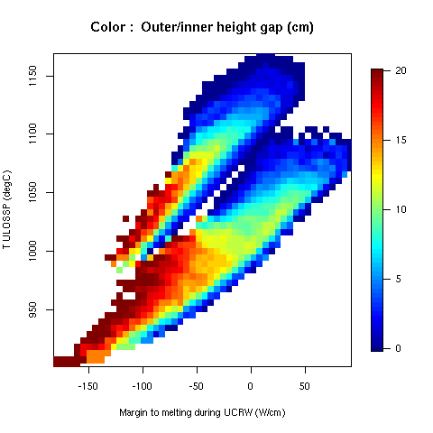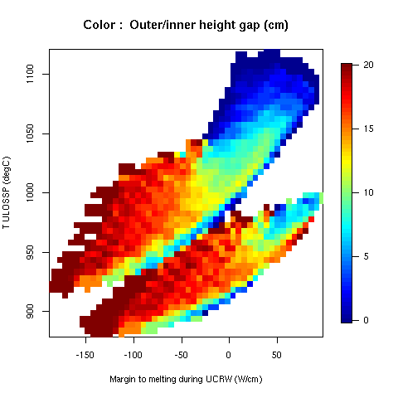
FIG. 7. Outer/inner height gap for the cores with 12 assembly rings (on the left) and with 13 assembly rings (on the right) in the space (Margin to fuel melting during UCRW, sodium temperature in ULOSSP)

The analysis of the prediction of the surrogate models shows that the core designs with the best compromise between a low sodium temperature in ULOSSP and a high margin to melt in UCRW conditions have the following characteristics:
- A high fuel pin number per assembly (271);
- Thin pins of about 8 mm diameter (due to the filtering of the low power density cores) with pellet/cladding gaps around 0.07-0.1 mm for the 12 assembly ring cores and around 0.04-0.06 mm for the 13 assembly ring cores;
- A small relative height between inner and outer core (0-5 cm) with either a short outer core to improve ULOSSP or a large outer core to improve behaviour in UCRW conditions;
- A relatively large fertile plate (15-20 cm) with either a fertile plate at the bottom of the core to improve ULOSSP or at the centre of the core to improve behaviour in UCRW conditions.
These trends are similar to the ones observed at 1000MWe [1]. The differences (mainly the appearance of thin pins instead of large pins on the Pareto front) comes from the application of the filter on the power density. However, the increase of the power from 1000 to 1100 MWe leads to a degradation of the safety performances both in ULOSSP and in UCWR. For the designs with 12 SA rings at 1100 MWe, the sodium temperature in ULOSSP lies in [901; 1170] °C and the margin to fuel melting in case of UCRW is in the range [-189; 98] W/cm. Thus, none of the 12 SA ring design allows to guarantee the absence of boiling (883°C at 1bar) in ULOSSP (in the considered space). For the designs with 13 SA rings at 1100 MWe, the sodium temperature in ULOSSP lies in [878; 1122] °C and the margin to fuel melting in case of UCRW is in the range [-189; 98] W/cm. Even if some of the 13 SA rings designs avoid sodium boiling in ULOSSP, none of them allows to avoid both boiling in ULOSSP and melting in UCRW (in the considered space). On the contrary, these objectives were achievable by the 13 SA rings designs at 1000 MWe [1].

Selection of optimized cores

Criteria and optimization objectives
For the selection of optimized cores at 1100 MWe, three additional safety criteria have been taken into account. First, the margin to fuel melting should be above 300 °C in nominal conditions: this is a standard criteria in SFR core conception that guarantees a melting probability below 10⁻⁴. Then, only the designs with a margin to fuel melting in UCRW higher than 20 W/cm have been kept: this margin has been used to take into account uncertainties of the meta-models and guarantees the absence of fuel melting. Finally, a criterion has been used to keep only the designs with an asymptotic sodium temperature in ULOSSP below 1050°C: this filter has been used to reduce the studied space but is not based on a physical phenomenon. In theory, the sodium temperature in ULOSSP should be below the sodium boiling point. However, this criterion was not usable for this study as no design in the considered space is able to avoid both fuel melting in UCRW and sodium boiling in ULOSSP. We recall that all the transients studied up to now are unprotected and that no passive safety rods are considered. Thus, designs with an asymptotic sodium temperature in ULOSSP in the range [883; 1050]°C have been considered acceptable under the hypothesis that protective systems such as passive safety rods (e.g. Curie Points Electro-Magnets rods or hydraulically suspended rods) will be added in the design. Then, the optimisation has been performed considering two objectives. The first one is safety related: it is to minimise the sodium temperature during ULOSSP. The second one is cost-related: it is to minimise the diameter of the core. The criteria and objectives are summarized in TABLE 4.

TABLE 4: CRITERIA AND OBJECTIVES OF OPTIMIZATION FOR THE SELECTION OF OPTIMIZED CORES
Performance | Accepted values | Objective
Power density (W/cm³) | [250; 375]
Margin to fuel melting in nominal conditions (°C) | >300
Margin to fuel melting in UCRW (W/cm) | >20
Asymptotic sodium temperature in ULOSSP (°C) | <1050 | To be minimized
Core diameter (cm) |  | To be minimized

The cores selected are those offering the best compromise between the two objectives. They correspond to the designs on the Pareto front in the space (Fissile core radius, Sodium temperature in ULOSSP) and are highlighted in green in the FIG. 8.

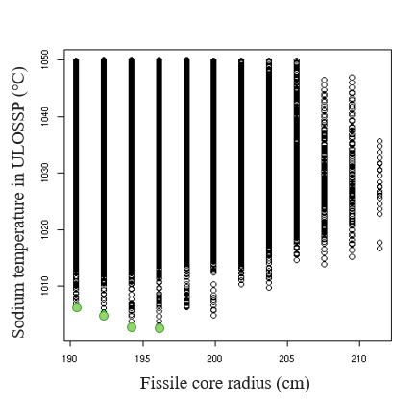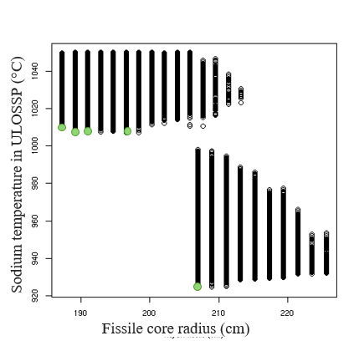
FIG. 8. Distribution of the cores with 12 assembly rings (on the left) and with 13 assembly rings (on the right) in the space (Fissile core radius, Sodium temperature in ULOSSP); the seletced cores are plotted in green.

Selection of an optimised 12 SA rings cores at 1100 MWe
The 12 SA ring core selected in [1] at 1000 MWe has been re-evaluated at 1100 MWe with the parametric computation scheme implemented in SDDS and composed of ERANOS, MAT5DYN and GERMINAL (see step 2 in section 2). The results are given in TABLE 5 in column “12-Ref”. As already mentioned, the sodium temperature in ULOSSP is closely above 1000 °C. The columns 12-C1 to 12-C4 give the characteristics and performances of the cores selected following the SDDS study at 1100 MWe outlined in this paper (highlighted in green in FIG. 8 left). These new designs have geometric characteristics and performances close to the core 12-Ref. In that respect, it has not been considered relevant to select a new design for the 12 SA rings configuration for operating at 1100 MWe.

TABLE 5. MAIN CHARACTERISTICS AND PERFORMANCES OF THE 12 SA RINGS SELECTED CORES
Parameter | 12-Ref | 12-C1 | 12-C2 | 12-C3 | 12-C4
Outer pellet radius [cm] | 0.3425 | 0.342 | 0.346 | 0.3515 | 0.3555
Inner clad radius [cm] | 0.35 | 0.35 | 0.355 | 0.36 | 0.365
Outer core height [cm] | 106 | 110 | 110 | 105 | 105
Outer/inner core height gap [cm] | 0 | 5 | 5 | 0 | 0
Inner fertile zone position (% of inner core height) | 35 | 30 | 30 | 30 | 30
Inner fertile zone height [cm] | 20 | 20 | 20 | 20 | 20
Number of pins per SA | 271 | 271 | 271 | 271 | 271
Fissile core radius [cm] | 187 | 187 | 189 | 190 | 192
Power density [W/cm3] | 314 | 310 | 304 | 304 | 298
Margin to fuel melting in nominal conditions [°C] | 433 | 418 | 434 | 392 | 408
Margin to fuel melting in UCWR [W/cm] | 29 | 20 | 21 | 20 | 20
Asymptotic temperature in ULOSSP [°C] | 1007 | 1006 | 1005 | 1003 | 1002

Selection of an optimised 13 SA rings cores at 1100 MWe
The results of the 13 SA ring core selected in [1] at 1000 MWe and re-evaluated at 1100 MWe with the parametric computation scheme are given in TABLE 6 in column “13-Ref”. As already mentioned, the core appears to have a negative margin to fuel melting in case of UCWR.
The column “13-C5” gives the characteristics and performances of the core selected following the new SDDS study at 1100 MWe (lowest green point in FIG. 8 right). The selected core possesses 271 fuel pins per assembly and the same core radius as the core 13-Ref. However, it has a positive margin to fuel melting in UCWR and only a slight degradation of its sodium temperature in ULOSSP. It better fits the safety criteria than the core selected in the SDDS study at 1000 MWe when operated at 1100 MWe.

TABLE 6. MAIN CHARACTERISTICS AND PERFORMANCES OF THE 13 SA RINGS SELECTED CORES
Parameter | 13-Ref | 13-C5
Outer pellet radius [cm] | 0.346 | 0.3455
Inner clad radius [cm] | 0.35 | 0.35
Outer core height [cm] | 94 | 92
Outer/inner core height gap [cm] | 5 | 0
Inner fertile zone position (% of inner core height) | 5 | 18
Inner fertile zone height [cm] | 20 | 15
Number of pins per SA | 271 | 271
Fissile core radius [cm] | 203 | 203
Power density [W/cm3] | 304 | 302
Margin to fuel melting in nominal conditions [°C] | 356 | 431
Margin to fuel melting in UCWR [W/cm] | -3 | 29
Asymptotic temperature in ULOSSP [°C] | 915 | 922

Complementary studies
Following the SDDS study at 1100 MWe, possible evolutions of some of the parameters and criteria have been identified. Some of them have been investigated in a recent complementary study.
Since cores with a higher pin number per assembly have better safety performances, the number of pins per assembly has been increased up to 331 (instead of 271). This shift leads indeed to a significant improvement of the cores behaviour in both ULOSSP and UCWR. However:
- The designs with 13 SA rings and 331 pins have a too large core diameter (or a too low power density). Thus, they do not meet the scope of the compact commercial SFR design.
- The designs with 12 SA rings and 331 pins have globally better safety performances than the designs with 12 SA rings and 271 pins but worse safety performances than the designs with 13 SA rings and 271 pins for equivalent core radius.
The variation range of the pellet –cladding gap has been shifted from [0; 0.11] mm to [0.05; 0.12] mainly for pin manufacturability reasons. This shift does not change the observed trends but some designs with a minimum gap (i.e. 0.05 mm) appear on the Pareto Front for the 13 SA rings cores.
The target burnup has been increased from 100 GWd/t to 110 GWd/t to take advantage of the use of ODS cladding (instead of AIM1) that should allow to achieve higher burnups. This does not change the observed trends but the campaigns duration is increased (of about a hundred days) and the safety performances slightly deteriorate.
Additional technical-economic criteria have been taken into account on the campaign length (to select only the designs with a campaign length above 1500 EFPD) and on the damages to the fuel cladding (to select only the designs with damages to the cladding below 150 dpa). With those criteria, an increased number of designs are eliminated, some of them being on the Pareto front and with a low sodium temperature in ULOSSP. Thus, the space of the available designs is even more restricted.

Conclusions and perspectives
Following the SDDS study at 1000 MWe meant to select a SFR design with a low core diameter, a new SDDS study has been performed, still with the objective of reducing SFR costs, considering a 10% increase of the nominal power. The general trends observed in this new study at 1100 MWe are similar to the ones of the study at 1000 MWe. In particular, the cores offering the best compromise between a reduced temperature of the sodium in ULOSSP and an increased margin to fuel melting in UCWR (thus located on the Pareto Front in this space) have similar geometrical characteristics in both studies.
However, a degradation of the safety performances is observed and impacts the behaviour in ULOSSP and in UCWR. Indeed, none of the designs allows both non-boiling in ULOSSP and non-melting in UCRW (in the considered space and with a filter on the power density above 250W/cm³). Nevertheless, a new 13 SA ring core design has been selected with a core diameter slightly above 4 m, that meets the non-melting criteria in UCRW. However, this compact design has a sodium temperature in ULOSSP would lead to sodium boiling under an ULOSSP transient. As a further study, it is foreseen to evaluate the behaviour of the selected core with best estimate codes to quantify the bias in the results due to the use of simplified models or codes (such as MAT5DYN for the accidental transients).
All the transients studied up to now are unprotected ones and do not include passive safety rods. If the route of a 1100 MWe commercial SFR core is favoured in the future, additional studies will be needed to assess the core safety behaviour of selected core when taking into account the protective systems. This work should be performed with a more precise modelling that the one based on MAT5DYN used in SDDS; for instance the CATHARE code [8] could be used. In addition, the investigation of the natural behaviour of the commercial SFR under severe accident conditions could be studied with the SIMMER code [9] in the future.
To conclude, some of the geometrical characteristics that enhance the ULOSSP behaviour tend to degrade the UCWR behaviour. In addition, the economic objectives of the commercial SFR (in particular the reduction of the core diameter) are mostly opposed to the safety objectives. And finally, the addition of safety criteria or technical-economic criteria reduces furthermore the studied space. These opposite constraints makes the optimisation of the commercial SFR quite complex. The strength of the developed method is that it enables to select different designs depending on the compromise one wants to make on the different objectives.
ACKNOWLEDGEMENTS
The authors wish to thank EDF-DIPNN, CEA and Framatome for the discussions on the range of the variable parameters and on the safety and technical-economic criteria for SFR core selection.
References
- POUMEROULY, S., GIRARDI, E., MERIOT, C., “Proposal of a compact core design for the 1000 MWe French commercial Sodium Fast Reactor by means of the SDDS multi-objective optimization tool”, Paper 360, Proceedings of FR21, Beijing, China (2022), under acceptance.
- BARJOT, F., SCHMITT, D., VENARD, C., “Multi-physics and multi-objective optimization methodology for sodium-cooled fast reactor conception”, Proceedings of ICAPP 2014, Charlotte, USA (2014).
- RINEISKI, A., et al. "Core safety measures in ESFR-SMART", Proceedings of PHYSOR 2018 conference, Cancun, Mexico (2018).
- RIMPAULT G. et al., “The ERANOS code and data system for fast reactor neutronic analyses”, Proceedings of PHYSOR 2002, Seoul, Korea (2002).
- MASSARA, S. et al., Dynamics of critical dedicated cores for Minor Actinide Transmutation, Nuclear Technology, Vol. 149, pp. 150-174, 2005.
- ROCHE, L., PELLETIER, M., “Modelling of the thermomechanical and physical processes in FR fuel pins using the GERMINAL code”, Proceedings of Symposium on MOX fuel technologies for medium and long term deployment, Vienna, Austria (2000).
- MARREL, A., et al., An efficient methodology for modelling complex computer codes with Gaussian processes, Computational Statistics and Data Analysis, 52 10 (2008) 4731-4744.
- EMONOT, Ph, SOUYRI, A., GANDRILLE, J. L., et al. CATHARE-3: A new system code for thermal-hydraulics in the context of the NEPTUNE project, Nuclear Engineering and Design, 241 11 (2011) 4476-4481.
- MASCHEK, W., RINEISKI, A., FLAD, M., et al., “The SIMMER safety code system and its validation efforts for fast reactor application”, Proceedings of International Conference on the Physics of Reactors 2008 (PHYSOR 08), Interlaken, Switzerland (2008).

