NEW FINITE ELEMENT NEUTRON KINETICS CODE SYSTEM FENNECS/ATHLET FOR COUPLED SAFETY ASSESSMENT OF (VERY) SMALL AND MICRO REACTORS

J. BOUSQUET
Gesellschaft für Anlagen- und Reaktorsicherheit (GRS) gGmbH
Forschungszentrum, Boltzmannstr. 14, D-85748 Garching, Germany
Email: jeremy.bousquet@grs.de

R. HENRY, A. SEUBERT
Gesellschaft für Anlagen- und Reaktorsicherheit (GRS) gGmbH
Forschungszentrum, Boltzmannstr. 14, D-85748 Garching, Germany

Abstract

To perform future coupled transient safety assessments of irregular geometry reactor kind and other innovative concepts, the Finite ElemeNt NEutroniCS (FENNECS) code is being developed at GRS. It solves the time-dependent and steady-state three-dimensional few-energy group diffusion equation in the Galerkin finite element representation using upright triangular prisms with linear basis functions as spatial elements. For the meshing of the irregular geometries, an external meshing tool PEMTY is being developed as a Python software module which generates the data required by FENNECS. In the paper, the Heat Pipe Micro Reactor (HPMR) core, whose specifications are to be found in a publicly available document, was modelled with the Monte Carlo code Serpent for two core configurations All Rods Out (ARO) and All Rods In (ARI). The multiplication factors obtained are in good agreements with the results provided in the benchmark. The validated Monte Carlo model is then used as reference for code-to-code comparison in the study. Homogenized macroscopic cross sections required for FENNECS are generated with the full core Serpent models in both core configurations. A model of the HPMR full core is also developed in FENNECS. Two cross section sets are obtained with the ARO and ARI core configurations Serpent simulations. FENNECS uses each cross section set to calculate multiplication factors, radial power distributions and axial peaking factors in both core configurations. The cross section set generated with the full core in ARI configuration with Serpent is a good compromise to obtain good agreements on the multiplication factors and the radial power distribution with the results obtained with Serpent. Although the HPMR studied here is the first test case, the obtained results support confidence that FENNECS can in future be applied to model very small modular reactors.

INTRODUCTION
Interest in (very) small and medium size reactor – (v)SMR – concepts for specific purposes has grown in the past few years for specific purposes like energy delivery at remote locations (replacement of diesel generator) or for space application. They generally represent designs of less than 10 MW(e) and are typically not Light Water Reactor (LWR)-based technologies. Deviating from regular assembly lattices as known from, e.g., LWRs, their geometries are often irregular. Though Monte Carlo methods are becoming more and more standard for steady state simulations, they are not yet mature enough for transient applications and not practicable due to their computational demands. To perform future coupled transient safety assessments of this kind of reactors and other innovative concepts, the Finite ElemeNt NEutroniCS (FENNECS) [1], [2] code is being developed at GRS. The paper considers the Heat Pipe Micro Reactor (HPMR) core proposed in a publicly available document [3].

FENNECS code

Solution method
FENNECS solves the time-dependent and steady-state three-dimensional few-energy group diffusion equation in the Galerkin finite element representation using upright triangular prisms with linear basis functions as spatial elements. The implementation of the finite element solution of the diffusion equation largely follows standard approaches as given by, e.g., [4]. Both direct and adjoint neutron flux distributions can be evaluated. Wielandt iteration is applied for convergence acceleration of the eigenvalue problem. The time integration of both transport and delayed neutron precursor equations is carried out implicitly which provides unconditional numerical stability. FENNECS is also coupled [2] with the GRS thermal-hydraulic system code ATHLET [5] for thermal-hydraulics feedback. FENNECS uses macroscopic cross section libraries in NEMTAB-like format [6] which may be parameterized with respect to up to six thermal-hydraulic feedback parameters with linear cross section interpolation. FENNECS has been first applied to the prismatic (or block type) high-temperature reactor MHTGR-350MW within an OECD/NEA benchmark activity [7] and the sodium cooled fast reactor concept ASTRID [8] within the EU project ESNII+.

Spatial meshing
For spatial meshing, FENNECS includes an internal meshing module for regular Cartesian and hexagonal lattices only. It also has an interface to read lists of nodes and elements connectivities from external ASCII files. For the meshing of the irregular geometries such as (v)SMRs, an external meshing tool is being developed as a Python software package: PEMTY (Python External Meshing Tool with Yaml input). PEMTY generates the mesh data required by FENNECS from an input written in a Yaml format. PEMTY performs the 3-d meshing in two steps: the first step is to perform the radial meshing (2-d). The second step is the axial meshing by repeating the radial meshing for each layer to constitute the 3-d meshing. Concerning the radial meshing, rectangles can be divided either into 4 or 16 triangles and regular hexagons can be divided either into 6 or 24 equilateral triangles.
The challenge of meshing the HMPR core lies in properly meshing the control drums, which surround a regular hexagonal lattice of fuel elements, as well as the circle shape of the reactor vessel:
- In [9], the implementation in PEMTY of the meshing of a circle embedded in a hexagonal lattice has been performed. The circular shape is approximated by regular polygons. Two polygon types are tested in [9]: a 12-edges polygon and a 24-edges polygon which are centred into a 7-hexagon lattice. Moreover, the radius of the polygon is adjusted so that the polygon area is equal to the circle area to preserve the mass of the absorber material. The approximation with the 24-edges polygon has shown better results and is chosen in the study.
- The reactor vessel can be interpreted in radial direction as an annulus (surface included between two circles). In the study, the annulus representing the reactor vessel is composed of two circles which are approximated by two 252-edges polygons with adjusted radius to preserve the area of the circles. The annulus is composed of 1208 triangles: each edge of the annulus is forming a quadrilateral which is divided into four triangles.

Heat Pipe Micro Reactor specifications
The paper considers the HPMR core proposed in the publicly available document [3]. The specifications provide a detailed description of all geometries. The core layout is composed of 192 hexagonal fuel elements surrounded by six control rod drums (see Fig. 1).
All fuel elements are identical: each one has a pitch of 5.4 cm and has a central cylindrical heat pipe with a diameter of 3 cm surrounded by the fuel contained within a hexagonal stainless steel (SS-316) can. Axially, each fuel element consists of two 15 cm axial reflector zones, composed of beryllium oxide (BeO), directly placed above and below the 100 cm fuel zone. The core laid on a support plate of 5 cm height composed of stainless steel (SS-316). The fuel is of metallic type consisting of 18.1% enriched uranium with a 10% weight fraction of zirconium (U-10Zr), assuming a porosity of 10% to allow for the swelling due to fission gas release.
To control the reactivity, six control drums are provided at the corners of the hexagonal shaped core. The control drums are cylinders of 10.8 cm diameter. They are composed of reflector material (aluminium oxide ceramic - Al₂O₃) and absorber material placed in 150° annular sectors of 2 cm thickness at the edge of the control drums. The absorber material is boron carbide (B₄C) with 90% enriched ¹⁰B.
The central position of the core is a safety control rod which fits within a single fuel element hexagonal can. Its diameter is 4.65 cm. It is composed of B₄C with 90% enriched ¹⁰B.
The radial reflector is composed of Al₂O₃. The cooling fluid is potassium (K). The total thermal power is 5 MW(th).

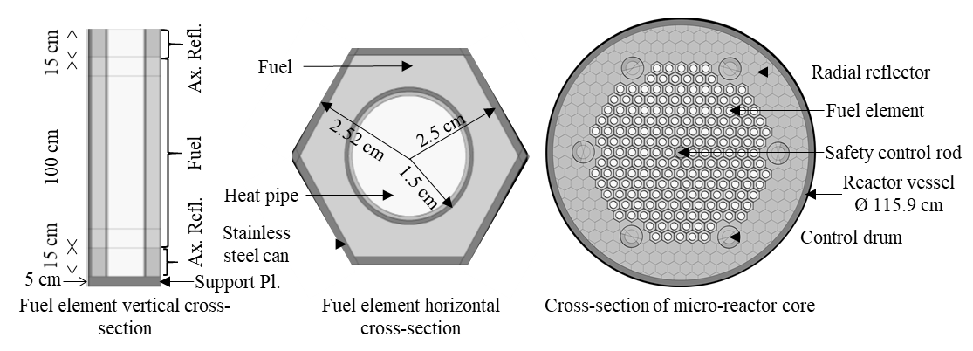
FIG. 1 HMPR core description. From left to right: fuel element vertical cross-section, fuel element horizontal cross-section, cross-section of the micro-reactor core.

Serpent Monte carlo model and results
4.1 HPMR full core model in Serpent

The purpose of the Serpent Monte Carlo model [10] is twofold. First, it serves as a reference model to compare with the FENNECS simulation results presented in Section 5. Second, it is used to generate few-group macroscopic cross section data for different material zones (e.g. fuel cells, control drums, etc.) which will be used for the deterministic calculations with FENNECS in Section 5. While the specifications provide a detailed description of all geometries, which allow explicit modelling of the structures, no mass density of any material is given. Thus, they must be gathered from open literature and are summarized in Table 1 with the potassium density derived from the mass of potassium per heat pipe [11]. Monte Carlo Serpent models are developed for two configurations:

- All Rods Out (ARO) configuration: This configuration is the most reactive state of the core where the absorber faces of all control drums are turned out of the core (see FIG. 2 on the left). This control drum position results in minimizing the absorption while maximizing the reflection.
- All Rods In (ARI) configuration: This configuration is the less reactive state of the core where the absorber faces of all control drums are turned towards the core (see FIG. 2 on the right). This control drum position results in maximizing the absorption while minimizing the reflection.

In both configurations, the central safety control rod is fully withdrawn from the core and is – in this work – modelled as a hexagonal can filled with coolant (no absorber material) instead of being an empty (voided) space. To reduce the statistical uncertainties for the multiplication factor below 1 pcm, each Serpent calculation is performed with 10,000 cycles (and 100 inactive cycles) of 1,000,000 source neutrons per cycle. All calculations are performed using the JEFF-3.1.1 continuous energy library.

TABLE 1. Density of THE materialS taken for THE Serpent simulations

Material | Density (g/cm³)
U-10Zr | 13.9032
BeO | 3.01
SS-316 | 7.970
Al₂O3 | 3.83
B₄C | 2.52

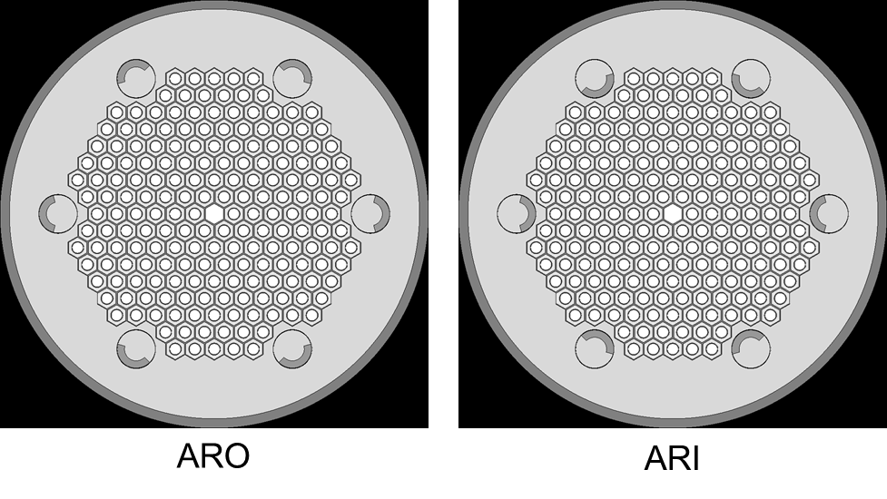
FIG. 2 HPMR core models in Serpent (radial views). Left: All Rods Out (ARO) core configuration. Right: All Rods In (ARI) core configuration.
4.2 HPMR few-group cross sections generation with Serpent

The homogenised macroscopic cross section libraries required for FENNECS have been generated using the 12-energy group structure shown in Table 2. It is based on the 8-energy group structure suggested in [12] which has been extended by additional group subdivisions. This 12-energy group structure has already been successfully applied in several SFR analyses (see [13] and [14]).
For each configuration, a set of cross sections is generated and named as XS_ARO and XS_ARI obtained in ARO and ARI configurations, respectively. Sixteen homogenized macroscopic cross section sets are generated (see Fig. 3):
- Cross sections of fuel assemblies are homogenised over all the assemblies of their core ring (there are eight fuel assemblies’ rings) i.e. eight different homogenized macroscopic cross section sets.
- One cross section set for both top and bottom radial reflector.
- Two homogenised cross section sets for the radial reflector: a first cross section set of the radial reflector is homogenised over the first hexagonal raw of the radial reflector (radial reflector 1 in Fig. 3) and the second cross section set is homogenised over the rest of the radial reflector part (radial reflector 2 in Fig. 3).
- One cross section set for the reactor vessel.
- One cross section set for the safety control rod (located in the centre of the core).
- The control rod drums are divided into two sectors: a cross section set homogenised over the sectors containing the absorber pad of the six control rod drums. The other cross section set is homogenised over the sectors containing only the reflector part of the six control rod drums.
- One cross section set for the support plate.

TABLE 2. Lower boundaries of the 12-energy group structure used for cross section generation with Serpent.

Group Index | Lower boundary [MeV] | Group Index | Lower boundary [MeV] | Group Index | Lower boundary [MeV]
1 | 6.0653E+00 | 5 | 1.1109E-01 | 9 | 2.0347E-03
2 | 2.2313E+00 | 6 | 4.0868E-02 | 10 | 7.4852E-04
3 | 8.2085E-01 | 7 | 1.5034E-02 | 11 | 1.4894E-04
4 | 3.0197E-01 | 8 | 5.5309E-03 | 12 | 1.0000E-11

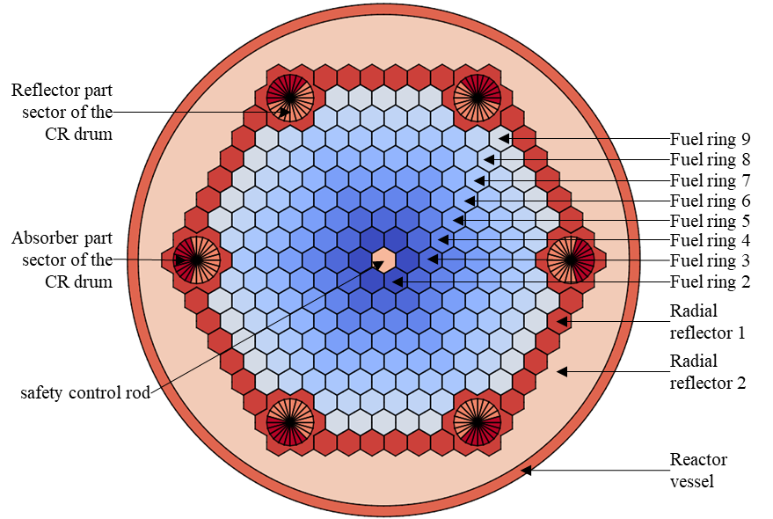
FIG. 3 HPMR core regions (denoted by different colors) for which cross section libraries are generated with Serpent (radial views).

HPMR full core results with Serpent
The multiplication factors taken from [3] and those obtained with Serpent are shown in Table 3. The difference between the multiplication factors is less than 25 pcm in ARO configuration and about 190 pcm in ARI. This demonstrates that both models are in good agreement with those performed in [3] and can be used for the cross sections’ generation required for FENNECS and can also be taken as reference for comparison purposes with FENNECS.

TABLE 3. Multiplication factors obtained with Serpent in ARO and ARI configurations and comparison with the benchmark results.

 | ARO |  | ARI
 | k_{eff} | uncertainty | k_{eff} | uncertainty
Benchmark k_{eff} [3] | 1.02321 | 3.60E-05 | 0.98953 | 3.60E-05
Serpent k_{eff} | 1.02344 | 6.50E-06 | 0.99137 | 6.80E-06
Deviation from the benchmark k_{eff}  (k_{eff}_bench)⁻¹ – (k_{eff}_serpent)⁻¹ [pcm] | 22 | - | 188 | -

During Serpent simulations, the radial assembly-wise power distribution is calculated. In ARO and ARI core configuration, the core has a twelfth symmetry. Thus, the assembly-wise radial power distribution is averaged on the twelve sectors and normalized to one (i.e. P_{norm} = P x 192 / P_{total}). FIG. 4 presents results obtained for the ARO and ARI core configurations. It can be observed that radial power tilt in the ARO core configuration is important. The power is concentred at the reactor centre (+27% of the average assembly power at assembly I) and decreases strongly from the centre to the core edge to -16% of the average assembly power (at assembly XIX). In the ARI core configuration, the power distribution is similar to the one in ARO configuration: the maximum and minimum power are located at the assemblies I and XVI, respectively. However, the radial power tilt is even more pronounced. So far, the radial power distribution has not been compared to data published in [3].
Fig. 5 shows the axial power peaking factor in the ARO and ARI core configurations obtained in the Serpent simulations. As expected, the maximum peaking factor is located at the centre of the fissile zone (at 70 cm) and is consistent with the value of 1.198 reported in [3]. The peaking factor distribution has a sinusoidal shape except at the top and bottom of the fissile zone where there is a small peak due to the axial reflector and is – despite the above-mentioned lack of material data – very similar to the shape published in [3]. Moreover, the bottom peak is higher than the one in the top due to the presence of the support plate at the bottom of the core. Furthermore, the peaking factor distribution is similar in both core configurations.

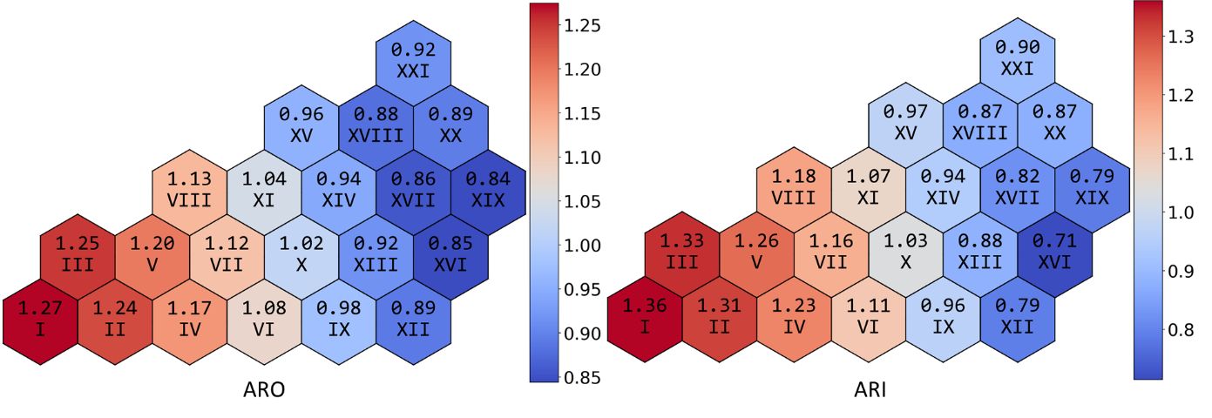
FIG. 4 Relative radial core power distribution (one twelfth of the core) in ARO (left) and ARI (right) core configurations obtained in Serpent simulations. Roman digits represent assembly’s identifier.

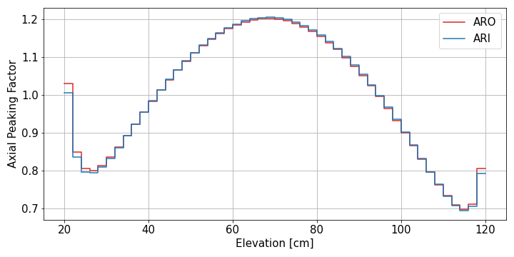
FIG. 5 Axial power peaking factor in ARO (red) and ARI (blue) core configurations obtained in Serpent simulations.

FENNECS model and results
5.1 HPMR core model in FENNECS

In radial direction, the meshing is derived from the regular lattice of the hexagonal fuel cells and the central safety rod cell. Each hexagonal cell is represented by 24 equilateral triangles. The control drums are meshed according to the method described in Section 2.2: each drum is approximated by a 24-edges polygon (with adjusted radius to preserve the area of the circle) centred into a 7-hexagon lattice. The reactor vessel is approximated according to the method described in Section 2.2: an annulus composed of two circles which are approximated by two 252-edges polygons (with adjusted radius to preserve the area of circles); each edge of the annulus is forming a quadrilateral which is divided into four triangles. FIG. 6 shows the radial meshing of the core in both ARO and ARI configurations. The reactor vessel is composed of 1008 prisms per layer. The axial discretization consists of 69 meshes: the mesh size is 2 cm and 1.875 cm in fissile zone and reflector zone, respectively. In both radial and axial directions, vacuum boundary conditions are applied in the FENNECS model.

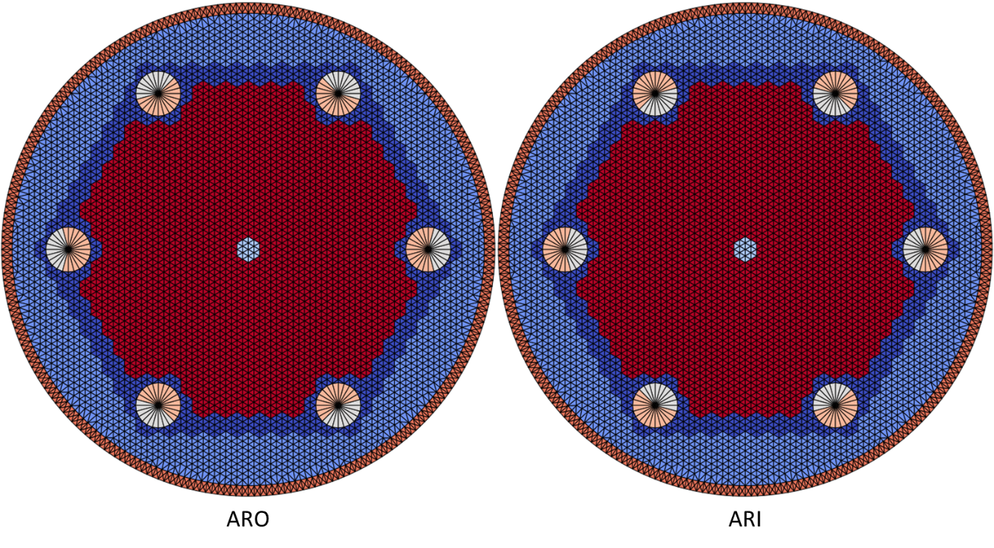
FIG. 6 Radial meshing of the HMPR core. Left: All Rods Out (ARO) core configuration. Right: All Rods In (ARI) core configuration.

5.2 FENNECS deterministic results

TABLE 4 shows the deviations on the multiplication factors obtained with FENNECS from Serpent results in both ARO and ARI core configurations. The smallest absolute deviation in the ARO configuration is obtained with the XS_ARO cross section set (37 pcm). However, this cross section set yields the largest absolute deviation in ARI core configuration (340 pcm). The XS_ARI cross section set yields in both core configurations similar deviations (-90 pcm and -97 pcm in the ARO and ARI configuration, respectively).
The radial power distribution is also calculated with FENNECS and using the two cross section sets and compared to the radial power distributions calculated by Serpent for the both configurations. Fig. 7 and Fig. 8 display the relative deviation in percent of the radial power distributions calculated by FENNECS with the XS_ARO and XS_ARI cross section sets, respectively, to the Serpent simulations (one twelfth of the core) in ARO and ARI core configurations, i.e. $(P_{FENNECS}-P_{serpent})/P_{serpent}$. Table 5 presents the minimum, the maximum and the root mean square of the previous radial power distribution deviations in percent. For the two cross section sets, the relative radial power deviations are between -4.83% and 3.06% and the root mean square is below 2.33%. For the four simulations, FENNECS overestimates the power in assemblies located in the center of the core and underestimates it in assemblies located at the edge of the core. Moreover, the various cross section sets have a little impact on the radial power distribution.
The axial peaking factor is also assessed by FENNECS. Fig. 9 shows the relative deviations in percent of the axial peaking factor calculated by FENNECS against the Serpent results (i.e. $({APF}_{FENNECS}-{APF}_{serpent})/{APF}_{serpent}$) with both cross section sets in both core configurations. The deviation is similar for the four simulations and remains low: between 38 cm and 116 cm the deviation is comprised between -1% and 1% and the peaking factor is underestimated in the bottom part (up to -3.29%) and overestimated (up to 2.92%) in the top part of the fissile zone by FENNECS. The typical wall time for FENNECS simulations is less than one minute.
While the XS_ ARI cross section set seems to be a suitable compromise to obtain good agreements on the multiplication factors and the radial power distribution with the results obtained with Serpent, further investigations are needed to explain the reason for these findings and to elaborate more systematically the appropriate cross section generation approach. The results obtained so far, however, indicate that FENNECS can be basically applied to model very small modular reactors. It is planned in the future to enable FENNECS to rotate the control rod drums during a transient simulation.

TABLE 4. Deviations on the multiplication factors obtained with FENNECS from Serpent results in ARO and ARI core configurations.
Cross section set | ARO core configuration | ARI core configuration
 | (k-eff_serpent)⁻¹ – (k-eff_fennecs)⁻¹ [pcm] | (k-eff_serpent)⁻¹ – (k-eff_fennecs)⁻¹ [pcm]
XS_ARO | 37 | 340
XS_ARI | -90 | -97

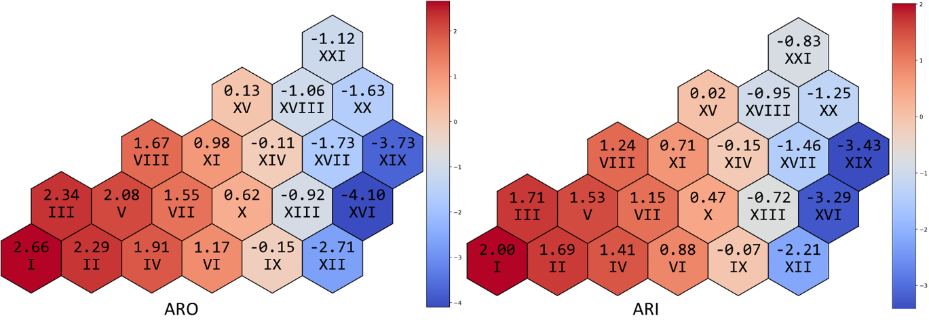
FIG. 7 Relative deviations in percent of the radial power distributions calculated by FENNECS with the XS_ARO set to the Serpent simulations (one twelfth of the core) in ARO (left) and ARI (right) core configurations. Roman digits represent assembly’s identifier.

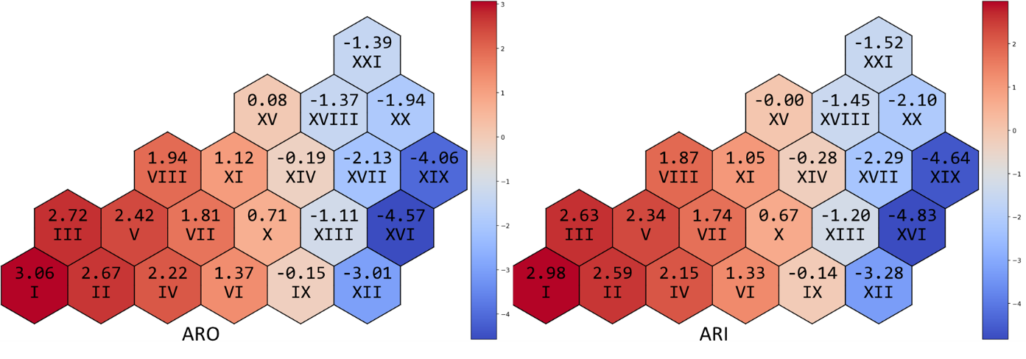
FIG. 8 Relative deviations in percent of the radial power distributions calculated by FENNECS with the XS_ARI set to the Serpent simulations (one twelfth of the core) in ARO (left) and ARI (right) core configurations. Roman digits represent assembly’s identifier.

TABLE 5. Minimum, Maximum and Root Mean Square of radial power distribution deviationS (in percent) between Serpent results and results obtained with FENNECS using the three various cross section sets XS_ARO and XS_ARI.
Core configuration | ARO |  | ARI
Cross section set | XS_ARO | XS_ARI | XS_ARO | XS_ARI
Minimum | -4.10% | -4.57% | -3.43% | -4.83%
Maximum | 2.66% | 3.06% | 2.00% | 2.98%
RMS | 1.96% | 2.24% | 1.57% | 2.33%
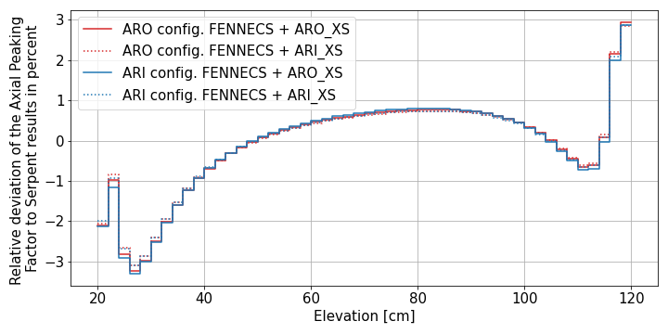
FIG. 9 Relative deviations in percent of the axial peaking factor calculated by FENNECS with the XS_ARO (solid lines) and XS_ARI (dashed lines) set to the Serpent simulations in ARO (red lines) and ARI (blue lines) configurations.

Conclusion
Emergence of new types of reactor and innovation concepts with irregular or complex geometries requires a geometrically flexible type of a neutron physics code to perform safety assessment. Though Monte Carlo methods are becoming more and more standard for steady state simulations, they are not yet mature enough for transient applications and not practicable due to their high computational demands. To perform future coupled transient safety assessments of this kind of reactors and other innovative concepts, the Finite ElemeNt NEutroniCS (FENNECS) code is being developed at GRS. It solves the time-dependent and steady-state three-dimensional few-energy group diffusion equation in the Galerkin finite element representation using upright triangular prisms with linear basis functions as spatial elements. For the meshing of the irregular geometries, an external meshing tool PEMTY is being developed as a Python software module which generates the data required by FENNECS.
In the paper, the Heat Pipe Micro Reactor (HPMR) core, whose specifications can be found in a publicly available document [3], was modelled with the Monte Carlo code Serpent for two core configurations All Rods Out (ARO) and All Rods In (ARI). The multiplication factors obtained are in good agreements with the results provided in the benchmark. The Monte Carlo model is then used as a reference for code-to-code comparison in the study: the multiplication factor and the radial power distribution calculated in both core configurations are taken as reference values. Homogenized macroscopic cross sections required for FENNECS are generated with the full core Serpent models in both core configurations. The model of the HPMR full core is also created for FENNECS. PEMTY generates a meshing where, in the radial direction, the hexagonal fuel assemblies are represented by 24 equilateral triangles, the control rod drums are approximated by a 24-edges polygon and the reactor vessel is approximated by an annulus composed of two circles which are approximated by two 252-edges polygons. The axial discretization consists of 69 meshes of around 2 cm height.
Two cross section sets are obtained with the ARO and ARI core configurations Serpent simulations. FENNECS uses each cross section set to calculate multiplication factors, radial power distributions and the axial peaking factor in both core configurations. The cross section set obtained during the ARI core Serpent simulation is a good compromise to obtain good agreements on the multiplication factors, the radial power distribution and the axial peaking factor with the results obtained with Serpent. Although the HPMR studied here is only a single test case, the obtained results support confidence that FENNECS can in future be applied to model such a kind of very small modular reactors.
It is planned in the future to develop FENNECS to simulate rotations of the control rod drums during a transient simulation.
ACKNOWLEDGEMENTS
This work was supported by the German Federal Ministry of Economic Affairs and Energy.
References
- Seubert, A., “A 3-D finite element few-group diffusion code and its application to generation IV reactor concepts”, PHYSOR 2020: Transition to a Scalable Nuclear Future, Cambridge, United Kingdom, March 29th-April 2nd, 2020 (https://www.epj-conferences.org/articles/epjconf/abs/2021/01/epjconf_physor2020_02010/epjconf_physor2020_02010.html) EPJ Web Conf. 247 (2021) 02010.
- Seubert, A., Bousquet J., Henry, R., “Recent advances of the FEM neutronics code for safety assessment of (v)SMR, generation IV and other innovative concepts”, 2021 The International Conference on Mathematics and Computational Methods Applied to Nuclear Science and Engineering (Proc. Int. Conf., Raleigh, NC, USA, 2021) to be published (paper accepted).
- Hu, G., Hu, R., Kelly, J. M., Ortensi, J., Multi-Physics Simulations of Heat Pipe Micro Reactor, internal report, Argonne National Laboratory, Illinois, USA, N. p. Web. doi:10.2172/1569948, ANL-NSE-19/25.
- Zienkiewicz, O. C., Tayler, R. L., The Finite Element Method. Vol. 1: Basic Formulation and Linear Problems. 4th edition MacGraw-Hill Book Company (1994).
- Austregesilo, H., Bals, C., Langenfeld, A., Lerchl, G., Schöffel, P., Skorek, T., Von der Cron, D., Weyermann, F., ATHLET 3.2 Models and Methods. GRS-P-1/Vol. 4, Rev. 5, Gesellschaft fuer Anlagen- und Reaktorsicherheit (GRS) gGmbH, Garching b. M., Germany (2019).
- Kostadin, I., Beam, T., Baratta, A., Irani, A., Trikouros, N. Pressurised Water Reactor Main Steam Line Break (MSLB) Benchmark:Volume I: Final Specifications. NEA/NSC/DOC(99)8, NEA/OECD, Paris, France (1999).
- Ortensi, J. OECD/NEA Coupled Neutronic/Thermal-Fluids Benchmark of the MHTGR-350 MW Core Design: Results for Phase-I Exercise 1, NEA/OECD, Paris, France (2018).
- Varaine, F.; Marsault, P.; Chenaud, M. S.; Bernardin, B.; Conti, A.; Sciora, P.; Venard, C.; Fontaine, B.; Devictor, N.; Martin, L.; Scholer, A. C.; Verrier, D., “Pre-conceptual design study of ASTRID”, 2012 International Congress on Advances in National Power Plants - ICAPP '12 (Proc. Int. Conf., Chicago, USA, 2012), American Nuclear Society, Chicago, IL, USA (2012).
- Bousquet, J., Seubert, A., Henry, R., “New finite element neutron kinetics coupled code system FENNECS/ATHLET for safety assessment of (very) Small and Micro Reactors”, J. Phys.: Conf. Ser. 1689 (2020) 012008.
- Leppänen, J., Pusa, M., Viitanen, T., Valtavirta, V., Kaltiaisenaho, T., “The Serpent Monte Carlo code: Status, development and applications in 2013”, Ann. Nucl. Energy 82 (2015) 142-150.
- J. W. Sterbentz, J. E. Werner, M. G. McKellar, A. J. Hummel, J. C. Kennedy, R. N. Wright, J. M. Biersdorf, Special Purpose Nuclear Reactor (5 MW) for Reliable Power at Remote Sites Assessment Report, INL/EXT-16-40741 Revision 1, April 2017.
- Waltar, A. E., Todd, D. R., Tsvetkov, P. V. Fast Spectrum Reactors. Springer Science+Business Media LLC, Boston, MA, USA (2012).
- Bousquet, J., Seubert, A., Henry, R., “3-d coupled PARCS/ATHLET transient simulation of SFR using detailed expansion modeling”, 2019 The International Conference on Mathematics and Computational Methods Applied to Nuclear Science and Engineering (Proc. Int. Conf., Portland, OR, USA, 2019), American Nuclear Society, Chicago, IL, USA (2019).
- Bousquet, J., Henry, R., Seubert, A., “3-d transient coupled simulation of Superphenix with PARCS/ATHLET”, EPJ Web Conf. 247 (2021) 06034.

