Novel neutronics design of the MYRRHA core

L. FIORITO¹, E. MALAMBU MBALA¹, G. KENNEDY¹, R. FERNANDEZ¹, G. VAN DEN EYNDE¹

¹SCK CEN, Mol, Belgium

lfiorito@sckcen.be

Abstract

MYRRHA, as in Multi-purpose hYbrid Research Reactor for High-tech Applications, is worldwide recognized as one of the most prominent projects in terms of ADS technology. Developed at SCK CEN, MYRRHA is intended to be a research facility able to work in subcritical mode as an accelerator-driven system, and in critical mode when decoupled from the proton accelerator. With lead-bismuth eutectic serving both as coolant and as a spallation target for the proton beam, MYRRHA acts as a technology demonstrator and a test platform for Heavy Liquid Metal (HLM)-cooled reactor technology for Gen IV systems. The high constant fast neutron flux levels achieved in the reactor core make it the ideal candidate for a flexible fast spectrum irradiation facility for fusion reactor development and fuel development for innovative reactors. Furthermore, MYRRHA contributes to demonstrating the technological feasibility of burning high-level nuclear waste, and in particular minor actinides, in a ADS system by achieving significant transmutation levels in representative conditions. Over the last 20 years, several neutronics designs of the MYRRHA critical and subcritical core configurations were investigated. Each design version aimed at complying with requirements made available by the technical advancement of the project as a whole. The optimization process driving the last core design revision 1.6 targeted an effective core fuel management and new layouts for material irradiation. Compared to the very first versions, the plutonium content in the MYRRHA MOX fuel is now limited to 30%. Also, irradiation rigs are included to reproduce a range of neutron spectra that are representative of thermal, fast and fusion reactors. SCK CEN has now released the MYRRHA design revision 1.8 with updated sub-critical and critical core configurations. Despite the major constraints of a smaller core and a lower cladding temperature limit (400 ⁰C), the core guarantees the highest performances in terms of transmutation and material irradiation as required by its application catalogue. In the paper, a description of the MYRRHA core design is provided. The major neutronics characteristics are also reported for two core layouts, namely at beginning-of-life (BoL) and at equilibrium.

Introduction
In 1997 SCK CEN launched the MYRRHA (Multi-purpose hYbrid Research Reactor for High-tech Applications) project [1], with the goal of designing a multi-purpose, flexible, irradiation facility that could replace the BR2 reactor and provide research ground for Accelerator Driven System (ADS) applications. MYRRHA was conceived as a pool-type ADS reactor with a proton accelerator linked to a subcritical core fuelled with MOX and cooled by lead-bismuth eutectic (LBE), with the chain reaction guaranteed by the proton beam interaction with the LBE spallation target. The MYRRHA concept, in its 2005 version, was offered as a design basis for the XT-ADS system within the EU-FP6 EUROTRANS [2] project in the context of partitioning and transmutation (P&T). In a later stage, a small-scale reactor called MYRRHA/XT-ADS was developed, with an optimization of the design choices based on the XT-ADS needs. As an upgrade of MYRRHA/XT-ADS, MYRRHA/FASTEF was developed within the FP7-CDT (Central Design Team) project [3]. Compared to its predecessor, both sub-critical and critical operation modes were requested. Within the CDT project the reactor was designed to an advanced engineering level with the following objectives in mind: being a high-flux and flexible fast spectrum irradiation facility, being an effective demonstrator of the ADS technology for high level waste transmutation, being a demonstrator of the lead fast reactor technology [4][5]. A further core revision was delivered in 2014 with the name “MYRRHA Design Revision 1.6” [6]. This version addressed the shortcomings of the CDT work, including the rather low expected fuel discharge burnup and the concerns regarding the use of 34.5 wt.%-enriched MOX. The outcome was a larger core that could operate both in critical and subcritical modes at 100 and 70 MWth, respectively. The fuel enrichment was changed to 30 wt.% plutonium [7].
New design constraints identified after the finalization of version 1.6, together with the need for a core size reduction, led to a further upgrade of the core design called “MYRRHA Design Revision 1.8”. This paper presents a summary of the neutronics studies carried out for the core design of such a revision. Both sub-critical and critical core configurations are reported and described for their start-up loading and for an equilibrium configuration. Performances in term of material irradiation and minor actinide transmutation are also investigated and compared to the imposed catalogue requirements.

Technical constraints and performance requirements
The MYRRHA reactor shall operate both in critical and sub-critical mode. For the latter, the specifications for the accelerated protons at the beam window include a nominal proton average beam current up to 4 mA and a nominal proton energy of 600 MeV [8]. A minimum thermal power of 50 MWth is requested to demonstrate the MYRRHA full concept in conditions scalable to an industrial ADS
As a multi-purpose machine, MYRRHA targets a list of application requirements that span over several domains. MYRRHA shall act as a fast spectrum research reactor for material and fuel research. For this purpose, provisions are made to include in-pile sections (IPSs) for material irradiation in the core active zone under high fast neutron flux conditions and representative irradiation temperatures and neutron spectra. A minimum of 15 dpa per calendar year are required to meet the application catalogue specifications [8]. The high fast neutron flux in irradiation targets shall also reproduce representative conditions for the efficient technological transmutation of high-level nuclear waste, including minor actinides (MAs). Fuel elements loaded with MAs shall be engineered in a fuel assembly (FA) in a core position that does not need to be instrumented. In particular, the transmutation of ²⁴¹Am should reach a minimum mass variation of 2 % in one reactor irradiation cycle of 90 days, considered as a measurable level at the SCK CEN laboratories [8]. MYRRHA also provides irradiation capabilities for the production of radioisotopes (RIs) for medical and industrial applications. The system should, in ADS mode, also incorporate a provision for material development for fusion reactors that need irradiation with high constant fast neutron fluxes resulting in 10 to 15 dpa per calendar year, at representative irradiation temperatures and with helium production in the range of 5 to 25 appm He/dpa.
The corrosion correlations derived from liquid metal corrosion experimental data obtained in LBE stagnant conditions lowered the maximum allowable temperature at the cladding-coolant interface from 466 ⁰C – as in the MYRRHA design revision 1.6 – to 400 ⁰C, given the limits on corrosion depth and fuel lifetime defined in Ref. [9]. This peak cladding temperature (PCT) limit was assumed as a design constraint for the reactor thermal power at any given reactor operational state. At the same time, the primary cooling system temperatures for the MYRRHA design revision 1.8 were modified to comply with the new requirements imposed on the PCT and to take into account the new core design and the reviewed thermal balance.
A major requirement driving the MYRRHA design revision 1.8 was to design a reactor that could achieve catalogue performances with the largest reduction in the dimensions of the several reactor components. This point was addressed by targeting the removal of one reflector crown. The core size reduction was allowed by relaxing the maximum irradiation dose allowed on the core barrel from 2 dpa – as in the MYRRHA design revision 1.6 – to 10 dpa, as supported by the available data for AISI 316LN stainless steel [10]. The core barrel was identified as a replaceable component with once every ten years being the maximum replacement frequency.

Computer codes and data
All particle transport studies to determine particle fluxes and spectra were performed with the general-purpose, continuous-energy Monte Carlo radiation-transport code MCNP-6.2.0 [11]. Neutrons, protons and photons were all accounted for in the particle transport calculations. The choice of selecting a Monte Carlo-based particle transport code such as MCNP was justified by the very high level of accuracy that can be achieved in modelling even complex geometries such as the core itself, and which could in principle make the model free from geometrical approximations.
Version 3.1.2 of the JEFF library [12] was used for all neutron transport and depletion calculations. Nuclear data were processed with the NJOY code [13] following the protocol indicated in the ALEPH-2 manual [14], [15]. The choice and suitability of the JEFF-3.1.2 nuclear data library as well as the CEM-03.03 [16] Cascade-Exciton Model (when tabulated nuclear data are not available) used for the subcritical analysis were addressed in [17], [18].
Computer calculations using high-quality codes such as ALEPH-2 [19] and MCNP-6.2.0 were used to produce a neutronics design of the reactor both for its beginning-of-life (BoL) and for its long-term operation at nominal power adopting the concept of a “equilibrium cycle”. A cycle-by-cycle loading/unloading and in-core (re)shuffling of the fuel assemblies (FAs) was incorporated in the irradiation model resorting to the specific features of the ALEPH-2 burnup code. Fuel reloading involves removing (partially) depleted or used FAs from the shutdown core and replacing them with fresh fuel. Then, the fuel still in the core is reshuffled, that is, FAs are moved to neighbouring locations with the purpose of maximizing the requested reactor performances, i.e., in MYRRHA being the largest neutron fluxes in the material irradiation experiments still complying with the PCT of 400 ⁰C [8].

Critical and subcritical MYRRHA core configurations

Rationale for the FA design
The design of a MYRRHA MOX fuel pin is comparable to that adopted for the Phénix sodium fast reactor (SFR) [20]. Differently from legacy MYRRHA design versions, the active height of the fuel column was increased from 600 mm to 650 mm to allow a reduction of the plutonium and americium content (Pu+Am relative to all heavy metal in the fresh fuel) from 35 % to 30 % – for which the availability seems guaranteed at a reasonable cost in the time horizon foreseen for building MYRRHA [6] – and simultaneously reducing the core power peaking factors [7].

Rationale for the shutdown and reactivity control system design
Two redundant and diverse systems for reactivity control and shutdown are designed for the MYRRHA core: the buoyancy-driven control rod bundles (CRs) and the gravity driven safety rod bundles (SRs). The CR system has the double function of reactivity control and SCRAM. A novelty of this design version is to compensate the burnup reactivity effects with the CR system in sub-critical mode, as in the previous revisions the reactivity was regulated by varying the proton beam current [6]. The SR system is redundant to the CR system for the emergency shutdown only and it is by design not used in the subcritical core since the sub-criticality itself is seen as an inherent safety margin [21]. The passive insertion of the CR and SR systems is based on buoyancy and gravity, respectively. The number of SRs and CRs and the required anti-reactivity for each system are inherited from the previous core design revisions and by considering single failure events [6], [22]. Boron carbide, B₄C, pellets – stacked in a 15-15Ti stainless steel clad and cooled by the primary LBE – were selected as neutron absorbing materials.

Irradiation in in-pile sections
To capitalize on the presence of in-pile sections (IPSs) in the reactor core, the number of rigs for material irradiation and experiments was maximized and they were located in regions with high neutron fluxes, e.g., the inner rings of the core. The core available positions to host IPSs are also limited to the 37 multifunctional channels (MFCs) reported in Figure 1.
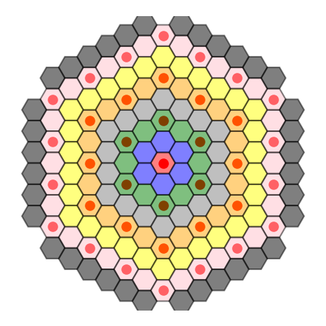
Figure 1: Sketch of the MYRRHA core layout. Different colors indicate different radial crowns. Red dots indicate the connection to a multifunctional channel.

In the subcritical core configuration, six IPSs for material testing and experiments are placed in the core central region with the highest and hardest neutron fluxes, allowing reaching catalogue performances without exceeding a proton beam current of 4 mA. In the critical core configuration, only one IPS for material irradiation is placed in the central assembly. Loading experiments at the core periphery is not considered as the irradiation performances would be too small.
IPSs for radio-isotope production were included in the core: six in the sub-critical configuration and three in the critical configuration. A preliminary design of the irradiation rig for the production of Mo-99 from HEU targets was derived from the in-house technology already used for decades at the BR2 reactor [23]. These IPSs act as mild neutron absorbers and were located close to the reflector in the core critical configuration to minimize any perturbation of the neutron flux spatial distribution.
In the sub-critical configuration, an irradiation rig for testing materials within the framework of research for nuclear fusion is located beneath the beam tube in the spallation target assembly in the radial centre of the core to maximize the ratio between He production and dpa.

Reflector assemblies
Each reflector assembly consists of a hexagonal bundle of five cylindrical pins, wrapped by 15-15Ti steel. MgO was selected as the reflective material for its desirable characteristics in terms of neutron shielding and a reflective efficiency. Other neutronics aspects such as activation and core power flattening were not considered.
Albedos at the reflector outer boundary and dpa on the core barrel were calculated for four different reflector materials: Be, BeO, MgO and YZrO. Beryllium and beryllium oxide were already considered for earlier revisions of the MYRRHA core design, while magnesium oxide is referred in the literature as the reference choice for the ASTRID reflector [24], [25]. Yttria stabilized zirconia (ZrO₂ + Y₂O₃) are already considered for the fuel pins’ insulation segments in MYRRHA. Calculations indicated that magnesium oxide produces the best performances in terms of neutron reflection by providing the largest albedo and consequently the largest increase in static reactivity. On the other hand, its reduced moderation capabilities – compared for instance to beryllium-made reflectors – increase the radiation damage on the core barrel. The lower current of thermal neutrons at the fuel-reflector interface reported in Figure 2 avoids the possibility of a hotspot in the peripheral fuel assemblies.

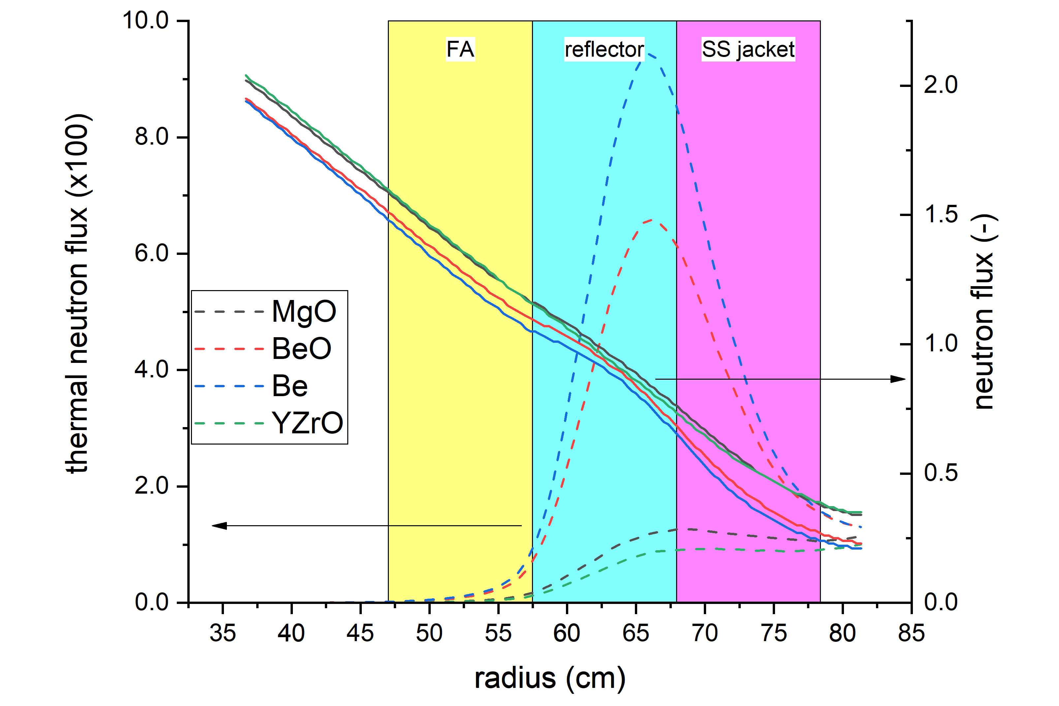
Figure 2: Total (solid lines) and thermal (dashed lines) neutron fluxes in the core periphery considering different levels of reflectors. Y-axes are in arbitrary units.

The reconsideration of the irradiation limit on the core barrel in the requirements of the MYRRHA design revision 1.8 and the adoption of MgO as a reflector material allowed reducing the number of concentric reflector rings from two to one in the latest MYRRHA core design revision, with a non-negligible impact on the reactor dimensions.

Reactor power evaluation
The PCT limit imposes an upper bound to the hot pin power and, ultimately, to the power of the whole core depending on the its spatial distribution. The maximum core power allowed for any potential MYRRHA core configuration was evaluated based on the following hypotheses and assumptions:
- a fixed FA geometry, based on a frozen MYRRHA FA design;
- 70 MW assumed as reference core power;
- a cosine-shaped axial power profile;
- no radial mass, momentum or energy exchanges within the FA (1-D approximation);
- convective heat transfer between fluid and clad determined by Kazimi-Carelli correlation [27].

The PCT was pinned to its limit of 400 °C and used as a boundary condition for determining the reactor power for any considered core configuration using calculated radial, axial and local power peaking factors as input data. The mass flow rate distribution in the different sub-channels within the FA, and in particular the flow reduction in the inner sub-channels, were evaluated accordingly.

BoL core layouts
At any envelop state, the core sub-criticality level shall be bound by the safety margin to criticality [21] and by the proton beam current upper limit of 4 mA [8]. In agreement with these considerations, it was assessed that 54 is the minimum amount of fresh FAs that can be loaded into the core at BoL, corresponding to a sub-criticality level defined by a calculated effective neutron multiplication factor k_{eff} of 0.93072, with a beam current of about 3.2 mA and corresponding to a reactor power of 58 MW. Core configurations at BoL with more FAs could provide equivalent irradiation performances with a lower beam current intensity, but they would demand a higher initial availability of fresh FAs.
In critical mode, the number of FAs loaded into the reactor core at BoL shall be sufficient to make the reactor critical and it must provide enough reactivity excess to compensate at least the reactivity effects introduced by burnup in one irradiation cycle for operation at nominal power. It was calculated that 69 fresh FAs provide enough reactivity excess to allow the reactor operation in critical mode with a reactor power of 56 MW.
Both the critical and sub-critical core layouts at BoL are reported in Figure 3. In Figure 3, as well as in Figure 4, the following nomenclature was adopted:
- LBE: hexagonal dummy-channel filled by LBE;
- STA: spallation target assembly;
- CR: channel containing the control rod bundle;
- SR: channel containing the safety rod bundle;
- IPS: in-pile section for irradiation experiments;
- RI: in-pile section for radioisotope production;
- MgO: reflector channel composed of reflector pins in magnesium oxide (MgO);
- 101-608: fuel assemblies (FAs) grouped in batches.

The FA subdivision into batches follows the core 1/3rd azimuthal symmetry around the central assembly, making each batch be composed of three FAs. Each batch is identified by a three digit number, i.e. XYY, where the first digit – i.e. X – indicates the core radial crown where the FA is located, and the second and third digits – i.e. YY – represent a counter with an increasing order to distinguish batches with different neutron flux levels (the counter increases as the neutron flux decreases).

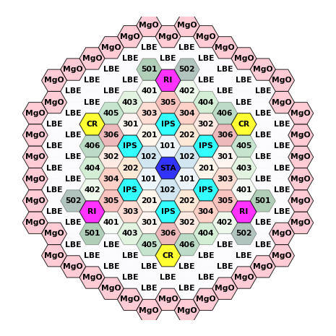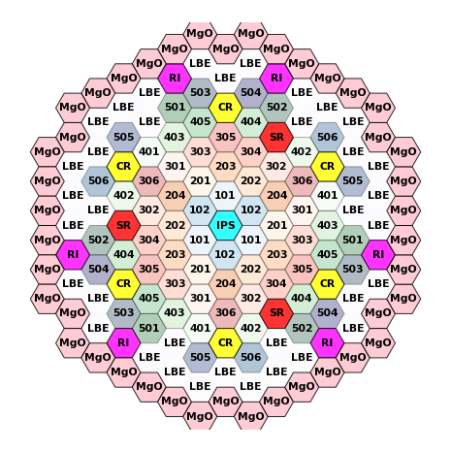
a) sub-critical | b) critical
Figure 3: Sketch of the sub-critical (a) and critical (b) MYRRHA core configurations at BoL for the design revision 1.8.

Equilibrium cycle
To provide uniform, well characterized and reproducible irradiation conditions for the experiments, the neutron fluxes in the fast IPSs shall be kept constant within each irradiation cycle and from cycle to cycle. These requirements are achieved by implementing a so-called IN-to-OUT in-core fuel shuffling strategy and by loading additional fresh FAs at each irradiation cycle. This loading/shuffling strategy has the advantage of generating high neutron fluxes in the core radial centre, i.e. where the experiments are present, but it inevitably creates a burden in terms of power peaking factors.
A dynamic equilibrium – both in terms of neutronics and power performances – in consecutive irradiation cycles was achieved simulating the operation of both the critical and sub-critical reactor configurations at a nominal power of 70 MW, adopting the parameters reported in Table 1. Despite the reactivity loss associated to burnup during a cycle, the equilibrium is restored at the beginning of each by loading six fresh FAs in the centre of the core.

Table 1: summary table of the parameters adopted to simulate the reactor operation to an equilibrium cycle.
Reactor lifetime | 40 a
Irradiation cycle length | 90 d
Down-period after every irradiation cycle | 30 d (90 d every 3 irradiation cycles)
Irradiation scheme | 90-30-90-30-90-90
Reactor irradiation period | 420 d
In-core FA shuffling strategy | IN-to-OUT
Irradiation power requirements | PCT ≤ 400 ⁰C
Core symmetry | 1/3rd
In-core loaded/unloaded FA per irradiation cycle | 6x6

The critical and sub-critical core configurations at equilibrium are reported in Figure 4.

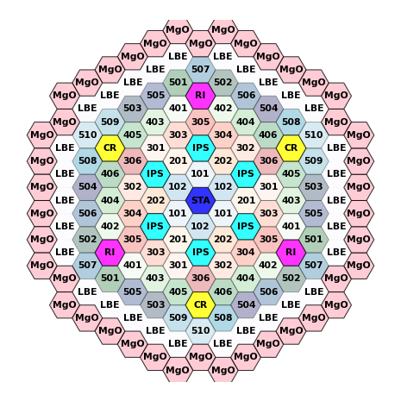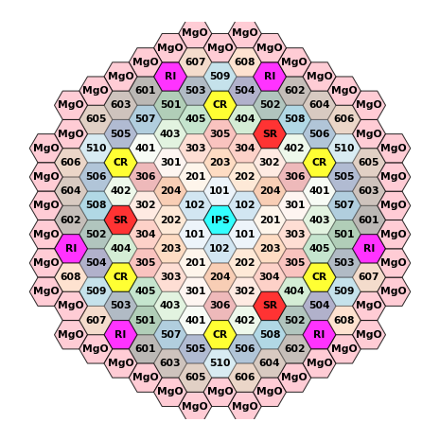
a) sub-critical | b) critical
Figure 4: sketch of the sub-critical (a) and critical (b) MYRRHA core configurations at equilibrium for the design revision 1.8.

Neutronics parameters and irradiation performance analysis

Basic core parameters
The critical MYRRHA core configuration can maintain criticality up to an equilibrium condition operating at a nominal power of 70 MW. The sub-critical MYRRHA core configuration operates at the same power with constant proton beam current of about 3.7 mA. It was calculated that the corresponding k_{eff} is about 0.93.

Power distribution
Radial, axial and local power factors were calculated for the critical and sub-critical MYRRHA core configurations to identify hotspots in the core. The radial power factor of a $i$-th FA was defined as the ratio between the power $P_{i}$ produced by the single FA and the average FA power, $\sum_{i}{P_{i}/N}$, where $N$ is the number of FAs in the core. The axial power factor for a $i$-th FA is defined as the ratio between the peak (axial) linear power ${\left.P_{i}(z)\right|}_{MAX}$ in the FA and the average FA linear power, $\int{dz P_{i}(z)}/\int{dz}$. The local power factor of a $i$-th FA is defined as the ratio between the power in the hottest pin $P_{i,j}$ in the FA and the average pin power in the FA, $\sum_{j}{P_{i,j}/M}$, where $M$ is the number of fuel elements in a FA.
Table 2 reports the radial, axial and local power peaking factors that define the hotspot in both the critical and sub-critical core configurations. In both cases the hotspot is located in the FA in the first crown of the core, approximatively at the fuel column mid-plane. It is clear that the presence of the spallation source in sub-critical mode entails a more peaked distribution of both neutron flux and power.

Table 2: Power distribution in the core for both sub-critical and critical modes.
 | Sub-critical core | Critical core
# FA @ BoL | 54 | 69
# FA @ BoC | 78 | 105
Reactor power / MW | 70 | 70
FA-averaged discharge burnup / GWd/tHM | 54 | 60
Power peaking factors @ BoC
radial | 1.76 | 1.73
axial | 1.30 | 1.19
local | 1.11 | 1.11

Discharge FA-averaged burnup values of about 54 GWd/tHM and 60 GWd/tHM were calculated respectively for the sub-critical core and for the critical core. The imposed constraints on the discharge burnup affected the in-core FA reshuffling strategy limiting the FA irradiation and residence time [28], [29].

Irradiation performances and limits
Peak neutron fluxes beyond 2 10¹⁵ cm⁻²s⁻¹ with a 15 % fast component above 0.75 MeV were achieved for stainless steel specimens loaded in the IPSs in the core central region. Equivalent neutron fluxes are obtained both for the critical and sub-critical core layouts as they are primarily limited by the PCT constraint.

Table 3: Irradiation performances of the core for both sub-critical and critical modes.
Peak neutron flux in experiments
total / cm⁻²s⁻¹ | 2.3 10¹⁵ | 2.3 10¹⁵
fast (>0.75 MeV) / cm⁻²s⁻¹ | 3.7 10¹⁴ | 3.5 10¹⁴

The radiation damage of the stainless steel specimens was assessed in terms of dpa per calendar year using the reference NRT method to calculate dpa [30], [31]. Average and peak doses of 10 and 14 dpa, respectively, were calculated for the irradiated material in one calendar year.
The subcritical core performances in terms of provision for material developments for fusion reactors were also assessed. Peak values of 36 dpa and 24 appm He/dpa were calculated for the stacks of tensile samples placed in the irradiation rig below the spallation target.

Minor actinide transmutation
Transmutation levels for minor actinides (MAs) in the MYRRHA core were calculated simulating a MA fuel pin engineered in the central position of the MYRRHA FA experiencing the highest neutron flux. Neutron spectra and fluxes used to convolute the MA reaction cross sections were taken from the sub-critical core at equilibrium conditions. The irradiation was modelled for a cycle of 90 days assuming a constant neutron flux. Under such conditions, the MA transmutation rates achievable in any MYRRHA reactor configuration depend only on the intensity and shape of the neutron fluxes available in the location where the MAs are loaded. The slightly softer neutron spectra in the critical reactor in the core central region are detrimental for the transmutation purposes as the MA capture-to-fission ratios ${σ_{γ}}/{σ_{f}}$ increase. This makes the MYRRHA core in sub-critical mode more attractive for an efficient MA transmutation.
The spectrum-averaged cross sections used to calculate the transmutation rates and MA mass variations are reported in Table 4. ²⁴¹Am and ²³⁷Np were selected for this exercise as they have the worst capture-to-fission cross section ratios amongst all actinides considered for transmutation, making the process particularly inefficient. The transmutation of any other actinide in equivalent conditions would yield better performances.

Table 4: Cross sections (in barns) averaged over the neutron spectra of the MYRRHA hottest fuel pellet and pin at BOC conditions.
nuclide / reaction | $$\left(n,f\right)$$ | $$\left(n,γ\right)$$
²⁴¹Am | 0.31 | 1.58
²³⁷Np | 0.41 | 1.33

In sub-critical mode, 3.5 % of the initial mass of ²⁴¹Am can be transmuted in one irradiation cycle, of which about 20 % fissions (see Table 5). Comparable results are obtained for ²³⁷Np. These results exceed the catalogue requirement of a 2 % mass variation of ²⁴¹Am.

Table 5: Relative mass variation (%) of ²⁴¹Am and ²³⁷Np for a MYRRHA irradiation cycle of 90 days. Transmutation rates were calculated using BoC conditions for the MYRRHA sub-critical core and different reaction cross sections, i.e. only fission and fission plus radiative capture.
nuclide / reaction | $$\left(n,f\right)$$ | $$\left(n,f\right)+\left(n,γ\right)$$
²⁴¹Am | 0.7 | 3.5
²³⁷Np | 0.9 | 3.2

Summary and conclusion
A new MYRRHA reactor design revision called 1.8 was implemented with the primary goal of reducing the reactor size and costs, still ensuring catalogue performances in terms of material irradiation and MA transmutation. Further constraints were imposed by a pellet-cladding temperature (PCT) limit of 400 ⁰C, a core minimal power of 50 MWth and a maximum proton beam current of 4 mA. The design of all core components, with the exception of the material adopted in the reflector assemblies, as well as the MOX fuel enrichment and composition remained unchanged from the design revision 1.6. The core size reduction was obtained by adopting only one crown of reflector assemblies. Results showed that the potential impact of this modification on the integrity of the core barrel is avoided by replacing the component every ten years. Still, the peak value of about 4 dpa in 10 years obtained with the new candidate reflector material – magnesium oxide – suggest that the frequency with which the component is replaced could be reduced at least by a factor two.
A sub-critical core and a critical core were designed respectively with 78 and 105 fuel assemblies (FAs) and a reference reactor power of 70 MW. The power level was mostly constrained by the PCT limit, but also by the high gradients in the power spatial distribution, which entailed higher peaking factors than in the previous core revision.
With a maximum beam current of 4 mA it was possible to achieve catalogue performances for material irradiation in IPSs with fast neutron flux and in irradiation devices that simulate neutron energies and material temperatures of fusion-like conditions. Also, the transmutation of a MAs pin was proved to be above the defined requirement, i.e., 2 wt.% mass variation of ²⁴¹Am in one irradiation cycle.
References
[1] P. D’hondt, “Pre-design of MYRRHA, A Multipurpose Accelerator Driven System for Research and Development,” in AIP Conference Proceedings, 2003, vol. 680, pp. 961–964.
[2] D. De Bruyn, D. Maes, L. Mansani, and B. Giraud, “From myrrha to XT-ADS: The design evolution of an experimental ADS system,” in AccApp’07, 2007.
[3] D. De Bruyn, P. Baeten, S. Larmignat, A. Woaye Hune, and L. Mansani, “The FP7 Central Design Team project: Towards a Fast-Spectrum Transmutation Experimental Facility,” in International Congress on Advances in Nuclear Power Plants 2010, ICAPP 2010, 2010, vol. 1, pp. 469–475.
[4] H. A. Abderrahim et al., “MYRRHA Technical Description,” SCK•CEN/927122/1.0, 2011.
[5] E. Malambu, G. Van Den Eynde, R. Fernandez, P. Baeten, and H. Aït Abderrahim, “MA transmutation performance in the optimized MYRRHA,” in International Nuclear Fuel Cycle Conference, GLOBAL 2013: Nuclear Energy at a Crossroads, 2013, vol. 1, pp. 775–780.
[6] E. Malambu Mbala and A. Stankovskiy, “Revised Core Design for MYRRHA-Rev1 .6,” SCK•CEN/3958903, 2014.
[7] G. Van den Eynde, E. Malambu, A. Stankovskiy, R. Fernandez, and P. Baeten, “An updated core design for the multi-purpose irradiation facility MYRRHA,” J. Nucl. Sci. Technol., vol. 52, no. 7–8, pp. 1053–1057, Aug. 2015.
[8] R. Fernandez, G. Van den Eynde, M. Schyns, G. Aït Abderrahim, Hamid, Scheveneels, and P. Schuurmans, “MYRRHA Reactor Scope justification,” SCK•CEN/30233162, 2019.
[9] S. Gavrilov, K. Lambrinou, and E. Stergar, “Presentation of the design provisions to prevent or control erosion and corrosion of the materials,” SCK•CEN R-6317, 2018.
[10] afcen, “RCC-MRx Design and Costruction Rules for Mechanical COmponents of Nuclear Installations: High Temperature, Research and Fusion Reactor,” afcen n⁰2015-171, 2015.
[11] C. J. Werner et al., “MCNP User’s Manual Code Version 6.2,” LA-UR-17-29981, 2017.
[12] OECD/NEA, “JEFF Report 21: The JEFF-3.1 Nuclear Data Library,” 2006.
[13] R. E. MacFarlane, D. W. Muir, R. M. Boicourt, A. C. Kaher, J. L. Conlin, and W. Haeck, “The NJOY Nuclear Data Processing System , Version 2016,” LA-UR-17-20093, 2019.
[14] A. Stankovskiy, G. Van Den Eynde, and L. Fiorito, “ALEPH A Monte Carlo Depletion Code – Version 2.8 User’s Manual,” R-7449, 2021.
[15] A. Stankovskiy, “Processing of the JEFF-3.1.1, JEFF-3.1.2 and ENDF/B-VII.1 neutron cross section data into multi-temperature continuous energy Monte Carlo radiation transport libraries,” Mol, SCK•CEN/1684326, 2012.
[16] S. G. Mashnik and A. J. Sierk, “CEM03.03 User Manual,” LA-UR-12-01364, 2012.
[17] A. Stankovskiy, “On the choice of nuclear data library for neutronics design of MYRRHA fast spectrum facility,” Mol, SCK•CEN-I-351, 2012.
[18] A. Stankovskiy, “On the choice of intermediate- and high-energy model for MYRRHA sub-critical core neutronics calculations,” Mol, SCK•CEN/1747786, 2012.
[19] A. Stankovskiy and G. Van den Eynde, “Advanced Method for Calculations of Core Burn-Up, Activation of Structural Materials, and Spallation Products Accumulation in Accelerator-Driven Systems,” Sci. Technol. Nucl. Install., vol. 2012, pp. 1–12, 2012.
[20] M. Sarotto et al., “The MYRRHA-FASTEF cores design for critical and sub-critical operational modes (EU FP7 Central Design Team project),” Nucl. Eng. Des., vol. 265, pp. 184–200, Dec. 2013.
[21] B. Arien, “Estimation of the safety margin against recriticality in the MYRRHA facility,” SCK•CEN/3583712, 2015.
[22] M. Sarotto et al., “FASTEF design changes to operate in critical mode,” UTFISSM-P9P0-020, 2012.
[23] S. Kalcheva, E. Koonen, and P. Gubel, “Detailed MCNP Modeling of BR2 Fuel with Azimuthal Variation,” Nucl. Technol., vol. 158, no. 1, pp. 36–55, Apr. 2007.
[24] D. Blanchet and B. Fontaine, “Reflector and Protections in a Sodium-cooled Fast Reactor: Modelling and Optimization,” EPJ Web Conf., vol. 153, 2017.
[25] D. Blanchet, Q. Barreau, and B. Fontaine, “ON CORE-REFLECTOR INTERFACE EFFECTS IN THE ASTRID SODIUM COOLED FAST REACTOR,” in ICAPP 2016, 2016.
[26] N. E. Todreas and M. S. Kazimi, Nuclear Systems Volume I: Thermal Hydraulic Fundamentals, Second Edition, 2nd ed. CRC Press, Taylor & Francis Group, 2011.
[27] M. S. Kazimi and M. D. Carelli, Clinch River Breeder Reactor Plant: Heat Transfer Correlation for Analysis of CRBRP Assemblies; Topical Report. CRBRP-ARD-0034, 1976.
[28] B. Boer, R. Delville, F. Belloni, G. Scheveneels, and M. Verwerft, “Assessment of limiting parameters of key damaging phenomena for the MYRRHA fuel pin,” SCK CEN/12089018, 2020.
[29] L. Fiorito, “Neutronics analysis of the MOX fuel utilization in MYRRHA,” Mol, SCK CEN/40916392, 2021.
[30] M. Norgett, M. Robinson, and I. Torrens, “A proposed method of calculating displacement dose rates,” Nucl. Eng. Des., vol. 33, pp. 50–54, 1975.
[31] K. Nordlund et al., “Primary Radiation Damage in Materials,” NEA/NSC/DOC(2015)9, 2015.

Even in the case the insertion of a single control rod or a single safety rod fails, each safety system can achieve and maintain a safe state.
With CRs partly inserted to ensure operation for an irradiation cycle at nominal power.

