Transient analysis of the CiADS reactor

core loaded with nitride fuel

B. LIU¹, S. LI¹, Y. ZHANG¹, J. WALLENIUS², B. XI¹, L. GU^{3,4,5}, J. LI^{3,4,5}, D. WANG¹

¹Fudan University, Shanghai, China
²AlbaNova University Centre, Stockholm, Sweden
³Chinese Academy of Sciences, Lanzhou, China
⁴University of Chinese Academy of Sciences, Beijing, China
⁵Lanzhou University, Lanzhou, China

Email contact of corresponding author: zhangyp@fudan.edu.cn

Abstract

The China initiative Accelerator Driven System (CiADS) is a nuclear energy system that can perform transmutation of long-lived radioactive nuclides in the spent fuel. In the paper, the CiADS reactor core loaded with nitride fuel was studied by using SAS4A/SASSYS-1 code. The calculation results of the unprotected transient over power (UTOP) and unprotected loss of flow (ULOF) accidents showed that the cladding will rupture when the reactivity insertion is over 600 pcm, and the cladding failure will not happen in all postulated ULOF cases.

Introduction
Nuclear power, as a clean energy source, still has one important issue to be solved, which is the difficult process of spent fuel. The conception of Accelerator Driven System (ADS) was exactly come up to simplify the disposal of spent fuel since 1990s [1]. ADS uses the protons from the accelerator to bombard heavy nuclei, which produces high flux of neutrons. Then these eternal neutrons will drive and maintain the subcritical reactor. In the operation of reactor, the long-lived radioactive nuclides will be transmuted to short-lived nuclides [2]. Moreover, the subcritical state of the reactor core will enhance the safety of the system [3]. After more than twenty years of study and preparations, the China initiative Accelerator Driven System (CiADS) was formally approved by the National Development and Reform Commission by 2015. The CiADS project adopted the design of “Superconducting linear accelerator + High-power spallation target + Subcritical reactor”, aiming at realizing the transmutation of spent fuel [4].
When it comes to the fuel in the core, most commercial reactors apply oxide fuel, which has good chemical and thermal stabilities and high melting points. Otherwise, the thermal conductivity of oxide fuel is very poor. Obviously, the continuous application of oxide fuel in Gen IV reactors is not in line with the quest for efficiency. We need to choose and study a new kind of nuclear fuel, for example, nitride fuel. Compared with oxides, nitrides as nuclear fuel have many unique advantages, such as higher thermal conductivities, higher fissile densities and longer fuel cycle time [5-9]. CiADS is a kind of advanced nuclear energy system in the future, and therefore, needs to take nitride fuel into consideration. Naturally, related research is very fundamental, especially about the feasibility and safety of nitride fuel in the reactor core.
This paper consists of 5 sections. Section 2 was about the simulation tool and model creation. Section 3 was an overview of the core design of CiADS and its safety parameters, and section 4 stated transient analysis results. The last section was the preliminary conclusion.

Simulation tool and modelling
The computer code used in this paper is SAS4A/SASSYS-1, developed by Argonne National Laboratory since the late 1960s. During the past 50 years’ improvements and enhancements, SAS4A/SASSYS-1 has the capability to analyse thermal, hydraulic and neutronic changes of power and flow transients, both in sodium cooled fast reactors and in lead/lead-bismuth eutectic cooled reactors. Besides, fuels studied in the code extended from oxide fuel to metallic fuel and nitride fuel. Based on the issue of CiADS subcritical reactor core loaded with uranium mononitride, SAS4A/SASSYS-1 is able to simulate the unprotected transient over power (UTOP) and unprotected loss of flow (ULOF) accidents.
The reactor core of CiADS is divided into two channels, peak channel and average channel respectively. The peak channel contains 1 fuel assembly and the average channel contains 51 assemblies. The power of the fuel assembly in the peak channel is 1.25 times higher than that in the average channel. In all channels, only one fuel pin is needed to describe, which means all fuel pins in one channel are modelled in the same way. Fig. 1 shows the single fuel pin model in the reactor core. In the basic single fuel pin model, one fuel pin not only includes the pin itself, but also involves coolant flow and structural materials surrounding it. The fuel pin itself generally contains fuel pellets, cladding, gas plenum and reflectors.

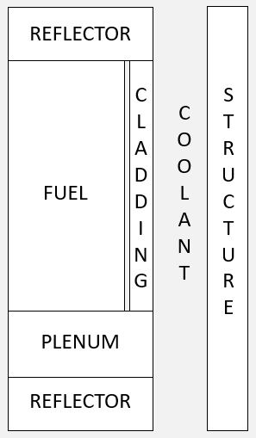
Fig. 1. Fuel pin model.

Core design of CiADS
According to the design details of CiADS [10,11], the subcritical core will operate at the thermal power level of 9.76MW. The arrangement of assemblies can be seen in Fig. 2, which includes 52 fuel assemblies. The fuel assemblies are square hexagons, including 60 fuel pins and 1 fastening bar per assembly. Besides the active zone, the fuel pin also includes upper/lower reflectors, lower gas plenum, upper tighten spring and top/bottom end caps. The cladding material is austenitic stainless steel 15-15Ti and the reflector material is YSZ. More detailed parameters of fuel assemblies can be seen in Table 1.

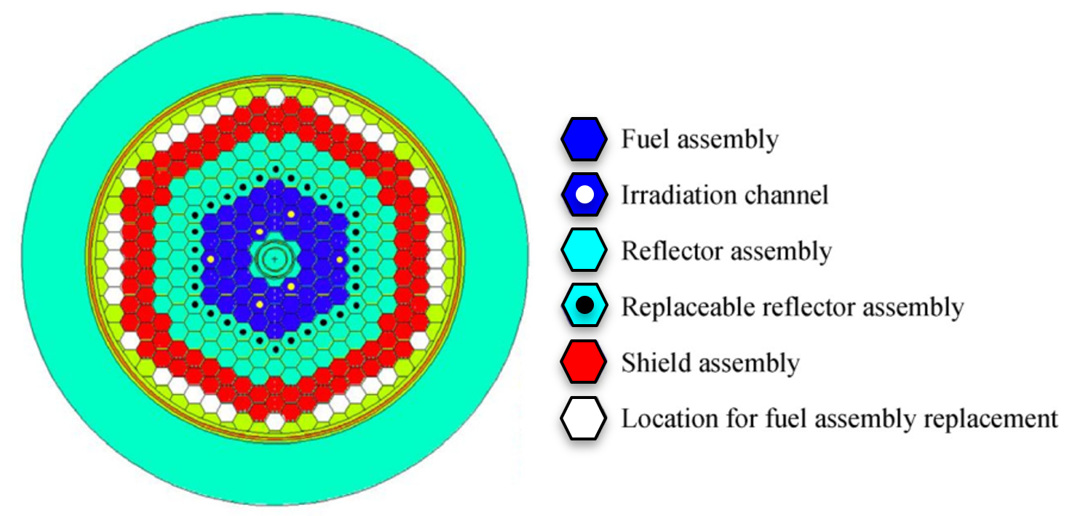
Fig. 2. Core design of CiADS [11].

TABLE 1. Fuel assembly design parameters [10]

Item | Unit | Value or description
External fuel assembly flat width | mm | 131
Fuel assembly inner across flat | mm | 123
Fuel pin pitch | mm | 15.1
Clad outer diameter | mm | 13.1
Clad thickness | mm | 0.65
Pellet outer diameter | mm | 11.5
Active height | mm | 1000
Upper/Lower reflector length | mm | 60/60
Upper spring length | mm | 50
Lower gas plenum length | mm | 150
Top/Bottom-cap length | mm | 56/65
Fuel rod total length | mm | 1441
Spiral wire wrap diameter | mm | 2
Fill gas | - | Helium
Fill gas pressure | MPa | 0.1
Clad material | - | 15-15Ti
Reflector material | - | YSZ (yttria-stabilized zirconia)
Spring material | - | AISI 302
Counterweight material | - | Tungsten

In the primary loop, the coolant is lead-bismuth eutectic and the total mass flowrate in the core is 672 kg/s. The design working pressure and temperature are 0.1 MPa and 280-380 ℃ respectively. The flow of coolant in the primary loop is forced circulation.

Safety parameters
Based on the core design of CiADS above, the safety parameters were calculated by Serpent. The composition of the fuel can be seen in Table 2. Serpent is a multi-purpose three-dimensional continuous-energy Monte Carlo particle transport code, developed at VTT Technical Research Centre of Finland. In Serpent, the basic geometry description relies on a universe-based constructive solid geometry. The geometry of the code is divided into different levels. For the core of CiADS, at the highest level, the geometry consists of the fuel pin, in which the fuel pellets are surrounded by the cladding and coolant. The next level is the fuel assembly, in which the pin universes are arranged in a regular hexagonal lattice. At the last level, the fuel assembly universes are arranged in another regular hexagonal lattice to form the three-dimensional core layout, which is surrounded by the reflector assemblies and the shield assemblies. The defined geometry consists of homogeneous material regions. In this simulation, Serpent reads continuous-energy cross sections from ACE format data libraries based on JEFF-3.2 evaluated data files. According to the simulation results, we can get the relevant safety parameters of CiADS shown in Table 3.

TABLE 2. Composition of the fuel

Nuclides | Atomic fraction
$${}_{92}^{235}U$$ | 0.115
$${}_{92}^{238}U$$ | 0.885
$${}_{7}^{15}N$$ | 1

TABLE 3. Safety parameters of CiADS core

Parameter | Unit | Value | Statistical Error
Delayed neutron fraction | - | 0.00693 | 0.00353
Prompt neutron life | ns | 500 | -
Axial expansion coefficient | $/K | -0.00636 | 0.00324
Radial expansion coefficient | $/K | -0.00888 | 0.00453
Coolant void worth | - | 0.0000732 | 0.0000175
Doppler coefficient | $/K | -0.00629 | 0.00319

Transient analysis
The cladding and structural materials in the CiADS reactor are both austenitic stainless steel 15-15Ti. In order to evaluate the creep rupture time, the Larson-Miller Parameter (LMP) is defined as the following equation [12]:
LMP = T[K][C + log₁₀(t_{r}[h])] (1)
where t_{r} is the creep rupture time, T is the failure temperature and C is a constant. According to the research of Filacchioni et al. [13], C is 17.125 for 15-15Ti, and the correlation between the equivalent hoop stress $σ_{eq}$ and LMP is:
$LMP = \frac{2060-σ_{eq}[MPa]}{0.095}$ (2)
In a fuel pin, the equivalent hoop stress of the cladding can be expressed as:
$σ_{eq}=\frac{\sqrt{3}}{2}P_{gas}\frac{r}{w}$ (3)
where $P_{gas}$ is the pressure of the gas plenum and r and w are the radius and thickness of the cladding respectively.
The failure temperature under different rupture time can be calculated through Equations (1)-(3), as Table 4 showed. Considering the error of the correlations and the fission gas production in the fuel burning, the failure temperature of the cladding is 1494 K in 1 s.

TABLE 4. Creep failure temperature limits for 15-15Ti

Gas plenum pressure | Failure temperature for different surviving time, K
 | 0.1 s | 1 s | 10 s | 100 s | 1000 s
1 MPa | 1724 | 1597 | 1488 | 1392 | 1308
5 MPa | 1721 | 1594 | 1485 | 1389 | 1306

UTOP
In the transient analysis of UTOP accident, the positive reactivity was inserted after 10 s of steady state condition. The external reactivity will be inserted within 0.1 s, as shown in Fig. 3 [14]. Such a postulated scenario may occur once some or all of the control rods were withdrawn from the reactor core. The response of fuel temperature and cladding temperature in the simulation can be seen in Fig. 4 and the power transients can be seen in Fig. 5. After 600 pcm reactivity insertion, as Fig. 6 showed, the major feedbacks were positive coolant reactivity and negative axial and radial reactivities. When the temperature rose due to the positive reactivity inserted, the coolant density may decrease and then provide a harder neutron spectrum, which would produce more neutrons because of larger fission cross sections of fissionable nuclides. This brought the core more positive reactivity. Meanwhile, rising temperature may lead to fuel pin axial expansion and core radial expansion and thus cause more leakage of neutrons, which brought the core more negative reactivity. With the influence of these three reactivity feedbacks, the core reached a new power level. When the reactivity inserted increased from 200 pcm to 600 pcm, the power will increase more rapidly. Consequently, the temperatures of the fuel and cladding were higher after more positive reactivity inserted. The maximum temperature of the cladding was 1454 K in the 600 pcm case, which was close to the working limit of clad material. Therefore, the limit to protect the cladding from rupture is 600 pcm in the UTOP accident based on our current simulations.

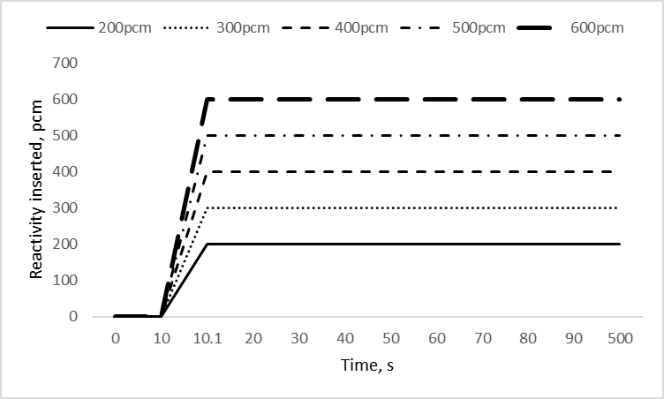
Fig. 3. Reactivity inserted of UTOP.

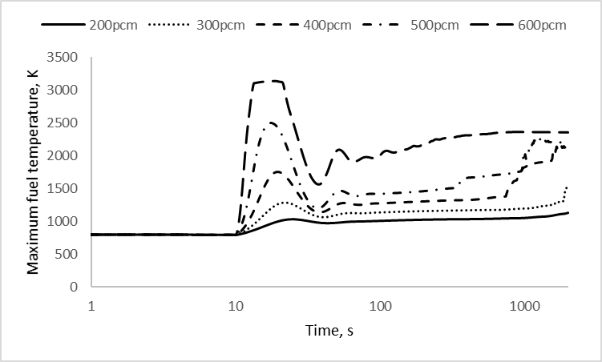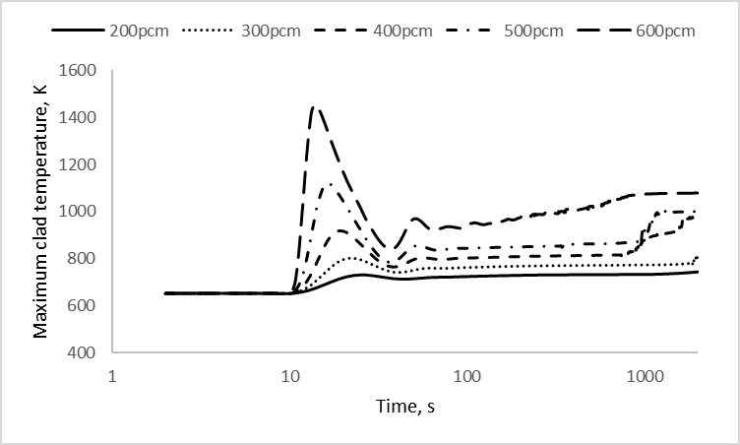
Fig. 4. Maximum fuel and clad temperatures in the UTOP cases.

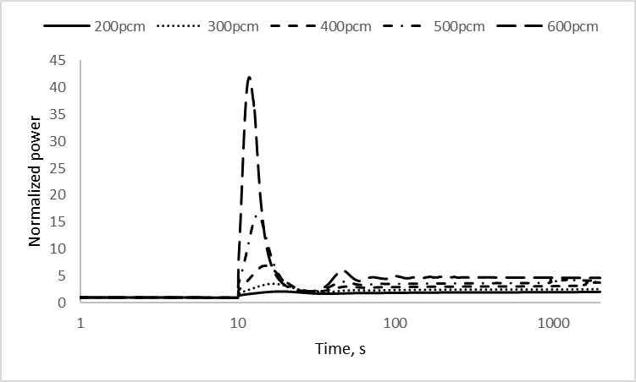
Fig. 5. Power transients in the UTOP cases.

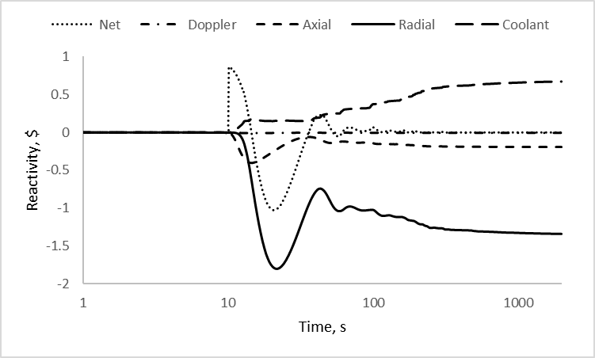
Fig. 6. Reactivity feedback at 600 pcm insertion case.

ULOF
In the transient analysis of ULOF accident, the coolant driving pressure will decrease exponentially with the halving times 2 s, 5 s and 10 s, as shown in Fig. 7 [15]. The accident was initiated after 10 s of steady state condition. Such a postulated scenario may occur once the primary pumps tripped due to technical failures or loss of power. The response of fuel temperature and cladding temperature in the simulation can be seen in Fig. 8 and the coolant flow transients can be seen in Fig. 9. At the 2 s halving time case, as Fig. 10 showed, the major feedbacks was negative radial reactivities. When the temperature rose due to the reduction of coolant flowrate, core radial expansion would be more severe and then lead to more leakage of neutrons. With the influences from radial reactivity feedback, the core would finally shut down itself. When the ramp rate of the coolant driving pressure increased, the coolant flow decreases more rapidly and the temperatures of the fuel and cladding were higher. The maximum temperature of the cladding was 760 K in the 2 s halving time case, which was still far from the failure temperature. Therefore, the cladding failure will not happen in the ULOF accident based on our current simulations.

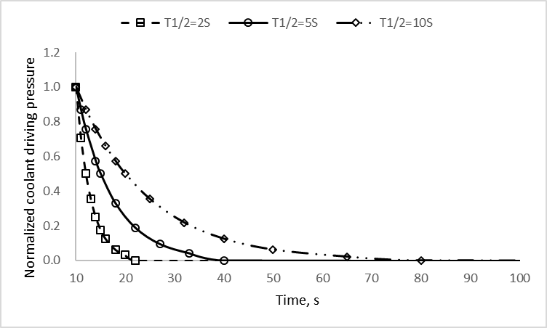
Fig. 7. Coolant driving pressure decay of ULOF.

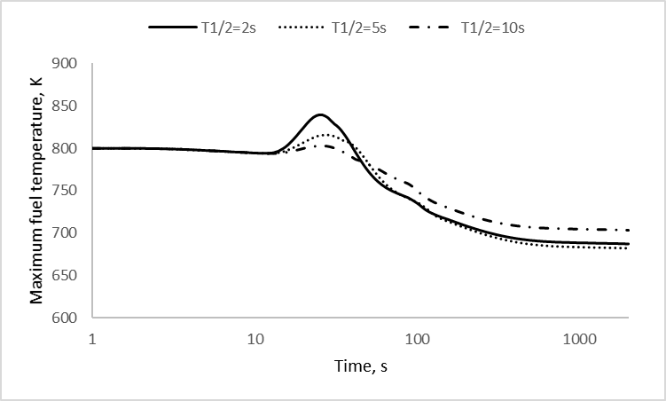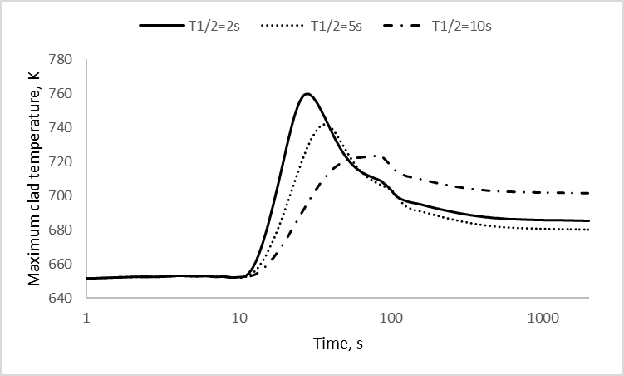
Fig. 8. Maximum fuel and clad temperatures in the ULOF cases.

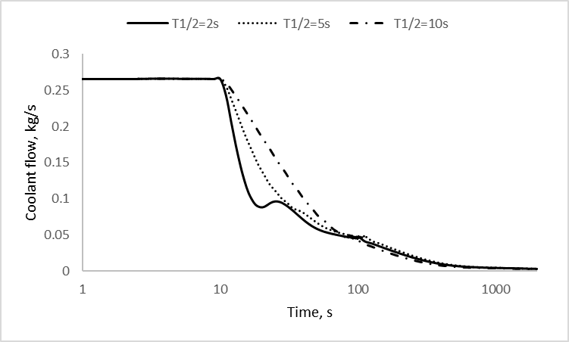
Fig. 9. Flow transients in the ULOF cases.

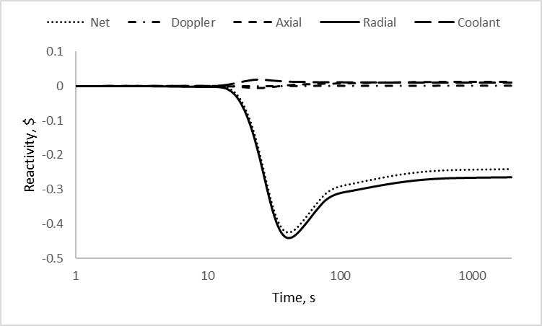
Fig. 10. Reactivity feedback at 2 s halving time case.

Conclusion
In this paper, we simulated the UTOP and ULOF accidents in the CiADS reactor core loaded with uranium mononitride and analysed the failure temperature of the cladding in these transients. The brief summary of maximum temperatures of fuel and cladding at different cases is listed in Table 5. Through the calculation results above, we can preliminarily conclude that:
- In the UTOP accident, the tolerance of positive reactivity insertion is 600 pcm in order to avoid the cladding rupture and the maximum fuel and cladding temperatures are 3138 K and 1454 K respectively.
- In the ULOF accident, the cladding will not rupture no matter the halving time of coolant driving pressure is 2 s, 5 s or 10 s, and the maximum fuel and cladding temperatures are 840 K and 760K occurring at 2 s halving time.

TABLE 5. Summary of the maximum temperatures achieved in different cases

Transient cases | Description | Max fuel temperature, K | Max clad temperature, K
UTOP | 200 pcm | 1132 | 744
 | 300pcm | 1551 | 809
 | 400pcm | 2152 | 977
 | 500pcm | 2499 | 1120
 | 600pcm | 3138 | 1454
ULOF | 2 s halving time | 840 | 760
 | 5 s halving time | 816 | 742
 | 10 s halving time | 803 | 724

References
- RUBBIA, C., Conceptual design of a fast neutron operated high power energy amplifier, CERN-AT-95-44 ET, CERN, Geneva (1995).
- HARADA, H., NAKAMURA, S., FUJII, T., Accelerator-driven systems (ADS) and fast reactors (FR) in advanced nuclear fuel cycles, a comparative study, J Nucl Sci Technol. 41.1 (2004) 1–6.
- SELTBORG, P., External source effects and neutronics in accelerator-driven systems (Doctoral dissertation, Fysik) (2003).
- PENG, T., GU, L., WANG, D., Conceptual design of subcritical reactor for China initiative accelerator driven system, Atomic Energy Science and Technology. 51.12 (2017) 2235–2241.
- YOUINOU, G., SEN, R., Impact of accident-tolerant fuels and claddings on the overall fuel cycle: a preliminary systems analysis, Nucl Technol. 188.2 (2014) 123–138.
- ROSS, S., ELGENK, M., MATTHEWS, R., Thermal conductivity correlation for uranium nitride fuel between 10 and 1923 K, J Nucl Mater. 151.3 (1988) 318–326.
- SZPUNAR, B., SZPUNAR, J., Thermal conductivity of uranium nitride and carbide, International Journal of Nuclear Energy. (2014).
- ARAI, Y., MAEDA, A., SHIOZAWA, K., Chemical forms of solid fission products in the irradiated uranium—plutonium mixed nitride fuel, J Nucl Mater. 210 (1994) 161–166.
- ZAKOVA, J., WALLENIUS, J, Fuel residence time in BWRs with nitride fuels, Ann Nucl Energy. 47 (2012) 182–191.
- YU, R., GU, L., SHENG, X., Review of fuel assembly design in lead‐based fast reactors and research progress in fuel assembly of China initiative accelerator driven system, Int J Energ Res. 45.8 (2021) 11552–11563.
- GU, L., SU, X., Latest research progress for LBE coolant reactor of China initiative accelerator driven system project, Front Energy. (2021) 1–22.
- LARSON, F., MILLER, J., A time-temperature relationship for rupture and creep stresses, Trans Asme. 74(1952) 765–771.
- FILACCHIONI, G., “Mechanical and structural behaviour of the second double stabilized stainless steels generation”, International Conference on Fast Reactor Core and Fuel Structural Behaviour, London (1990).
- ZHANG, Y., WALLENIUS, J., GU, L., Axial expansion for prompt safety of a small lead-cooled reactor, Ann Nucl Energy. 147 (2020) 107733.
- LI, R., CHEN, X., BOCCACCINI, C., R Study on Severe Accident Scenarios: Pin Failure Possibility of MYRRHA-FASTEF Critical Core, Energy Procedia. 71 (2015) 14–21.

